**Ansible Assignment**

**Q1. Create an ansible set up of 5 nodes ( 1 control + 2 ubuntu and centos each)**

Note: Due to personal laptop resource contraints I have created an ansible set up of 3 nodes (1 control + 2 managed nodes)

1. Installing Virtual Box + Vagrant on windows

<https://www.ansibletutorials.com/installing-vagrant-and-virtualbox>

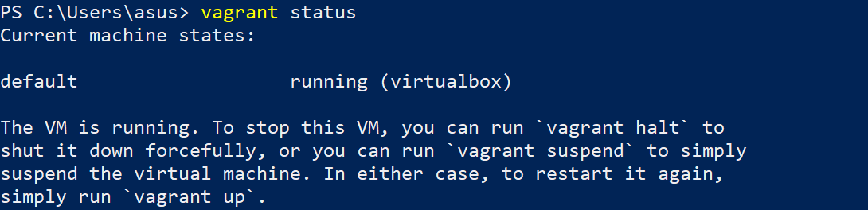

1. Installing ansible module in master node

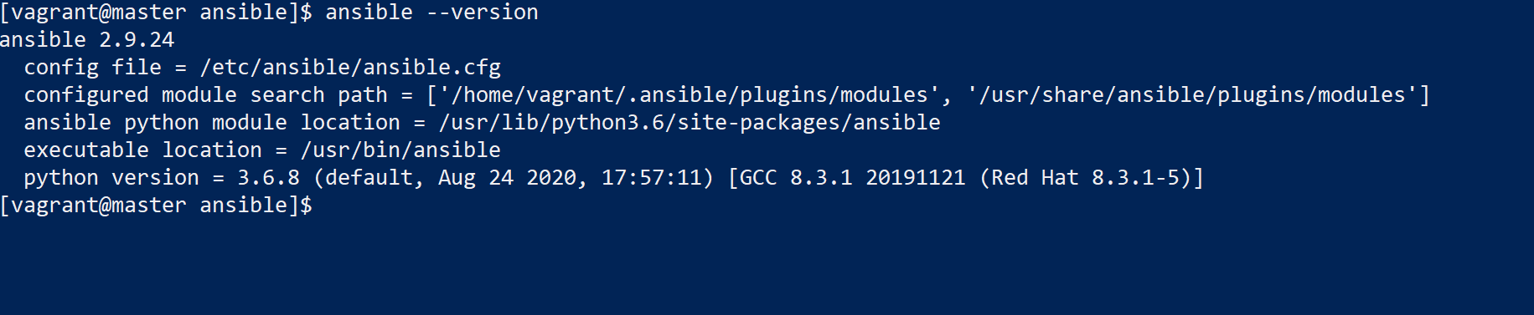

1. Adding host file configuration

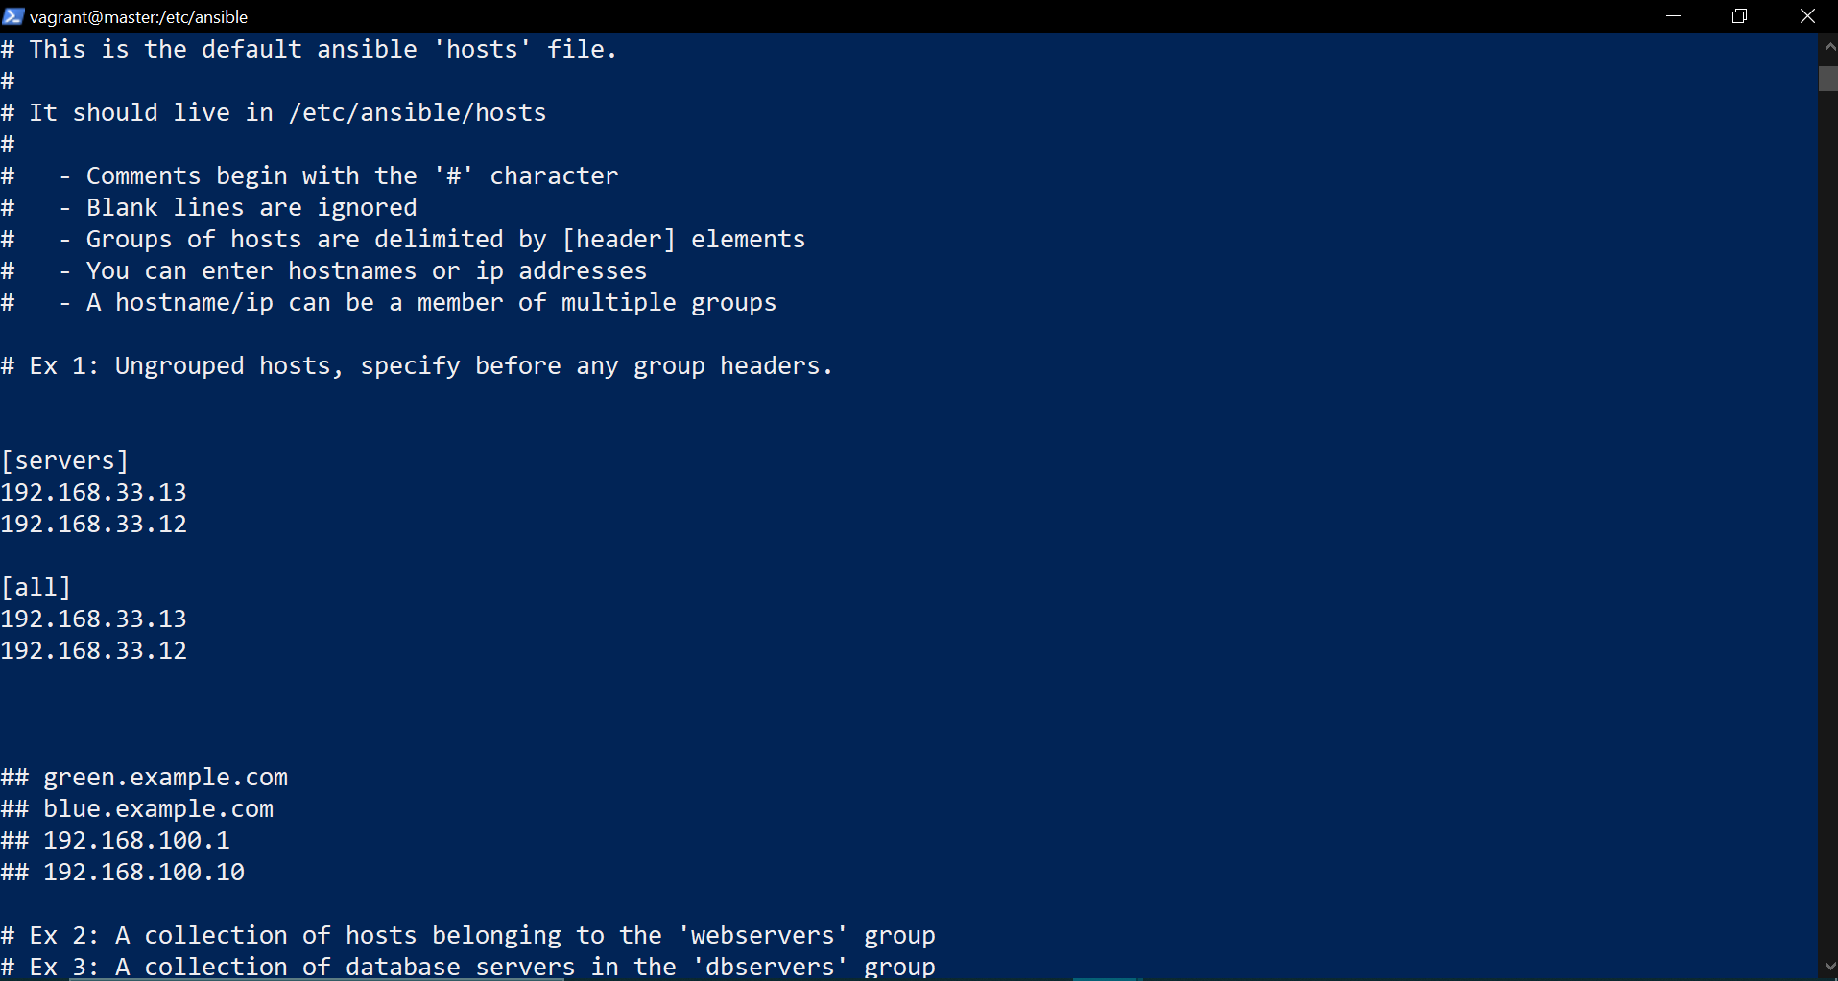

1. Pinging all the hosts using:

ansible -i /etc/ansible/hosts all -m ping

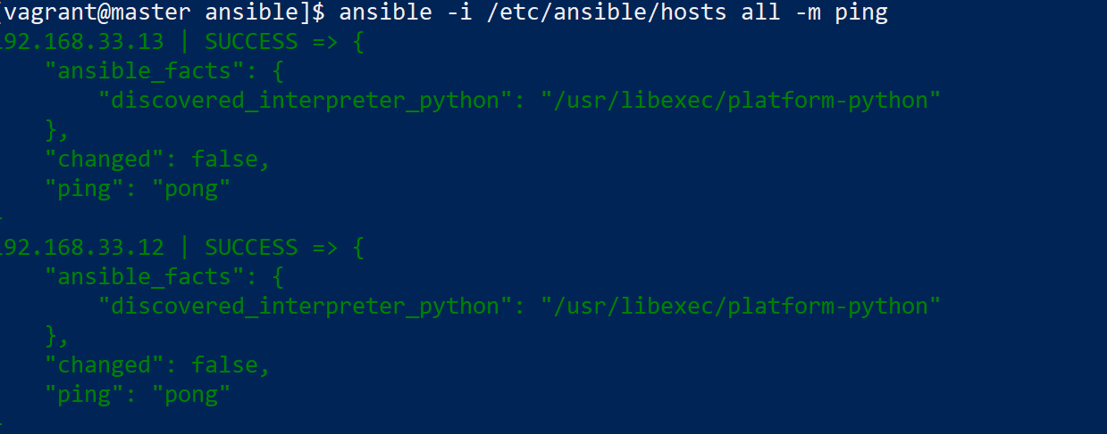

All machines are up and running which includes 1 control node and 2 managed nodes

**Q2. Create an ansible playbook to create a file called /opt/hashedin.txt with any content and copy the same file to control node from the managed nodes at any location**

Create a playbook inside ansible directory



Run the playbook

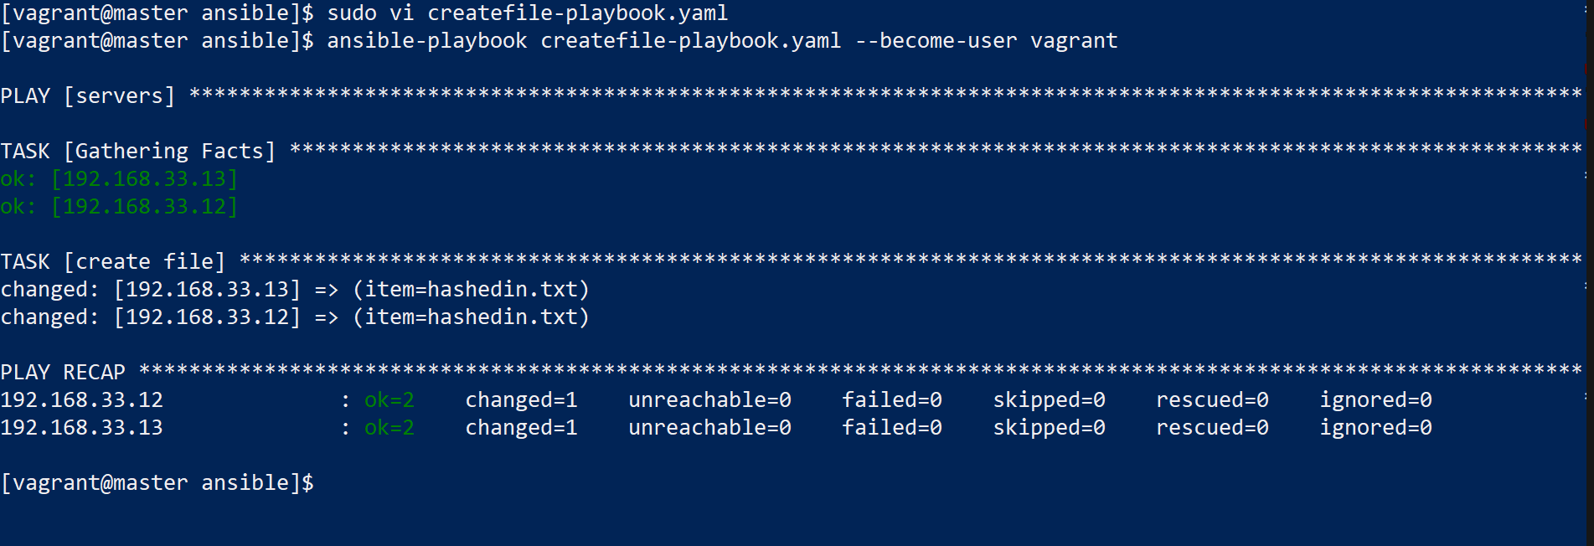

Ssh into the nodes and check if file is create

Node1



Node2



**Q3. Create an ansible playbook which contains the IP address of the host on which the playbook runs**

Create ansible playbook



Run the playbook

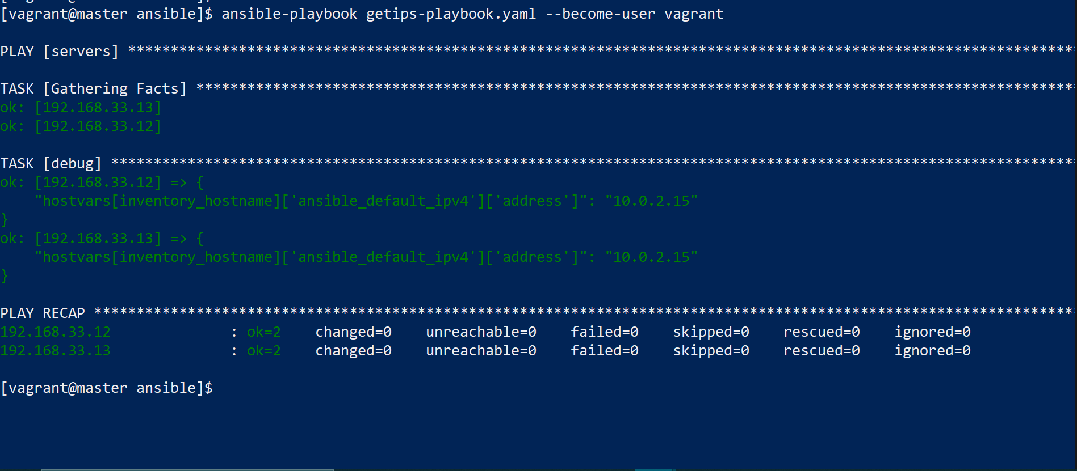

**Q4. Create Ansible playbook:**

**To install nginx on centos and and deploy a sample webpage**

**To install apache on ubuntu and and deploy a sample webpage**

Add host entries in hosts file



Make required changes in ansible.cfg file

Add the following lines:

remote_user=vagrant

timeout=60

[privilege_escalation]

become=True

become_method=sudo

become_user=root

#become_ask_pass=False

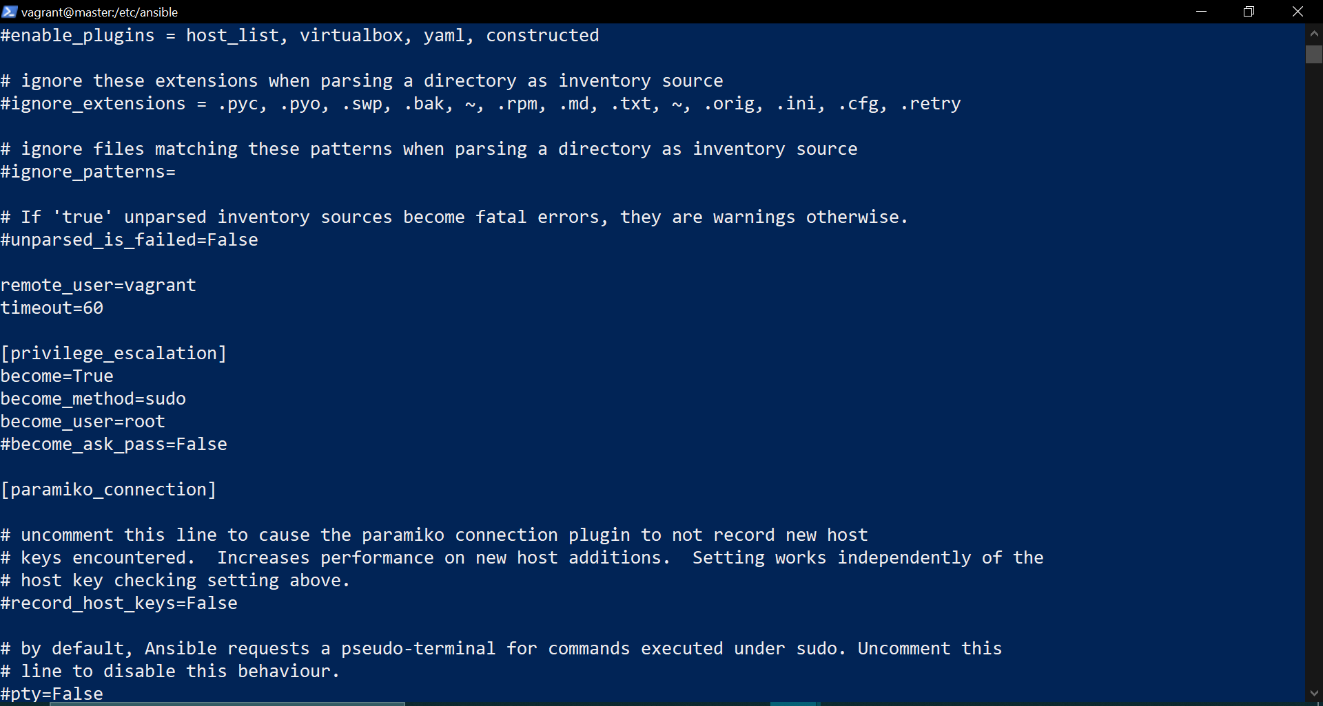

Create a playbook to install epel package and nginx package and then enable the nginx service



Run the playbook

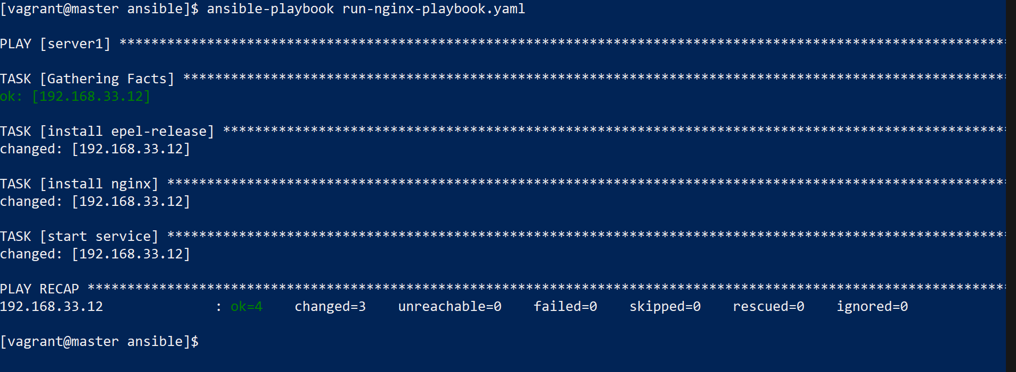



Now the nginx is installed on one of the node= node1

**To install apache on centos node:**

Create playbook:



Run the playbook

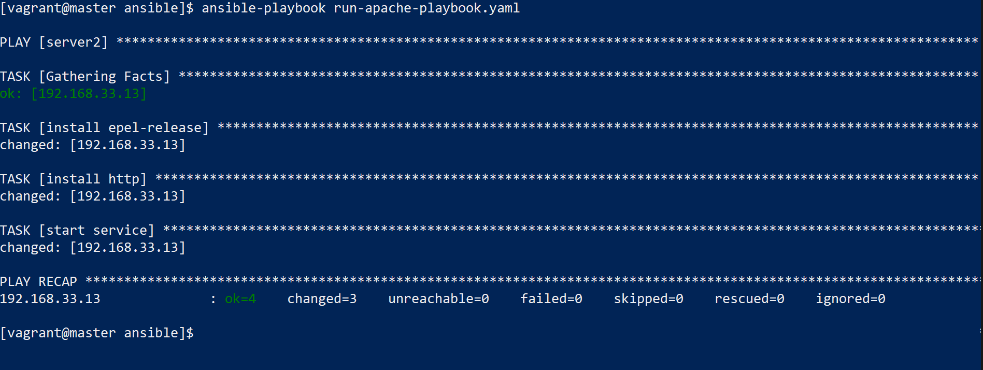

**Q5. Write an ansible playbook to install docker on managed node. Deploy a nginx container. The default page of nginx should be viewable from IP address of managed node.**

Create a playbook to install docker

Start the service and also include step to install a docker container



Q6. Use ansible to add a rule in the firewall to add the ips in the centos/ubuntu group

