COVID 19 Data Analysis

Vidit Vivek Sharma

21/09/2021

# COVID 19 Analysis

Let us start with the analysis that we did in the class with Jane Wall.

We use this module to look at the steps in a data analysis in a reproducible manner using COVID-19 data. First we find some data sources.

We look at the [nytimes]<https://github.com/nytimes/covid-19-data> and [Johns Hopkins University]<https://github.com/CSSEGISandData/COVID-19> github sites. After reviewing a little, we find that JHU gives more detail on their sources and data.

## Step 1 - Identify and import the data

We start by reading in the data from the four main csv files.

## Get current Data in the four files  
# they all begin the same way  
url_in <- "https://raw.githubusercontent.com/CSSEGISandData/COVID-19/master/csse_covid_19_data/csse_covid_19_time_series/time_series_covid19_"  
file_names <- c("confirmed_global.csv",  
 "deaths_global.csv",  
 "confirmed_US.csv",  
 "deaths_US.csv")  
urls <- str_c(url_in,file_names)

Then we read in the data and see what we are working with.

global_cases <- read_csv(urls[1], show_col_types = FALSE)  
global_deaths <- read_csv(urls[2], show_col_types = FALSE)   
US_cases <- read_csv(urls[3], show_col_types = FALSE)  
US_deaths <- read_csv(urls[4], show_col_types = FALSE)

## Step 2 - Tidy up the data

After looking at global_cases and global_deaths, we would like to tidy those datasets and put each variable (date, cases, deaths) in its own column. Also, we don’t need Lat and Long for the analysis we are planning, so we get rid of those and rename Region and State to be more R friendly.

global_cases <- global_cases %>%  
 pivot_longer(cols = -c(`Province/State`,`Country/Region`, Lat, Long),   
 names_to = "date",values_to = "cases") %>%  
 select(-c(Lat,Long))  
  
global_deaths <- global_deaths %>%  
 pivot_longer(cols = -c(`Province/State`,  
 `Country/Region`, Lat, Long),   
 names_to = "date",   
 values_to = "deaths") %>%  
 select(-c(Lat, Long))  
  
   
global <- global_cases %>%   
 full_join(global_deaths) %>%  
 rename(Country_Region =`Country/Region`,Province_State =`Province/State`) %>%  
 mutate(date = mdy(date))

## Joining, by = c("Province/State", "Country/Region", "date")

Lets look at the summary of the table we created.

# look at a summary of the data to see if there are problems  
summary(global)

## Province_State Country_Region date cases   
## Length:169353 Length:169353 Min. :2020-01-22 Min. : 0   
## Class :character Class :character 1st Qu.:2020-06-21 1st Qu.: 146   
## Mode :character Mode :character Median :2020-11-20 Median : 2297   
## Mean :2020-11-20 Mean : 286349   
## 3rd Qu.:2021-04-21 3rd Qu.: 51809   
## Max. :2021-09-19 Max. :42088171   
## deaths   
## Min. : 0   
## 1st Qu.: 1   
## Median : 35   
## Mean : 6604   
## 3rd Qu.: 841   
## Max. :673774

Removing cases where the cases are equal to zero.

# get rid of rows with no cases  
global <- global %>% filter(cases > 0)

US_cases <- US_cases %>%  
 pivot_longer(cols = -(UID:Combined_Key),   
 names_to = "date",   
 values_to = "cases") %>%  
 select(Admin2:cases) %>%  
 mutate(date = mdy(date)) %>%  
 select(-c(Lat, Long_))  
   
US_deaths <- US_deaths %>%  
 pivot_longer(cols = -(UID:Population),   
 names_to = "date",   
 values_to ="deaths") %>%  
 select(Admin2:deaths) %>%  
 mutate(date = mdy(date)) %>%  
 select(-c(Lat, Long_))  
US <- US_cases %>%   
 full_join(US_deaths)

## Joining, by = c("Admin2", "Province_State", "Country_Region", "Combined_Key", "date")

We notice that we don’t have population data for the world data. If we plan to do comparative analysis So we add population data and a variable called Combined_Key that combines the Province_State with the Country_Region

global <- global %>%   
 unite("Combined_Key",   
 c(Province_State, Country_Region),   
 sep = ", ",   
 na.rm = TRUE,   
 remove = FALSE)

Let’s add in population data to the global dataset.

uid_lookup_url <- "https://raw.githubusercontent.com/CSSEGISandData/COVID-19/master/csse_covid_19_data/UID_ISO_FIPS_LookUp_Table.csv"  
uid <- read_csv(uid_lookup_url) %>%  
 select(-c(Lat, Long_, Combined_Key, code3, iso2, iso3, Admin2))

## Rows: 4196 Columns: 12

## -- Column specification --------------------------------------------------------  
## Delimiter: ","  
## chr (7): iso2, iso3, FIPS, Admin2, Province_State, Country_Region, Combined_Key  
## dbl (5): UID, code3, Lat, Long_, Population

##   
## i Use `spec()` to retrieve the full column specification for this data.  
## i Specify the column types or set `show_col_types = FALSE` to quiet this message.

global <- global %>%   
 left_join(uid, by = c("Province_State", "Country_Region")) %>%  
 select(-c(UID, FIPS)) %>%  
 select(Province_State, Country_Region, date,  
 cases, deaths, Population,  
 Combined_Key)  
global

## # A tibble: 153,341 x 7  
## Province_State Country_Region date cases deaths Population Combined_Key  
## <chr> <chr> <date> <dbl> <dbl> <dbl> <chr>   
## 1 <NA> Afghanistan 2020-02-24 5 0 38928341 Afghanistan   
## 2 <NA> Afghanistan 2020-02-25 5 0 38928341 Afghanistan   
## 3 <NA> Afghanistan 2020-02-26 5 0 38928341 Afghanistan   
## 4 <NA> Afghanistan 2020-02-27 5 0 38928341 Afghanistan   
## 5 <NA> Afghanistan 2020-02-28 5 0 38928341 Afghanistan   
## 6 <NA> Afghanistan 2020-02-29 5 0 38928341 Afghanistan   
## 7 <NA> Afghanistan 2020-03-01 5 0 38928341 Afghanistan   
## 8 <NA> Afghanistan 2020-03-02 5 0 38928341 Afghanistan   
## 9 <NA> Afghanistan 2020-03-03 5 0 38928341 Afghanistan   
## 10 <NA> Afghanistan 2020-03-04 5 0 38928341 Afghanistan   
## # ... with 153,331 more rows

## Step 3 - Visualize the data

Let’s focus our analysis on the US data for now.

Let’s look at the total number of cases over time and the total deaths over time for the US as a whole and for a given state.

US_by_state <- US %>%  
 group_by(Province_State,Country_Region,date)%>%  
 summarize(cases=sum(cases),deaths=sum(deaths),  
 Population=sum(Population))%>%  
 mutate(deaths_per_mill=deaths*1000000/Population)%>%  
 select(Province_State, Country_Region,date,  
 cases, deaths, deaths_per_mill,Population)%>%  
 ungroup()

## `summarise()` has grouped output by 'Province_State', 'Country_Region'. You can override using the `.groups` argument.

US_totals <- US_by_state %>%  
 group_by(Country_Region, date) %>%  
 summarize(cases = sum(cases), deaths = sum(deaths),   
 Population = sum(Population)) %>%  
 mutate(deaths_per_mill = deaths *1000000 / Population) %>%  
 select(Country_Region, date,  
 cases, deaths, deaths_per_mill, Population) %>%  
 ungroup()

## `summarise()` has grouped output by 'Country_Region'. You can override using the `.groups` argument.

Lets plot the data for US as a whole.

US_totals %>%   
 filter(cases > 0) %>%  
 ggplot(aes(x = date, y = cases)) +  
 geom_line(aes(color = "cases")) +  
 geom_point(aes(color = "cases")) +  
 geom_line(aes(y = deaths, color = "deaths")) +  
 geom_point(aes(y = deaths, color = "deaths")) +  
 scale_y_log10() +  
 theme(legend.position="bottom",  
 axis.text.x = element_text(angle = 90)) +  
 labs(title = "COVID19 in US", y= NULL)

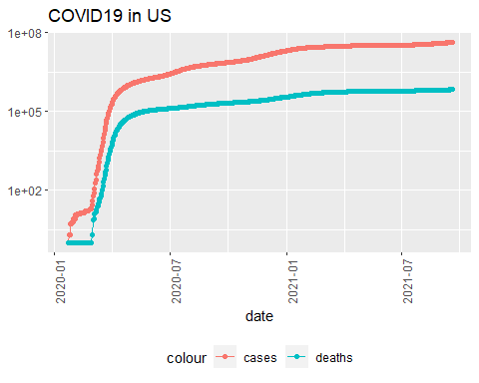

Lets plot the data for New York state.

state <- "New York"  
US_by_state %>%   
 filter(Province_State == state) %>%  
 filter(cases > 0) %>%  
 ggplot(aes(x = date, y = cases)) +  
 geom_line(aes(color = "cases")) +  
 geom_point(aes(color = "cases")) +  
 geom_line(aes(y = deaths, color = "deaths")) +  
 geom_point(aes(y = deaths, color = "deaths")) +  
 scale_y_log10() +  
 theme(legend.position="bottom",  
 axis.text.x = element_text(angle = 90)) +  
 labs(title = str_c("COVID19 in ", state), y= NULL)

## Warning: Transformation introduced infinite values in continuous y-axis  
  
## Warning: Transformation introduced infinite values in continuous y-axis

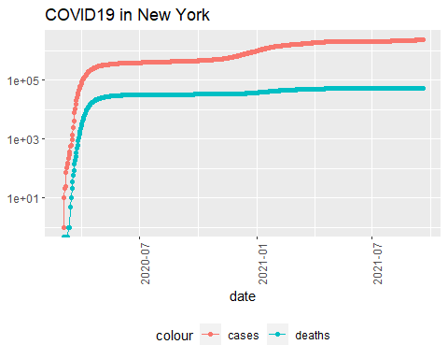

## Step 4 - Analyse the data

So our graph looks like COVID has leveled off.Lets look at the number of new cases and deaths per day.

US_by_state <- US_by_state %>%  
 mutate(new_cases = cases - lag(cases),   
 new_deaths = deaths - lag(deaths))  
US_totals <- US_totals %>%  
 mutate(new_cases = cases - lag(cases),   
 new_deaths = deaths - lag(deaths))

Lets Visualize the number of new cases and deaths per day to see if that raises new questions.

US_totals %>%  
 ggplot(aes(x = date, y = new_cases)) +  
 geom_line(aes(color = "new_cases")) +  
 geom_point(aes(color = "new_cases")) +  
 geom_line(aes(y = new_deaths, color = "new_deaths")) +  
 geom_point(aes(y = new_deaths, color = "new_deaths")) +  
 scale_y_log10() +  
 theme(legend.position="bottom",  
 axis.text.x = element_text(angle = 90)) +  
 labs(title = "COVID19 in US", y= NULL)

## Warning: Transformation introduced infinite values in continuous y-axis  
  
## Warning: Transformation introduced infinite values in continuous y-axis  
  
## Warning: Transformation introduced infinite values in continuous y-axis  
  
## Warning: Transformation introduced infinite values in continuous y-axis

## Warning: Removed 1 row(s) containing missing values (geom_path).

## Warning: Removed 1 rows containing missing values (geom_point).

## Warning: Removed 1 row(s) containing missing values (geom_path).

## Warning: Removed 1 rows containing missing values (geom_point).

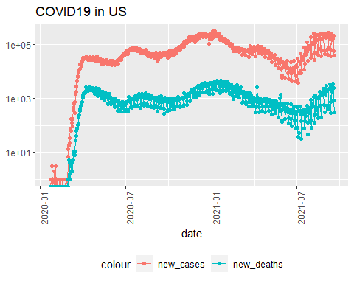

state <- "New York"  
US_by_state %>%   
 filter(Province_State == state) %>%  
 ggplot(aes(x = date, y = new_cases)) +  
 geom_line(aes(color = "new_cases")) +  
 geom_point(aes(color = "new_cases")) +  
 geom_line(aes(y = new_deaths, color = "new_deaths")) +  
 geom_point(aes(y = new_deaths, color = "new_deaths")) +  
 scale_y_log10() +  
 theme(legend.position="bottom",  
 axis.text.x = element_text(angle = 90)) +  
 labs(title = str_c("COVID19 in ", state), y= NULL)

## Warning in self$trans$transform(x): NaNs produced

## Warning: Transformation introduced infinite values in continuous y-axis

## Warning in self$trans$transform(x): NaNs produced

## Warning: Transformation introduced infinite values in continuous y-axis

## Warning in self$trans$transform(x): NaNs produced

## Warning: Transformation introduced infinite values in continuous y-axis

## Warning in self$trans$transform(x): NaNs produced

## Warning: Transformation introduced infinite values in continuous y-axis

## Warning: Removed 1 row(s) containing missing values (geom_path).

## Warning: Removed 1 rows containing missing values (geom_point).

## Warning: Removed 1 row(s) containing missing values (geom_path).

## Warning: Removed 6 rows containing missing values (geom_point).

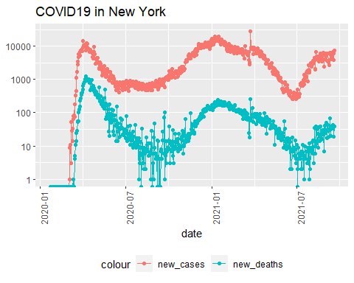

Which are the worst and best states? How to measure this? Perhaps look at case rates and death rates per 1000 people?

US_state_totals <- US_by_state %>%   
 group_by(Province_State) %>%  
 summarize(deaths = max(deaths), cases = max(cases),  
 population = max(Population),   
 cases_per_thou = 1000* cases / population,  
 deaths_per_thou = 1000 * deaths / population) %>%   
 filter(cases > 0, population > 0)   
US_state_totals %>%  
 slice_min(deaths_per_thou, n = 10)

## # A tibble: 10 x 6  
## Province_State deaths cases population cases_per_thou deaths_per_thou  
## <chr> <dbl> <dbl> <dbl> <dbl> <dbl>  
## 1 Northern Mariana Islands 2 263 55144 4.77 0.0363  
## 2 Vermont 298 31634 623989 50.7 0.478   
## 3 Hawaii 714 75480 1415872 53.3 0.504   
## 4 Virgin Islands 67 6458 107268 60.2 0.625   
## 5 Alaska 469 100360 740995 135. 0.633   
## 6 Maine 984 83910 1344212 62.4 0.732   
## 7 Puerto Rico 3074 179144 3754939 47.7 0.819   
## 8 Oregon 3569 309841 4217737 73.5 0.846   
## 9 Utah 2787 490985 3205958 153. 0.869   
## 10 Washington 7201 620752 7614893 81.5 0.946

US_state_totals %>%   
 slice_max(deaths_per_thou, n = 10)

## # A tibble: 10 x 6  
## Province_State deaths cases population cases_per_thou deaths_per_thou  
## <chr> <dbl> <dbl> <dbl> <dbl> <dbl>  
## 1 Mississippi 9214 473413 2976149 159. 3.10  
## 2 New Jersey 27190 1133228 8882190 128. 3.06  
## 3 Louisiana 13418 725637 4648794 156. 2.89  
## 4 New York 54904 2373659 19453561 122. 2.82  
## 5 Alabama 13210 770391 4903185 157. 2.69  
## 6 Arizona 19513 1066803 7278717 147. 2.68  
## 7 Massachusetts 18445 790953 6892503 115. 2.68  
## 8 Rhode Island 2812 168449 1059361 159. 2.65  
## 9 Arkansas 7445 485056 3017804 161. 2.47  
## 10 Florida 51240 3528698 21477737 164. 2.39

## Step 5 - Model the data

We might need to introduce more variables here to build a model. Which do you want to consider? Population density, extent of lockdown, political affiliation, climate of the area? When you determine the factors you want to try, add that data to your dataset, and then visualize and model and see if your variable has a statistically significant effect.

mod <- lm(deaths_per_thou ~ cases_per_thou, data = US_state_totals)  
summary(mod)

##   
## Call:  
## lm(formula = deaths_per_thou ~ cases_per_thou, data = US_state_totals)  
##   
## Residuals:  
## Min 1Q Median 3Q Max   
## -1.4081 -0.2939 -0.0211 0.2741 1.1586   
##   
## Coefficients:  
## Estimate Std. Error t value Pr(>|t|)   
## (Intercept) 0.031944 0.241155 0.132 0.895   
## cases_per_thou 0.014662 0.001924 7.620 4.53e-10 ***  
## ---  
## Signif. codes: 0 '***' 0.001 '**' 0.01 '*' 0.05 '.' 0.1 ' ' 1  
##   
## Residual standard error: 0.5044 on 53 degrees of freedom  
## Multiple R-squared: 0.5228, Adjusted R-squared: 0.5138   
## F-statistic: 58.07 on 1 and 53 DF, p-value: 4.534e-10

US_state_totals %>% slice_min(cases_per_thou)

## # A tibble: 1 x 6  
## Province_State deaths cases population cases_per_thou deaths_per_thou  
## <chr> <dbl> <dbl> <dbl> <dbl> <dbl>  
## 1 Northern Mariana Islands 2 263 55144 4.77 0.0363

US_state_totals %>% slice_max(cases_per_thou)

## # A tibble: 1 x 6  
## Province_State deaths cases population cases_per_thou deaths_per_thou  
## <chr> <dbl> <dbl> <dbl> <dbl> <dbl>  
## 1 Tennessee 14332 1178168 6829174 173. 2.10

x_grid <- seq(1, 151)  
new_df <- tibble(cases_per_thou = x_grid)  
US_state_totals %>% mutate(pred = predict(mod))

## # A tibble: 55 x 7  
## Province_State deaths cases population cases_per_thou deaths_per_thou pred  
## <chr> <dbl> <dbl> <dbl> <dbl> <dbl> <dbl>  
## 1 Alabama 13210 7.70e5 4903185 157. 2.69 2.34  
## 2 Alaska 469 1.00e5 740995 135. 0.633 2.02  
## 3 Arizona 19513 1.07e6 7278717 147. 2.68 2.18  
## 4 Arkansas 7445 4.85e5 3017804 161. 2.47 2.39  
## 5 California 67966 4.64e6 39512223 117. 1.72 1.75  
## 6 Colorado 7374 6.49e5 5758736 113. 1.28 1.68  
## 7 Connecticut 8463 3.84e5 3565287 108. 2.37 1.61  
## 8 Delaware 1920 1.28e5 973764 132. 1.97 1.96  
## 9 District of Co~ 1167 5.89e4 705749 83.4 1.65 1.25  
## 10 Florida 51240 3.53e6 21477737 164. 2.39 2.44  
## # ... with 45 more rows

Let us use the model to predict the State total cases and also plot the actual data for comparision.

US_tot_w_pred <- US_state_totals %>% mutate(pred = predict(mod))  
US_tot_w_pred %>% ggplot() +  
geom_point(aes(x = cases_per_thou, y = deaths_per_thou), color = "blue") +  
geom_point(aes(x = cases_per_thou, y = pred), color = "red")

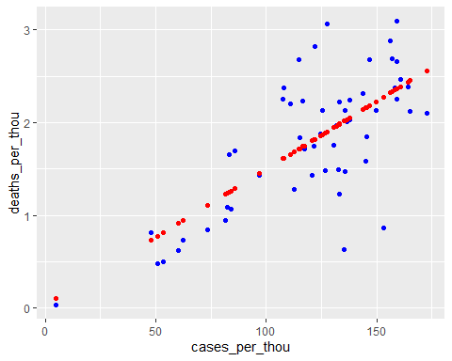

From the above graph we can see that the there is more concentration towards the prediction line as compared to the rest of the graph.

## Step 6 - Additional Analysis (Beyond what is done in the class)

Ratio of death and cases can be used to comment on the medical infrastructure of a country or State? First we need to analyse the number of deaths and cases.

Let us take a look at the number of cases compared to the population and also to the number of death versus the number of cases of a country or a state. This could help us understand the extent of medical infrastructure in the country or state.

Lets first take a look at the global data for percentage of cases and the percentages of deaths compared to the population.

global_total <- global %>%   
 group_by(Country_Region) %>%  
 summarize(deaths = max(deaths), cases = max(cases),  
 population = max(Population),   
 cases_percentage = (cases / population)*100,  
 deaths_percentage = (deaths / population)*100,  
 death_cases_per =(deaths / cases)*100) %>%   
 filter(cases > 0, population > 0)

Lets plot the cases_percentage and deaths_percentage for the global data.

global_total %>%   
 ggplot(aes(x = cases_percentage, y = deaths_percentage )) +  
 geom_point(color="blue")+ geom_label_repel(aes(label = Country_Region),   
 box.padding=0.35,   
 point.padding = 0.5,   
 segment.color = 'grey50')

## Warning: ggrepel: 179 unlabeled data points (too many overlaps). Consider  
## increasing max.overlaps

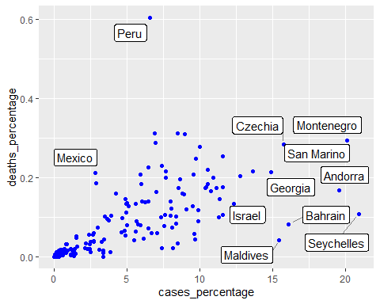

Lets do the same thing for US state data.

US_total <- US_by_state %>%   
 group_by(Province_State) %>%  
 summarize(deaths = max(deaths), cases = max(cases),  
 population = max(Population),   
 cases_percentage = (cases / population)*100,  
 deaths_percentage = (deaths / population)*100,  
 death_cases_per =(deaths / cases)*100) %>%   
 filter(cases > 0, population > 0)

US_total %>%   
 ggplot(aes(x = cases_percentage, y = deaths_percentage )) +  
 geom_point(color="blue")+ geom_label_repel(aes(label = Province_State),   
 box.padding=0.35,   
 point.padding = 0.5,   
 segment.color = 'grey50')

## Warning: ggrepel: 38 unlabeled data points (too many overlaps). Consider  
## increasing max.overlaps

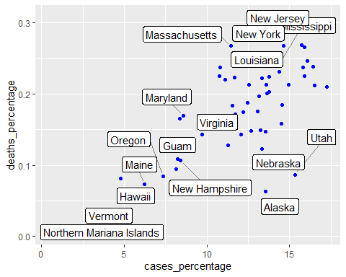

The above graphs show us the relation between the cases_percentage and deaths_percentage.

Now let us take look at the death to cases percentage with countries that have population greater than 1 million to find out the top 10 worst countries.

global_total %>%   
 filter(population>1000000)%>%  
 select(Country_Region,deaths,cases,population,death_cases_per)%>%  
 slice_max(death_cases_per, n = 10)

## # A tibble: 10 x 5  
## Country_Region deaths cases population death_cases_per  
## <chr> <dbl> <dbl> <dbl> <dbl>  
## 1 Yemen 1643 8667 29825968 19.0   
## 2 Peru 199066 2167008 32971846 9.19  
## 3 Mexico 271503 3569677 127792286 7.61  
## 4 Sudan 2878 37995 43849269 7.57  
## 5 Syria 2127 30709 17500657 6.93  
## 6 Ecuador 32661 507003 17643060 6.44  
## 7 Egypt 16970 296929 102334403 5.72  
## 8 Somalia 1063 19004 15893219 5.59  
## 9 Taiwan* 840 16141 23816775 5.20  
## 10 Liberia 283 5904 5057677 4.79

Now let us find the top 10 worst states in US. Here worst state refer to the states where the percentage of death to cases is maximum. Here we also take the states with the populations greater than 10000 to exclude the islands and other smaller states with very small population.

US_total %>%   
 filter(population>10000)%>%  
 select(Province_State,deaths,cases,population,death_cases_per)%>%  
 slice_max(death_cases_per, n = 10)

## # A tibble: 10 x 5  
## Province_State deaths cases population death_cases_per  
## <chr> <dbl> <dbl> <dbl> <dbl>  
## 1 New Jersey 27190 1133228 8882190 2.40  
## 2 Massachusetts 18445 790953 6892503 2.33  
## 3 New York 54904 2373659 19453561 2.31  
## 4 Connecticut 8463 384342 3565287 2.20  
## 5 Pennsylvania 28858 1379478 12801989 2.09  
## 6 District of Columbia 1167 58851 705749 1.98  
## 7 Michigan 21997 1109643 9986857 1.98  
## 8 Maryland 10263 519097 6045680 1.98  
## 9 Mississippi 9214 473413 2976149 1.95  
## 10 New Mexico 4675 244720 2096829 1.91

Here we can build a model on the bases of death to cases percentage with the population of the US state

mod1 <- lm(death_cases_per~population, data = US_total)  
summary(mod1)

##   
## Call:  
## lm(formula = death_cases_per ~ population, data = US_total)  
##   
## Residuals:  
## Min 1Q Median 3Q Max   
## -0.92101 -0.29200 -0.03219 0.26812 0.88171   
##   
## Coefficients:  
## Estimate Std. Error t value Pr(>|t|)   
## (Intercept) 1.377e+00 7.226e-02 19.050 <2e-16 ***  
## population 1.588e-08 7.702e-09 2.062 0.0441 *   
## ---  
## Signif. codes: 0 '***' 0.001 '**' 0.01 '*' 0.05 '.' 0.1 ' ' 1  
##   
## Residual standard error: 0.4096 on 53 degrees of freedom  
## Multiple R-squared: 0.07429, Adjusted R-squared: 0.05682   
## F-statistic: 4.253 on 1 and 53 DF, p-value: 0.04409

# Conclusion

From the various graphs we can see that Covid cases and deaths follow a similar trends. although the scale of the graph is logarithmic, we can see that the pecks are the times when a specific wave is going on and the number of cases are reduction because of the people getting vaccinated.

ALso according to the above analysis, we can say that the states with a higher death to cases percentage have a lower medical infrastructure compared to the ones that have a lesser. As the states with lower death to cases percentage, here the people got better medical care and their better treatment led to a speedy recovery. Thus the states with higher death to cases percentage, couldn’t provide better medical care and that might be one of the reasons for a higher death count.

## Possible sources of bias

Here we need to take a look at the possible sources of bias as there can be reports with data that already have a bias and also those whole introduce a bias while in the report.

Here one of the possible sources of the bias is the data source , as we do not know that how the data is being calculated had how it is being reported. Another possible source of bias can be the medical data reported, we have come across various cases where the cases are under reported or the cause of death has been stated as something else although Covid with the reason the patient went into that state. Another possible source of bias is the percentage of population that was too scared to get them self tested for covid 19 when their first symptoms stated to emerge. Another possible source of bias can be me, as I have developed the report based on my understanding thus a bias in my understand can get translated into the report.