
Project: LockedMe.com

PROJECT CLIENT:
Company Locker’s Pvt. Ltd

DEVELOPED BY:
Vidit Sharma

SOFTWARE REQUIREMENT SPECIFICATION(SRS)

A. INTRODUCTION & SCOPE:

We need to design and develop a prototype of the application so as to ensure following options:

OPTION 1:
The first option should return the current file names in ascending order.
- The root directory can be either empty or contain few files or folders in it.

OPTION 2:
The second option should return the details of the user interface such as options displaying the following:
- Add a file to the existing directory list
  - You can ignore the case sensitivity of the file names
- Delete a user specified file from the existing directory list
  - You can add the case sensitivity on the file name in order to ensure that the right file is deleted from the directory list
  - Return a message if FNF (File not found)
- Search a user specified file from the main directory
  - You can add the case sensitivity on the file name to retrieve the correct file
  - Display the result upon successful operation
  - Display the result upon unsuccessful operation
- Option to navigate back to the main context.

OPTION 3:
- There should be a third option to close the application

B. FUNCTIONALITIES & WORK FLOW:

Welcome Step:
It will provide provide following options-
1 -> Display files in directory
2 -> Add, Delete or Search
3 -> Exit Program
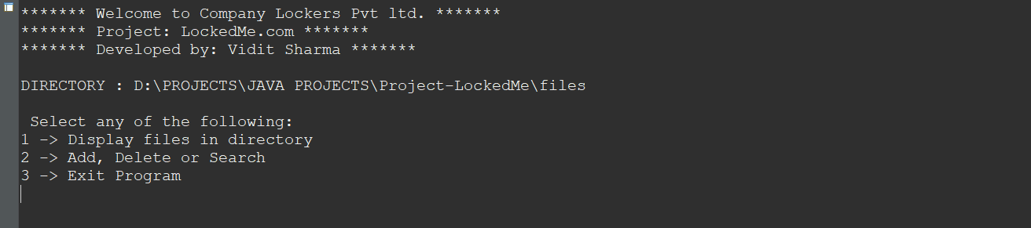
Step 1:
To Display Files
- PRESS ‘1’: To Display all files.
Prompt: Folder is empty

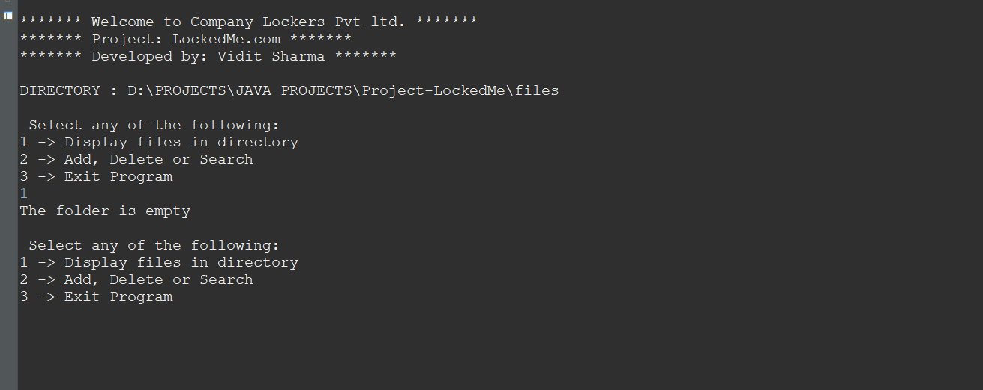

Step 2:
For Modification and Search:
- PRESS ‘2’: To Add, Delete, Search and Go back.
Prompt: Select any of the following:
a -> Add a file
b -> Delete a file
c -> Search a file
d -> Go Back to Main Menu

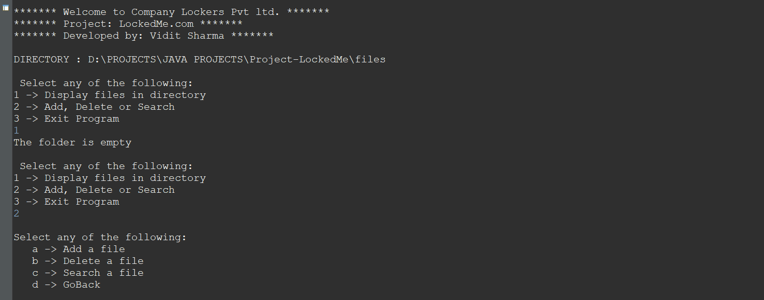

Step 2(a):
Adding three files- Rohit.txt, Virat.txt, Bumrah.txt:

- PRESS ‘a’: To add file one by one
Prompt 1: Please Enter a File Name:
After the name entered-
Prompt 2: File ... added to Directory...

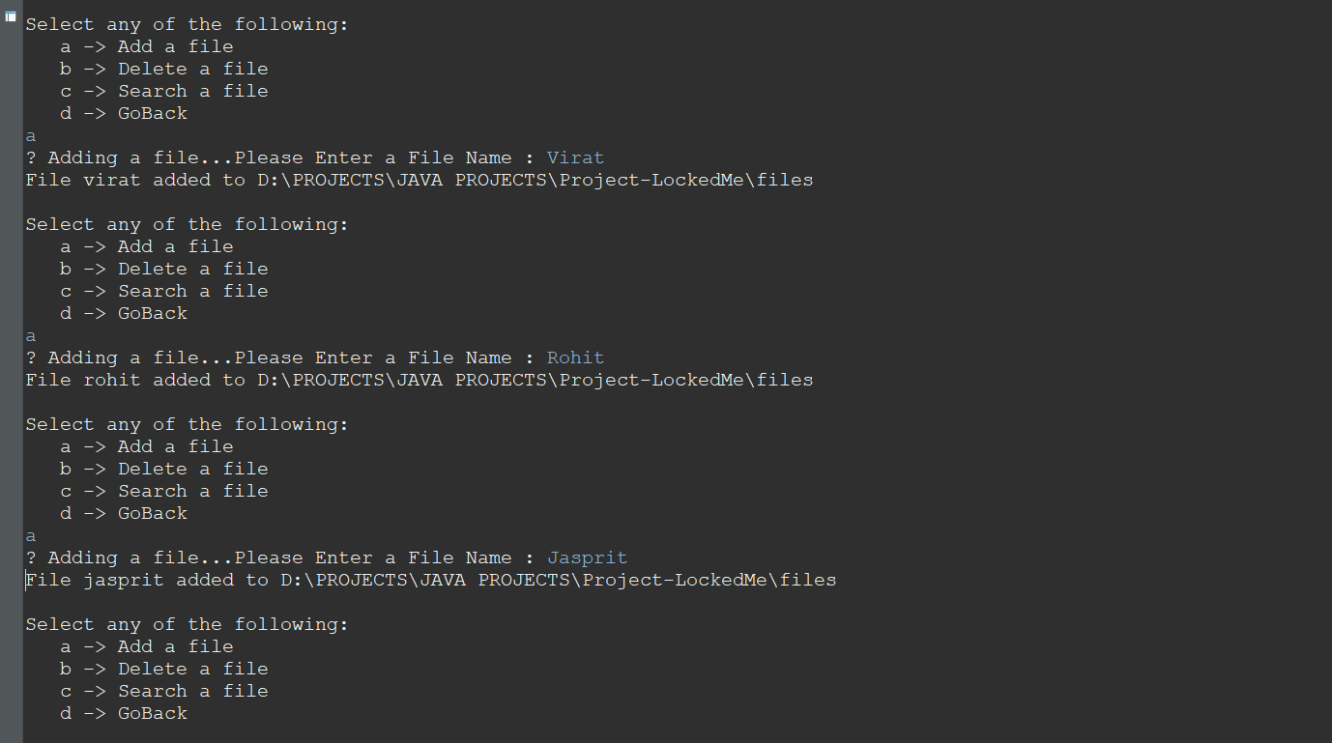

Step 2(b):
Return to Main menu to see if all files are added and sorted.

- Press ‘d’: To Go Back to Main Menu
- Press ‘1’: To Display all files.
  - All three files must display and sorted in ascending order.
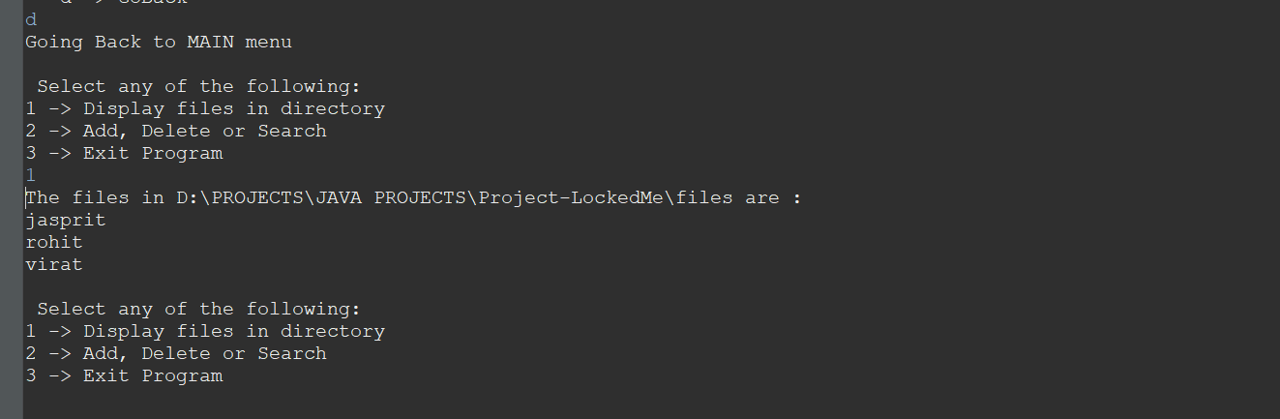

Step 3:
Delete Files

- PRESS ‘2’: To Add, Delete, Search and Go back.
- Press ‘b’: To Delete files
Prompt 1: Please Enter a File Name:
After the name entered-

- If DELETE unsuccessful : "Delete Operation failed. FILE NOT FOUND"
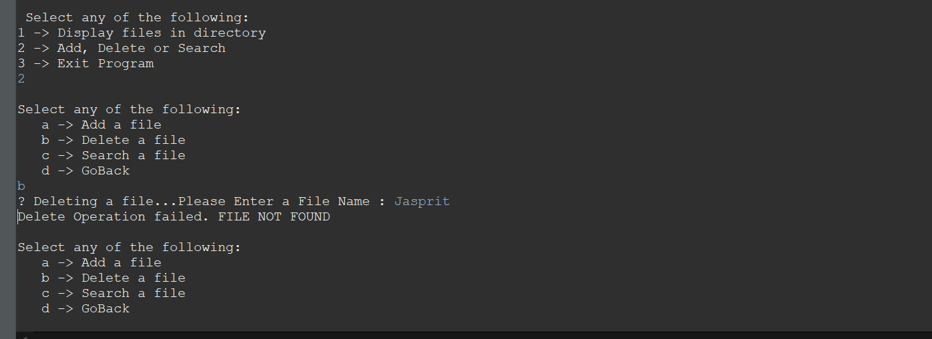
NOTE: As the File we search for is ‘Jasprit’ but the file which got saved in our Folder is ‘jasprit’ as it got converted to lowercase character. So, FILE NOT FOUND.

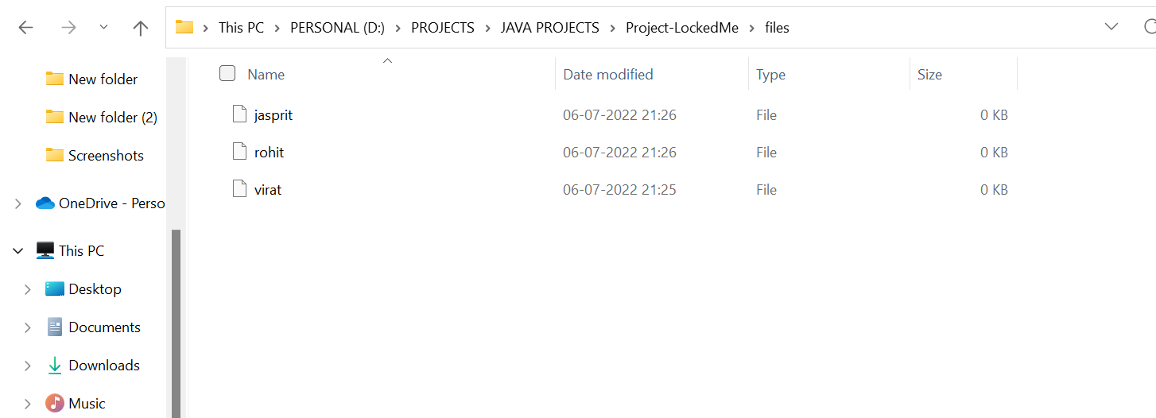

- If DELETE successful: "File "....." deleted from "....

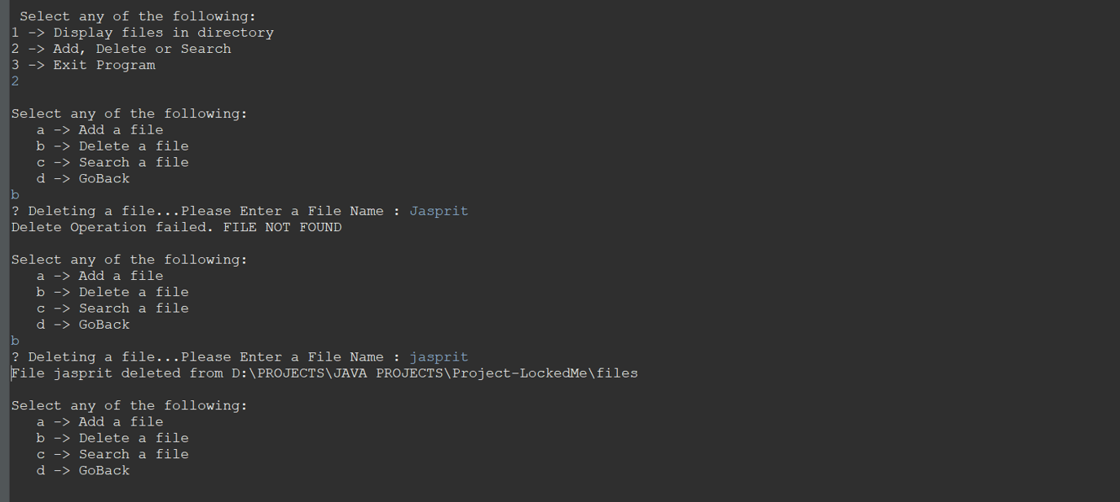
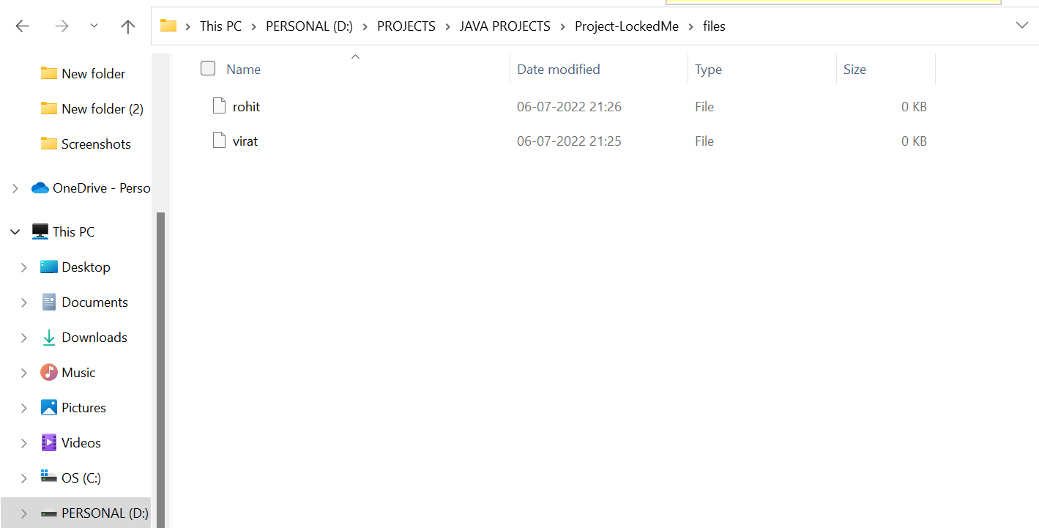

Step 4:
Search files

- Press ‘c’: To Search the files
Prompt 1: Searching a file...Please Enter a File Name
After the name entered-
  - If Successful Search: "FOUND : File ... " " exists at " .....

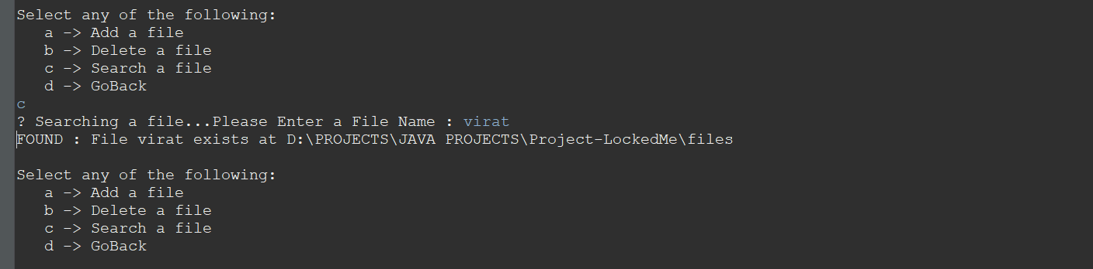

  - If Unsuccessful search: File NOT found (FNF)

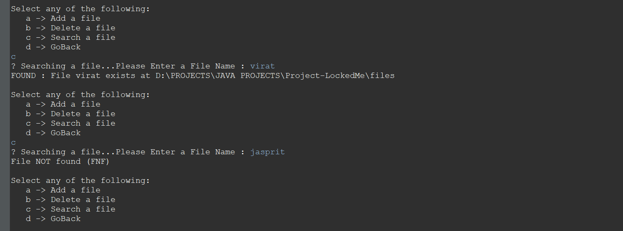

Step 5:
Navigating back to Main Menu

- Press ‘d’: To Navigate back to Main Menu

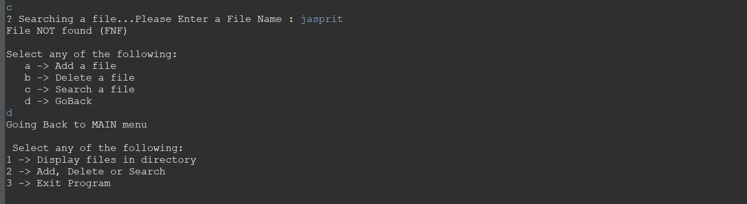

Step 6:
Exit the program

- Press ‘3’: To Exit the program.
Prompt: Thank you for choosing “Company Lockers -LockedMe”

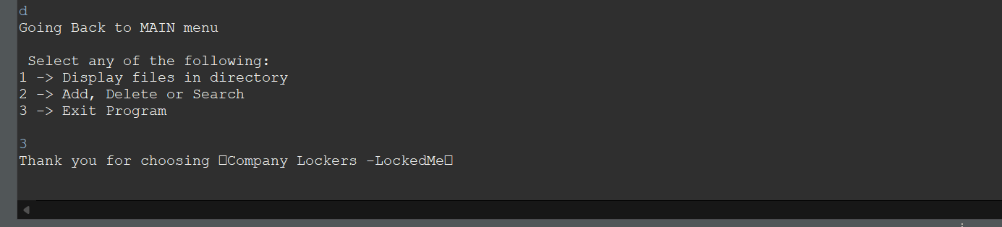

C. TECHNOLOGY STACK:
- Scrum: An efficient agile framework to deliver the product incrementally
- Eclipse/IntelliJ: An IDE to code for the application
  - Java: A programming language to develop the prototype
- GitHub: To store the application code and track its versions
  - Git: To connect and push files from the local system to GitHub

D. TIME ESTIMATIONS:

- 5-7 days

E. TEAM:

- Developer: Vidit Sharma
- Git Location(Source Code): https://github.com/vidit153/CompanyLockers.git

