

School of Engineering and Technology

Data Structure Report File
B.Tech CSE (Data Science)

Submitted to:
Dr. Swati Gupta

Prepared By:
Vidit Bansal
2401420018

S. No. | Topics | Page
1. | Inventory Management System | 3
2. | Browsing History Navigation System | 9
3. | Ticket Management System Using Linear Queue | 11
4. | Singly Linked List | 13
5. | Reverse of String Using Stack | 15
6. | Balanced Parentheses Using Stack | 16

- Inventory Management System

Input -

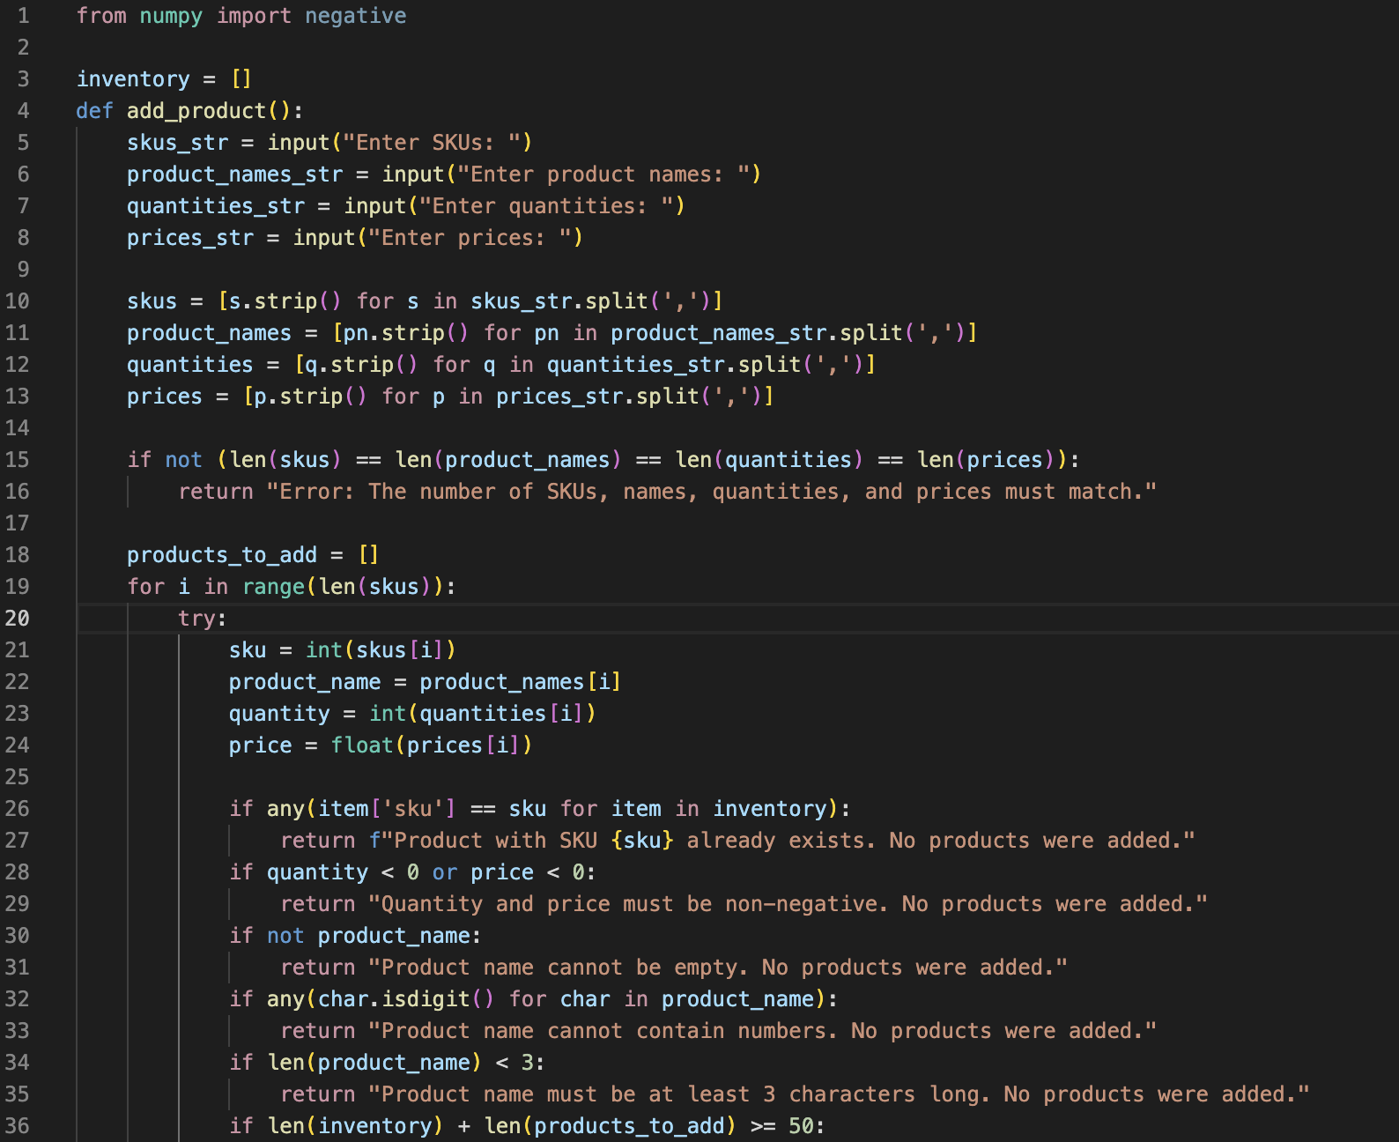
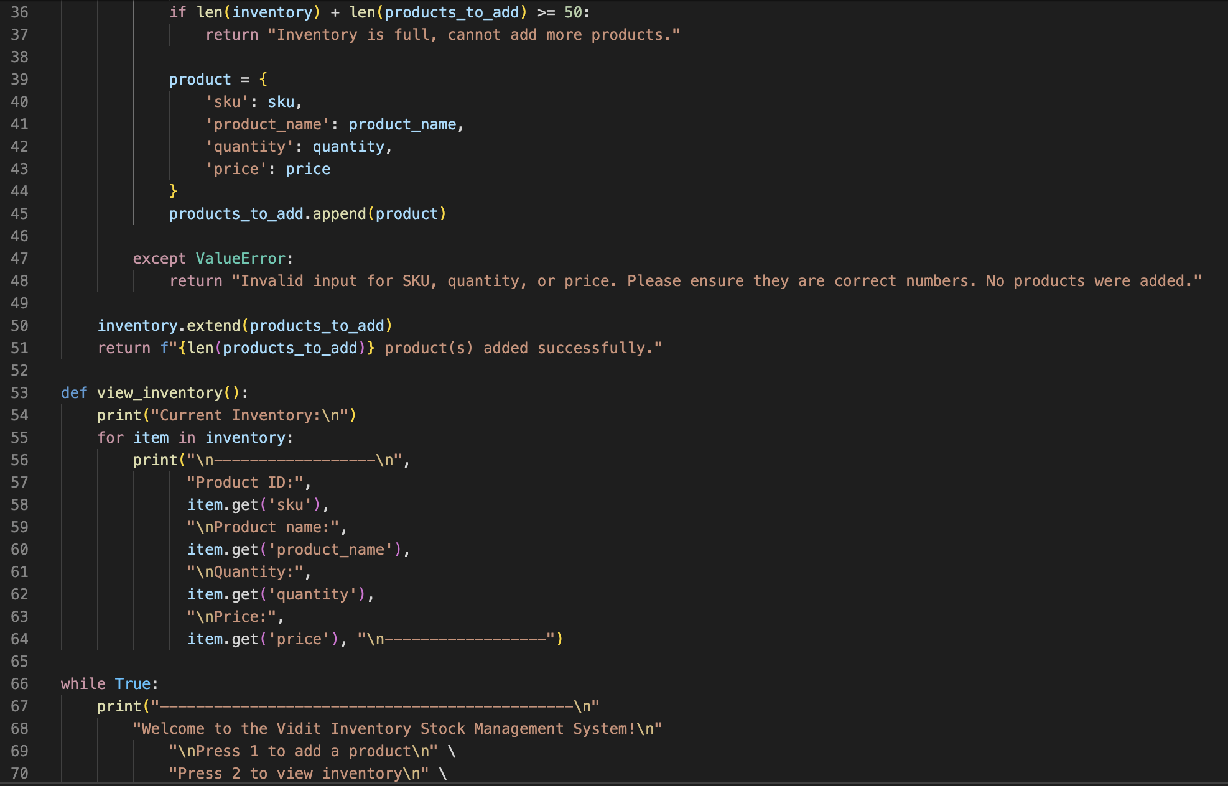
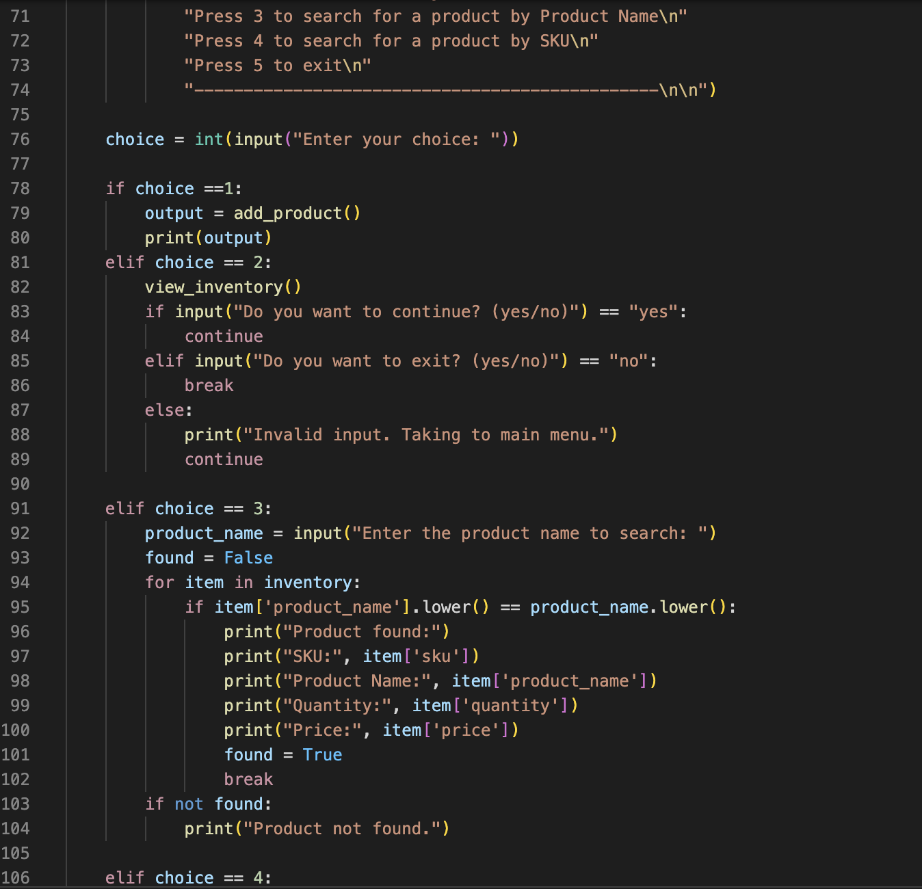
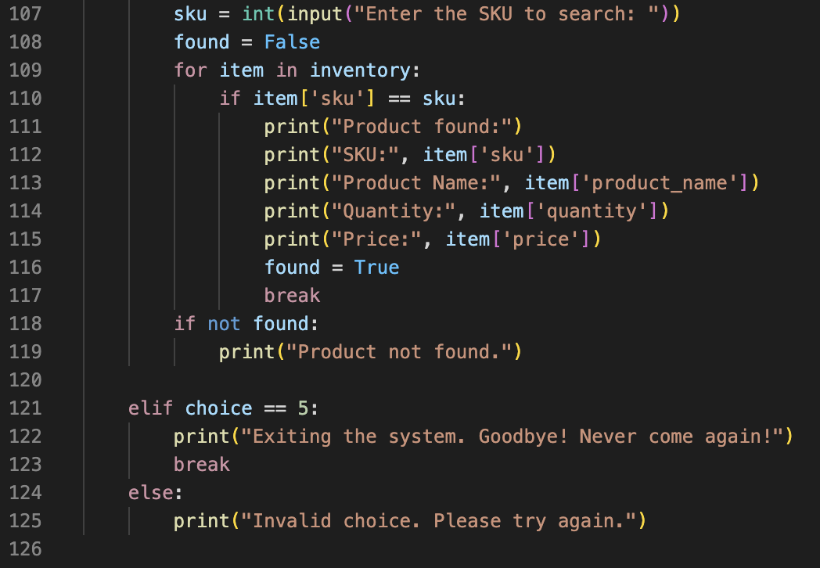

Output –
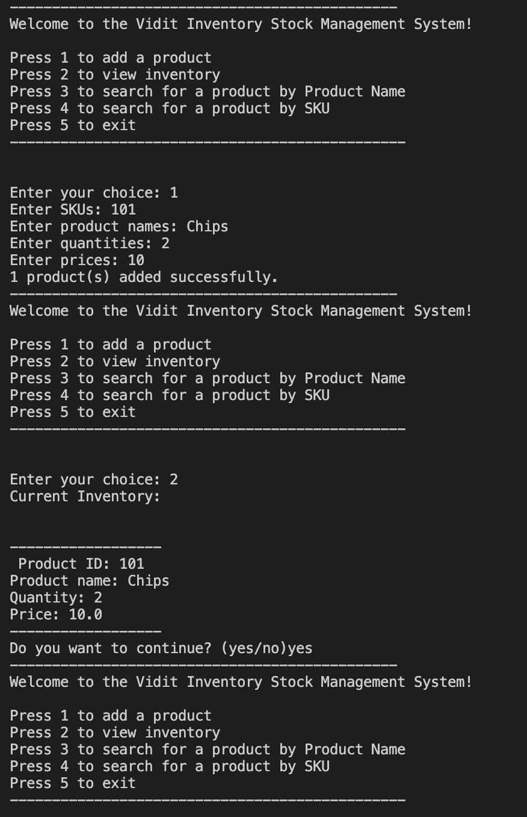
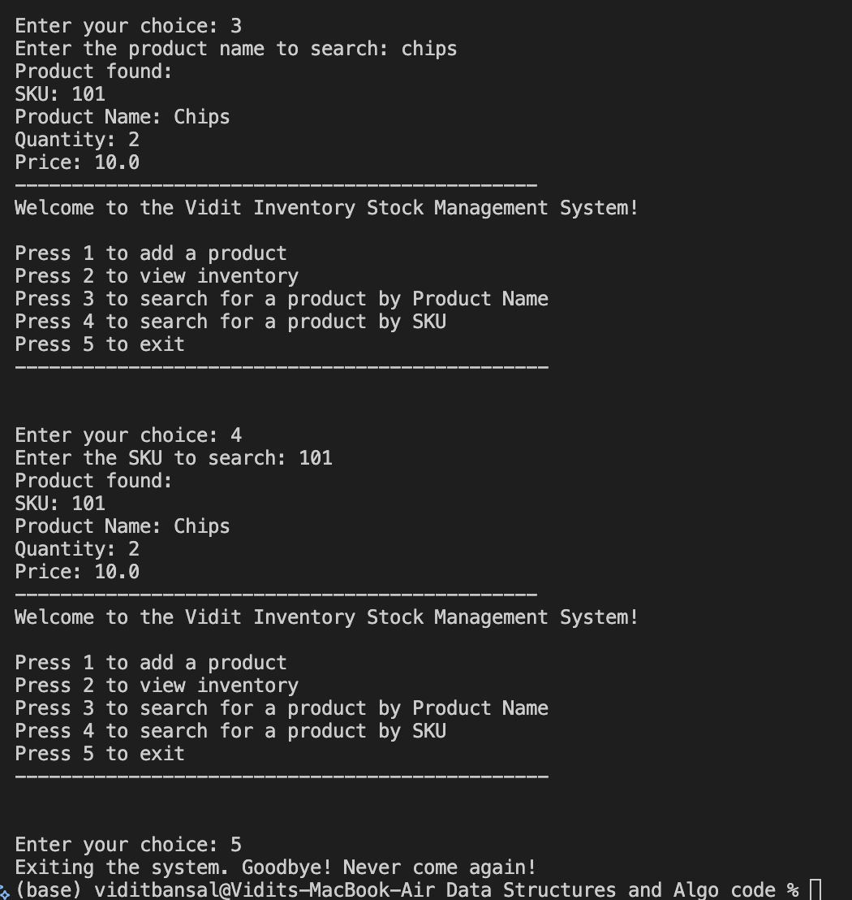

2. Browsing History Navigation History

Input -
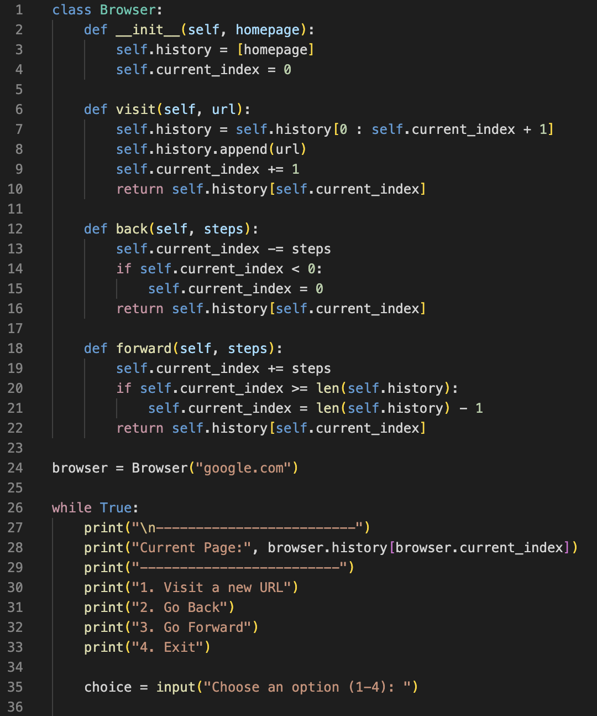

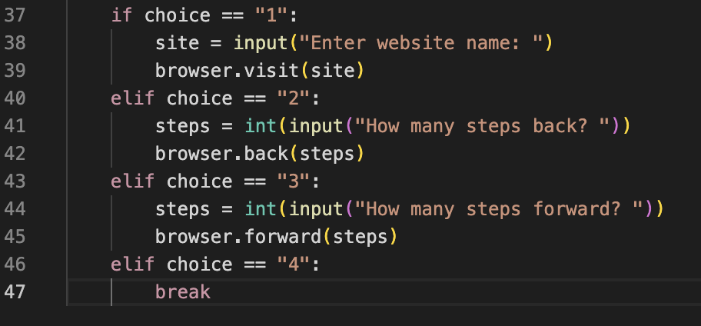

Output:

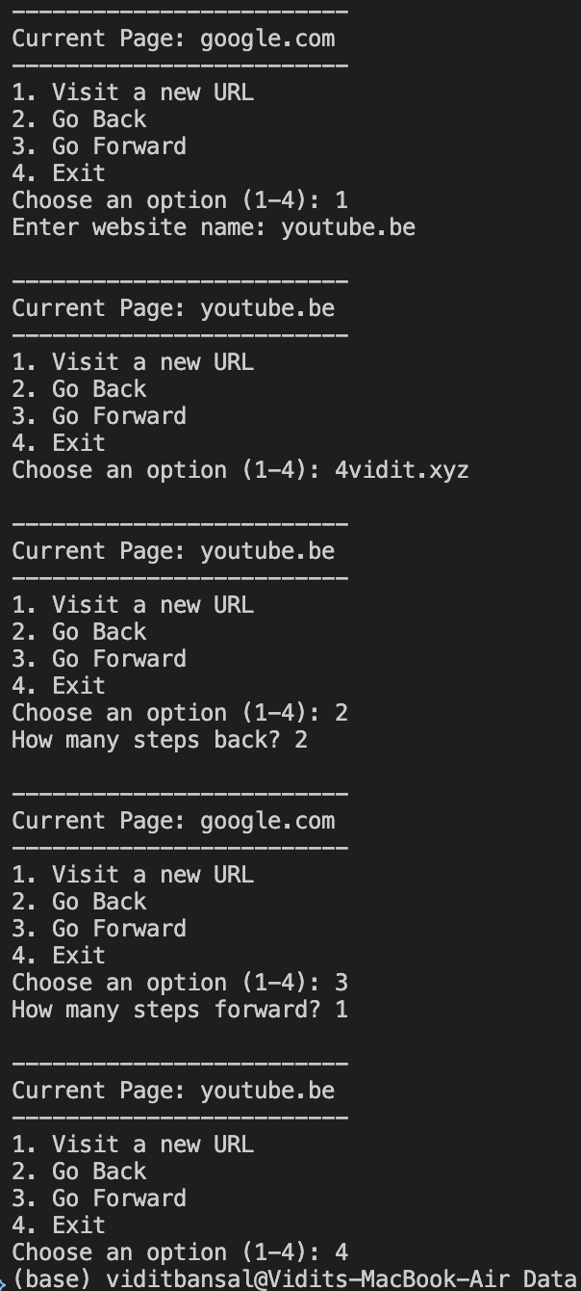
3. Ticket Management System Using Linear Queue

Input -
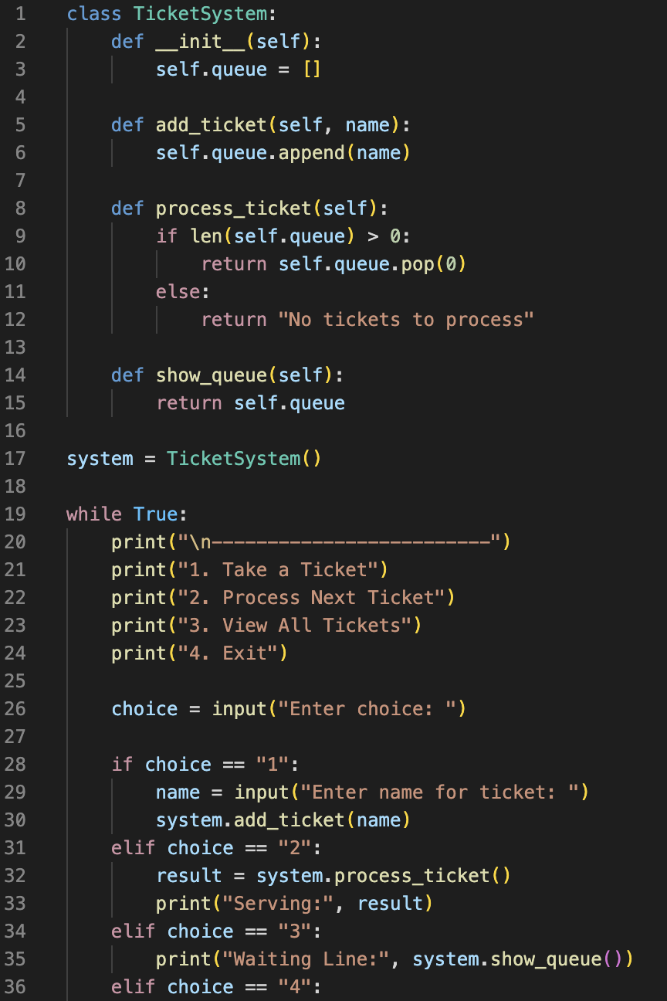
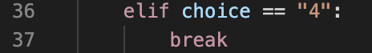

Output:
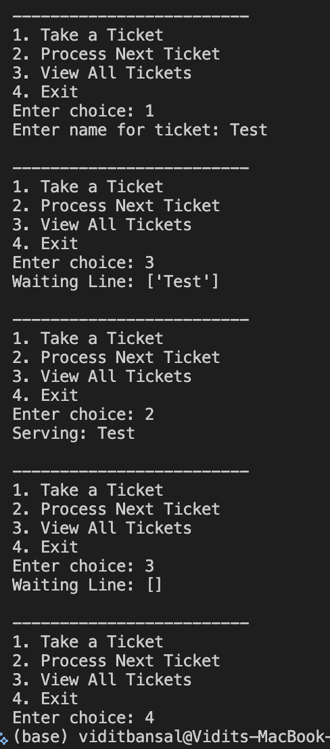

4. Singly Linked List

Input -
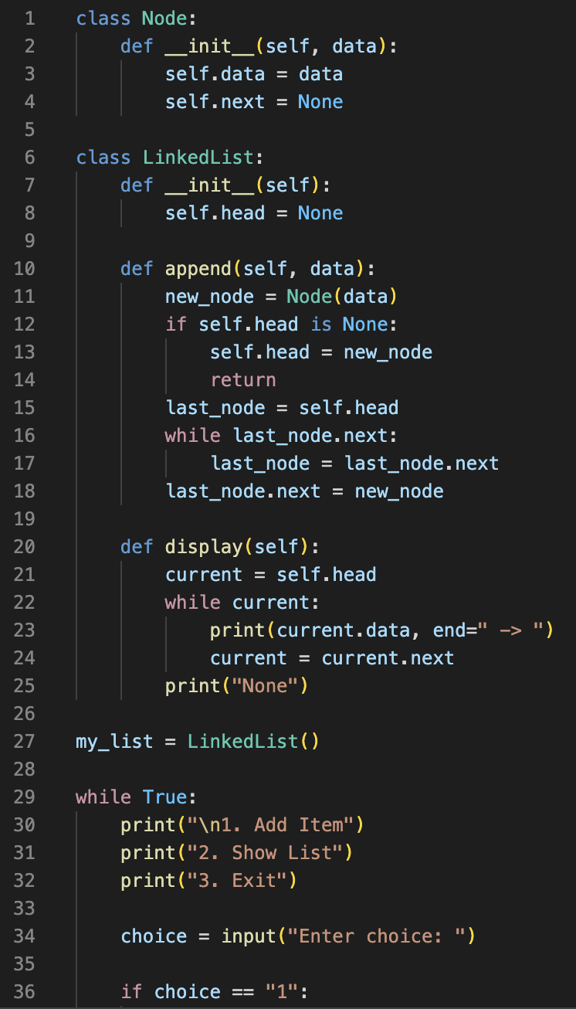
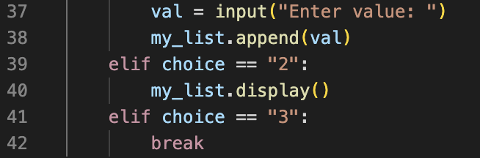

Output:

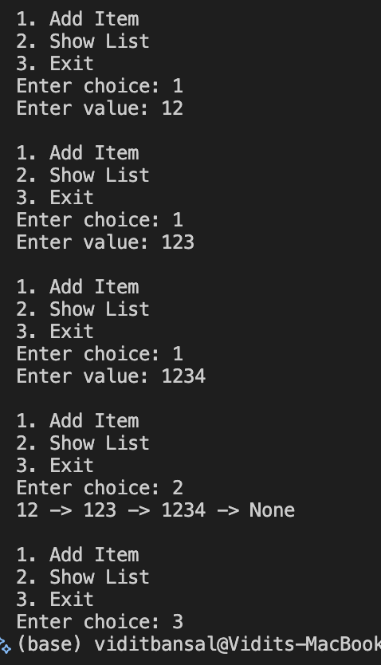

5. Reverse of String Using Stack

Input -
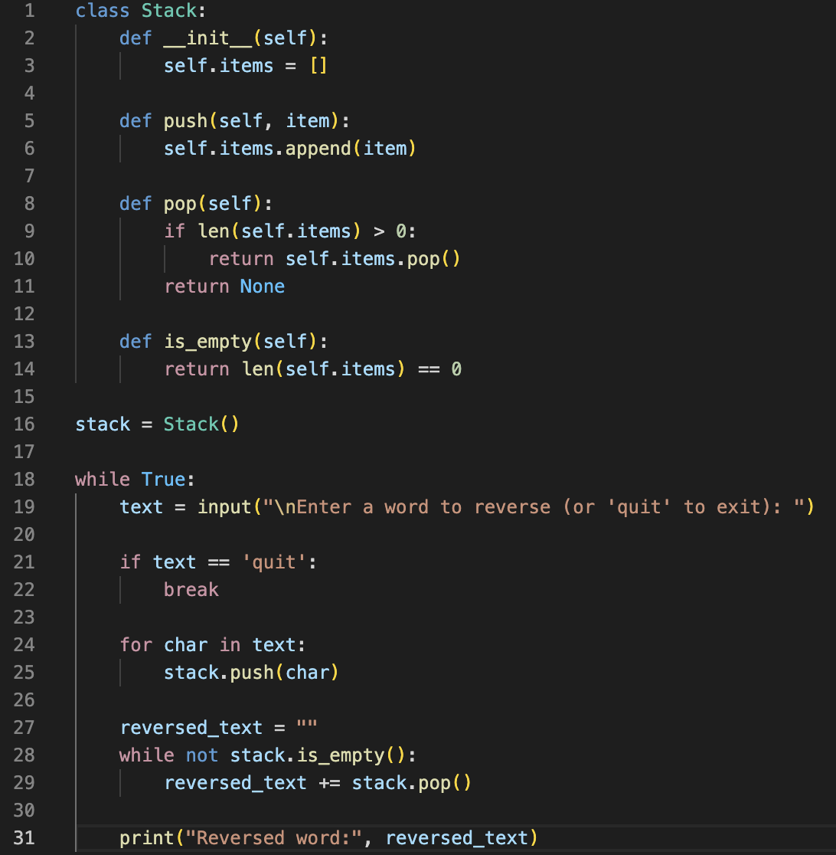

Output:
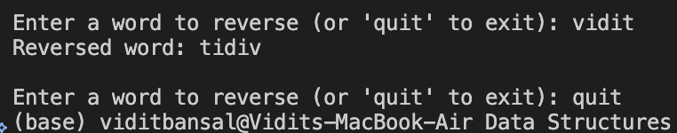
6. Balanced Parenthesis Using Stack

Input -
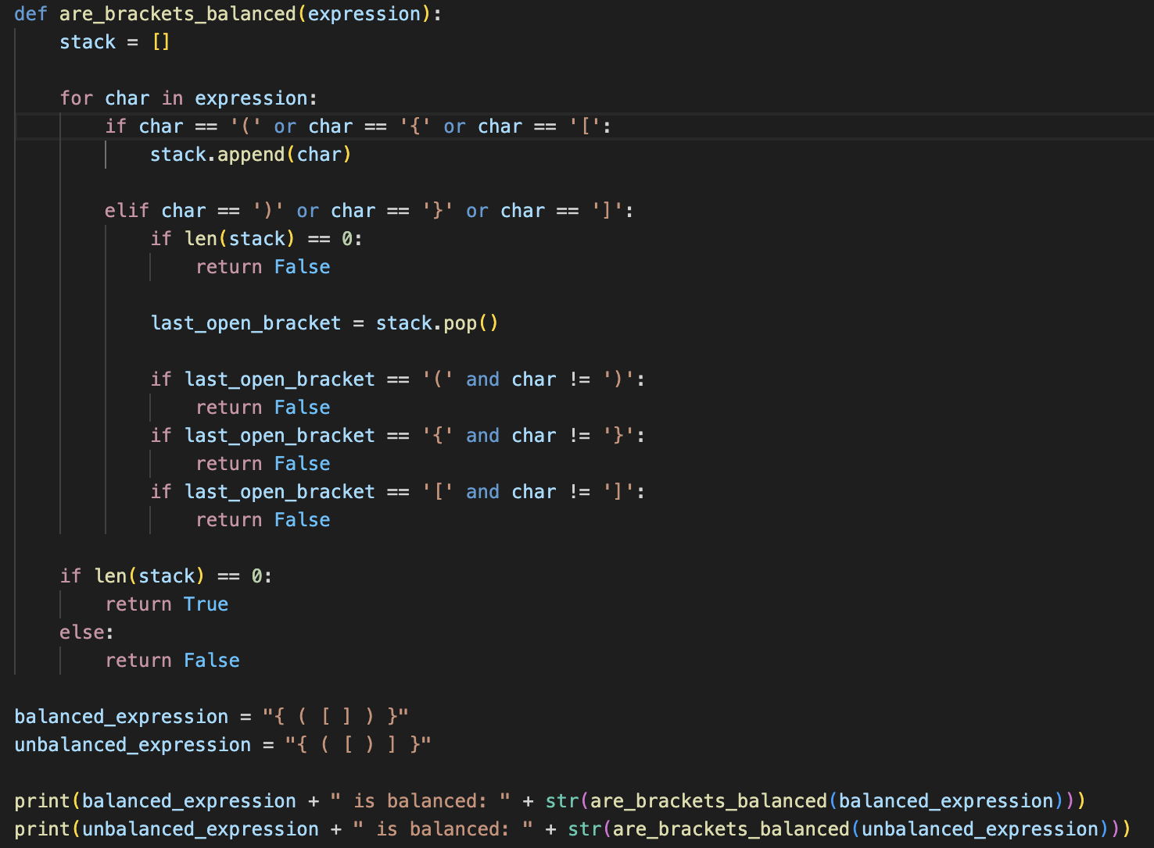

Output:

