AGI LMS
Per-Student Cost Analysis Report

January 2026
Prepared for AGI Online Stakeholders

CONFIDENTIAL

Table of Contents
1. Executive Summary
2. Platform Architecture Overview
3. Current Platform Statistics
4. Infrastructure Costs (Fixed)
5. AI Feature Cost Analysis (Variable)
5.1 Flashcard Generation (GPT-5)
5.2 Page Explanation (GPT-4o)
5.3 Voice Chat (GPT-4o Realtime)
5.4 Text Embeddings
6. Per-Student Cost Model
7. Cost Scaling Analysis
8. Cost Distribution Breakdown
9. Recommendations

1. Executive Summary
This document provides a comprehensive cost analysis of the AGI Online Learning Management System (LMS) on a per-student basis. The analysis covers all operational costs including hosting infrastructure, AI-powered learning features, and digital certification services.

Key Findings
- Total Monthly Fixed Costs: $92.15/month ($1,105.80/year)
- AI Cost per Student (one course): ~$6.57 (variable, usage-dependent)
- Certificate Cost per Student: ~$0.81
- Total Estimated Cost per Student: ~$8.80 per course completion
- Current Active Students: ~65 (excluding test accounts)
- Current Active Courses: 17 courses (avg 10.4 modules each)
- Largest Cost Driver: Voice Chat (~68% of AI costs)

Cost Category | Monthly | Annual | Per Student (Course)
Render Hosting | $25.00 | $300.00 | $0.38
MongoDB Atlas | $0.00 | $0.00 | $0.00
Certifier.io | $67.15 | $805.80 | $0.81
AI Features (OpenAI) | Variable | Variable | ~$6.57
TOTAL | $92.15 + AI | $1,105.80 + AI | ~$8.80*
*Based on 65 active students, each completing one course with average AI feature usage.

2. Platform Architecture Overview
The AGI Online LMS platform operates on the following technology stack, each with distinct cost implications:

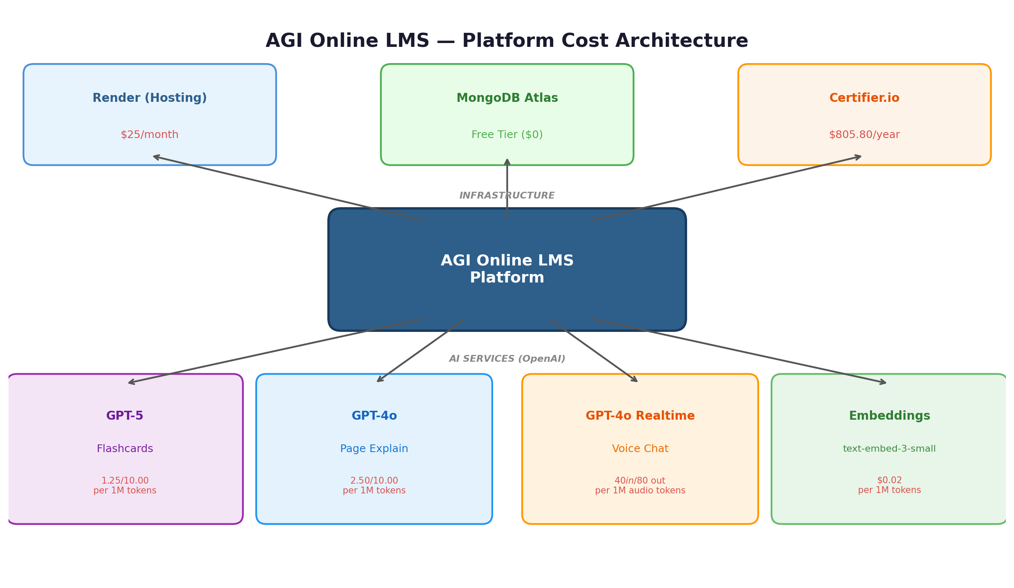

The platform integrates four OpenAI AI services for student learning enhancement, alongside cloud hosting on Render, a MongoDB database, and Certifier.io for digital credential issuance.

3. Current Platform Statistics
The following data was extracted from the production MongoDB database (January 2026):

Metric | Value | Notes
Total Student Accounts | 71 | All registered students
Active Real Students | ~65 | Excluding 6 test/demo accounts
Total Courses | 17 | All published courses
Avg Modules per Course | 10.4 | Range: 8 to 13 modules
Total Enrollments | 107 | Real student enrollments
Certificates Issued | 23 | To unique real students (via Certifier)
Multi-Course Students | ~5 | Students enrolled in 2+ courses

Top Courses by Enrollment
Course | Enrollments | Modules
Certified Sustainability & Leadership | 31 | 12
Certified Project Management Professional | 23 | 11
Certified Human Resource Professional | 11 | 11
Certified Project Manager | 9 | 11
Certified Supply Chain Professional | 6 | 9
Certified Logistics Manager | 5 | 10
Other Courses (11) | 22 | 8-13 each

4. Infrastructure Costs (Fixed)
These are recurring costs that remain constant regardless of student count or usage.

4.1 Render (Web Hosting)
Item | Detail
Service | Render Cloud Hosting
Plan | Web Service
Cost | $25.00 / month
Annual Cost | $300.00 / year
What It Covers | Node.js backend server, API endpoints, WebSocket for voice chat, static file serving

4.2 MongoDB Atlas (Database)
Item | Detail
Service | MongoDB Atlas
Plan | Free Tier (M0)
Cost | $0.00 / month
Storage Limit | 512 MB
What It Covers | Student data, courses, enrollments, quiz attempts, certificates, event logs
Risk | May need upgrade ($9-57/mo) as data grows beyond 512 MB

4.3 Certifier.io (Digital Certificates)
Item | Detail
Service | Certifier.io
Plan | Professional (Annual Billing)
Cost | $805.80 / year ($67.15 / month equivalent)
Credential Limit | 1,000 credentials / year
Credentials Used | 23 of 1,000 (2.3% utilized)
Cost per Credential | $0.81 (if all 1,000 used)
Effective Cost per Credential | $35.03 (at current 23 usage)
Reset Date | 1st October 2026
Renewal Date | 10th November 2026

Note: The Certifier Professional plan is significantly underutilized at 2.3% of capacity. At maximum utilization (1,000 credentials/year), the cost per certificate drops to $0.81. Current effective cost per certificate is $35.03 due to low issuance volume.

Fixed Cost Summary
Service | Monthly Cost | Annual Cost | Per Student/Month*
Render Hosting | $25.00 | $300.00 | $0.38
MongoDB Atlas | $0.00 | $0.00 | $0.00
Certifier.io | $67.15 | $805.80 | $1.03
TOTAL FIXED | $92.15 | $1,105.80 | $1.42
*Per student/month calculated based on 65 active students.

5. AI Feature Cost Analysis (Variable)
The AGI LMS platform integrates four AI-powered features using OpenAI APIs. These are variable costs that scale with student usage. All prices reflect current OpenAI API rates (January 2026).

OpenAI API Pricing Reference
Model | Feature | Input (per 1M tokens) | Output (per 1M tokens)
GPT-5 | Flashcard Generation | $1.25 | $10.00
GPT-4o | Page Explanation | $2.50 | $10.00
GPT-4o Realtime (text) | Voice Chat | $5.00 | $20.00
GPT-4o Realtime (audio) | Voice Chat | $40.00 (input) | $80.00 (output)
text-embedding-3-small | Embeddings | $0.02 | N/A
Whisper-1 | Speech-to-Text | Included in Realtime API

5.1 Flashcard Generation (GPT-5)
The flashcard generation feature creates AI-powered study flashcards from module content. Each module generates approximately 10 flashcards through a multi-stage pipeline.

Component | Token Estimate | Cost
System prompt (expert career coach) | ~200 tokens (input) | $0.00025
Module content chunks | ~2,000 tokens (input) | $0.0025
Flashcard output (10 cards) | ~3,000 tokens (output) | $0.030
TOTAL PER MODULE | ~5,200 tokens | ~$0.033
PER COURSE (10 modules) | ~52,000 tokens | ~$0.33

5.2 Page Explanation (GPT-4o)
Students can request AI explanations of any PDF document page. The system extracts page text and generates a simplified educational explanation.

Component | Token Estimate | Cost
System prompt (educational tutor) | ~150 tokens (input) | $0.000375
Page text content | ~300 tokens (input) | $0.00075
AI explanation output | ~700 tokens (output) | $0.007
TOTAL PER PAGE | ~1,150 tokens | ~$0.008
PER MODULE (3 pages explained) | ~3,450 tokens | ~$0.024
PER COURSE (10 modules) | ~34,500 tokens | ~$0.24
Assumption: Average student explains 3 document pages per module. Actual usage may vary.

5.3 Voice Chat (GPT-4o Realtime)
The voice chat feature provides real-time AI tutoring through a WebSocket connection to OpenAI's Realtime API. This is the most expensive AI feature due to audio token pricing.

Component | Estimate | Cost
Audio input (student speaks) | ~2 minutes | $0.12
Audio output (AI responds) | ~2 minutes | $0.48
Text tokens (system prompt + context) | ~500 tokens | Negligible vs audio
TOTAL PER SESSION (1-3 min) | ~2 min avg | ~$0.60
PER MODULE (1 session assumed) | 1 session | ~$0.60
PER COURSE (10 modules) | 10 sessions | ~$6.00

Important: Voice chat is the dominant cost driver, accounting for approximately 91% of per-student AI costs. Audio tokens are 16-32x more expensive than text tokens. Longer sessions or more frequent use will significantly increase costs.

Voice Chat Cost Sensitivity
Avg Session Duration | Cost per Session | Cost per Course (10 modules) | Impact
1 minute | $0.30 | $3.00 | Minimal usage
2 minutes | $0.60 | $6.00 | Average (estimated)
5 minutes | $1.50 | $15.00 | Heavy usage
10 minutes | $3.00 | $30.00 | Extended tutoring

5.4 Text Embeddings (text-embedding-3-small)
Embeddings are used for vector search during flashcard generation to retrieve relevant content chunks. The cost is negligible.

Component | Token Estimate | Cost
Module content chunks | ~5,000 tokens | $0.0001
PER COURSE (10 modules) | ~50,000 tokens | ~$0.001
Embeddings contribute less than 0.02% of total AI costs and are effectively negligible.

6. Per-Student Cost Model
This section presents the estimated total cost for one student completing one full course on the AGI LMS platform.

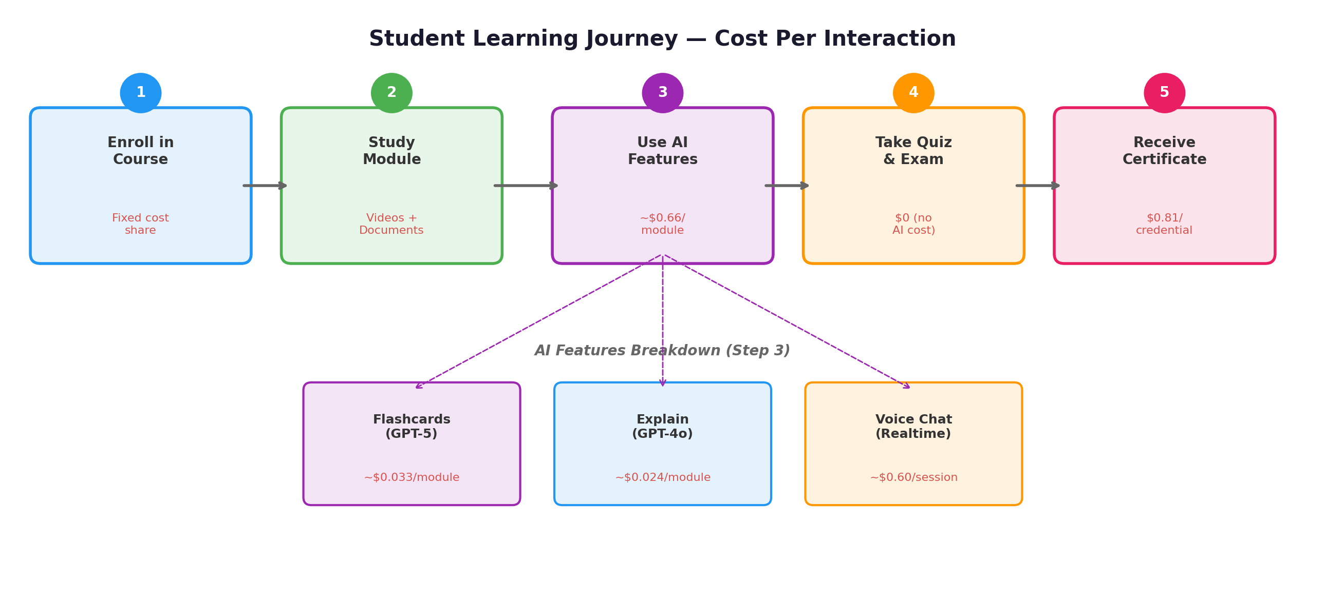

Complete Per-Student Cost (Single Course)
Cost Component | Per Module | Per Course (10 modules) | % of Total
Flashcard Generation (GPT-5) | $0.033 | $0.33 | 3.8%
Page Explanation (GPT-4o) | $0.024 | $0.24 | 2.7%
Voice Chat (GPT-4o Realtime) | $0.60 | $6.00 | 68.2%
Embeddings | $0.0001 | $0.001 | <0.1%
AI Subtotal | $0.66 | $6.57 | 74.7%
Infrastructure Share (monthly) | — | $1.42 | 16.1%
Certificate Issuance | — | $0.81 | 9.2%
TOTAL PER STUDENT | — | $8.80 | 100%

Assumptions:
- 65 active students sharing infrastructure costs
- Average course has 10 modules
- Student generates flashcards for each module (1x per module)
- Student uses "Explain" feature on 3 document pages per module
- Student has one 2-minute voice chat session per module
- Student earns one certificate upon course completion
- Certifier cost based on full plan utilization ($0.81/credential)

7. Cost Scaling Analysis
The following analysis shows how per-student costs change as the platform scales to more students. Fixed infrastructure costs decrease per student as the base grows, while AI costs remain constant per student.

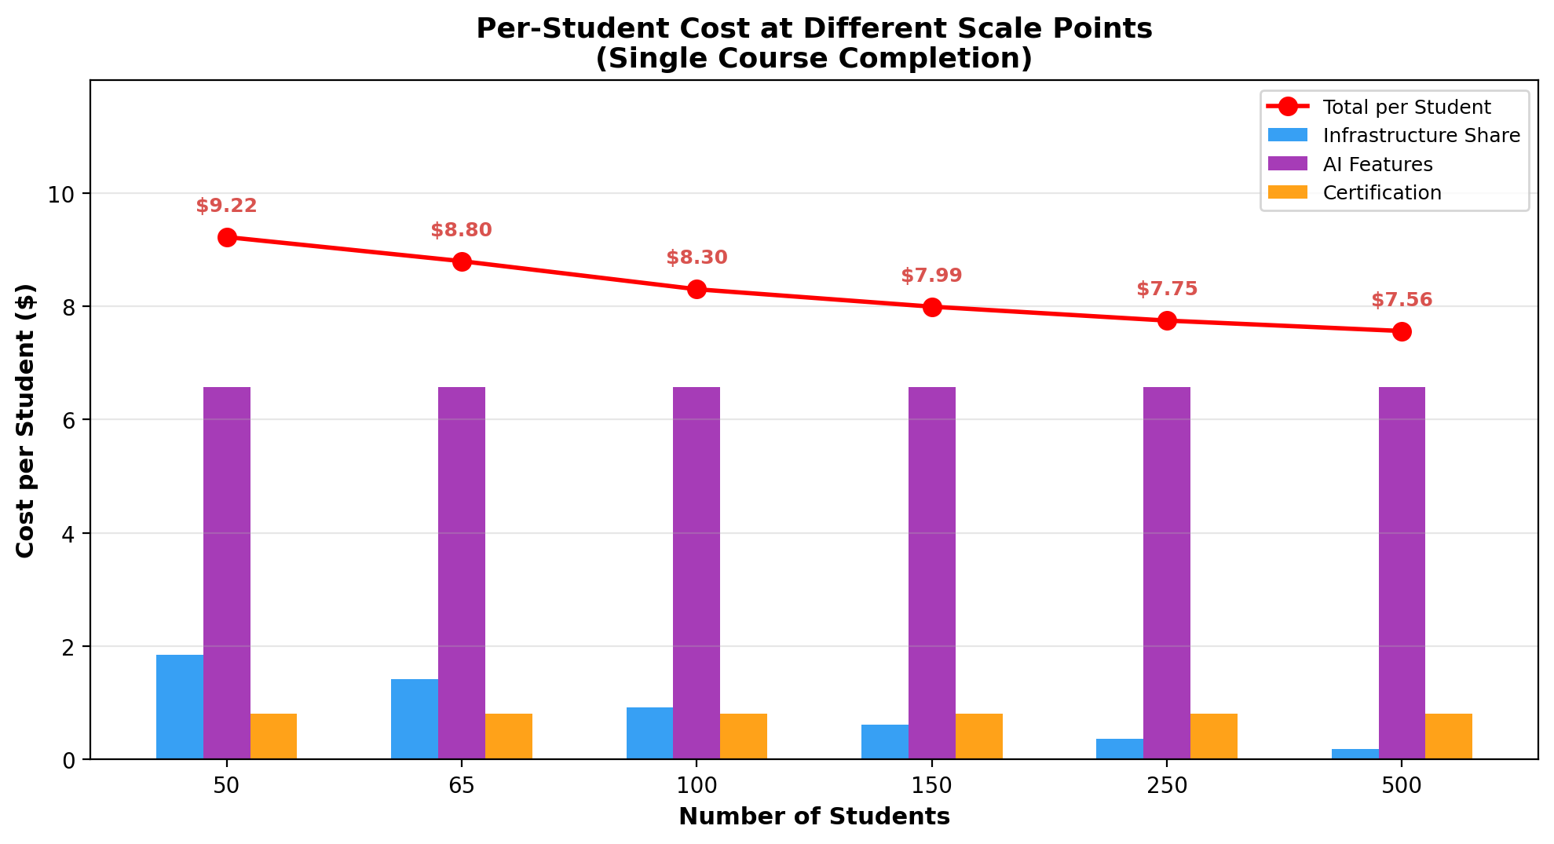

Student Count | Infra Share/Student | AI Cost/Student | Cert/Student | Total/Student | Total Monthly Cost
50 | $1.84 | $6.57 | $0.81 | $9.22 | $92.15 + $369
65 (current) | $1.42 | $6.57 | $0.81 | $8.80 | $92.15 + $427
100 | $0.92 | $6.57 | $0.81 | $8.30 | $92.15 + $657
150 | $0.61 | $6.57 | $0.81 | $7.99 | $92.15 + $986
250 | $0.37 | $6.57 | $0.81 | $7.75 | $92.15 + $1,643
500 | $0.18 | $6.57 | $0.81 | $7.56 | $92.15 + $3,285

Key Insight: At scale (500+ students), the per-student cost converges to approximately $7.56, dominated by AI usage costs ($6.57) and certification ($0.81). Infrastructure costs become negligible at scale. The primary lever for cost reduction is optimizing voice chat usage.

Scaling Considerations
- MongoDB Free Tier Limit: The free tier provides 512 MB storage. As student count grows beyond 200-300, an upgrade to M10 ($9/mo) or M20 ($57/mo) may be required.
- Certifier Credential Limit: The Professional plan allows 1,000 credentials/year. If student completions exceed 1,000/year, an upgrade will be needed.
- Render Hosting: Current $25/mo plan should handle 500+ concurrent users. Upgrade may be needed for >1,000 simultaneous students.
- OpenAI Rate Limits: High concurrent voice chat sessions may hit API rate limits. Consider implementing session queuing at scale.

8. Cost Distribution Breakdown
The charts below illustrate the relative cost distribution for per-student expenses and monthly fixed costs.

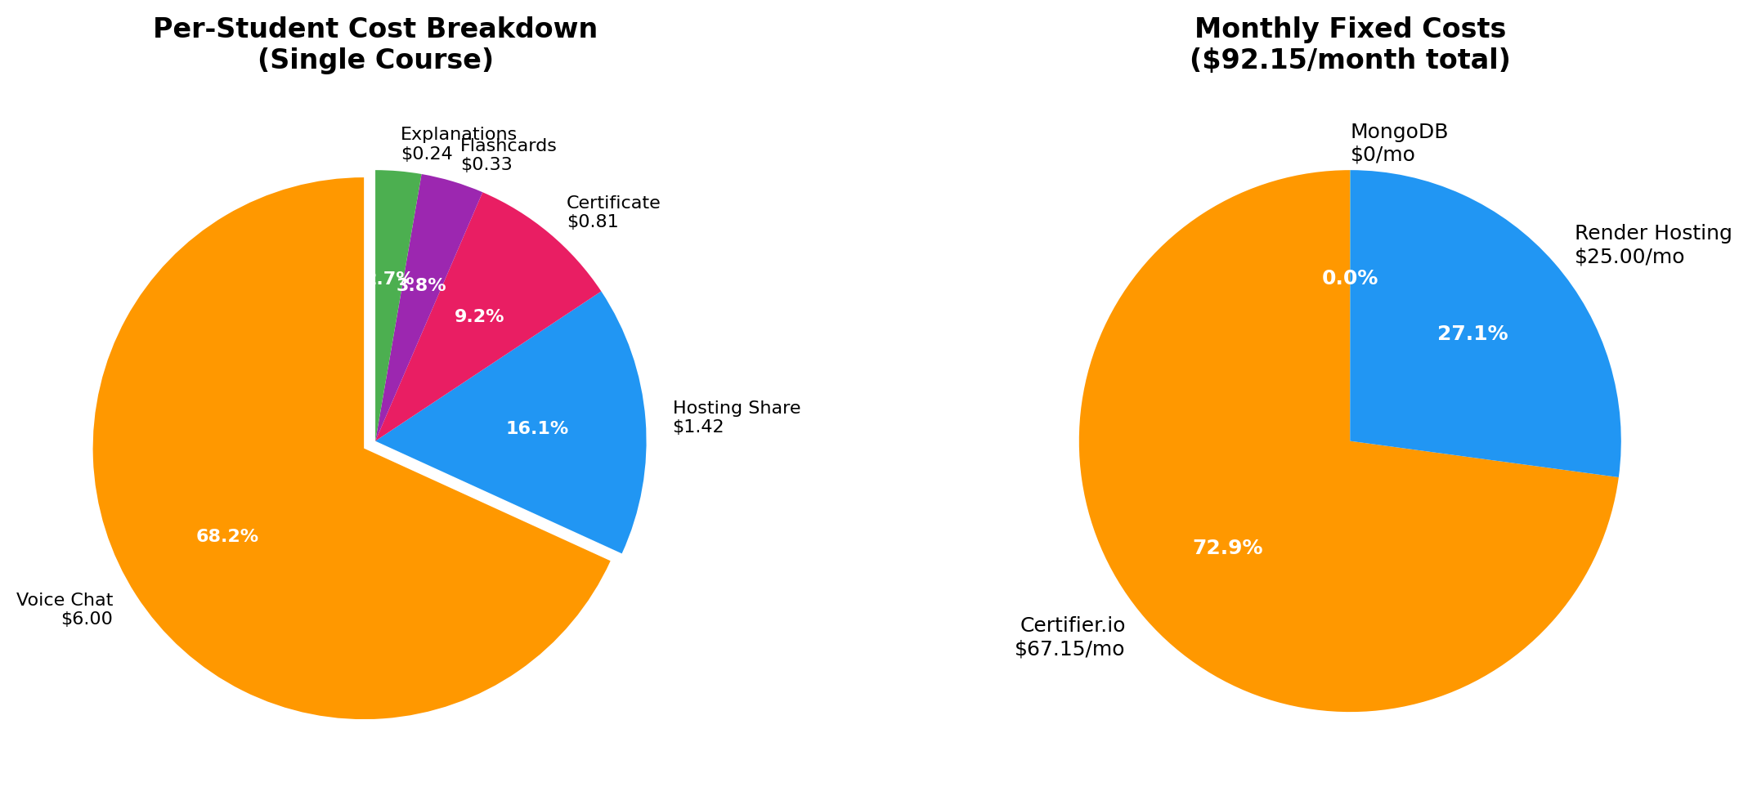

Analysis: Voice Chat represents 68% of per-student costs. The Certifier.io subscription represents 73% of fixed monthly costs but is significantly underutilized (2.3% of capacity). Optimizing voice chat session lengths or frequency is the most impactful lever for reducing per-student costs.

9. Recommendations

Monitor Voice Chat Usage
Voice chat is the dominant cost driver at ~$6.00/student/course. Track average session duration and frequency. Consider implementing session time limits (e.g., 3-minute cap) or daily usage quotas to control costs.

Maximize Certifier Utilization
Only 23 of 1,000 annual credentials have been issued (2.3%). Each unused credential effectively costs $0.81 in wasted capacity. Increasing certificate issuance improves the cost-per-credential ratio from $35.03 to as low as $0.81.

Consider GPT-5 Mini for Flashcards
GPT-5 Mini ($0.25/$2.00 per 1M tokens) offers ~80% of GPT-5 quality at 20% of the cost. Flashcard generation costs could drop from $0.33 to ~$0.07 per course — a 79% reduction in flashcard costs.

Evaluate MongoDB Scaling Plan
The free tier (512 MB) will eventually be insufficient. Plan for an M10 upgrade ($9/month) when approaching 300+ students to avoid service disruption.

Implement API Usage Dashboards
The codebase already tracks API usage and costs. Expose this data in an admin dashboard for real-time cost monitoring and alerting on unusual spikes.

Consider Prompt Caching for Repeated Queries
OpenAI offers 90% savings on cached input tokens. If many students ask similar questions about the same module content, prompt caching could significantly reduce explanation and voice chat costs.

Appendix: Methodology & Data Sources
- Student & Enrollment Data: Extracted directly from the production MongoDB Atlas database (agi_student_platform_dev). Test accounts (Logan Pacey, Vidit Bhatnagar, Rejin Rajan, Peter Parker, Jyothi, Suleman Gido) were excluded.
- OpenAI Pricing: Based on official OpenAI API pricing as of January 2026. GPT-5: $1.25/$10.00 per 1M tokens. GPT-4o: $2.50/$10.00 per 1M tokens. GPT-4o Realtime audio: $40/$80 per 1M tokens (~$0.06/$0.24 per minute).
- Token Estimates: Derived from analysis of actual system prompts, typical page content lengths, and output format specifications in the source code.
- Voice Chat Duration: Estimated at 1-3 minutes average session duration based on stakeholder input.
- Infrastructure Costs: Render hosting at $25/month. MongoDB Atlas free tier. Certifier Professional plan billed annually at $805.80.
- Certifier Data: From the Certifier.io billing dashboard — Professional plan, annual billing, 1,000 credentials/year limit, 23 credentials issued.

— End of Document —

