BRITEthink
Assessor Dashboard
Feature Documentation & UI Showcase
February 2026
Version 1.0

Table of Contents
1. Overview
2. Layout & Navigation
3. Course Selector
4. Home Dashboard
5. Assessments
6. Sign-Off Workflow
7. Progress Tracking
8. Portfolio & Evidence
9. Document Management
10. Materials
11. Work Hours
12. Members
13. Global Search
14. Learner Context Switching

1. Overview
The BRITEthink Assessor Dashboard is a modern, role-based learning management interface designed for NCFE qualification assessors. It provides a comprehensive toolkit for managing learner assessments, tracking progress, handling evidence portfolios, and maintaining documentation — all within a clean, icon-driven sidebar navigation.

Tech Stack
- Next.js 16 with App Router
- React 19 with Server & Client Components
- TypeScript for type safety
- Tailwind CSS 4 for styling
- MongoDB with Mongoose 9 ODM
- NextAuth v5 for authentication
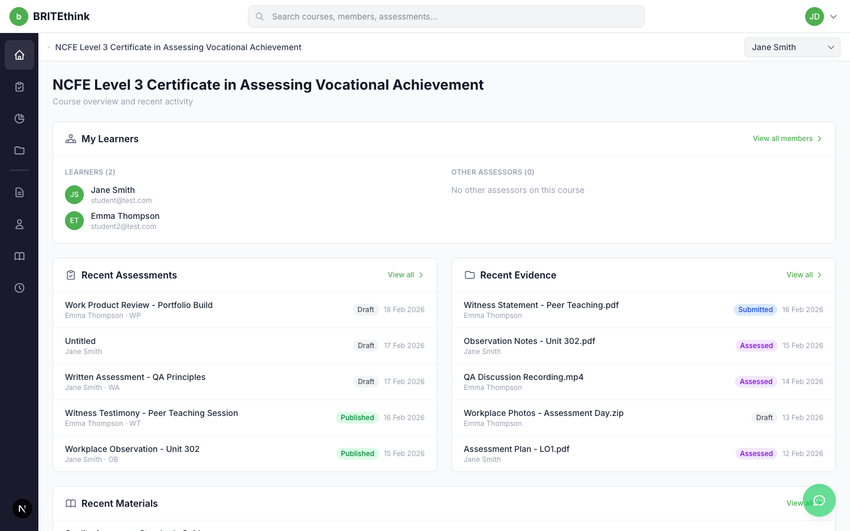
Figure 1: Home Dashboard — Course overview with summary cards

2. Layout & Navigation
The dashboard uses a 3-part layout system: a 65px icon sidebar for navigation on the left, a flexible main content area in the center, and an optional 420px detail panel that slides in from the right when viewing assessment details.

Icon Sidebar
The sidebar features 8 navigation icons organized into two groups. The top group (Home, Assessments, Progress, Portfolio) covers the primary workflow. Below a divider, the bottom group (Course Documents, Personal Documents, Materials, Work Hours) handles supplementary features. Each icon shows a tooltip on hover.
Figure 2: Icon Sidebar — 8 navigation icons on dark background

Top Navigation Bar
The top navigation bar spans the full width and includes the BRITEthink logo, a global search bar with debounced search across members/assessments/evidence, and a user avatar dropdown for account actions.
Figure 3: Top Navigation Bar — Logo, search bar, and user avatar

Navigation Reference
Icon | Page | Route | Description
Home | Course Overview | /c/{slug} | Dashboard with summary cards
Clipboard | Assessments | /c/{slug}/assessments | Assessment CRUD with detail panel
Chart | Progress | /c/{slug}/progress | 4-column criteria drill-down
Folder | Portfolio | /c/{slug}/portfolio | Evidence grid/list with upload
Document | Course Documents | /c/{slug}/documents | File manager with folders
Person | Personal Documents | /c/{slug}/personal-documents | Read-only learner documents
Books | Materials | /c/{slug}/materials | Teaching materials with categories
Clock | Work Hours | /c/{slug}/work-hours | Time logging by date

3. Course Selector
The course selector is the landing page at /c, displaying all qualifications assigned to the logged-in assessor. Each course card shows the qualification level, title, course code, and number of enrolled learners. Clicking a card navigates to that course's dashboard.
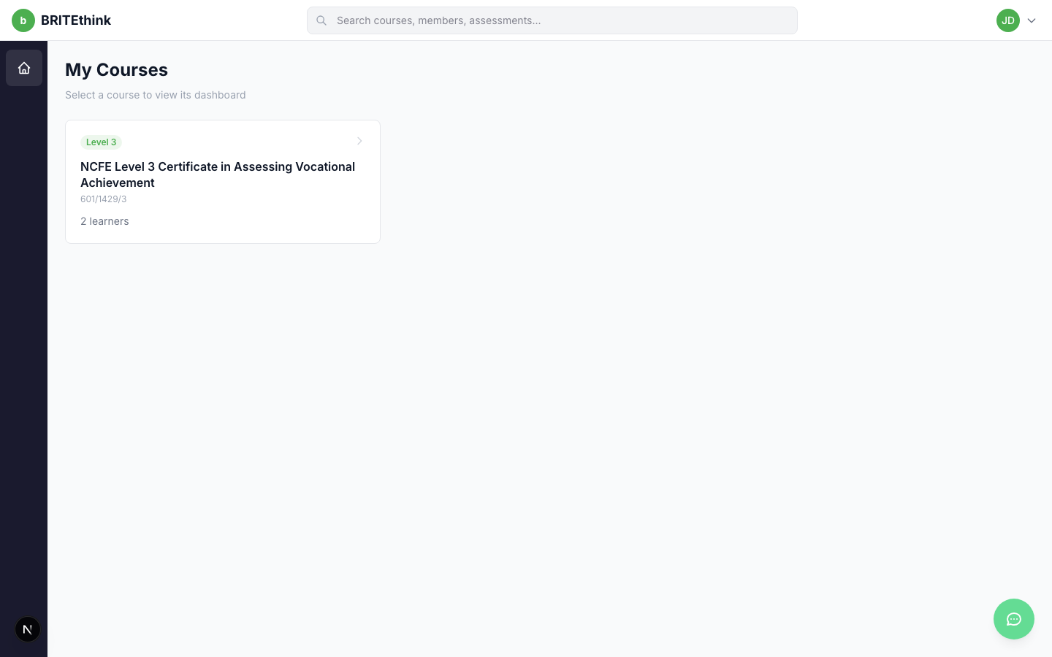
Figure 4: Course Selector — "My Courses" with qualification cards

4. Home Dashboard
The home dashboard provides a bird's-eye view of the course with four summary sections:
- My Learners — Lists all enrolled learners and other assessors on the course
- Recent Assessments — Shows the latest assessments across all learners with status and type
- Recent Evidence — Displays recently uploaded evidence files
- Recent Materials — Shows recently added teaching materials

Figure 5: Home Dashboard — Four summary cards overview

5. Assessments
The Assessments page is the core feature of the dashboard. It displays assessment cards in a responsive grid, grouped by time period (Today, Yesterday, This Week, This Month, Older). Each card shows the assessment date, title, learner name, and type badge.

Assessment Types
The system supports 7 assessment types, each with a unique color and abbreviation:
- OB — Observation
- PD — Professional Discussion
- RA — Reflective Account
- VA — Verbal Assessment
- WA — Written Assessment
- WP — Work Product
- WT — Witness Testimony
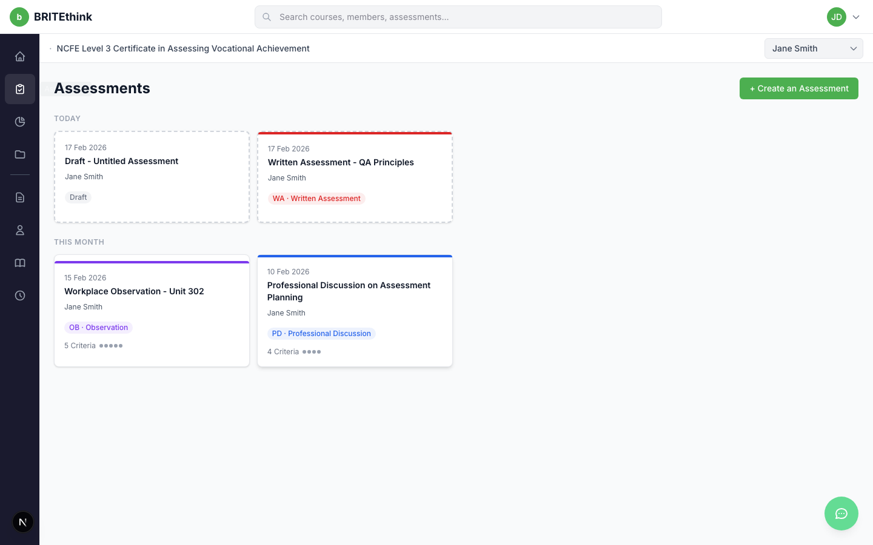
Figure 6: Assessment Card Grid — Cards grouped by time period

Detail Panel
Clicking any assessment card opens a 420px detail panel on the right side of the screen. The panel includes a header with date picker, title input, save status indicator, and action buttons. Below, it contains the following sections:
- Assessment Type — Grid of 7 type buttons for categorizing the assessment
- Plan Intent — Text area for describing the assessment purpose
- Plan Implementation — Text area for describing how the assessment will be conducted
- Evidence Mapping — Link evidence files to this assessment
- Criteria Mapping — Map assessment criteria from the qualification to this assessment
- Sign-Off Status — 4-step sequential sign-off workflow
- Remarks — Threaded comments for assessor/learner communication
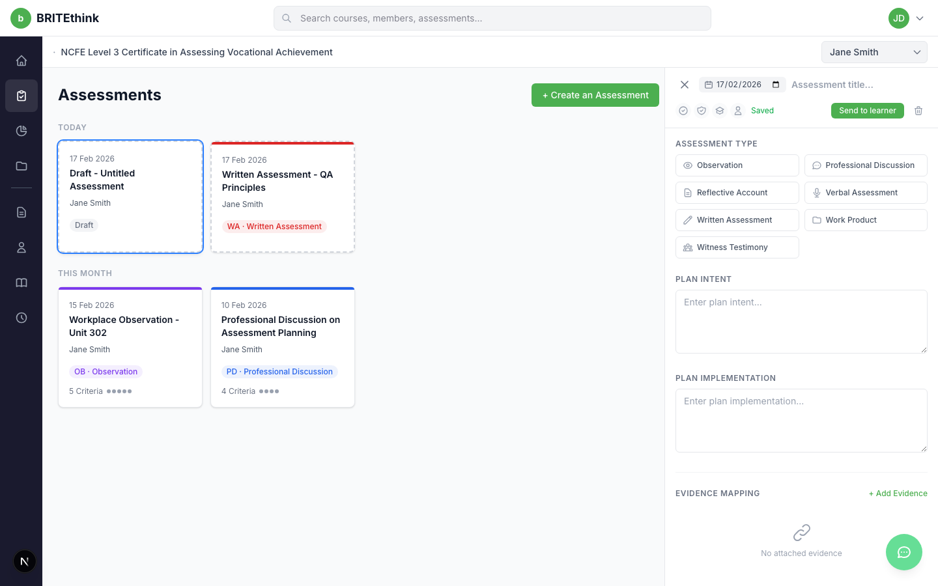
Figure 7: Assessment Detail Panel — Full page showing card grid with detail panel
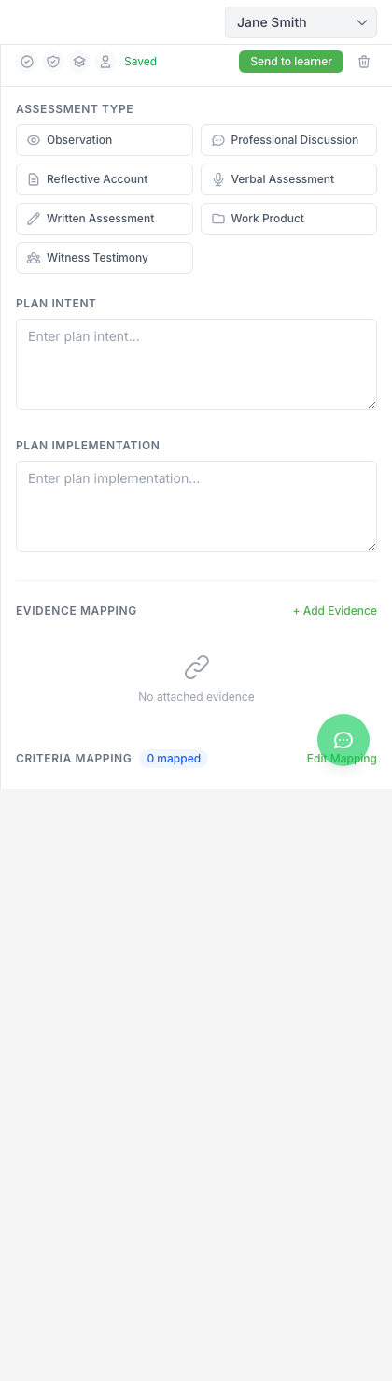
Figure 8: Detail Panel Close-Up — Assessment type selector and plan sections

Creating Assessments
Clicking "+ Create an Assessment" opens a learner selection flow. The assessor selects which learner the assessment is for, and a new draft assessment is created with today's date. Draft assessments use a dashed border and can be published by clicking "Send to learner".
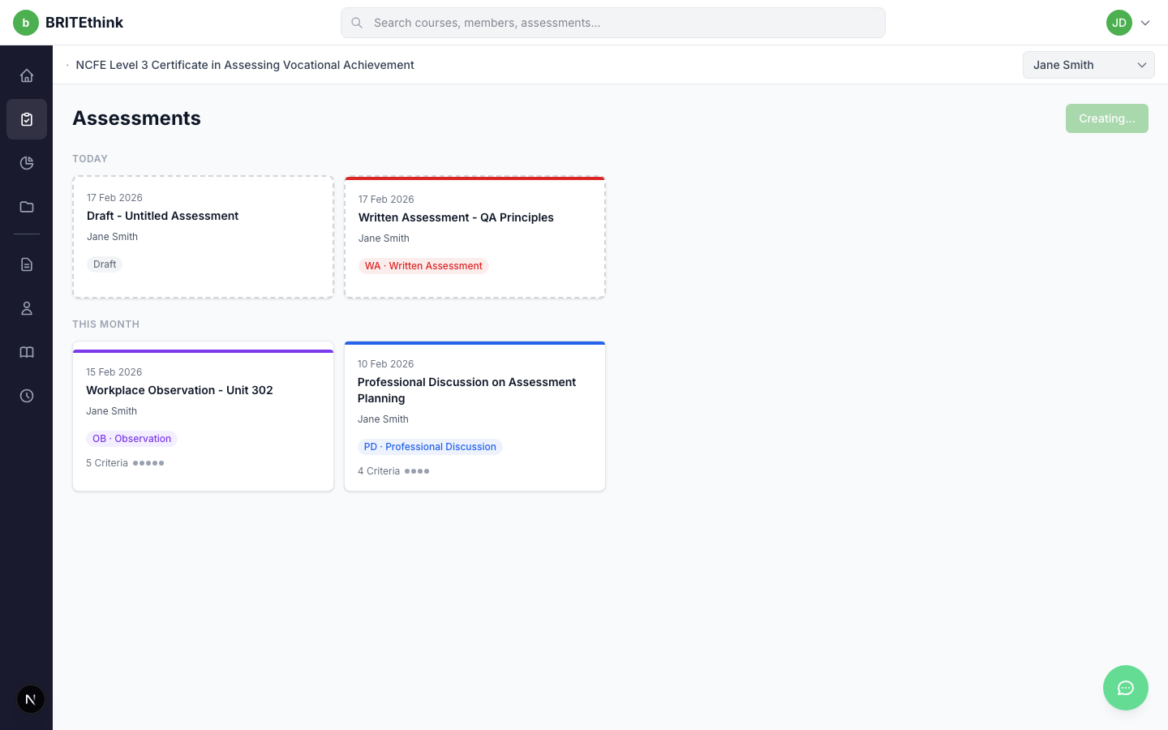
Figure 9: Create Assessment — Assessment creation flow

Filtering by Learner
Assessments can be filtered by learner using the dropdown in the sub-header. Selecting a different learner refreshes the card grid to show only that learner's assessments.
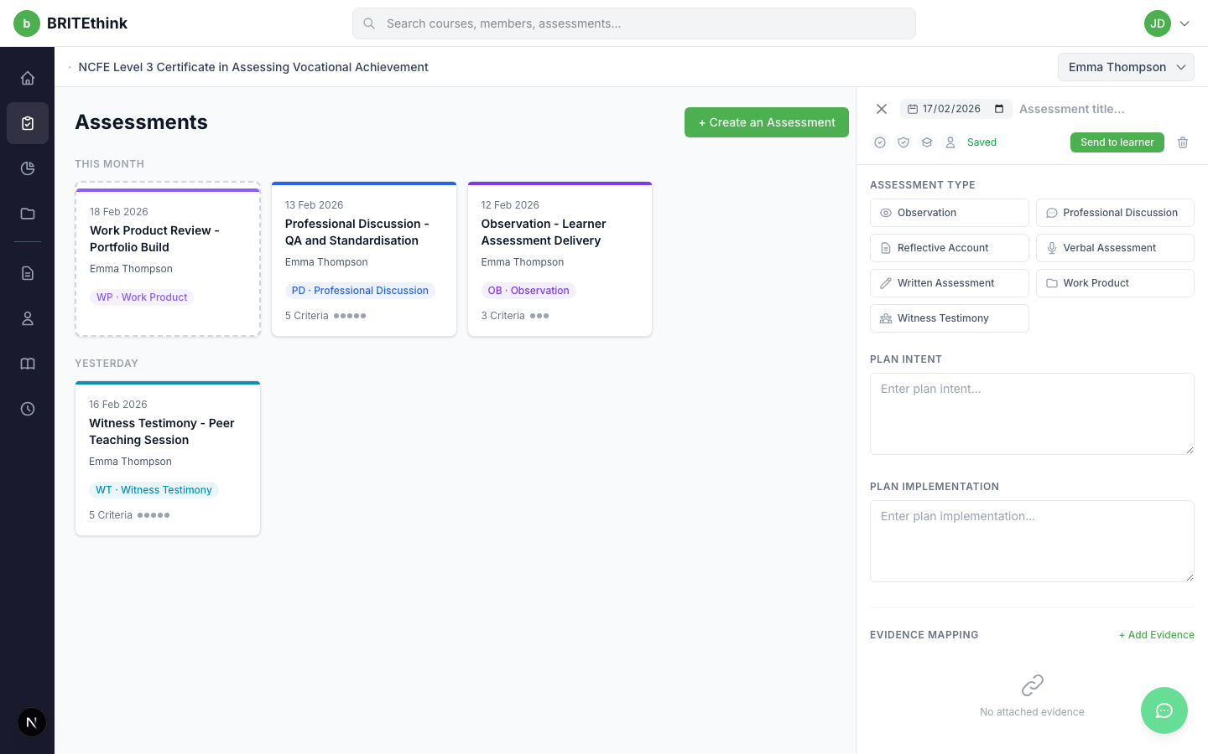
Figure 10: Filtered Assessments — Showing Emma Thompson's 4 assessments

6. Sign-Off Workflow
Each assessment includes a 4-step sequential sign-off process. Steps must be completed in order, and each step is performed by a specific role:
- Step 1: Assessor — The assessor signs off confirming the assessment is complete
- Step 2: Internal Quality Assurer (IQA) — Internal review and quality assurance
- Step 3: External Quality Assurer (EQA) — External moderation and verification
- Step 4: Learner — The learner acknowledges and accepts the assessment

The sign-off section displays a progress bar, completion count (e.g. "2/4 Complete"), and role cards with status indicators. Signed steps show a green checkmark with the date, pending steps show a clock icon, and rejected steps show a red indicator.
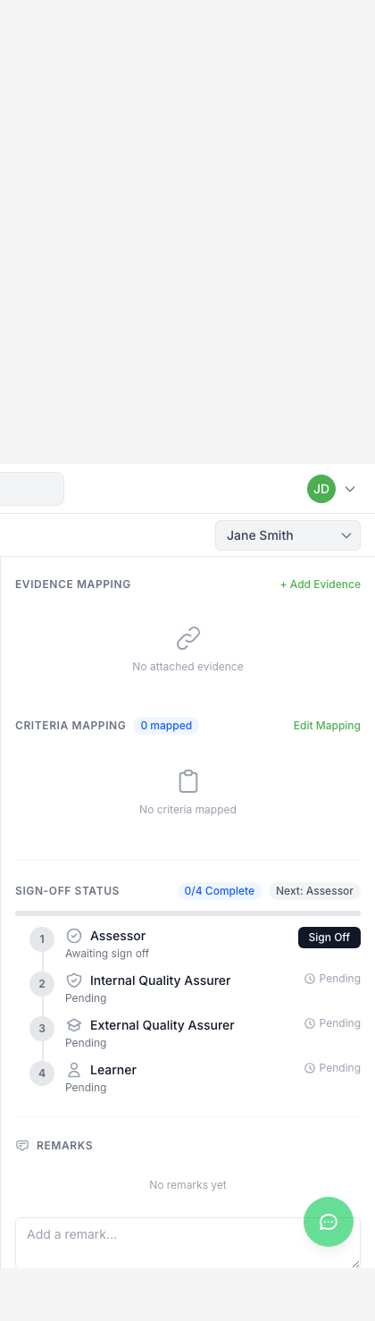
Figure 11: Sign-Off Status — 4-step workflow in the detail panel

7. Progress Tracking
The Progress page provides a 4-column drill-down view for tracking learner achievement against qualification criteria:
- Column 1: Units — Lists all qualification units with reference codes, titles, and progress bars showing criteria completion percentage
- Column 2: Learning Outcomes — When a unit is selected, shows its learning outcomes (LO1, LO2, etc.) with individual progress
- Column 3: Assessment Criteria — When an outcome is selected, shows its criteria (AC 1.1, AC 1.2, etc.) with green checkmarks for met criteria and gray circles for unmet
- Column 4: Linked Assessments — When a criterion is selected, shows all published assessments mapped to it

A summary card at the top shows overall course progress with the count of met criteria out of total.
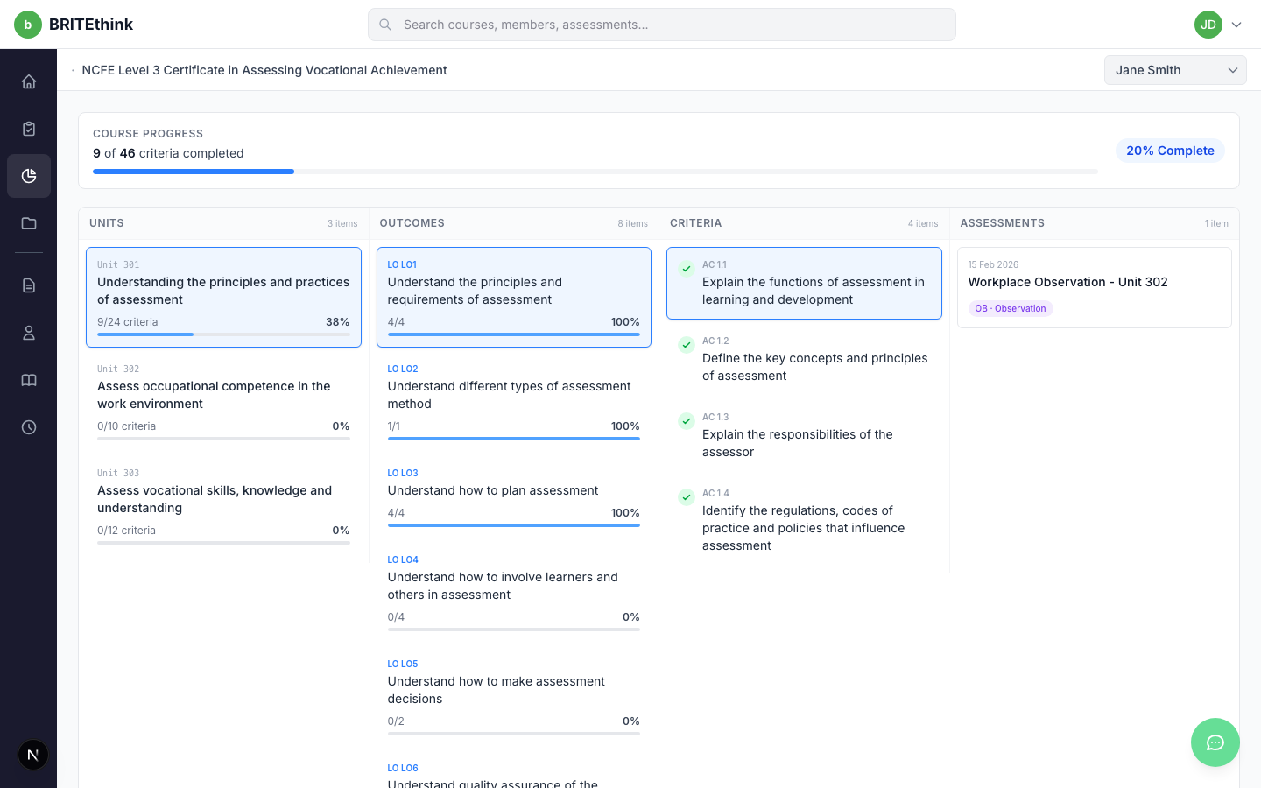
Figure 12: Progress Tracking — 4-column drill-down from Units to Assessment Criteria

8. Portfolio & Evidence
The Portfolio page manages evidence files uploaded by learners or assessors. It features:
- Grid/List view toggle — Switch between card grid and table list views
- Upload Evidence button — Upload files to associate with assessments
- Status filter — Filter by Draft, Submitted, or Assessed status
- File type filter — Filter by PDF, Word, Image, or Video
- Sort toggle — Sort by newest or oldest
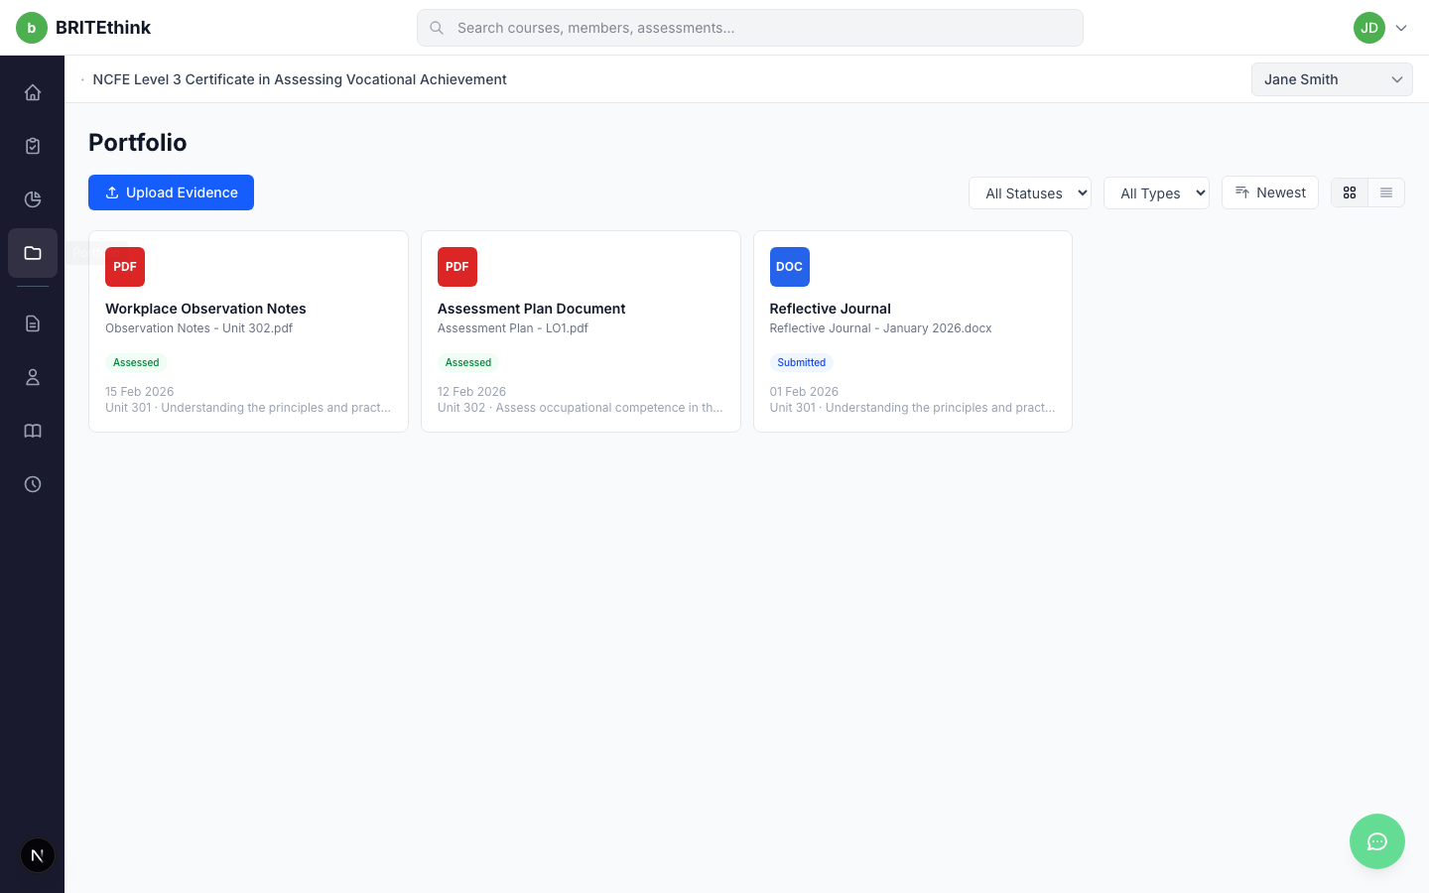
Figure 13: Portfolio Grid View — Evidence cards with filters
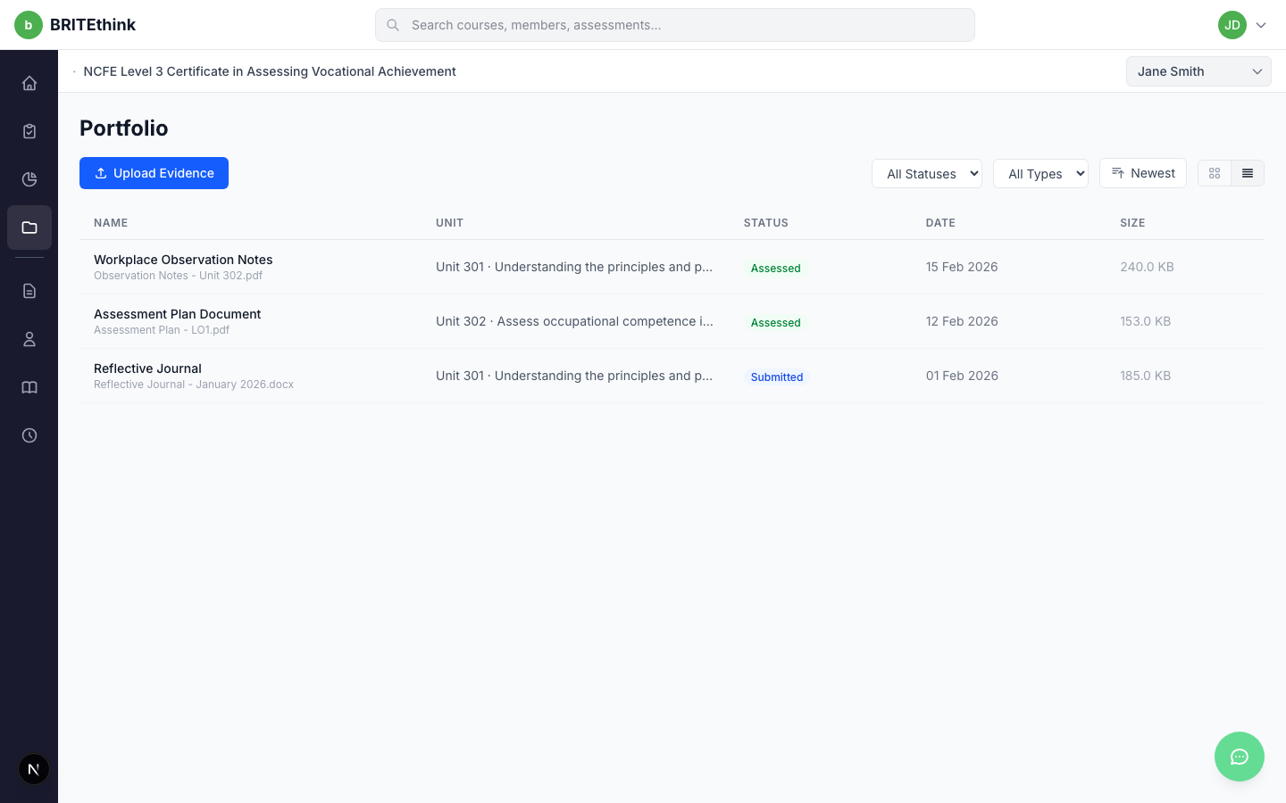
Figure 14: Portfolio List View — Tabular evidence display

9. Document Management

Course Documents
The Course Documents page provides a full file manager for managing course-level documentation. Assessors can upload files, create folders, and organize documents with breadcrumb navigation. A file type filter and grid/list view toggle are available in the toolbar.
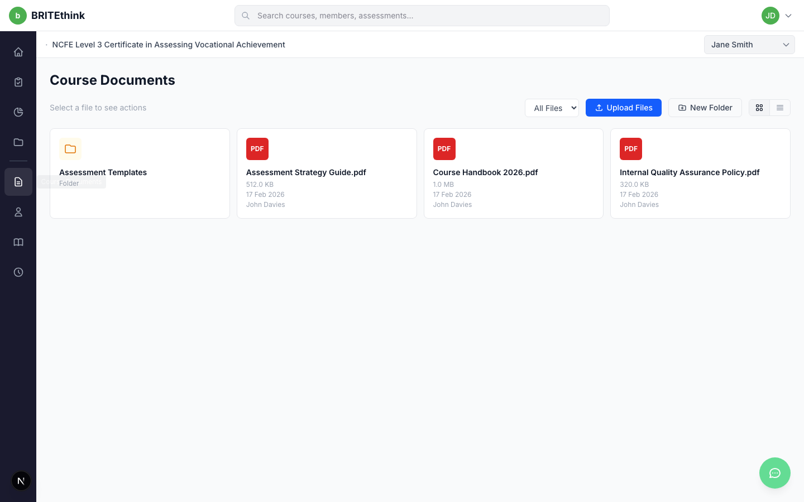
Figure 15: Course Documents — File manager with Upload Files and New Folder buttons

Personal Documents
The Personal Documents page shows a read-only view of documents uploaded by the selected learner. This allows assessors to review learner-submitted files without the ability to modify them.
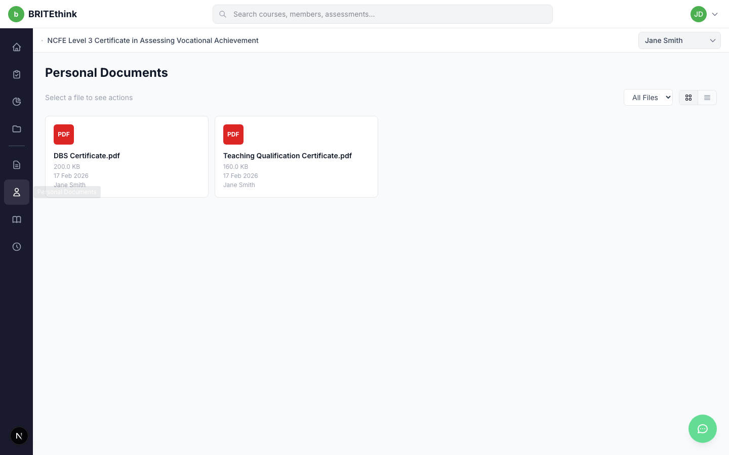
Figure 16: Personal Documents — Read-only learner document view

10. Materials
The Materials page manages teaching and learning materials organized by category. Five material categories are supported:
- Manual — Course manuals and handbooks
- Slides — Presentation materials
- Video — Video-based learning resources
- Guidance — Assessment guidance documents
- Template — Templates for assessments and portfolios

The interface shares the same file manager UI as Course Documents, with folder support, file uploads, and category filtering.
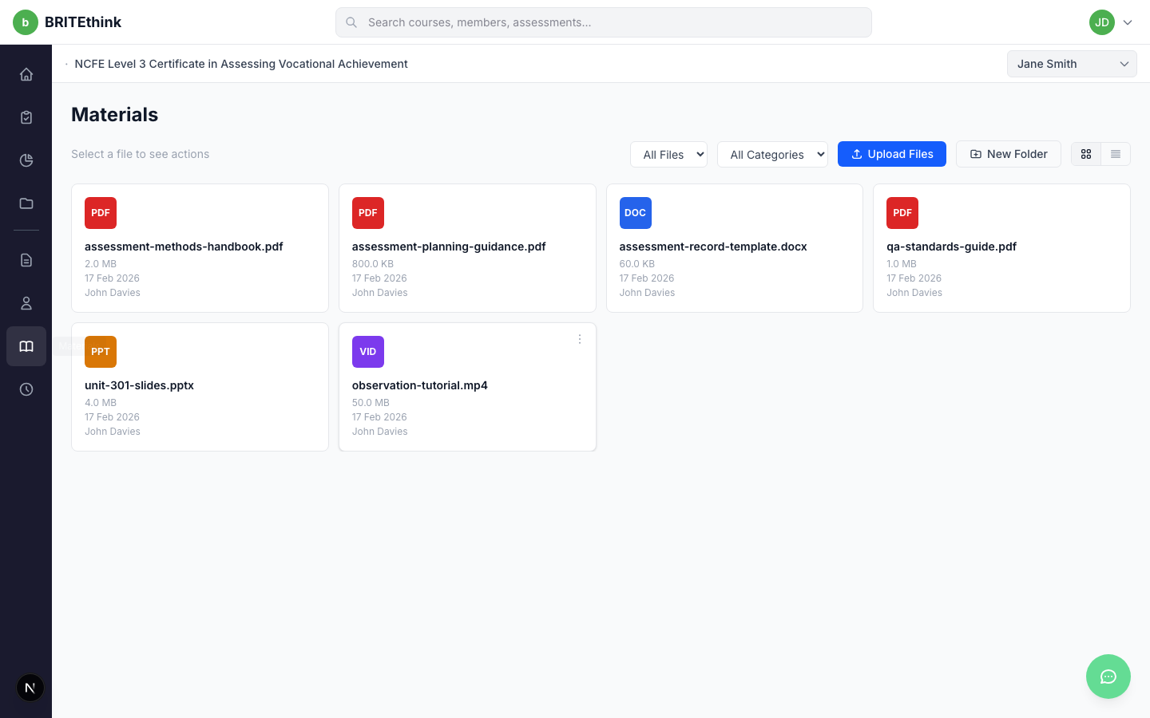
Figure 17: Materials — Teaching materials with category filter

11. Work Hours
The Work Hours page provides day-by-day time logging for tracking learner work experience. Key features include:
- Day Navigator — Browse between dates with Previous Day / Next Day buttons
- Work hour entries — Each entry shows the learner, activity description, and hours/minutes
- + New button — Add a new work hour entry for the selected date
- Daily Total — Automatically calculates the sum of hours for the current day
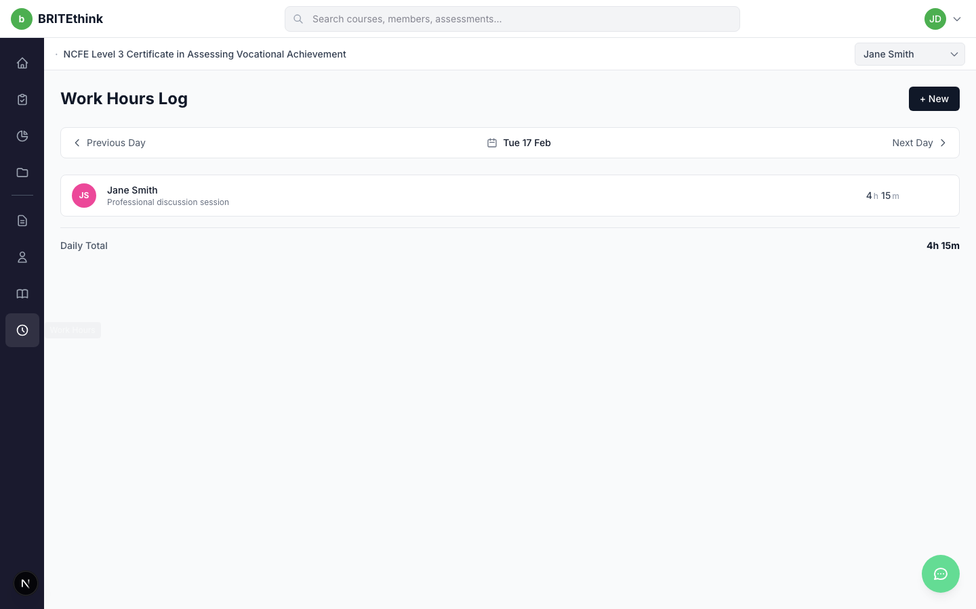
Figure 18: Work Hours — Day navigator with entries and daily total

12. Members
The Members page displays two sections:
- Team Members — Other assessors assigned to the same qualification, showing their name, email, and role badge
- Learner Groups — Learners organized by cohort (e.g. 2026-Q1), with expandable/collapsible groups showing learner names, emails, and enrollment status
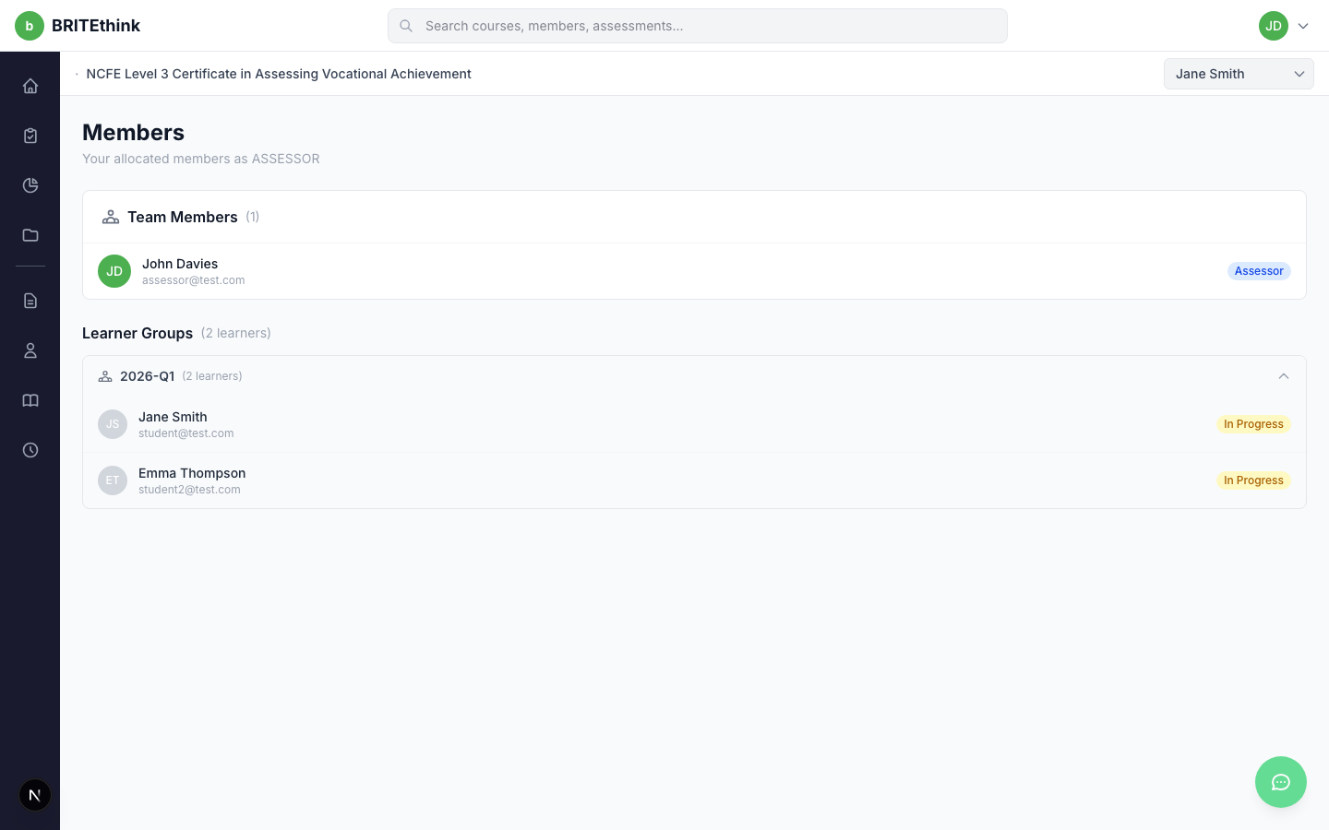
Figure 19: Members — Team members and learner groups

13. Global Search
The global search bar in the top navigation provides debounced search across three categories: Members, Assessments, and Evidence. Results appear in a dropdown with category tabs and highlighted match text. Clicking a result navigates to the relevant page.
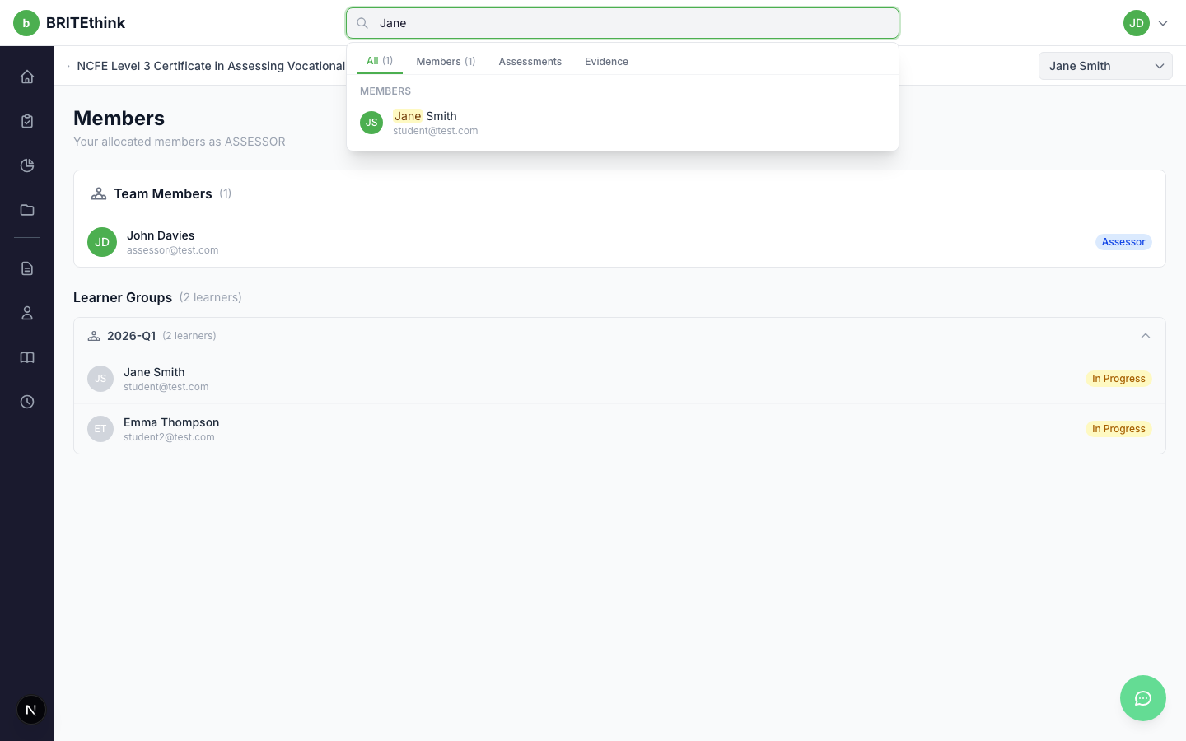
Figure 20: Global Search — Search results dropdown with category tabs

14. Learner Context Switching
A learner dropdown in the sub-header allows assessors to filter all pages by a specific learner. The selected learner persists across navigation via a URL query parameter. Pages that require learner context (like Assessments and Progress) automatically reflect the selected learner's data.
Figure 21: Learner Dropdown — Sub-header with learner selection

Mobile Responsive Design
The dashboard is fully responsive. On mobile devices, the sidebar collapses into a hamburger menu that opens as a full-screen overlay. The assessment detail panel takes over the full screen on mobile instead of appearing as a side panel.
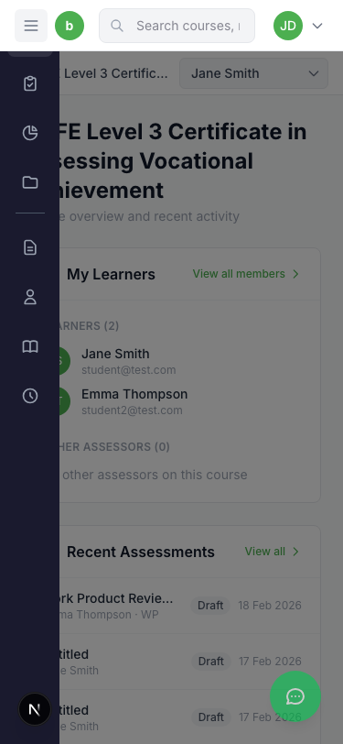
Figure 22: Mobile Sidebar — Hamburger menu with overlay navigation
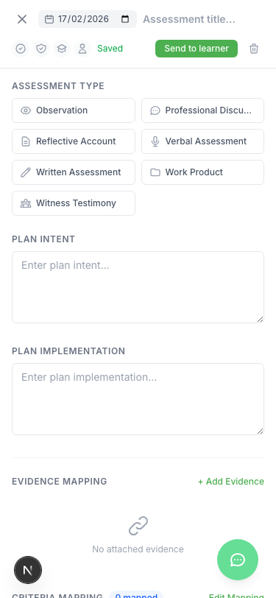
Figure 23: Mobile Detail Panel — Full-screen assessment detail on mobile

