
 | Coming Soon! May 2006  39843 Cedar Blvd. Unit # 320, Building #7  2 Bedroom Condo w/ 2 Bathrooms  1071 Sqft, Built 1986  Best Location 3rdFloor w/ High Ceilings  Courtyard Pool View of North Clubhouse  Wood Burning Fireplace w/ Gas Starter  Washer & Dryer Included  New Oven/Range, New Paint  New Carpet & Linoleum  Bathrooms Remodeled  North & South Clubhouse  2 Pools, Hot Tub, Sauna & Showers  Fitness Center in South Clubhouse  HOA is $287 per month  One Covered Parking and  One Uncovered Parking  On Site Managers  Secured Building near 880 & 84  California Home and Mortgage  Valenn Orais 408 453-5511 or 408 937-5511  Stacy Truong 415 336-9425 or 408 944-9131  Fax Offers: 408 904-5533  Email: valenn_orais @yahoo.com  stacytruong@sbcglobal.net  Receive property listings by email, just log on to  www.housevalu.net and input your search criteria. |  | 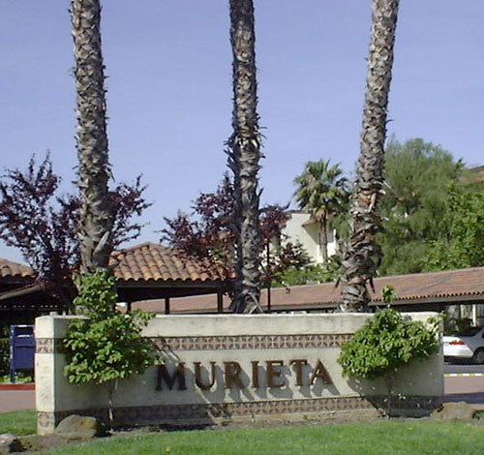  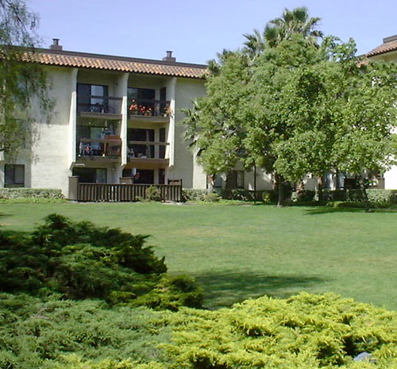  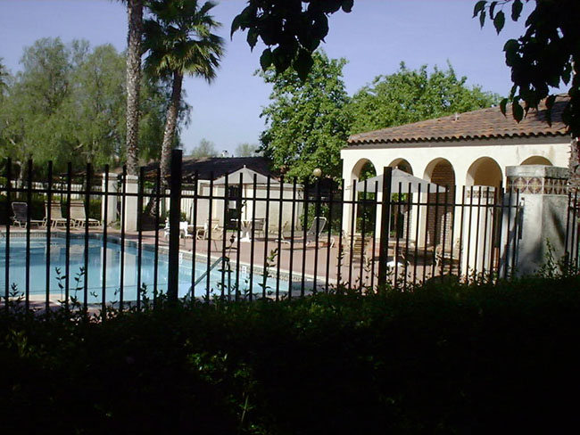
  An equal housing broker  If your house is currently listed, this is not intended as a solicitation. |  |  |  | $399,000

