Secure Encrypted Chat Platform
Comprehensive System Design Document

Executive Summary
This document explains the architecture and design of a secure encrypted chat platform implementing end‑to‑end encryption, real‑time communication, and behavior analysis using machine learning.

Problem Statement
Modern messaging platforms often centralize control over user data. This system focuses on privacy, encryption, and scalable messaging infrastructure while maintaining usability.

Design Goals
Security, scalability, reliability, and privacy are the primary design goals. The platform ensures encrypted messaging while supporting millions of real‑time connections.

High Level Architecture
The platform consists of a client application, a Node.js backend handling messaging and authentication, a Redis layer for fast state management, a MongoDB database, and a Python AI microservice.

Encryption Model
Hybrid encryption is implemented using AES for message encryption and RSA for secure key exchange. The server never sees plaintext messages.

Authentication
Authentication uses JWT tokens and bcrypt password hashing. OAuth support can also be integrated for third‑party login.

Real‑Time Communication
Socket.io enables bidirectional messaging channels allowing instant message delivery and presence updates.

Database Design
MongoDB collections store encrypted messages, users, group information, and metadata logs.

AI Behavior Analysis
A Python FastAPI service analyzes behavioral signals using an Isolation Forest algorithm to detect spam or malicious activity.

Zero Trust Security Model
Every request must be authenticated and validated. Encryption is enforced at every layer.

Threat Model
Threats include interception, spam bots, credential theft, and infrastructure attacks. Mitigations include TLS, encryption, rate limiting, and anomaly detection.

Scalability Strategy
The backend is stateless and horizontally scalable. Redis stores session mappings and real‑time state.

Deployment Architecture
Services can be deployed using containerized infrastructure and orchestrated through cloud platforms.

Monitoring
System health metrics and logs ensure reliability and early anomaly detection.

Future Improvements
Possible improvements include decentralized identity, post‑quantum cryptography, and peer‑to‑peer communication.

System Architecture Diagram
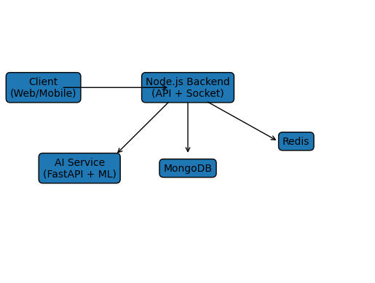

Encryption Flow Diagram
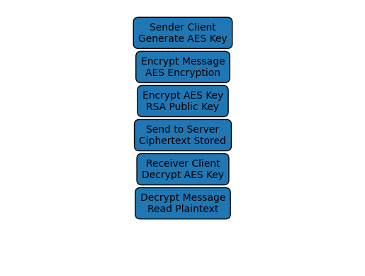

Messaging Sequence Diagram
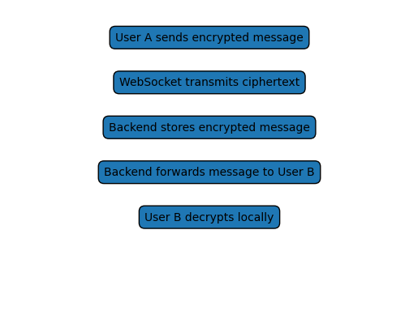

Conclusion
This architecture demonstrates how secure messaging platforms can be implemented using modern cryptographic techniques and scalable infrastructure.

