**Combinations™ (Rules) V 1.1**

1. Game created, basic rules by McM
   1. Quatra added, thanks to MrLol
   2. Rarities added, thanks to e8000
2. Balancing Attackers (went live) 1.8.2016
   1. Rule fixes, spell Farmer Army costs (3-8) instead of (2-7) cards now; green7501 updated

One game of combinations™ is usually 20-30 minutes long. It's made for two players.

For this game, you'll need:

Pack of gaming cards, used for Remi:

2-10 x4; Jack x4; Queen x4; King x4; Ace x4; Joker x2

At the start:

First, one of the players mix cards and give the deck to other player. That one must then take the top 10-40 cards(he/she can decide how many) and put them on the bottom of the deck.

At the begining of the game, players play one round of Rock, Paper, Scissors. The winner can choose, who will start first and draw cards from the deck first. Then they both draw five (5) cards from the deck.

So, every player starts with 200 Life Points.

Every turn:

If there are player A and B and player A starts, then turns go:

A,B,A,B,A,B…

When you start a new turn, you draw two (2) cards from the deck. Then you can summon combinations (possible combinations are shown on the last page), but you need wanted cards to summon them, called ingreedments. There are three types of combinations:

-Attackers (that can attack other attackers and players)

-Armaments (that you can give to an attacker or yourself as an upgrade)

-Spells (that can be only activated, if you are controling a wizard)

Game Board:

Game board tells us, where to place already-used cards, alive combinations and undrawn cards.

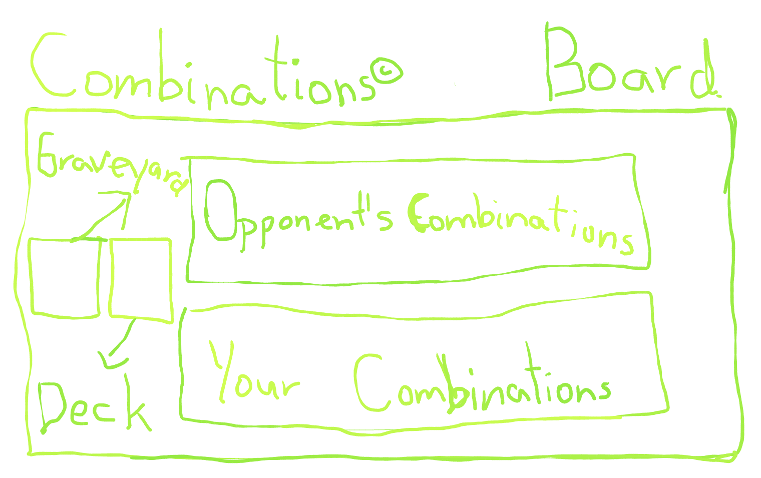

That's, how does the game board look like.

Cards used for attackers, armaments and spells, that have been destroyed, are placed to the **GRAVEYARD**.

When you and your opponent mixed the cards, you should place them to the second rectangle, called the **DECK**. From it you draw cards.

Cards, that you have drawn, you should put them in your hand.

The biggest rectangle is for your and your opponent's combinations. Here belongs attackers, that are still alive and armaments. If an armament was on attacker, that is destroyed later, put an attacker and an armament to the graveyard.

How to Summon a Combination:

Let's say that this cards are in my hand:

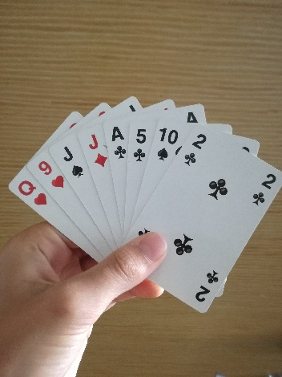So, there is one combination called Dentex. For it you need a 10 and a 2. And if you take a look at the last two cards, you can see that I can activate it.

Activation is easy. You just put cards, needed for an activation on the field turned verticaly on the field, where you put all the other combinations.

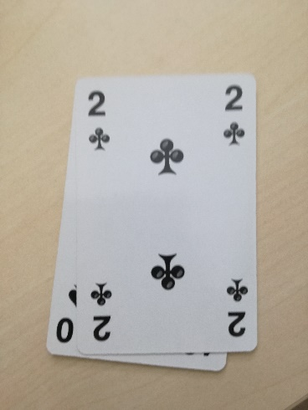

That's how it should look like 🡪

If you want to use an armament, place all cards needed for it horizontaly, under the attacker:

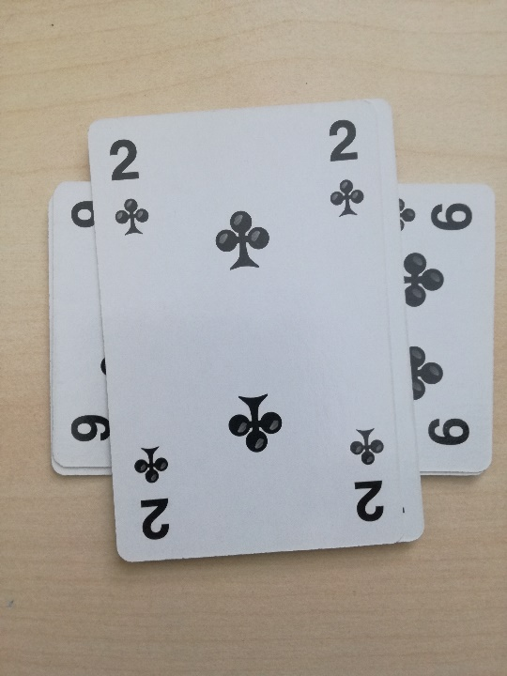

Besides the summoning combinations, you can also attack your opponent's attackers. Every attacker has its Attack (The first number) and Life points (The second number), but it can't attack the same round, as you activated it (it needs one turn to get ready). Each combination can attack only once per turn (it must be your turn so you can attack).

So, if combination X attacks combination Y, Y's Life points are deducted equal to X's Attack (40 Life Points-40 Attack=0 Life Points), but X also loses its Life points equal to Y's Attack (30 Life Points-20 Attack=10 Life Points). And if Attackers' health gets 0 (or lower), it dies (then put it and all of its armaments to the graveyard). So at this situation, X survives and Y dies.

X (40 Attack/30 Life Points)

Y (20 Attack/40 Life Points)

But it also can happen, that both or none of them die, so attack wisely.

If your opponent got out of Attackers, you can attack your opponent directly. As It's written at the AT THE START section, both players have 200 Life Points. If your opponent's Life Points gets 0 (or lower), you win, or conversely. You can also win, if your opponent Surrends or, if it runs out of cards in its hand and combinations.

You can attack and activate your combinations at any sequence you want.

At the end of your turn, you can draw another card, if you haven't activated any combination this turn.

Trading:

If you can't get a card you want, you can trade with your opponent.

For Example:

You: I need an Ace

Opponent: Ok, I can give it, if you give a Jack.

You: I don't have a Jack.

Opponent: What about a Queen.

You: Ok.

(You trade your Queen for an Ace)

*The End*

But it can happen, that your opponent don't want to trade. At that case, yoou can't get a wanted card.

Abilities:

Some attackers have they own ability. Some abilities got activated only once, while activated (In that case, there will be a sign AT in the front (Activate)).

If an ability lasts only while an attacker is alive, than there would be a sign **WA** (While Alive).

Every Armament has its own ability, that tells, what does exactly do.

Some will give an attacker some Life Points, some Attack and some of them has an ability to destroy a Attacker, but every attacker can have only one (1) armament. There are some armaments (like bomb), that can be used on yourself.

All spells have their own abilities, but only one spell is made for targeting attackers. Spells are useful, but you need a wizard to make them.

If an attacker's ability is, that it equips an armament, its gains attack/health/ability of that armament.

Rarity:

Rarity is not important. Its just tells you, how good a comnination is.

There are four types of rarities:

Common, Rare, Epic and Legendary.

Combinations:

J-Joker K-King Q-Queen Jack-Jack A-Ace B-Any Black Card

8*2= 8+8 Q*3=Q+Q+Q

Attackers:

Name Ingreedments Points Ability Rarity

|  |  |  |  |  |
| --- | --- | --- | --- | --- |
| e8000 | J+K+Q+10 | 75/25 | Can attack first round. | Legendary |
| MrLol | J+J+2 | 60/85 | None | Legendary |
| McM | J+Q+Jack*2 | 25/45 | AT: Gets Bazooka. | Legendary |
| Tessi | J+A | 35/25 | AT: Take a control of any opponent's attacker. | Legendary |
| Wizard | K+3 | 15/35 | WA: You can use spells. | Epic |
| Dark Master* | A+2+B | 35/20 | AT: Destroys all other cards, that are made of an any black card. | Epic |
| green7501 | Jack*2+2 | 15/50 | WA: When this attacker attacks, you can look at the opponent's hand. If he has a Joker in his hand, this card takes no battle damage this attack. | Epic |
| Farmer's Totem | Q+Q+2 | 0/90 | WA: Choose One:  -Your Farmers have 30/30  -Your Farmers can attack twice per turn.  When ability was set, you can't change it.. | Rare |
| King | K*2+Q | 25/40 | AT: Give all of your other attackers an axe. | Rare |
| Killer | 10+9+4 | 30/10 | AT: Destroy an attacker. | Rare |
| Fisherman | 9+3+2 | 15/20 | AT: Steals an ability of any opponent's attacker | Rare |
| Dentex** | 10+2 | 25/30 | AT: Gets Tooth. | Common |
| Farmer | 1 Card (Any) | 20/20 | Only one farmer can be summoned per turn. | Common |

*Also Known as Parrotex.

**A fish. <https://en.wikipedia.org/wiki/Common_dentex>

Armaments:

Name Ingreedments Bonus Who can equip it to Rarity

|  |  |  |  |  |
| --- | --- | --- | --- | --- |
| Bomb | 9+6 | Kill 1 Attacker, for an use for its attack. | You, Attacker | Rare |
| Bazooka | 10*2+9*2+8 | Kill 3 Attackers, for an use of its attack (1 Per Turn) | Attacker | Epic |
| Teeth | Q | +10 Attack | Attacker | Common |
| Sword | 10+5+B | +20 Attack | Attacker | Common |
| Shield | Jack+9 | +15 Health | You, Attacker | Rare |
| Axe | 7+5+3 | +15 Attack  +5 Health | Attacker | Rare |
| Armor | 4*3 | +25 Health | Attacker | Common |

Spells:

Name Ingreedments Effect Rarity

|  |  |  |  |
| --- | --- | --- | --- |
| Immune Potion | 9+7+6 | Choose one of your attackers. It is immune for:  -1 of your opponent' s turn  -2 of your opponent's turns, but it can't attack or activate abilities. | Rare |
| Farmer Army | 3-8 | Convert these cards(3-8) into farmers and place them to the field. | Epic |
| Dark Hole | 9+5+2 | Destroy ALL attackers. | Epic |
| Revival | 4 Cards (Any) | Draw the top 2 cards from the graveyard. | Common |
| Cancellation | 7+9+10 | This spell can be activated  Choose One:  -Counter the spell, activated by an opponent.  -Destroy an armament, activated by an opponent.  -If an opponent's attacker attacks, your attackers or you take no damage this attack. | Rare |

There is a special combination, called quatra. For it, you need four same cards (as: 8, 8, 8, 8). It does one of the next two abilities (you choose, which one)

-Destroy ALL attackers.

-Your opponent loses 50% of its current life points, if that's less than 50, it loses 20 of them instead.