Lab-1
import re
import nltk
from nltk.corpus import stopwords
from nltk.tokenize import word_tokenize
from nltk.stem import PorterStemmer, WordNetLemmatizer
from nltk.sentiment import SentimentIntensityAnalyzer
from sklearn.metrics import confusion_matrix, precision_score, recall_score, f1_score

nltk.download('punkt', quiet=True)
nltk.download('punkt_tab', quiet=True)
nltk.download('stopwords', quiet=True)
nltk.download('wordnet', quiet=True)
nltk.download('omw-1.4', quiet=True)
nltk.download('vader_lexicon', quiet=True)

print("--- Step 1: Input Text ---")
input_text = input("Enter a paragraph: ")
if not input_text.strip():
input_text = "This movie is absolutely wonderful and great, but the ending was terrible and boring."
print(f"Using default text: {input_text}")

print("\n--- Step 2: Text Cleaning and Normalization ---")
cleaned_text = re.sub(r'[^a-zA-Z\s]', '', input_text).lower().strip()
print(cleaned_text)

print("\n--- Step 3: Tokenization ---")
tokens = word_tokenize(cleaned_text)
print(tokens)

print("\n--- Step 4: Remove Stop Words ---")
stop_words = set(stopwords.words('english'))
filtered_tokens = [w for w in tokens if w not in stop_words]
print(filtered_tokens)

print("\n--- Step 5 & Step 6: Stemming and Lemmatization ---")
stemmer = PorterStemmer()
lemmatizer = WordNetLemmatizer()

stemmed_tokens = [stemmer.stem(w) for w in filtered_tokens]
lemmatized_tokens = [lemmatizer.lemmatize(w) for w in filtered_tokens]

print("Stemmed Tokens:")
print(stemmed_tokens)
print("Lemmatized Tokens:")
print(lemmatized_tokens)

print("\n--- Step 7: Sentiment Classification ---")
sia = SentimentIntensityAnalyzer()
processed_sentence = " ".join(lemmatized_tokens)
score = sia.polarity_scores(processed_sentence)
predicted_label = "Positive" if score['compound'] >= 0 else "Negative"

print(f"Sentiment Scores: {score}")
print(f"Predicted Class: {predicted_label}")

print("\n--- Step 8: Confusion Matrix ---")
sample_actual = ["Positive", "Negative", "Positive", "Negative", "Positive"]
sample_predicted = ["Positive", "Negative", "Negative", "Negative", "Positive"]

cm = confusion_matrix(sample_actual, sample_predicted, labels=["Positive", "Negative"])
print("Labels: ['Positive', 'Negative']")
print(cm)

print("\n--- Step 9 & Step 10: Final Evaluation Results ---")
precision = precision_score(sample_actual, sample_predicted, pos_label="Positive")
recall = recall_score(sample_actual, sample_predicted, pos_label="Positive")
f1 = f1_score(sample_actual, sample_predicted, pos_label="Positive")

print(f"Precision : {precision:.4f}")
print(f"Recall : {recall:.4f}")
print(f"F1-Score : {f1:.4f}")

output:
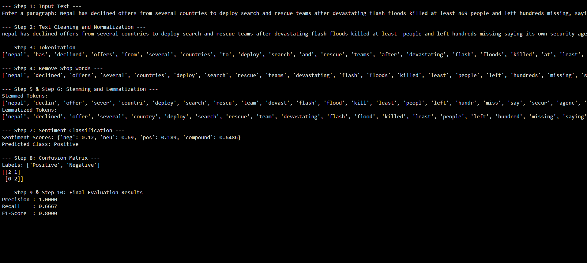
--- Step 1: Input Text ---
Enter a paragraph: Nepal has declined offers from several countries to deploy search and rescue teams after devastating flash floods killed at least 469 people and left hundreds missing, saying its own security agencies are capable of handling the operation. The decision comes as rescue teams continue to search through mud and debris following Wednesday’s flash flood along the Bhotekoshi and Trishuli river systems near the Nepal-China border. According to The Kathmandu Post, Nepal’s foreign ministry has received multiple official and unofficial requests from countries and international organisations seeking to send their own rescue personnel. Officials, however, said the government had decided that Nepali security agencies should lead the operation.

--- Step 2: Text Cleaning and Normalization ---
nepal has declined offers from several countries to deploy search and rescue teams after devastating flash floods killed at least people and left hundreds missing saying its own security agencies are capable of handling the operation the decision comes as rescue teams continue to search through mud and debris following wednesdays flash flood along the bhotekoshi and trishuli river systems near the nepalchina border according to the kathmandu post nepals foreign ministry has received multiple official and unofficial requests from countries and international organisations seeking to send their own rescue personnel officials however said the government had decided that nepali security agencies should lead the operation

--- Step 3: Tokenization ---
['nepal', 'has', 'declined', 'offers', 'from', 'several', 'countries', 'to', 'deploy', 'search', 'and', 'rescue', 'teams', 'after', 'devastating', 'flash', 'floods', 'killed', 'at', 'least', 'people', 'and', 'left', 'hundreds', 'missing', 'saying', 'its', 'own', 'security', 'agencies', 'are', 'capable', 'of', 'handling', 'the', 'operation', 'the', 'decision', 'comes', 'as', 'rescue', 'teams', 'continue', 'to', 'search', 'through', 'mud', 'and', 'debris', 'following', 'wednesdays', 'flash', 'flood', 'along', 'the', 'bhotekoshi', 'and', 'trishuli', 'river', 'systems', 'near', 'the', 'nepalchina', 'border', 'according', 'to', 'the', 'kathmandu', 'post', 'nepals', 'foreign', 'ministry', 'has', 'received', 'multiple', 'official', 'and', 'unofficial', 'requests', 'from', 'countries', 'and', 'international', 'organisations', 'seeking', 'to', 'send', 'their', 'own', 'rescue', 'personnel', 'officials', 'however', 'said', 'the', 'government', 'had', 'decided', 'that', 'nepali', 'security', 'agencies', 'should', 'lead', 'the', 'operation']

--- Step 4: Remove Stop Words ---
['nepal', 'declined', 'offers', 'several', 'countries', 'deploy', 'search', 'rescue', 'teams', 'devastating', 'flash', 'floods', 'killed', 'least', 'people', 'left', 'hundreds', 'missing', 'saying', 'security', 'agencies', 'capable', 'handling', 'operation', 'decision', 'comes', 'rescue', 'teams', 'continue', 'search', 'mud', 'debris', 'following', 'wednesdays', 'flash', 'flood', 'along', 'bhotekoshi', 'trishuli', 'river', 'systems', 'near', 'nepalchina', 'border', 'according', 'kathmandu', 'post', 'nepals', 'foreign', 'ministry', 'received', 'multiple', 'official', 'unofficial', 'requests', 'countries', 'international', 'organisations', 'seeking', 'send', 'rescue', 'personnel', 'officials', 'however', 'said', 'government', 'decided', 'nepali', 'security', 'agencies', 'lead', 'operation']

--- Step 5 & Step 6: Stemming and Lemmatization ---
Stemmed Tokens:
['nepal', 'declin', 'offer', 'sever', 'countri', 'deploy', 'search', 'rescu', 'team', 'devast', 'flash', 'flood', 'kill', 'least', 'peopl', 'left', 'hundr', 'miss', 'say', 'secur', 'agenc', 'capabl', 'handl', 'oper', 'decis', 'come', 'rescu', 'team', 'continu', 'search', 'mud', 'debri', 'follow', 'wednesday', 'flash', 'flood', 'along', 'bhotekoshi', 'trishuli', 'river', 'system', 'near', 'nepalchina', 'border', 'accord', 'kathmandu', 'post', 'nepal', 'foreign', 'ministri', 'receiv', 'multipl', 'offici', 'unoffici', 'request', 'countri', 'intern', 'organis', 'seek', 'send', 'rescu', 'personnel', 'offici', 'howev', 'said', 'govern', 'decid', 'nepali', 'secur', 'agenc', 'lead', 'oper']
Lemmatized Tokens:
['nepal', 'declined', 'offer', 'several', 'country', 'deploy', 'search', 'rescue', 'team', 'devastating', 'flash', 'flood', 'killed', 'least', 'people', 'left', 'hundred', 'missing', 'saying', 'security', 'agency', 'capable', 'handling', 'operation', 'decision', 'come', 'rescue', 'team', 'continue', 'search', 'mud', 'debris', 'following', 'wednesday', 'flash', 'flood', 'along', 'bhotekoshi', 'trishuli', 'river', 'system', 'near', 'nepalchina', 'border', 'according', 'kathmandu', 'post', 'nepal', 'foreign', 'ministry', 'received', 'multiple', 'official', 'unofficial', 'request', 'country', 'international', 'organisation', 'seeking', 'send', 'rescue', 'personnel', 'official', 'however', 'said', 'government', 'decided', 'nepali', 'security', 'agency', 'lead', 'operation']

--- Step 7: Sentiment Classification ---
Sentiment Scores: {'neg': 0.12, 'neu': 0.69, 'pos': 0.189, 'compound': 0.6486}
Predicted Class: Positive

--- Step 8: Confusion Matrix ---
Labels: ['Positive', 'Negative']
[[2 1]
[0 2]]

--- Step 9 & Step 10: Final Evaluation Results ---
Precision : 1.0000
Recall : 0.6667
F1-Score : 0.8000

