Summary: In this lab you'll use Otto to build a comprehensive analysis from raw data sources. The business case: GreenTech Manufacturing is looking to tackle a critical sustainability challenge facing their five UK production facilities. The company consumes over 42 million kWh annually running energy-intensive operations, and with UK carbon offset costs at £85/ton CO2, their environmental impact is becoming a significant financial burden.
The key insight: the UK's electricity grid carbon intensity swings dramatically throughout the day. Your mission is to build an intelligent forecasting system that learns from 30 days of historical weather and carbon data to predict these low-carbon windows up to 7 days in advance, then identifies which flexible operations can be strategically shifted from high-carbon hours to clean-energy windows.
The dataset
You're working with five data sources that together tell the story of your manufacturing energy footprint:
Source | What it provides
UK Carbon Intensity API | Real-time and historical carbon intensity of the UK electricity grid
Open-Meteo Weather API | Historical and forecast weather data for predictive modeling
Facilities (CSV) | 5 UK manufacturing sites with annual energy consumption and location
Machines (CSV) | 125 machines with energy draw, type, and whether they're can be scheduled
Production Schedule (CSV) | Weekly shift patterns showing when each machine runs

Lab 1: Agentic Analysis
Step 1: Build data pipeline:
We want to create a brand new flow. Before you build anything, I want you to create a plan in a markdown file and put it in a plan folder first that I will approve. In this flow we want to:

1. Use custom Python read components to ingest hourly weather data (from the OpenMeteo API - https://open-meteo.ascend.dev/) and carbon data (UK Carbon Intensity API - https://uk-carbon-intensity.ascend.dev/intensity) for the past 30 days. I only need the following latitude, longitude:
(53.4808,-2.2426), (52.4862, -1.8904), (53.8008, -1.5491), (51.4545, -2.5879), (51.5074, -0.1278), make sure to hard code this in the OpenMeteo API read component. These ingestion components should gracefully handle schema changes, rate limits, and retries with exponential backoff. Use the live APIs only (never mock or fabricate data). Inspect a real sample response from each endpoint directly from the endpoint URL using HTTP before implementing parsing logic. You must
inspect live API responses from the exact endpoint URLs you will implement against before writing any parser code, and you must use those observed payloads—not documentation summaries—as the source of truth for response structure.

2. Create a model to help us understand the impact of weather & time of day on carbon prices and impact. Use a carbon price assumption of £85/ton CO2 and use fixed tariff values of £0.135/kWh off-peak, £0.145/kWh mid-peak, and £0.155/kWh on-peak, with the model determining the hourly bucket assignment.

3. Ingest forecast data from the OpenMeteo API and create an hourly predictive model for carbon impact based on the weather forecast and time of day for the next 7 days, use the model that was built in step 2.

4. Layer in our own operations data to determine optimal operations windows and cost savings (both in carbon offsets and energy cost savings) based on rescheduling. The relevant data is in the data folder (read_facilities, read_machines, read_production_schedule). Build the carbon optimization model to maximize combined weekly financial savings (total_savings_gbp = energy_cost_savings_gbp + carbon_cost_savings_gbp) Only recommend a reschedule when total_savings_gbp > 0 and carbon_savings_kg > 0. And only evaluate machines where schedulable = true

5. Produce a final interactive dashboard artifact for operations leaders showing: total combined savings, facility-level summary savings, machine-level recommended windows, energy cost savings, carbon savings in kg, carbon cost savings

IMPORTANT NOTES: Please make sure to build iteratively, running and testing components to validate that the output makes sense and understand the schema before building downstream components. Each time you make changes to correct an error, only run the component that you
are fixing, you do not need to run the full flow. Once the whole pipeline is complete, then run it end to end.

View plan that Otto is creating: Use preview button to review and approve what otto is about to do:
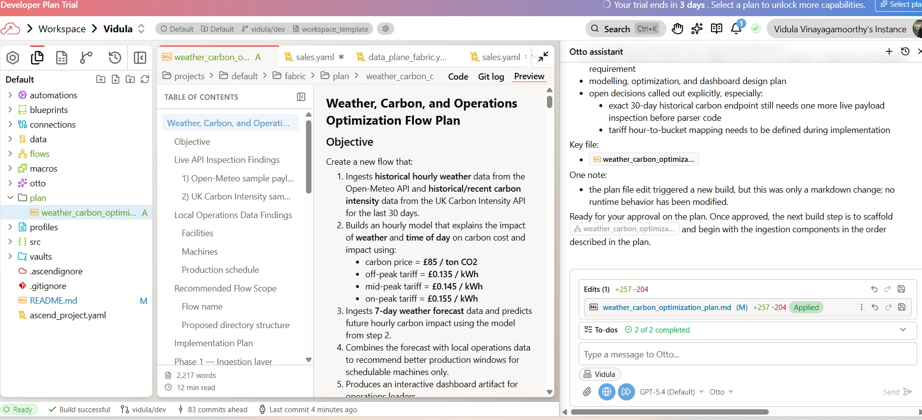

Otto isn't generating code in isolation — it's looking at the actual data coming back from the APIs and cross-referencing it with your operations data. If something fails, Otto reads the actual error message and fixes the issue based on what it observed.

Application built:
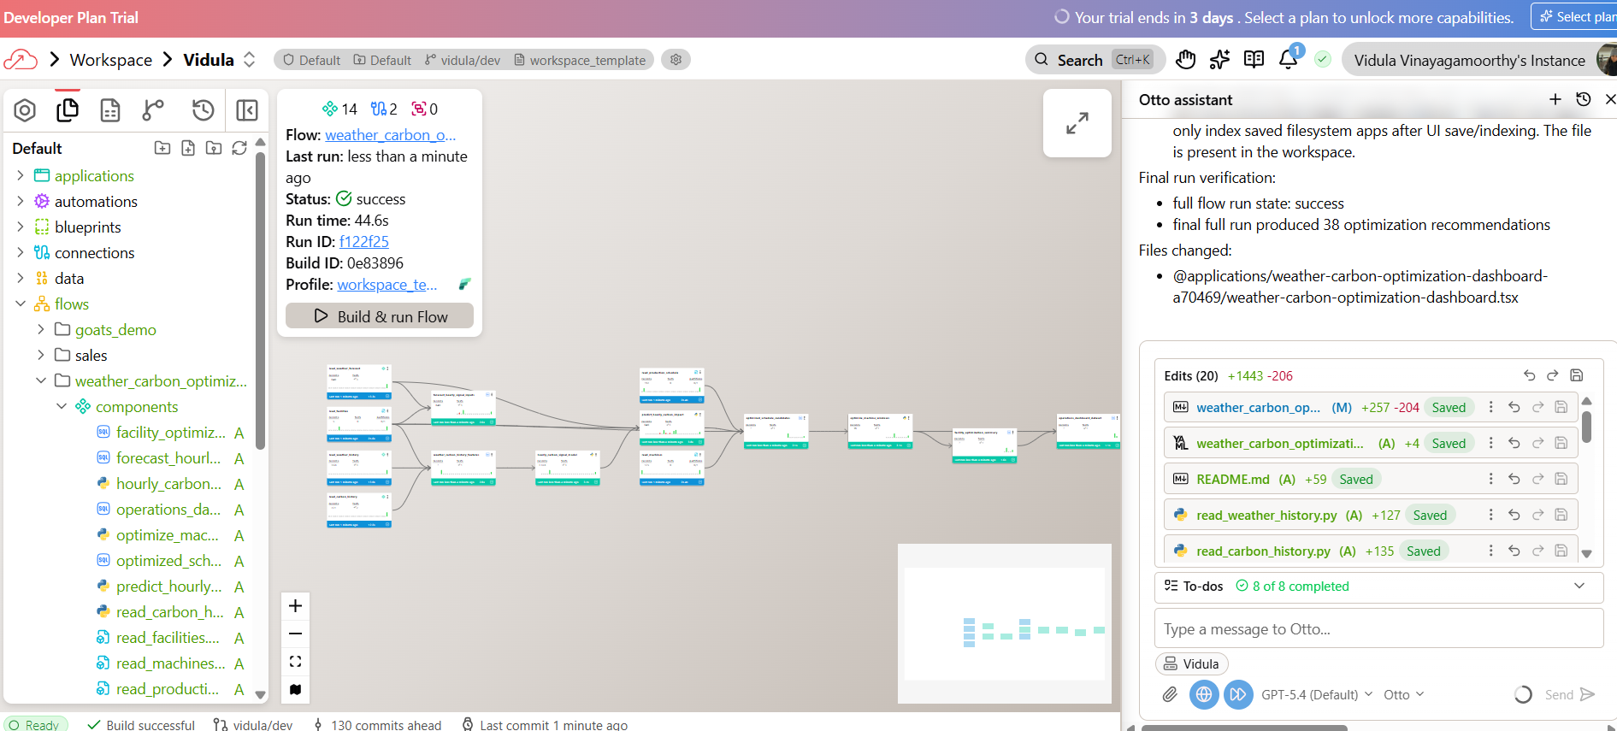

Errors sent can be prompted to Otto, and you can ask it to fix the error eg below – dashboard error seen:

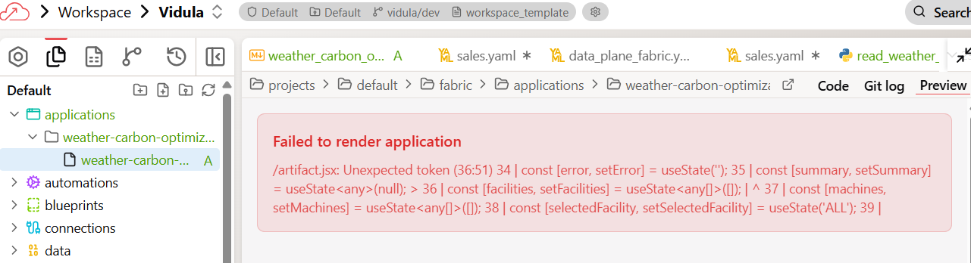

The dashboard view was fixed automatically by otto and could be viewed:

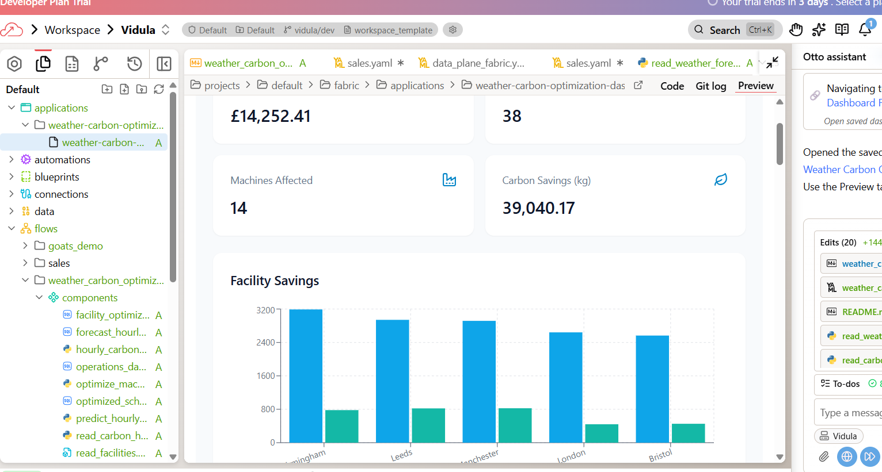
Step 2: Verify the pipeline
Give me a quick summary of the optimization results. How many machines can we reschedule? What are the projected savings?
Output:
Quick summary:
- 14 machines can be rescheduled
- 40 recommended reschedule windows
- 5 facilities affected
Projected savings:
- £15,095.37 total projected savings
  - £12,004.00 energy cost savings
  - £3,091.37 carbon cost savings
- 36,369.00 kg projected carbon savings
Top facilities by total savings:
- Bristol: £3,172.63
- London: £3,169.94
- Birmingham: £3,046.79
- Leeds: £2,882.34
- Manchester: £2,823.66
Top recommendation examples:
- Leeds, Paint Oven 5, Wednesday 22:00 → 03:00: £752.36
- Manchester, Paint Oven 1, Wednesday 22:00 → 00:00: £734.89
- Leeds, Paint Oven 5, Thursday 22:00 → 01:00: £706.28
- Birmingham, Paint Oven 3, Wednesday 22:00 → 01:00: £695.08
One note:
- The final full end-to-end run produced 38 recommendation rows.
- The headline summary above comes from the validated optimization output snapshot used for the dashboard and summary queries, which shows 40 rows / 14 machines.

Otto - connecting to two live APIs, ingesting 30 days of historical data, building a predictive model, cross-referencing with your operations data, and producing scheduling recommendations with cost savings. Otto handled the Python, SQL, and API calls. You directed the analysis. That's the division of labor that scales.
Can view data via the ‘explore’ tab:

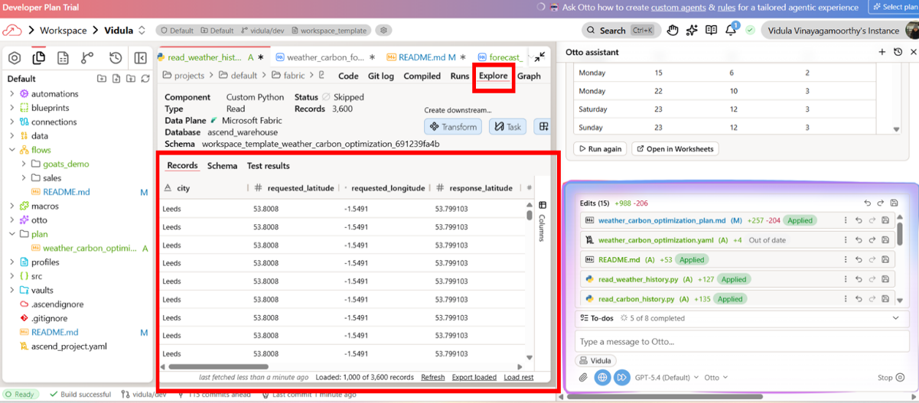
Lab 2: Verifying agent output:

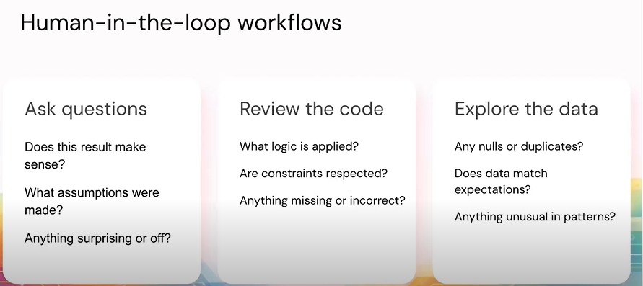
- Explore the optimization results — drill into the data behind the recommendations
- Verify the code — inspect the SQL transforms and check the optimization logic
- Verify the data — look at the underlying tables for surprises
- Build visualizations that tell the story for operations leadership
- Create a boardroom-ready executive summary

Check 1: Understand the output
- Do the savings feel realistic?
- Are certain machines or facilities dominating unexpectedly?
- Is anything surprising?
Can I defend every number in this output?

Check 2: Inspect the code
- Are joins and transformations correct?
- Does the optimization respect the schedulable column?
- Are shift boundaries (±8 hours) enforced?
- Is the predictive model using the correct data?

Check 3: Check the data underneath
- Any nulls or duplicates?
- Do timestamps align correctly?
- Does the operations data match expectations?

Give me an overview of the pipeline you built. How did you go about building it? What assumptions did you make without asking me? Tell me about the scheduling optimization results. Which facilities have the biggest savings opportunity? Which machine types are being rescheduled the most?

One of the assumptions as per below – it talks about five facilities, which is valid. Validate the assumptions it has made without asking you:

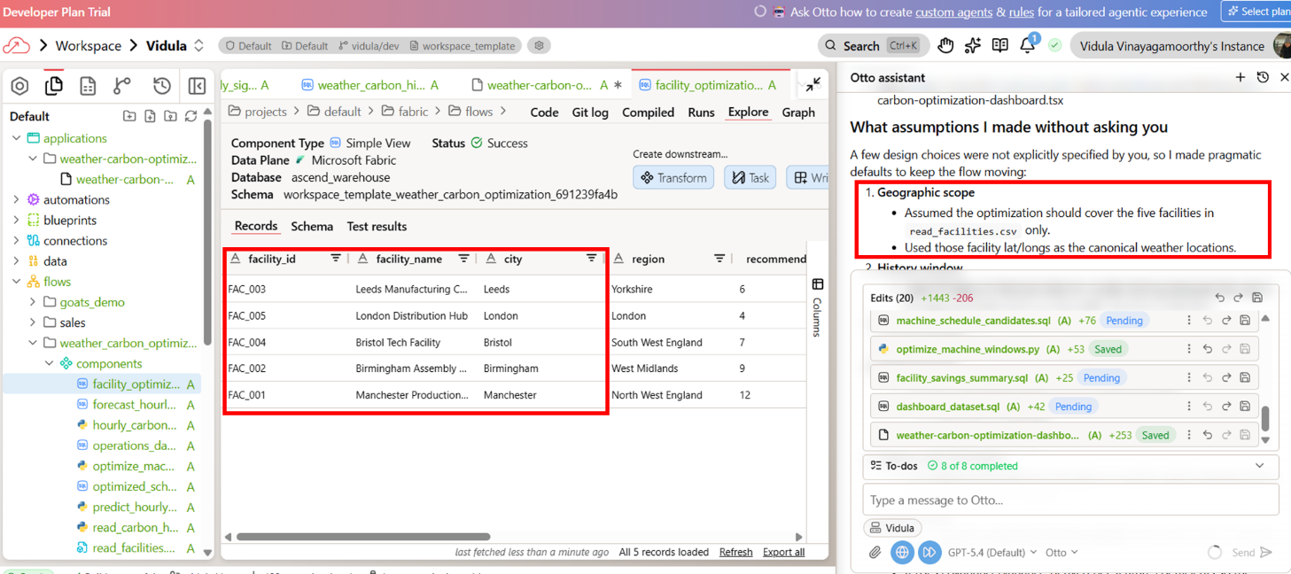
If something doesn’t match – you can ask otto to change and rerun.

Which machines are currently scheduled during the highest carbon intensity windows? Show me the top 10 worst offenders.

Otto will write the sql query to find the above answer. If you cant understand sql query, you can prompt otto to explain the code or take you to the component directly.

Step 2: Verify the code
Does the optimization respect schedulable=true only? can you open the component that has the logic?

Validation code:
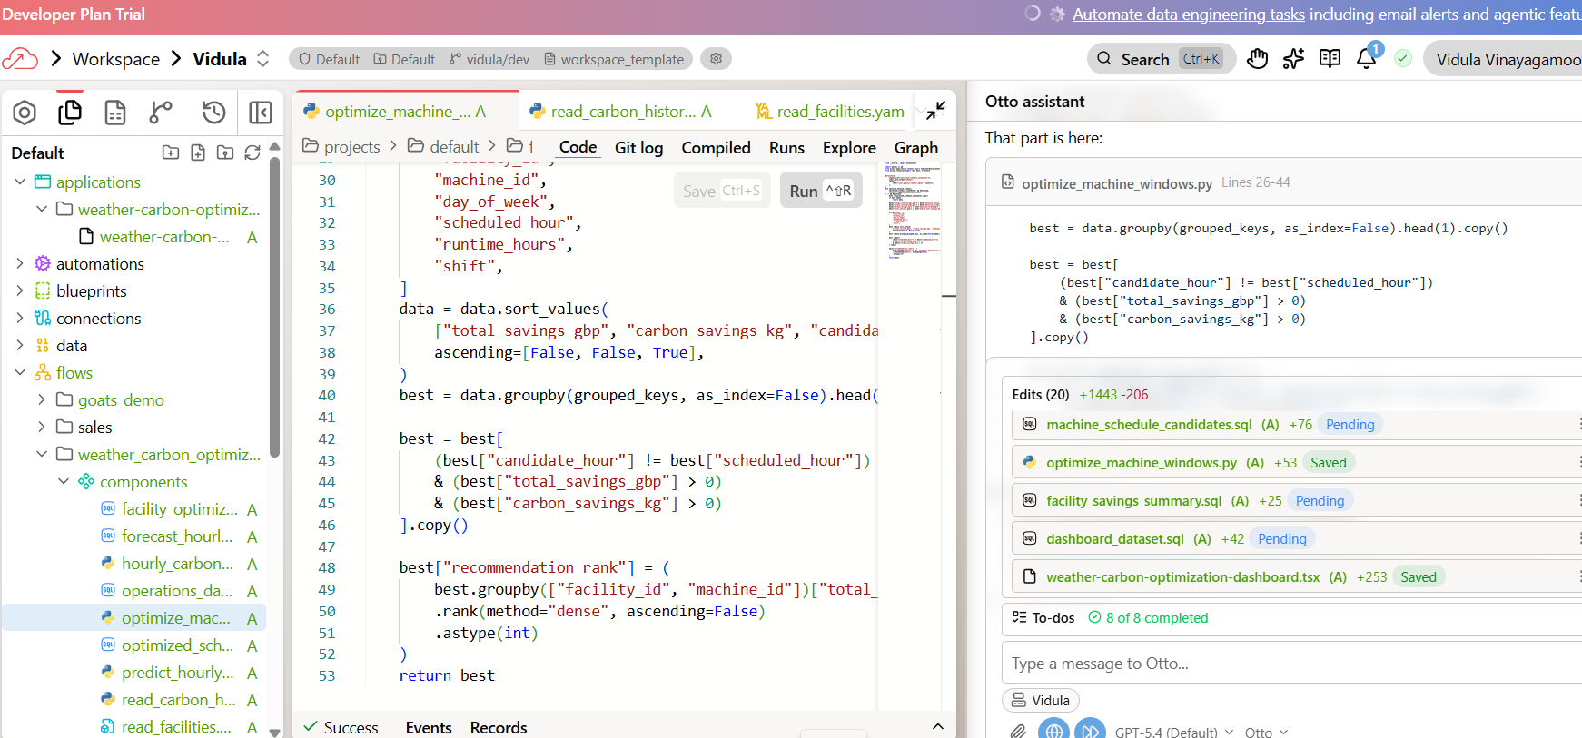

Step 3: Verify the data
Are all 5 facilities represented in the optimization output?
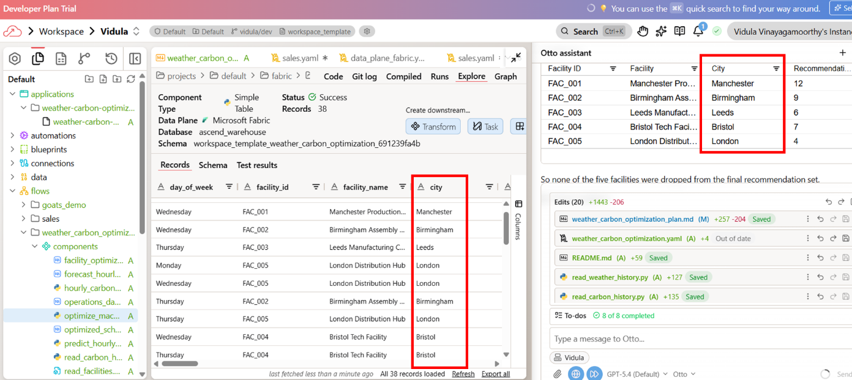

Step 4: build visualisation
Create a visualization we can share with our operations leaders detailing the optimal operation windows for each machine and facility as well as clear cost savings for the next week of operations. Show both the operations we can reschedule and the ones that are already optimal or can't be moved. The result should be an executive summary of the impact of switching our scheduling from static weekly operations, to optimized windows each week.

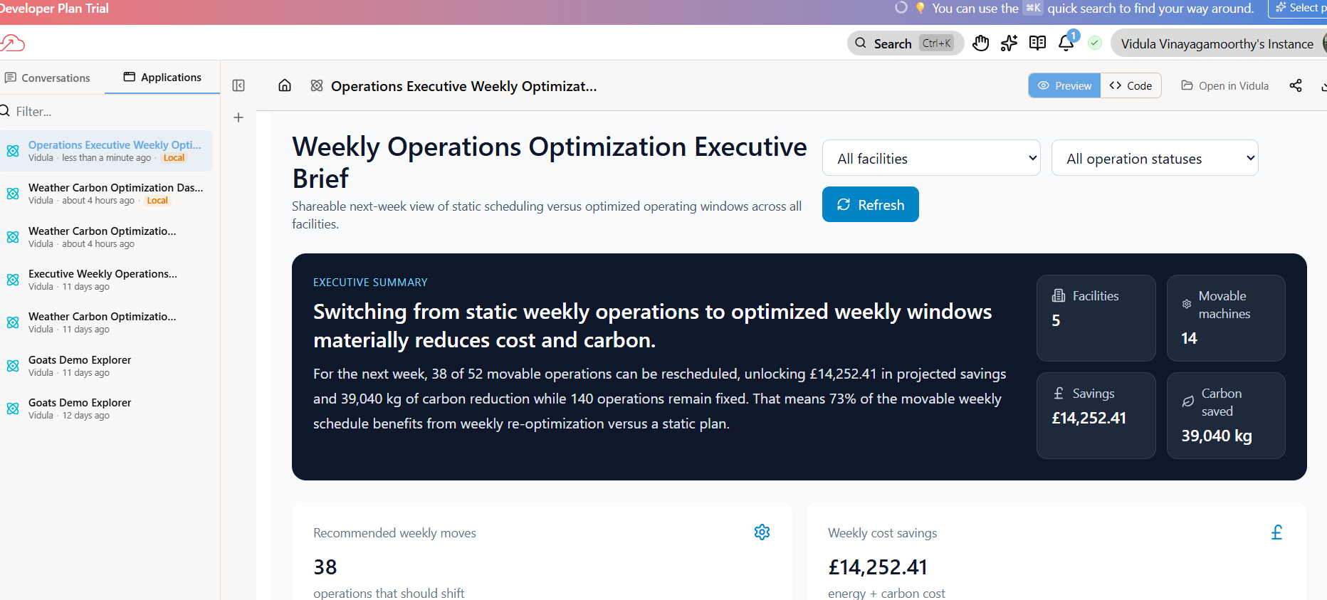

Lab 3: Repeatable workflow
- Update your read components to remove hardcoded dates
- Schedule the pipeline to run daily
- Add an alert for when carbon intensity spikes during a scheduled operation window
- Add an automation that alerts you when the pipeline fails

Step 1: Fix the read components
I want to make sure I can run this flow everyday with updated weather and carbon data. Can you review these read components in my flow for production readiness. Check for hardcoded dates or static time windows. Fix anything you find and run the flow to confirm it still works.

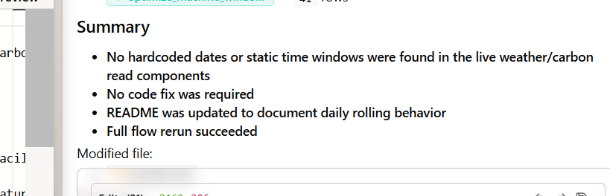

Step 2: Schedule the pipeline

Create an Automation for this Flow to run daily at midnight UTC. Event based automation

The graphical view and code is shown below that was created:
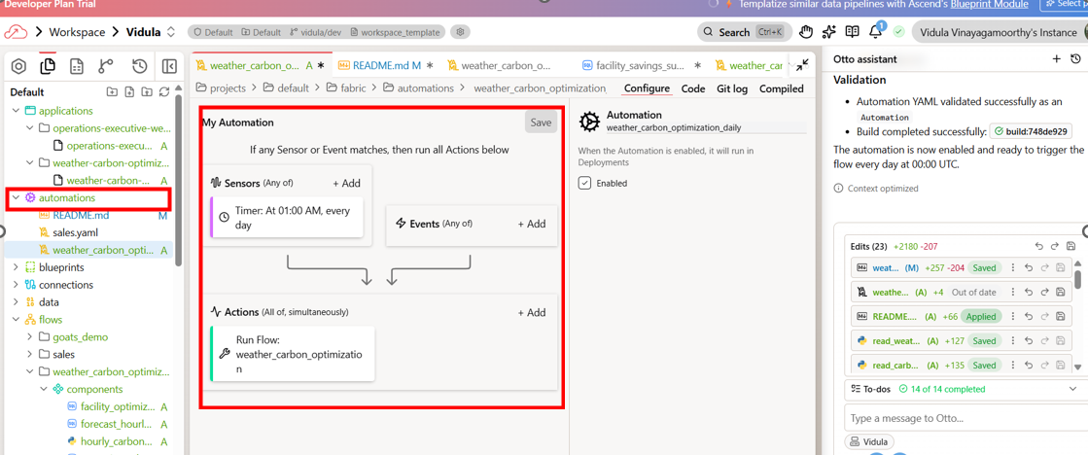

Automation code:
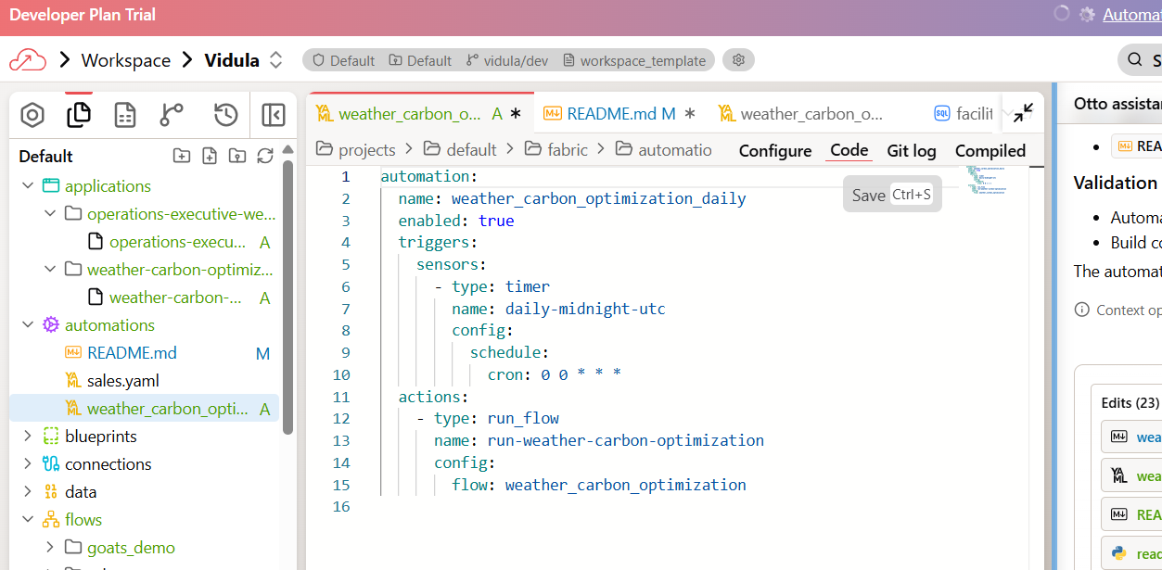
Automations don’t run on workspace. When ready – you can deploy code.

Step 3: Add a carbon intensity threshold alert
Create a separate Automation (don’t modify the daily schedule) for this flow that triggers on flow run successes. The automation should:
1. Run Otto to review the carbon intensity forecast for the next 7 days
2. When any schedulable machine is currently scheduled to run during a high carbon intensity window (top 25% of forecasted hours), send me an email
3. The email should include which machines are affected, which facility they’re in, what the current and optimal time windows are, and the projected savings from rescheduling

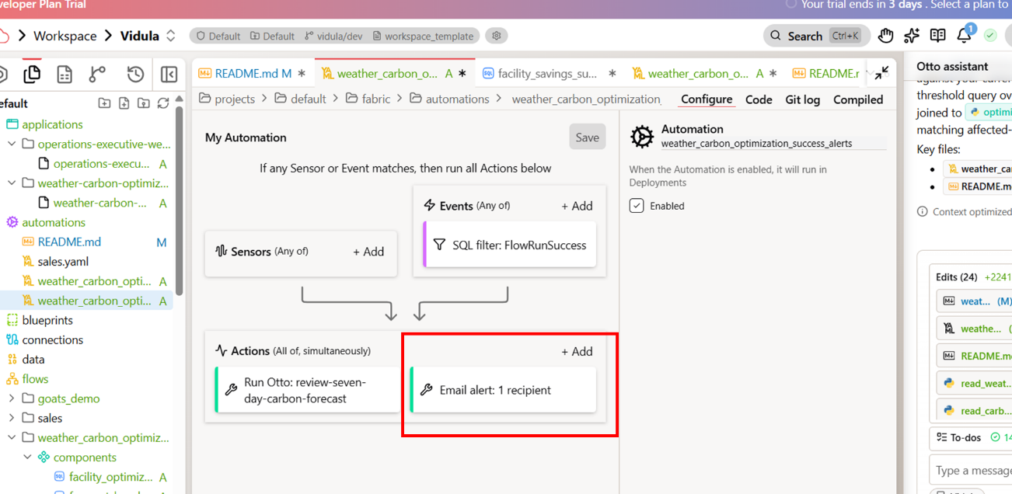

Extra links from bootcamp:

Recorded session on bootcamp: https://www.data-and-ai-bootcamp.com/agentic-analytics-labs

Agentic Analytics step by step instructions: https://docs.ascend.io/bootcamp/track-2-agentic-analytics

Trial evironment: https://asc-8c61a2be-cf9f-47d3.app.ascend.io/home

