Upload project on netbeans and run Main.java file. After this a window will pop which is looks like below figure:

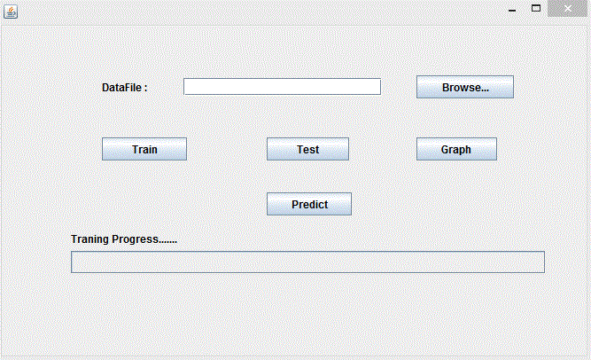

Click on browse button and select _Niftydailydata.txt file and click on Train button and training will be started after completion of training click on Test button and select nifty.txt file. After completion of testing click on Graph button graph will pop up between predicted value and actual value.

At last click on Predict button it will suggest to you what you have to do either you sale the shares or buy the shares or retain the shares.