SmartExpense – Personal Expense Tracker

Pelapolwatte Lekamlage Vidura Kawmantha Pelapolwatte

Project Overview
SmartExpense is a Mobile Application that helps the user keep track of their daily expenses on food, clothes, etc. This app provides users with valuable insights on their spending patterns monthly under different expense categories. Based on the information provided by this app, the end-users can mitigate the unnecessary costs and maintain their expenses accordingly.

Objectives
- Provide users with accurate insights into their monthly spending patterns
- Users can add, update, or delete expenses
- Provide a clean, user-friendly interface for the users
- Supports offline access using a local database

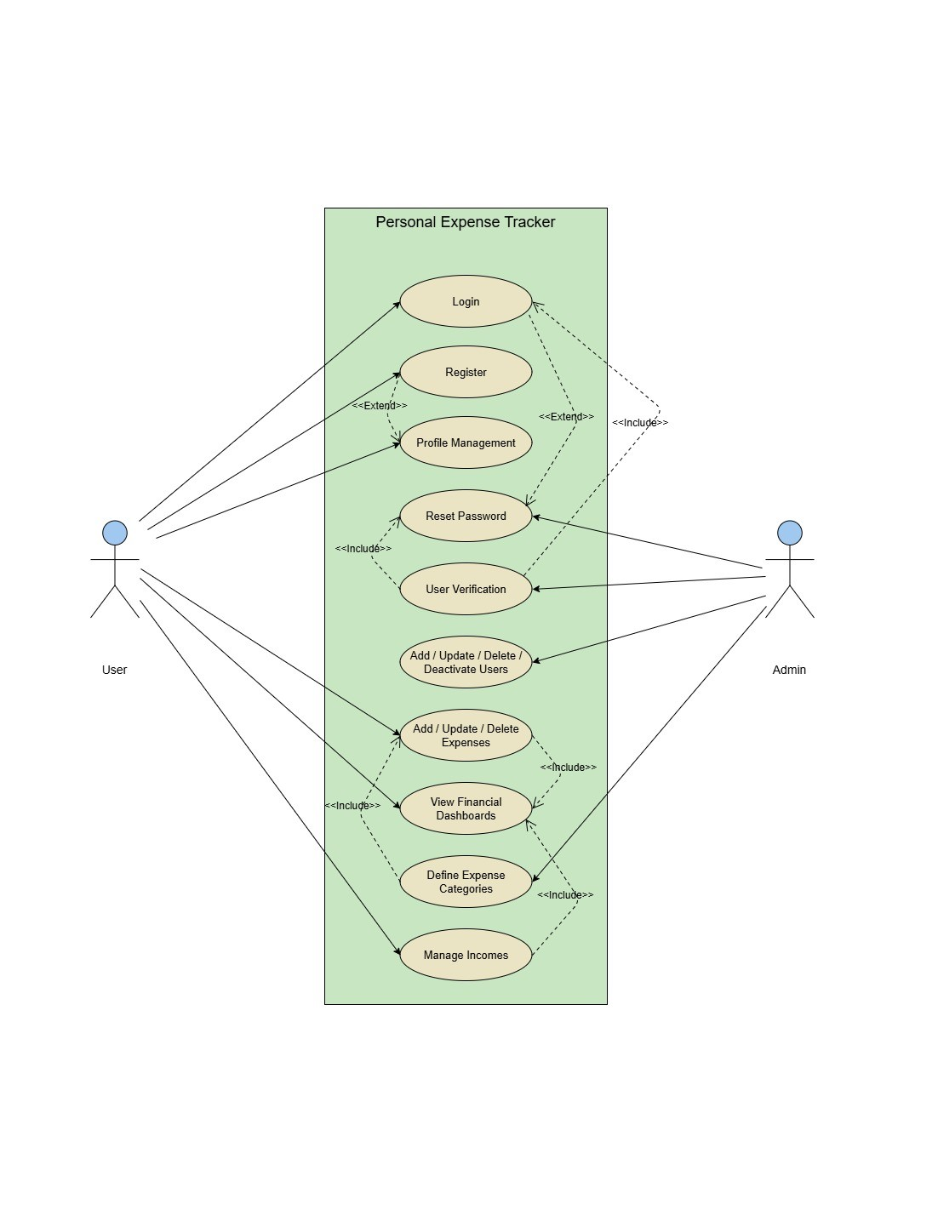
Use Cases

UI Sketches

Login / Sign Up
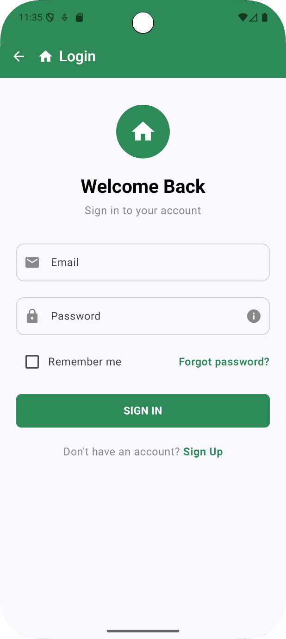
The Login page is where the users can enter their username and password to login to the app. The users can sign up to the system as well.
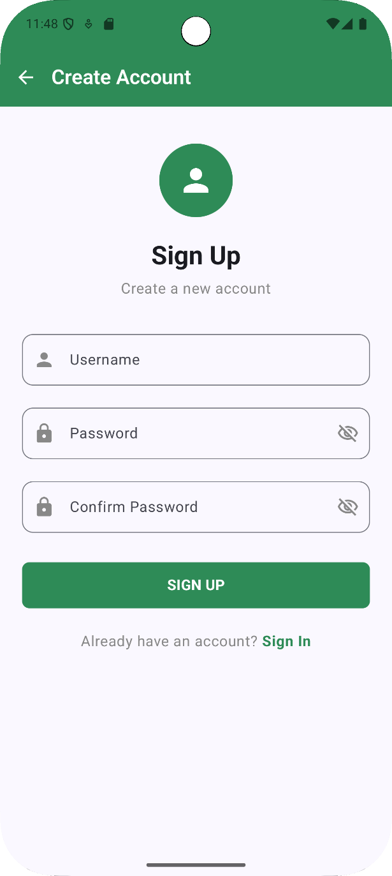
The sign-up page allows users to enter their username and password to register for the system.

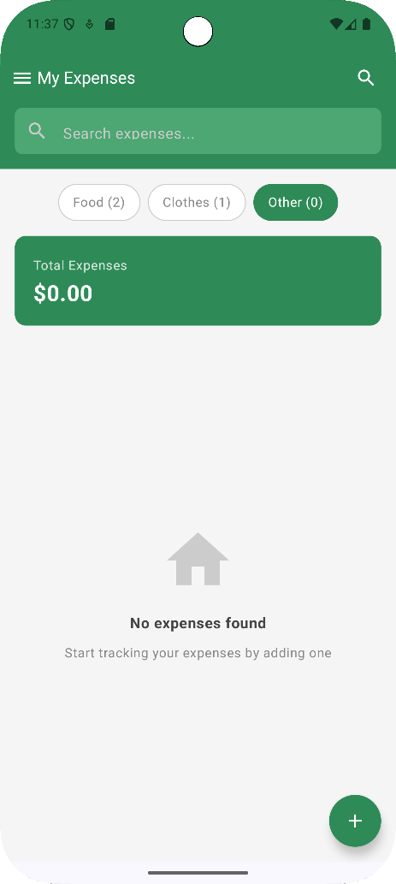
Expense Management Pages
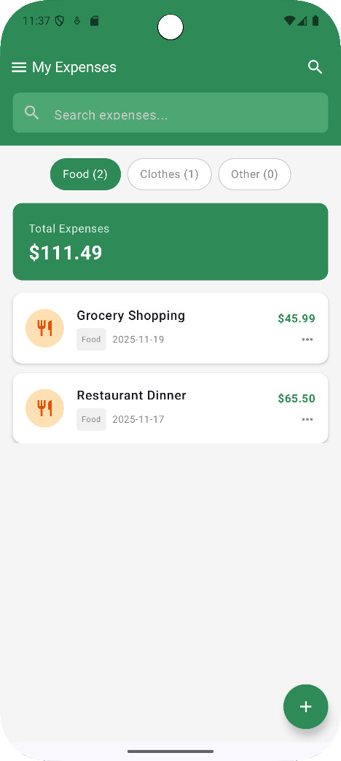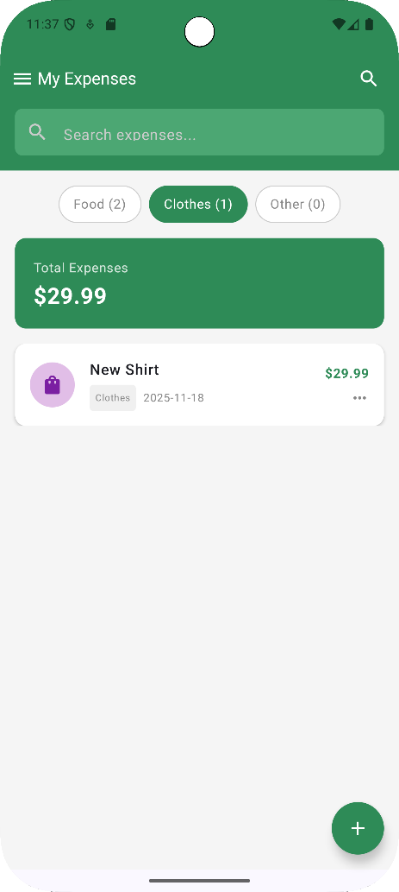
There are 3 expense management pages in the system for maintaining expenses for food, clothes and other expenses. They allow the user to view, add, update or delete the expenses for different expense categories. The Add expense page allows the user to enter expense details.

Dashboards
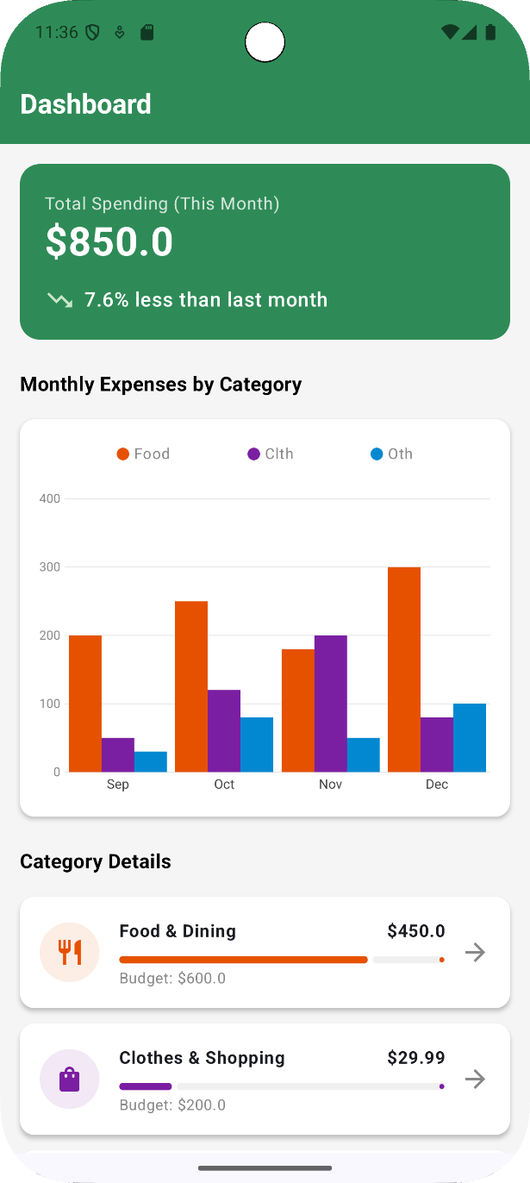

The dashboard provides the user with insights into all the transactions made for the current and previous months. It will show the spendings for the current month and how much more or less that the user has spent compared to the past month, and data like spending trends, monthly spending according to different expense categories, etc.

GitHub Repository
https://github.com/vidura-95/Smart_Expense.git

