Robotics Mini Project: Kinematic Analysis of a Robot Arm

Team Members:

|  |  |
| --- | --- |
| W.M.J.C. Kumara | 190328V |
| B.S.V.W. Munasinghe | 190397E |
| R.M.C.D.H. Ranasinghe | 190498N |

## **Frame Assignment and DH Table**

|  |  |  |  |  |
| --- | --- | --- | --- | --- |
| Link |  |  |  |  |
| 1 |  | 90⁰ |  |  |
| 2 |  | 0 | 0 |  |
| 3 |  | 0 | 0 |  |
| 4 |  | 0 | 0 |  |

## **Forward Kinematics**

* Symbols have the following meanings.
* Transformation Matrices

## **Inverse Kinematics**

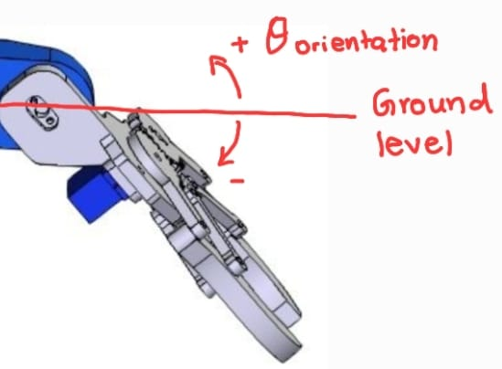Take the desired end position as .

Take the desired end effector orientation as and we get,

Using the geometric relationship, we can take,

Using the transformation matrix and desired position ,

or

and

Solving the above two equations we get,

When ,

When ,

Finally, we solve for , Knowing that is the addition of all

* The solutions are filtered to obtain only one solution by considering the range of the physical joints of the arm. (Each joint is limited to rotate only 180 degrees)
* The limits for the angles defined by our team are as follows. (Convention is the same as used in the frame assignment)

|  |  |  |
| --- | --- | --- |
| Angle | Minimum | Maximum |
|  | 0⁰ | 180⁰ |
|  | 0⁰ | 180⁰ |
|  | -135⁰ | 0⁰ |
|  | -90⁰ | 90⁰ |

## **Manipulator Jacobian**

## **Controlling the Arm**

* We have designed an interface to control the robot arm’s joints using python. We can use either forward kinematics or inverse kinematics.
* 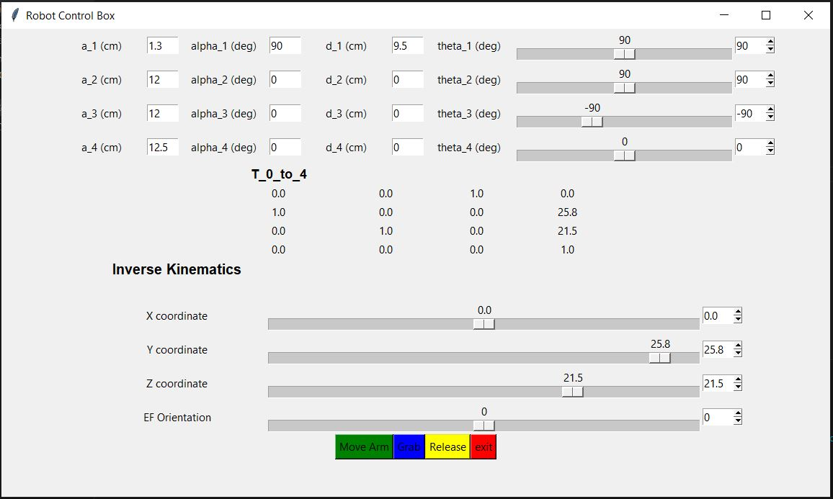The set angles are sent to the Arduino board to move the servo motors.

Set the DH parameters of the arm and control each angle independently

Set the desired position and orientation of the end effector to move the arm

* For the angle movement, we obtained a generalized trajectory equation in joint space. The parameters for the equation are change of angle and desired time frame **T.**

|  |  |  |
| --- | --- | --- |
| Time | angle | velocity |
| t=0 | 0 | 0 |
| t=T |  | 0 |

* Solving the equation for boundary conditions, we get,
* When an angle change is present, the trajectory points for each joint is calculate within a time loop which lasts for a time frame of **T**. Then the calculated angles are written to motors at each time step.