SE2030 – Software Engineering
BSc (Hons) in Information Technology · Year 2 Semester 1 · 2026
WebTourGuide
Web-Based Tour Booking and Guide Platform for Sri Lanka
Final Report
Member name | Student ID | GitHub | Major function
[Member name] | [IT number] | vidusewofficial | User & Authentication, Destination Management
[Member name] | [IT number] | jiyoshansj-art | Tour Package Management
[Member name] | [IT number] | madanayakebn | Tour Guide Management
[Member name] | [IT number] | MedawalaRMWD | Booking Management
[Member name] | [IT number] | NeranjanaHMI | Trip Planning Management
[Member name] | [IT number] | AponsuLASK | Customer Support Management

Item | Details
Group ID | [Insert Group ID]
Module | SE2030 – Software Engineering
Submission | Final Report (Week 13)
Submission date | [Insert submission date]

Table of Contents
2. Introduction 3
2.1 Project Overview 3
2.2 Objectives 3
2.3 Target Users and Stakeholders 3
2.4 Scope and Limitations 3
3. Requirements 5
3.1 Functional Requirements 5
3.2 Non-Functional Requirements 5
3.3 Constraints and Assumptions 6
4. Design 7
4.1 System Architecture 7
4.2 Use Case Diagram 7
4.3 Class Diagram 8
4.4 Database Design / ER Diagram 9
4.5 User Interface Design 10
5. Implementation 11
5.1 Tools and Technologies 11
5.2 Key Features Developed 11
5.3 Design Patterns Applied 11
5.4 Validation and Testing 12
5.5 Screenshots of Core Functions 12
6. Project Management 13
6.1 Agile Approach and Sprint Summary 13
6.2 Task Distribution 13
6.3 Development Timeline 14
7. Conclusion and Future Work 15
7.1 Summary of Achievements 15
7.2 Challenges Faced 15
7.3 Suggestions for Improvement 15
8. Individual Contribution, Teamwork and Lessons Learned 16
9. References 17
10. Appendix 18
A. Source Code 18
B. Activity Diagrams 18
C. Ethical Considerations (summary) 18

2. Introduction

2.1 Project Overview
WebTourGuide is a full-stack web application that brings tourist destinations, tour packages, licensed tour guides, bookings, trip planning and customer support for Sri Lanka into a single platform. Today tourists rely on scattered social-media pages, phone calls and printed brochures to plan a trip, and small tour operators have no shared channel to reach them. WebTourGuide replaces this with one role-based system.
The system is built as a Java 17 Spring Boot REST API backed by a MySQL 8.0 database, with a React single-page frontend. Access is secured with JSON Web Tokens (JWT) and role-based authorisation for four user roles: Tourist, Tour Guide, Staff and Admin.

2.2 Objectives
- Give tourists one place to browse destinations, packages and guides, with search, filtering, sorting and side-by-side comparison.
- Let tourists book packages and guides online and track each booking through its lifecycle (Pending, Confirmed, Rescheduled, Completed, Cancelled).
- Let tourists build day-by-day trip itineraries linked to real destinations, and export them as text, CSV or calendar files.
- Give Staff and Admin tools to manage content, bookings, guide applications and support tickets from one back office.
- Provide a structured, auditable process for vetting tourists who apply to become tour guides.
- Protect personal data with hashed passwords, JWT authentication and role-based access control on every endpoint.

2.3 Target Users and Stakeholders
Stakeholder | Description and interaction with the system
Tourist | Main end user. Registers, browses destinations, packages and guides, makes bookings, plans trips, raises support tickets and may apply to become a guide.
Tour Guide | A tourist account promoted after an approved application. Manages its own profile, languages, skills, certifications, location and availability.
Staff | Back-office employee. Manages destinations, packages and bookings, reviews guide applications and resolves support tickets.
Admin | Has every Staff capability, plus user account management, final approval of guide applications and deletion of destinations.
Tour operators (indirect) | Businesses whose packages and guides gain online visibility through the platform.

2.4 Scope and Limitations
In scope:
- User registration, login and role-based access (Tourist, Tour Guide, Staff, Admin).
- Destination management with category, location, coordinates and image gallery.
- Tour package management linked to destinations, with search, sorting and comparison.
- Tour guide profiles, availability, ranking and the guide application and approval workflow.
- Booking management covering create, confirm, reschedule, complete and cancel.
- Trip planning with day-by-day items and export to plain text, CSV and calendar (.ics).
- Customer support tickets linked to bookings, with a staff queue.
- Admin user management (list, view, update, deactivate).
Out of scope: online payment processing, real-time chat between tourists and guides, native mobile applications, live map navigation, email/SMS notifications and a multi-language user interface. These are discussed under Future Work.

3. Requirements

3.1 Functional Requirements
ID | Module | Requirement
FR1 | User & Auth | The system shall let visitors register with name, email, phone and password, and log in to receive a JWT.
FR2 | User & Auth | The system shall restrict every protected endpoint by role (Tourist, Tour Guide, Staff, Admin).
FR3 | User & Auth | Admin shall be able to list, view, update and deactivate user accounts.
FR4 | Destinations | Staff and Admin shall create and edit destinations; only Admin shall delete them.
FR5 | Destinations | Any visitor shall search destinations by name, category, location or any field.
FR6 | Destinations | The system shall block deleting a destination still referenced by packages or trip items.
FR7 | Tour Packages | Staff and Admin shall create, update and deactivate packages linked to a destination.
FR8 | Tour Packages | Visitors shall search, sort (price, duration, newest) and compare packages.
FR9 | Tour Guides | Tour Guides shall edit their own profile and toggle availability; Admin may edit any profile.
FR10 | Tour Guides | Visitors shall search guides by skill, language and location, ranked by rating, experience or languages.
FR11 | Guide Applications | Tourists shall apply to become guides; Staff review and Admin approve or reject with a note.
FR12 | Guide Applications | Approval shall promote the user to TOUR_GUIDE and create the linked guide profile.
FR13 | Bookings | Tourists shall book a package, optionally with a specific guide, for a future date and party size.
FR14 | Bookings | Staff and Admin shall confirm, reschedule, complete or cancel bookings; tourists see only their own.
FR15 | Trip Planning | Tourists shall create, edit and delete trip plans with day-by-day items linked to destinations.
FR16 | Trip Planning | Tourists shall export a trip plan as plain text, CSV or an iCalendar (.ics) file.
FR17 | Support | Tourists shall raise inquiry, complaint, cancellation or reschedule tickets, optionally linked to a booking.
FR18 | Support | Staff shall work a ticket queue; resolving a cancellation ticket shall cancel the linked booking.

3.2 Non-Functional Requirements
Quality | Requirement and how it is met
Security | Passwords are stored only as BCrypt hashes. Every protected request carries a JWT validated by JwtAuthFilter, and @PreAuthorize enforces role checks on controllers. Services also enforce ownership (a tourist cannot read another tourist's bookings or tickets).
Data validity | Bean Validation annotations (@NotBlank, @Size, @Email, @Min, @FutureOrPresent, @DecimalMin and others, over 60 in total) reject invalid input before it reaches the database. Matching checks run in the React forms.
Performance | Public listing pages respond within 2 seconds for typical data volumes. An index on tour_guides.is_available speeds up guide search, and open-in-view is disabled to avoid lazy-loading overhead.
Usability | A consistent React UI with navigation by role, loading and error states, and role="alert"/role="status" feedback banners on forms.
Reliability | A GlobalExceptionHandler returns consistent JSON errors (400, 403, 404) instead of stack traces. Cascading deletes keep trip items consistent with their plan.
Maintainability | Layered architecture (Controller, Service, Repository, DTO) per module, and Strategy, State and Observer patterns isolate behaviour that changes.
Portability | Runs on any OS with Java 17, Node.js and MySQL 8. A separate application-prod.properties profile supports deployment.

3.3 Constraints and Assumptions
- Users access the system through a modern desktop or mobile web browser with an internet connection.
- The backend requires Java 17 and a MySQL 8.0 server; the frontend requires Node.js to build.
- Payments are agreed offline; the system records booking prices but does not process payments.
- Uploaded images are limited to 10 MB per file and stored on the server's local file system.
- Guide ratings are entered by Staff/Admin; the system does not yet collect tourist reviews.
- The project was delivered by a team of six within one semester (Weeks 3 to 13), which limited scope.

4. Design

4.1 System Architecture
WebTourGuide follows a three-tier client–server architecture. The React frontend calls the Spring Boot REST API through Axios; the API applies security, business rules and persistence through Spring Data JPA to MySQL. Each business module (user, destination, tourpackage, tourguide, guideapplication, booking, tripplan, support) has its own entity, repository, service, controller and DTO classes.
Tier | Components
Presentation | React SPA (Vite), React Router routes, ProtectedRoute for role-guarded pages, Axios API helpers per module
Application | Spring Boot REST controllers → services → repositories; JwtAuthFilter and SecurityFilterChain; GlobalExceptionHandler
Data | MySQL 8.0 database webtourguide_db with 11 tables
Request flow: Browser → JwtAuthFilter → SecurityFilterChain → Controller → Service → Repository → MySQL.

4.2 Use Case Diagram
Four actors use the system. Tourist and Tour Guide are separate account roles; Admin generalises Staff, so every Staff use case is also available to Admin, while Manage User Accounts is reserved for Admin. This matches the @PreAuthorize rules in the code.
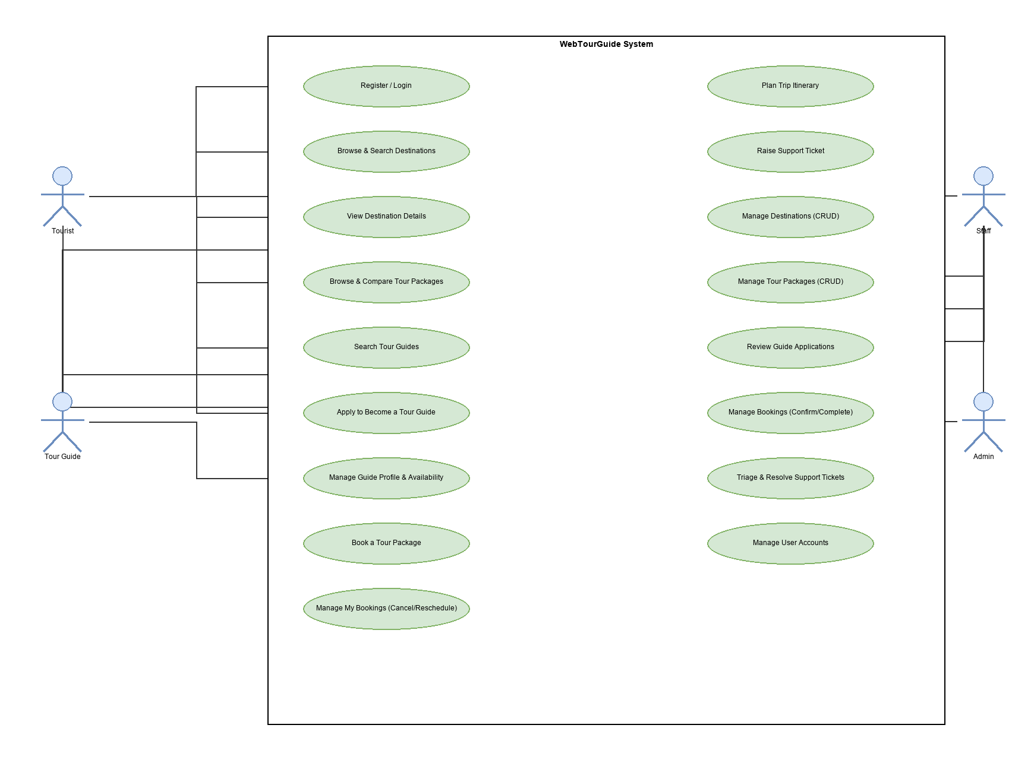
Figure 1 – Use case diagram of WebTourGuide

4.3 Class Diagram
User is the root of the domain model. It has an optional one-to-one TourGuide profile and one-to-many links to the destinations it creates, and to its bookings, trip plans, guide applications and support tickets. TripPlan composes TripPlanItem (cascade and orphan removal). A booking optionally references a package and a guide, and a support ticket optionally references a booking.
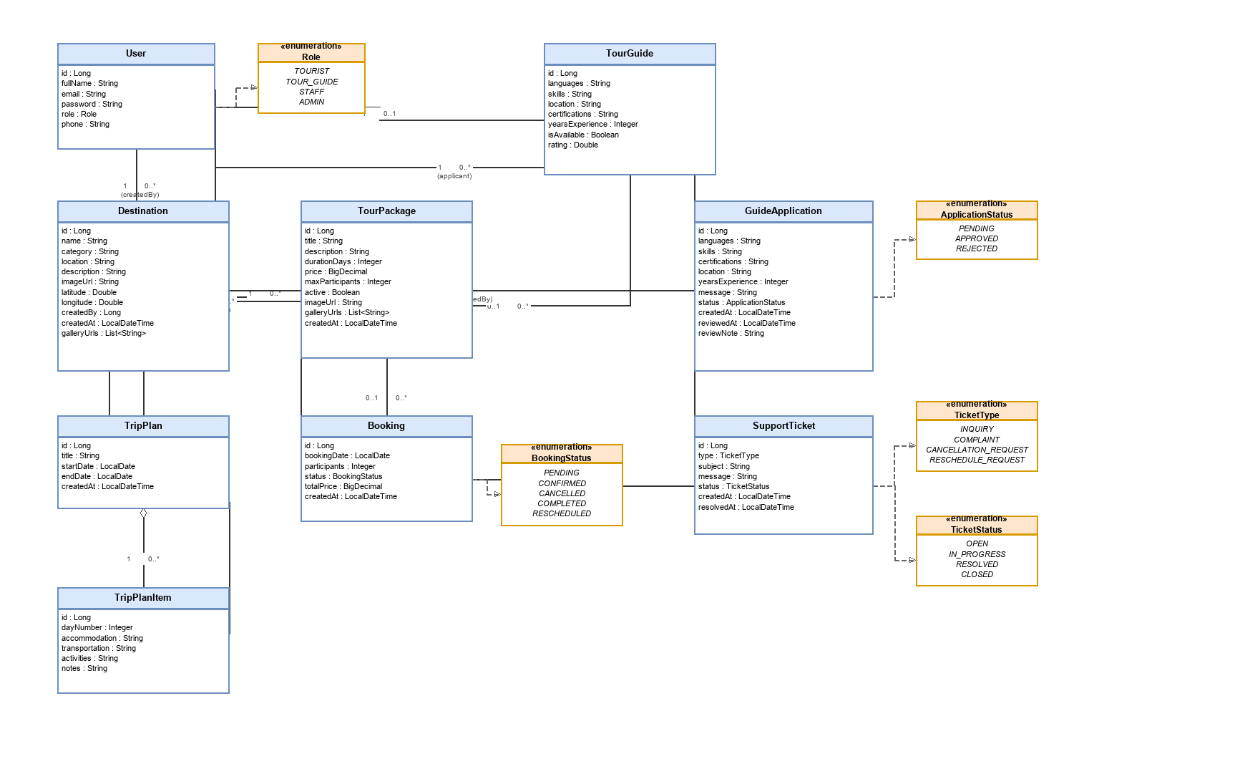
Figure 2 – Class diagram of the core domain model

4.4 Database Design / ER Diagram
The database contains 11 tables. Nine core entities are shown below; destination_gallery and tour_package_gallery are image collection tables owned by destinations and tour_packages. Enumerated columns hold user roles (TOURIST, TOUR_GUIDE, STAFF, ADMIN), booking status, application status, ticket type and ticket status.
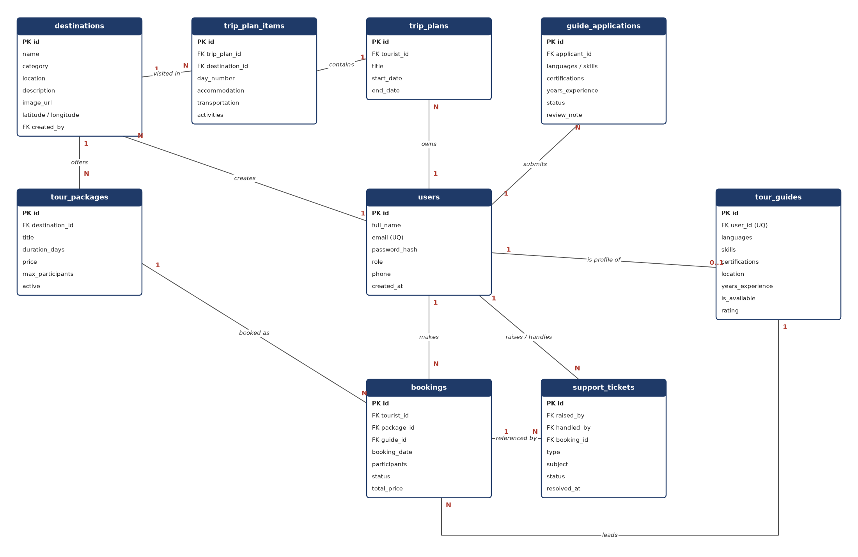
Figure 3 – Entity-relationship diagram (from database/schema.sql)
Relationship | Cardinality | Rule
users – tour_guides | 1 : 0..1 | user_id is UNIQUE; created when a guide application is approved
destinations – tour_packages | 1 : N | Every package belongs to one destination
users – bookings | 1 : N | A tourist makes many bookings
tour_packages / tour_guides – bookings | 1 : N | Both foreign keys are optional
bookings – support_tickets | 1 : N | Optional; used for cancellation and reschedule requests
trip_plans – trip_plan_items | 1 : N | ON DELETE CASCADE
destination_gallery, tour_package_gallery | 1 : N | ON DELETE CASCADE

4.5 User Interface Design
The frontend has 25 pages grouped by module. Navigation links appear according to the logged-in role, and admin pages are wrapped in a ProtectedRoute that redirects unauthorised users to the login page.
Module | Screens | Description
Home & Auth | Home, Services, Login/Register | Landing page with featured content; combined auth page
Destinations | List, Detail, Admin Form | Searchable card grid, detail with gallery, create/edit form
Tour Packages | List, Detail, Compare, Admin Form | Sort and filter packages, compare side by side
Tour Guides | List, Profile, Edit, Create, Apply | Guide search and ranking, self-edit, guide application
Bookings | New Booking, My Bookings, All Bookings | Booking form, tourist history, staff dashboard with status filters
Trip Planner | My Trips, Trip Editor | Day-by-day itinerary editor with destination dropdown and export
Support | New Ticket, My Tickets, Staff Queue | Raise and track tickets; staff triage queue
Admin | User Management, Guide Applications | Account administration and application review
[Insert screenshot: Home page and destination list]
Figure 4 – Home and destination list screens
[Insert screenshot: Trip editor and booking dashboard]
Figure 5 – Trip editor and booking dashboard

5. Implementation

5.1 Tools and Technologies
Area | Technology
Backend language & framework | Java 17, Spring Boot 4.1 (Web MVC, Data JPA, Security, Validation)
Authentication | JJWT 0.11.5 (JSON Web Tokens), BCrypt password hashing
Database | MySQL 8.0, Hibernate ORM, MySQL Connector/J
Frontend | React 19, Vite 8, React Router 7, Axios, Framer Motion
Build & quality | Maven, npm, Lombok, oxlint
Testing | JUnit 5, Mockito, Spring Boot Test (MockMvc), Postman collections
IDEs & tools | IntelliJ IDEA, Visual Studio Code, MySQL Workbench/Shell, draw.io, Git and GitHub

5.2 Key Features Developed
Module | Implemented features
User & Auth | Register/login with JWT, role-based security, admin user management (list, update, deactivate)
Destination Management | CRUD, search by name/category/location/any field, image upload and gallery, delete protection
Tour Package Management | CRUD linked to destinations, sorting by price/duration/newest, comparison page
Tour Guide Management | Profiles, availability toggle, search and ranking, guide application and approval workflow
Booking Management | Create, confirm, reschedule, complete, cancel; tourist and staff dashboards with filters
Trip Planning | Trip plans with day items, destination dropdown, export to text, CSV and iCalendar
Customer Support | Ticket types and lifecycle, staff queue, auto-assignment, booking auto-cancellation, audit log

5.3 Design Patterns Applied
Pattern | Where | Why
Strategy | destination/search (Name, Category, Location, AnyField) | Swap search behaviour per request without if/else chains in DestinationService
Strategy | tourpackage/sorting (Price ↑/↓, Shortest, Newest) | Add new sort orders without changing TourPackageService
Strategy | tourguide/ranking (Rating, Experience, LanguageCount) | Rank guide search results by the user's chosen criterion
Strategy | tripplan/export (PlainText, CSV, Calendar) | Each export format is one class used by TripPlanExporter
State | booking/state (Pending, Confirmed, Rescheduled, Completed, Cancelled) | Each state allows only valid transitions, so illegal status changes are rejected
Observer | support/observer (BookingCancellationObserver, TicketAuditLogObserver) | SupportTicketService notifies observers on status change; cancellation and audit logic stay decoupled

5.4 Validation and Testing
Inputs are validated on both sides: Bean Validation on every request DTO, and matching client-side checks in the React forms. Business rules (ownership checks, future booking dates, allowed status transitions) are enforced in the service layer and return clear 400, 403 or 404 responses.
The backend has 11 test classes with 72 JUnit test cases covering services, controllers, the booking state machine, ticket observers, trip export strategies and the search, sort and ranking strategies. Five Postman collections provide regression tests for the REST endpoints, including role and ownership checks.

5.5 Screenshots of Core Functions
[Insert screenshot: Package comparison]
Figure 6 – Comparing tour packages
[Insert screenshot: New booking form with validation messages]
Figure 7 – Booking form with input validation
[Insert screenshot: Staff support queue]
Figure 8 – Staff support ticket queue
[Insert screenshot: Admin guide application review]
Figure 9 – Guide application review

6. Project Management

6.1 Agile Approach and Sprint Summary
The team used Scrum with two-week sprints, delivering one module, or a closely related pair, per sprint. Each sprint started with planning from the product backlog, used short stand-ups to track progress, and ended with a review demo and merge into the main branch. Work was tracked on feature branches (for example feature/destination-management) and integrated through pull requests.
Sprint | Focus | Key deliverables | Status
1 | Foundation & Authentication | Spring Boot and React scaffold, full MySQL schema, JWT register/login, global exception handling | Done
2 | Destination Management | Destination CRUD, list/detail/admin pages, role restrictions, Postman tests | Done
3 | Tour Packages & Tour Guides | Package CRUD and comparison, guide profiles, availability index, guide search | Done
4 | Booking Management | Booking lifecycle endpoints, New Booking, My Bookings and All Bookings dashboards | Done
5 | Trip Planning | TripPlan/TripPlanItem with cascade, My Trips and Trip Editor pages, tests | Done
6 | Customer Support | Ticket lifecycle linked to bookings, auto-cancel, Staff Queue, tests | Done
7 | Integration & Guide Applications | Guide application workflow, admin user management, cross-module links, design patterns | Done
8 | Hardening & Final Delivery | Expanded tests, validation and UI polish, production profile, documentation | Done

6.2 Task Distribution
Member | Major function | Main responsibilities
[Name] (vidusewofficial) | User & Auth, Destinations | Security and JWT, user and admin user management, destination module, destination search strategy, integration and documentation
[Name] (jiyoshansj-art) | Tour Packages | Package entity and API, package list/detail/compare/admin pages, sorting strategy
[Name] (madanayakebn) | Tour Guides | Guide profiles and availability, guide pages, ranking strategy, guide application UI
[Name] (MedawalaRMWD) | Bookings | Booking lifecycle API, booking state pattern, booking dashboards
[Name] (NeranjanaHMI) | Trip Planning | Trip plan and item API, trip editor pages, export strategy
[Name] (AponsuLASK) | Customer Support | Ticket API and lifecycle, observer pattern, ticket and staff queue pages
Responsibilities are taken from each member's commit history; please confirm before submission.

6.3 Development Timeline
Week | Milestone
Week 3 | Proposal presentation and proposal report submitted
Weeks 4–5 | Requirements refined, schema and architecture designed, Sprint 1
Weeks 5–9 | Sprints 2–6: module development and per-module testing
Week 10 | Progress presentation (75% complete) and design document submitted
Weeks 10–12 | Sprints 7–8: integration, guide applications, design patterns, testing and polish
Week 13 | Final presentation, viva and final report submission

7. Conclusion and Future Work

7.1 Summary of Achievements
The team delivered a working, integrated web platform covering all six major functions: destinations, tour packages, tour guides, bookings, trip planning and customer support. It also includes user and admin management and a guide application workflow. All modules support full CRUD with validation, connect to a single MySQL database and are secured with JWT and role-based access. Six design pattern applications (four Strategy, one State, one Observer) keep changeable behaviour isolated, and 72 automated tests plus Postman suites support regression testing.

7.2 Challenges Faced
- Cross-module integration: bookings, tickets, guides and trip plans reference each other, so changes in one module broke others. This was solved with shared DTOs, clear service boundaries and regression tests.
- Security and ownership: role checks alone did not stop a tourist reading another tourist's data. Ownership checks were added in the service layer.
- Booking status rules: status changes were scattered in if/else blocks. These were replaced with the State pattern so only valid transitions are allowed.
- Merge conflicts and coordination: six members worked in parallel, which caused conflicts. These were reduced with feature branches, pull requests and module ownership.

7.3 Suggestions for Improvement
- Integrate an online payment gateway for bookings.
- Add email and SMS notifications for booking and ticket updates.
- Let tourists rate and review guides and packages after a completed booking.
- Add map-based destination discovery and route planning.
- Provide multi-language support (Sinhala, Tamil, English) and a mobile app.
- Deploy to the cloud with CI/CD, and define a data retention policy for closed bookings and tickets.

8. Individual Contribution, Teamwork and Lessons Learned
The table below summarises each member's role, the main challenges they faced, how they overcame them, and what they learned from the project.
Member | Role | Challenges faced | How overcome | Lessons learned & reflection
Sewmika K.B.V.V  IT25101994 | User & Authentication, Destination Management | Securing the system so tourists, guides and admins could only reach their own data and endpoints. Keeping destination data consistent, because packages and trip plans used free-text destination names. | Set up Spring Security with a JWT filter and role-based rules, and added ownership checks in the service layer. Replaced free-text destination fields with a dropdown loaded from the destination API, and built destination search using the Strategy pattern. | I learned how stateless JWT authentication works and that security has to be planned from the start, not added at the end. Handling integration and documentation taught me to announce API changes early so other members are not blocked.
Jiyoshan S.J  IT25103990 | Tour Package Management | Linking packages to destinations and guides, and building a compare page for packages with different structures. Supporting several sort orders without making the controller complex. | Used DTOs so the frontend received only the fields it needed. Implemented sorting with the Strategy pattern, so a new sort option is one new class with no controller changes. | I saw how design patterns make code easier to extend. I also got better at designing clean REST endpoints and at reviewing other members' pull requests.
Madanayaka B.N  IT25104063 | Tour Guide Management | Managing guide availability so a guide is not double-booked. Ranking guides fairly when they have different experience and language skills. | Checked availability against confirmed bookings in the service layer. Built a ranking strategy that combines experience, languages and rating, and agreed the shared rules with the Bookings module owner. | Agreeing the contract with other module owners before coding saves rework. I also learned to test edge cases such as overlapping dates.
Medawela R.M.W.D  IT25102912 | Booking Management | Booking status changes were spread across if/else blocks, which allowed invalid transitions such as cancelling a completed booking. | Applied the State pattern so each booking state defines its own allowed transitions. Added validation for dates and traveller counts and wrote tests for each transition. | The State pattern made complex business rules much easier to read and change. Since bookings connect to most other modules, I learned to communicate breaking changes clearly.
Neranjana H.M.I  IT25101978 | Trip Planning Management | The trip editor manages many related items (days, activities and destinations), and keeping it in sync with the API was difficult. Supporting more than one export format was also a challenge. | Split the API into separate trip plan and trip item endpoints, and loaded the destination list into the editor. Implemented exporting with the Strategy pattern so each format is handled separately. | I learned to break a large UI into smaller components and to integrate a frontend with a backend API step by step. Planning my tasks per sprint helped me manage my time.
Aponsu L.A.S.K  IT25101084 | Customer Support Management | Notifying the right people whenever a ticket's status changed. Designing a clear ticket lifecycle and a staff queue that was easy to manage. | Used the Observer pattern so listeners react to ticket events without coupling the ticket service to them. Defined clear lifecycle states and built a staff queue page filtered by status. | I learned the value of loose coupling and of designing features around the end user. Writing clear documentation also made it easier for teammates to use my API.
Teamwork
- Module ownership: each member owned one major function end to end (entity, API and pages), which gave clear responsibility and fewer overlaps.
- Branches and pull requests: every feature was built on its own Git branch and merged into main only after a pull request review.
- Regular communication: weekly progress meetings and a group chat for daily updates helped us raise blockers early.
- Shared conventions: we agreed on DTOs, error responses and API naming early, and documented them in the API reference.
- Joint integration testing: before each sprint review we tested the modules together and fixed cross-module bugs as a team.

9. References
[1] I. Sommerville, Software Engineering, 10th ed. Boston, MA, USA: Pearson, 2016.
[2] E. Gamma, R. Helm, R. Johnson, and J. Vlissides, Design Patterns: Elements of Reusable Object-Oriented Software. Reading, MA, USA: Addison-Wesley, 1994.
[3] K. Schwaber and J. Sutherland, "The Scrum Guide," Scrum.org, Nov. 2020. [Online]. Available: https://scrumguides.org/scrum-guide.html
[4] VMware Tanzu, "Spring Boot Reference Documentation." [Online]. Available: https://docs.spring.io/spring-boot/
[5] VMware Tanzu, "Spring Security Reference." [Online]. Available: https://docs.spring.io/spring-security/reference/
[6] Oracle, "MySQL 8.0 Reference Manual." [Online]. Available: https://dev.mysql.com/doc/refman/8.0/en/
[7] Meta Platforms, "React Documentation." [Online]. Available: https://react.dev/
[8] Vite, "Vite Guide." [Online]. Available: https://vite.dev/guide/
[9] Remix Software, "React Router Documentation." [Online]. Available: https://reactrouter.com/
[10] Axios, "Axios Documentation." [Online]. Available: https://axios-http.com/docs/intro
[11] JJWT, "Java JWT: JSON Web Token for Java and Android." GitHub. [Online]. Available: https://github.com/jwtk/jjwt
[12] Hibernate, "Hibernate Validator Reference Guide." [Online]. Available: https://hibernate.org/validator/documentation/
[13] Postman, "Postman Learning Center." [Online]. Available: https://learning.postman.com/
[14] JGraph, "draw.io Documentation." [Online]. Available: https://www.drawio.com/doc/

10. Appendix

A. Source Code
GitHub repository: [Insert repository link] (access granted to the module lecturers).

B. Activity Diagrams
One activity diagram per major function was submitted with the Week 10 Design Document. The editable sources are in SE_Project/diagrams of the repository:
- 03 – Book a Tour Package
- 04 – Guide Application and Approval
- 05 – Plan a Trip Itinerary
- 06 – Raise and Resolve a Support Ticket
- 07 – Manage Destinations

C. Ethical Considerations (summary)
- Data privacy: passwords stored only as hashes; personal data role-gated end to end; location data kept at city/area level.
- Consent and transparency: guide applications are opt-in; users are told before a cancellation ticket automatically cancels a booking.
- Accessibility: ARIA alert/status roles on forms, keyboard navigation and sufficient colour contrast.
- Fairness: structured guide vetting criteria and a mandatory review note on rejection.
- AI use: AI tools were used for learning and documentation support only; all work was reviewed and can be explained by its authors.

