BSc (Hons) in Information Technology
IT2020 – Software Engineering | Year 2, Semester 1, 2025
Lab 06 – Design Patterns
Group Project Report
WebTourGuide
Tour Booking & Guide Platform
Item | Details
Group ID | Y2-S1-MLB-B2G2-03
Project | WebTourGuide
Patterns applied | Strategy, State, Observer
Technology | Java 17, Spring Boot, React
Submission date | [Insert date]

Contents
1. Group Details 2
2. Design Pattern(s) Used 3
2.1 Pattern Roles in Our Code 3
2.2 Pattern Summaries 4
3. Justification for Each Pattern 5
3.1 Strategy – Destination Search (Destination Management) 5
3.2 Strategy – Tour Package Sorting (Tour Package Management) 5
3.3 Strategy – Tour Guide Ranking (Tour Guide Management) 5
3.4 Strategy – Trip Plan Export (Trip Planning Management) 6
3.5 State – Booking Lifecycle (Booking Management) 6
3.6 Observer – Support Ticket Status Changes (Customer Support Management) 7
3.7 Overall Benefits 8
4. Screenshots of Implementation 9
4.1 Strategy – Destination Search 9
4.2 Strategy – Tour Package Sorting 11
4.3 Strategy – Tour Guide Ranking 13
4.4 Strategy – Trip Plan Export 15
4.5 State – Booking Lifecycle 18
4.6 Observer – Support Ticket Status Changes 20
5. Code Files 22
5.1 Folder Structure 22
5.2 Class Roles 22
5.3 How to Run in NetBeans 23
5.4 Where the Patterns Live in the Web Application 23

1. Group Details
Group ID: Y2-S1-MLB-B2G2-03 Project: WebTourGuide – Tour Booking & Guide Platform
WebTourGuide is a web application where tourists browse destinations and tour packages, find and book tour guides, plan multi-day trips and raise support requests, while staff and administrators manage the catalogue, bookings and support queue. Each group member owned one module, and each module applies a design pattern (Section 2).
No. | Student Name | Student ID | Module Responsibility
1 | [Member name] | [IT number] | Destination Management
2 | [Member name] | [IT number] | Tour Package Management
3 | [Member name] | [IT number] | Tour Guide Management
4 | [Member name] | [IT number] | Booking Management
5 | [Member name] | [IT number] | Trip Planning Management
6 | [Member name] | [IT number] | Customer Support Management

2. Design Pattern(s) Used
Our team applied three behavioural design patterns across the six modules of WebTourGuide. The Strategy pattern is used four times, because four modules each need to choose between several interchangeable algorithms at runtime. The State pattern manages the booking lifecycle, and the Observer pattern connects Customer Support to Booking Management.
Pattern | Module | Applied to | Selected at runtime by
Strategy | Destination Management | Searching destinations by name, location, category or any field | GET /api/destinations/search?by=
Strategy | Tour Package Management | Sorting packages by price (low/high), duration or newest | GET /api/packages?sort=
Strategy | Tour Guide Management | Ranking guides by rating, experience or number of languages | GET /api/guides/ranked?by=
Strategy | Trip Planning Management | Exporting a trip plan as plain text, CSV or iCalendar (.ics) | GET /api/trip-plans/{id}/export?format=
State | Booking Management | Booking lifecycle: Pending, Confirmed, Rescheduled, Completed, Cancelled | The booking's current status
Observer | Customer Support Management | Reacting to support-ticket status changes (audit log, auto-cancel booking) | Every ticket status update

2.1 Pattern Roles in Our Code
Each pattern is implemented with the standard roles. The class names below are the same in the WebTourGuide web application and in the standalone demo project submitted with this report.
Use | Interface | Context / Subject | Concrete classes
Destination search | DestinationSearchStrategy | DestinationSearchContext | NameSearchStrategy, LocationSearchStrategy, CategorySearchStrategy, AnyFieldSearchStrategy
Package sorting | PackageSortStrategy | PackageSortContext | PriceLowToHighSort, PriceHighToLowSort, ShortestDurationSort, NewestFirstSort
Guide ranking | GuideRankingStrategy | GuideRankingContext | RatingRankingStrategy, ExperienceRankingStrategy, LanguageCountRankingStrategy
Trip plan export | TripPlanExportStrategy | TripPlanExporter | PlainTextExportStrategy, CsvExportStrategy, CalendarExportStrategy
Booking lifecycle | BookingState | Booking | PendingState, ConfirmedState, RescheduledState, CompletedState, CancelledState
Ticket status | TicketStatusObserver | SupportTicketService (subject) | TicketAuditLogObserver, BookingCancellationObserver

2.2 Pattern Summaries
Strategy defines a family of algorithms, puts each one in its own class behind a common interface, and lets a context object use any of them interchangeably. The algorithm can be swapped at runtime without changing the context.
State lets an object change its behaviour when its internal state changes. Each state is a class that decides which actions are allowed and what the next state is, replacing large conditional statements on a status field.
Observer defines a one-to-many dependency: when the subject changes, all registered observers are notified automatically. The subject only knows the observer interface, not what each observer does.

3. Justification for Each Pattern
For each use we describe the problem in WebTourGuide, why the chosen pattern fits it, and how it improved the design compared with the straightforward alternative.

3.1 Strategy – Destination Search (Destination Management)
Problem. Tourists search destinations in four different ways: by name, by location, by exact category, or by a keyword that may appear in any of those fields. A first version would put an if/else chain on the search type inside DestinationService, and every new search mode would mean editing and re-testing that method.
Why Strategy fits. The four searches are different algorithms for the same task ("find destinations for a keyword") and the user chooses one at runtime through the by parameter. This is exactly the situation the Strategy pattern targets.
How it improves the design.
- Open/Closed: a new search mode (for example, search by nearby coordinates) is a new class; DestinationService and the controller do not change.
- No conditional logic: the service looks up the strategy by its key and calls executeSearch(); there is no switch on the search type.
- Single Responsibility and testability: each strategy contains one query and is unit-tested on its own (DestinationSearchStrategyTest).

3.2 Strategy – Tour Package Sorting (Tour Package Management)
Problem. The package list can be ordered by lowest price, highest price, shortest duration or newest first. Hard-coding these orders in the service would mix presentation choices with business logic and make the list endpoint grow with every new ordering.
Why Strategy fits. Each ordering is an interchangeable algorithm, represented as a Comparator. The tourist selects it with ?sort= and the PackageSortContext applies whichever strategy it holds.
How it improves the design.
- New orderings (for example, "most popular") are added as one small class each.
- The context returns a new sorted list and never modifies the input, so the same data can be sorted several ways safely.
- Unknown sort keys are rejected with a clear error listing the allowed values, generated from the registered strategies.

3.3 Strategy – Tour Guide Ranking (Tour Guide Management)
Problem. Tourists want to see the "best" guides first, but "best" depends on what they care about: highest rating, most experience, or the most languages spoken. Each definition needs its own tie-breaking rules.
Why Strategy fits. Each ranking rule is a separate, interchangeable algorithm with its own tie-breakers. The GuideRankingContext ranks the guide list with whichever rule the tourist chose through /api/guides/ranked?by=.
How it improves the design.
- Ranking rules are isolated, so changing how experience ties are broken cannot affect the rating ranking.
- The same ranking can be combined with filters (for example, available guides only) without new code paths.
- Each rule is verified independently in GuideRankingStrategyTest.

3.4 Strategy – Trip Plan Export (Trip Planning Management)
Problem. A tourist can download their itinerary as a readable text file, as a CSV spreadsheet, or as an iCalendar (.ics) file that imports into Google Calendar or Outlook. The formats share no output logic and each needs its own file extension and content type.
Why Strategy fits. All three formats perform the same operation ("turn this trip plan into a file") in completely different ways, chosen by the user at download time.
How it improves the design.
- Each format, including its MIME type and file extension, is encapsulated in one class, so the controller simply asks the strategy for them.
- Adding a PDF export later requires only a new TripPlanExportStrategy implementation.
- Format-specific rules (CSV quoting, iCalendar escaping) stay out of TripPlanService.

3.5 State – Booking Lifecycle (Booking Management)
Problem. A booking moves through Pending, Confirmed, Rescheduled, Completed and Cancelled. Which actions are allowed depends on the current status: for example, a completed booking cannot be cancelled, and a rescheduled booking must be confirmed again. Implemented with conditionals, every action method in BookingService would repeat a switch on the status, and adding a status would mean editing all of them.
Why State fits. The booking's behaviour changes with its internal status, and the rules form a clear state machine. The State pattern models each status as its own class that allows only its valid transitions.
Current state | Allowed actions → next state | Rejected actions
Pending | confirm → Confirmed; reschedule → Rescheduled; cancel → Cancelled | complete
Confirmed | complete → Completed; reschedule → Rescheduled; cancel → Cancelled | confirm
Rescheduled | confirm → Confirmed; reschedule → Rescheduled (new date); cancel → Cancelled | complete
Completed | none (final state) | all actions
Cancelled | none (final state) | all actions

How it improves the design.
- Invalid transitions are rejected in one place: BookingState rejects every action by default, and each state overrides only what it allows.
- Booking and BookingService contain no status conditionals; they call booking.confirm(), booking.cancel() and so on.
- The lifecycle is easy to read and test: each state class is a few lines and maps directly to the table above (BookingStateTest).

3.6 Observer – Support Ticket Status Changes (Customer Support Management)
Problem. When staff change a support ticket's status, other parts of the system must react. Resolving a cancellation-request ticket must actually cancel the linked booking, and every status change should be written to an audit log. In the future we also want e-mail notifications. Putting all of this inside SupportTicketService.updateStatus() would tightly couple Customer Support to Booking Management and make the method grow with every new side effect.
Why Observer fits. One event (a status change) must trigger several independent reactions, and the set of reactions is expected to grow. The service acts as the subject and notifies every registered TicketStatusObserver.
How it improves the design.
- Loose coupling: the support service does not depend on booking logic; BookingCancellationObserver owns that rule.
- Extensibility: an e-mail notifier can be added as a new observer, and Spring registers it automatically, with no change to the service.
- Consistency: observers run before the ticket is saved, so if the booking cannot be cancelled, the ticket is not marked as resolved.

3.7 Overall Benefits
Design principle | How the patterns support it in WebTourGuide
Open/Closed Principle | New search modes, sort orders, ranking rules, export formats, booking states and ticket reactions are added as new classes without modifying existing ones.
Single Responsibility | Each strategy, state and observer class does one job; the services coordinate instead of containing every rule.
Composition over inheritance | Contexts hold a strategy reference and delegate to it, so behaviour can be swapped at runtime with setStrategy().
Loose coupling | Contexts and subjects depend only on interfaces, never on concrete classes.
Testability | Small, focused classes are covered by dedicated unit tests in the web project.

4. Screenshots of Implementation
The figures below show the key classes of each pattern (interface, a concrete class and the context or subject) and the console output of the demo program Main.java, run from the submitted WebTourGuidePatterns project. Package and import lines are omitted from the code screenshots for brevity.

4.1 Strategy – Destination Search
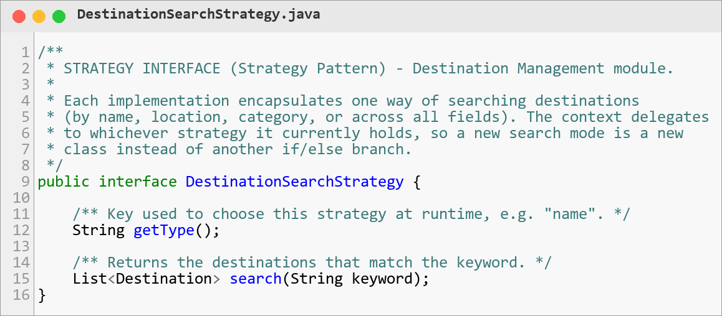
Figure 1: Strategy interface DestinationSearchStrategy
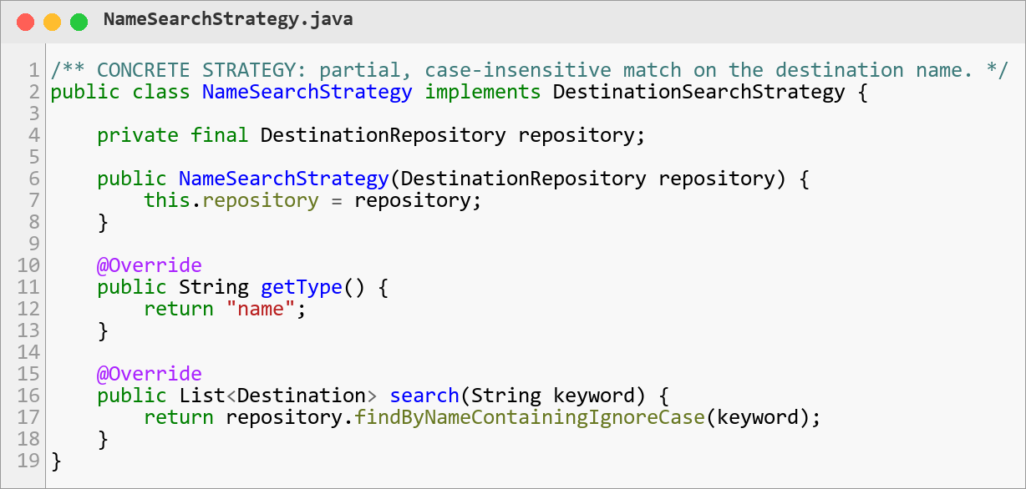
Figure 2: Concrete strategy NameSearchStrategy
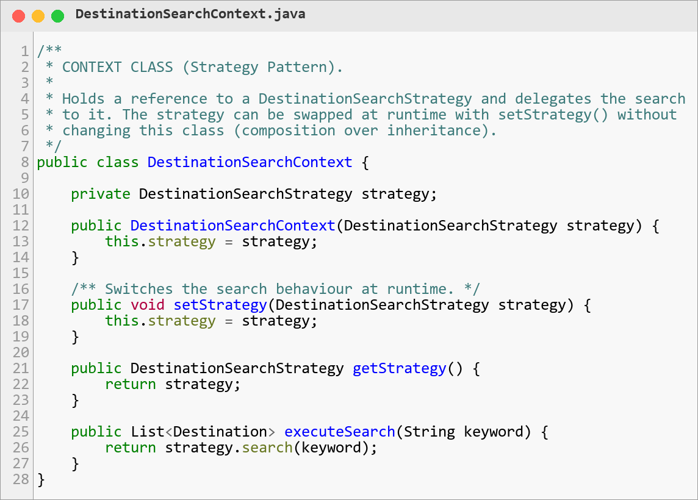
Figure 3: Context class DestinationSearchContext with setStrategy()
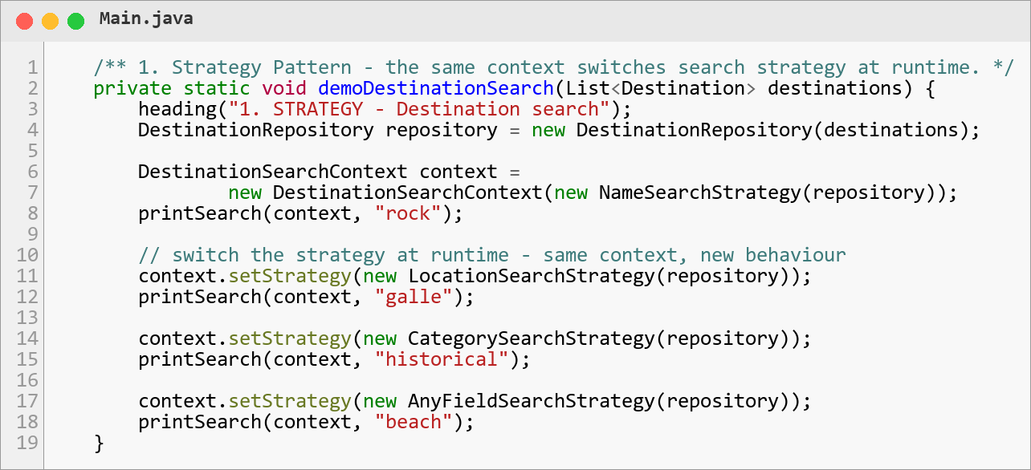
Figure 4: Main switching the search strategy at runtime
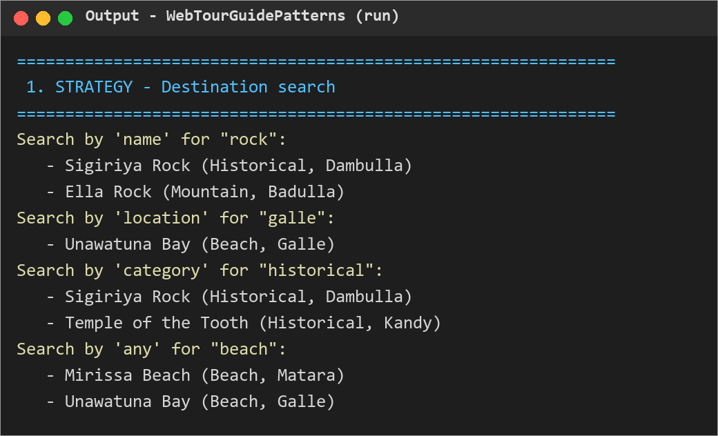
Figure 5: Output: the same context searching with four different strategies

4.2 Strategy – Tour Package Sorting
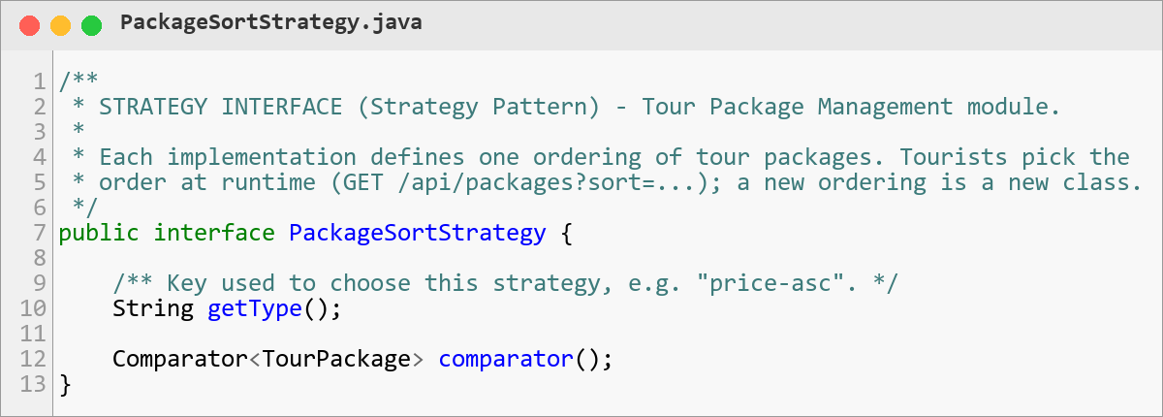
Figure 6: Strategy interface PackageSortStrategy
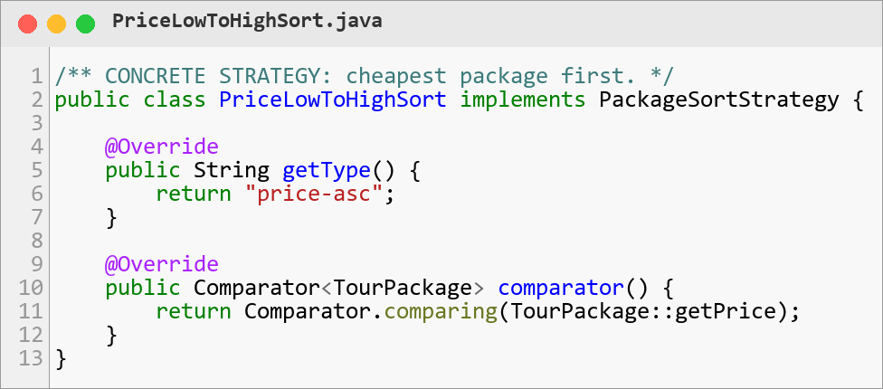
Figure 7: Concrete strategy PriceLowToHighSort
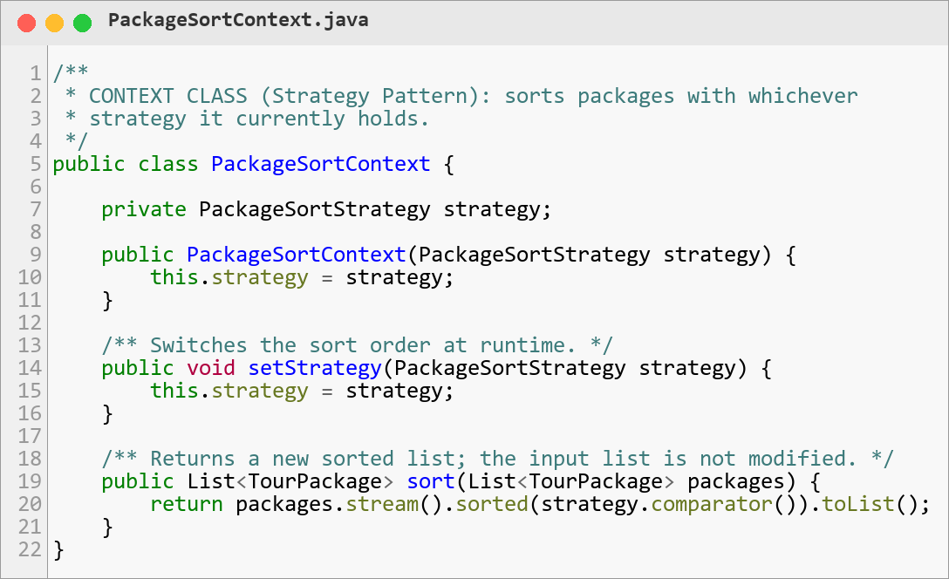
Figure 8: Context class PackageSortContext
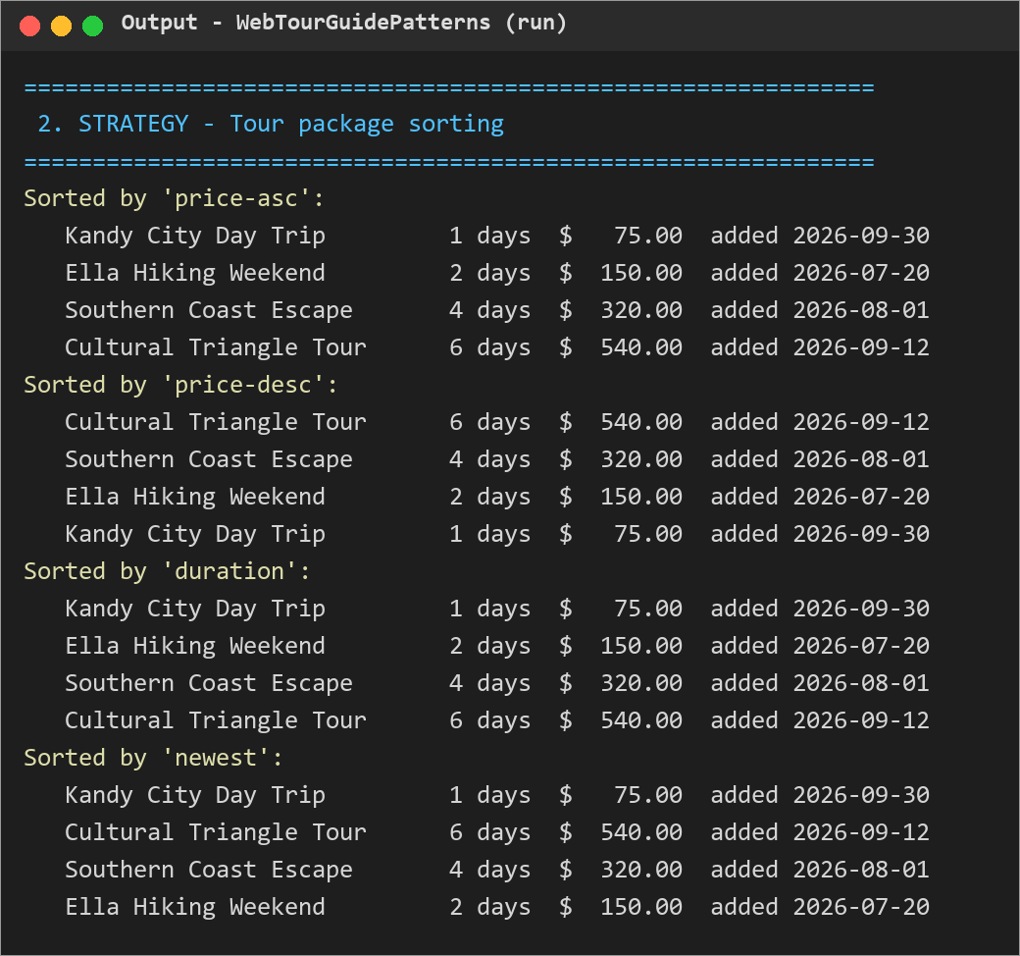
Figure 9: Output: one package list sorted by four strategies

4.3 Strategy – Tour Guide Ranking
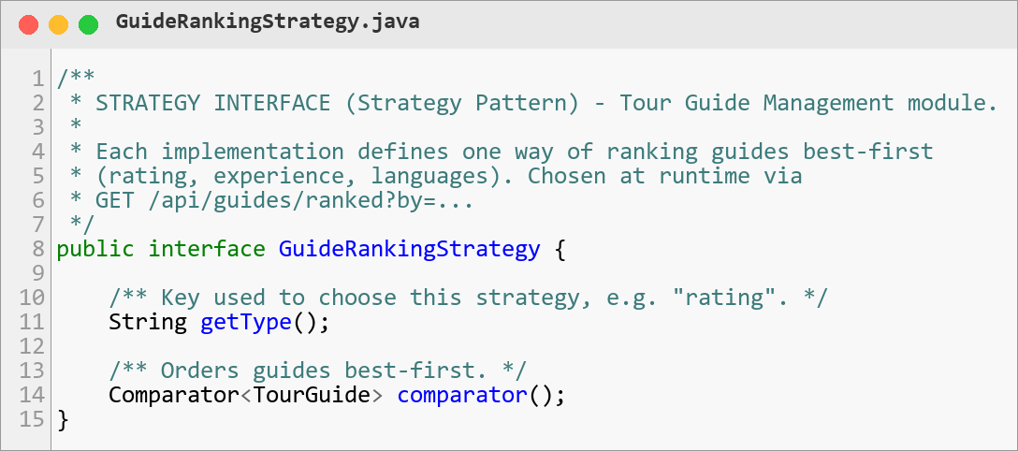
Figure 10: Strategy interface GuideRankingStrategy
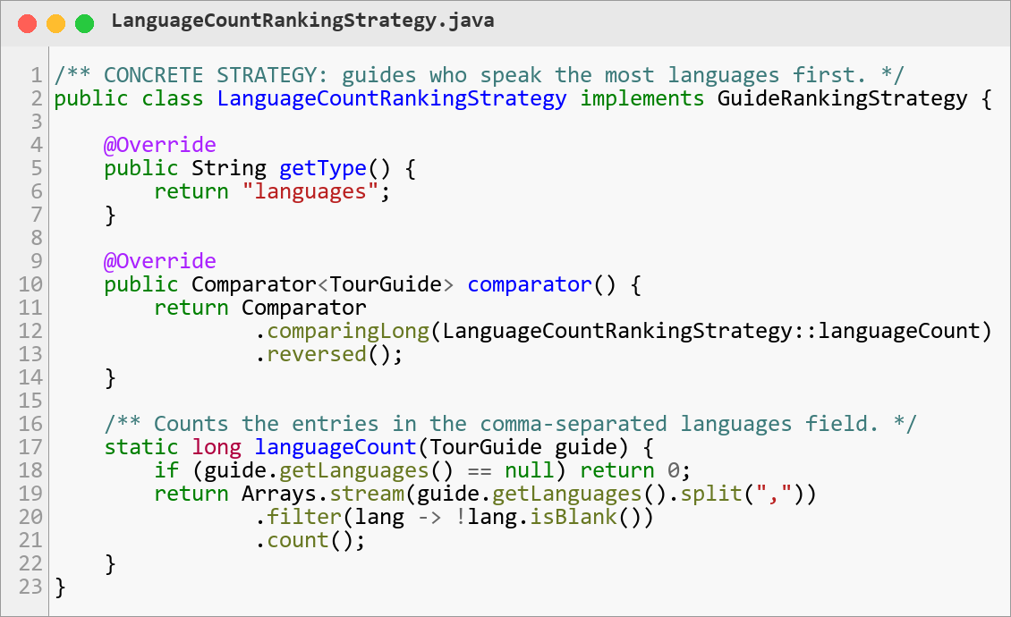
Figure 11: Concrete strategy LanguageCountRankingStrategy
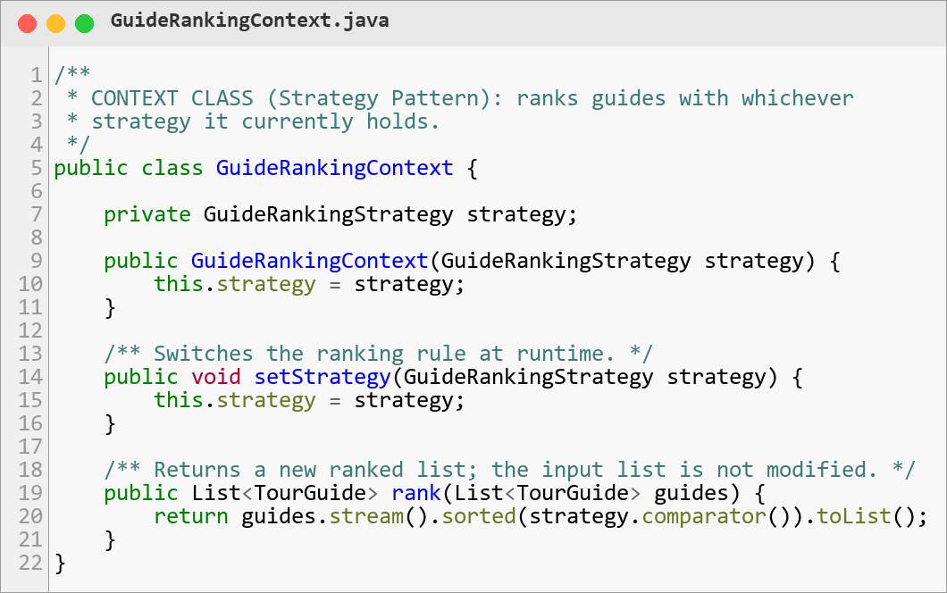
Figure 12: Context class GuideRankingContext
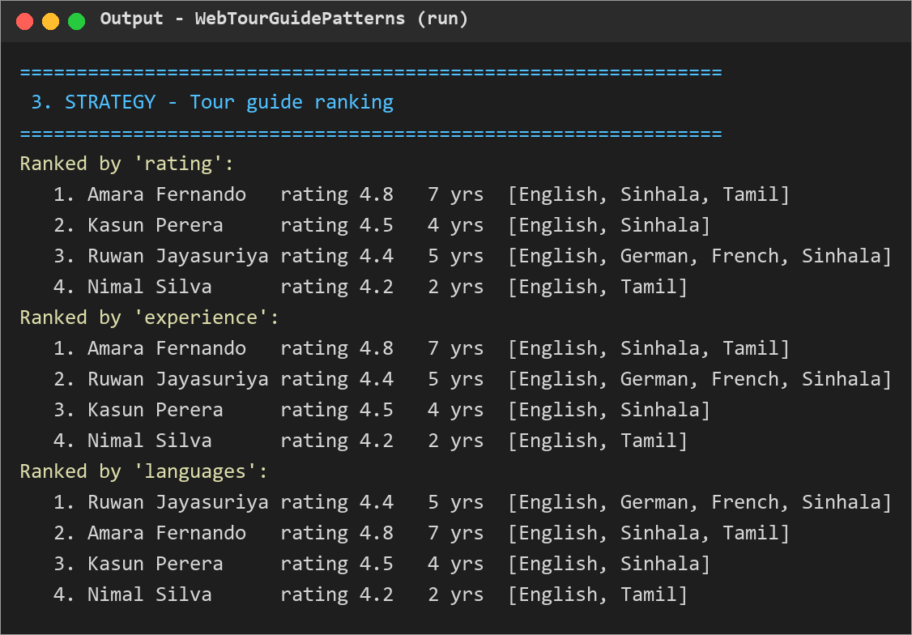
Figure 13: Output: the same guides ranked by rating, experience and languages

4.4 Strategy – Trip Plan Export
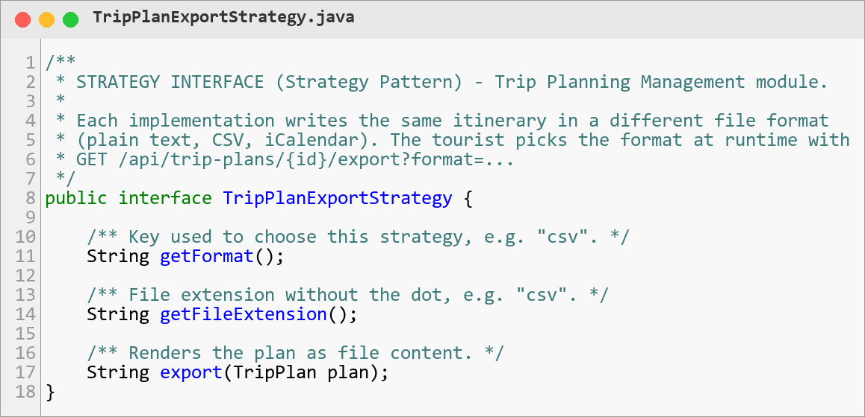
Figure 14: Strategy interface TripPlanExportStrategy
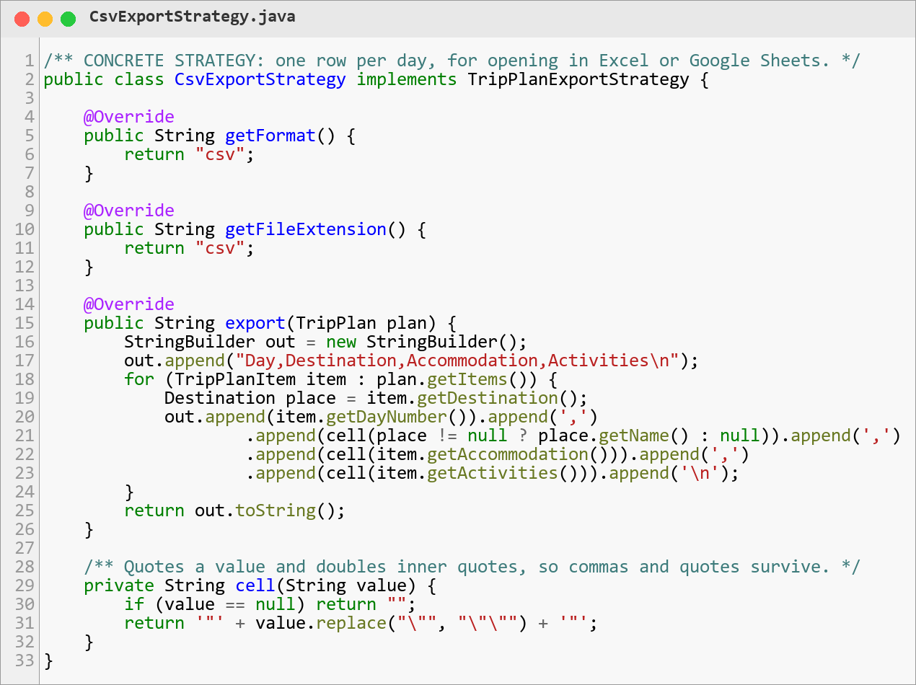
Figure 15: Concrete strategy CsvExportStrategy
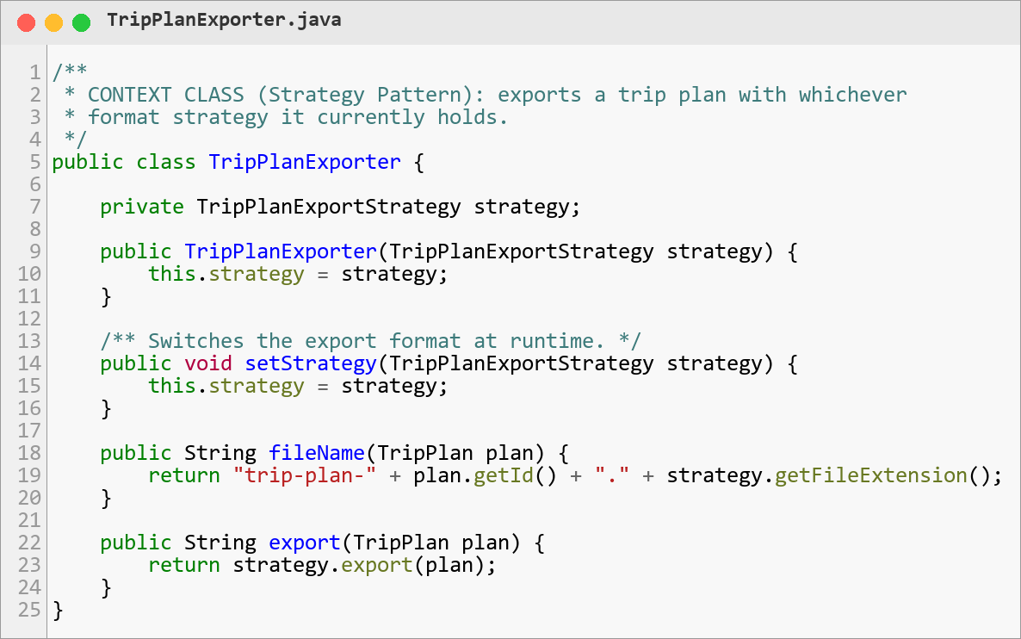
Figure 16: Context class TripPlanExporter
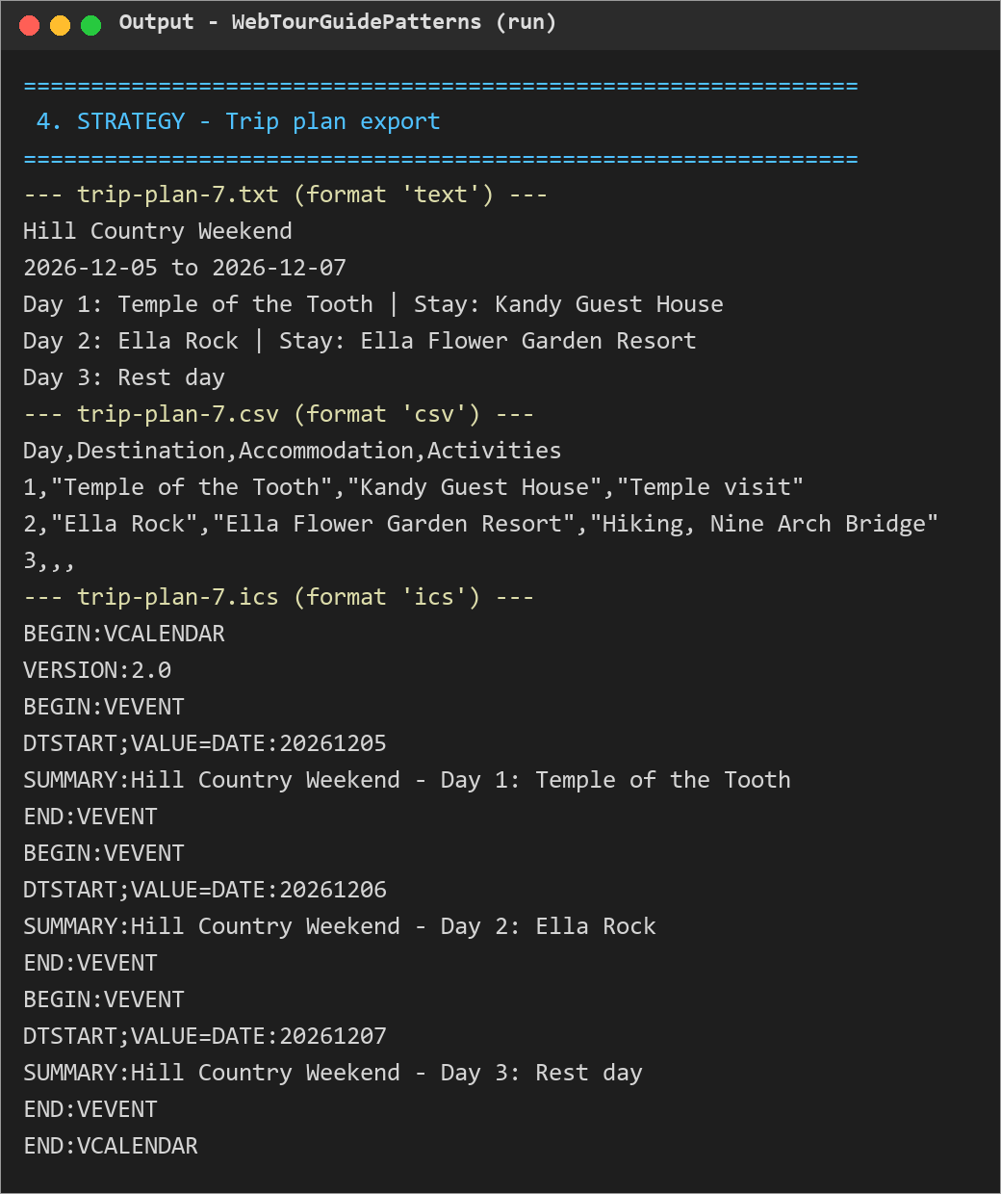
Figure 17: Output: one trip plan exported as text, CSV and iCalendar

4.5 State – Booking Lifecycle
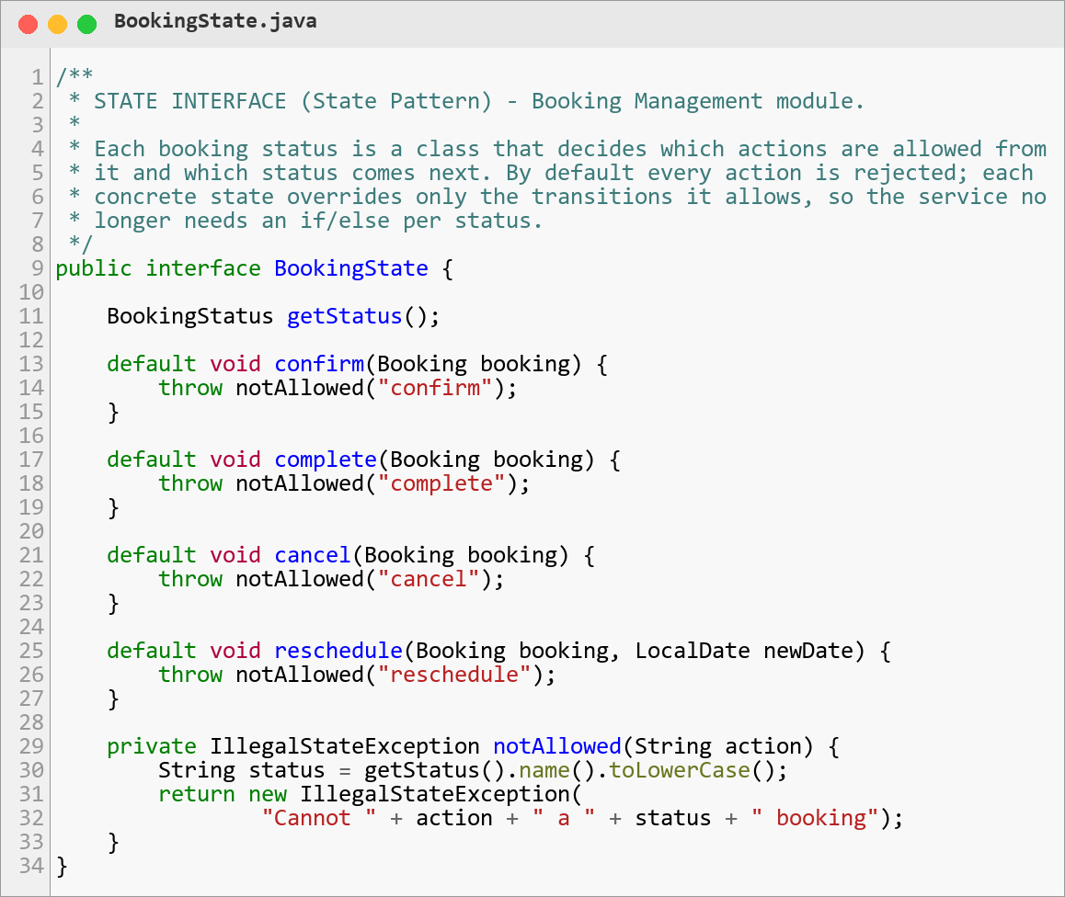
Figure 18: State interface BookingState with default rejections
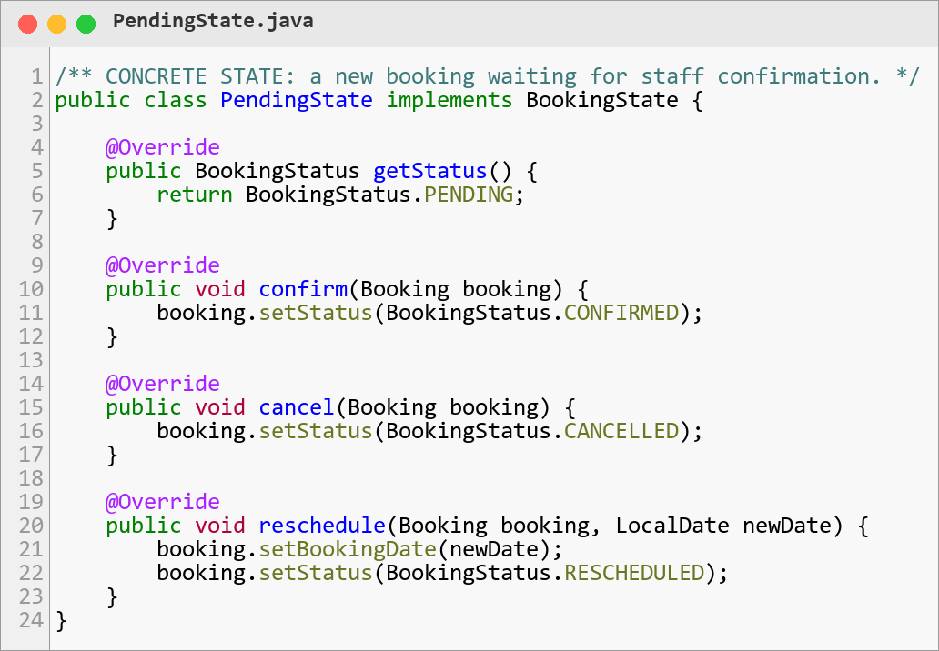
Figure 19: Concrete state PendingState
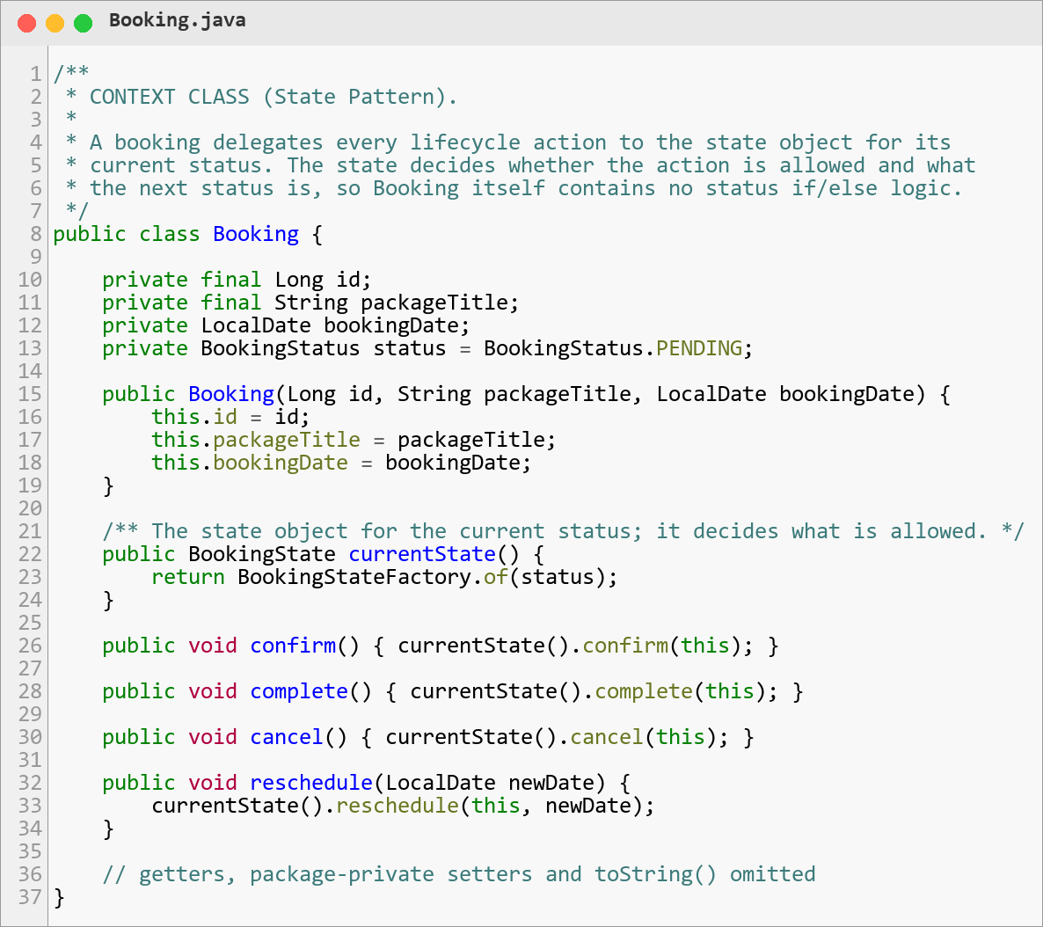
Figure 20: Context class Booking delegating to its current state
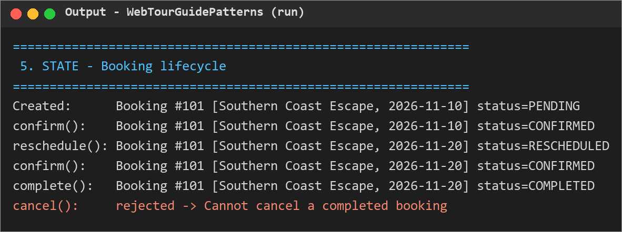
Figure 21: Output: valid transitions succeed; cancelling a completed booking is rejected

4.6 Observer – Support Ticket Status Changes
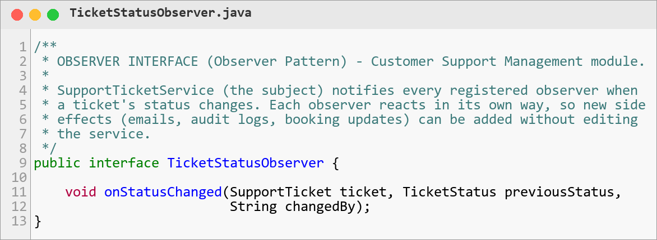
Figure 22: Observer interface TicketStatusObserver
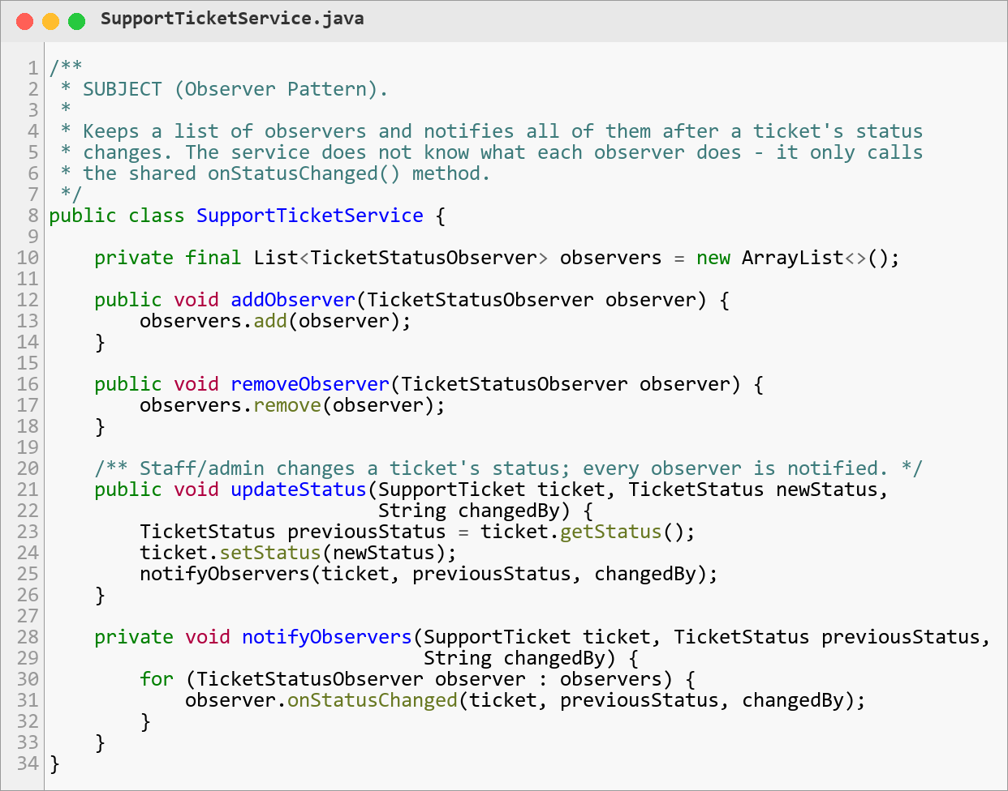
Figure 23: Subject SupportTicketService notifying registered observers
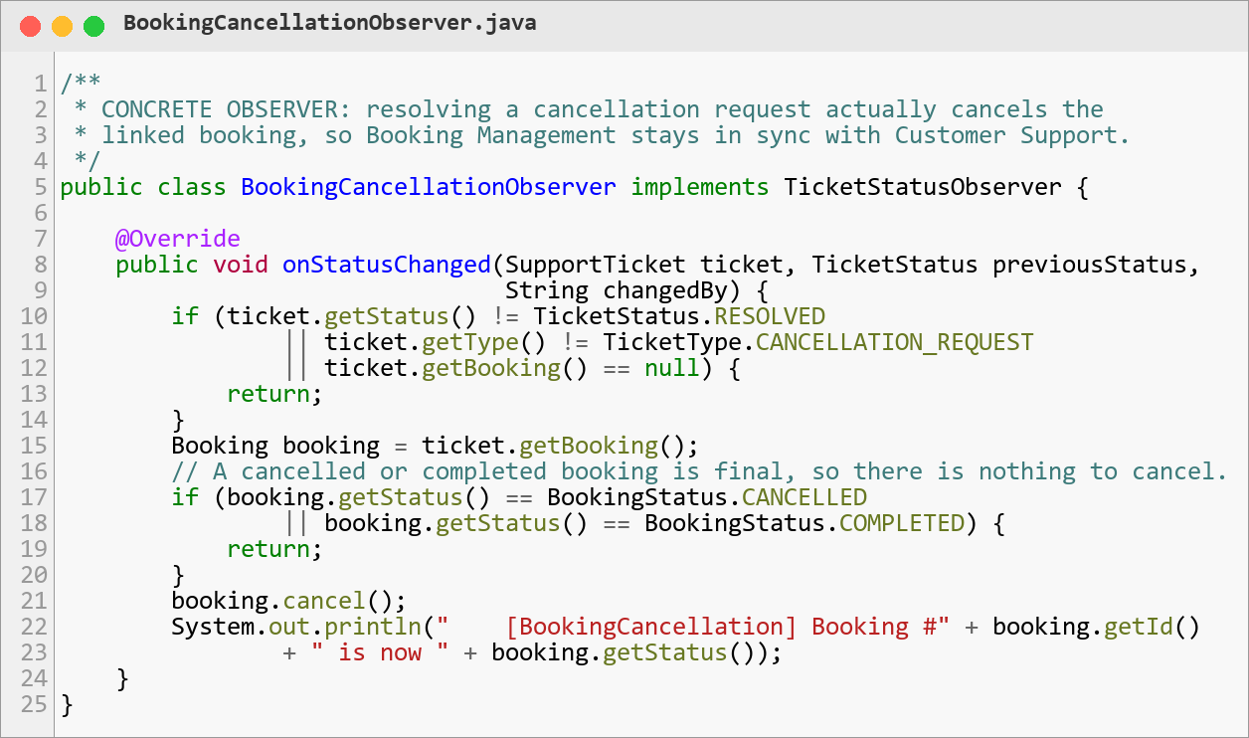
Figure 24: Concrete observer BookingCancellationObserver
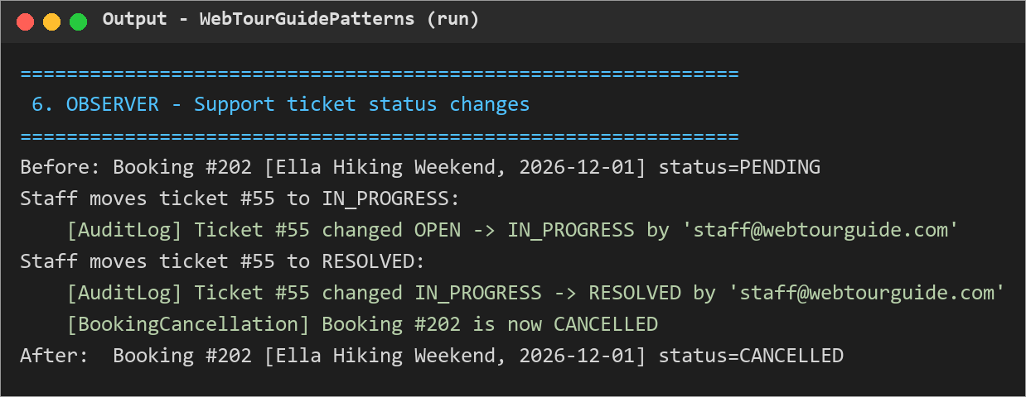
Figure 25: Output: resolving a cancellation request notifies both observers and cancels the booking

5. Code Files
The submitted source code is a clean, self-contained Java 17 project, WebTourGuidePatterns, that runs without a database or web server. It reproduces the pattern classes of the WebTourGuide web application using sample data, so the patterns can be run and inspected directly in NetBeans. Each package corresponds to one module, and every class is labelled in its Javadoc with its pattern role (STRATEGY INTERFACE, CONCRETE STRATEGY, CONTEXT CLASS, STATE INTERFACE, CONCRETE STATE, SUBJECT, OBSERVER INTERFACE, CONCRETE OBSERVER).

5.1 Folder Structure
Lab06_DesignPatterns/
├── Lab06_DesignPatterns_Report_WebTourGuide.docx (this report)
├── README.md (how to run)
├── screenshots/ (figures used in this report)
└── WebTourGuidePatterns/ (NetBeans / Maven project)
├── pom.xml
└── src/main/java/com/webtourguide/patterns/
├── Main.java Main class - runs all six demos
├── model/ Sample data classes (Destination, TourPackage, ...)
├── destination/ Strategy: destination search
├── tourpackage/ Strategy: package sorting
├── tourguide/ Strategy: guide ranking
├── tripplan/ Strategy: trip plan export
├── booking/ State: booking lifecycle
└── support/ Observer: support ticket status

5.2 Class Roles
Role | Classes
Main class | Main – creates sample data and demonstrates every pattern, including switching strategies at runtime.
Interfaces | DestinationSearchStrategy, PackageSortStrategy, GuideRankingStrategy, TripPlanExportStrategy, BookingState, TicketStatusObserver
Context classes | DestinationSearchContext, PackageSortContext, GuideRankingContext, TripPlanExporter, Booking (State context), SupportTicketService (Observer subject)
Concrete classes | 4 search strategies, 4 sort strategies, 3 ranking strategies, 3 export strategies, 5 booking states, 2 observers
Supporting classes | Model classes in model/, DestinationRepository (in-memory data), BookingStateFactory, enums BookingStatus, TicketStatus, TicketType

5.3 How to Run in NetBeans
- Open NetBeans and choose File → Open Project.
- Select the WebTourGuidePatterns folder (NetBeans recognises it as a Maven project) and click Open Project.
- Right-click the project and choose Run (or open Main.java and press Shift + F6).
- The Output window shows the six demonstrations seen in Section 4.
Without an IDE, the project can be run from its folder with mvn compile exec:java, or compiled with javac and run with java com.webtourguide.patterns.Main.

5.4 Where the Patterns Live in the Web Application
In the full WebTourGuide application (Spring Boot API), the same patterns are wired in as Spring components and selected through the REST API:
Pattern use | Package in webtourguide-api
Destination search | com.webtourguide.destination.search
Package sorting | com.webtourguide.tourpackage.sorting
Guide ranking | com.webtourguide.tourguide.ranking
Trip plan export | com.webtourguide.tripplan.export
Booking lifecycle | com.webtourguide.booking.state
Ticket status observers | com.webtourguide.support.observer

