Spatiotemporal Prediction of Electric Vehicle Charging Demand
Data Science Lab Project Report

Submitted by: ______________________________
Roll number: ______________________________
Course: Data Science Lab
Guide: ______________________________
Institution: ______________________________
Date: ______________________________
Dataset: UrbanEV - Li, H. et al. (2025), Scientific Data 12, 523. All figures and numbers in this document were generated from the project's executed code.

1. Introduction
Electric vehicles (EVs) are spreading quickly in large cities, and charging infrastructure has to keep up. Shenzhen, China, has one of the largest electric fleets in the world, including taxis and ride-hailing vehicles that charge many times a day. How much energy is drawn from chargers changes strongly from hour to hour and from one part of the city to another.
This project builds a machine-learning system that forecasts the hourly EV charging demand (in kWh) of every charging zone in Shenzhen one hour ahead. Three regression models (Linear Regression, Random Forest and LightGBM) are trained on the public UrbanEV dataset and compared on a strict chronological test period. The best model is deployed in a local web application (Streamlit) where users can view forecasts per zone, on a city map and over a full day.

2. Problem Statement
Charging demand varies greatly by time and location: some stations are under-used while others are overcrowded at peak hours. This affects drivers (queues), charging operators (capacity and pricing), urban planners (where to add chargers) and electricity providers (grid load). The task is to predict the total energy (kWh) delivered by EV chargers in each zone during the next hour, using only information available before that hour starts. Because the target is a continuous number, this is a supervised regression problem.

3. Objectives
- Collect, inspect and understand the UrbanEV spatiotemporal charging dataset for Shenzhen.
- Preprocess and integrate the charging, zone, station, charger-power and adjacency data.
- Engineer leakage-free features for next-hour forecasting.
- Analyse relationships between demand and the other variables using Pearson correlation.
- Train Linear Regression, Random Forest and LightGBM regressors and compare them with MAE, MSE, RMSE and R².
- Interpret the models (coefficients, feature importance, residuals) and select the best one.
- Deploy the selected model in a user-friendly web application.

4. Dataset Description
Source: UrbanEV - An Open Benchmark Dataset for Urban Electric Vehicle Charging Demand Prediction (Li et al., Scientific Data, 2025). The zone-level, cleaned and aggregated version is used, with hourly resolution. The files are provided as CSV.
Property | Value
Charging zones | 275
Hourly timestamps | 4,344
Period | 2022-09-01 to 2023-02-28
Zone-hour records | 1,194,600
Charging stations (raw station file) | 1,682
Charging piles with rated power | 22,650 (19,556 AC, 3,094 DC)
Missing values in hourly files | 0

4.1 Files used
File | Content | Shape
charge_1hour/volume.csv | Energy delivered per zone-hour (kWh) - TARGET | 4,344 x 275 (wide)
charge_1hour/occupancy.csv | Number of charging piles in use | 4,344 x 275
charge_1hour/duration.csv | Charging duration | 4,344 x 275
charge_1hour/e_price.csv | Electricity price (RMB/kWh) | 4,344 x 275
charge_1hour/s_price.csv | Service price (RMB/kWh) | 4,344 x 275
charge_1hour/volume-11kw.csv | Energy from <=11 kW chargers (part of volume) | 4,344 x 275
zone-information.csv | Zone ID, longitude, latitude, charger count, area, perimeter | 275 x 6
station_information.csv (raw) | Station -> zone, slow / fast charger counts | 1,682 x 7
pile_rated_power.csv | Charger (pile) power in kW and AC/DC type | 22,650 x 4
adj.csv / distance.csv | Zone adjacency (0/1) and distances (m) | 275 x 275
charge_5min/volume.csv | 5-minute volume (used only for a consistency check) | 52,128 x 275

Each hourly file is a wide table: one time column plus one column per zone ID. The zone columns, the TAZID values in zone-information.csv and the row/column order of adj.csv and distance.csv were verified to refer to the same 275 zones in the same order.
Target variable volume: mean 261.5 kWh per zone-hour, median 53.7 kWh, maximum 16,732.5 kWh; 5.5% of zone-hours have zero demand.

5. Data Preprocessing
- Reshaping: the six wide hourly files were stacked into one long table with one row per (time, zone): 1,194,600 rows.
- Missing values, duplicates and negative values: none were found (0 in every file). Forward-fill, duplicate removal and clipping at 0 are kept as safeguards.
- Time consistency: 4,344 consecutive hours with no gaps or duplicate timestamps.
- Data types: measurements converted to float32 and zone IDs to integers to save memory.
- Invalid coordinates: zone 348 had longitude/latitude = 0; it was replaced by the mean location of the zone's stations.
- Adjacency matrix: 20 one-directional links were made symmetric; 4 zones without neighbours use their 3 nearest zones (from distance.csv).
- Scaling: only Linear Regression needs it; a StandardScaler is fitted on training data only, inside a pipeline.

5.1 Data validation checks
Check | Result | Conclusion
Hourly volume = sum of 5-minute volumes | max difference 0.000434 kWh | Hourly data is consistent
Zone charger counts = sum of station slow + fast counts | 100% match | Station file used for charger features
e_price daily profile repeats previous day | 97.4% of zone-days | Prices are a known tariff
s_price daily profile repeats previous day | 97.1% of zone-days | Prices are a known tariff
volume_11kw <= volume | 99.4% of rows | Component of target - excluded
Adjacent zones' mean distance | about 2 km (vs 22 km non-adjacent) | Adjacency aligned correctly

5.2 Data integration
Static attributes were joined to each zone-hour by zone ID: number of chargers, share of fast chargers, average rated power per charger (from pile_rated_power.csv, linked via station_id -> zone) and total charger power (capacity, kW). Hourly demand never exceeds the zone's total charger power, which confirms the capacity feature is physically consistent.

6. Feature Engineering
Prediction horizon: next hour. A row (zone, hour t) has the target volume at hour t. All features use information from hour t-1 or earlier, or information known in advance for hour t (calendar, public holidays, tariff prices, zone attributes). Lags are computed separately for each zone.
Group | Features | Meaning
Demand history | volume_lag1, volume_lag24, volume_lag168, volume_roll24_mean | Zone's own demand 1 h, 24 h and 168 h earlier; mean of the last 24 h
Activity history | occupancy_lag1, duration_lag1 | Chargers in use and charging duration in the previous hour
Spatial | neighbor_volume_lag1 | Average previous-hour demand of adjacent zones
Tariff | e_price, s_price | Electricity and service price for the hour (published tariff)
Calendar | hour, day, dayofweek, is_weekend, is_holiday, hour_sin, hour_cos, dow_sin, dow_cos | Hour, day, weekday, weekend and holiday flags, sine/cosine cycles
Zone | num_piles, fast_share, avg_pile_kw, capacity_kw, area, longitude, latitude | Charger count and power, zone area and location

In total 25 input features are used. month is created but not used as an input: training covers Sep-Dec while the test set is February, a value never seen in training. The first 168 hours are dropped because the weekly lag is not yet defined.

6.1 Chronological split
Split | Rows | Start | End
train | 759,000 | 08 Sep 2022 | 31 Dec 2022
val | 204,600 | 01 Jan 2023 | 31 Jan 2023
test | 184,800 | 01 Feb 2023 | 28 Feb 2023

All zones of one timestamp are always in the same split, and the splits never overlap in time. The validation month is used only for LightGBM early stopping and for model selection.

6.2 Leakage prevention
- Same-hour occupancy and duration are only known after the hour ends, so only their 1-hour lags are used.
- volume_11kw is part of the target and is never used as an input.
- Lag values were spot-checked on 2,000 random rows against the original data (all correct).
- Scaling and every learnt quantity are fitted on training data only.

7. Correlation Analysis
Exploratory analysis is limited to Pearson correlation, computed on the training period (759,000 rows). Same-hour occupancy, duration and volume_11kw are included only for discussion.
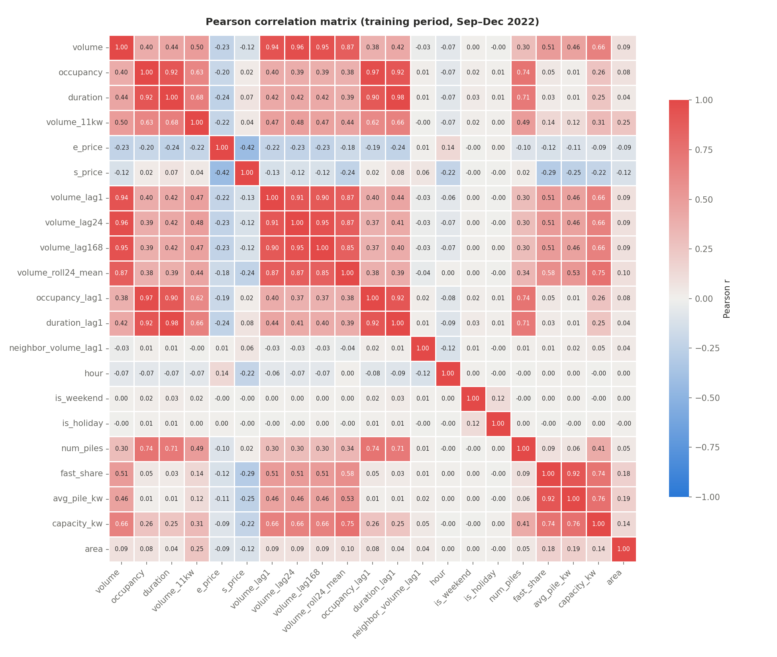
Figure 1. Pearson correlation matrix (training period).

7.1 Correlation with the target
Feature | Pearson r | Strength | Role
volume_lag24 | 0.96 | strong positive | model input
volume_lag168 | 0.95 | strong positive | model input
volume_lag1 | 0.94 | strong positive | model input
volume_roll24_mean | 0.87 | strong positive | model input
capacity_kw | 0.66 | moderate positive | model input
fast_share | 0.51 | moderate positive | model input
volume_11kw | 0.50 | moderate positive | excluded - part of the target (leakage)
avg_pile_kw | 0.46 | moderate positive | model input
duration | 0.44 | moderate positive | excluded - same-hour value unknown at forecast time
duration_lag1 | 0.42 | moderate positive | model input
occupancy | 0.40 | moderate positive | excluded - same-hour value unknown at forecast time
occupancy_lag1 | 0.38 | weak positive | model input
num_piles | 0.30 | weak positive | model input
e_price | -0.23 | weak negative | model input
s_price | -0.12 | negligible | model input
area | 0.09 | negligible | model input
hour | -0.07 | negligible | model input
neighbor_volume_lag1 | -0.03 | negligible | model input
is_weekend | 0.00 | negligible | model input
is_holiday | -0.00 | negligible | model input

7.2 Pooled vs within-zone correlation
Feature | Pooled r | Median within-zone r
volume_lag1 | 0.94 | 0.93
volume_lag24 | 0.96 | 0.56
volume_lag168 | 0.95 | 0.39
volume_roll24_mean | 0.87 | 0.49
occupancy_lag1 | 0.38 | 0.67
duration_lag1 | 0.42 | 0.93
neighbor_volume_lag1 | -0.03 | 0.30
e_price | -0.23 | -0.40
s_price | -0.12 | 0.29
hour_cos | 0.05 | 0.28

7.3 Multicollinearity (|r| >= 0.8 among inputs)
Feature 1 | Feature 2 | Pearson r
volume_lag24 | volume_lag168 | 0.95
occupancy_lag1 | duration_lag1 | 0.92
fast_share | avg_pile_kw | 0.92
volume_lag1 | volume_lag24 | 0.91
volume_lag1 | volume_lag168 | 0.90
volume_lag1 | volume_roll24_mean | 0.87
volume_lag24 | volume_roll24_mean | 0.87
volume_lag168 | volume_roll24_mean | 0.85

7.4 Interpretation
- Strongest predictors among model inputs: volume_lag24 (r = 0.96), volume_lag168 (r = 0.95), volume_lag1 (r = 0.94). Recent demand in the same zone is the best single indicator of next-hour demand.
- Same-hour occupancy (r = 0.40) and duration (r = 0.44) move with demand but are only known after the hour ends, so the models use their 1-hour lags instead (r = 0.38 and 0.42).
- volume_11kw has r = 0.50 with the target because it is a component of it (energy from <=11 kW chargers); using it would leak the answer.
- Electricity price r = -0.23 and service price r = -0.12: prices follow a daily time-of-use tariff, so part of their correlation reflects the time of day rather than a direct price effect.
- Zone size/capacity: num_piles r = 0.30, capacity_kw r = 0.66 - larger zones deliver more energy on average.
- hour has r = -0.07: Pearson only measures LINEAR association, and the daily cycle is not linear in the hour number, which is why sine/cosine hour features are used.
- neighbor_volume_lag1 has pooled r = -0.03, but inside each zone over time the median r is 0.30. Pooled correlation is dominated by size differences between zones (a large zone can border small ones); within a zone, busier neighbours do go with busier hours.
- hour_cos has median within-zone r = 0.28, confirming a clear daily cycle that the raw hour number hides.
- Negative correlations: e_price (r = -0.23)
- Multicollinearity (|r| >= 0.8) among inputs: volume_lag24 ~ volume_lag168 (r = 0.95); occupancy_lag1 ~ duration_lag1 (r = 0.92); fast_share ~ avg_pile_kw (r = 0.92); volume_lag1 ~ volume_lag24 (r = 0.91); volume_lag1 ~ volume_lag168 (r = 0.90); volume_lag1 ~ volume_roll24_mean (r = 0.87); volume_lag24 ~ volume_roll24_mean (r = 0.87); volume_lag168 ~ volume_roll24_mean (r = 0.85). This makes Linear Regression coefficients unstable to interpret, but does not harm tree-based models' predictions.
- Correlation does not imply causation; it only measures linear co-movement.

8. Algorithms Used

8.1 Linear Regression
Models the target as a weighted sum of the features: ŷ = b0 + b1·x1 + ... + bn·xn. The weights minimise the sum of squared errors (ordinary least squares). It is fast and interpretable, but it can only represent linear relationships, and its coefficients become unstable when features are strongly correlated (multicollinearity). Features are standardised so coefficients are comparable.

8.2 Random Forest Regressor
An ensemble of decision trees (bagging). Each tree is trained on a random sample of rows and considers a random subset of features at each split; the forest prediction is the average of all trees. Averaging reduces variance, captures non-linear relationships and interactions, and gives impurity-based feature importance.

8.3 LightGBM Regressor
A gradient-boosting framework. Trees are built one after another; each new tree is fitted to the remaining errors (gradients) of the current ensemble, and its contribution is scaled by a learning rate. LightGBM grows trees leaf-wise and uses histogram-based splitting, which makes it fast and memory-efficient on large tabular data. Early stopping on the validation set prevents overfitting.

8.4 Naive reference forecasts
Two forecasts that involve no learning are reported for context: repeat the previous hour's demand (lag-1) and repeat the demand at the same hour one week earlier (lag-168). A useful model must clearly beat them.

9. Model Implementation
Model | Configuration
Linear Regression | StandardScaler -> LinearRegression (scikit-learn)
Random Forest | 100 trees, max_depth 18, min_samples_leaf 20, max_features 0.5, max_samples 0.3
LightGBM | learning_rate 0.05, num_leaves 63, min_child_samples 50, subsample 0.8, colsample_bytree 0.8, up to 3,000 trees with early stopping (100 rounds) on validation RMSE
All models | same 25 features, same training rows, random seed 42, predictions clipped at 0 kWh

Model | Training rows | Training time (s) | Saved size (MB)
Linear Regression | 759,000 | 1.00 | 0.00
Random Forest | 759,000 | 63.10 | 23.60
LightGBM | 759,000 | 24.90 | 0.80

LightGBM stopped early at 369 trees.

9.1 Two prediction modes
Users can pick any date from 1 October 2022 up to today. Two kinds of models make this possible, each built with all three algorithms:
 | Mode 1: dataset period | Mode 2: future dates
Dates | 1 Oct 2022 - 28 Feb 2023 | 1 Mar 2023 - today
Models | Next-hour models (25 features incl. recent demand) | Profile models (calendar, holidays, typical prices, zone attributes, zone typical demand)
Training | Walk-forward: each month predicted by models trained only on earlier months | All six months (evaluated first on February 2023)
Output | Prediction AND actual demand, error and accuracy label | Estimate with a typical error range (no actual data exists)

September 2022 is not offered: it is the first month, so no earlier data exists to train on. Future-date holiday flags use the official public-holiday schedules up to 2026.

9.2 Software architecture
- Backend (src/): data loading, preprocessing, feature engineering, correlation analysis, training, evaluation, walk-forward forecasting, future-date models and a prediction service. python train.py runs the whole pipeline once.
- Frontend (Streamlit app): Home, Demand Forecast, Prediction vs Actual, Demand Map, Zone Insights, Compare Zones and About the Model pages. The app only loads saved models and results; no training happens in the interface.
- Notebook: the full analysis, using the same src modules so results are identical.
- Persistence: models saved with joblib; data cached as Parquet; results saved as CSV/JSON/PNG.

10. Evaluation Metrics
- MAE = (1/n) Σ |y - ŷ| - the average absolute error in kWh; easy to interpret.
- MSE = (1/n) Σ (y - ŷ)² - squares errors, so large errors are penalised strongly (units kWh²).
- RMSE = √MSE - like MSE but back in kWh; used for model selection.
- R² = 1 - Σ(y - ŷ)² / Σ(y - ȳ)² - share of the variance in demand explained by the model (1 = perfect).
All metrics are computed on the February 2023 test period, which was never used for training or model selection.

11. Results and Comparison
Model | MAE (kWh) | MSE | RMSE (kWh) | R²
Linear Regression | 48.70 | 33,799.61 | 183.85 | 0.9535
Random Forest | 35.56 | 26,215.02 | 161.91 | 0.9639
LightGBM | 34.28 | 20,355.55 | 142.67 | 0.9720
Naive (lag-1) | 51.49 | 82,381.59 | 287.02 | 0.8867
Naive (lag-168) | 77.19 | 104,835.52 | 323.78 | 0.8558

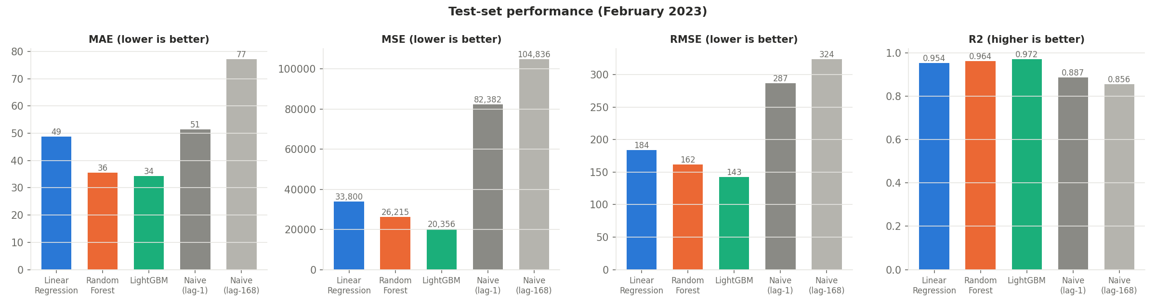
Figure 2. Test-set metrics for all models and baselines.

11.1 Overfitting and underfitting check
Model | Train RMSE | Validation RMSE | Test RMSE
Linear Regression | 190.91 | 176.15 | 183.85
Random Forest | 157.93 | 152.18 | 161.91
LightGBM | 123.47 | 141.37 | 142.67

The tree models show small gaps between training and test error (LightGBM: 123.5 -> 142.7 kWh), so there is little overfitting. Linear Regression has a higher error even on its own training data (190.9 kWh), a sign of underfitting: the relationship is not purely linear.
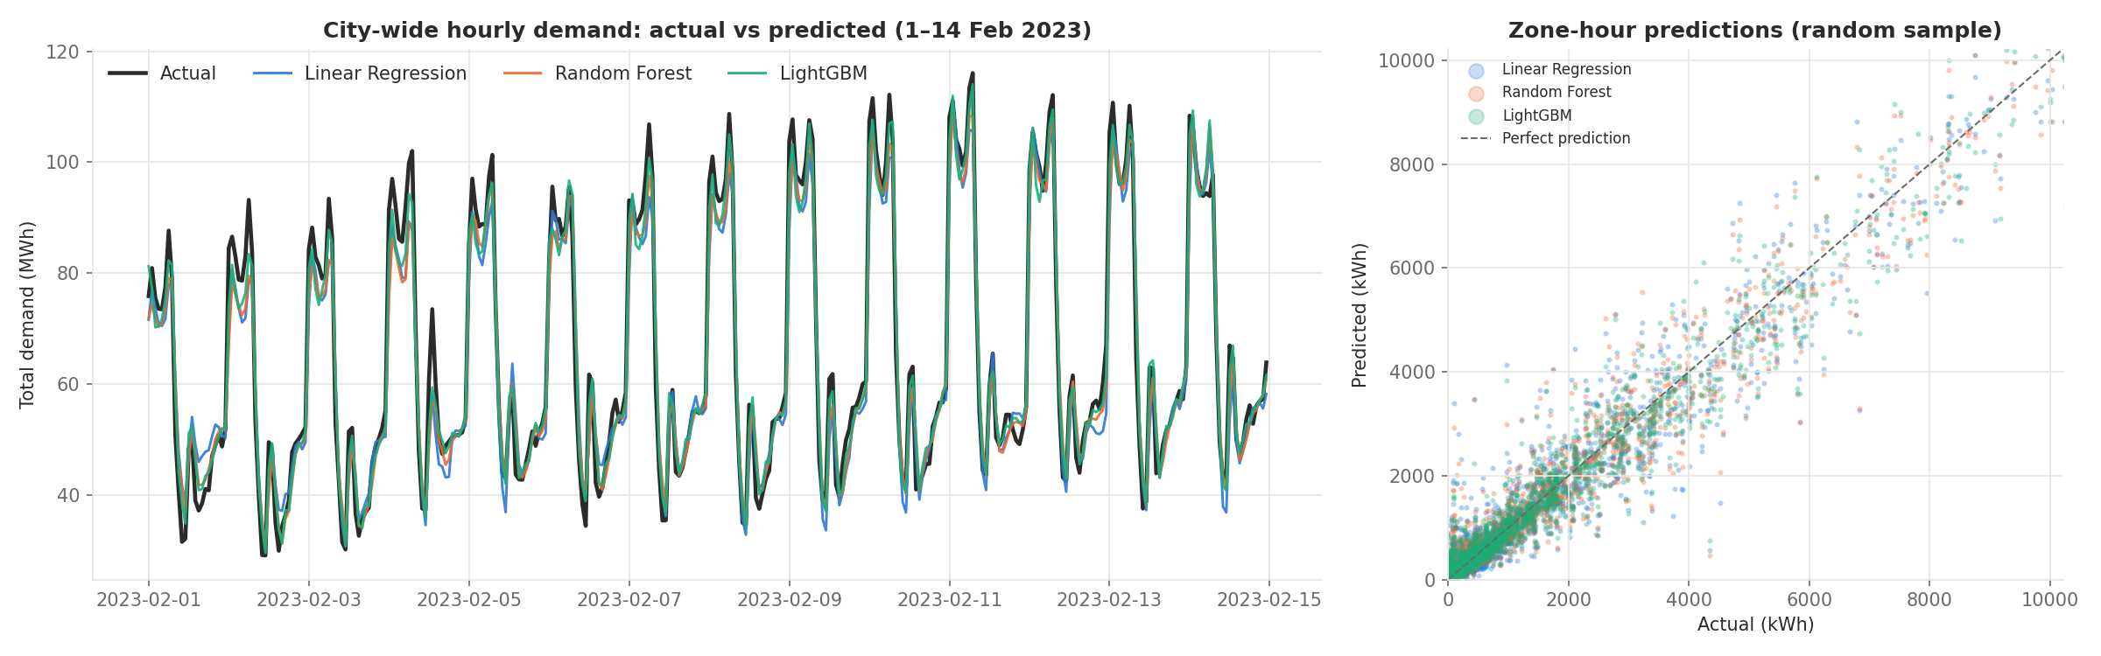
Figure 3. Actual vs predicted demand on the test period.
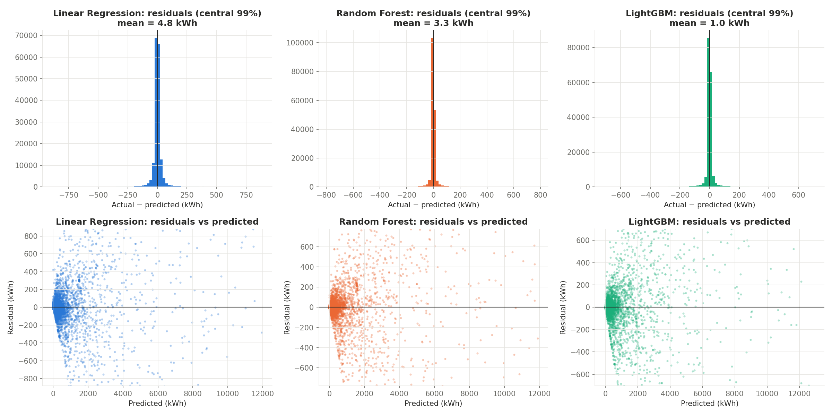
Figure 4. Residual analysis (actual - predicted).
Residuals are centred close to zero for all models. Errors grow for zones with high demand, which is expected because large zones vary more in absolute kWh.
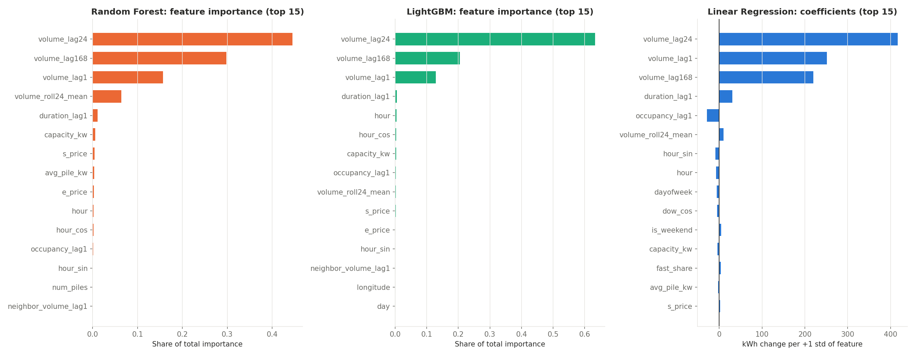
Figure 5. Feature importance (tree models) and Linear Regression coefficients.

11.2 Linear Regression coefficients (top 10)
Feature | Coefficient (kWh per +1 std)
volume_lag24 | 417.21
volume_lag1 | 251.44
volume_lag168 | 219.78
duration_lag1 | 30.67
occupancy_lag1 | -28.31
volume_roll24_mean | 10.20
hour_sin | -9.13
hour | -7.46
dayofweek | -5.97
dow_cos | -4.73

11.3 LightGBM feature importance (top 10)
Feature | Share of importance
volume_lag24 | 63.2%
volume_lag168 | 20.5%
volume_lag1 | 12.9%
duration_lag1 | 0.6%
hour | 0.5%
hour_cos | 0.3%
capacity_kw | 0.3%
occupancy_lag1 | 0.2%
volume_roll24_mean | 0.2%
s_price | 0.2%

11.4 Final model selection
The model with the lowest validation RMSE is LightGBM (Linear Regression: 176.2, Random Forest: 152.2, LightGBM: 141.4). The choice was confirmed on the test set, where LightGBM achieved MAE 34.3 kWh, RMSE 142.7 kWh and R² 0.9720. RMSE reduction: 22.4% vs Linear Regression, 11.9% vs Random Forest, 50.3% vs Naive (lag-1).
Gradient boosting builds trees sequentially, each correcting the remaining errors, so it captures non-linear effects (daily cycles, zone size, interactions between recent and weekly demand) that a linear equation cannot, and with early stopping it avoids overfitting. Random Forest averages independent trees and is limited in depth for memory reasons, which leaves slightly more error.

11.5 Walk-forward results (month by month)
Each month was predicted by models trained only on the months before it. These are the predictions shown in the application for the dataset period.
Predicted month | Linear Regression RMSE | Random Forest RMSE | LightGBM RMSE
2022-10 | 186.72 | 174.55 | 168.48
2022-11 | 183.72 | 170.49 | 154.53
2022-12 | 201.87 | 185.21 | 161.15
2023-01 | 176.15 | 152.18 | 143.57
2023-02 | 182.00 | 157.23 | 140.02
Oct-Feb (all) | 186.39 | 168.56 | 154.18

LightGBM had the lowest error in 5 of 5 months; over the whole period its RMSE was 154.2 kWh (R² 0.966). Errors fall as more training months become available, so the model ranking is stable over time.

11.6 Future-date models
Model | MAE (kWh) | MSE | RMSE (kWh) | R²
Reference (zone typical demand) | 81.09 | 95,017.98 | 308.25 | 0.8693
Linear Regression | 80.11 | 91,155.70 | 301.92 | 0.8746
Random Forest | 83.78 | 108,124.26 | 328.82 | 0.8513
LightGBM | 85.89 | 116,433.37 | 341.22 | 0.8398

Tested on February 2023 after training on earlier months. The best future-date model is Linear Regression (RMSE 301.9 kWh), only 2.1% better than simply using the zone's typical demand (308.2 kWh), and far less precise than next-hour forecasting (140.0 kWh on the same month). Without recent real demand, the best available estimate is close to the zone's usual pattern; the tree models fitted Sep-Jan specifics that did not carry over to February. Future estimates are therefore labelled as estimates in the application.

12. Conclusion
- The UrbanEV dataset was fully inspected and validated (1,194,600 zone-hours); all files and identifiers align.
- A leakage-free next-hour forecasting pipeline with 25 features was built and verified.
- All three models clearly outperform the naive forecasts; LightGBM is the best model (R² 0.972, average error 34.3 kWh per zone-hour).
- The most influential features are volume_lag24, volume_lag168, volume_lag1: recent demand history, especially the same hour on the previous day, drives next-hour demand.
- Demand is concentrated overnight: 46% of all energy is delivered between 00:00 and 07:59, when electricity prices are lowest.
- Zones with more fast chargers and higher installed power deliver more energy.
- Walk-forward forecasting confirmed the ranking in every month from October to February.
- Without recent demand, future-date estimates are close to typical-demand averages: recent history is what makes accurate forecasting possible.
- Everything is deployed in a local web application where users pick any date: dataset-period dates are compared with actual demand, later dates receive clearly-labelled estimates.
Practical applications: operators can plan capacity, maintenance and dynamic pricing; drivers can avoid busy hours; planners can identify zones where chargers are under pressure; grid operators can anticipate EV charging load.

13. Limitations
- Only six months of data: yearly seasonality cannot be learnt, and calendar month cannot be used as a feature.
- Results are specific to Shenzhen and its large electric taxi fleet; other cities may behave differently.
- No weather or event data; public holidays are represented only by a flag.
- Forecasts are one hour ahead and evaluated on historical data; the application is not connected to live data.
- Future-date estimates reflect Sep 2022 - Feb 2023 patterns only (no summer months, no EV growth after February 2023) and cannot be checked against actual demand. Holiday dates after the dataset come from official schedules and should be verified.
- Small inconsistencies between source files (e.g. the rated-power list covers fewer stations than the station file) were documented, not corrected.
- Random Forest was size-limited to run on a laptop, which may cost some accuracy.

14. Future Scope
- Add weather, traffic and event data, and a full public-holiday calendar.
- Forecast several hours or days ahead (multi-step forecasting).
- Compare with sequence and graph models (LSTM/GRU, STGCN, Graph WaveNet) that use the adjacency matrix directly.
- Connect the application to live charging data for real-time forecasts and alerts.
- Apply the pipeline to other cities' charging data to test generalisation.

15. References
- Li, H., Qu, H., Tan, X., You, L., Zhu, R., & Fan, W. (2025). UrbanEV: An Open Benchmark Dataset for Urban Electric Vehicle Charging Demand Prediction. Scientific Data, 12, 523. https://doi.org/10.1038/s41597-025-04874-4
- Breiman, L. (2001). Random Forests. Machine Learning, 45, 5-32.
- Ke, G. et al. (2017). LightGBM: A Highly Efficient Gradient Boosting Decision Tree. Advances in Neural Information Processing Systems 30.
- Pedregosa, F. et al. (2011). Scikit-learn: Machine Learning in Python. Journal of Machine Learning Research, 12, 2825-2830.
- Hyndman, R. J., & Athanasopoulos, G. (2021). Forecasting: Principles and Practice (3rd ed.). OTexts.

