**How to run the app?**

**Prerequisite Requirements:**

* You should have anaconda install on your machine. Download it from [Anaconda | Individual Edition](https://www.anaconda.com/products/individual).
* Should be familiar with basic command line arguments like ls and cd.

**Steps:**

1. Open the anaconda prompt.

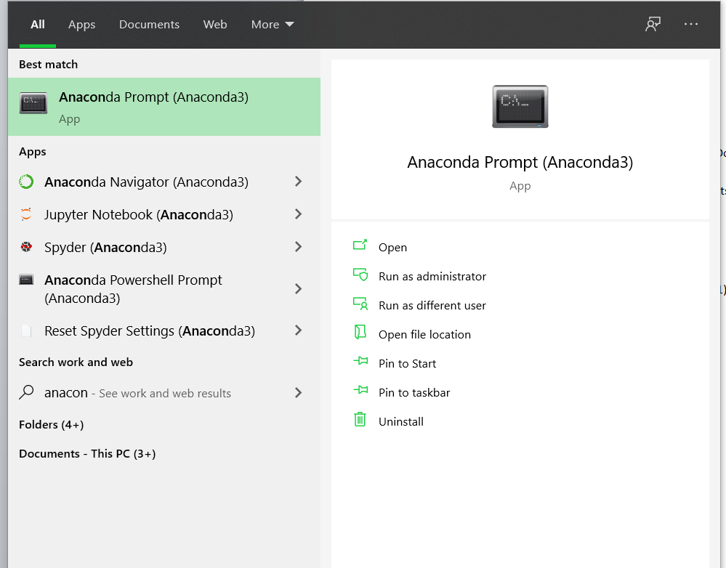

2. Update conda by writing: conda update conda

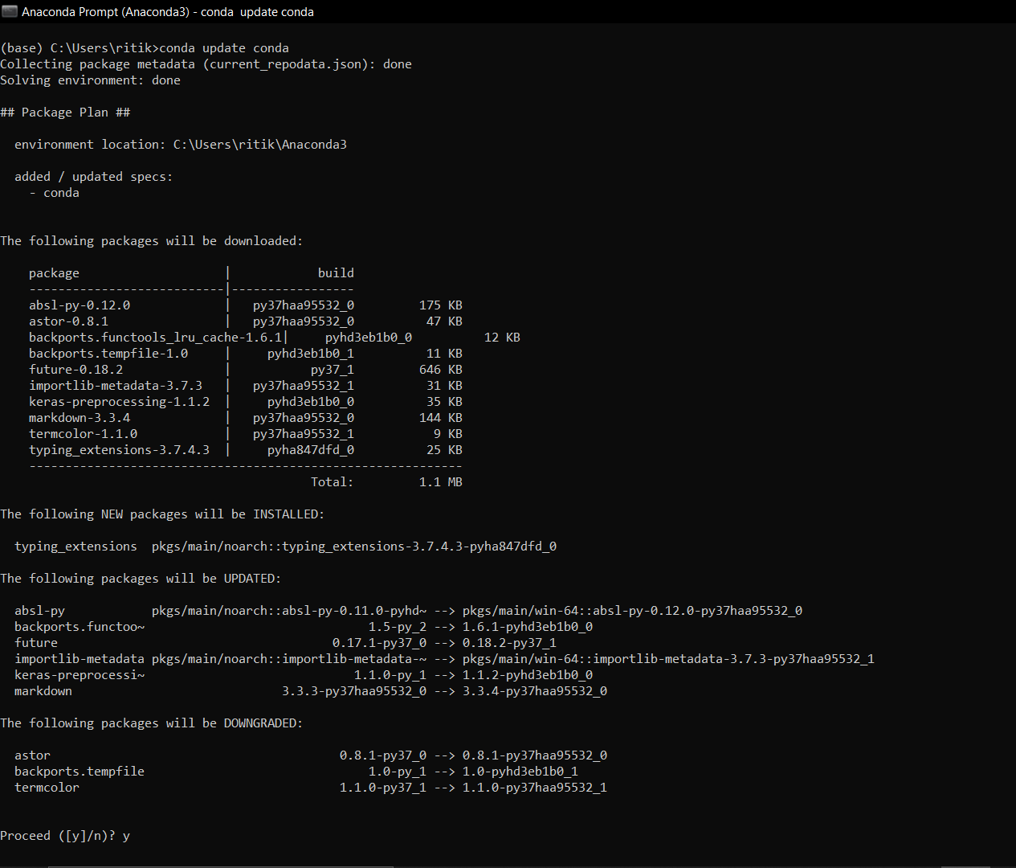

3. Create a new anaconda environment (eg. djangoEnv1) by writing

conda create –n djangoEnv1

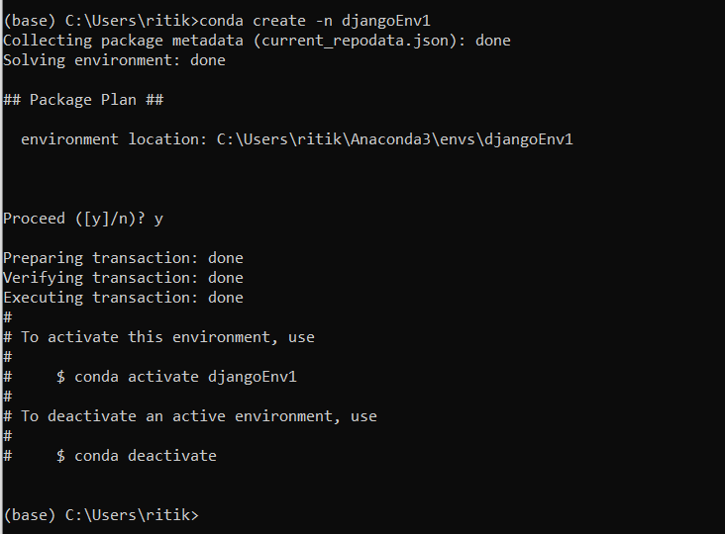

4. Open the file location in command prompt and activate the anaconda environment there.

(a) Open the folder containing the project

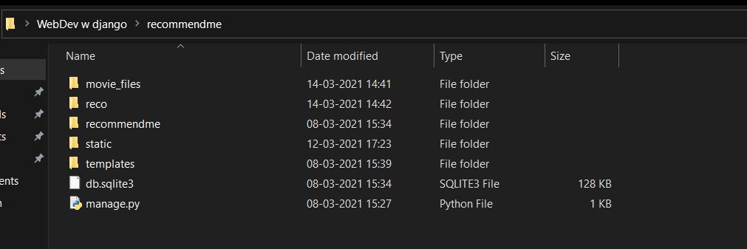

(b) Get the file path of the folder by clicking the top bar and copy it.

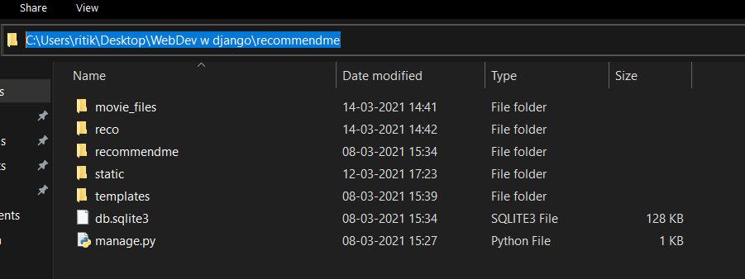

(c) Open the command prompt and write:

cd (filepath)

eg. cd C:\Users\ritik\Desktop\WebDev w django\recommendme

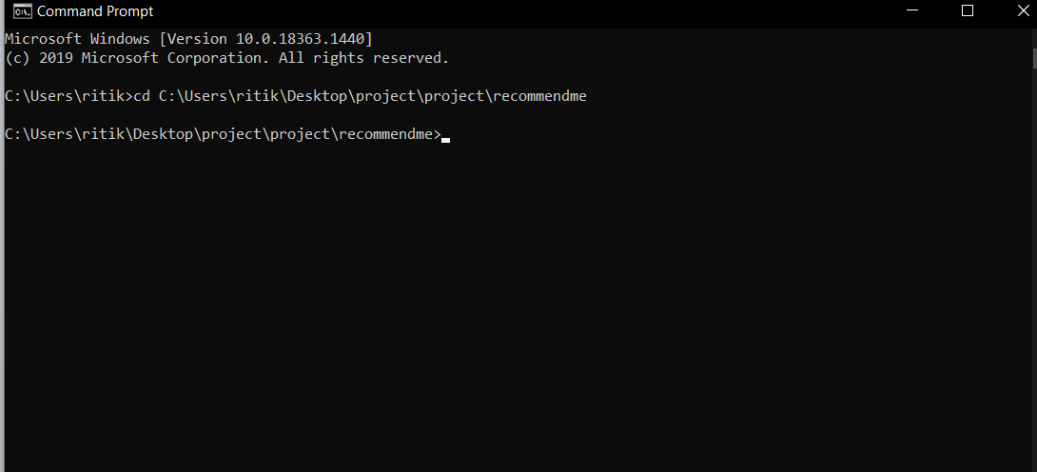

(d) Now to activate the new anaconda environment here write:

conda activate djangoEnv1

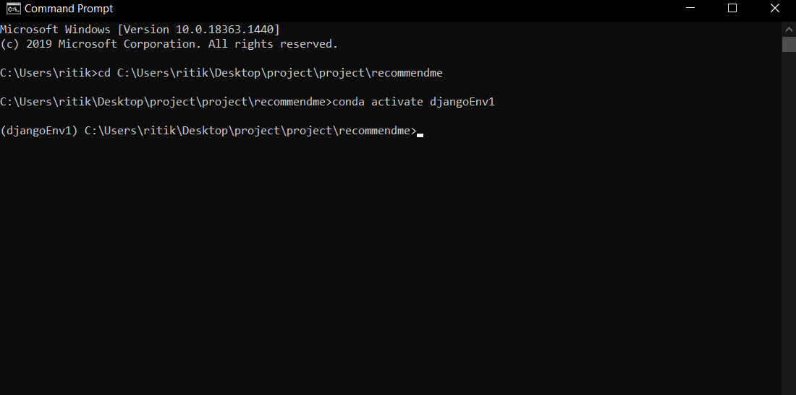

5. Now write:

pip freeze

to know which all packages are pre-installed in your environment. We will be needing django, pandas and numpy.

If these are not installed in your environment install them by writing:

pip install (package name)

Here I am using:

Django == 3.0.5

numpy == 1.19.5

pandas == 0.24.2

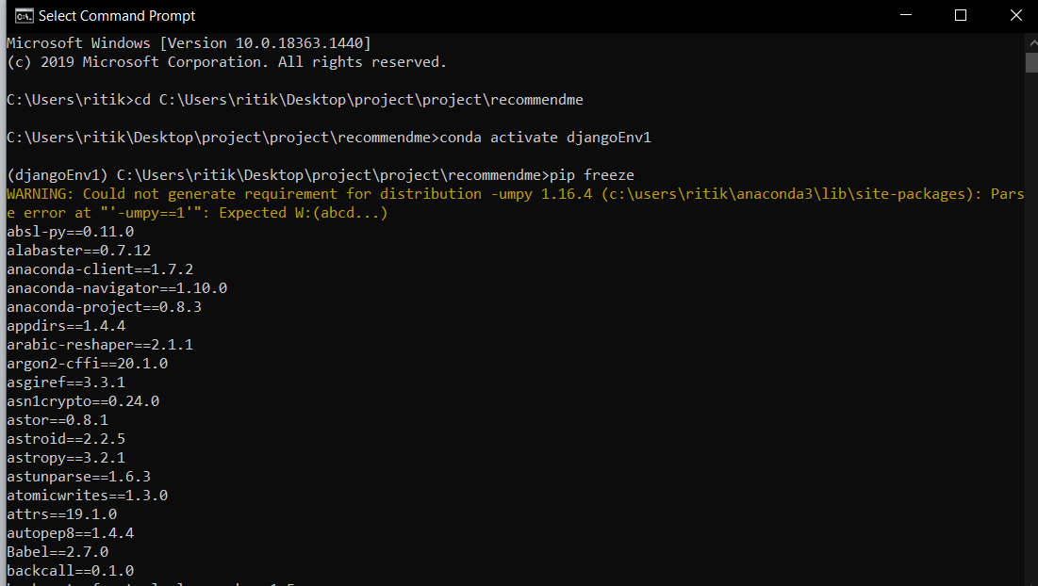

6. If these packages are installed write:

python manage.py runserver

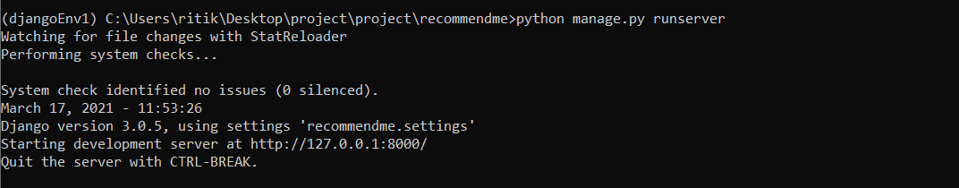

7. Copy the link given in the line Starting development server at and open it in your web browser.

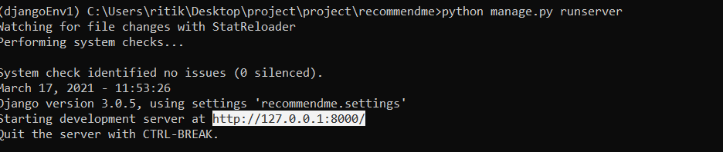

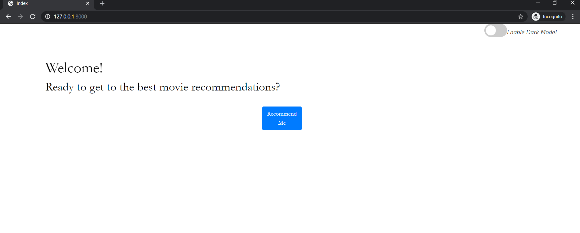

8. To stop the server from running the app go back to the command prompt and use the combination:

Ctrl + C to stop the server

