NAME: VIDUSHI TANEJA

COURSE: BSC STATISTICS HONS

ROLL NUMBER: 20201234

1. **PING:**  the ping command send an ICMP echo requests to a packet destination. You can use it to either ping a domain name or any IP address.

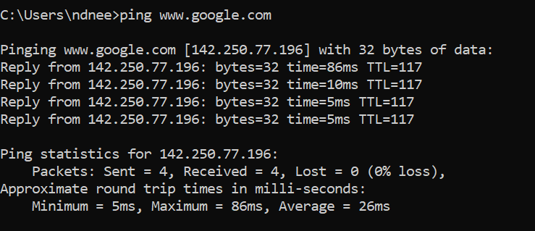

**IPCONFIG/IFCONFIG:** The ipconfig command is used on Windows, while the ifconfig command is used on Linux, Mac OS X, and other Unix-like operating systems. These commands allow you to configure your network interfaces and view information about them.

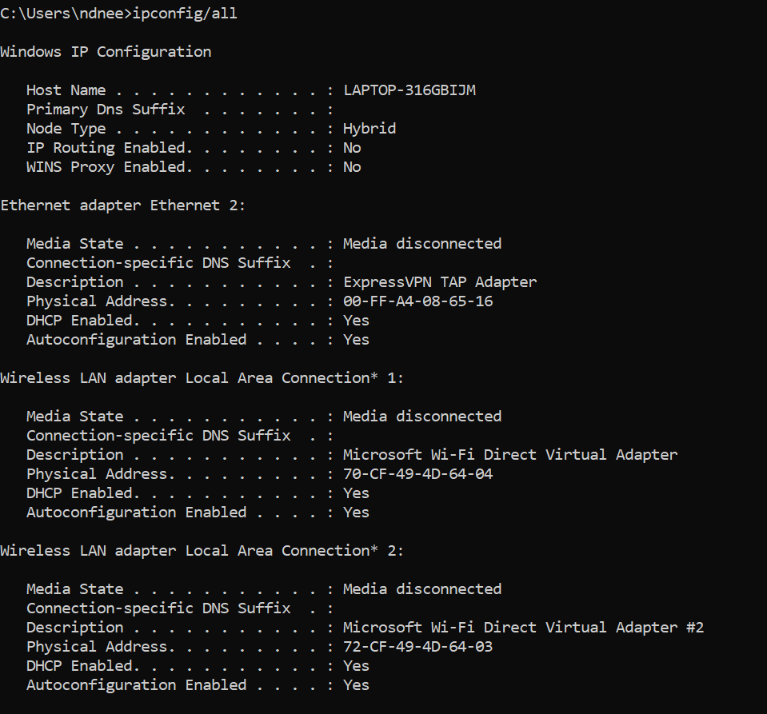

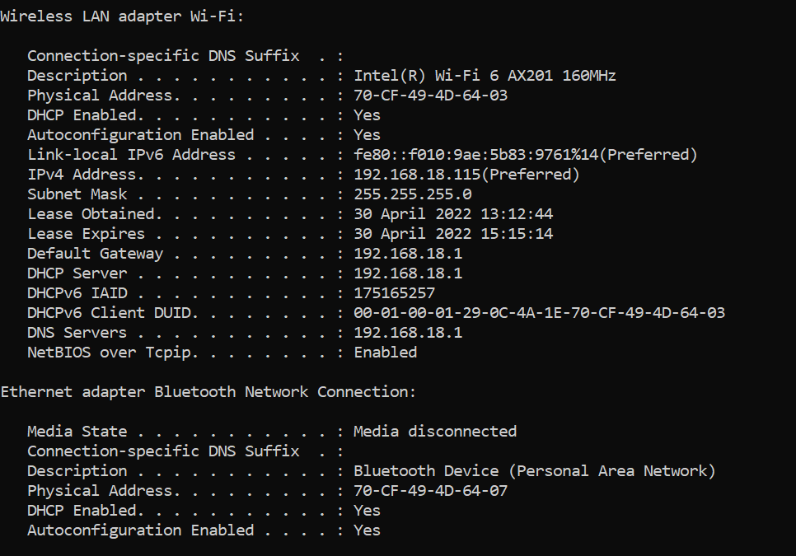

Here, the ipconfig/all command is used to display all the configured network interfaces, IP addresses, DNS servers, and other information.

**TRACERT:** the tracert command is similar to ping, but provides information related to the path that has been taken by a packet.

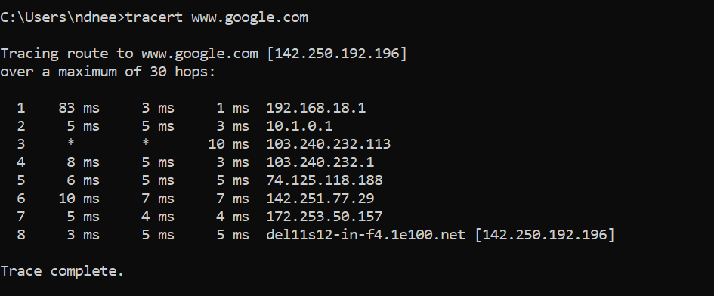

**ARP:** The arp command displays and modifies the Internet-to-adapter address translation tables used by the Address in *Networks and communication management*. The arp command displays the current ARP entry for the host specified by the *HostName* variable.

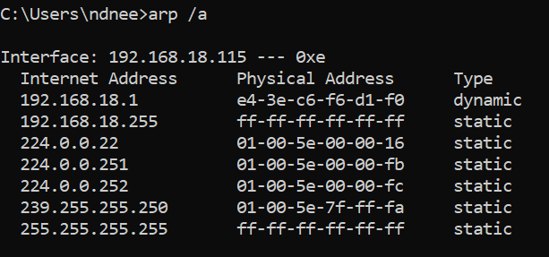

**NETSTAT:** netstat stands for network statistics. This command displays incoming and outgoing network connections as well as other network information.

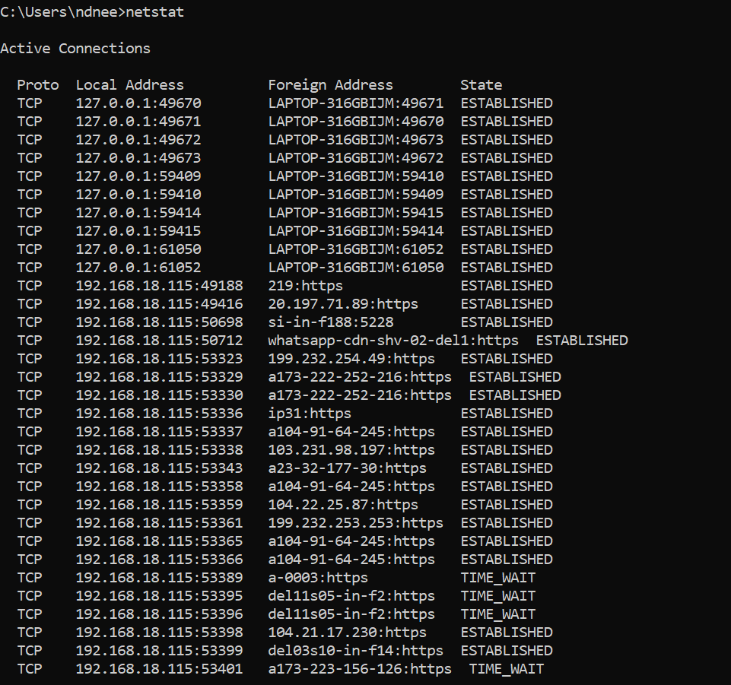

**WHOIS:** The whois command looks up the registration record associated with a domain name. This can show you more information about who registered and owns a domain name, including their contact information.