No-Code Business Predictor
Predicting Mobile App User Churn using AWS SageMaker Canvas
Step-by-Step Implementation with Screenshots

Step 1: Prepare the Dataset
The first step is creating the CSV dataset that will be used to train the churn prediction model. The file mobile_app_churn.csv contains customer records with fields: CustomerID, App_Usage_Minutes, Support_Calls, Subscription_Plan, Months_Subscribed, Reported_Bugs, and Will_Churn (the target variable).


The mobile_app_churn.csv dataset showing 25 customer records with 7 columns including the binary target column Will_Churn.

Step 2: Navigate to SageMaker Canvas
In AWS SageMaker Studio, navigate to Applications and IDEs in the left sidebar and select Canvas. SageMaker Canvas is the no-code ML environment that allows building models without writing any code.


The Applications and IDEs sidebar in SageMaker Studio with Canvas selected.

Step 3: Import the Dataset into Canvas
Create a new Tabular dataset by uploading the prepared CSV file. Select Local upload as the data source and drag/drop or select the mobile_app_churn.csv file. The file is validated and shown as ready to import on the right panel before proceeding.

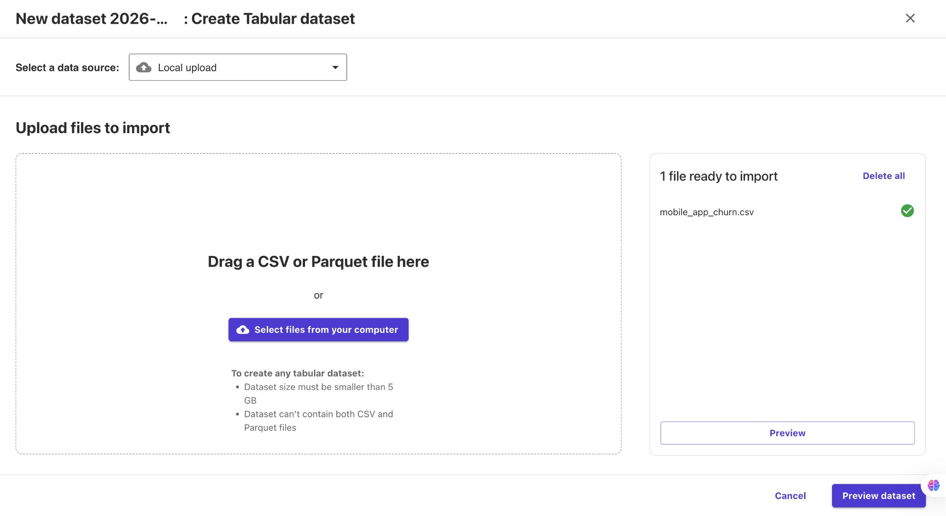
Canvas dataset creation dialog with mobile_app_churn.csv uploaded and ready to import.

Step 4: Create a New Model
Create a new model named Customer-Churn-Predictor. For the problem type, select Predictive analysis — this is used to build models with tabular datasets that predict single or multiple categories (binary classification in our case).

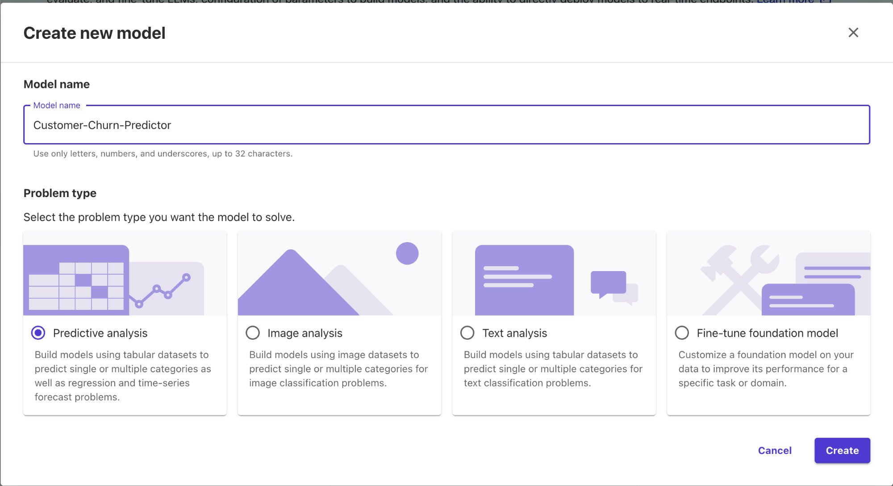
Create new model dialog with Customer-Churn-Predictor as the model’s name and Predictive analysis as the problem type.

Step 5: Select the Dataset
On the Select tab, choose the AWS project dataset (our uploaded mobile_app_churn.csv, now renamed). This dataset shows 7 columns, 25 rows, and 175 cells, created on 03/19/2026 with status Ready. Click Select dataset to proceed to the Build step.

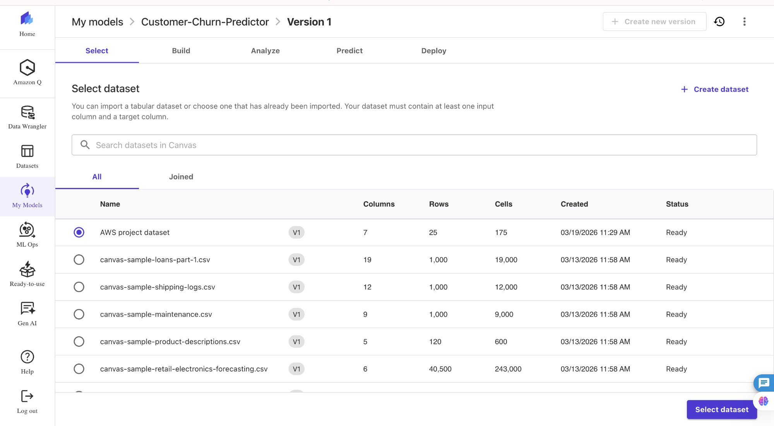
Dataset selection screen with the AWS project dataset (7 columns, 25 rows) selected and ready.

Step 6: Configure the Build — Select Target Column
In the Build tab, Canvas displays all columns in the dataset along with their data types and feature types. Select Will_Churn as the target column — this is the binary column (True/False) the model will learn to predict. Canvas automatically identifies it as a Binary feature type with 2 unique values.

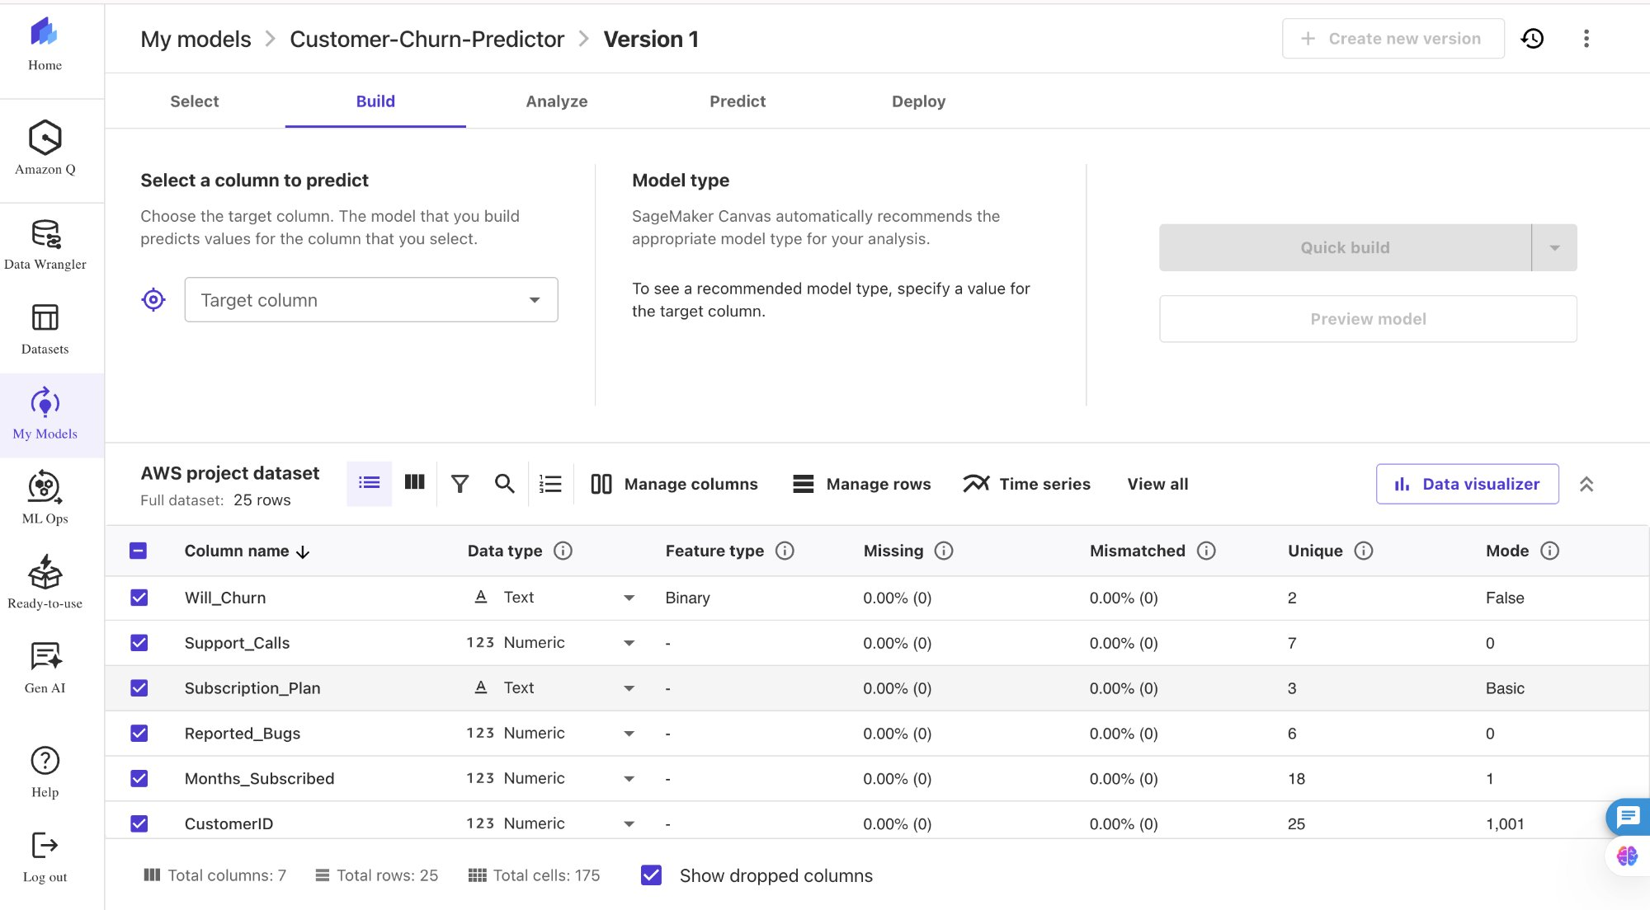
The Build tab showing all 7 dataset columns. Will_Churn is identified as a Binary feature type with Mode = False.

Step 7: Train the Model with Quick Build
After selecting Will_Churn as the target column, initiate a Quick Build. Canvas begins by preprocessing the dataset — handling missing values, encoding categorical variables like Subscription_Plan, and normalising numeric features. This preprocessing runs in the background and may take a few minutes.

The Build tab showing the preprocessing notification: "Preprocessing your dataset. This can take a few minutes."

Step 8: Analyze Model Results
Once training completes, Canvas moves to the Analyze tab and displays the model's performance metrics. The Quick Build achieved 100% Accuracy and an F1 score of 1.000 on the dataset. The Column Impact analysis reveals that Subscription_Plan is the most influential feature, contributing 100% of the model's predictive power for Will_Churn.

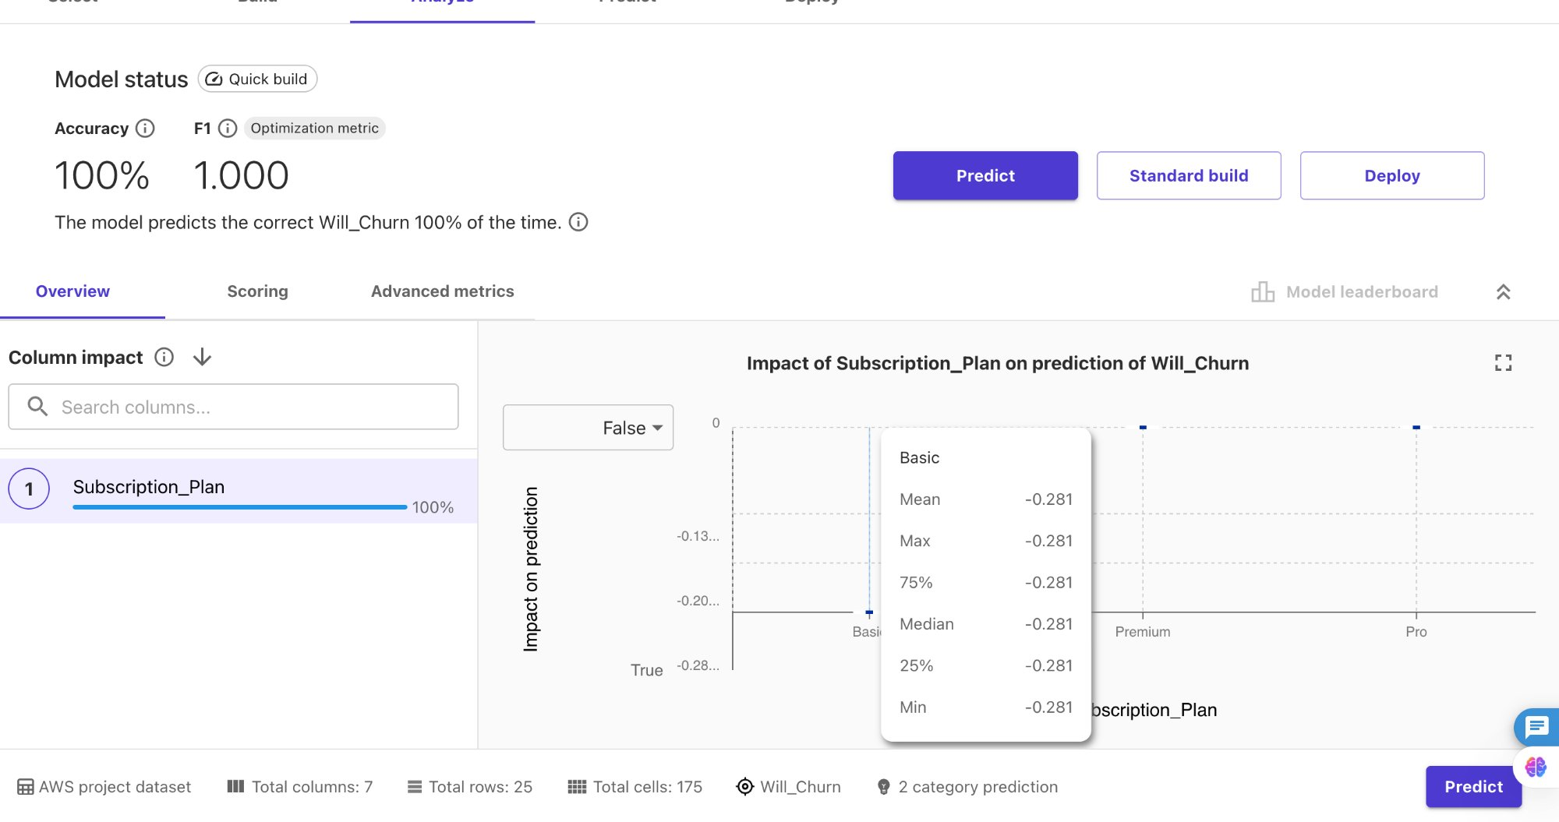
The Analyze tab showing 100% accuracy, F1 = 1.000 (Quick Build), with Subscription_Plan having 100% column impact on Will_Churn prediction.

Step 9: Generate Predictions — Batch Prediction
Navigate to the Predict tab to generate predictions. The Batch prediction option allows running predictions across an entire dataset at once. Predictions can be triggered manually or set to run automatically. The All-Jobs panel tracks all prediction jobs with their configuration, input dataset, and row count.

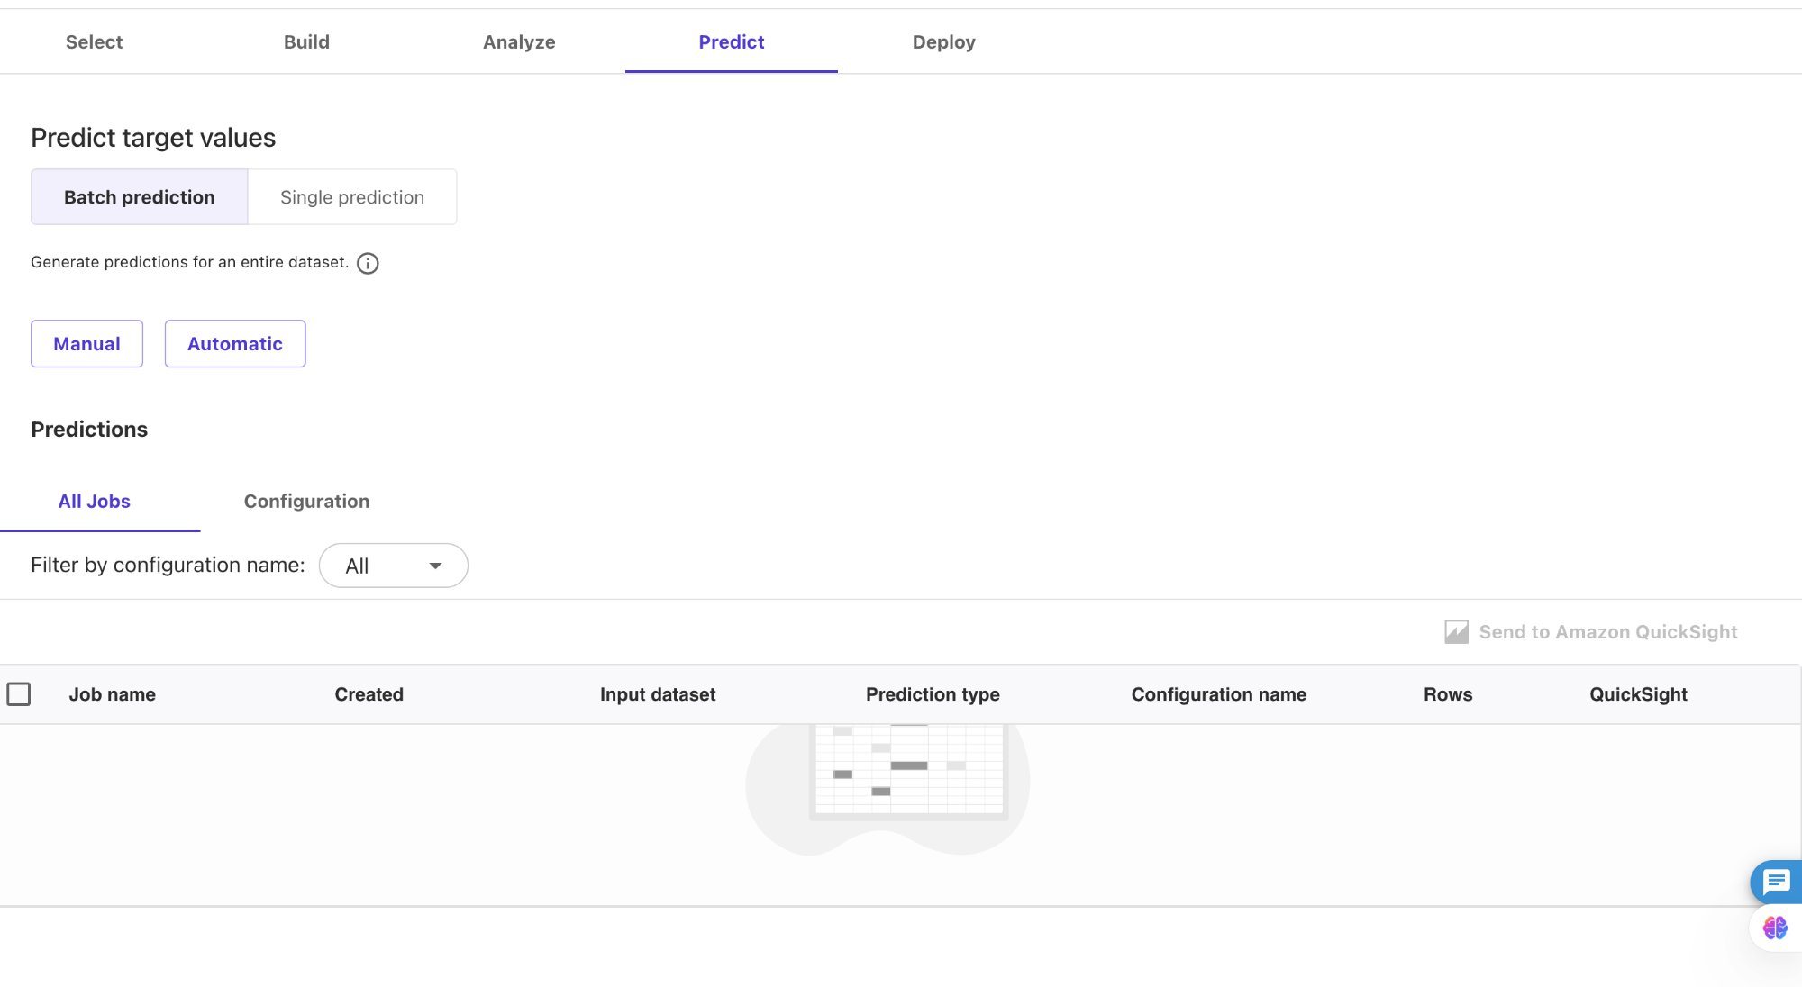
The Predict tab showing the Batch prediction view with Manual and Automatic options. No jobs have been run yet.

Step 10: Single Prediction — Real-Time Inference
The Single prediction tab allows real-time inference by entering individual feature values manually. Entering CustomerID = 1001, App_Usage_Minutes = 10, Support_Calls = 0, Subscription_Plan = Basic, Months_Subscribed = 1, Reported_Bugs = 0 produces a prediction of Will_Churn = True with 53.513% confidence.

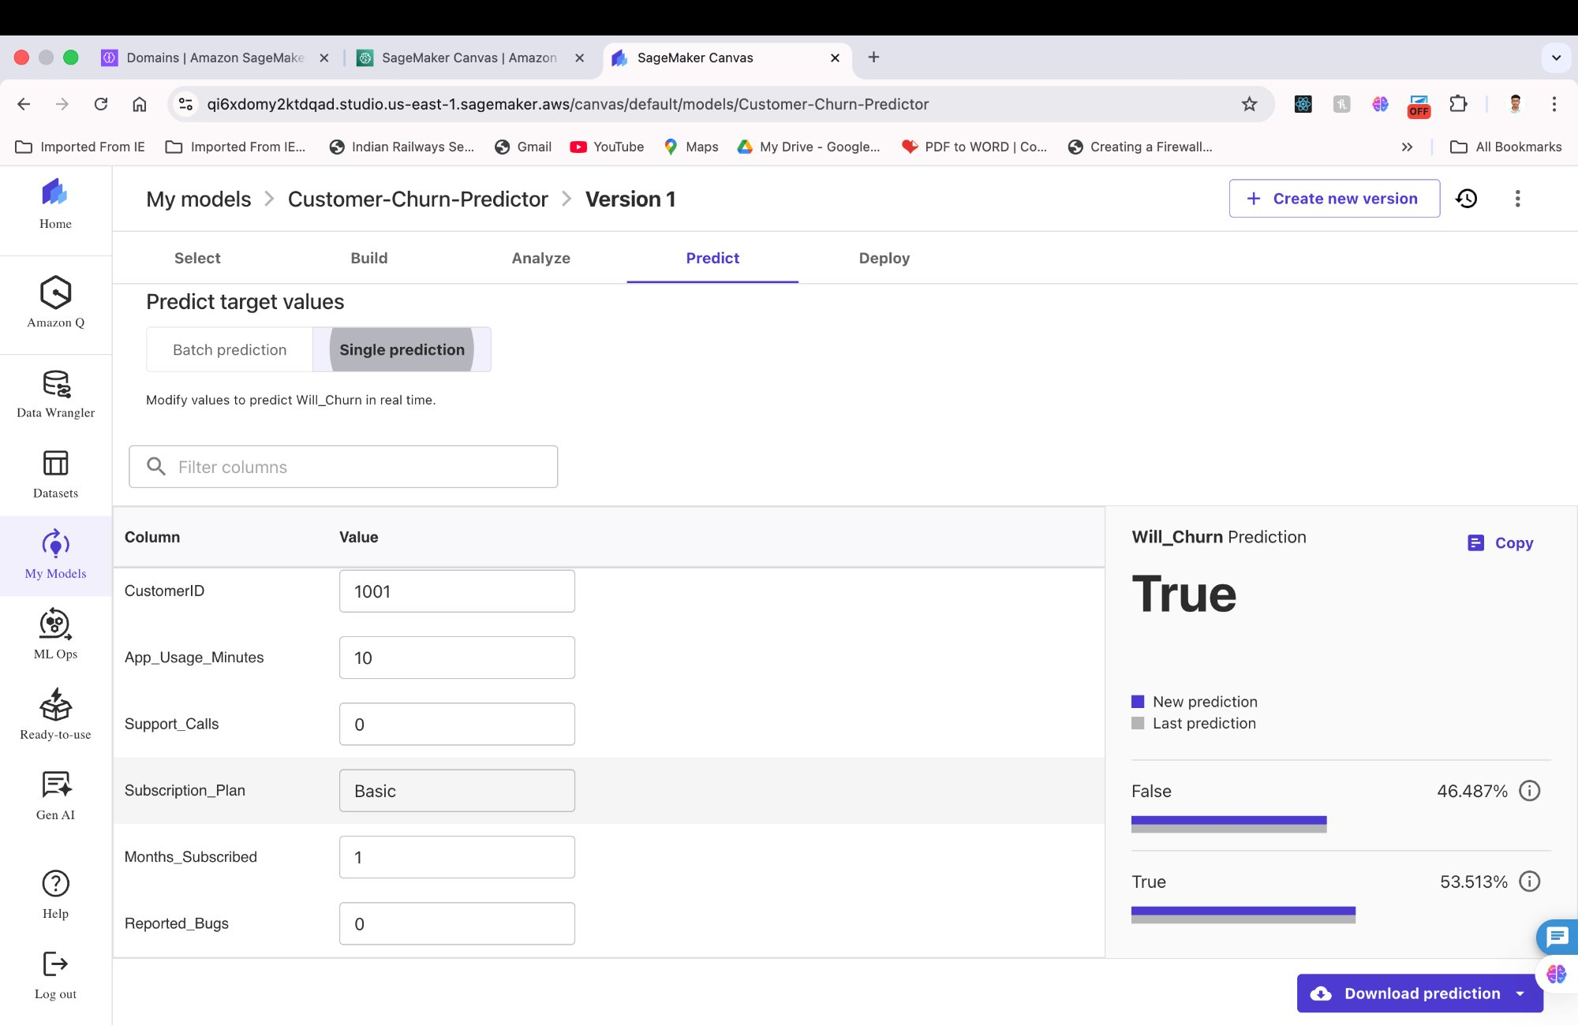
Single prediction for CustomerID 1001 — the model predicts Will_Churn = True with a 53.513% probability.

The feature importance panel confirms that Subscription_Plan carries 100% of the predictive weight, with all other features contributing 0%. This indicates the model learned that subscription tier is the dominant churn driver in this dataset.

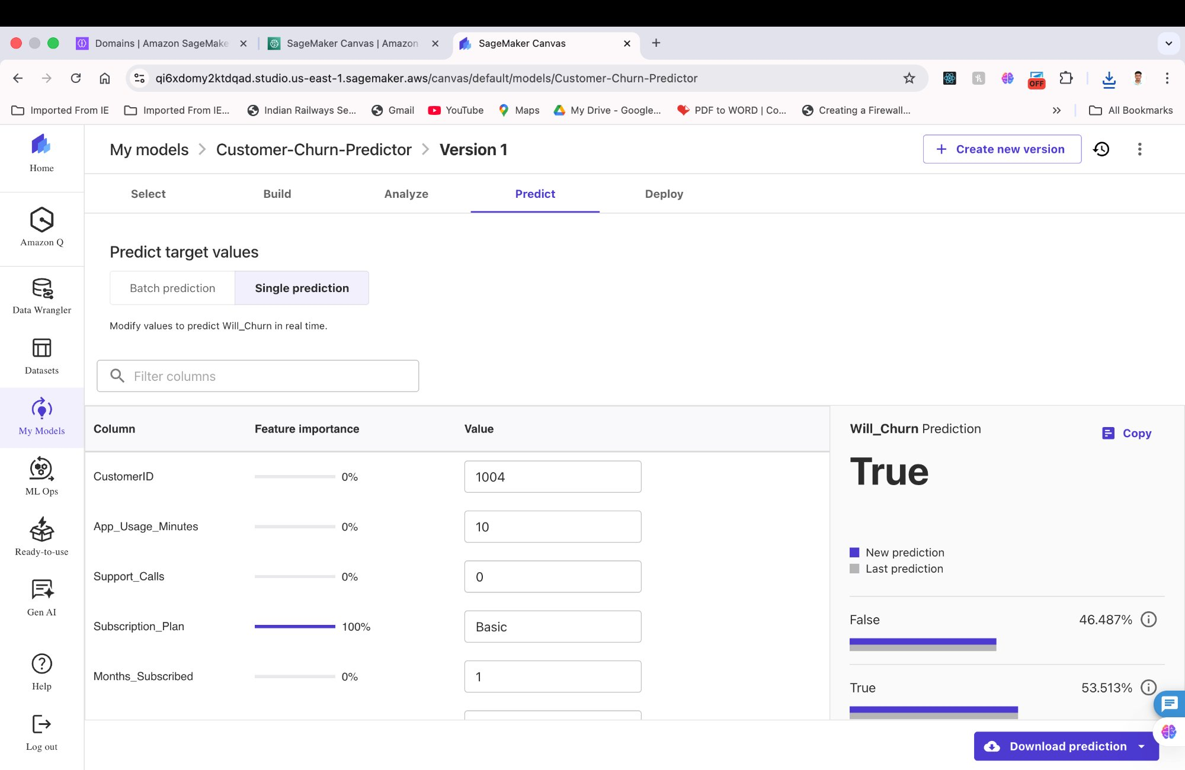
Single prediction for CustomerID 1004 with feature importance overlay, showing Subscription_Plan at 100% importance.

Result: Will_Churn Prediction
The final prediction result clearly shows Will_Churn = True with a 53.513% probability, confirming that the customer is predicted to churn. The confidence breakdown shows False at 46.487% and True at 53.513%, demonstrating the model's probabilistic output rather than a hard classification threshold.

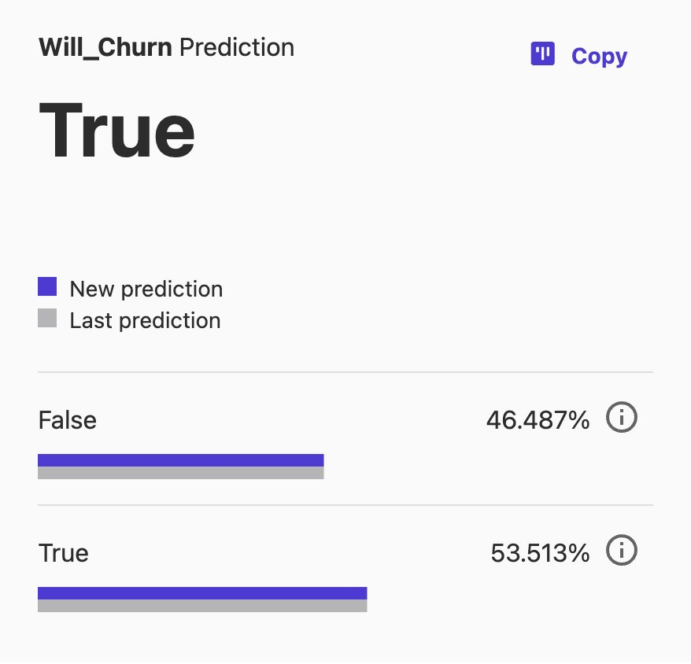
Result — Will_Churn Prediction = True (53.513%). The model predicts this customer will churn based primarily on their Basic subscription plan tier.

