Possession

Divine Intervention

Stealth/Action

Special Weapons

Normal Weapons

Different types of enemies

Regen mechanic and ammo refill, special weps

Night/Day/Alarm army bases

Relationship between Devil and son

Relationship between Devil and archangel

Projectile possession

Cutscenes between levels

Objective to damn the special person in each level

Advancing through levels, gaining new weapons and abilities

Possess someone, lose your body, gain instant hp, lose regeneration but gain ammo.

Angels from divine intervention can possess humans

Darkness at first, first mistake that breaks stealth, lights up the whole level

Ammo based npcs, limited ammo overall, incentive to always change possession

Top down shooter

Pixel art

Gore+blood

No Mormons

Specialized npcs – heavy npcs can carry macine guns

No “boss fights”

Music changes when transitioning between stealth and action

What happens and how does the demon end a possession?? Teleport next to the possessed?

Possession is a slow projectile

Starts from origin and goes to mouse position

If it hits an enemy, it possesses it, if it doesn’t hit anything you end possession and appear at the mouse position

Limited charges on possession, regen by killin enemies

Maximum insanity enemies, kill themselves, damaging you and alerting nearby enemies

High insanity enemies become unpredictable increasing their damage and enabling friendly fire. ???

NPC anti stealth patrols.

Different colored doors ?

Possess colored npcs to access these doors ?

Killing colored npcs give u key

Divine intervention increases if you kill

Once it reaches maximum, angels come in the level and hunt you down

Bottom left Health(globe ex: diablo) and charges(globe :Price of Persia) around the health

Bottom right Demon Sensor(Sonar, from interior to exterior) and insanity level

Over the top dialog ( ex : hmm, aaahh, ugh)

Mind room (intermission area), dark around, in game when insanity is close to full you get tendrils around the screen(small), Demon father “overlaps” your character when you kill (at random) when you get charges

No collision with NPCs, only with walls

100% divine level will get divine intervention, angels come down and can posses other NPCs

Divine level stacks, how many angels come is not considered yet because it depends on balance

You get stunned 3 seconds until angels do their stuff(arrival animation, posses etc)

Name from latin with some changed characters for each individual(The Law, The Judge etc.)

Demon portal looks like warlock portal to order hall, the target is sucked by that portal to hell.

Level end you get a scoreboard with information on relevant parts of what you did(enemies killed, health regened, etc.)

Ultar: archangel

Matra’zim: Demon father

Initial phase of the game: 9 levels split in 3 zones each(The third one being the target)

1 difficulty

New Game, Continue, Level Select(No Cinematics), Maybe Rating System. 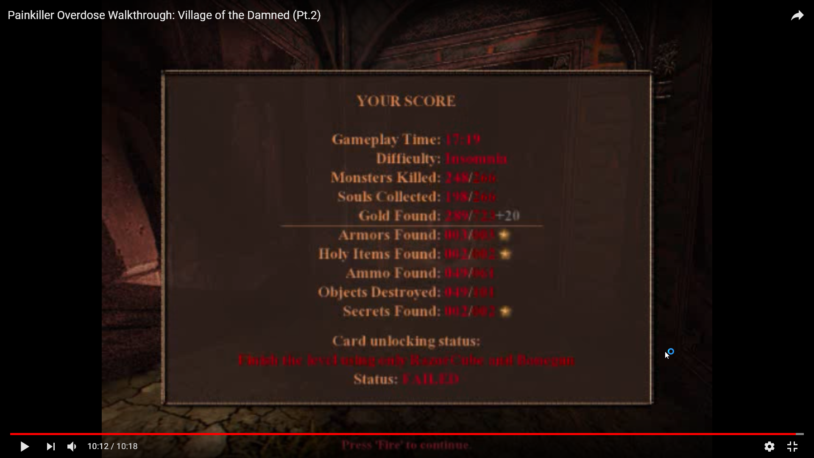

Level Reset on Death. Saves at the ending.

Score Multiplier Mini Event at the end

1 week for Design (Everything in the game put in documents, including a marketing and advertising plan.)  
3 weeks of Concept Design (UI,concept art, pixel art, sound design)

Prototype (Art + intial character + basic sound and interface) 2 months

Rest of the game (additional levels and enemies and functionalities) 3.5 months ~

1.5 month marketing + bug testing + presentation

