**API Architecture**

The Global Trade Visualizer API is a REST API that is responsible for providing the front-end layer with the information it needs to display to the user. Therefore, it is important that the structure of this API ensures fast performance and maintainability.

In order to achieve these goals, the structure of this component is following two major design patterns, the MVC and Repository patterns.

Firstly, the MVC pattern in the context of this API mainly means that the data the system requires is stored in a model and accessed/modified by controllers.

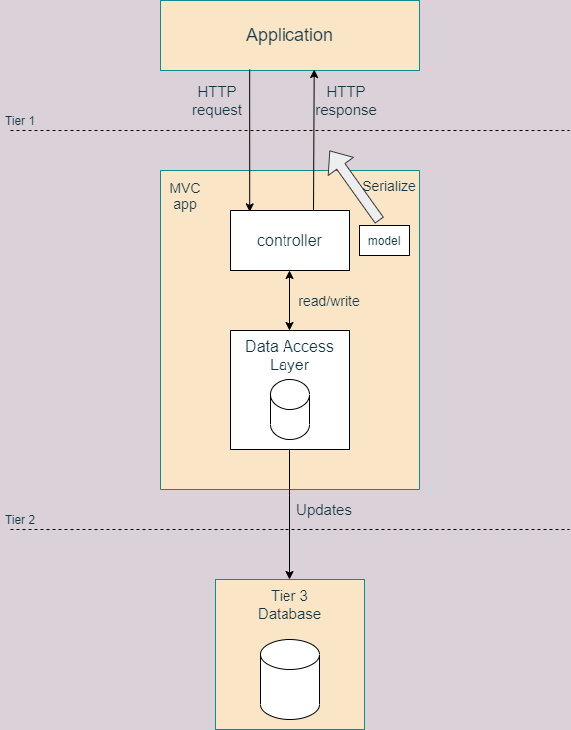

This pattern ensures that the business logic is completely separated by the view and the information (model) is manipulated by components with strict and clear responsibilities (controllers). This way the application is further modularized and contributes towards the goals of having a fast and maintainable system. Through these separations of concerns the system can access only the data it requires for certain tasks through specific controllers and it also allows for unrelated functionalities to still work if others fail.

However, this design pattern does not ensure that the system is completely modularized and easily scalable. The high coupling between the API and the data access layer is an issue that the next important design pattern aims to solve, the repository pattern.

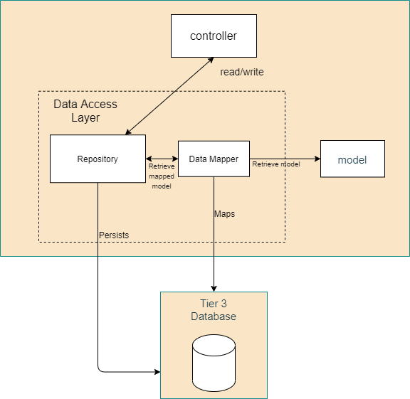

By inserting this Repository component into the structure of the API it creates an abstraction layer between the before mentioned layers. This means that the API is loosely coupled to the data layer as the logic for accessing and retrieving data is stored in the repository component. The API now only knows what procedures to access in order to retrieve data but no specific implementation is required.