**System Architecture**

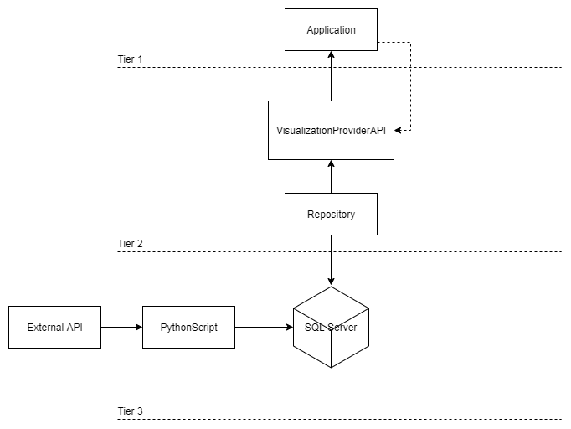

The design of the system follows a three tier architecture. This way the system is separated into 3 different layers with their own unique responsibility.

The first tier is the interface layer which consists of the User Application made in Unreal Engine, this layer being responsible for the graphical representation of the content and information to the end user and communicates with the second layer through API calls.

The second tier is the application layer which contains the business logic responsible for providing functionality to the presentation layer.

The third tier is the data layer which consists of the storage system, in this case it contains the database system which is queried by the application layer.

By using this layered architecture, it is ensured that the system is modularized which helps with hastening the development process as work load can be divided and balanced among developers specialized in specific areas/technologies.

Furthermore, modularizing the system into these layers makes the system more easily scalable as more functionality can be added when needed into these specific tiers without affecting or requiring other changes in the other tiers. This also means that the cost of one of those layers failing or crashing is reduced because it only affects their own layer, therefore the other tiers’ performance will be less impacted than in a non-layered system.