Customer Profiling

The marketing manager wishes to have a report on customer Profiling in order for him to have an overview of the company clients.

One of first steps is to create a project in SSDT and add a data source.

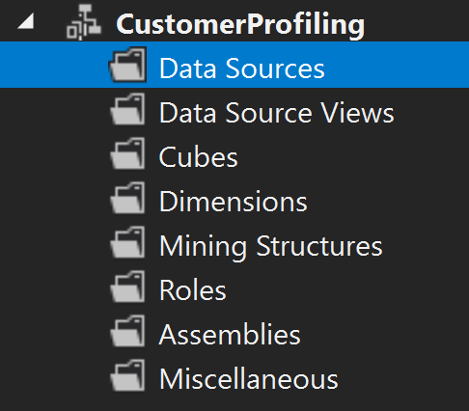

The process of creating a new data source begins by setting up the connection between our data warehouse model found in SSMS and the Analysis Services project.

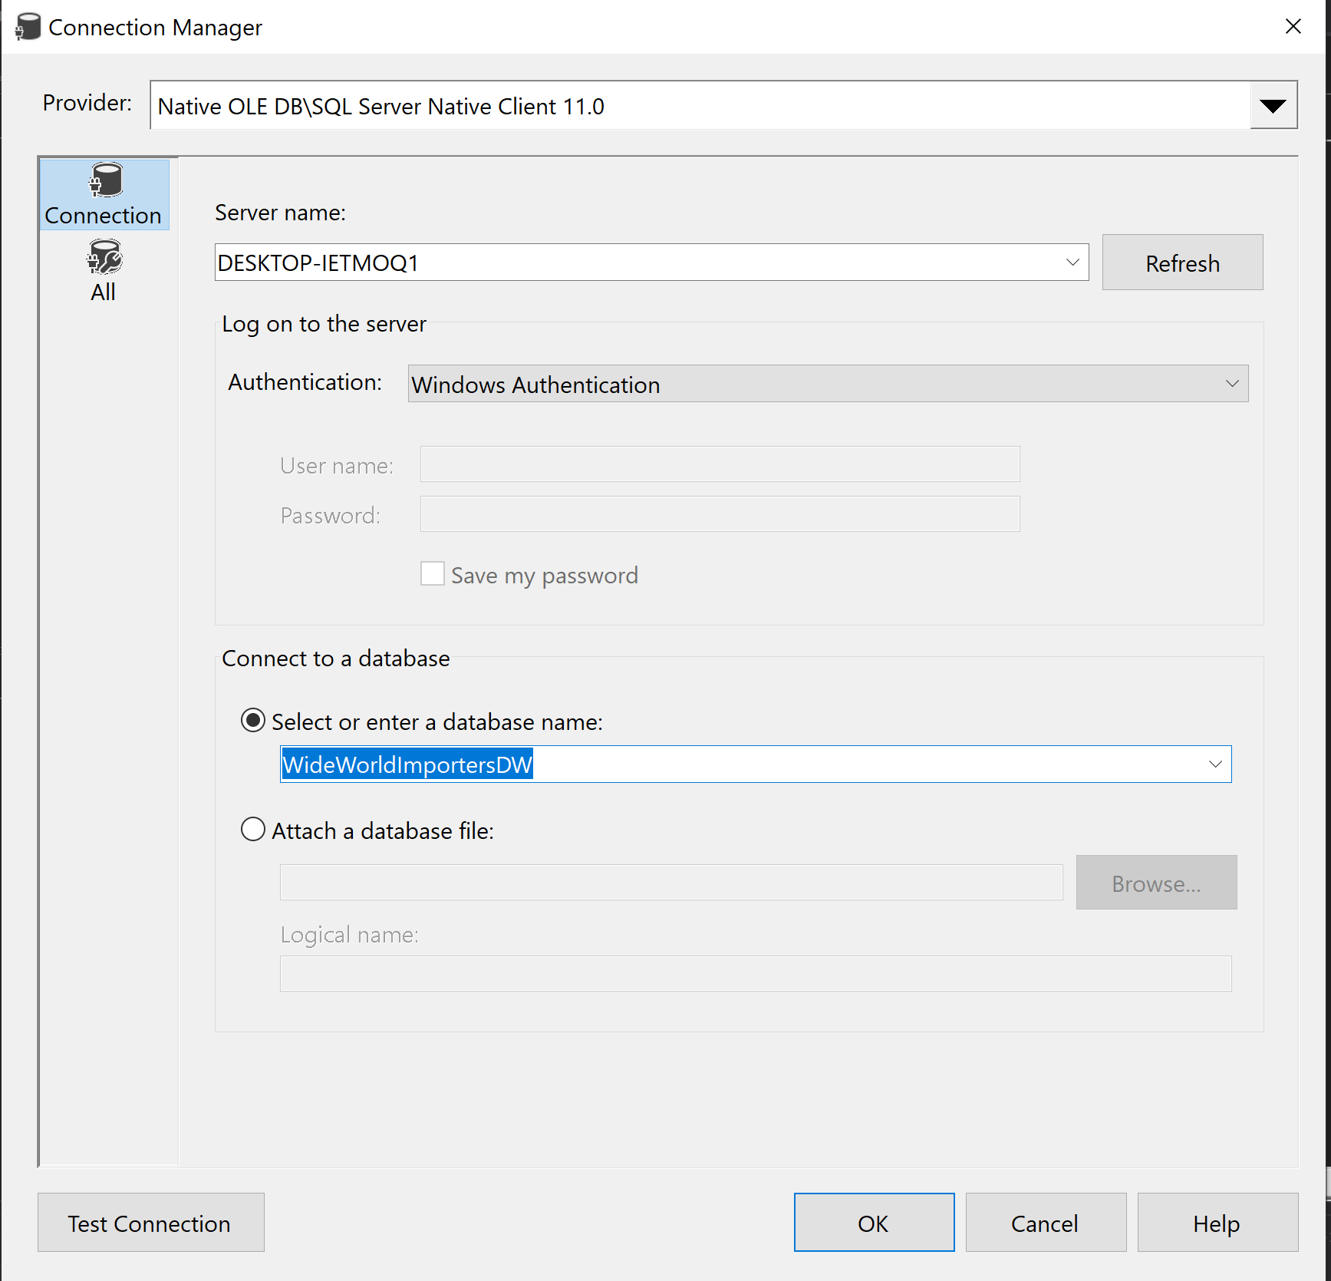

Furthermore after setting up the connection we have to introduce our user credentials which will be in case the system current ones.

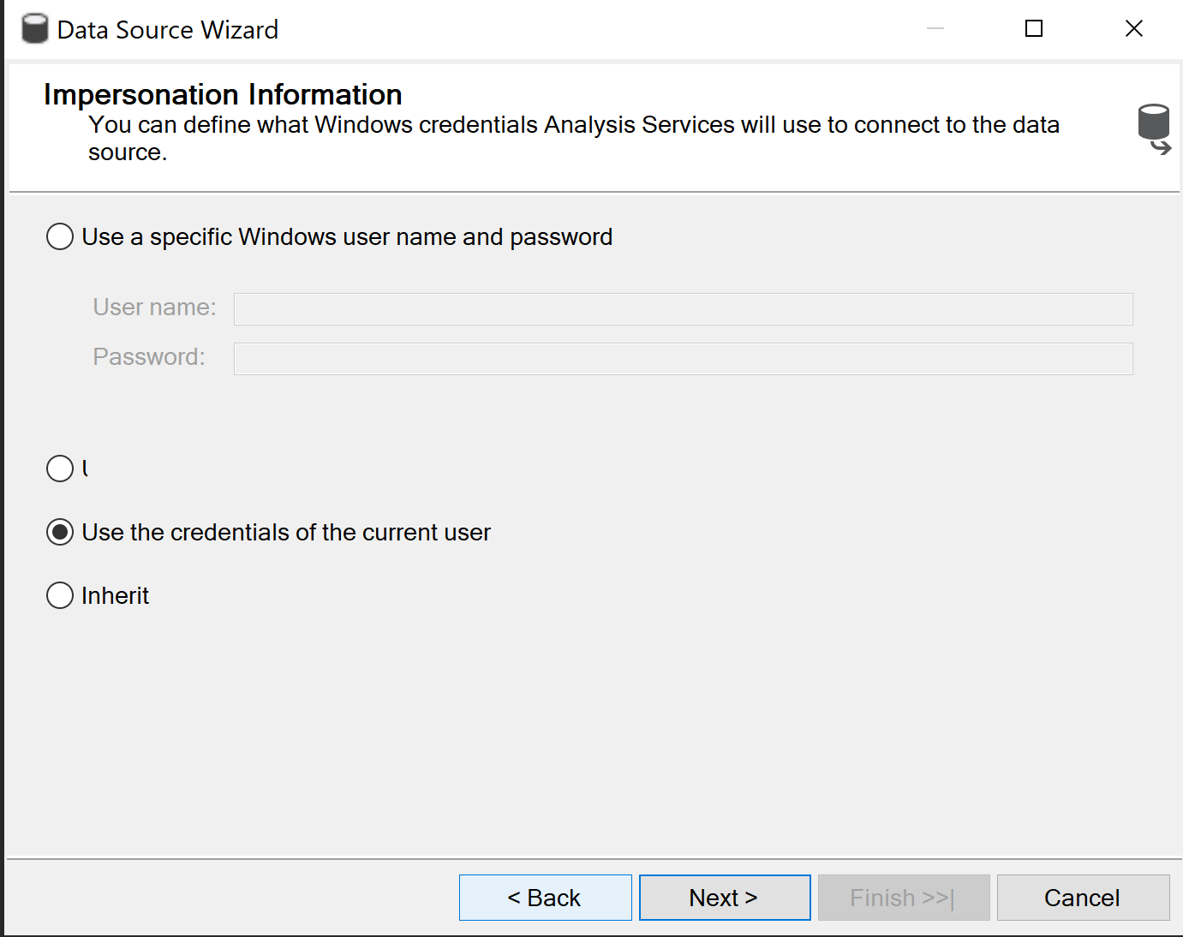

When everything is done we can see that the *data source* was added into our project.

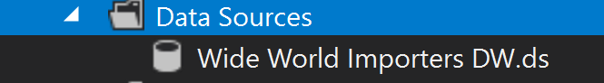

After creating the data source we will move further into adding a *data source view* which is necessary for our cube. In there we gonna select the tables which are necessary for the item which includes the Sale fact table as well as the dimensional ones

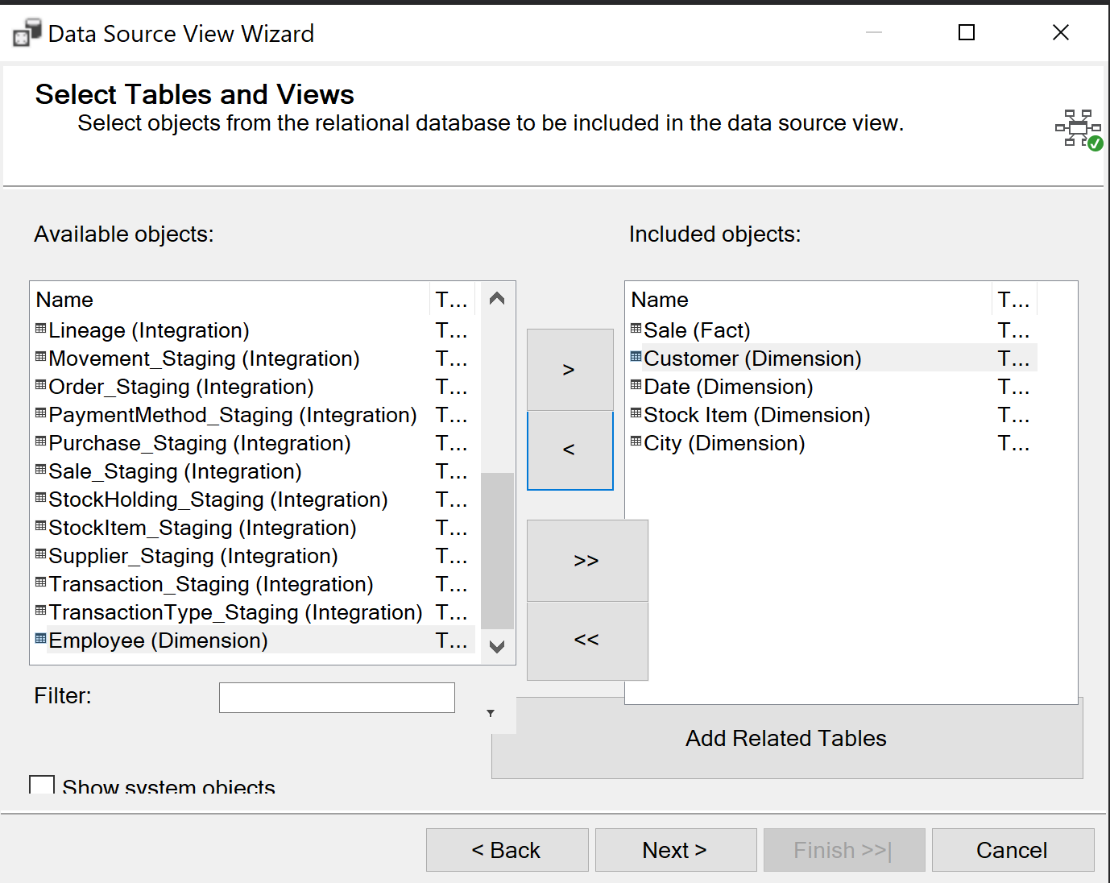

Finishing with the creation of our data source view we can move into *building the cube*. In the first phase we have to add the view to our cube.

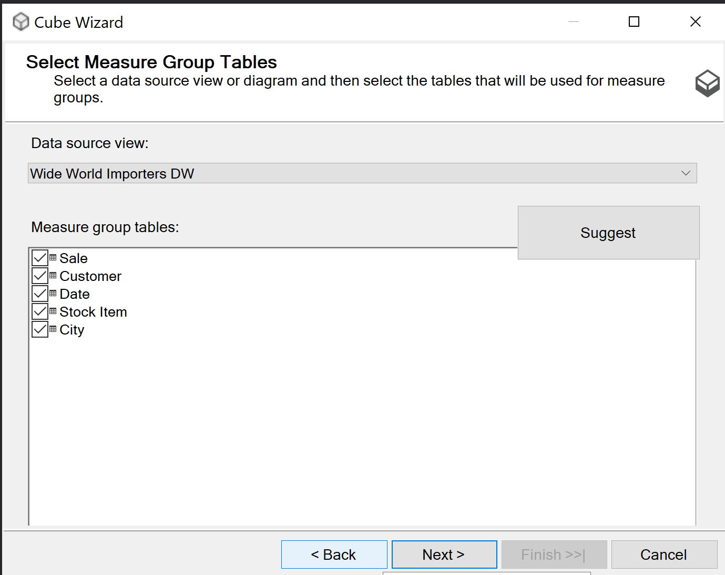

Afterwards we can select which *measures* do we need in our case for the moment we gonna keep all of them as we might find them useful later in the process.

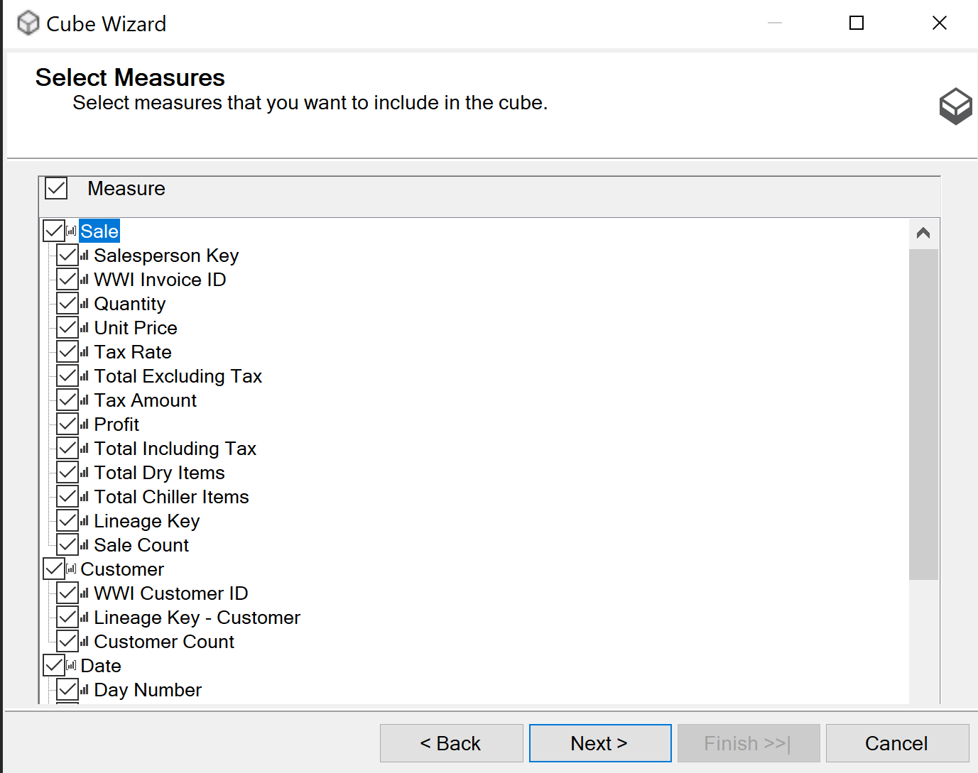

Concluding with the cube wizard process we can now see a digram that represents our cube, displaying the tables and the relationship between them.

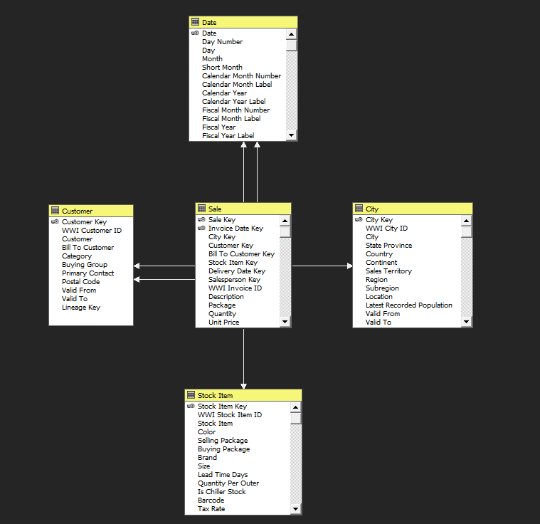

Once we have our cube ready we can start adding modifications that would be useful for our reports, for example we can add a *zone hierarchy* in our City Table.

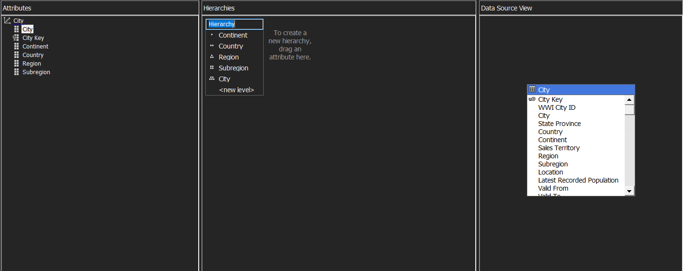

After making all the necessary adjustments to our cube we are prepared to *deploy it to analysis services*. Now if we go to the SSMS the *cube can be browsed* from there.

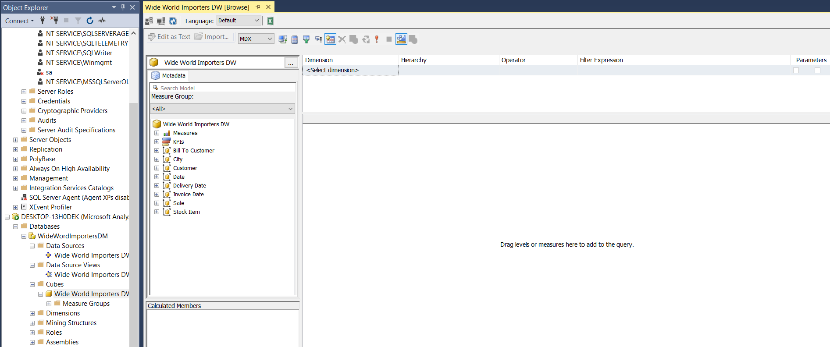

The next step of our process is to create the reports into PowerBi which is a data visualization tool

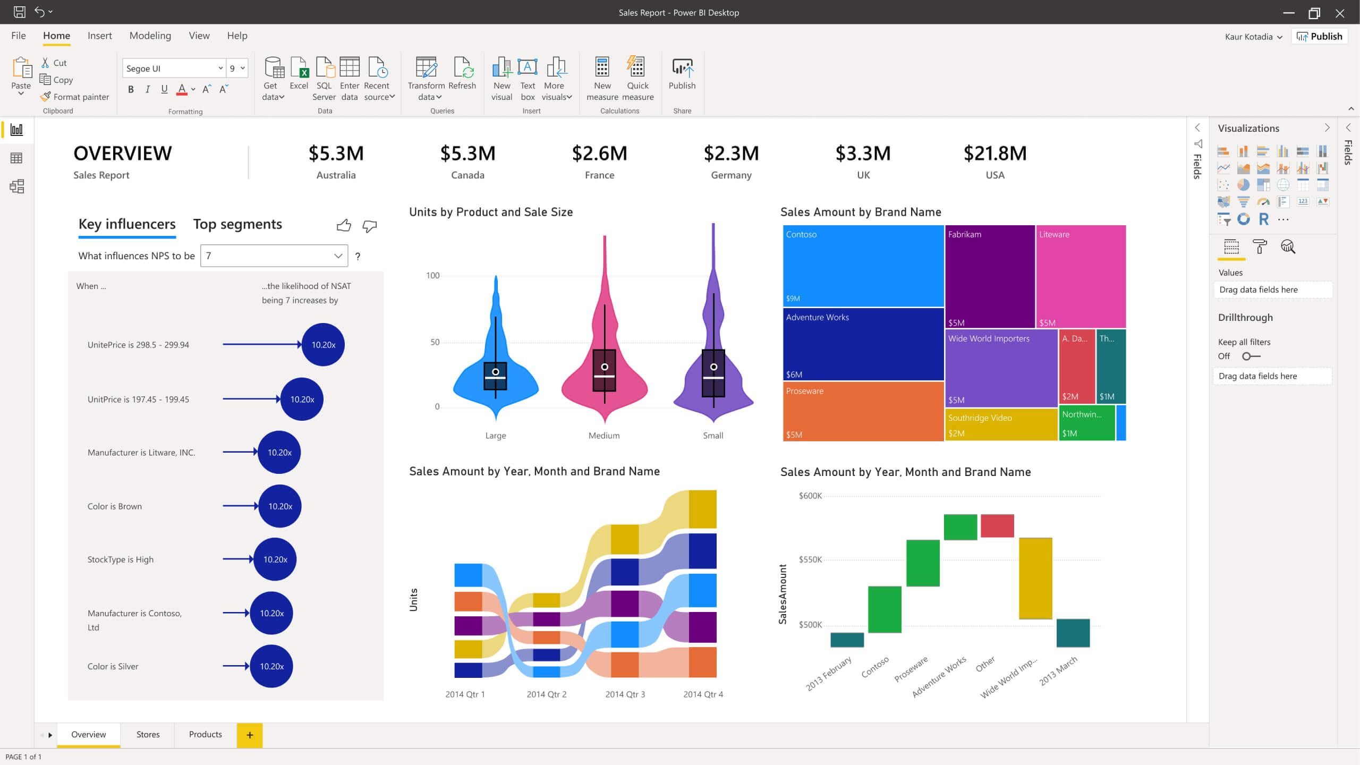

To begin making our reports first we have to create a connection, this could be of two types *import or live connection* as you can see in the picture below.

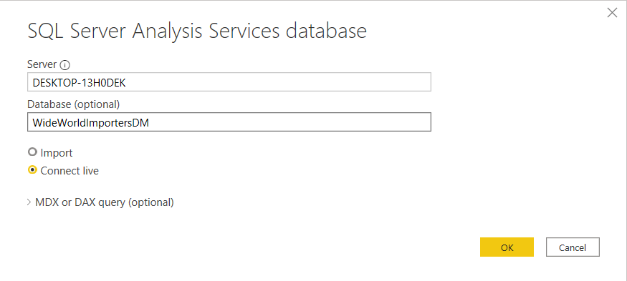

Once we are done with setting up the connection we can notice that our cube data is now present into Power BI as well.

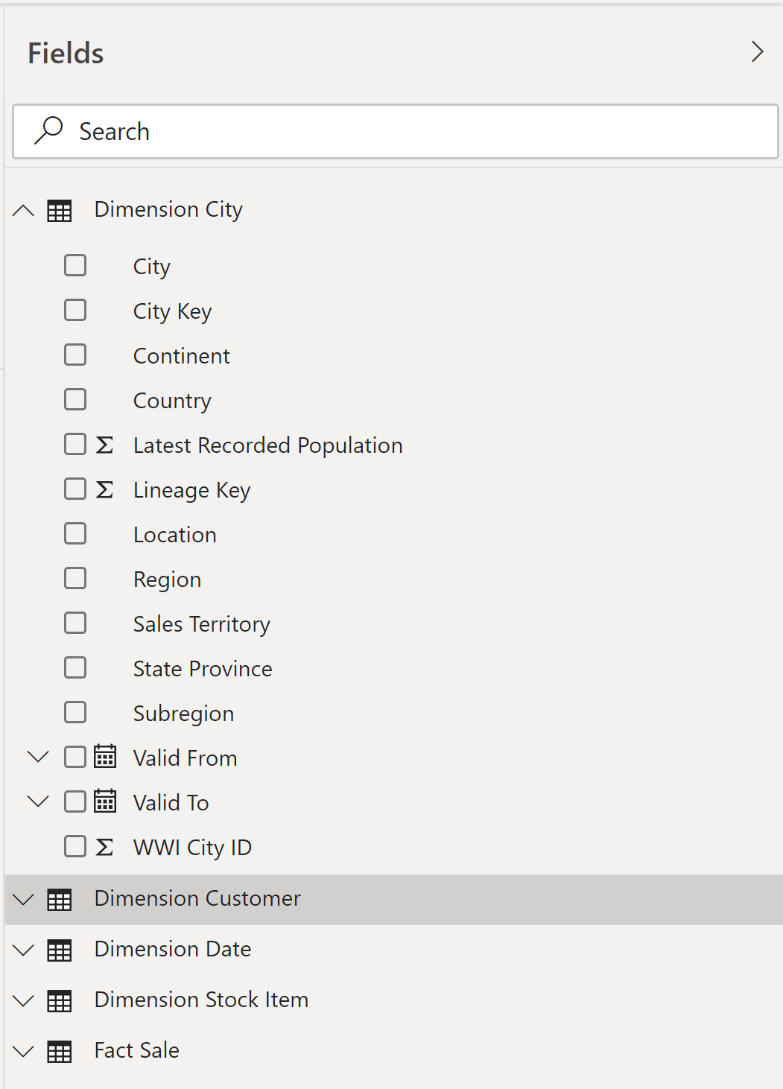

After that we can begin creating our reports for the marketing manager to better understand the purchasing patterns of the customer and how improve the company interaction with them.

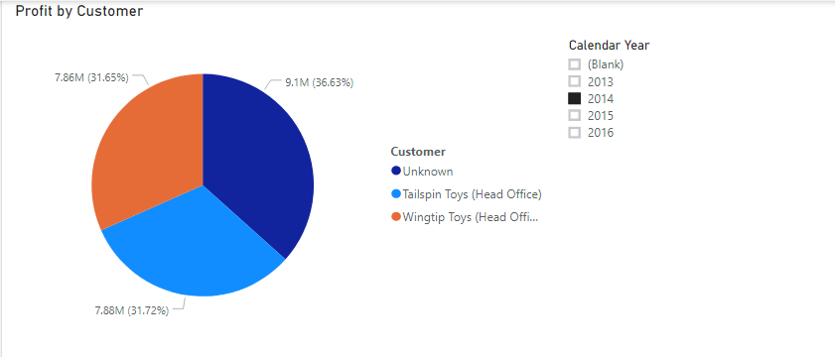

One of the first reports that was developed is it “Profit by Customer", which is *pie chart* where the manager can observe the profit generated by each customer, as we can see in the picture above we have two companies “Tailspin Toys" and “Wingtip Toys" that are our main clients, altough a fair share of the market is represented by unknown customers which can mean that the marketing team needs to gather more data about the clientele. Furthermore we can also see the profit over different years.

To further improve this report we can add a *drilldown* and use another atribute which will be the color of the items in order to see if the item color has any corellation.

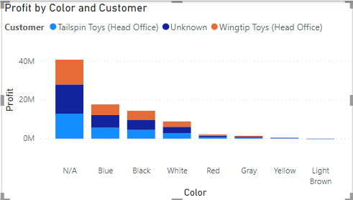

As we can visualize for most of the items the color of the object was unknown so it may require more data for a better analysis.

Another perspective for our manager which is worth taking into account is the city from where the customers come from, for that reason another report was created where can see the profit generated from each city.

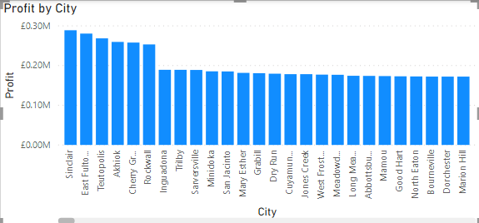

From the report we can notice a few outliers city where the profit is higher but for most of them we can see that there is a constant trend.

Another important aspect which is necessary to be acknowledge, is the items in which the customers are the most interested, for that reason the next report was created.

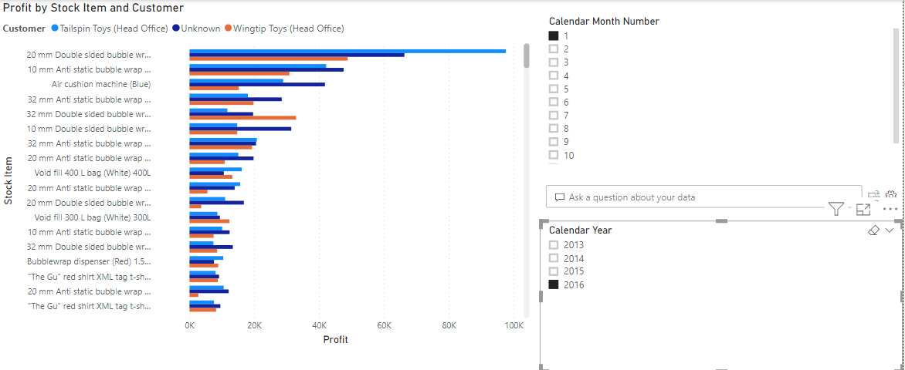

In the above picture we can see the profit by stock item and customer and observe which products are the most bought by the clients, moreover by adding two slicers we can also gain insights into which item was the most popular into a specific month of the year.

To expand our perspective on the data we will do a further analysis using Microsoft SSRS. One of the first steps will be to create our project using SSDT.



Afterwards we must create a data source in order to get the data into our model

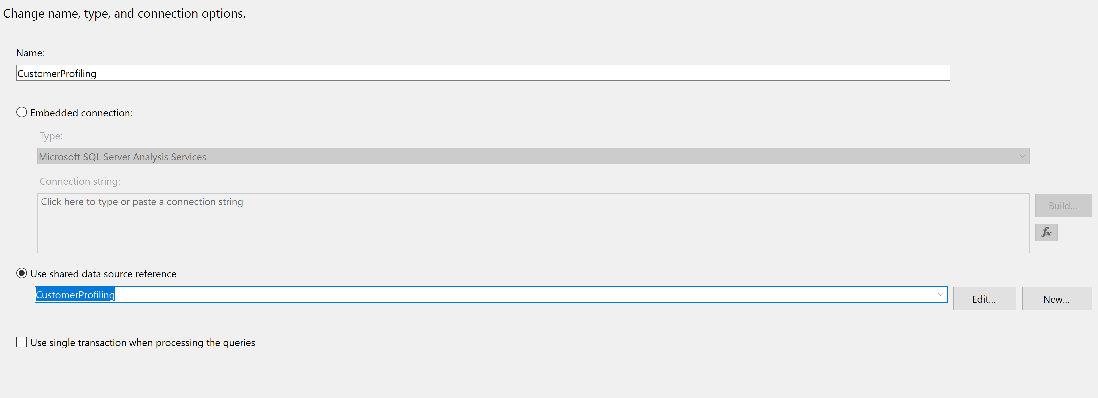

Then from we gonna extract into our datasets only the columns in which we are interested, in this case we will further explore the relationship between the customers and their residence city.

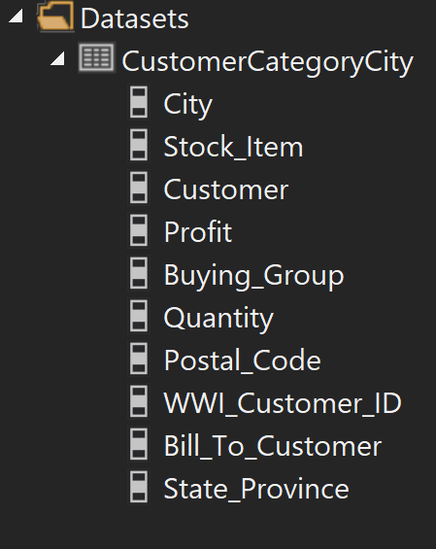

After creating our dataset we can continue by creating our model with the desired colums *using the matrix template.*

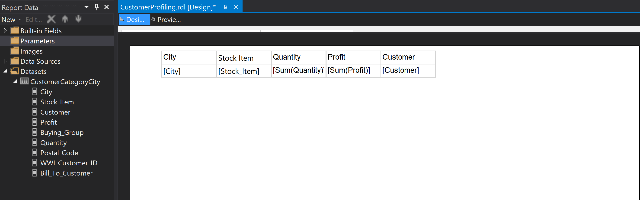

To improve our model we can add another column named “State province" and using the *drilldown* we can see from each state in which city there are customers and the profit generated by them.

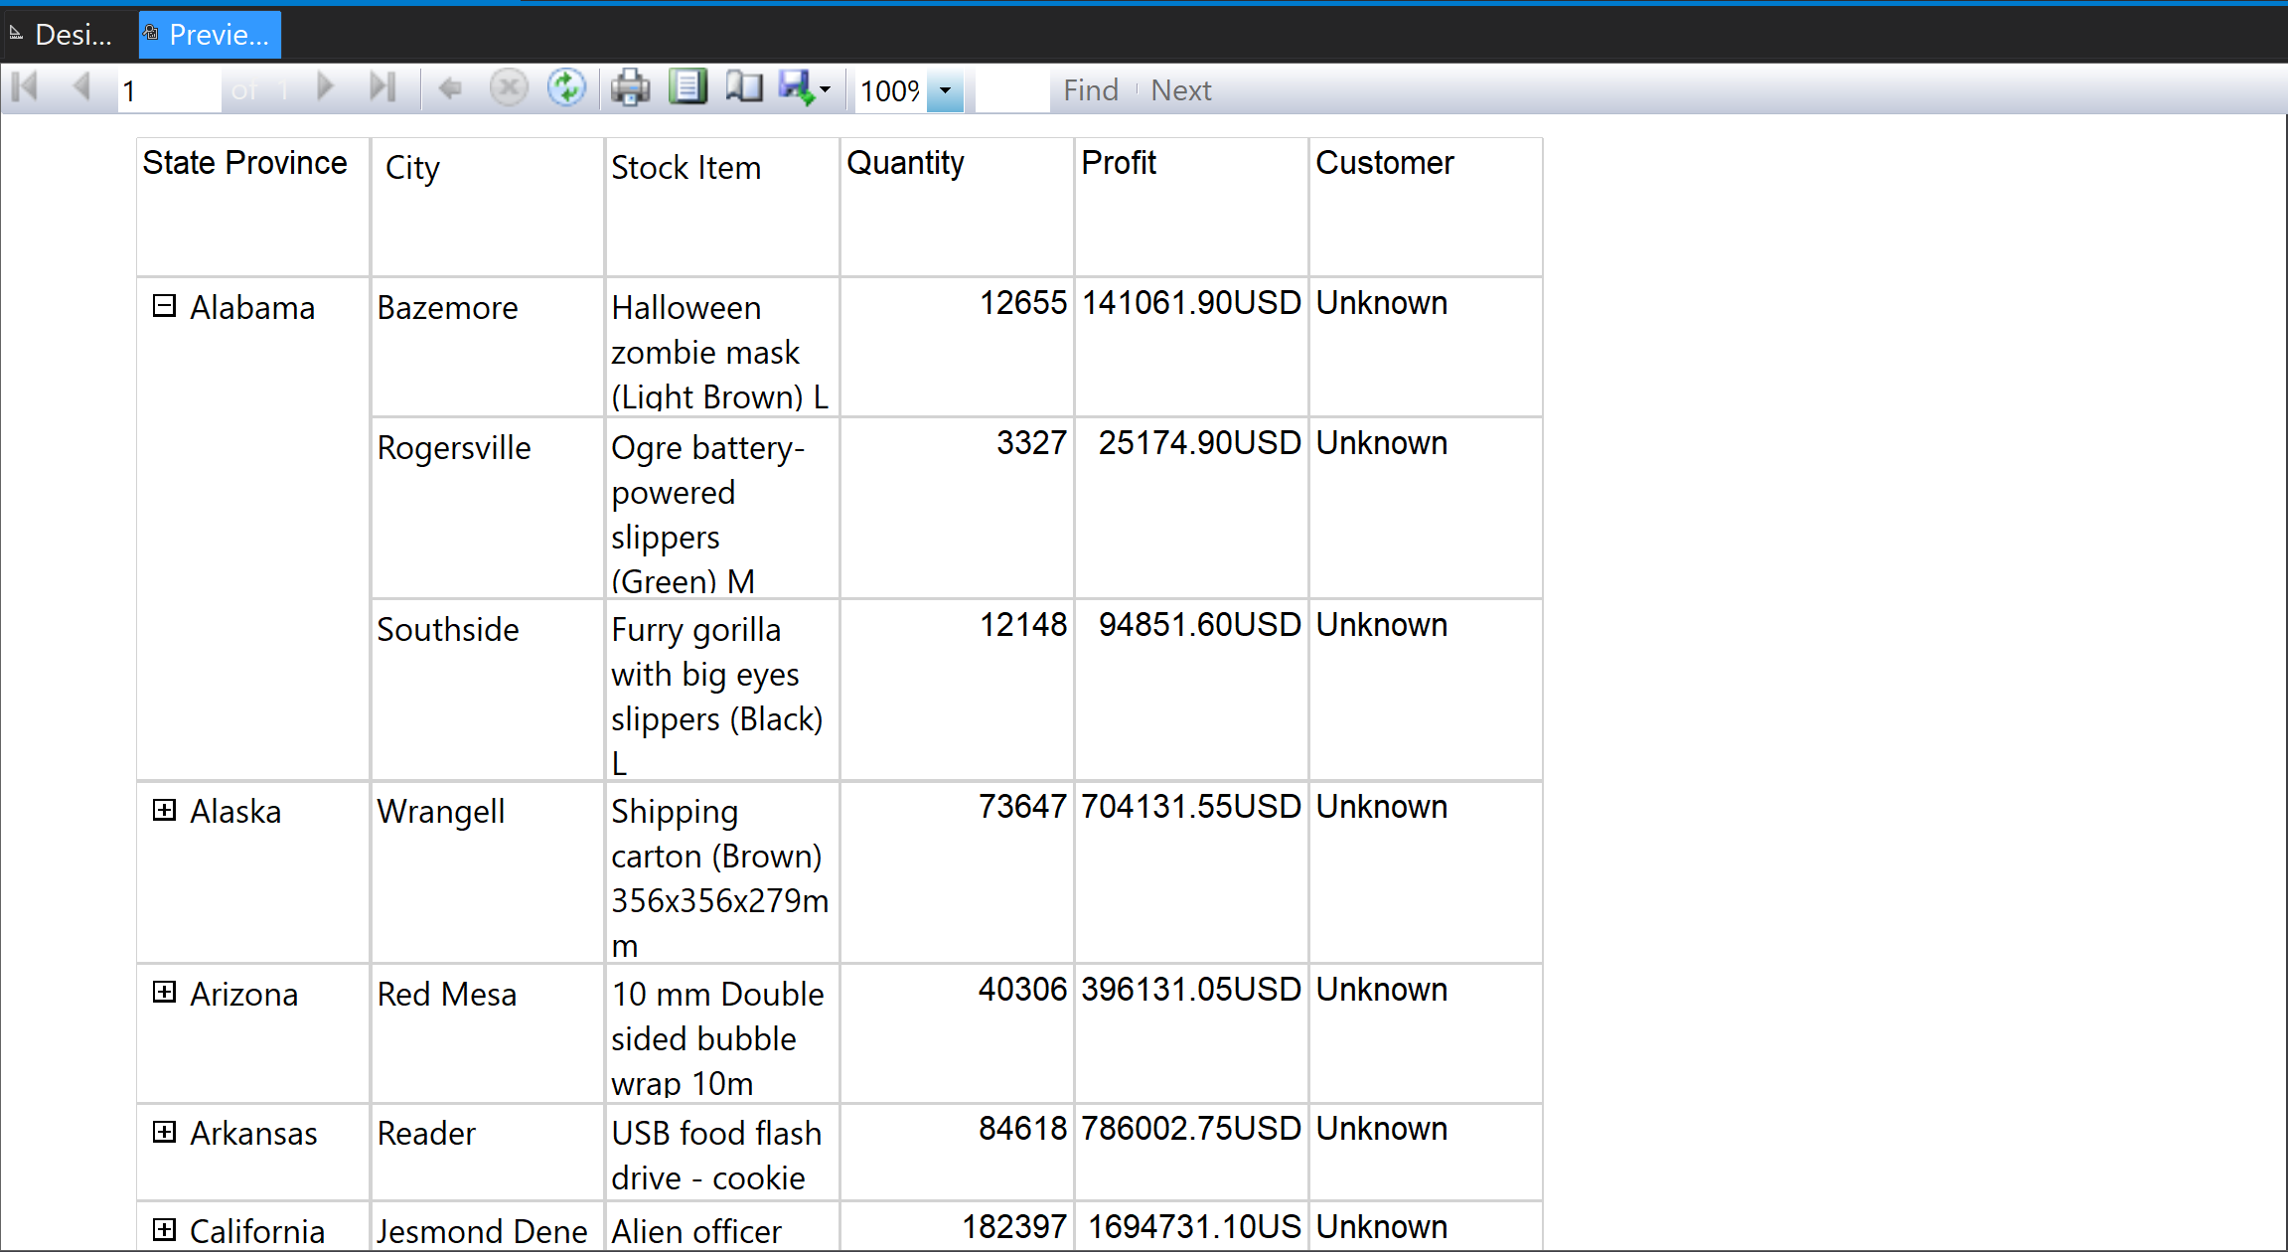

After finishing our report we have to set up the server in order to *deploy it*. For that purpose we gonna use the Report Server Configuration Manager.

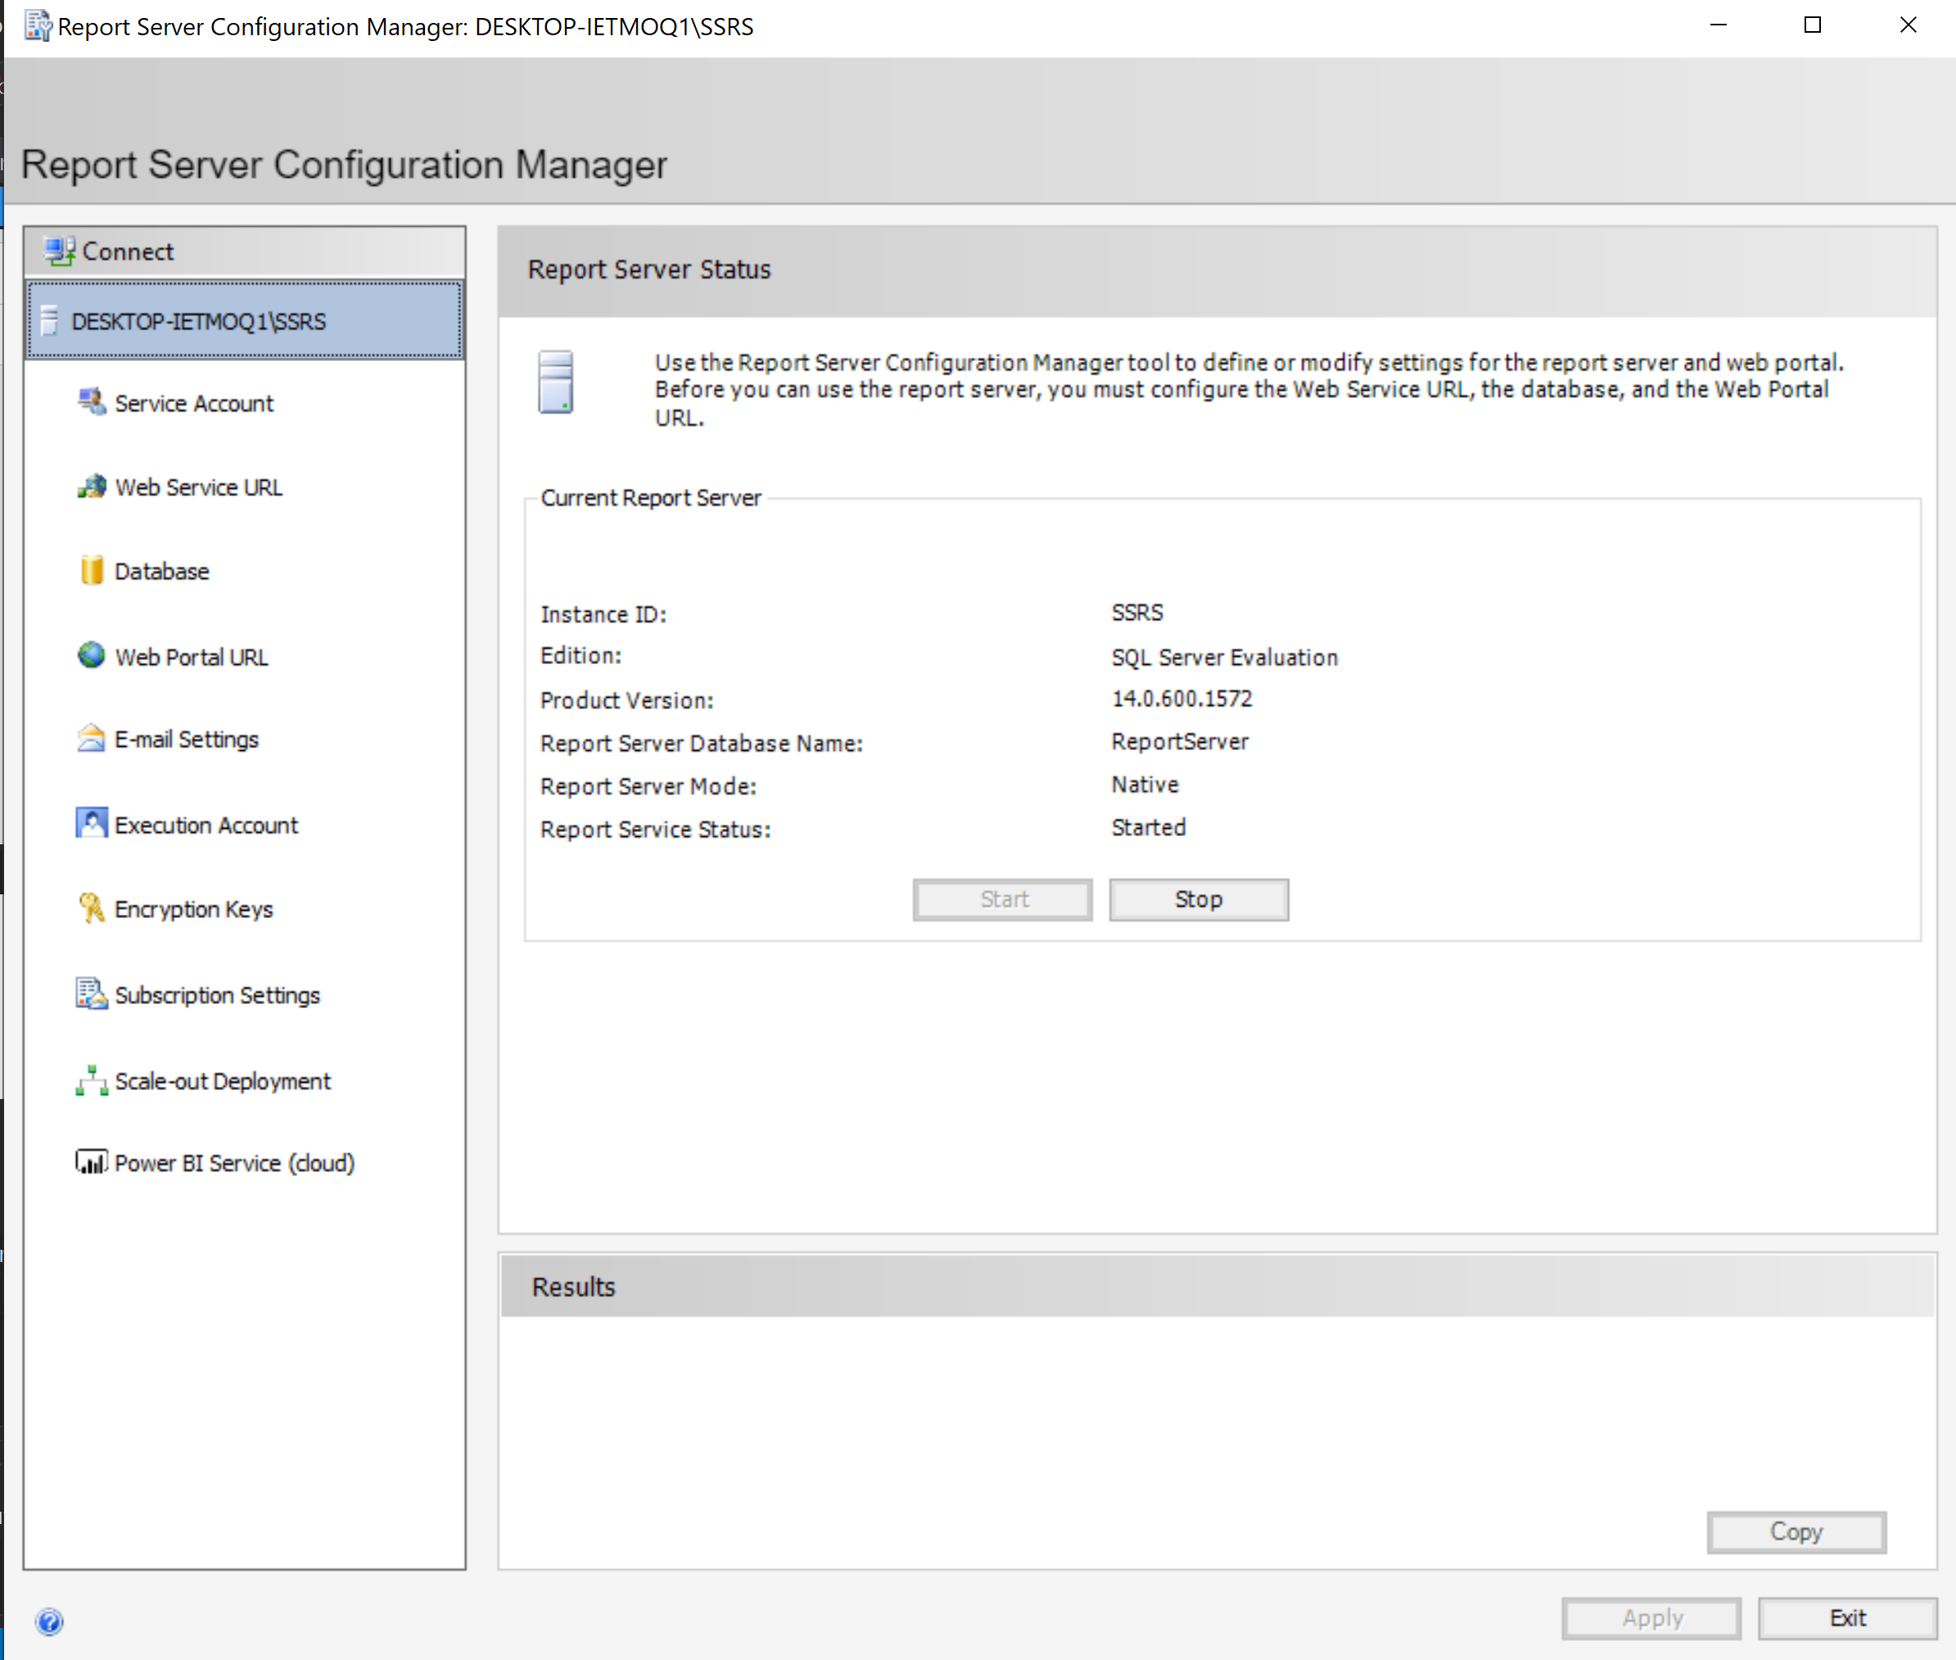

To check if our server is online we have to acces the “Web service url'.

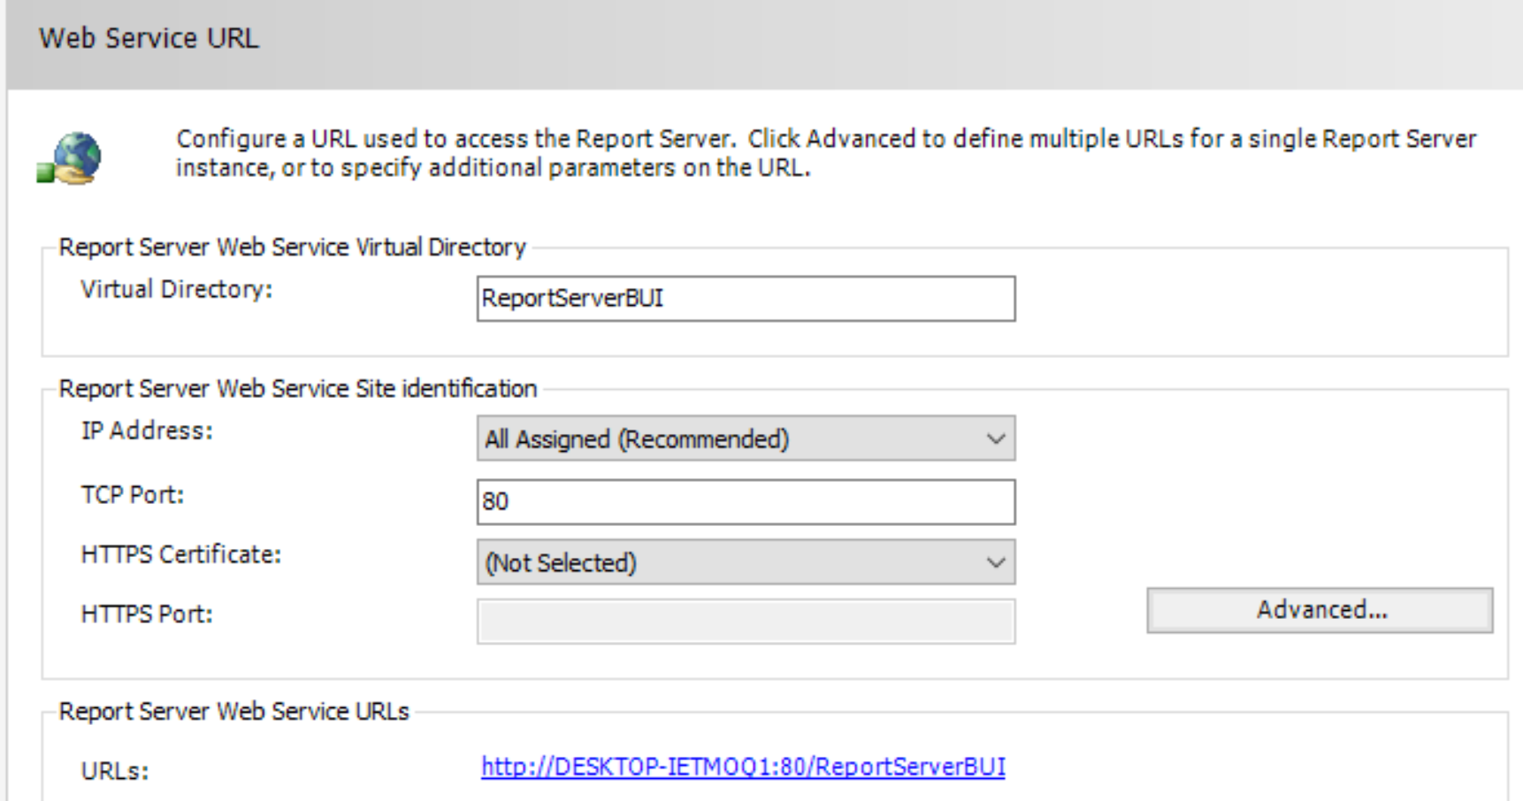

If when we acces the url a image similar with the one below pops up it means that the server is live and we can start using it.

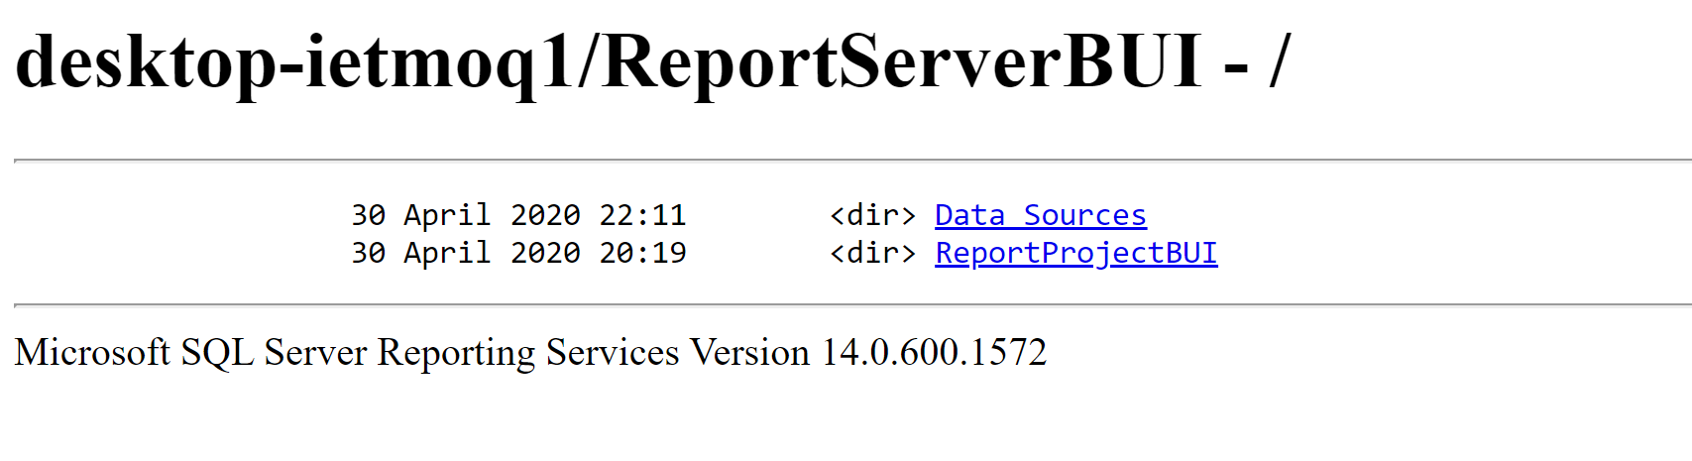

After deploying our data, in order to display it we have to use the “Web Portal url" which can be found also in the “Report Configuration Manager"

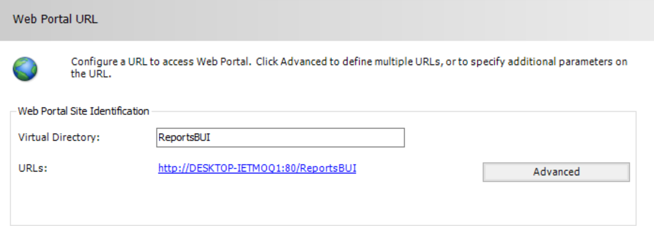

If we now acces the this link we will able to see our data.

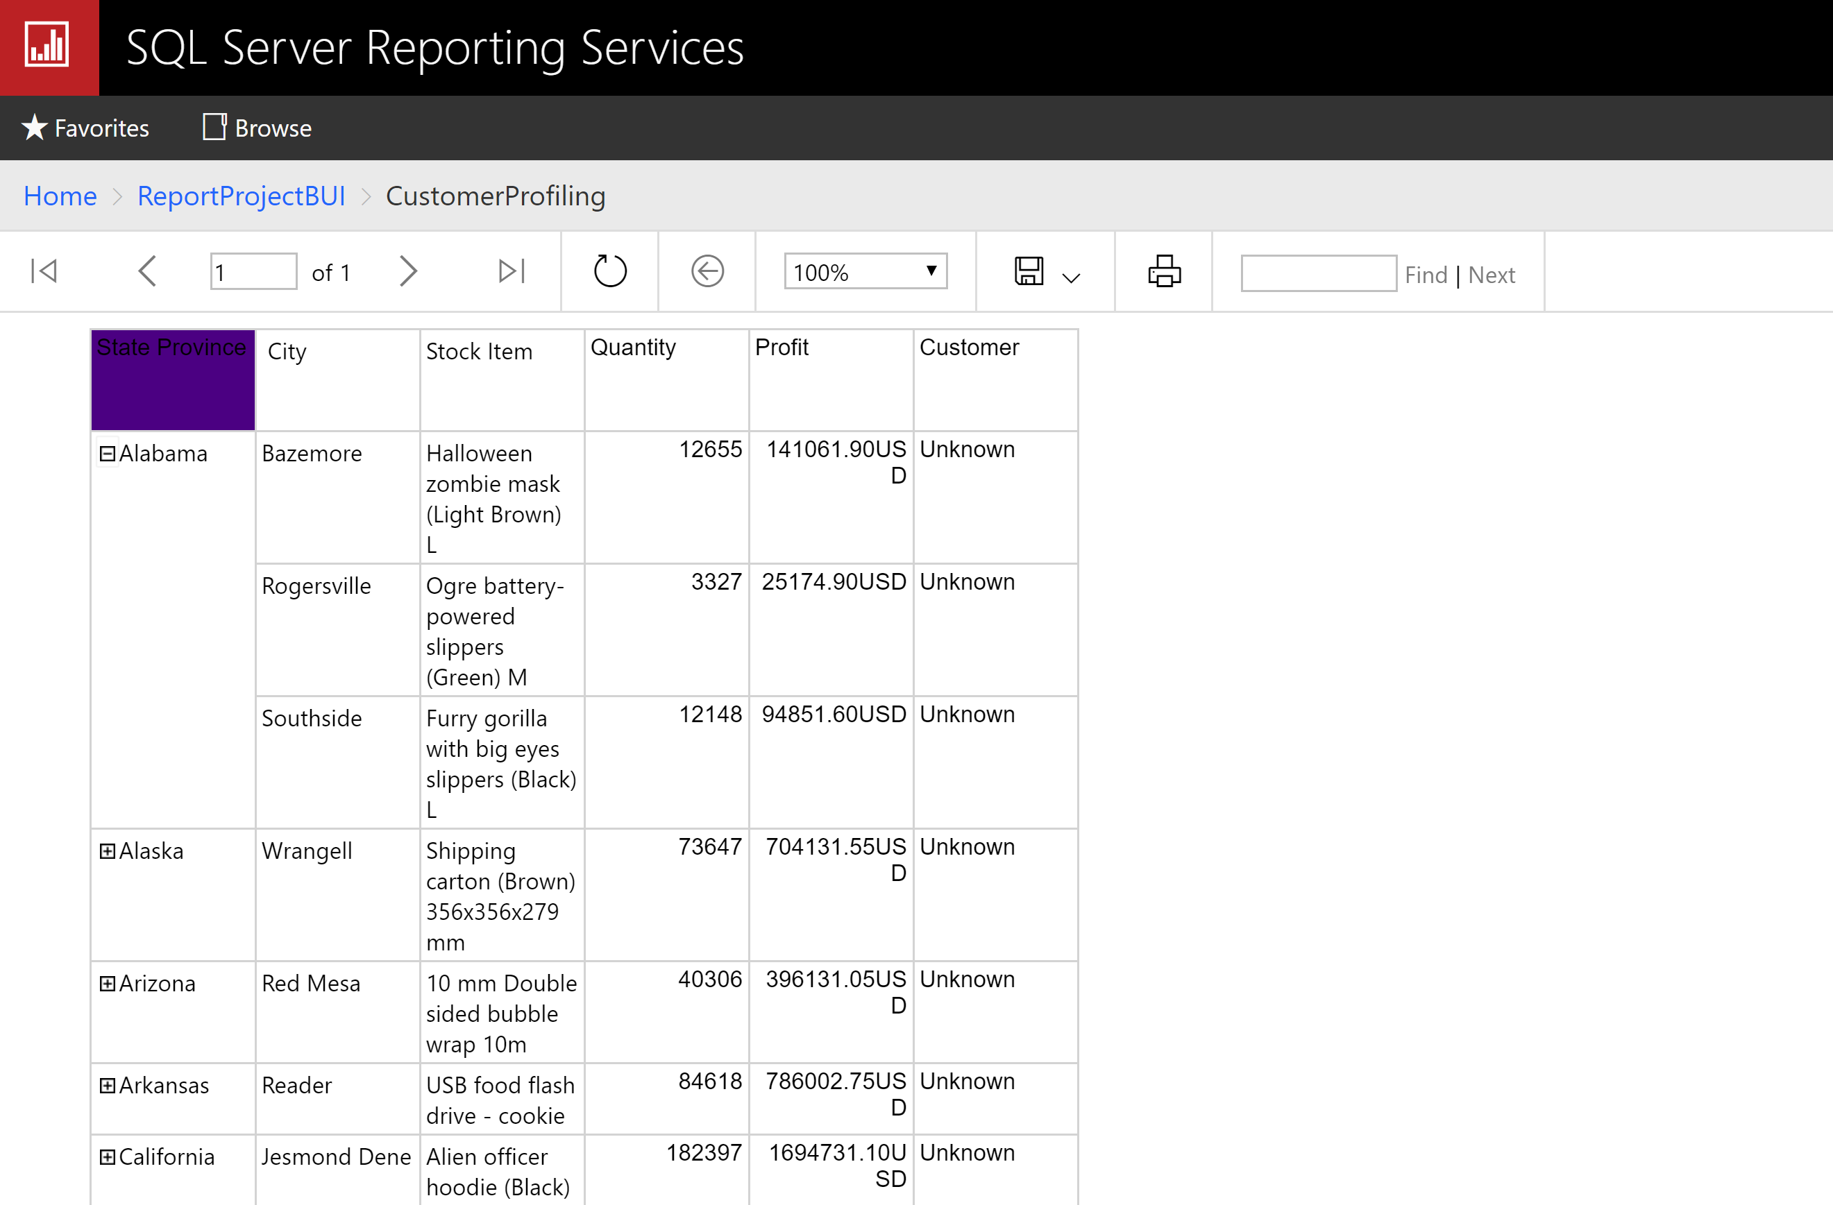

Moving on from here we can also create *Mobile reports* which can be used display the data in different formats moreover for other devices such as tablets or smartphones. For that we can use *the shared dataset* which can be taken also from the report server.

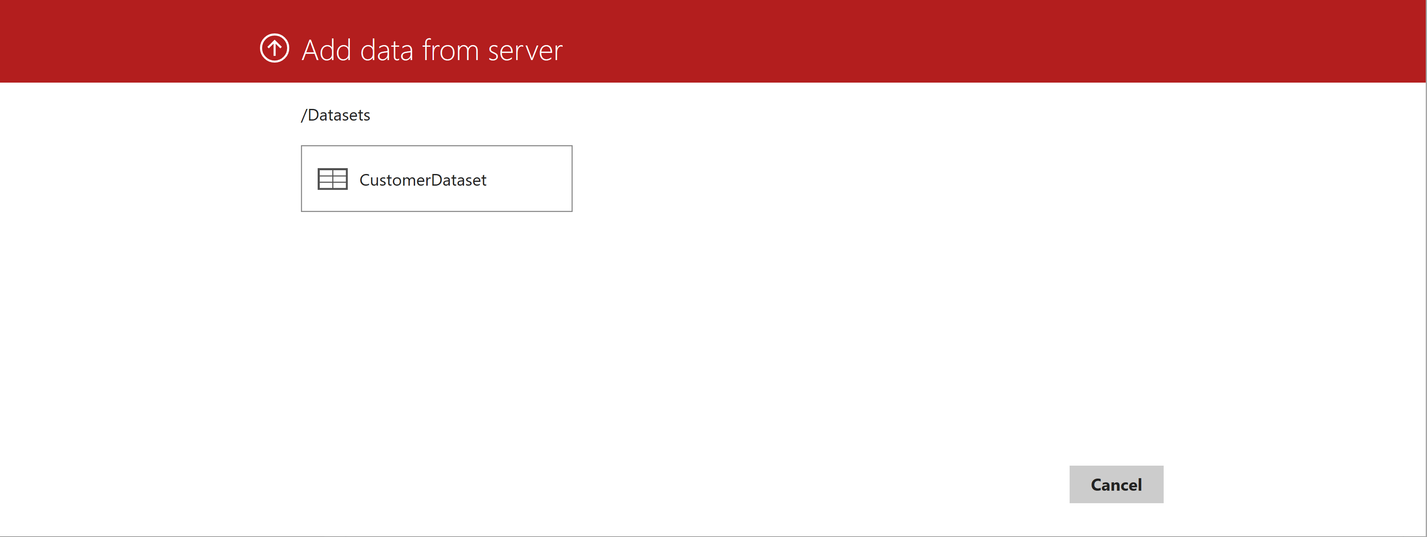

For creating the mobile reports we will use the “Microsoft Mobile Publisher". The first step would be to import our data and visualize as you can see in the picture below.

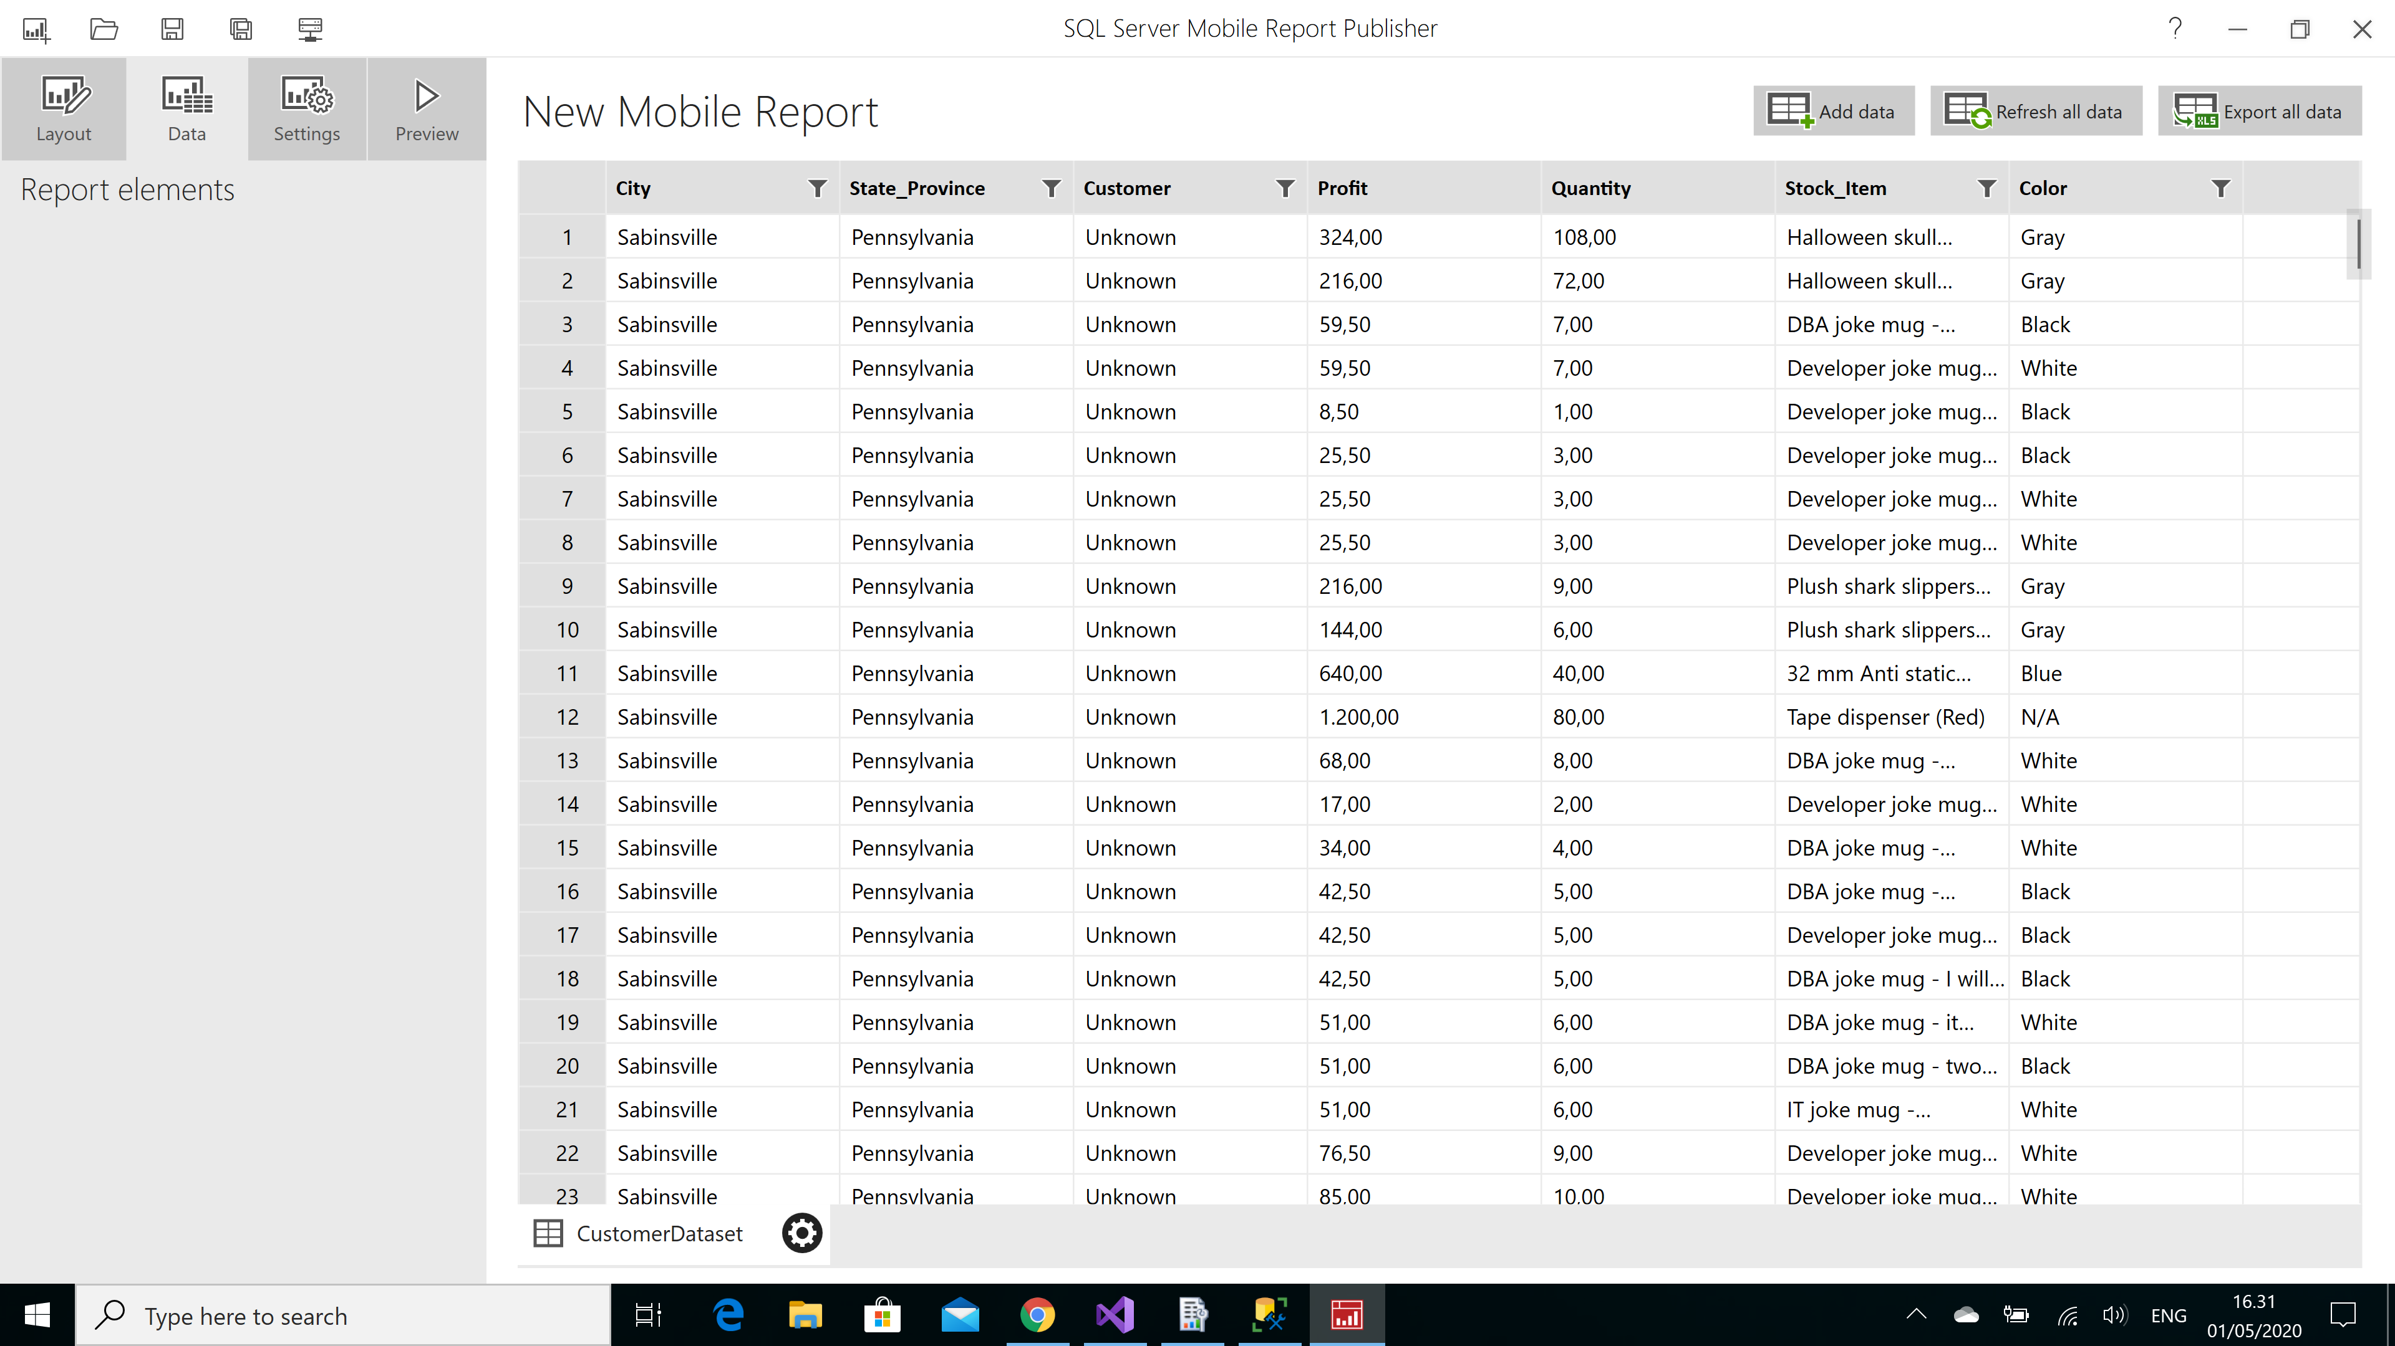

From there we can create our reports, in the next picture how the report would look on a mobile device.

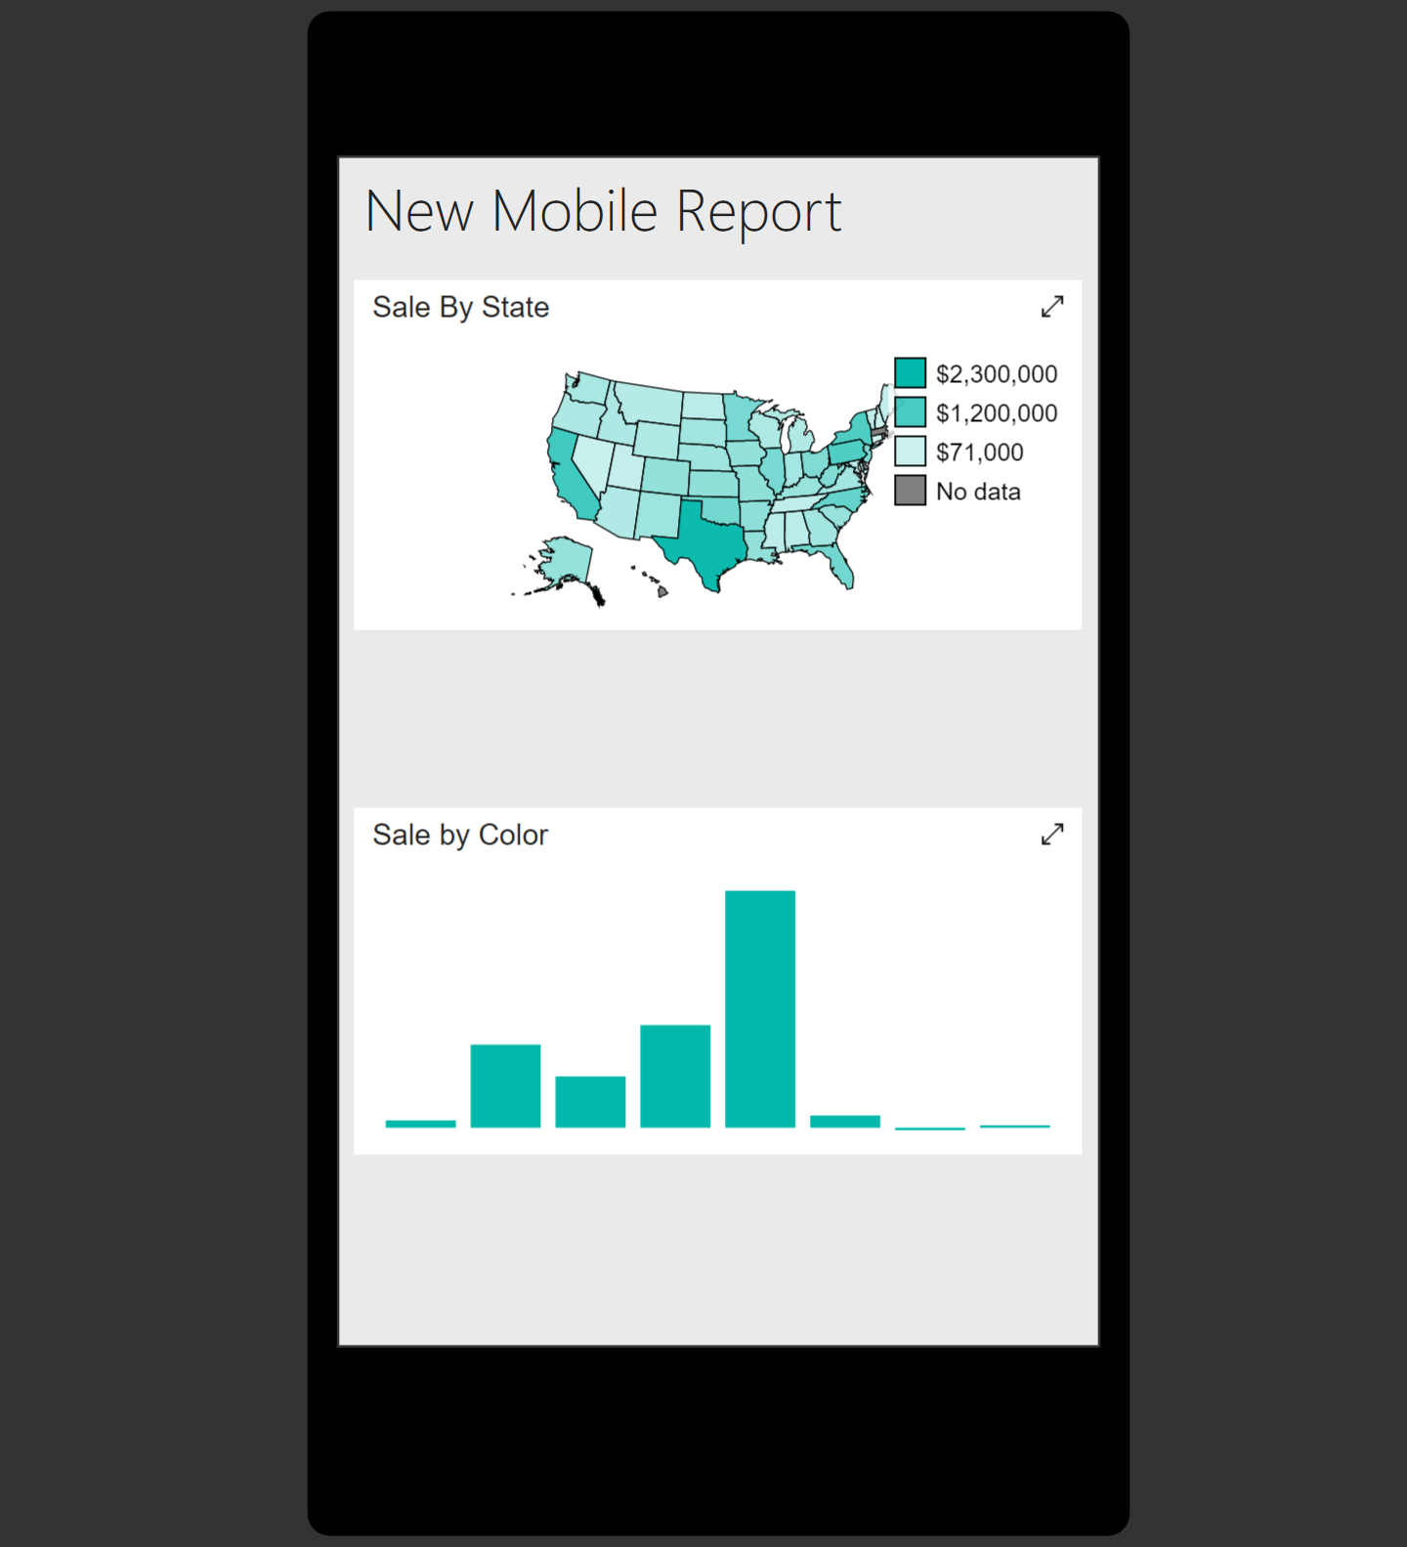

In the above image we can see two reports which will helps us to gain insight into the the customer profiles by seeing the profit from each state, by using this type of analysis we can see in which region of the country the marketing team might need to improve their promotion or if they have to redirect their focus into different areas. Moreover, we can also see the sale depending on the items color.

In order to gain a new perspective over the data, in the “Analysis services" we can create a project *using a tabular model.*

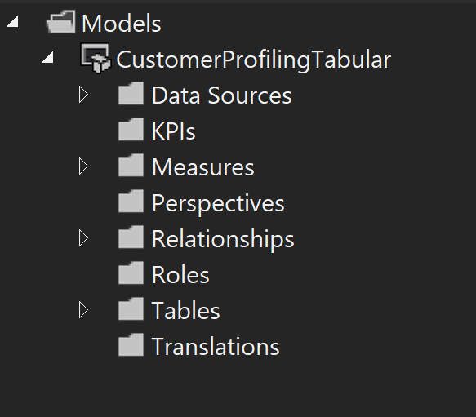

After creating the project the first step is to add the data source, we will import only the tables necessary for our analysis.

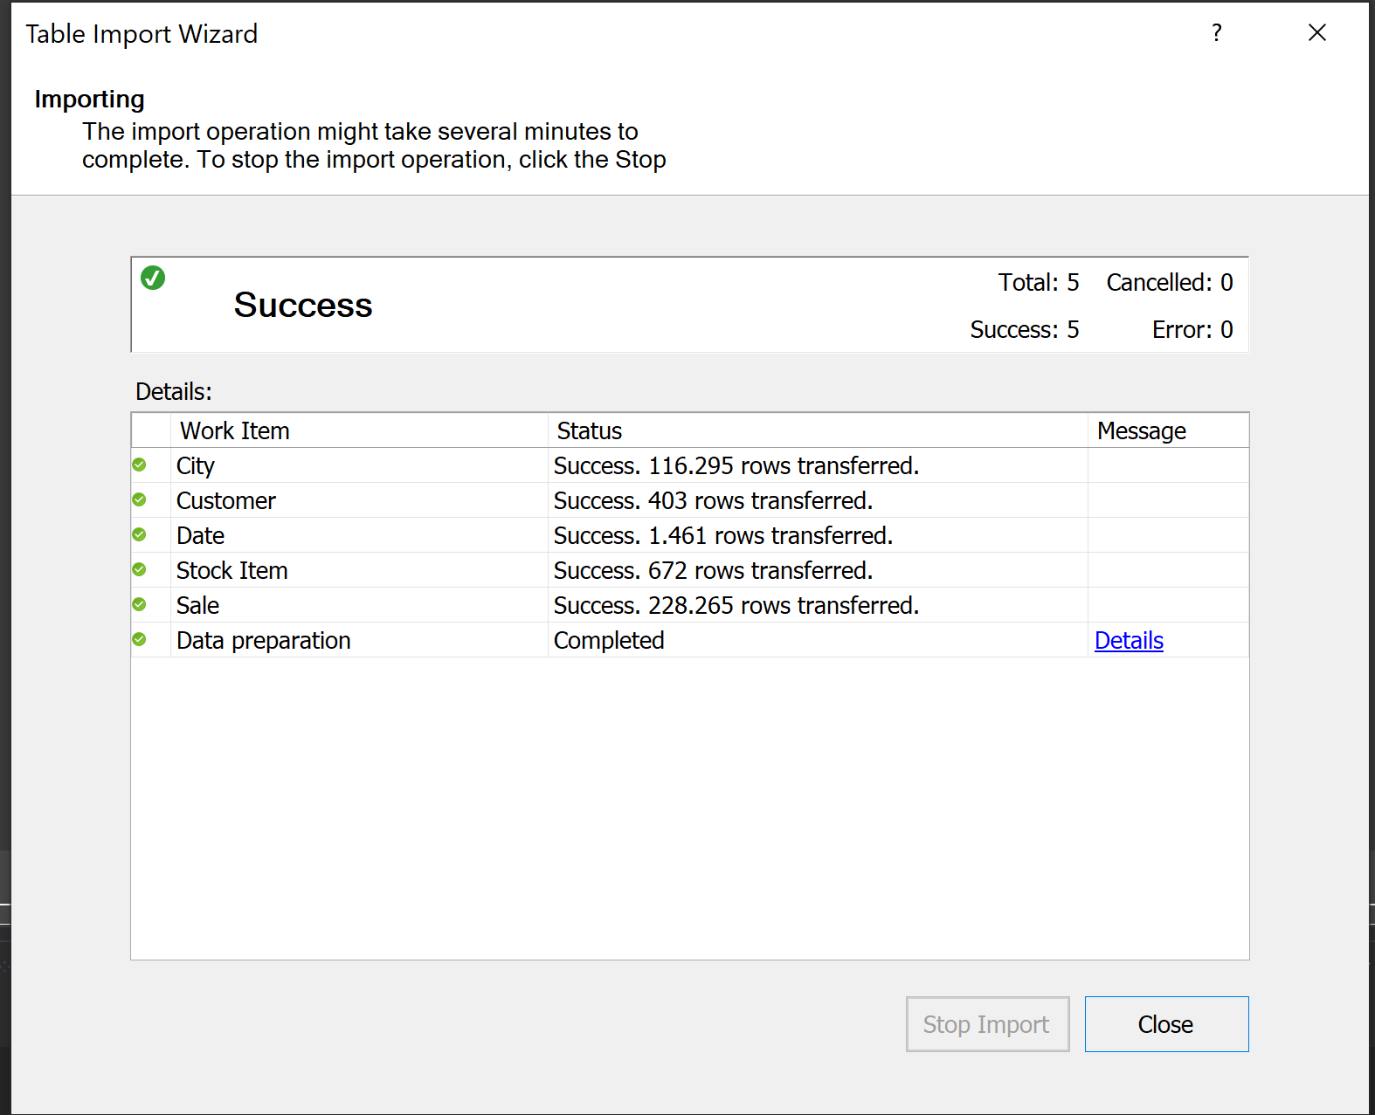

Once we have the data transfered we can also take a look at the relantionship between tables by checking the diagram.

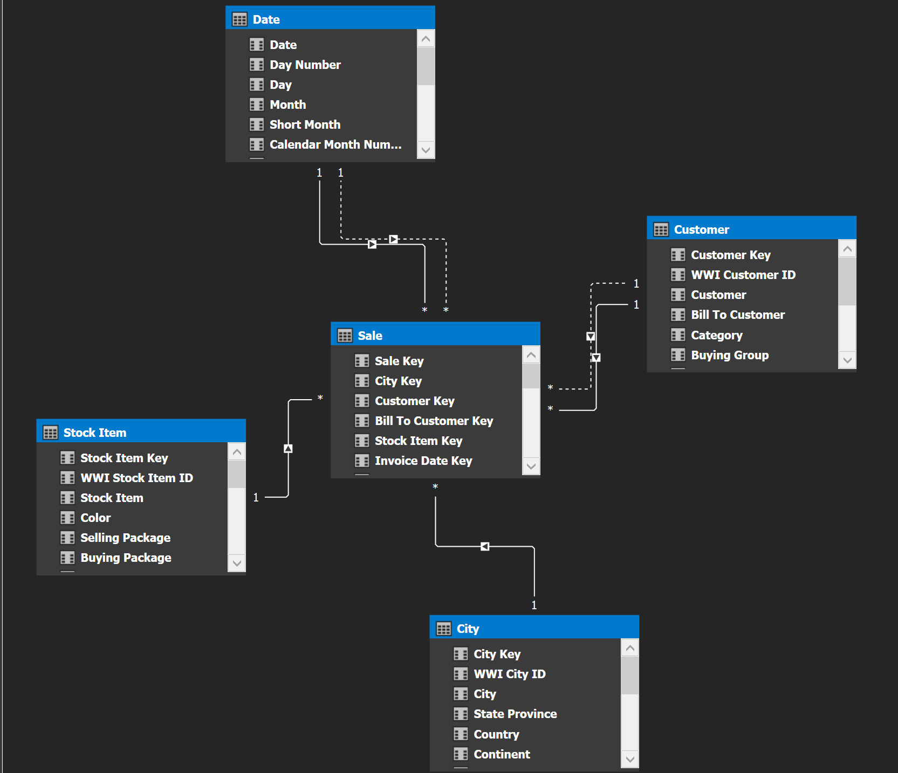

After inspecting our data we can make some adjustments, for example by *renaming one our columns* as “Company ' to “Company name".

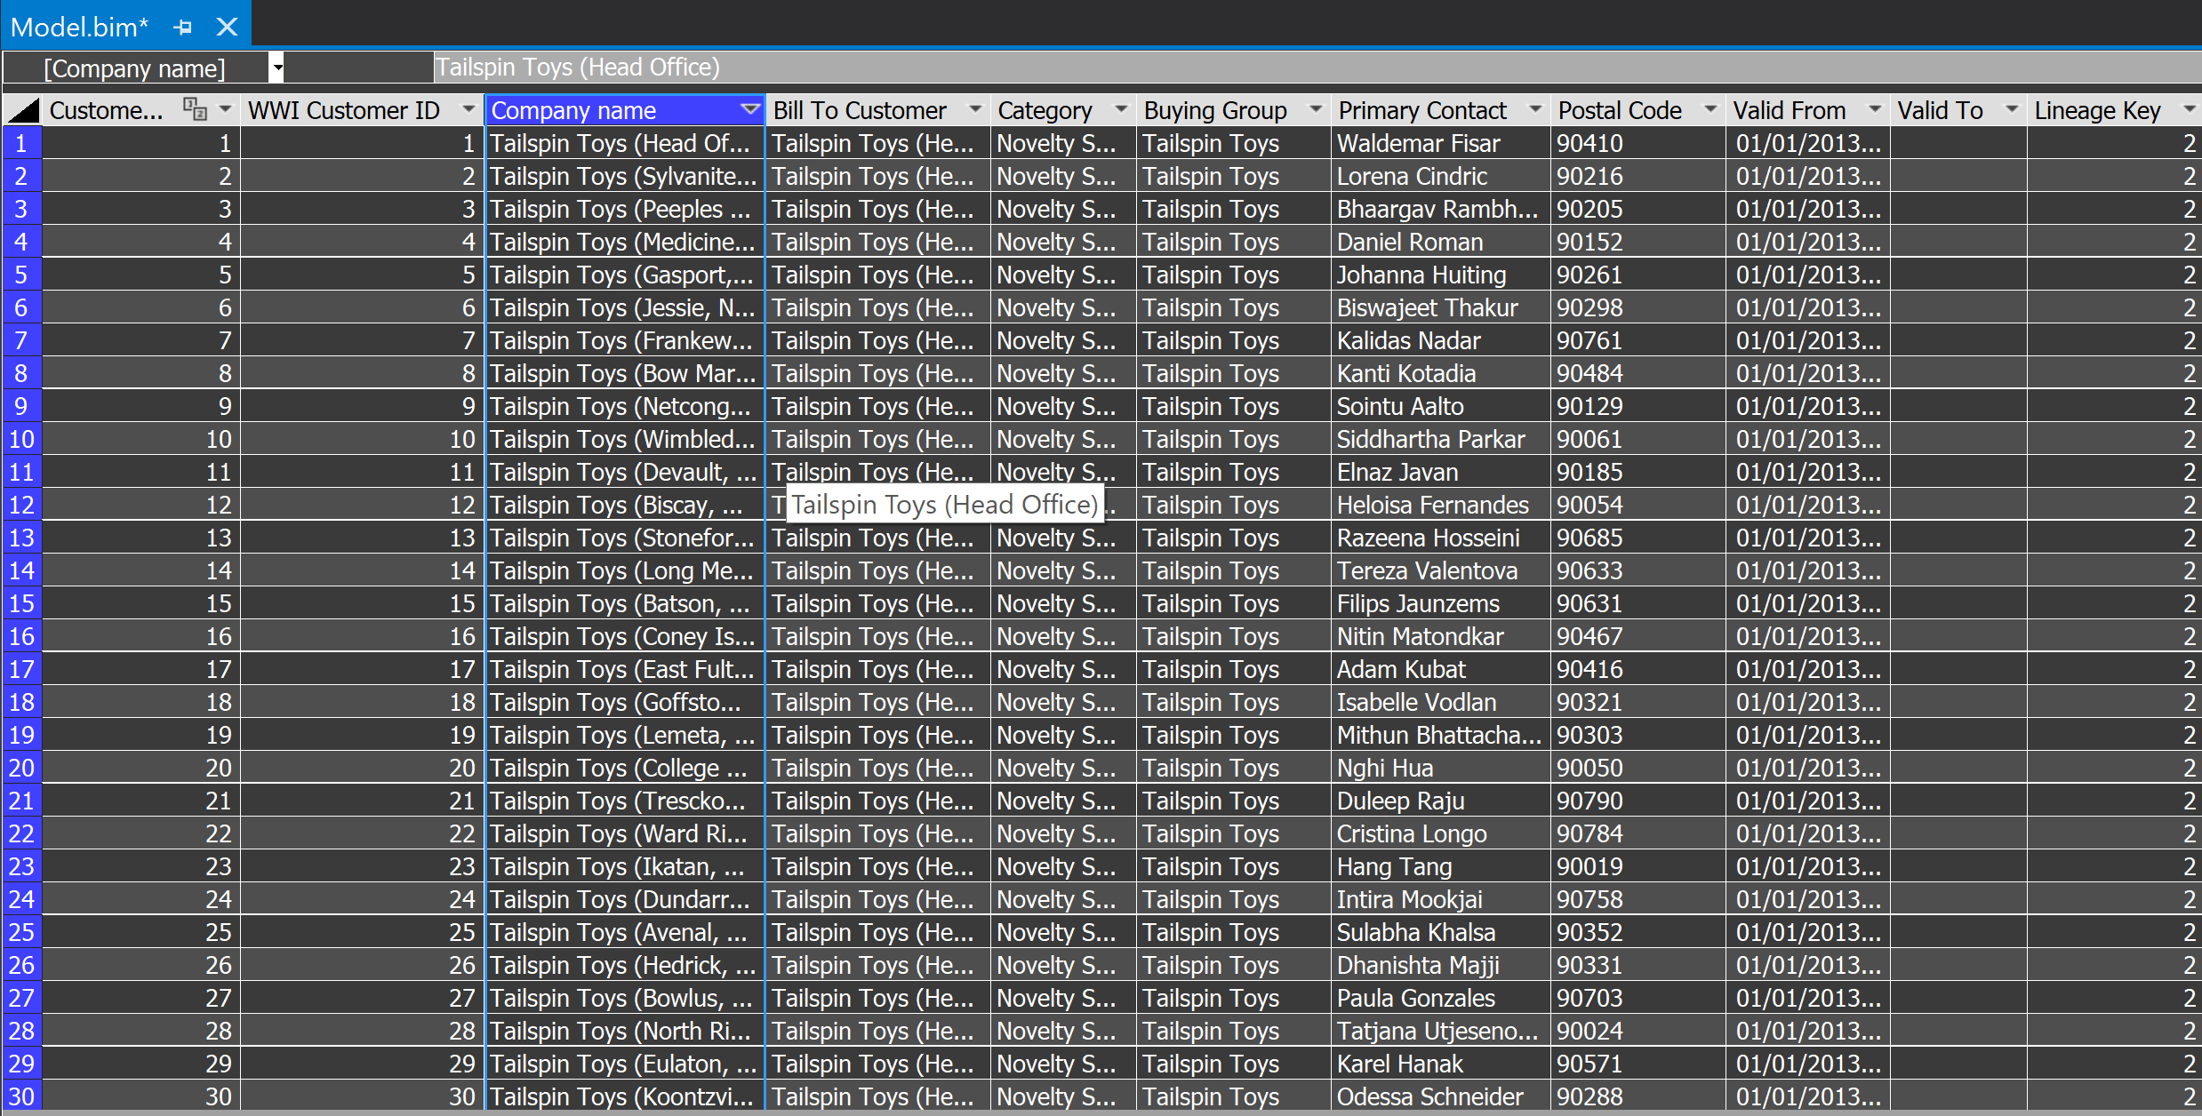

To gain new findings from our data we can *use a measure* to calculate our total number of customers.

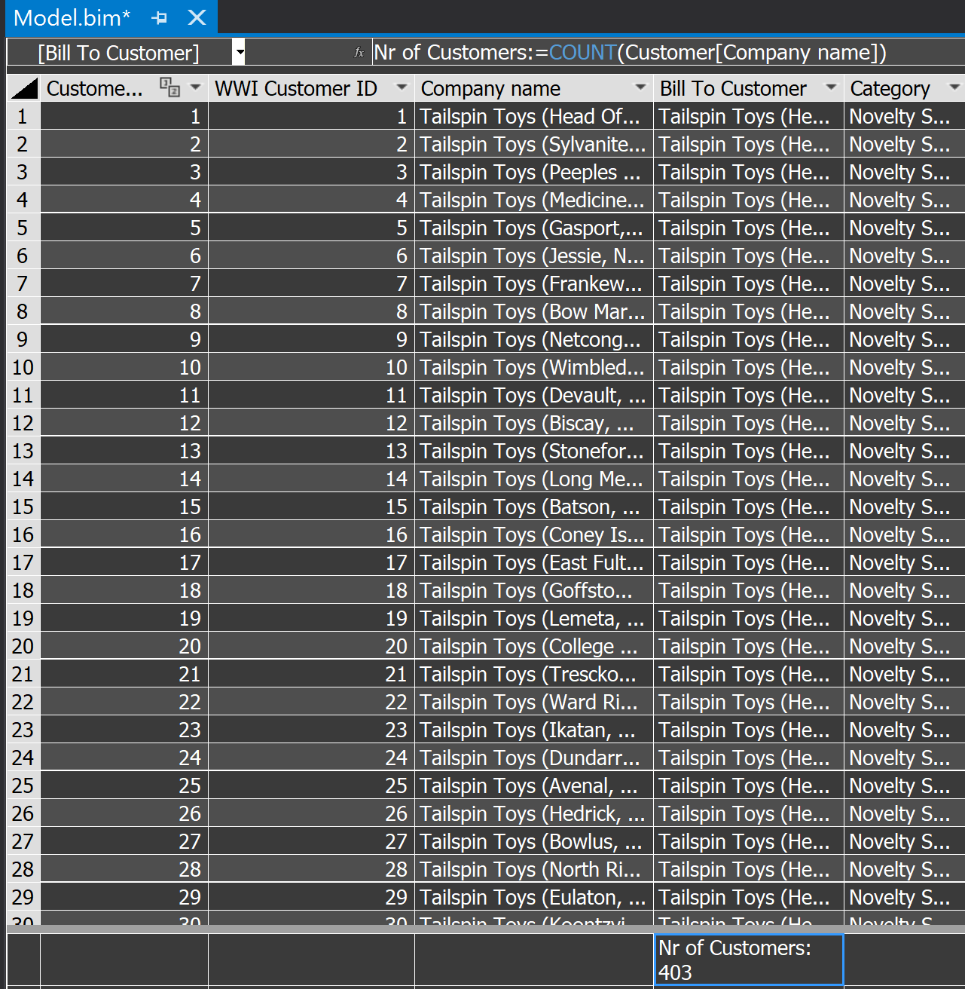

After taking all this into considertation, now we are ready to *deploy our model*

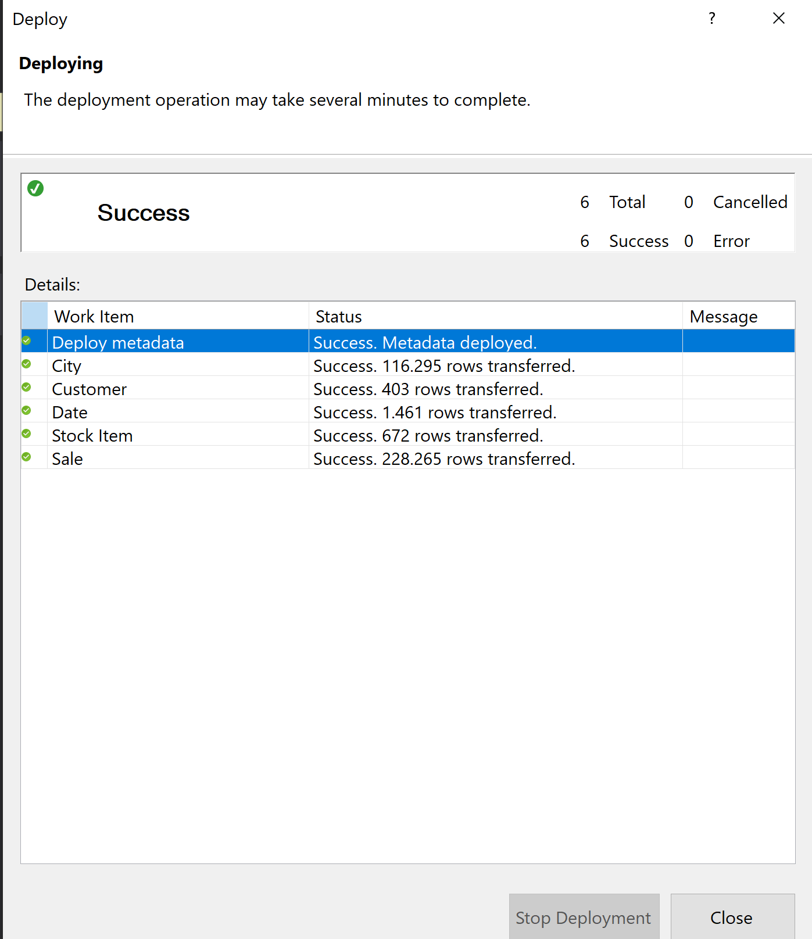

In the next section we will discuss our findings gained from using Microsoft SSIS.

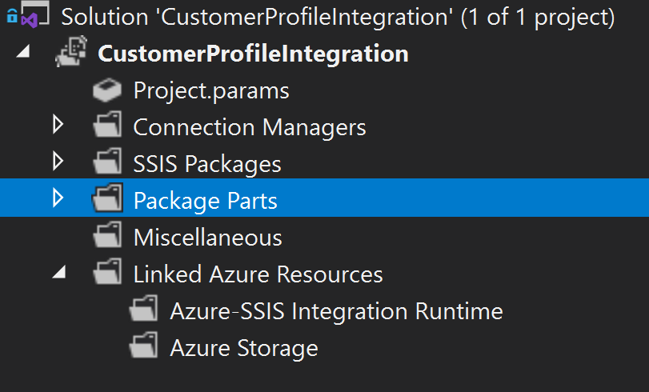

After creating the project will have to add two connection managers:

A source one which will use the the “ADO.NET"

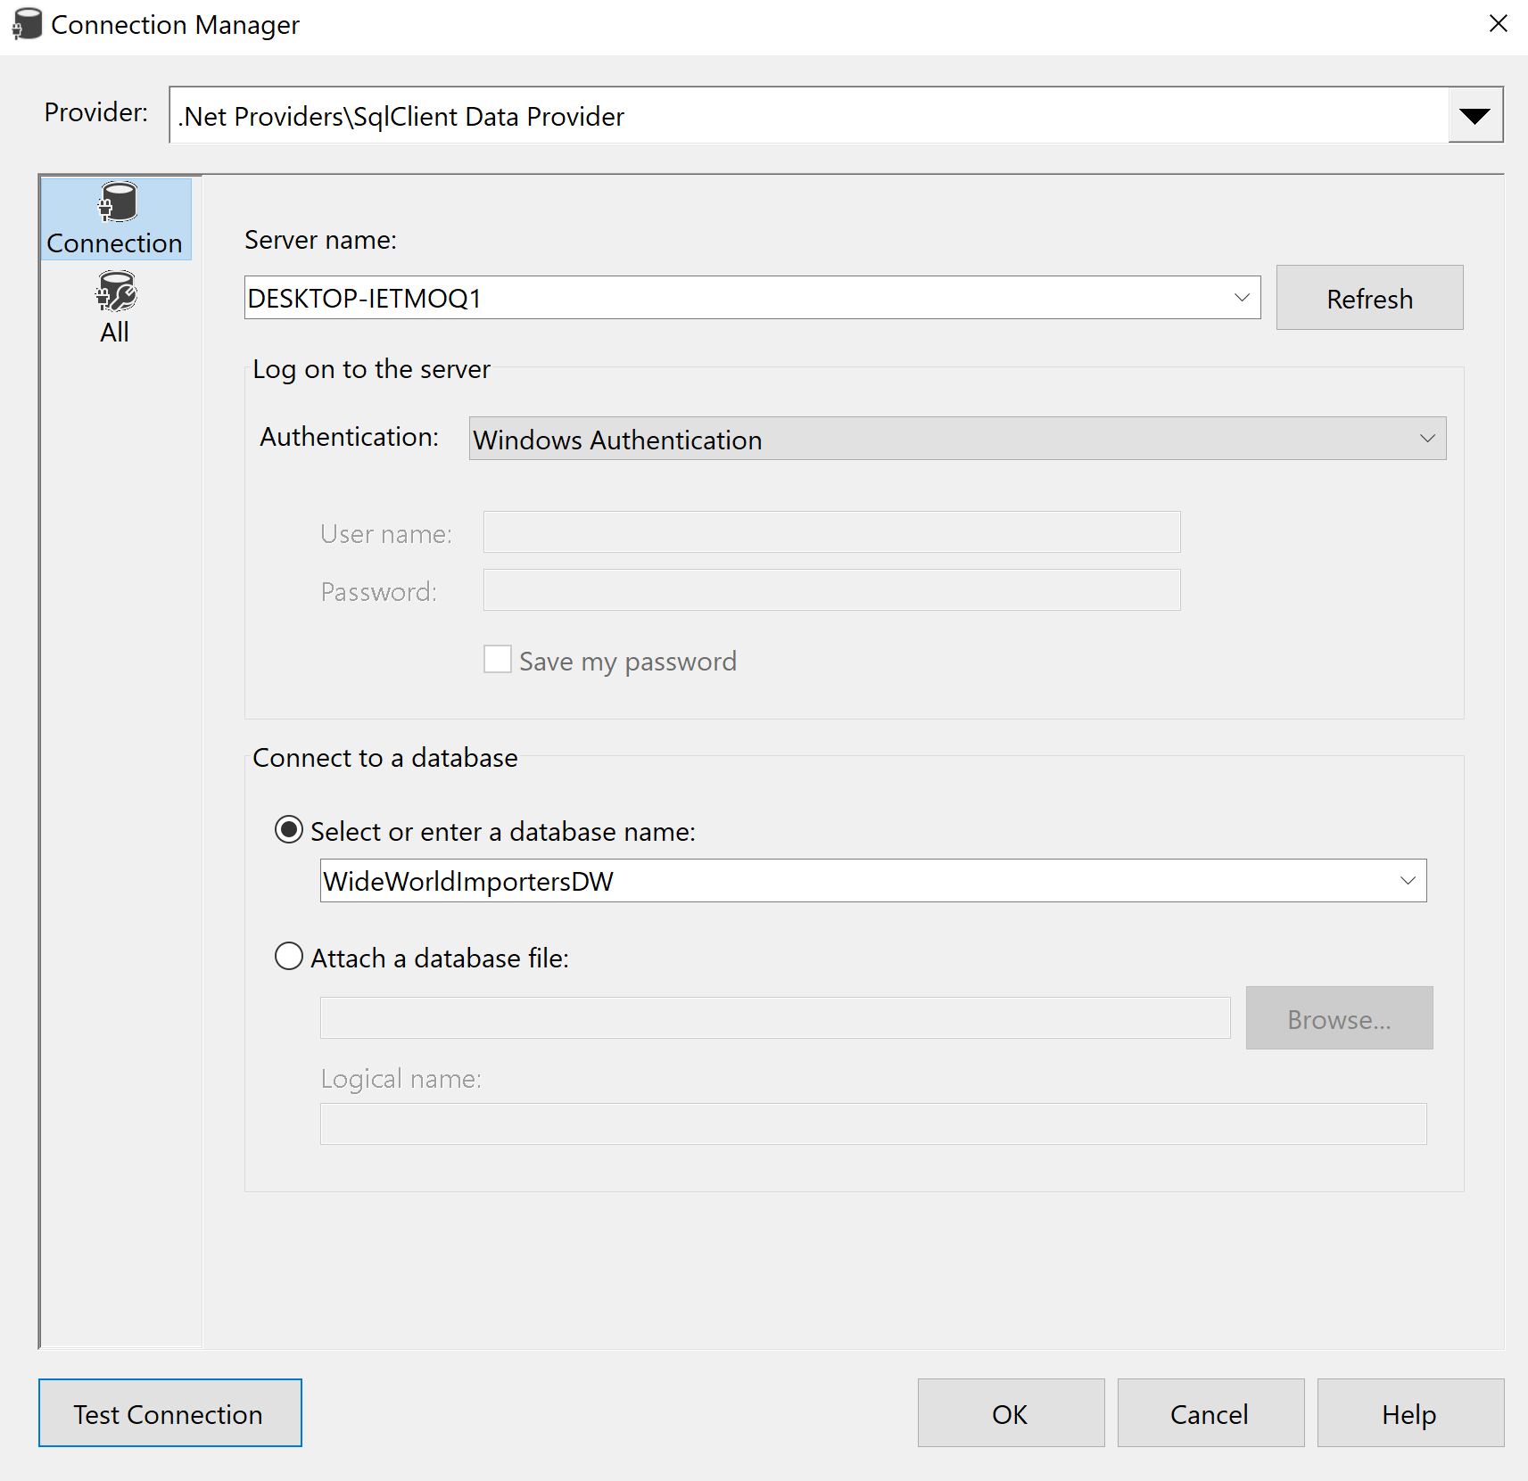

And a destionation one which will be “OLE DB”

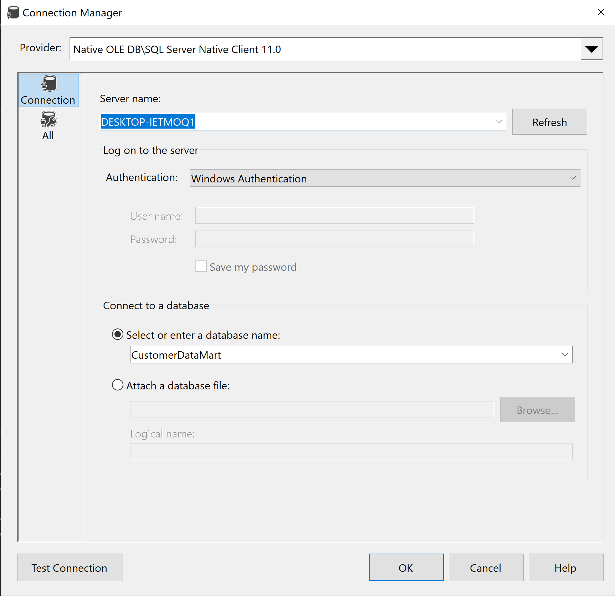

After seting up the connection we can create our Data flow where we will take data from our customer table and put into a Data Mart

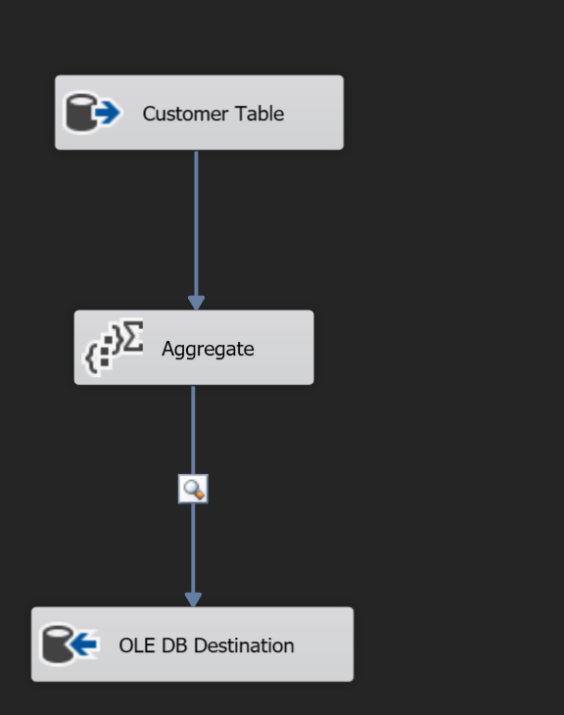

As it can be observed in picture above before transfering our data we are adding a transformation using an “Aggregate".

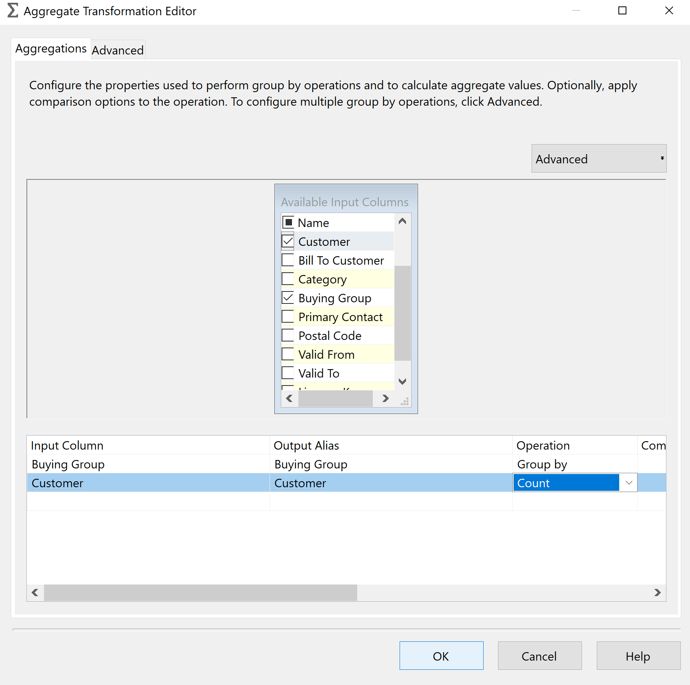

By Agregatting we can obtain the numer of clients that we have in each buying group, the result can be previewed using a data viewer as observed in the picture below.

