The CEO wants to have a report on profitability over time in sales.

The following steps will describe the process which generated the report for the CEO.

1. Inside SSDT, create a Data Source that extract the sales data from Wide World Importers DW

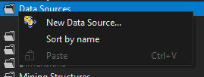

2. A Wizard will appear in which create a data source based on an existing or new connection must be selected. This make it possible to connect to the Wide World Importers database.

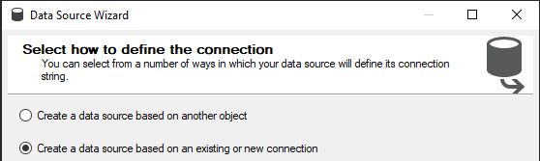

3. Press New to create this connection. In the connection manager, input the server name, select the authentication and write the name of the database to create the connection.

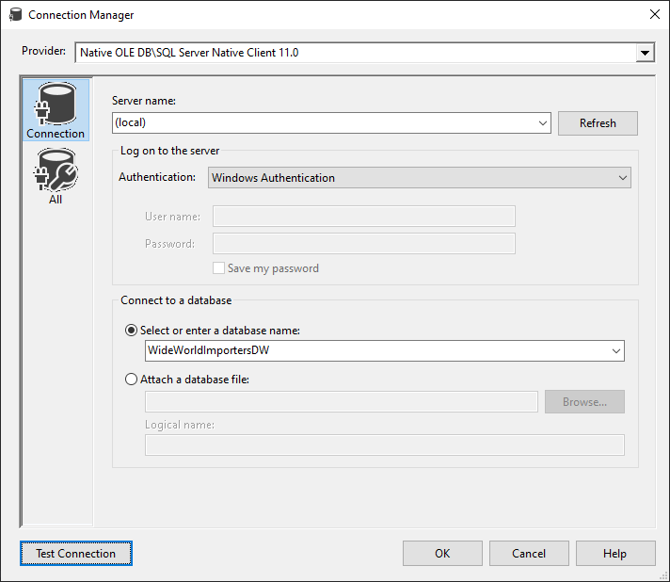

4. Press Next. Input the user name and password for the windows account. This will be used to authenticate to the database and request data whenever is needed.

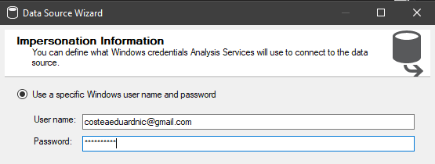

5. Write the of the database to identify the correct data source.

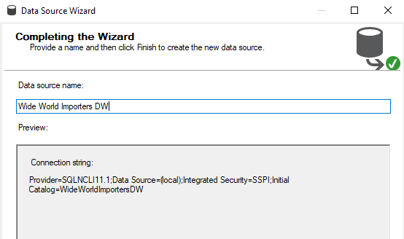

6. The next step is to create the data source view for the wide world importers using the data source that was just created.

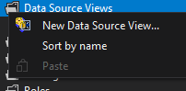

7. Select the data source that was just created and move to the next step.

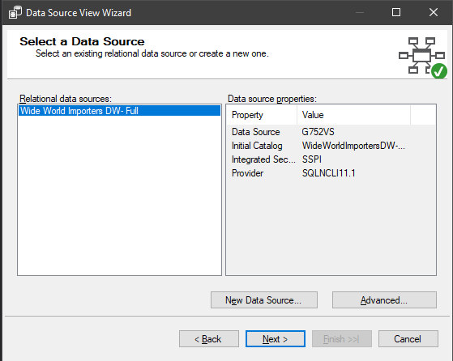

8. Find and select the Sale (Fact) table. Press add related tables. This should be the result.

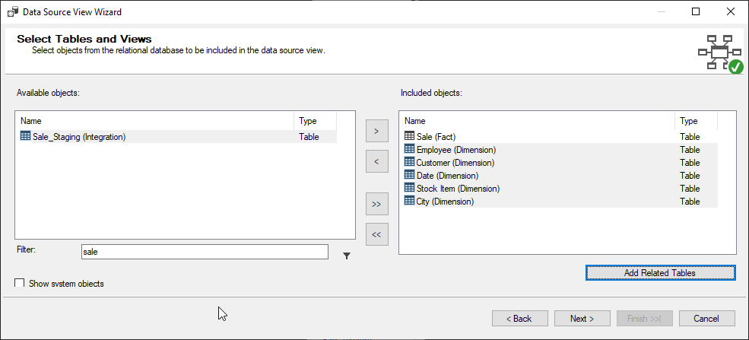

This will ensure that every table that is related to Sale will be accessible.

9. Finish by naming it.

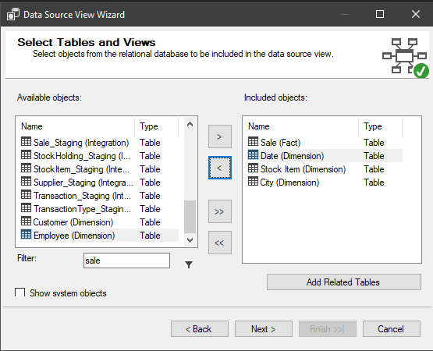

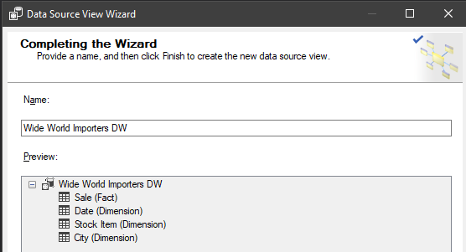

It will look like this

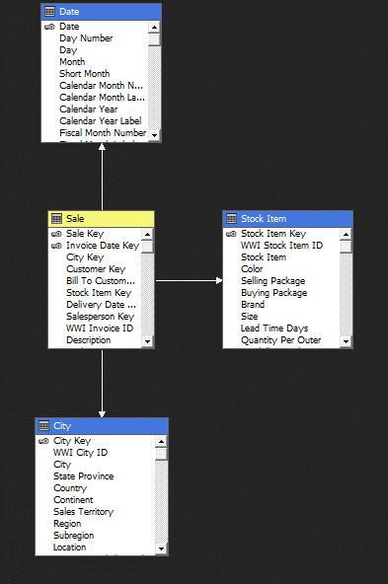

10. Remove Delivery Date from the list of dimensions in the data source view to ensure no duplicates in Date dimension as they would both feed in it.

11. The next step is creating the cube based on the data source view. Because the data source view was created, the option use existing tables can be selected.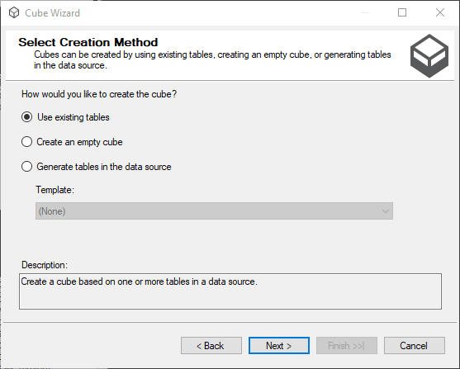

12. First the fact table is selected because it contains all the measures.

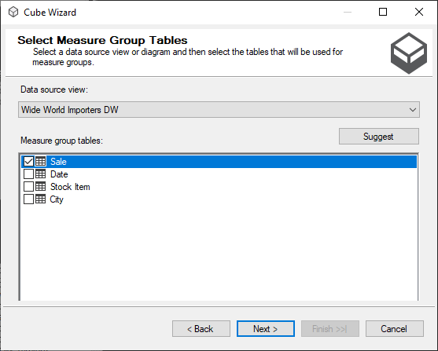

13. Select all the measures. In the end what is not needed will not be used in the report. If there are problems with space, the extra measures can be removed.

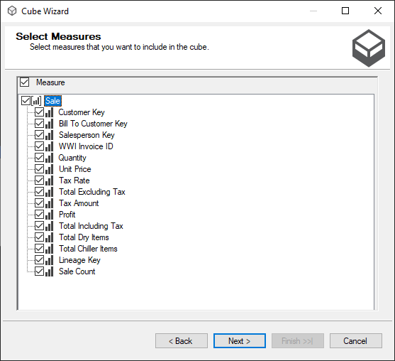

13. Each Dimension will be selected for the analysis.

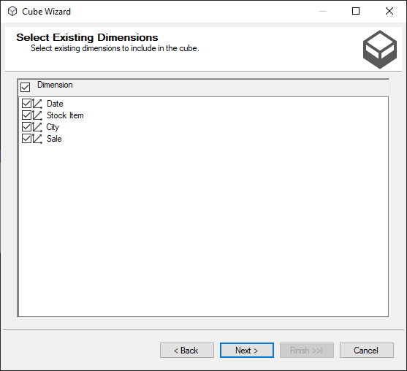

14. The last part is naming the cube.

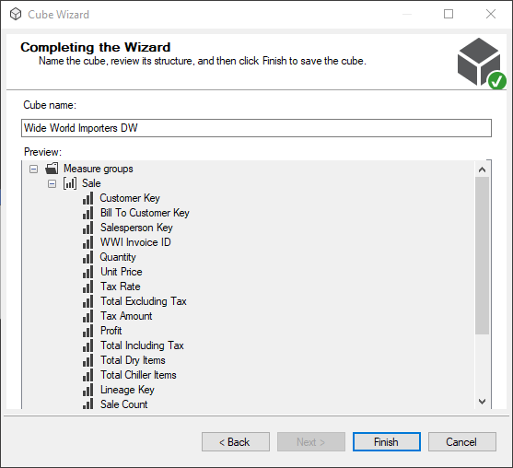

It will look like this

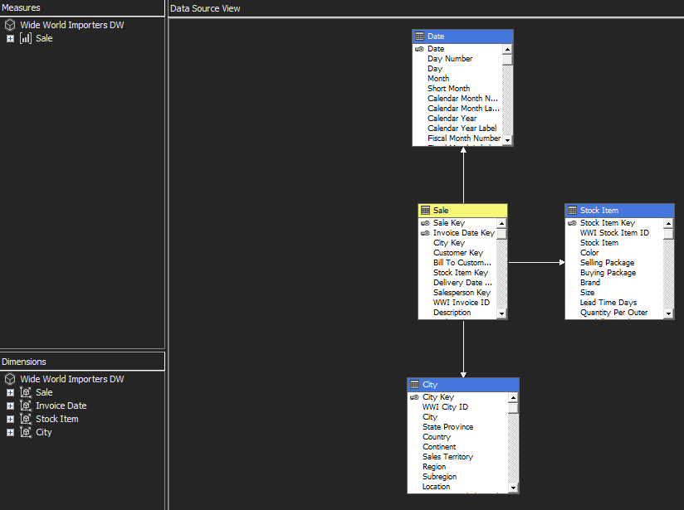

15. Now it is time to do some adjustments to the dimensions. First the date keys in Invoice Date and Delivery Date have the regular format and it is helpful to set them directly to the date type and create a hierarchy.

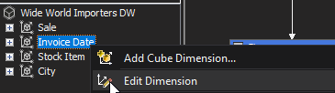

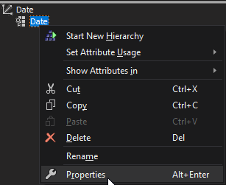

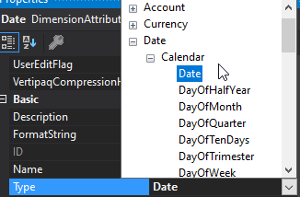

The same goes for delivery date

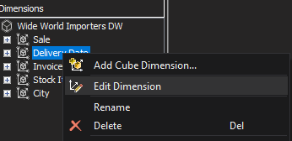

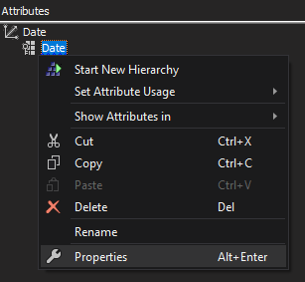

16. To create a hierarchy, all the attributes of the hierarchy must be selected and then the hierarchy is created as follows:

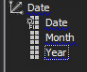

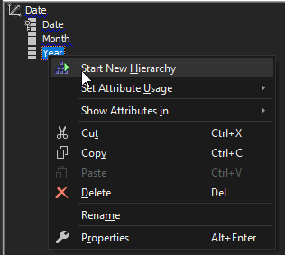

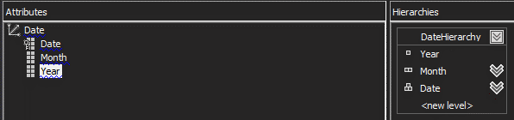

17. The next step is to specify the attribute relationship.

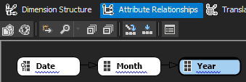

Date is the most specific and has a relationship to month and then year.

18. Now the cube is ready to be used for reporting. It has a date hierarchy, the measure for profit and a time dimension with some extra attributes if a deeper analysis is needed. After making sure the properties are set appropriately, the cube can be deployed to analysis services after it has been built.

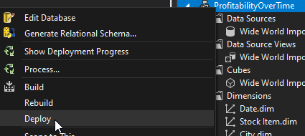

If we browse the cube, everything is there

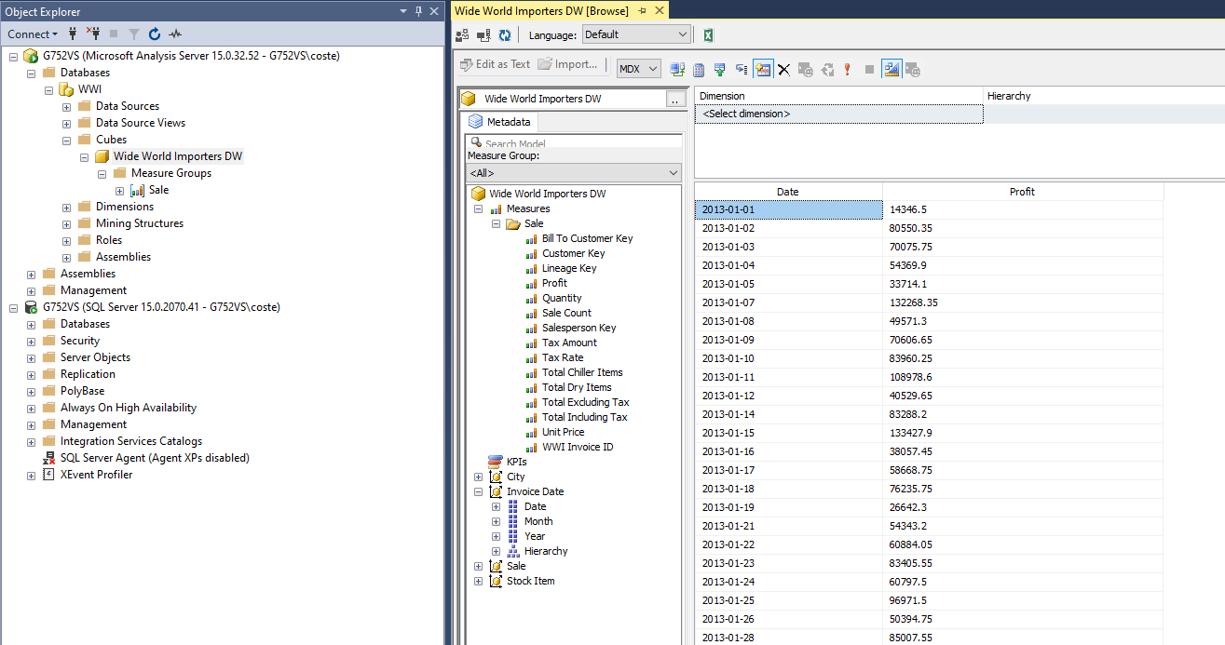

19. The next part is the PowerBI report. The first step is getting the data.

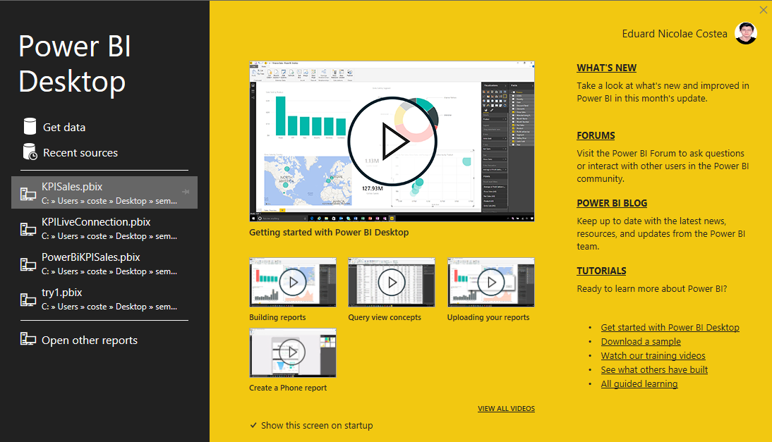

Select the sql server analysis services database and then input the parameters for connection.

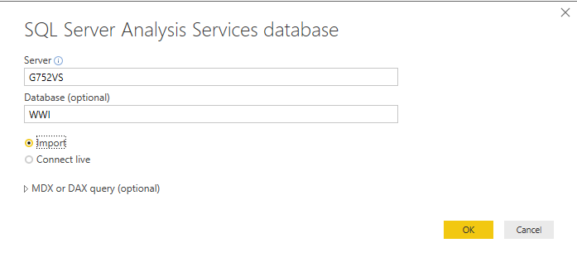

Select the data

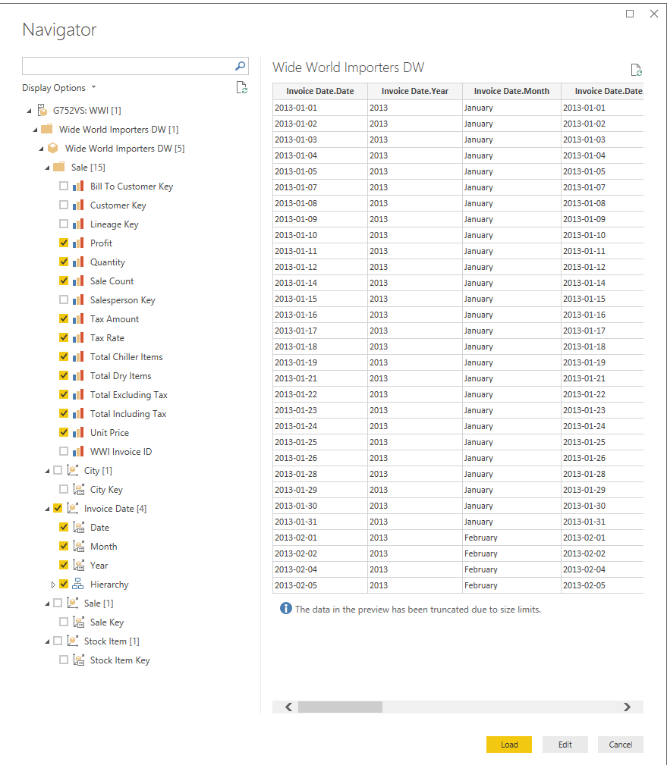

The next step is preparing the data. To do that, there is the option Transform Data.

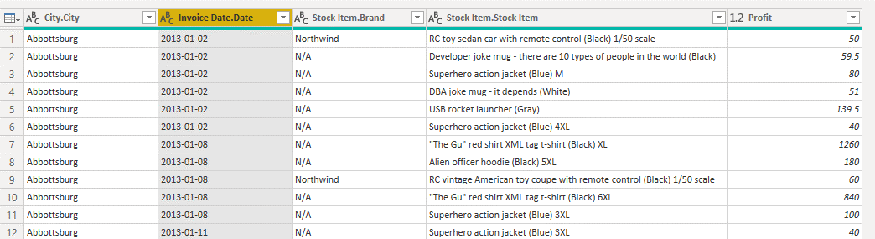

The last adjustments will be setting Date to Date data type and setting more appropriate names for the columns. The result of the transformation is this:

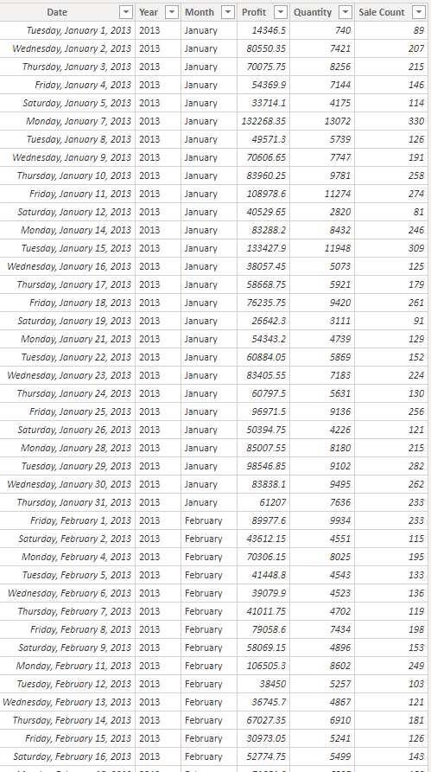

20. Next part is creating YTD measures for our reports. To create a new measure we have to use a DAX formula.

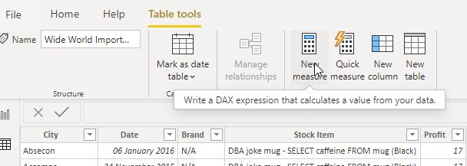





21. The next step is preparing the page for the report.

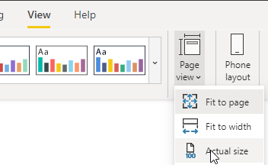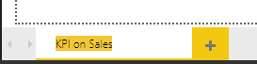

22. A KPI Chart

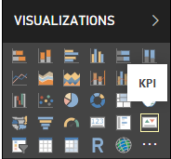

From this chart it is easy to see that profit have gone down, but the reason might not be obvious from this chart.

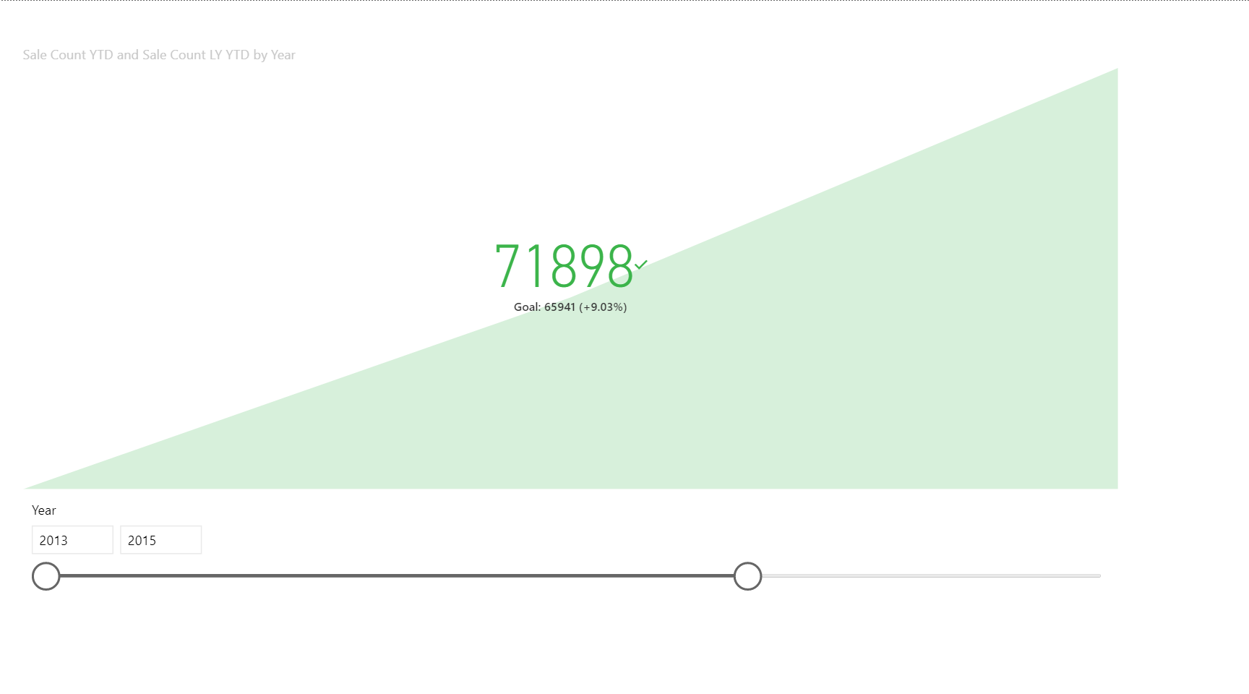

We have the months only up to 2016.

A different KPI can help with this.

23. Using the new measures (Sale Count LY YTD and Sale Count YTD) and filtering on 2016 will offer the possibility to compare the situation for 2016 to the situation in 2015.

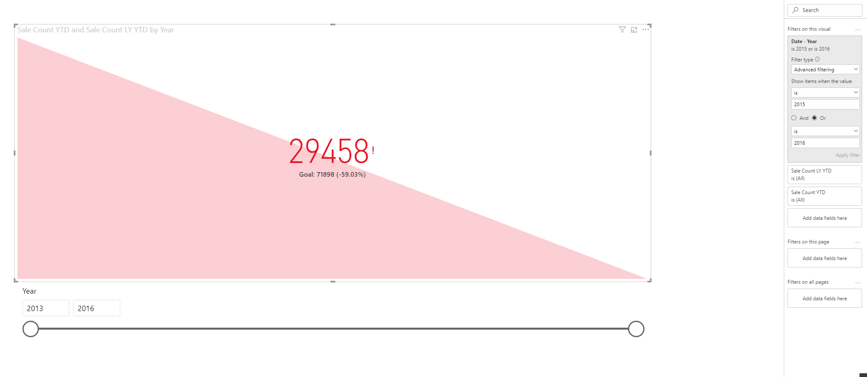

25. The next part is preparing a report for SSRS. It would be worth checking the profitability over time for some brands. There are 3 components: Shared Data Sources, Shared Datasets, Reports



The first step is to build the link to the database

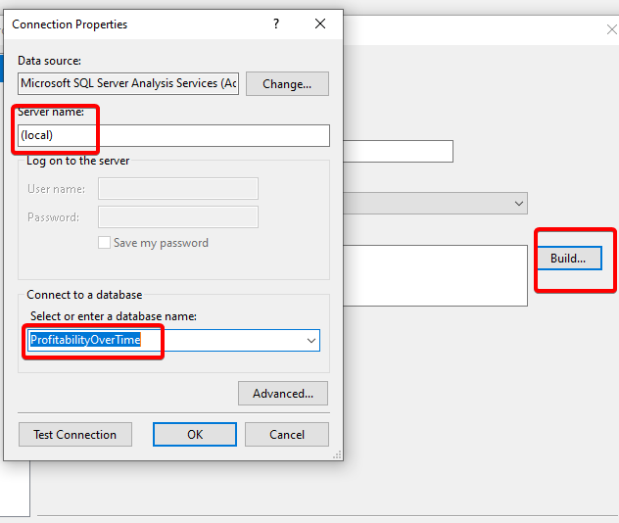

26. The shared datasets are based on the shared data sources.



When creating the shared data sources, it is important to enter in query designer to pick the data for the report

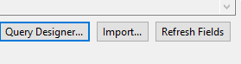

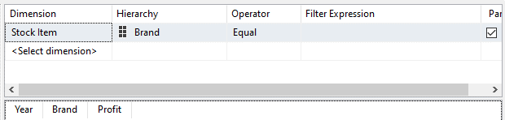

Brand as parameter will help filter out for specific brands.

27. Now comes the part that involves creating the report

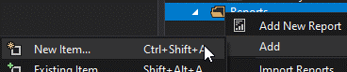

A textbox will be inserted to write a title for the report.

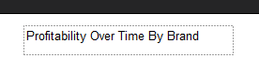

The components of the report have to be added. When the dataset is added, the parameter is also added together with it.

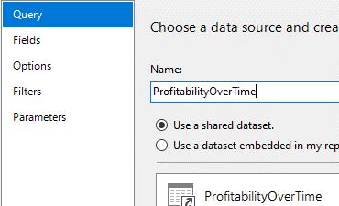

A line chart will be the best option for analyzing a trend.

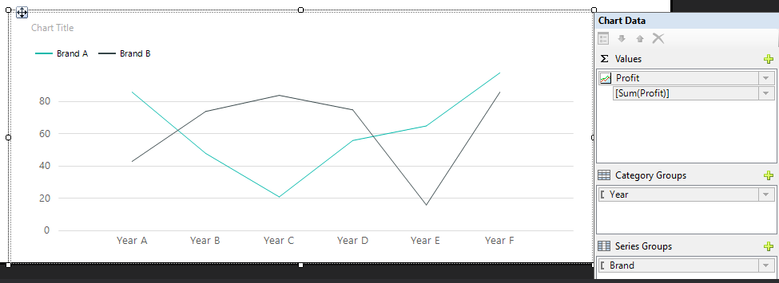

The result is:

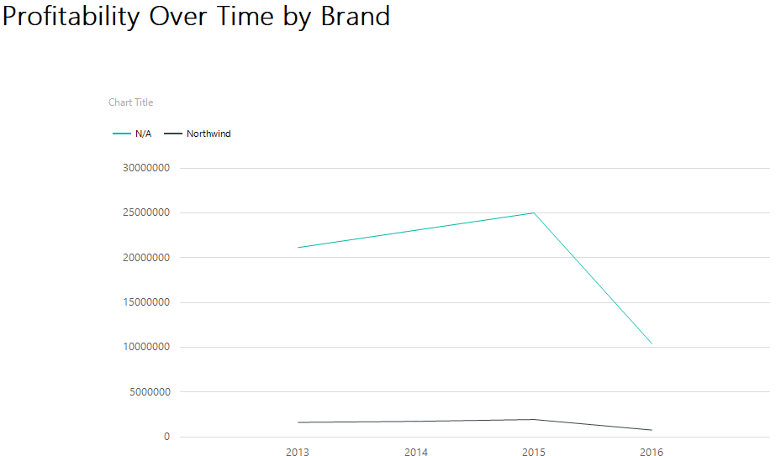

27. Now the solution can be deployed to SSRS. In the properties, the overwritedatasets and overwritedatasources are set to true to overwrite any previous mistakes and maintain with fresh data. The targetserverurl is updated to include the path of the local SSRS.

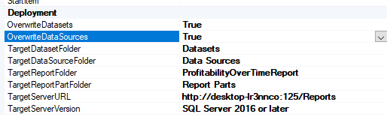



The final result is:

