The Finance Manager wants to have a report on payment method in transactions.

1. The first step is creating a data source for transactions from Wide World Importers DW.

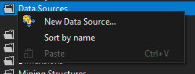

2. To establish the connection with the database a new connection has to be created.

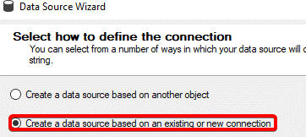

3. In the connection manager there are 3 fields to modify: write (local) for server name, set windows authentication for authentication and WideWorldImporters for a database name

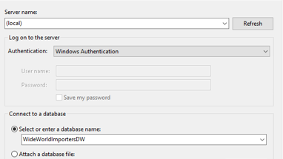

4. Next step is to input the user specific username and password for windows to easily deploy the components to analysis services.

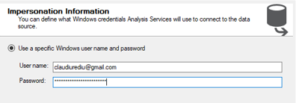

5.Using the connection a data source view will be created.

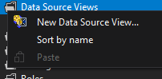

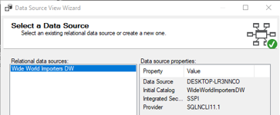

6. Select Transaction as fact and then add related tables

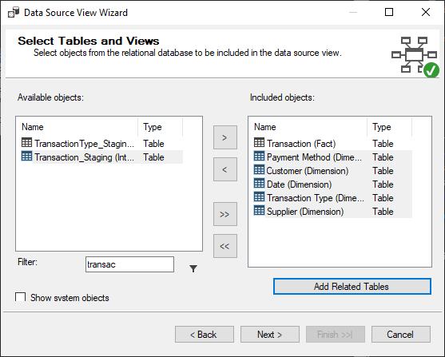

The result will look like this

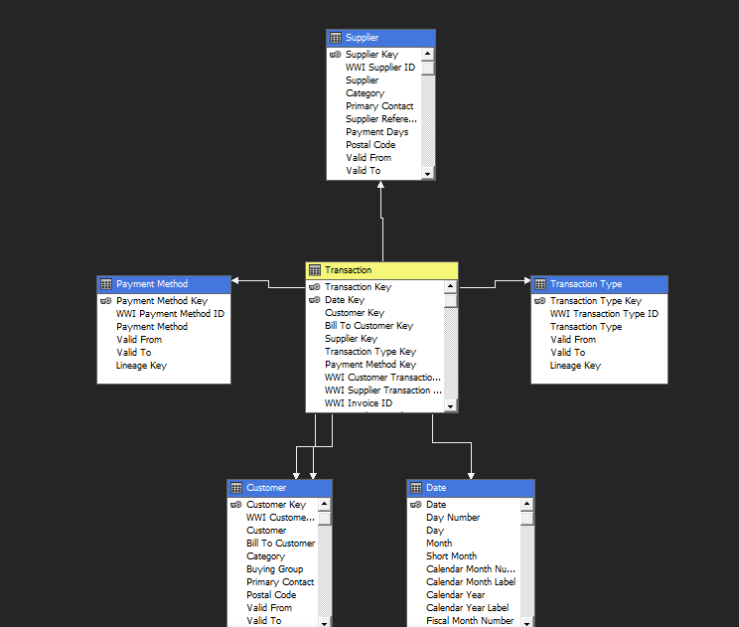

From this, there is no interest in customer or transaction type.

7. When creating the cube, we will not select customer and transaction type

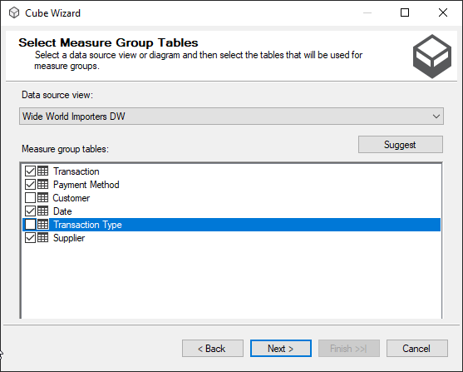

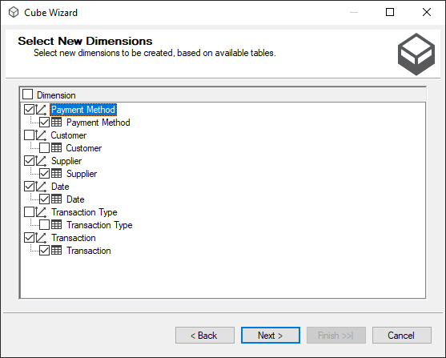

Also making sure that Customer and Transaction Type are not added.

The result is this

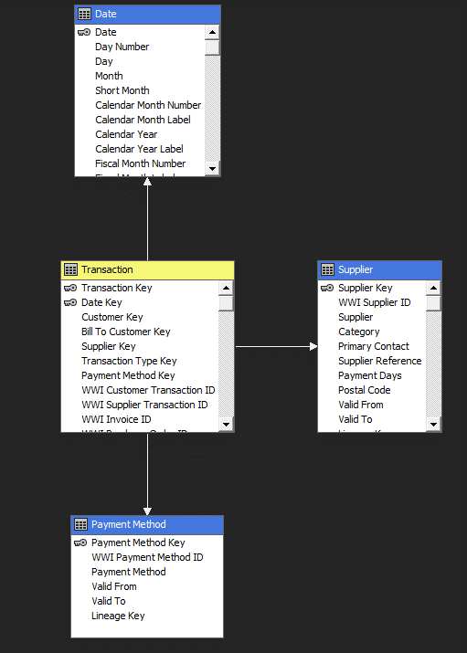

8. Now the attributes must be added to the dimension.

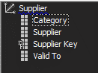

For supplier it is important to have the name of the supplier, if it is still valid and the category of the supplier.

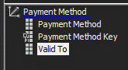

For payment method, the payment method name and if it still valid will be used.

By checking the data, the only fields worth keeping are the total including tax and the row count for transactions.



9. In setting up the cube, the date dimension can be set as a type time to ensure that it works as it should.

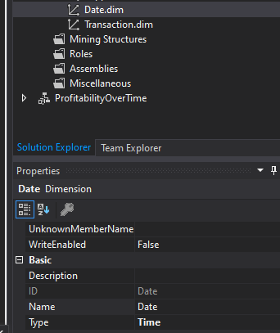

10.The current step will involve bringing the data inside powerbi. Select SQL Server Analysis Services as the source.

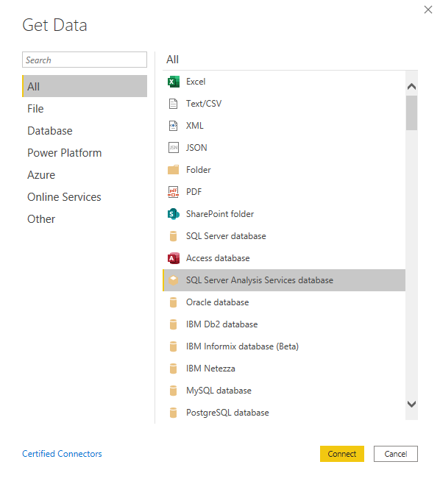

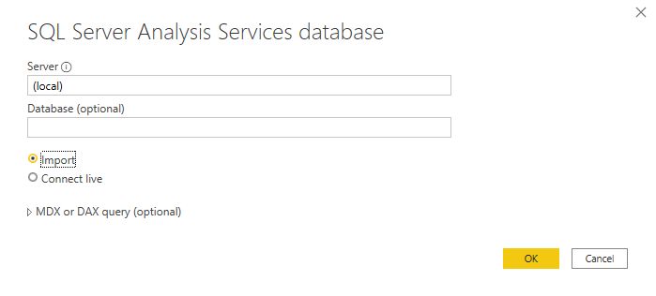

Write the server name and select import so the data is in powerbi constantly.

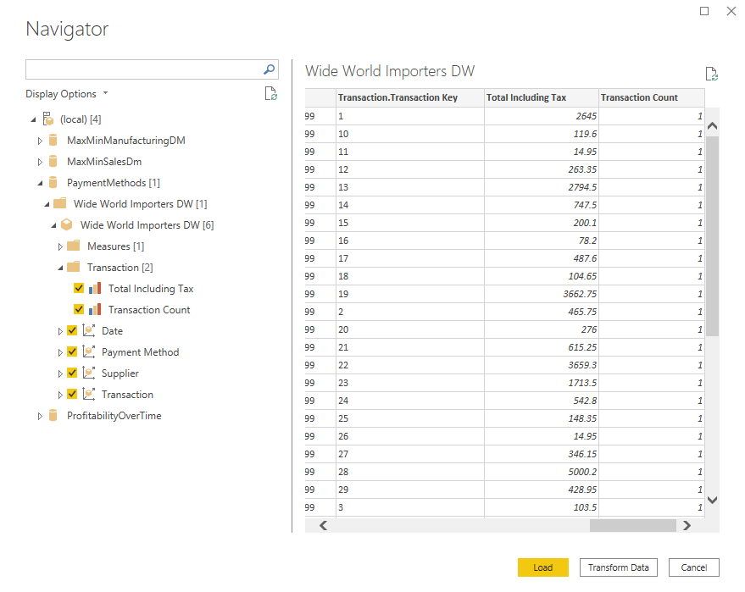

This is what it looks like.

11. Now to have the data ready, it will have to be transformed. The type of the field date will be set to date. This in turn will create a hierarchy that can be used in the report.

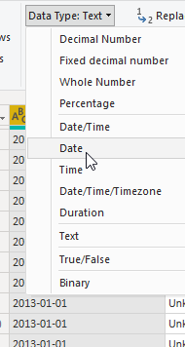

After removing the keys, the data is ready.

12. 2 measures can be defined that will be helpful in creating the reports. Transaction count YTD and Transaction count YTD LY, which makes it easy to compare the number of transactions during the year that has not finished.





The DAX formula make use of date and transaction count. The Last Year YTD takes the same YTD, but twelve months back.

12. After setting the name of the page and making sure view is set to actual view, a starting point would be a pie chart to see the payment methods used in transactions.

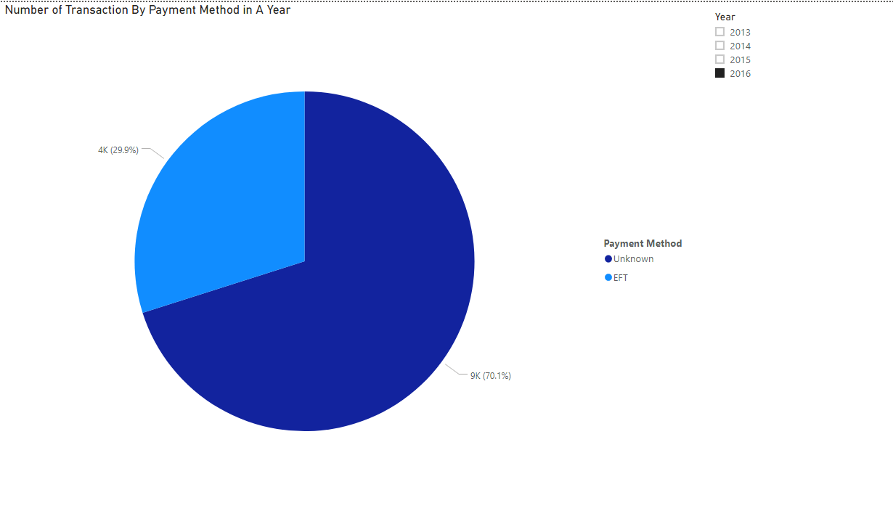

The legend is set to payment method and values to transaction count.

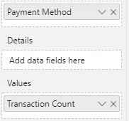

The slicer is added to check the transactions methods in a certain year.

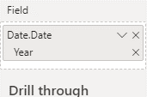

The best form of slicer for this is the list as there is no need for multiple years.

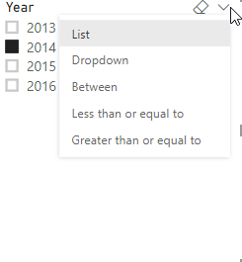

It is visible that only two payment methods are used. Unknown and EFT. Something else that is visible is the very big share of Unknown. Is that the case for each month in a year?

13. A stacked area chart will help in seeing clearer how big of a difference is between the two types of payment methods.

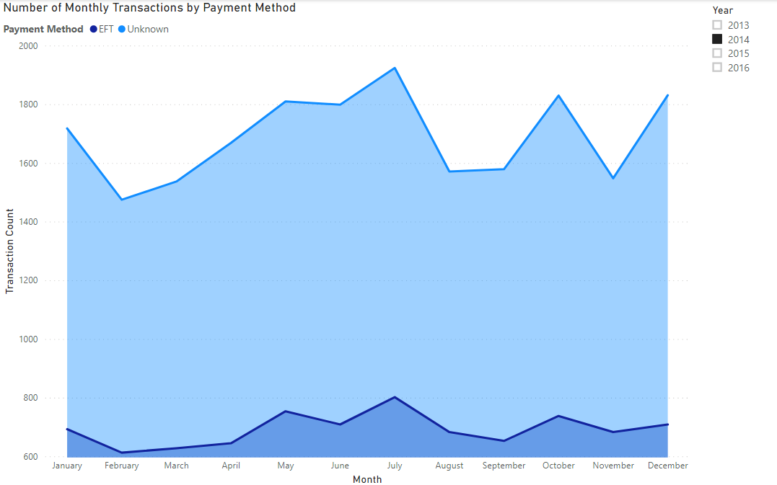

The legend is the payment method and the axis consists of the months.

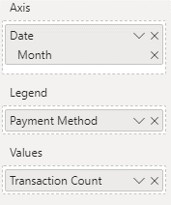

A slicer has been added to select a certain year. It seems it is the general situation that the unknown payment methods are more present than the EFTs.

Even though this is the case, does the number of transactions manage to reach the amount that it did last year?

14. A gauge can be a good indicator for goals.

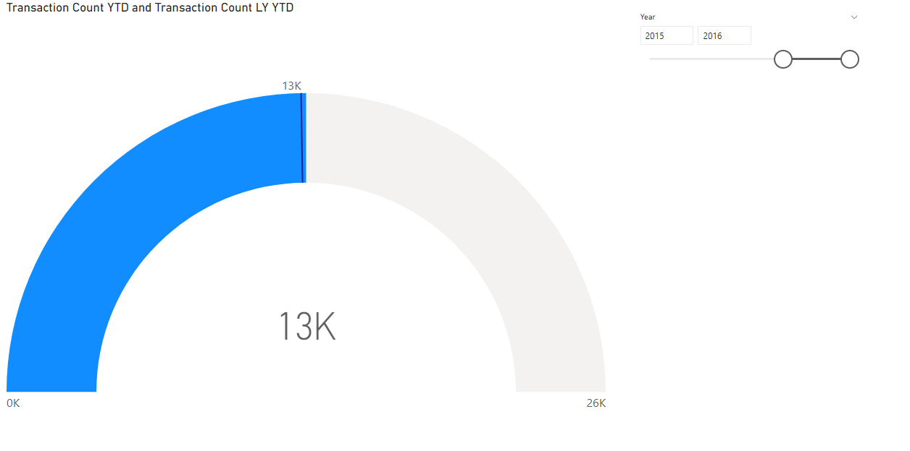

The target values for this gauge is set to be the number of transactions YTD with the target value of transactions count last year YTD.

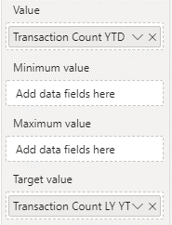

15. The next part is creating reports in SSRS. After creating the project. The first part is creating the Data Source.

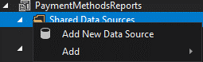

To establish the connection, build must be pressed and then the info for the connection has to be included.

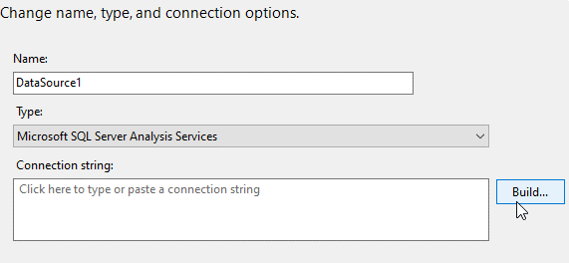

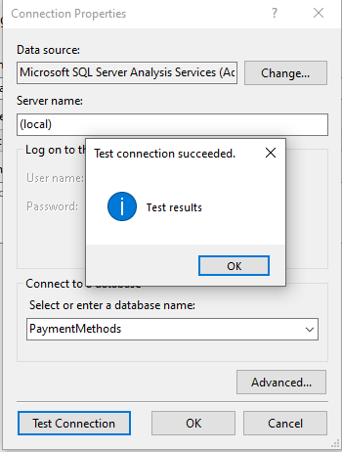

Now it is ready to produce the dataset.

16. Creating a dataset includes adding the connection details and transforming the new columns.

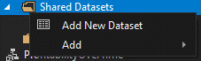

Add PaymentMethod to the name, select PaymentMethod as the data source and then press QueryDesigner.

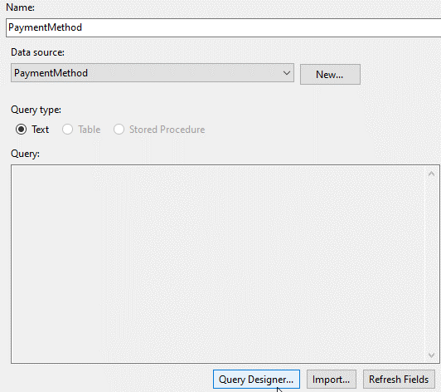

A new menu similar to the one in analysis services will appear where the fields can be selected for the dataset. The measure that will be used will be the Total Including Tax with Supplier, Payment Method, Year and Month to analyze how each supplier contributed to the total. Year will be set as a parameter as it will be a yearly report.

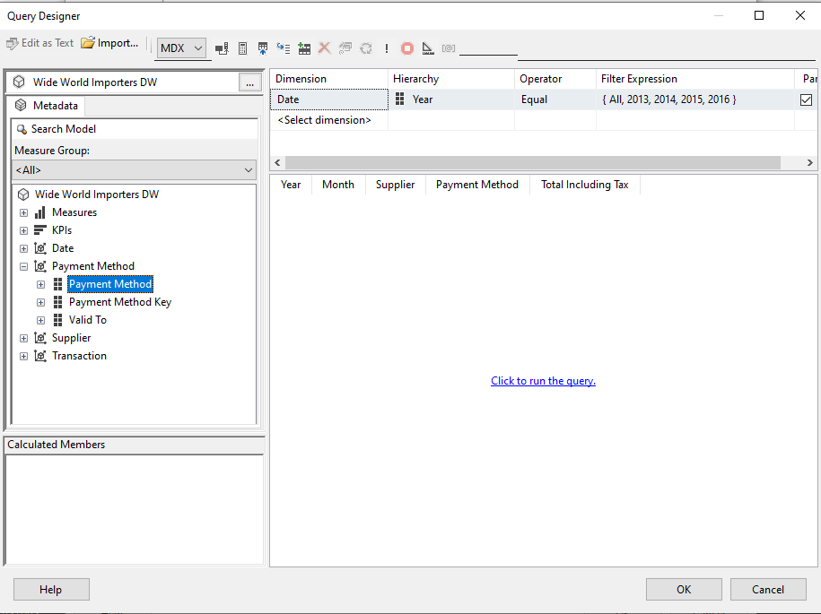

17. The following step is to create the report.

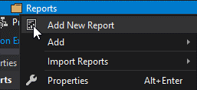

The dataset will be added. The parameter will be added at the same time with the dataset.

For the datasource, use shared data source reference should be used

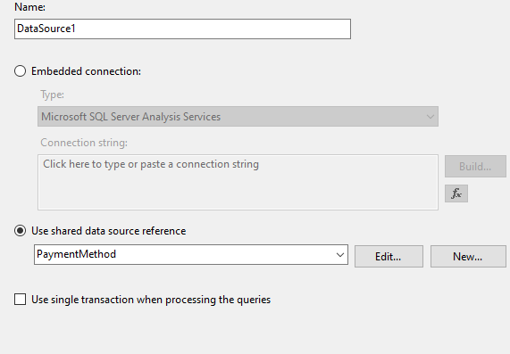

The name of the parameter will be changed from date year to Year

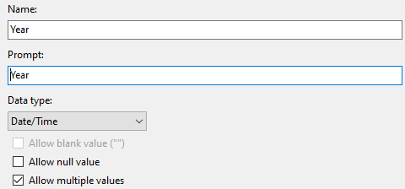

For the default value of the parameter, the first one will be used

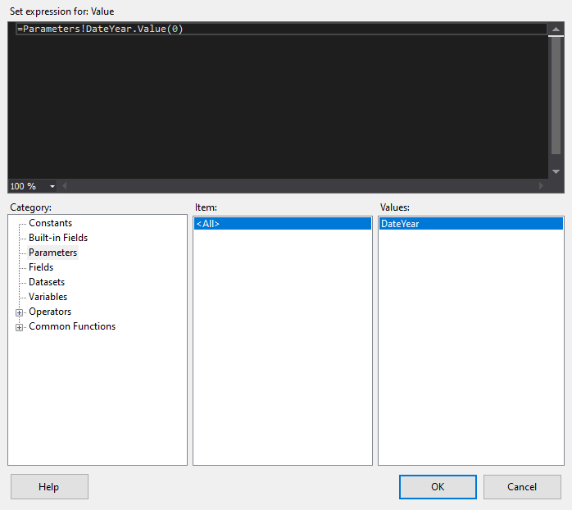

A textbox will be added to write the name. For the report, a matrix visualization will be used that will have year as rows with month as a hidden subgroup you can drill on.

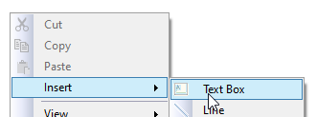

For the measures, the sum of Total Including Tax will be taken

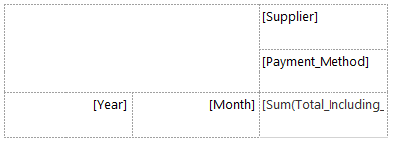

Now the fields month and payment method should be set as drill down elements

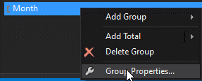

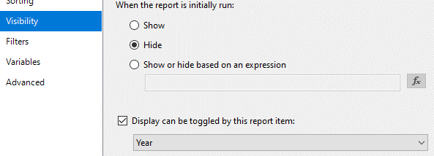

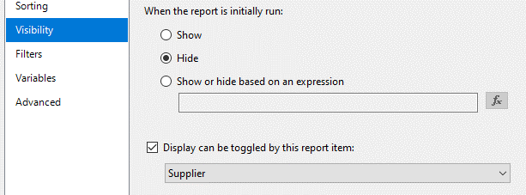

Coloring the table can be used to make the table more understandable.

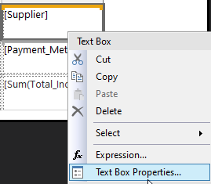

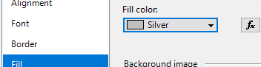

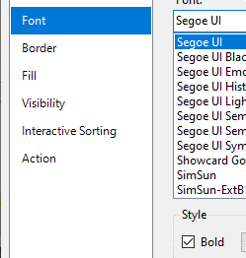

Setting the currency would make the total more understandable to a reader.

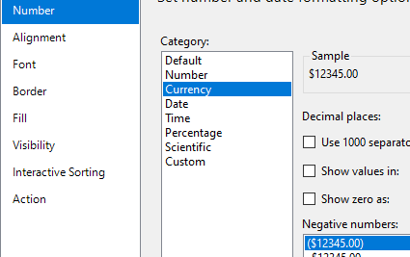

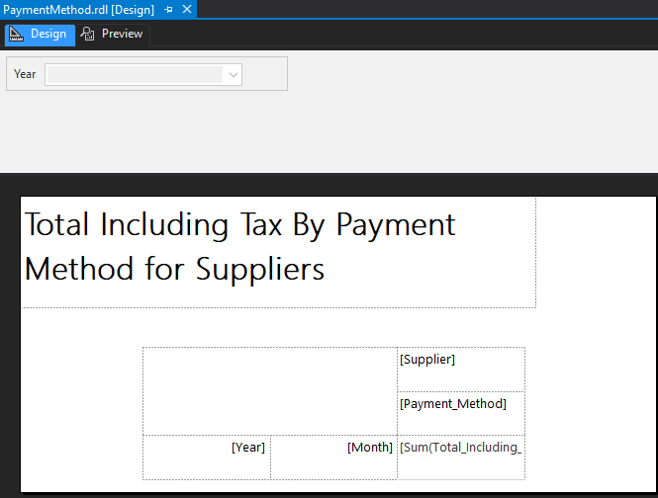18. The next step is to send the report to SSRS

For the deployment, the overwriteDatasets and datasources options are set to true. The TargetServerURL has to be updated to the correct one.

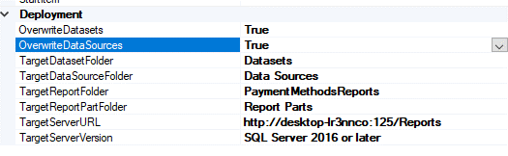

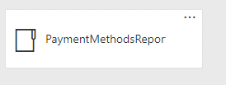

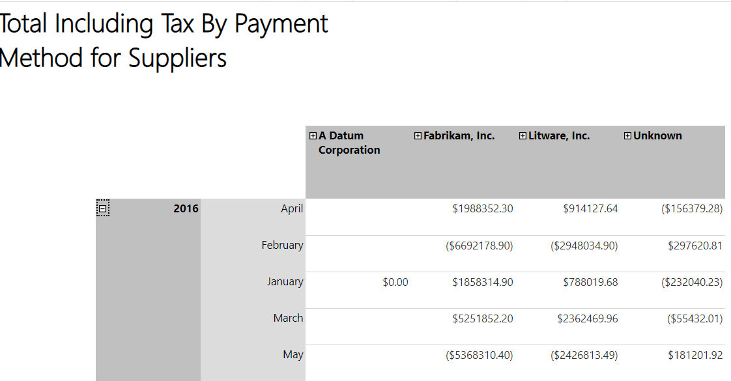

19. A mobile report can be created so it can be visualized on different mediums. A category chart can be used to have the different methods of payment stacked.

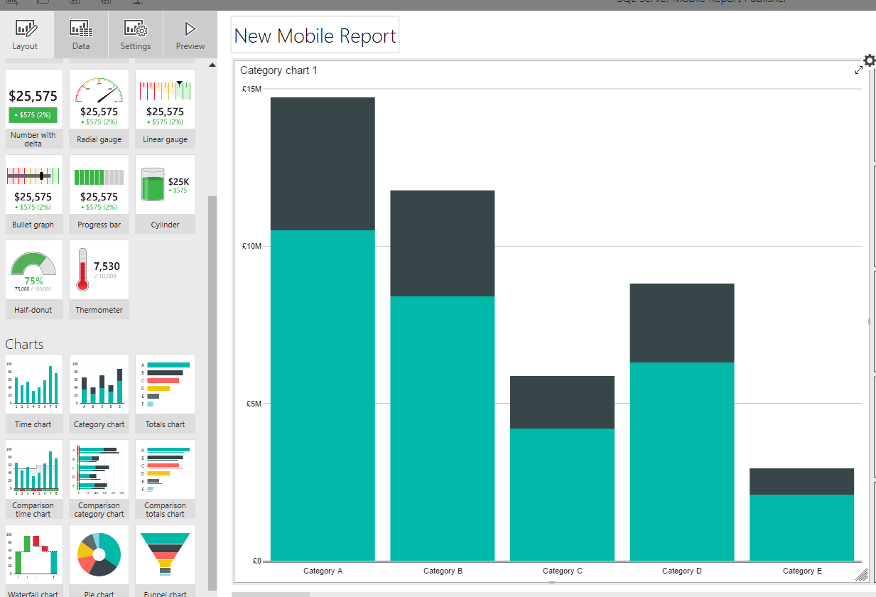

20. Adding a dataset is straightforward. Press Add data, select the server and from the datasets choose what is needed

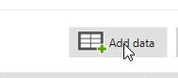

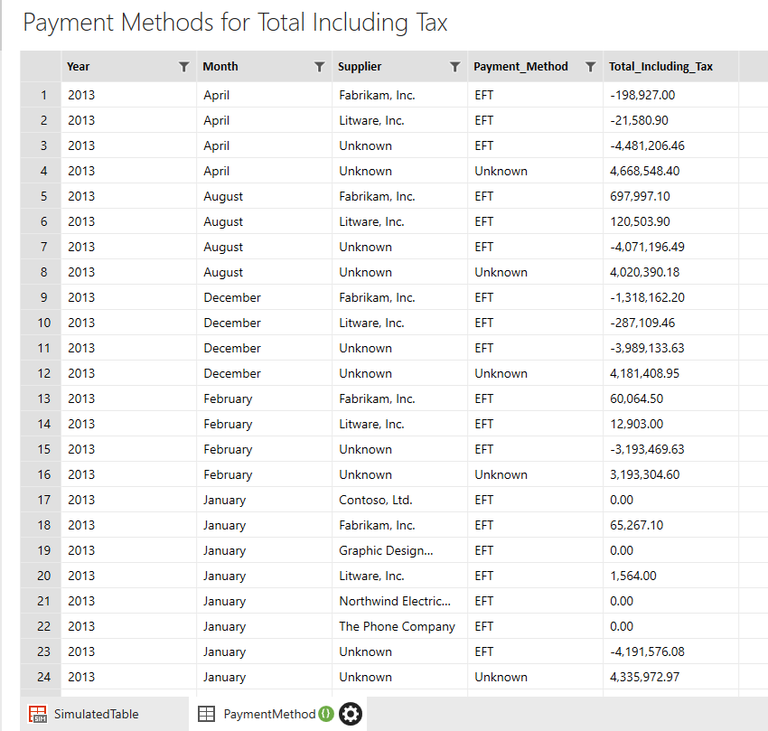

Now the data properties have to bet. For the series name field, the payment method will be used and for the main series the total including tax.

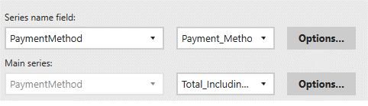

To the layout a slicer for supplier would he helpful to see different suppliers and their aggregates.

A selection list is picked and in data properties the Supplier will be selected. The filter will be set on Supplier.

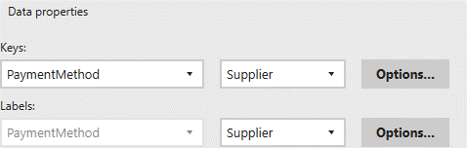

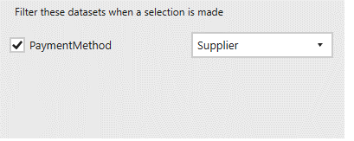

Also for the data properties in the stacked column chart the payment method has to be set to be filtered by Supplier.

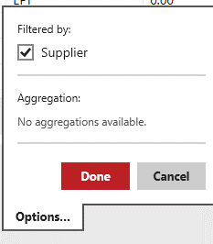

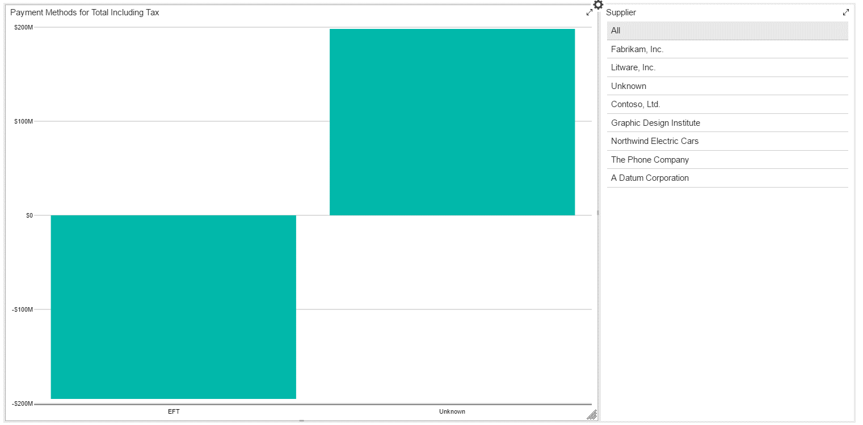

The currency is set to dollars

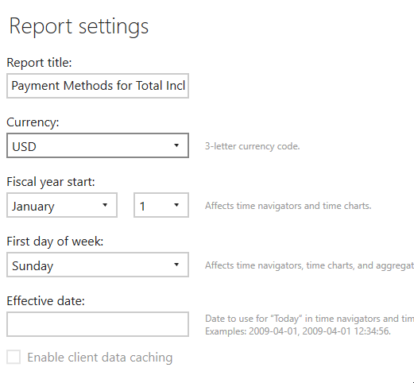

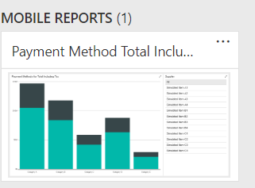

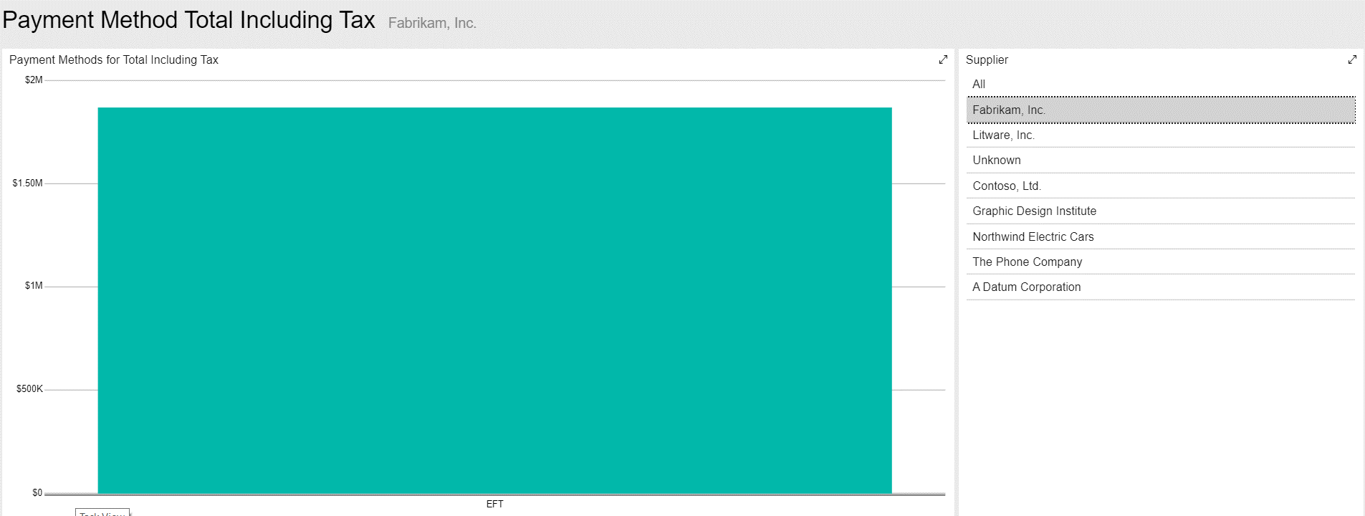

21. The next part is creating a tabular model for the transaction type. The first step after creating the project is to add the data source.



A connection is established with the sql database that holds the Wide World Importers data for which the windows credentials are provided.

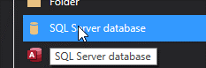

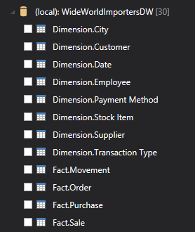

The necessary components are made of fact transaction together with the dimensions Payment Method, Date, Supplier.

In the power query editor, columns such as customer key, lineage key and other columns that are not going to be used will be removed so there is less redundant data.

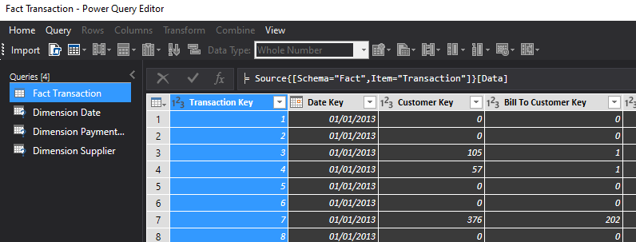

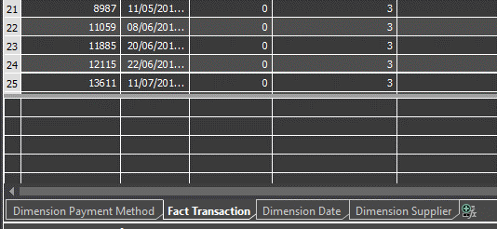

Once the columns are in, they can be renamed

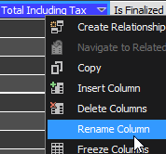

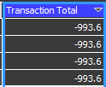

The foreign key columns are not useful in the analysis, so they can be set to hidden.

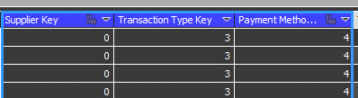



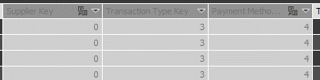

22.The tabular model can be set as the default for SSDT.

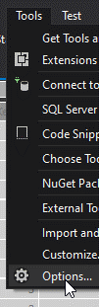

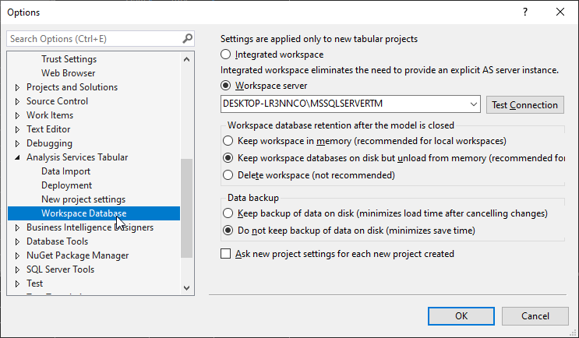

23.A new measure can be added to calculate the sum of transactions.

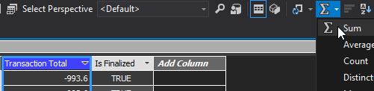

The format can be set to currency and with currency symbol set to dollar.



A second measure can be created for calculating the total for “Unknown” Payment Method. For this a DAX function will be used and Related to make sure only Unknown Payment Methods will be used.

Transaction Total Unknown PM:=SUMX(FILTER('Fact Transaction',RELATED('Dimension Payment Method'[Payment Method])="Unknown"),'Fact Transaction'[Transaction Total])

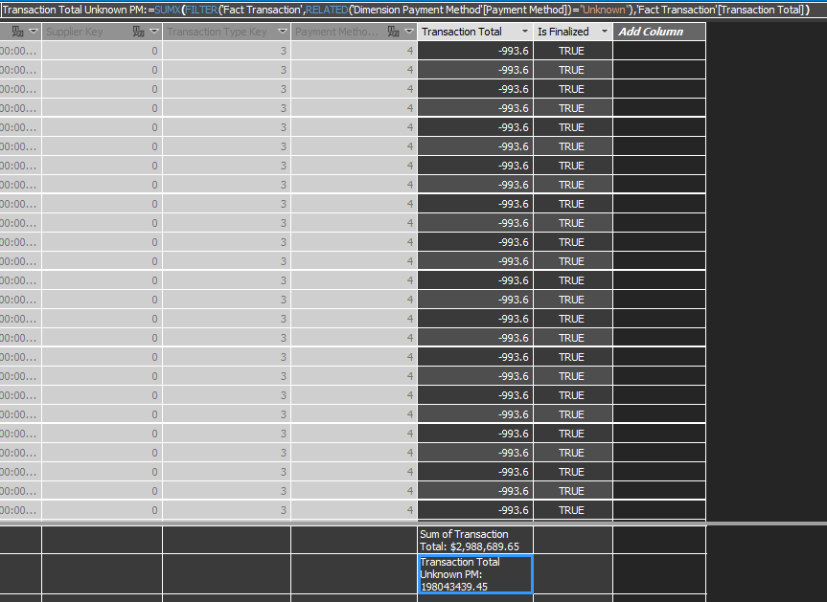

A third measure can be created in which there are all the transactions except Unknown. This will be helpful in making a KPI in which the goal is to have more income from sources other than Unknown.

Transaction Total Not Unknown PM:=SUMX(FILTER('Fact Transaction',RELATED('Dimension Payment Method'[Payment Method])<>"Unknown"),'Fact Transaction'[Transaction Total])

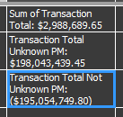

24. Creating a KPI out of Transaction Total of Unknown and of Transaction Total of Not Unknown

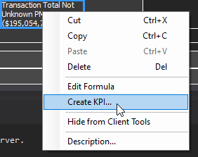

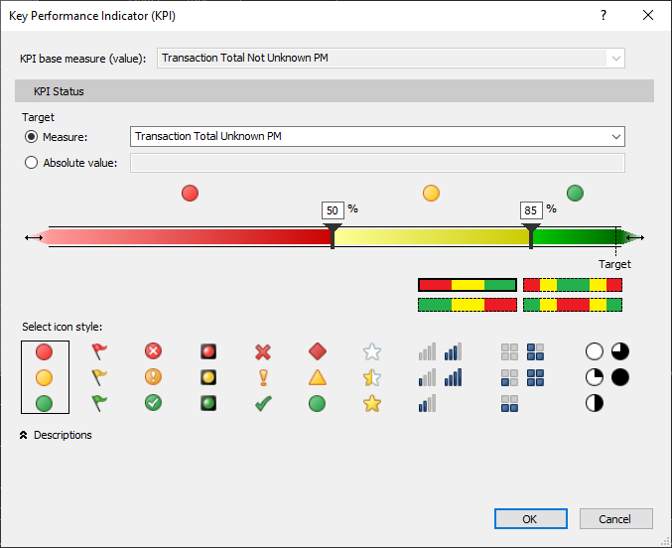

What is needed is to have most of the transactions be not Unknown.

25. The next step is deploying the model.

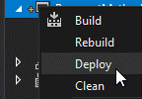

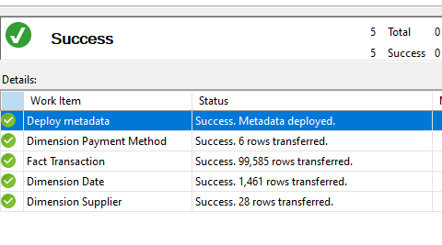

26. The next part is going to be creating Integration Services for the Payment Method. After the project is created, the first step is going to create the project and then setup a data flow.

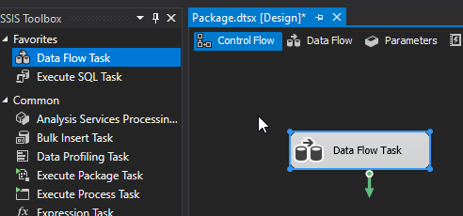



A connection must be created to the source of the data.

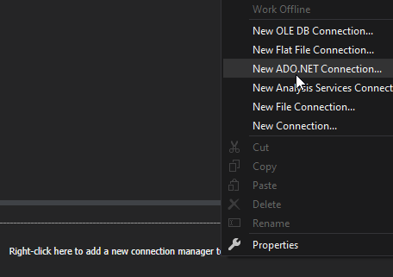

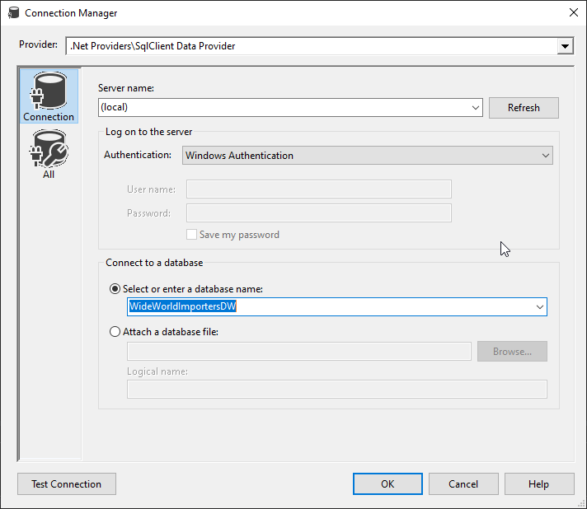

An ADO NET Source item must be added to get the fact table for the Data Mart.

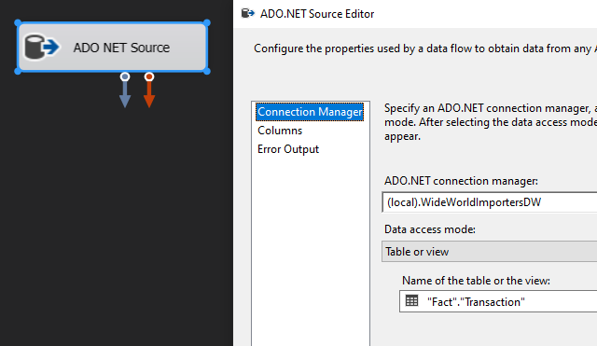

Now we have one of the tables as a source.

27. For the destination to be created, a new connection must be established.

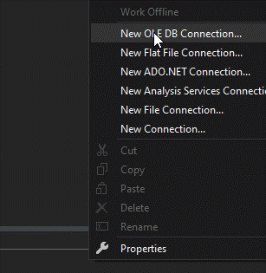

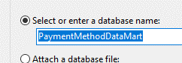

Now an OLE DB Destination is needed to the flow.

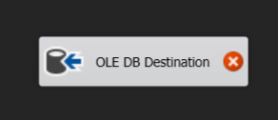

The destination table for the data is Fact Transaction inside the Payment Method Data Mart

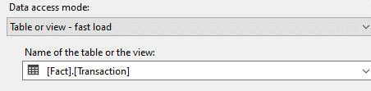

The columns are automatically mapped because they have the same name.

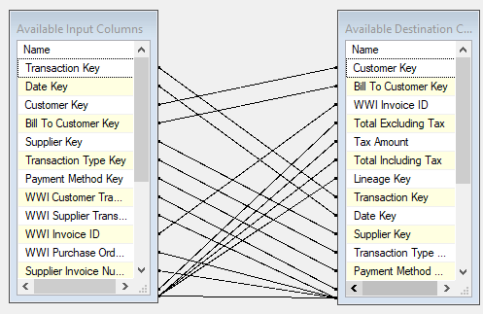

It is important to remove the transaction key from the mapping as it will generate by itself automatically.

28. The next step is just repeating the process for all the dimensions used in the data mart.

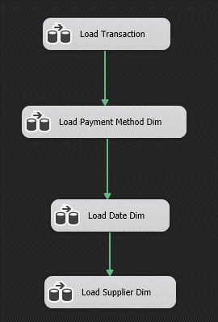

Each follows the same structure of Load Transaction.

29. A better idea would be to put the fact to be last. In case any restriction are in point, there will be no problems.

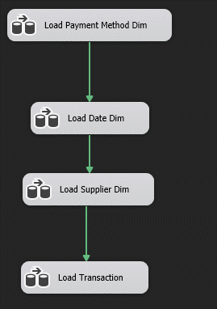

30. The next step is deploying the IS.

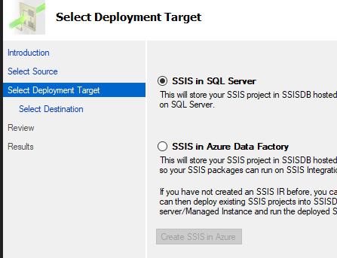

First, a catalog must be created to be able to run any SSIS.

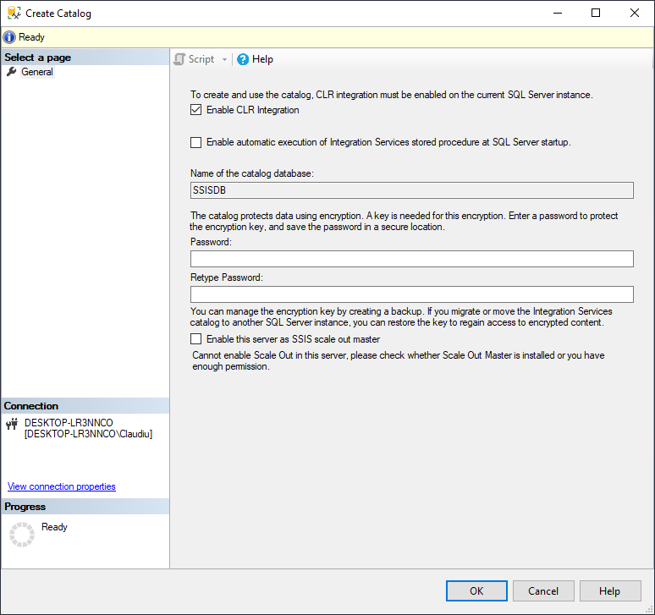

For this, integration services has to be installed as a feature.

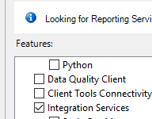



A new folder is created inside SSISDB from SSDT called Payment Method.



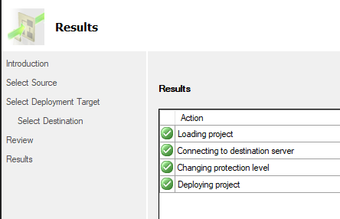

The project is now deployed.