SCRUM has been applied during the process of meeting the deadline of the course assignment. Once the product backlog was created the first sprint backlog has been developed through the decisions of the team members. The tasks were then distributed to all the members. During the first sprint all the tasks were completed and at the SCRUM meeting the next sprint backlog has been created consisting of the documentation for the features we implemented in the first sprint. The tasks were again split to all four members.

After the second sprint has finished the team had the Sprint retrospective. At the meeting the main topic of discussion was the achievement of completing our tasks and what we could improve on. The main things we could have improved on is the time in which we have done our tasks and create a proper documentation of the use of SCRUM.

The assignment also went through all the phases of Unified Process. In the inception phase the product backlog was created together with the first sprint backlog. The meeting consisted also of deciding of how much time there is needed to invest so everything would be complete at the end of the deadline.

In the next phase a domain model was created together with the requirements of the system. This helped in creating the features by the same blueprint.

In the construction phase the system was brought to a stable build in which everything worked as intended. At the end of this phase the documentation regarding it was updated and expanded upon with the description of each design pattern and how it works in the system.

In the last phase the system had it functionality tested with Junit Tests and hard input of data in the system, being polished on any shortcomings. In this phase the documentation was finished and updated to be at the same stage with the build of the system.

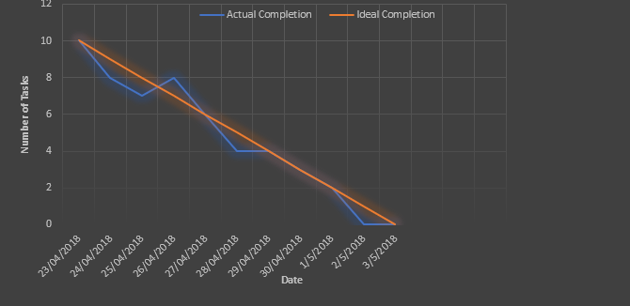

The burndown chart has 2 AXIS that consist of the number of tasks and the date. This chart was used to see how much time it was needed for the completion of the assignment and how efficient was the team in achieving everything on schedule. As seen in the chart, for most of the time, the team was in front of the schedule and everything was achieved as expected or even better.