**Process Report**

**Group 6**

**Zair**

Claudiu Rediu 266129

Dominika Kubicz 266148

Nikita Roskovs 266900

Tudor Ciobanu 267632

**Supervisors:**

Ib Havn (IHA)

Joseph Chukwudi Okika (JOOK)

Knud Erik Rasmussen (KERA)

Mona Wendel Andersen (MWA)

**[Number of characters]**

**ICT Engineering**

**Semester 2**

**8.06.2018**

**Table of content**

1 Introduction 1

2 Group Description 3

2.1 Belbin Roles 3

2.2 SWOT Analysis 4

2.3 Cultural Difference 7

2.4 The Group 8

3 Project Initiation 9

4 Project Description 10

5 Project Execution 11

6 Personal Reflections 12

7 Supervision 13

8 Conclusions 14

Appendices

# Introduction

In the beginning of February 2018 we formed a group in order to work on the semester project. At the moment of agreeing to work as a team we didn’t know yet what we will be working on.

This project we were able to decide what we want to work on. We have received some guidelines how the system should work, but we were allowed to make up a case for the project. We came up with two ideas that all group members were excited about. Both ideas were approved by our supervisor, so we chose the one that fitted us more. We decided to work on a system that is suitable for a flight company. We named our company ZAir and we created a program where the administrator can store flights while the company’s customers cant book tickets for these flights.

Before we started to work on the project, we had to set some rules in our team. Together we created a group contract, and all members agreed to the regulations from the contract. All of us had to sign it in order to clinch the agreement.

Like every other team we went through four stages of team formation which are forming, storming, norming and preforming. In our case first three stages passed very quickly and we got without any problems to the preforming stage.

During the working time everyone found a suitable role in the team. All members fulfilled their roles in the team, which made our time together very productive. Each member had some part of the project to work on. We had it all planned on a website [www.trello.com](http://www.trello.com) to which all members had access to. If we needed help then we were able to notify all members very easily. This allowed us to keep track of the amount of work we still needed to do and what we already did. We also could see who is working currently on.

Our meeting were held always at the university. We helped each other with our problems and did what we were assigned to do. Not all meetings were long and expected. Sometimes we stayed after classes for a couple of minutes to discuss some details so we can move forward with our work.

Thanks to the very good communication among the group members the time spend together was pleasant, and the project was a success.

# Group Description

The group consists of four team members from three different nationalities.

## Belbin Roles[1]

According to Belbin team roles each member has a certain “tendency to behave” while working in a team.

**Claudiu Rediu** (Romania)

**Sharper** – keeps the team working, takes care so that the group doesn’t lose focus. The risk is that he might get emotional in order get things done.

**Co-ordinator** – concentrates on the team’s objective and can divide work between people appropriately. Might sometimes get too excited about delegating work.

**Tudor Ciobanu** (Romania)

**Specialist** – has a very good knowledge on a special topic. Sometimes might put his work over the group work.

**Implementer** – is needed in order to properly plan the most efficient way of working. It might be hard for an implementer to relinquish their plans.

**Nikita Roskovs** (Latvia)

**Implementer** – is very good at finding a most efficient way to work, and plan it. It might take him some time to change the plans for a greater good.

**Complete finisher** – is very good at putting a final touch to others work, to check on mistakes and return the work in a perfect condition. Sometimes might get over focused on the details.

**Dominika Kubicz** (Poland)

**Complete finisher** – pays a lot of attention to the details, is good at fixing small mistakes, cares for the work at its best quality. On the other hand, can get too extreme with the details.

**Specialist** – is specialized in one area of knowledge. Specialist can concentrate on only his part of work.

## SWOT Analysis

In order to better introduce all the team members we created diagrams showing our SWOT analysis. Bellow we have five diagrams, one for each team member and one for the whole team.

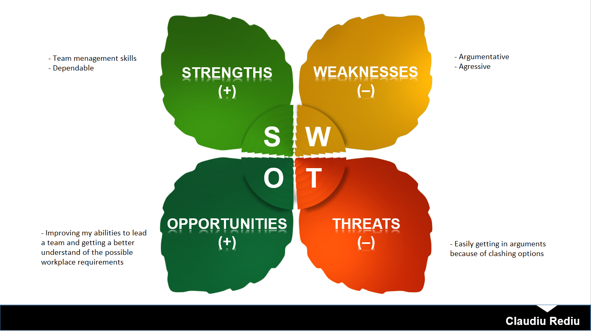

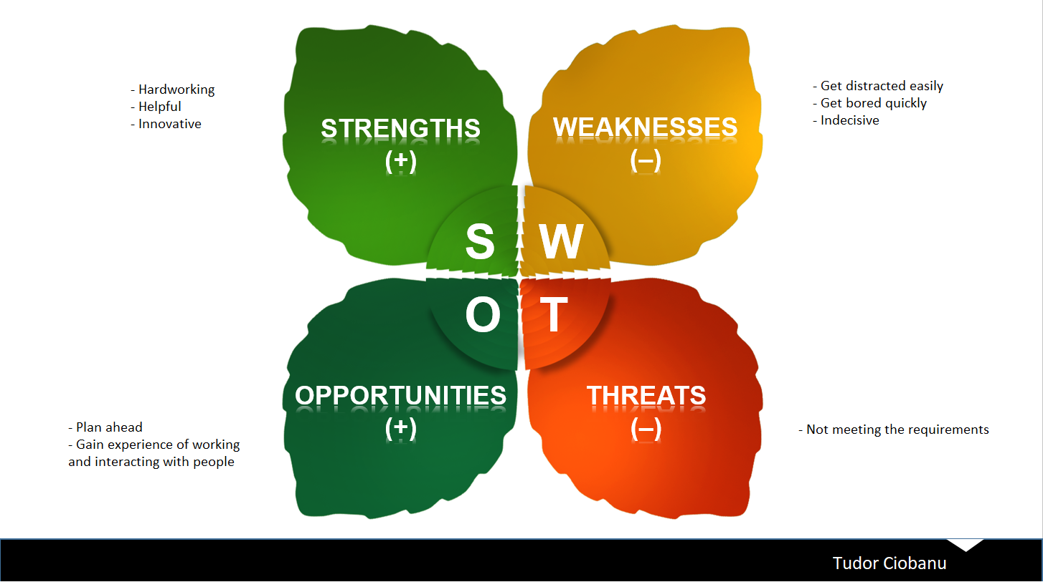

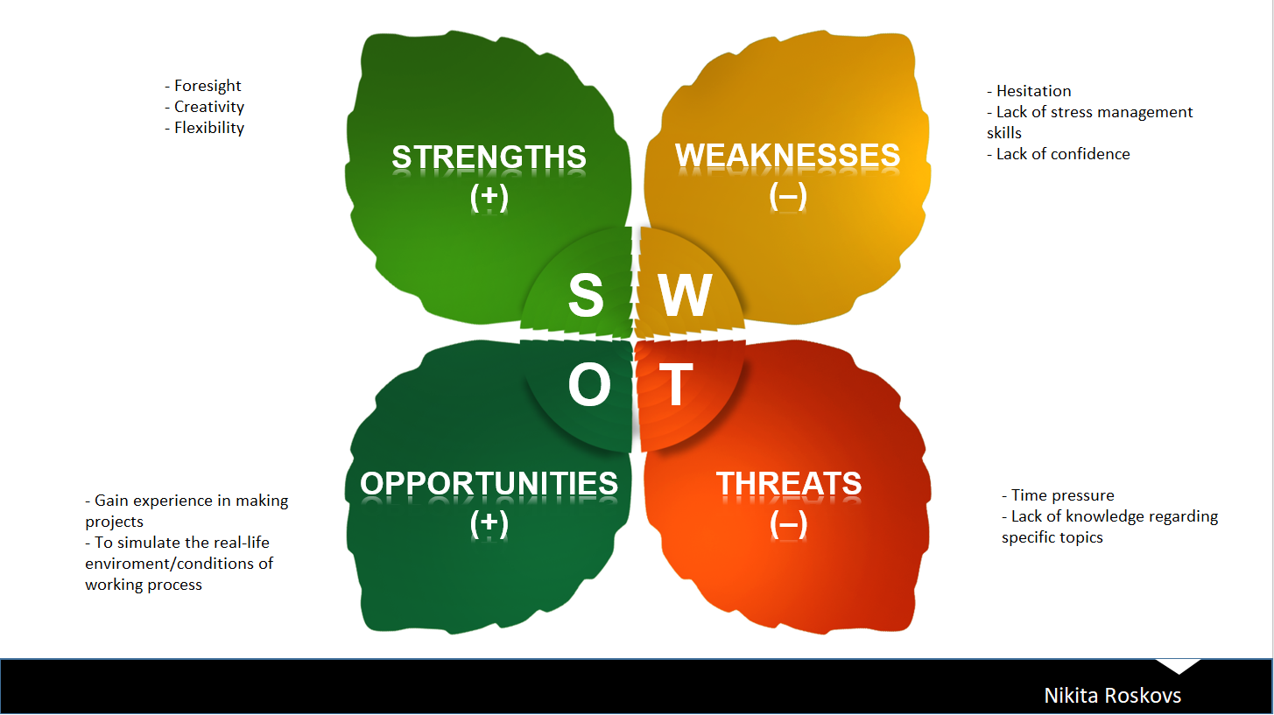

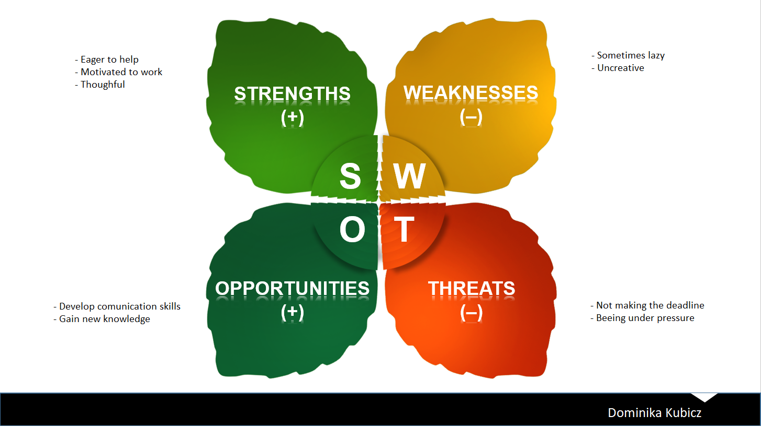

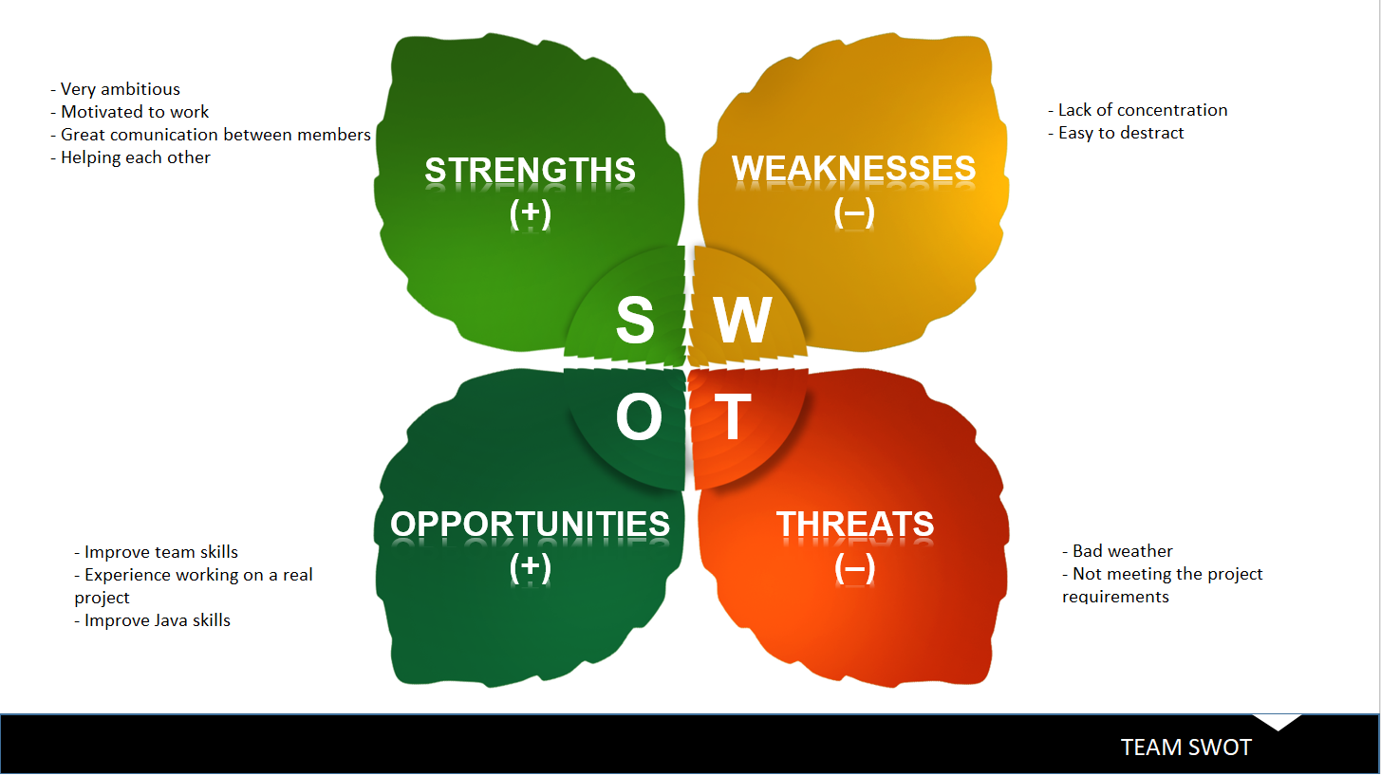

## Cultural Difference[2]

Our team consists of members from three countries. All countries scored a certain amount of points for different dimensions. The scores are shown on the figure 1.

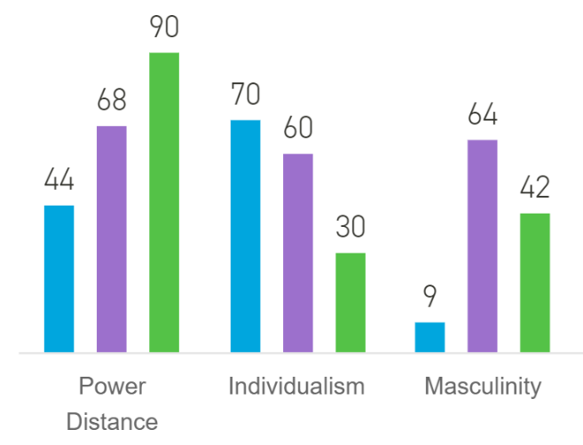

*Figure 1*

**Latvia**

In the power distance dimension Latvia scored lowest from all three countries. That means that Latvian people prefer to work as a team and equality between the team members, although they still show respect towards the authorities.

Individualism is also very popular in Latvia. Children from the beginning are taught that it is important to take responsibility for their action. Also they tend to speak their mind, and are very tolerant towards other.

Latvians motivation is that they do what they like. They don’t feel comfortable with praising, and are very careful not to offend anybody. All of that is because they vave very low masculinity.

**Romania**

Because Romania scored very high in the power distance dimension, that means that the people are used to a hierarchy and accept their place. They are used to others telling them what to do.

The score of individualism shows that in Romania there is actually a collectivistic society. That means that they take group responsibility very serious, and they also take very serious relationships between group members.

Romania has a Feminine society, which means that people “work in order live”. They value equality and solidarity. The conflicts between them are solved very easily.

**Poland**

Just like Romanian society Poland also is a hierarchal society, because of its high power distance score. People agree to their place in the hierarchical order, and are used to being told what to do.

In the Individualism dimension Poland scored quite high, meaning that they care about themselves and the closest family. In such society offence causes a loss in self-esteem and guilt. The promotions and hiring is based not on the relationship but on merit.

Poland is considered a Masculine society. That means that people “live in order to work”. The conflicts are settled by fighting them out.

## The Group

All group members have experienced before working in a group of people. Dominika and Tudor have already been working as a team last year.

Even that our cultural background was different we managed to work together. There were no fights between team members. The relationships between each other were very friendly. Everyone felt comfortable during the meetings.

In our group we had members with Belbin roles from each of the following dimensions:

* Action Oriented Roles (Nikita – implementer, complete finisher)
* People Oriented Roles (Claudiu – Co-ordinator)
* Thought Oriented Roles (Tudor, Dominika – specialists)

Thanks to the fact that we had all of the tree dimensions covered, our team members worked together very well, and enjoyed the time we spent together.

# Project Initiation

As every other team, in the initiation phase we went through the four team formation stages, which are Forming, Storming, Norming, and Performing.[3] In the first stage all members were exited about the upcoming challenge and working with new people. Storming phase was almost unnoticeable in our team. Everyone found their place immediately, there were no fights. None of us tried to impose their working style, we found a way to work together. Norming came surprisingly quickly, because of the lack of disagreements between members. Reaching the preforming stage was no challenge for us.

The most important document for us was the group contract. We created it by discussing together, everyone was able to add some rules that they wanted the whole team to follow. In order to prove our will to work on the project, everyone agreed to the rules from the contract and signed it. All team members did their best to respect the regulations.

From the start the whole team agreed to meet at university. We also considered holding meetings thorough the internet, but there was no need for that. For the meetings all members showed up. There were couple of times when one or two members couldn’t show up because of some personal reasons, but apart from that the attendance was perfect.

At the very beginning we received from our teachers guidelines for the project. We were allowed to pick a case ourselves, but it had to match the guidelines. We came up with two ideas. Frist we thought of making a car rental system, with different cars for rent. Our second idea was to make a flight booking system. Both of our ideas got approved, and the teacher let us choose the one we preferred. We decided to proceed with the flight system.

Our team had no problems in working together ever since we started. We had to choose a product owner and SRUM master in order to follow the SCRUM framework. We decided that Tudor will be the Project Owner, Claudiu the SCRUM Master and Nikita and Dominika were the team.

# Project Description

Creating project description was much easier for all of us this time. We already had experience from last semester, so we knew how to properly do it. Because the project case was created by us we could very precisely describe the project. We started with the background description. From all the sources we found, we chose the one that were most reliable, and appropriate for our case. Finding an airlines which was struggling with the same dilemma of creating a tailored system was very helpful to properly show the problem that ZAir was struggling with as well. More troubles came with the definition of purpose. We knew what the goal of the system was, but we had to explain it with proper words. Our first draft of the problem statement was not good enough. After one meeting with one of the supervisors we had to reformulate it. Delimitations were easy to make. We had many creative features for our system, but we were aware that we are not able to implement them all, so we gave some of them up. **(CHOICE OF MODELS AND METHODS)** We created a proper Time Schedule at the end knowing that it will most probably change in time. Most trouble we had with the Risk Assessment. We had to assign responsibility to prevent a risk to a certain person We didn’t know each other too well so it was challenging to pick a right person to assign it to.

To conclude the Project Description phase went smooth, without bigger problems. With already some previous experience we were able to stand up to the challenge and do our best to properly write the document.

# Project Execution

For content see Appendix 2 “Process Report – VIA Engineering Guidelines”.

# Personal Reflections

For content see Appendix 2 “Process Report – VIA Engineering Guidelines”.

# Supervision

Through the duration of the project we had numerous supervisor meetings. Our first supervisor meeting was with Mona Wendel Andersen. We were at the point of creating our Background Description in our Project Description. We wanted to make sure that the project will be properly introduced. Mona gave us useful tips, which we immediately executed.

# Conclusions

For content see Appendix 2 “Process Report – VIA Engineering Guidelines”.

**Appendices**

1. <http://www.belbin.com/media/1336/belbin-for-students.pdf>
2. https://www.hofstede-insights.com/country-comparison/denmark,latvia,poland/
3. https://www.mindtools.com/pages/article/newLDR_86.htm