|  |
| --- |
| **ZAir**  **User Guide** |

**Claudiu Rediu 266129**

**Dominika Kubicz 266148**

**Nikita Roskovs 266900**

**Tudor Ciobanu 267632**

**Table of content**

Introduction iii

1 Register 1

2 Log In 3

3 Searching for flights 4

4 Booking and canceling a ticket 8

5 Managing flights in the system 13

# Introduction

The purpose of this document is to describe the useage of system of ZAir. It describes in simple steps how to properly use the sytem.

In simple steps it is described how to use the basic features of the system.

# Register

In order to have acces to the system the user has to create an account.

1. Press “Sign up”

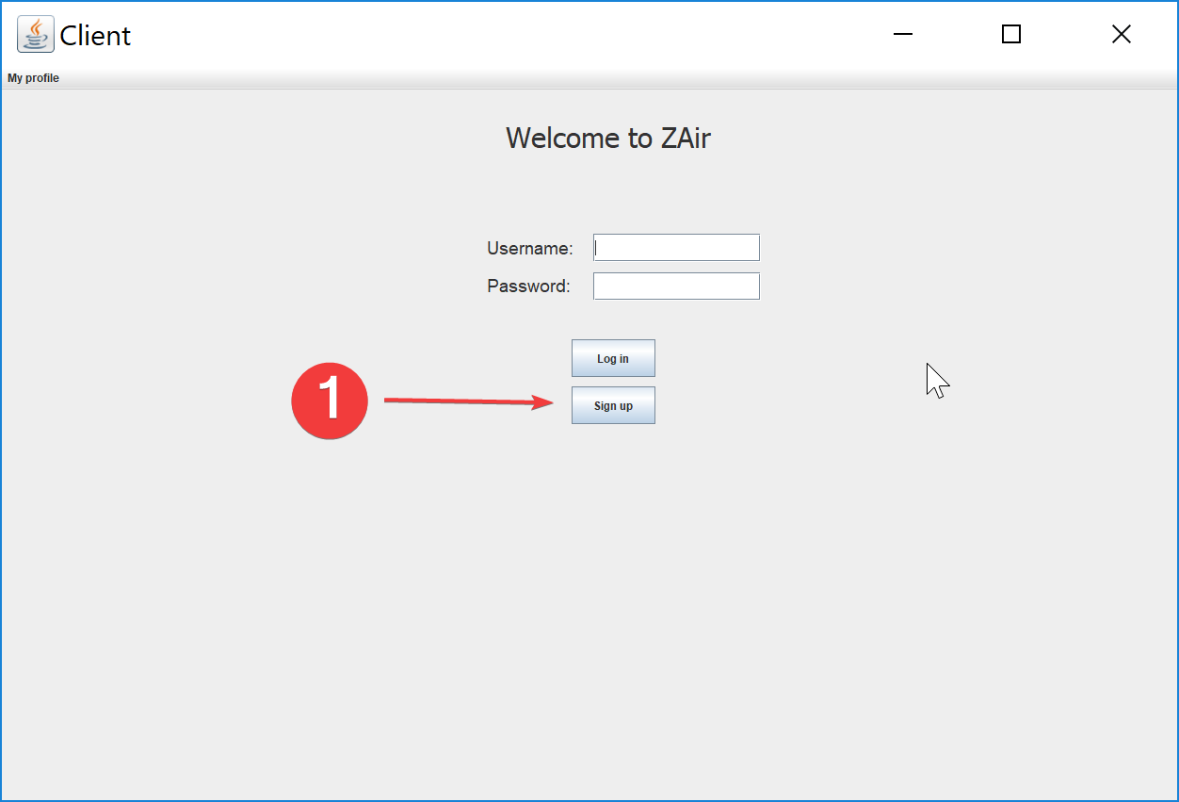

1. Input required data

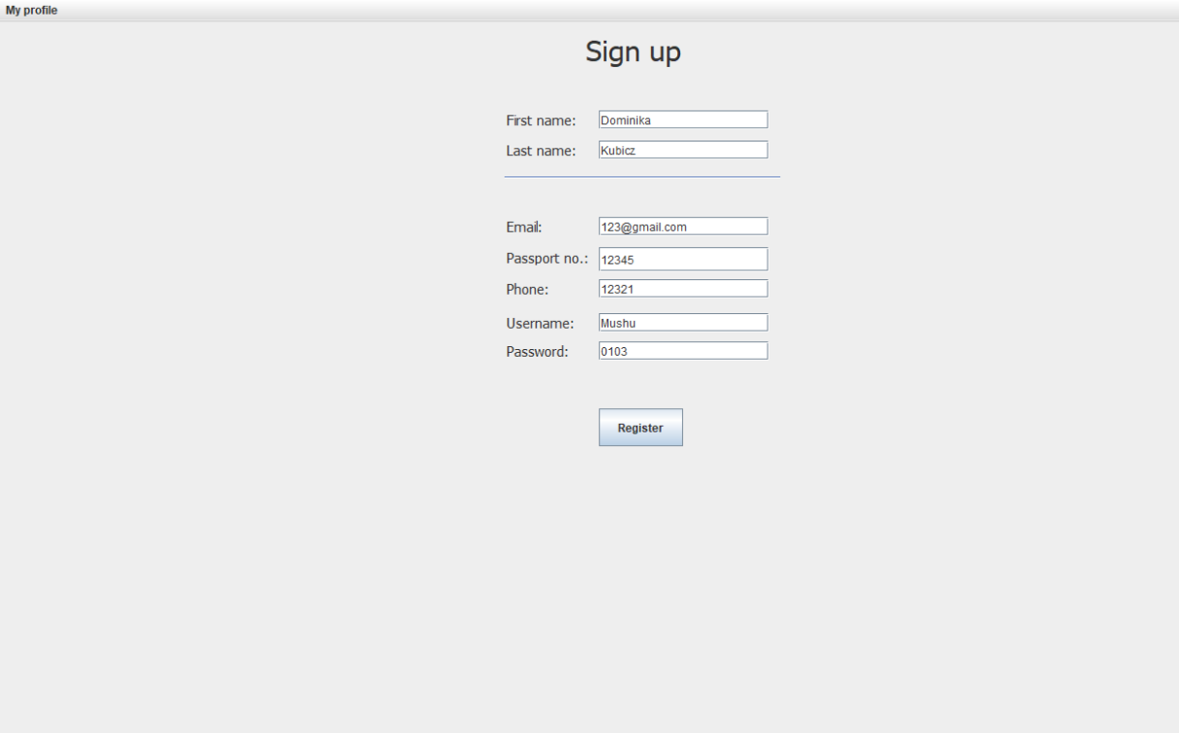

1. Press “Register”

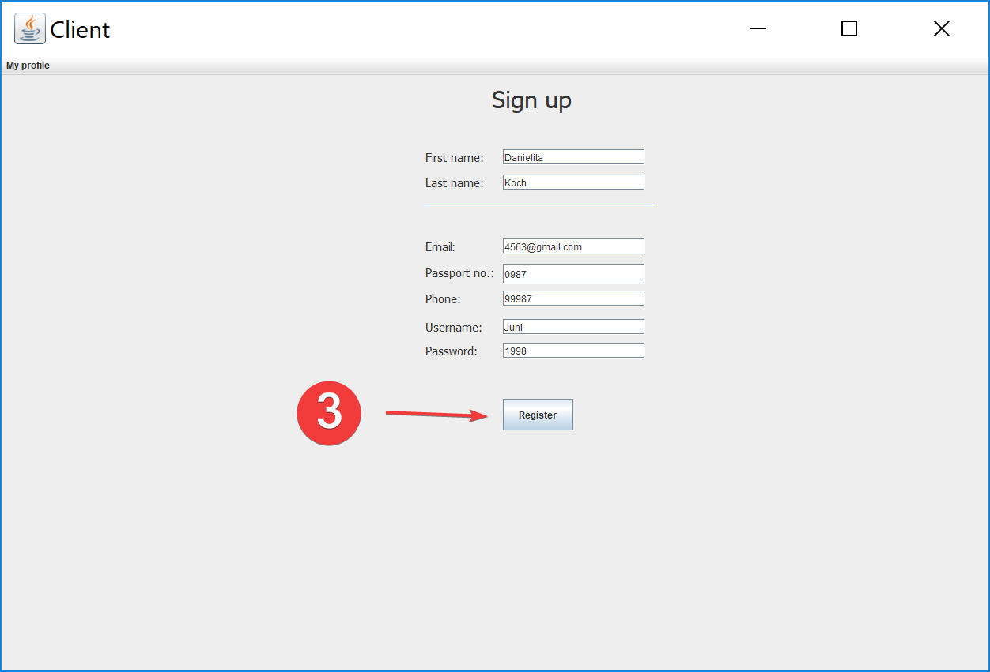

1. 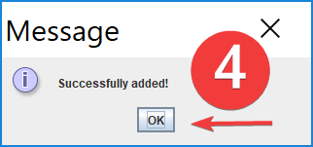Press “Ok”

# Log In

In order to view the flights the you must log in (if you haven’t created an account yet go to Register).

1. 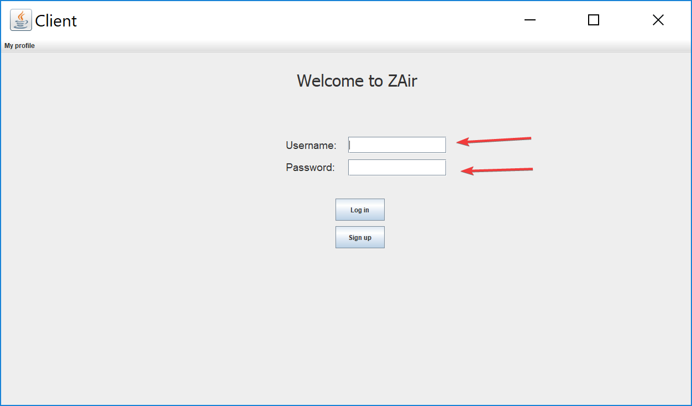Input username and password
2. 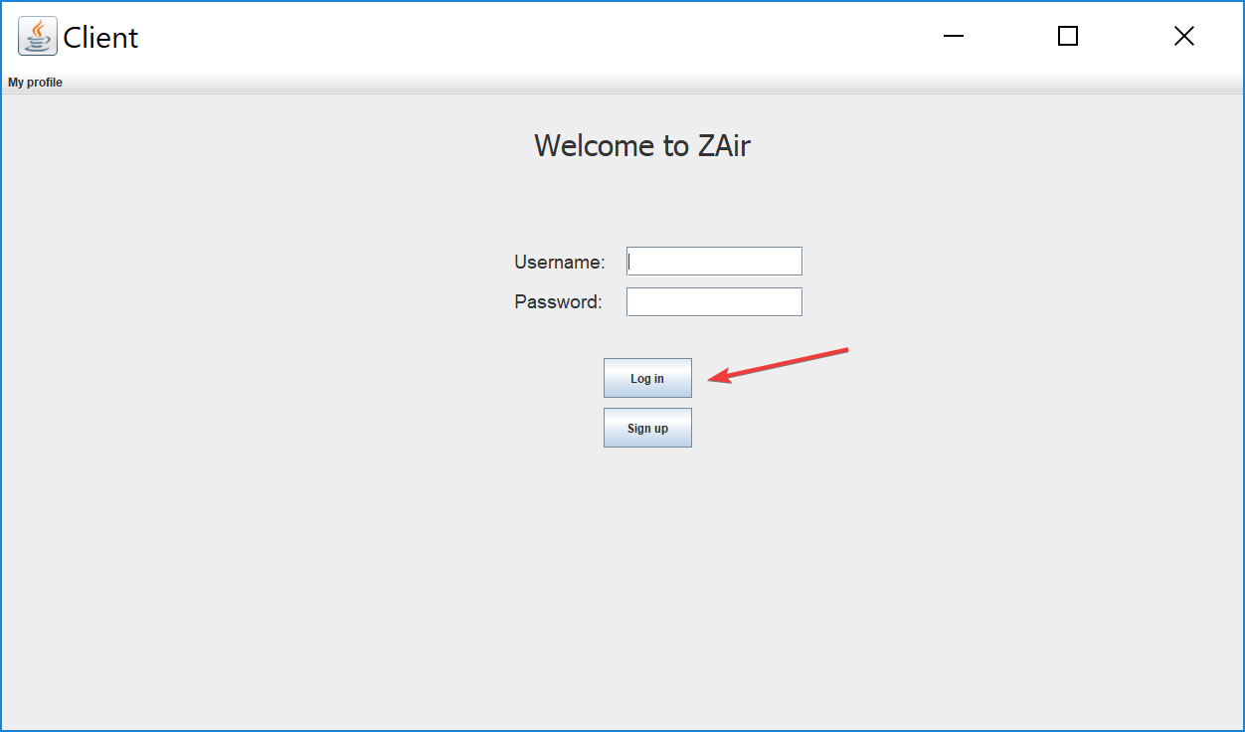Press “Log in”

# Searching for flights

After the log in the system will display the following interface:

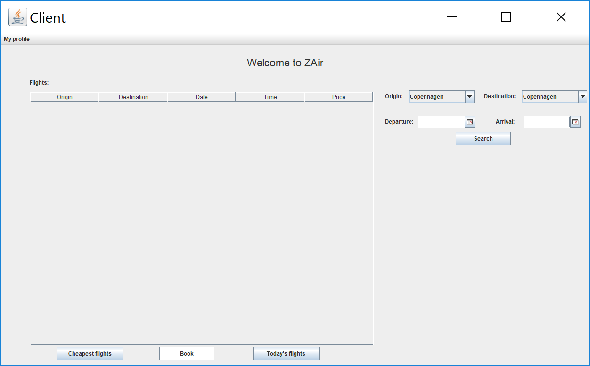

You can search flights using different coditions:

1. Search flight by price
   1. Press button “Cheapest flights”

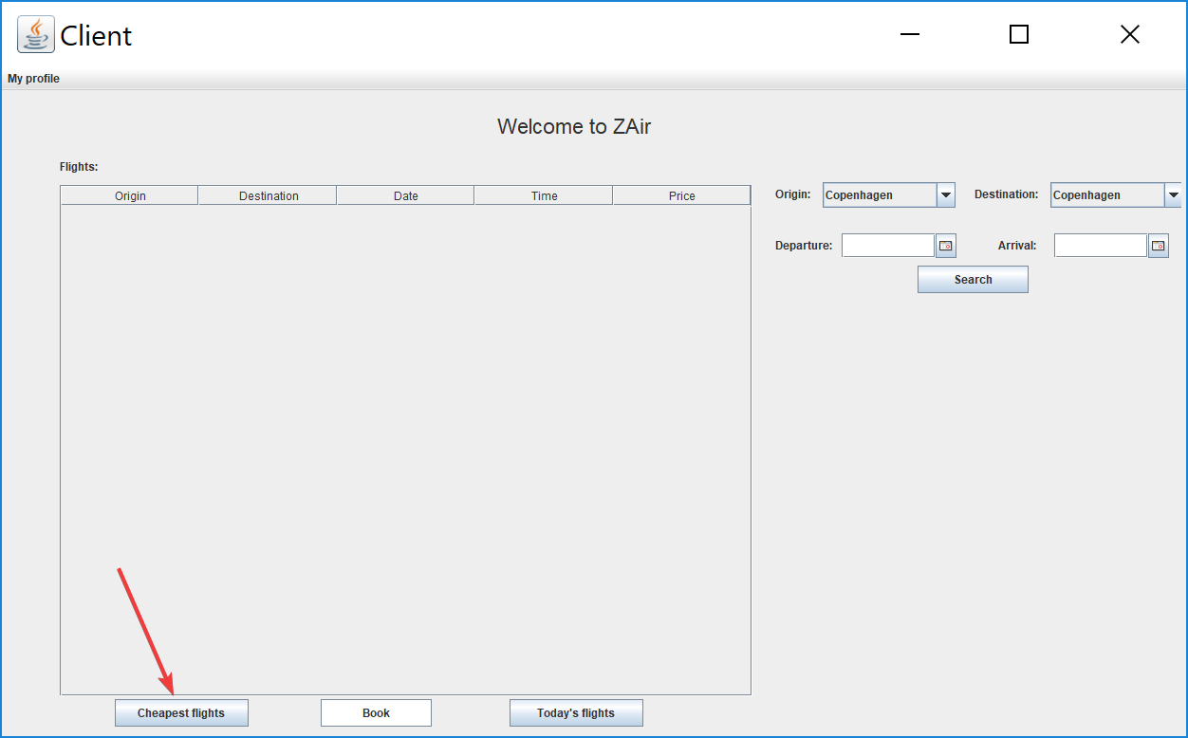

2

1. Search flights by today’s date
   1. Press “Today’s flights”

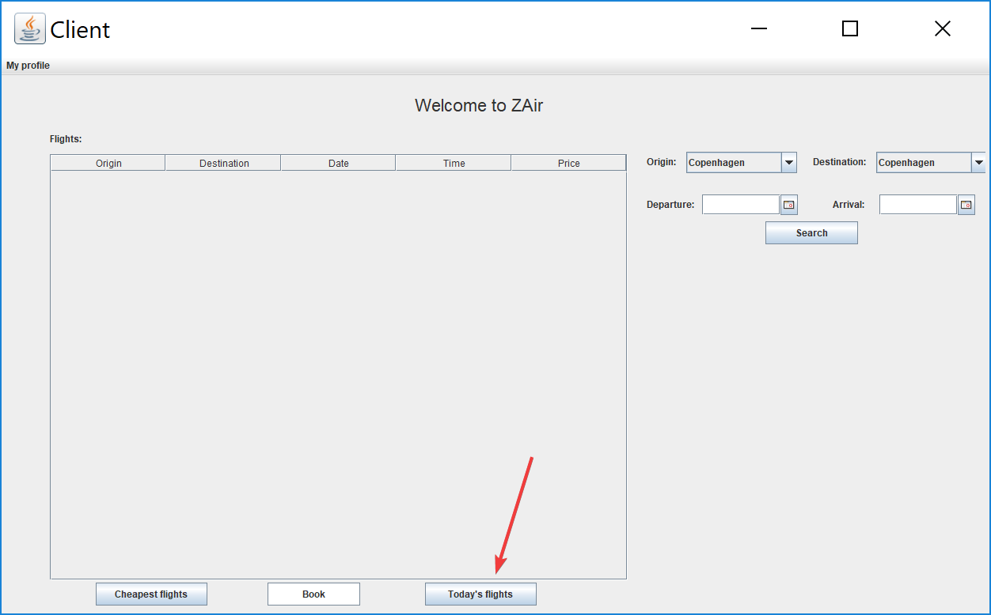

1. Search flights by origin, destination and date
   1. Choose origin and destination from the dropdown list

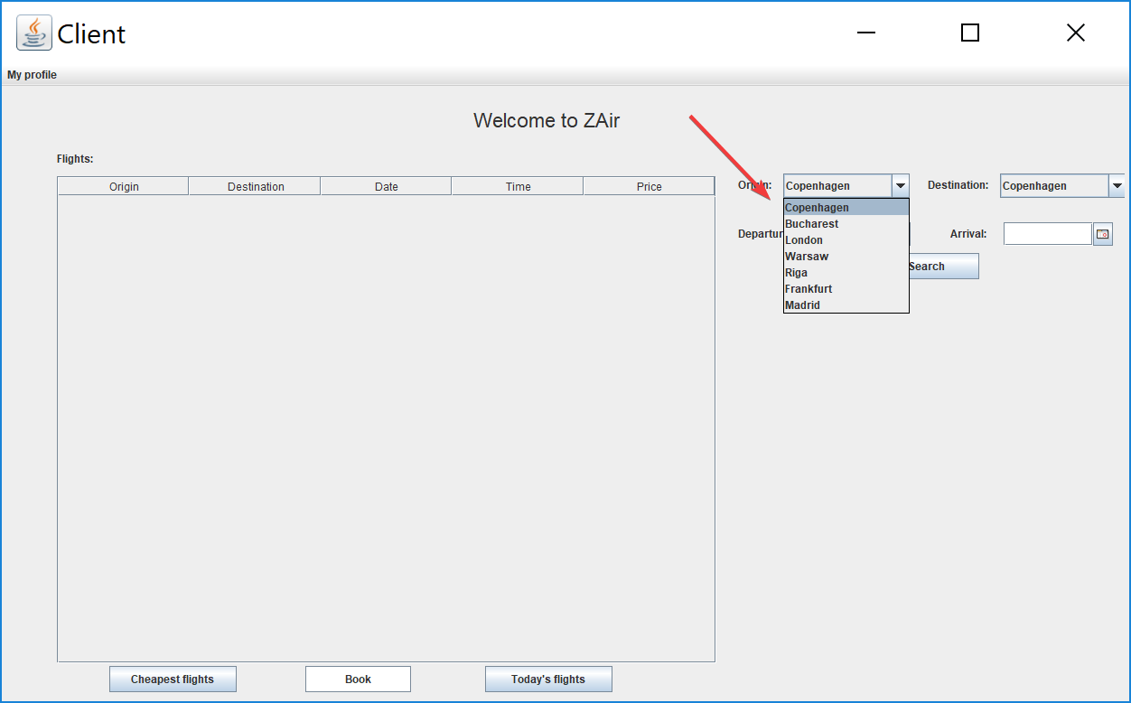

* 1. Choose a departure and arrival date from the callendar

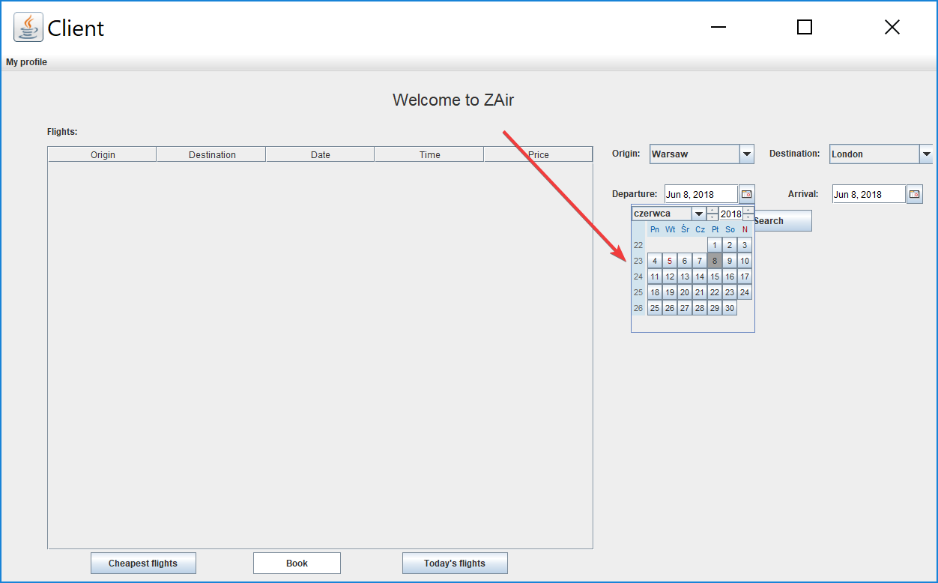

* 1. Press “Search”

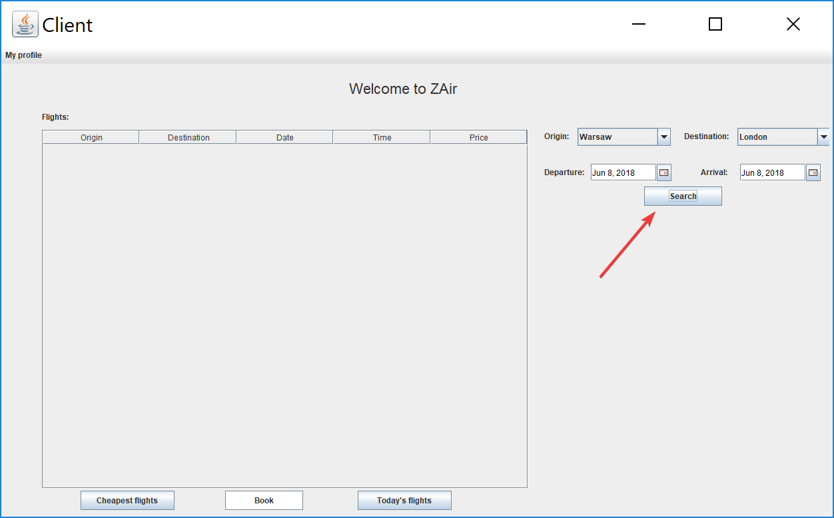

After defining a search condition the system will diplay flights.

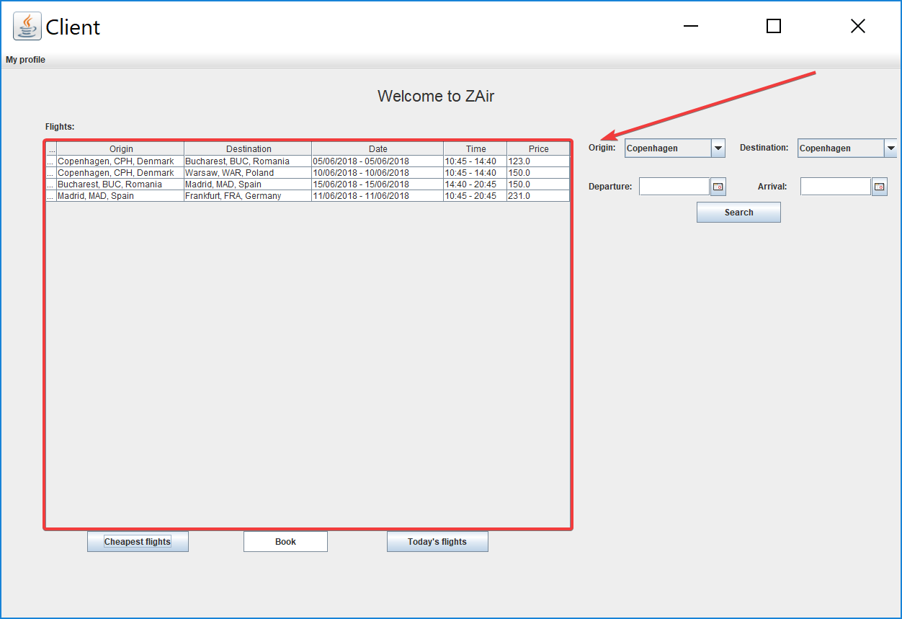

If there are no flights matching a condition the system will display the following message.

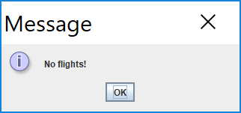

# Booking and canceling a ticket

To book a ticket you have to:

1. Select a flight from the displayed list

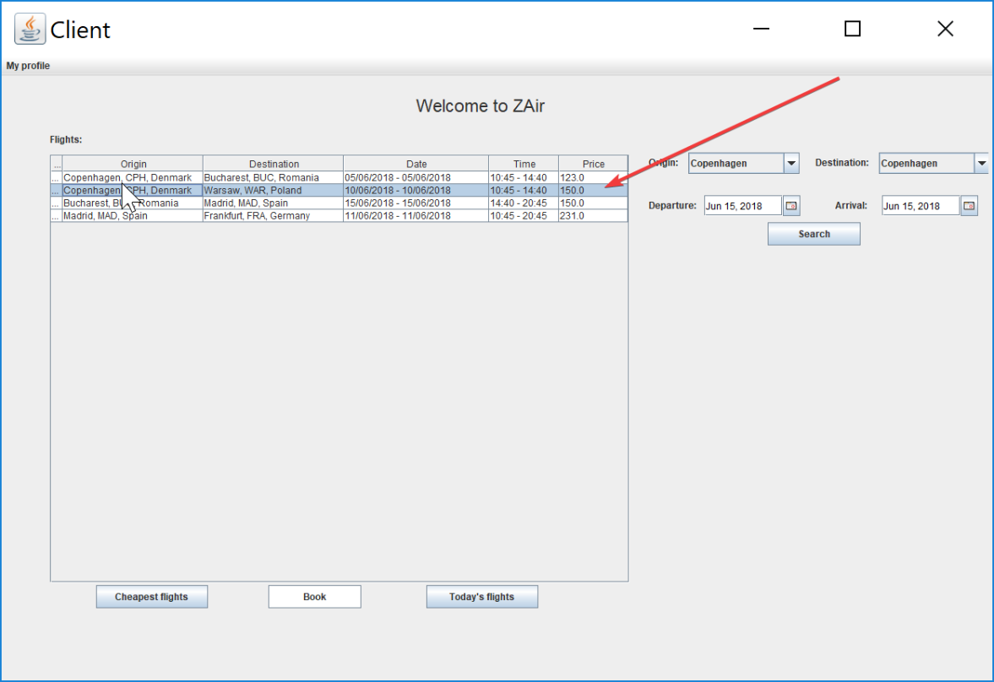

1. Press “Book”

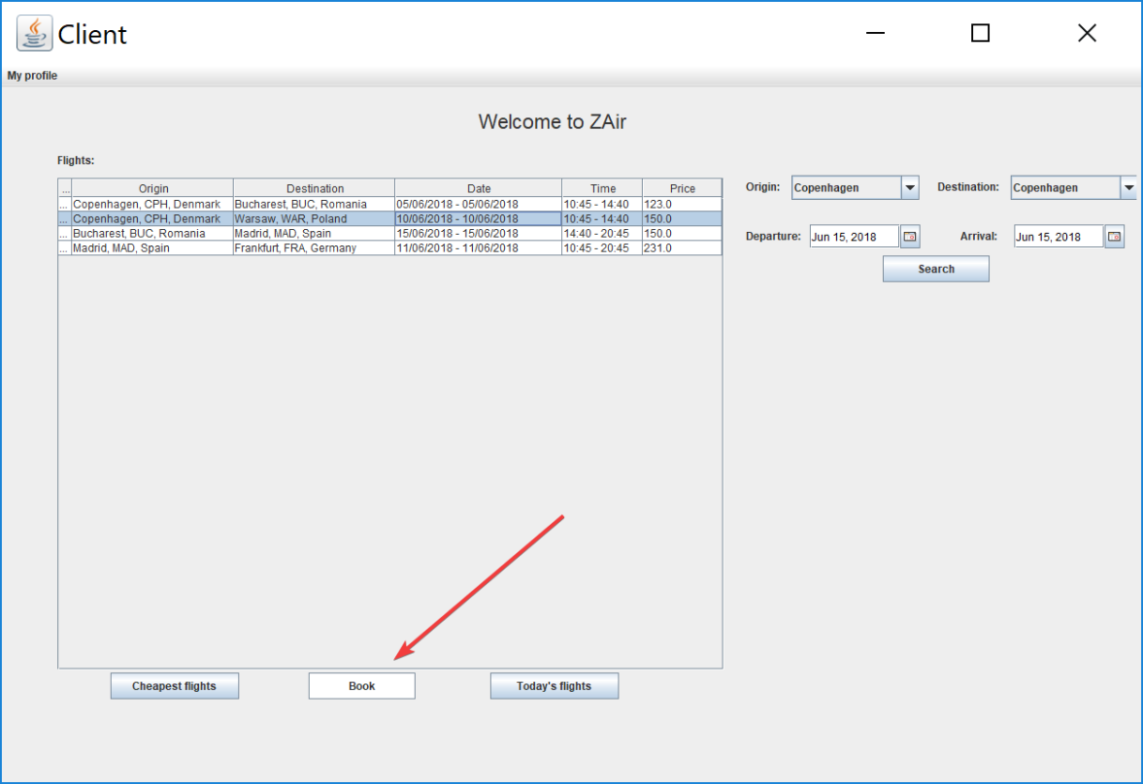

1. Choose a seat from the displayed list

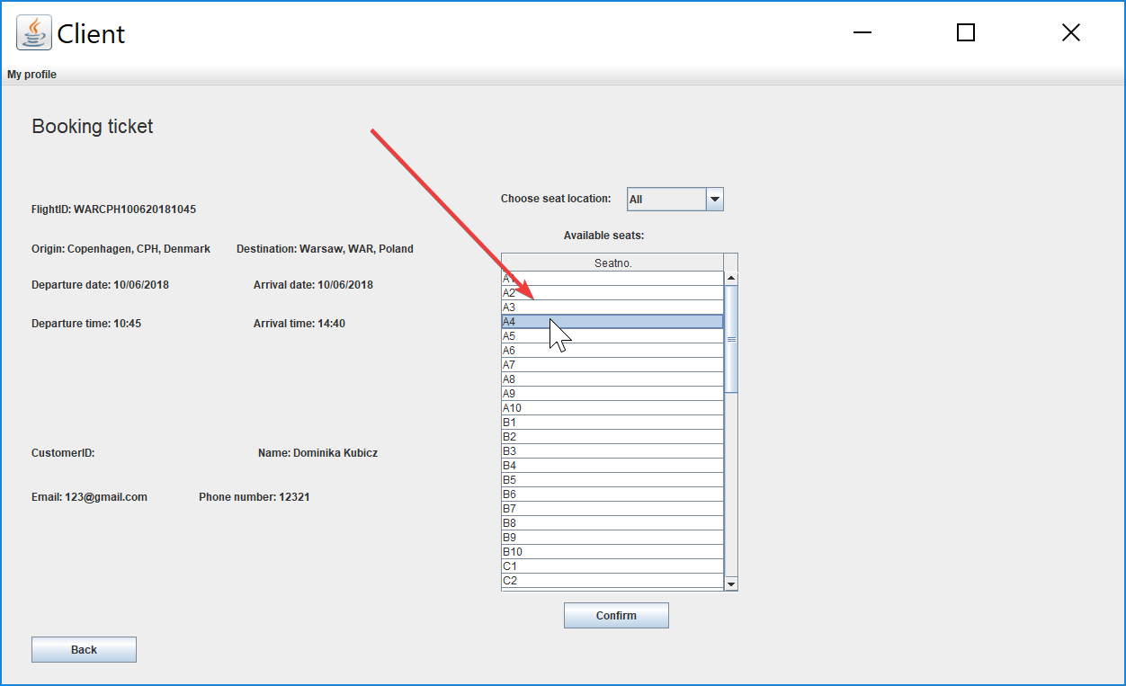

1. Press “Confirm”

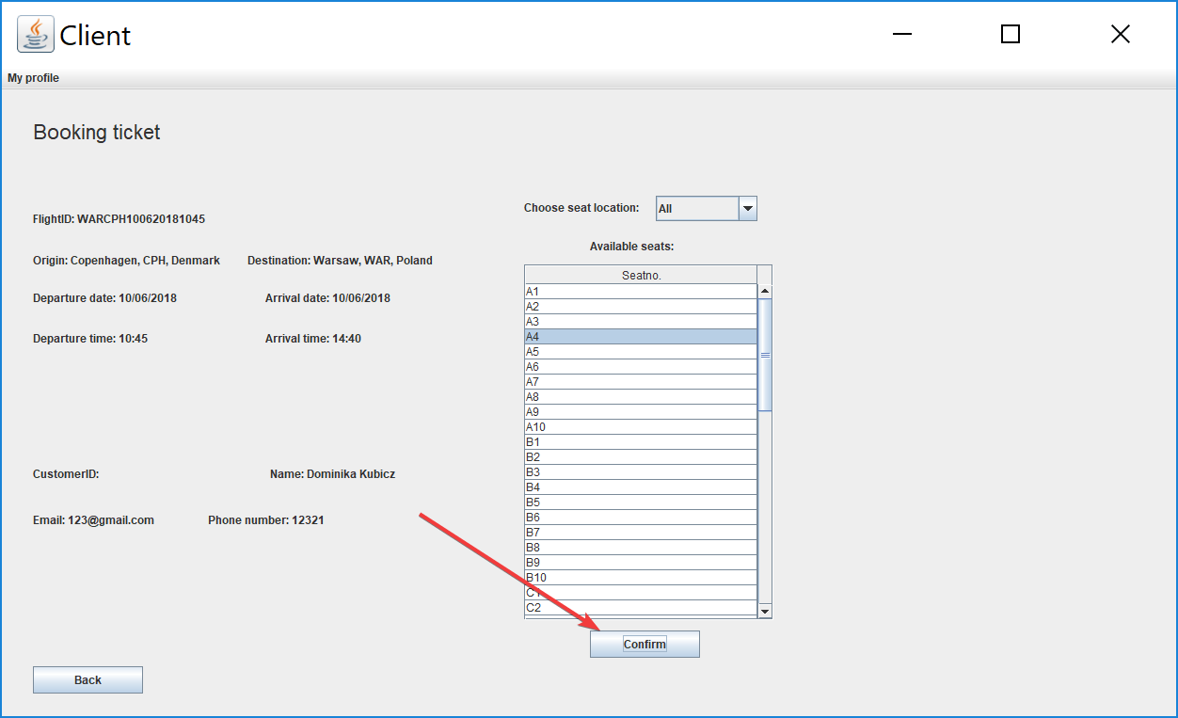

1. Press “Ok” on the pop up window

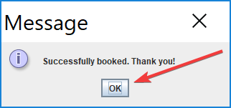

To cancel a booking you have to:

1. Press “My profile”

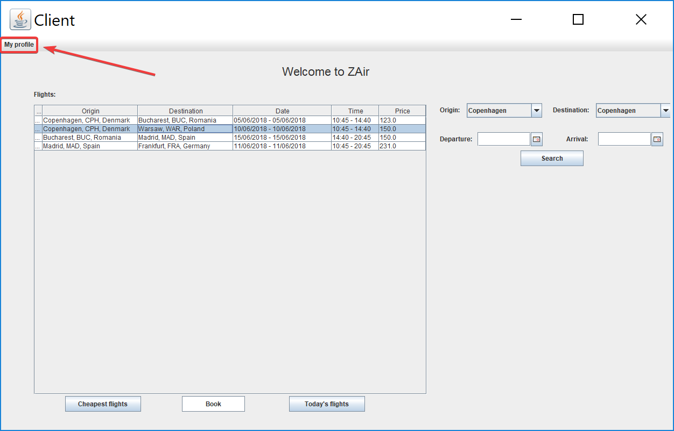

1. Press “View Profile”

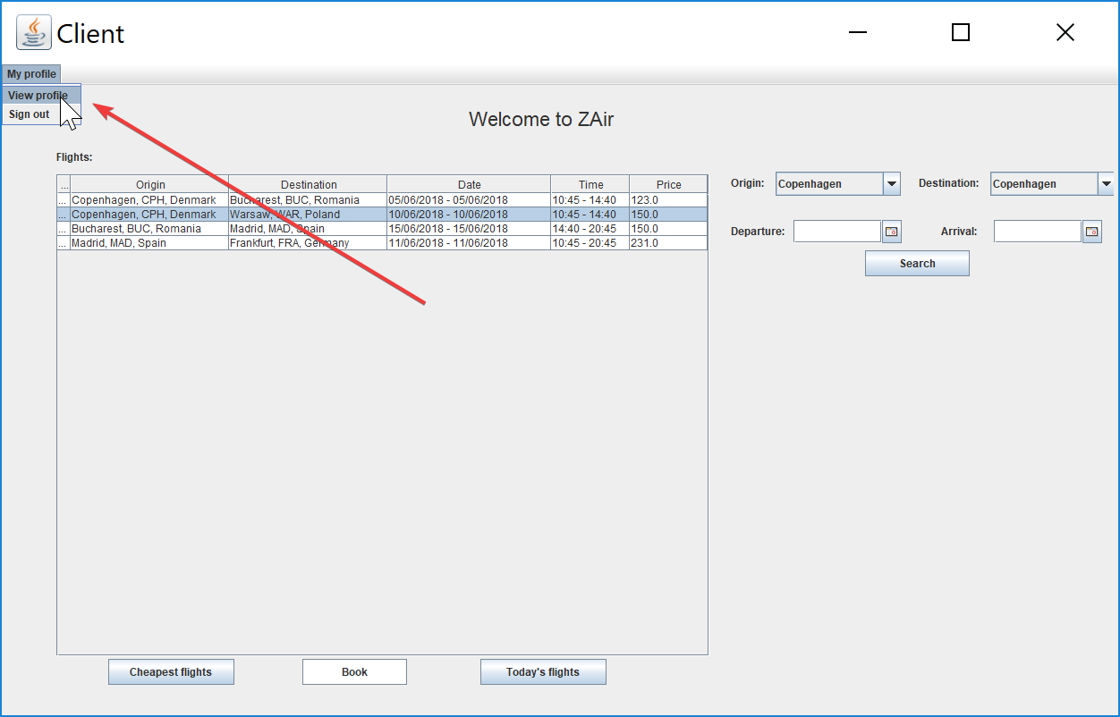

1. Select a ticket from “My flight history”

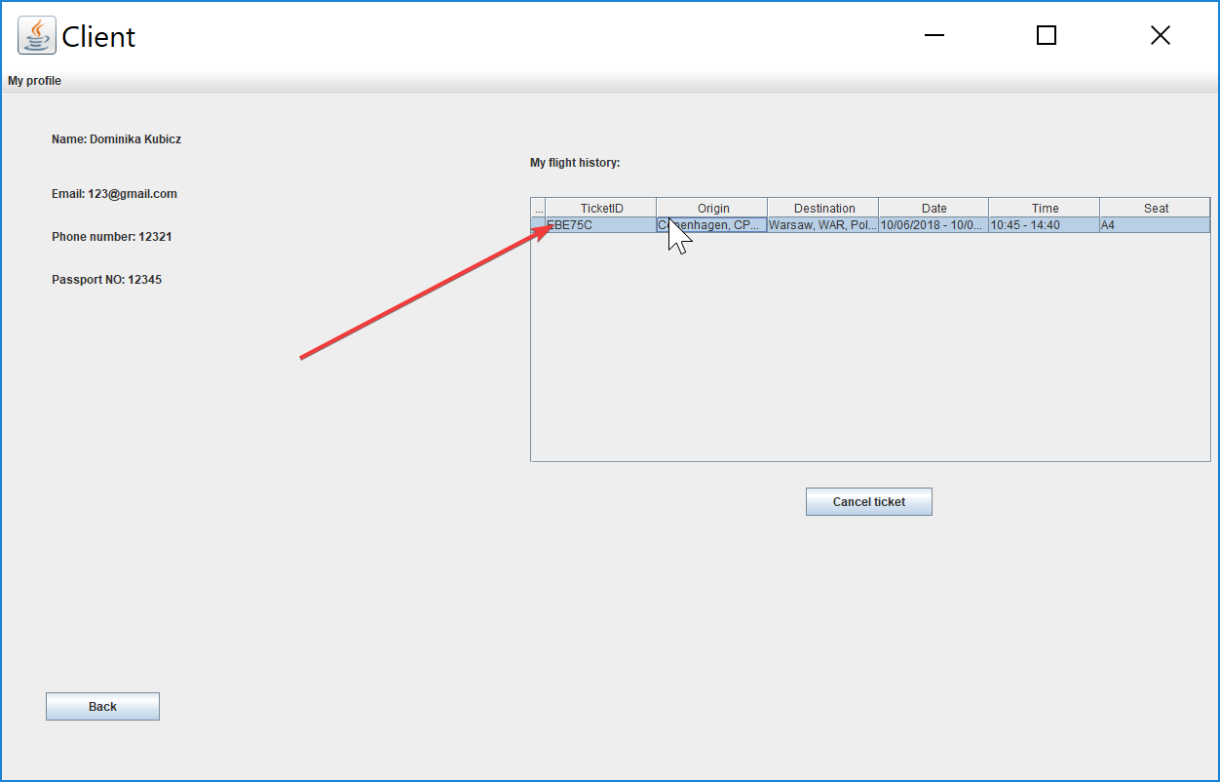

1. Press “Cancel ticket”

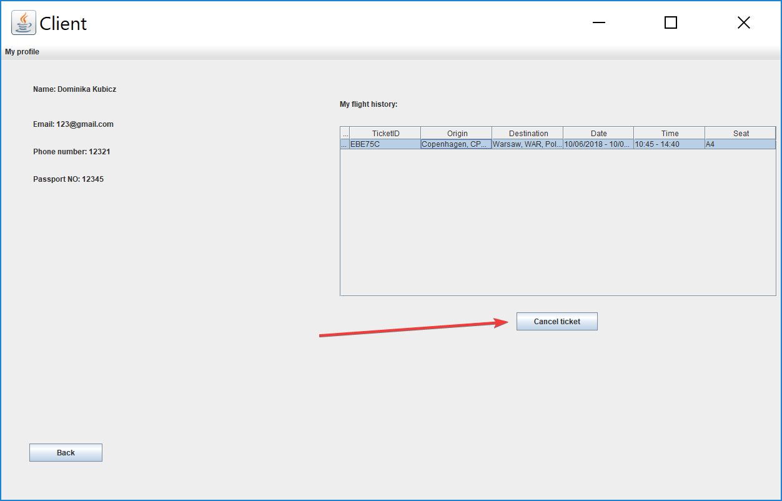

1. Press “Yes” on the pop up window

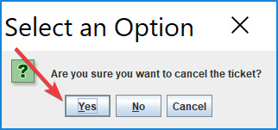

# Managing flights in the system

To add to the system you have to:

1. Press “Add”

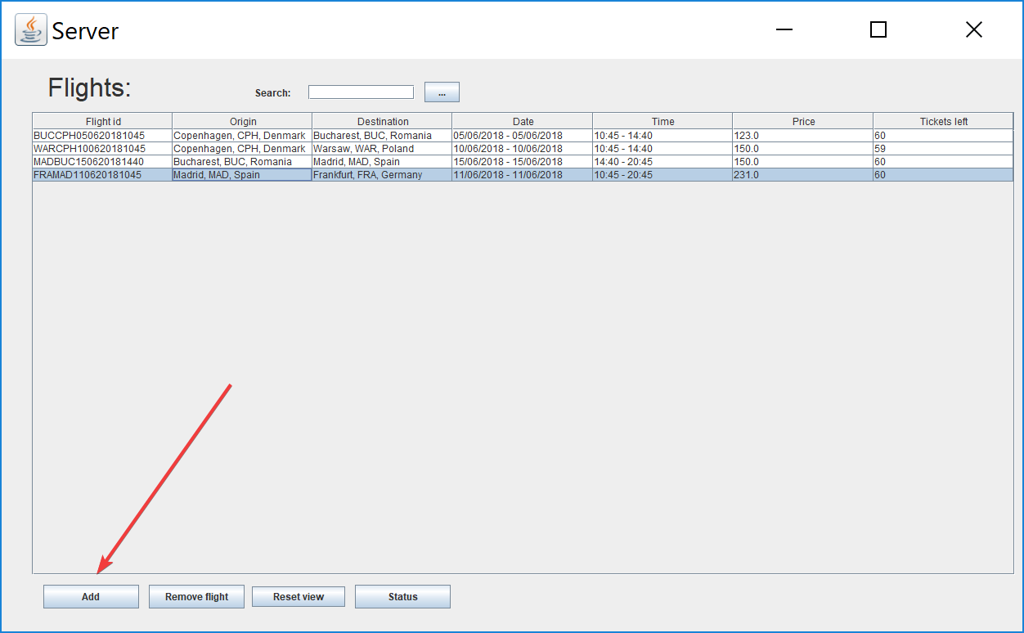

1. Choose origin and destination from the drop down list

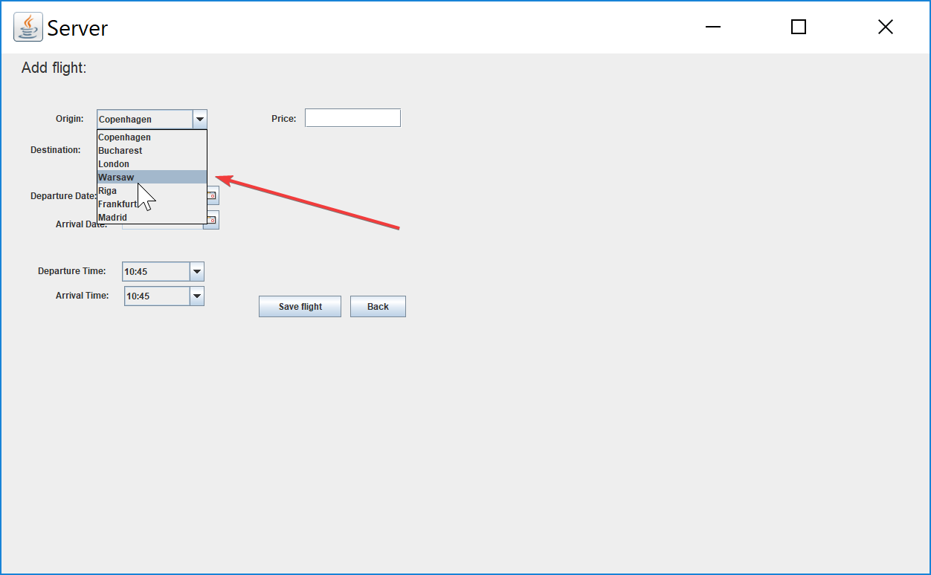

1. Pick a departure and an arrival date from the calendar

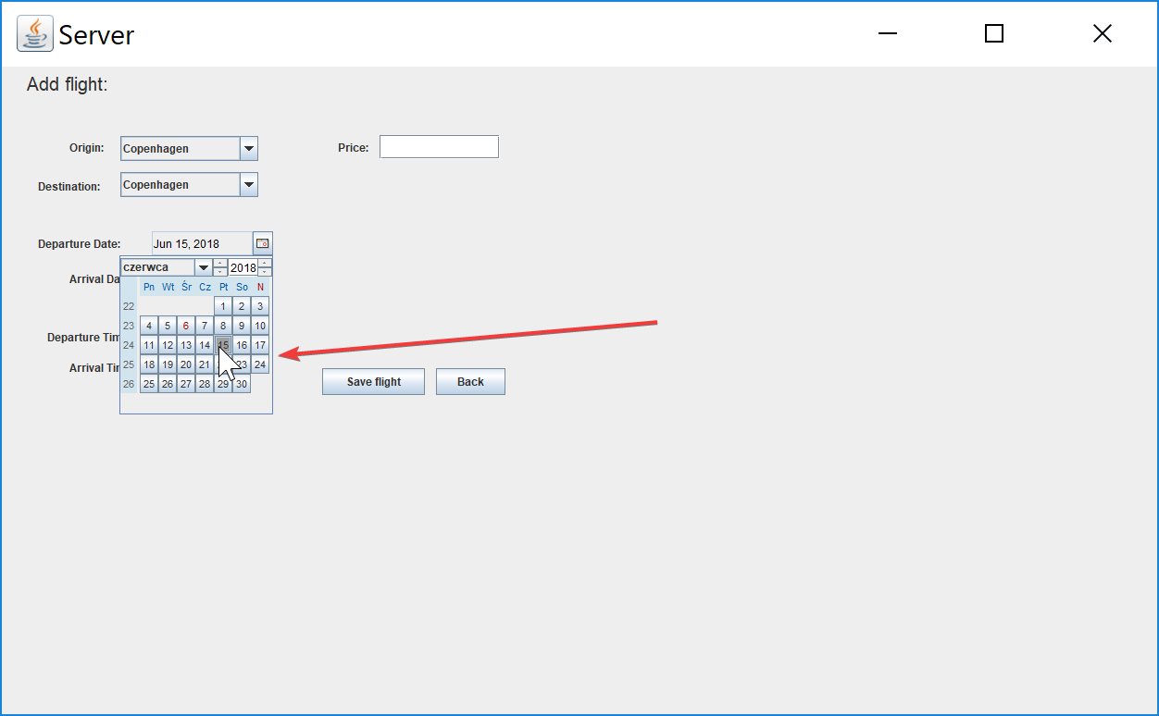

1. Pick an arrival and a departure time from the drop down list

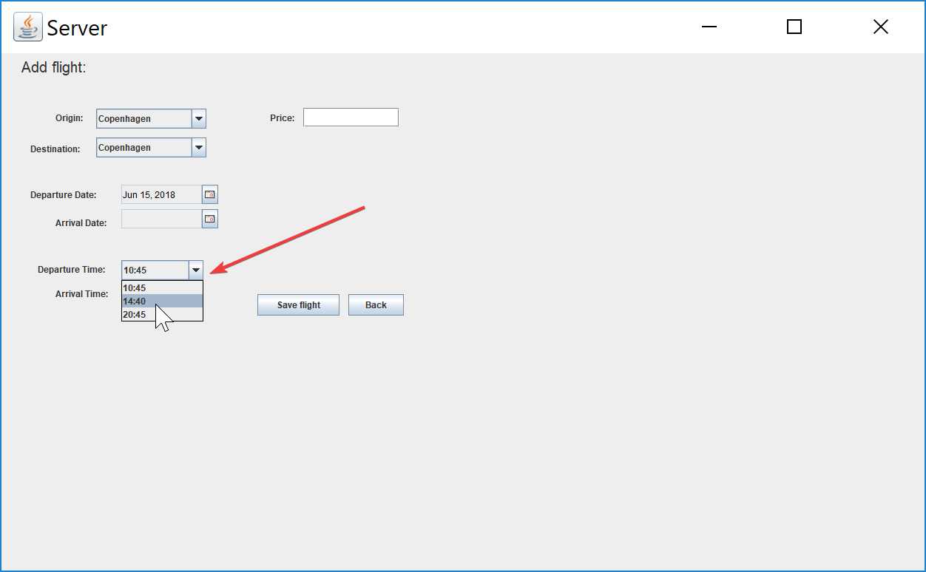

1. Type in a price

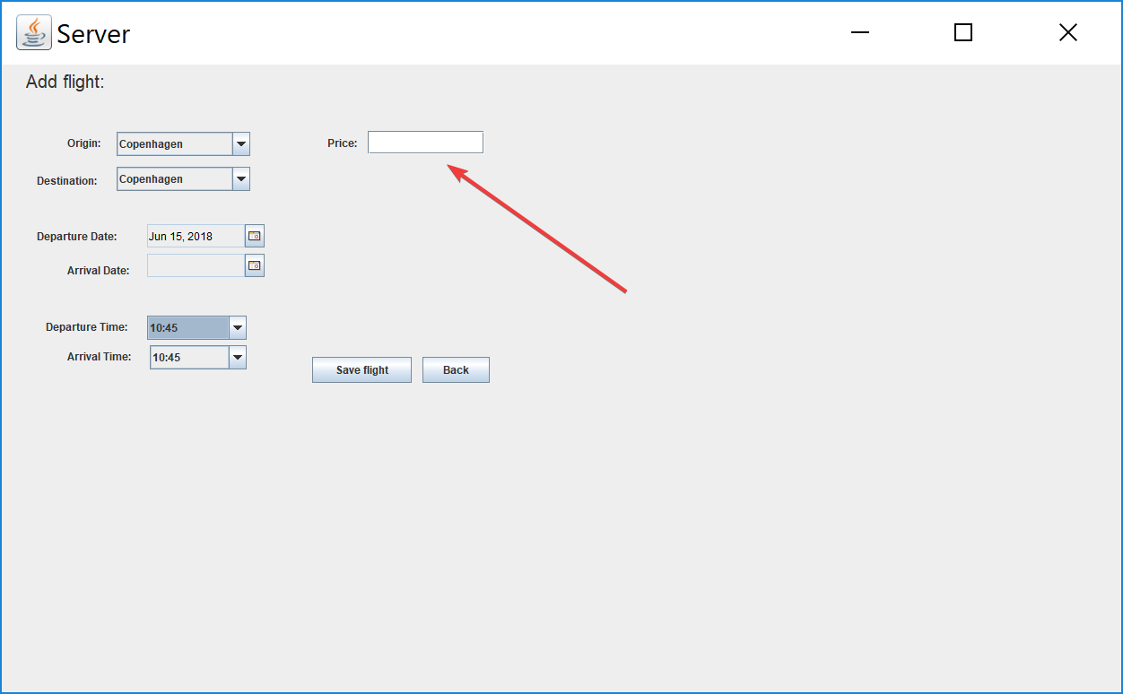

1. Press “Save flight”

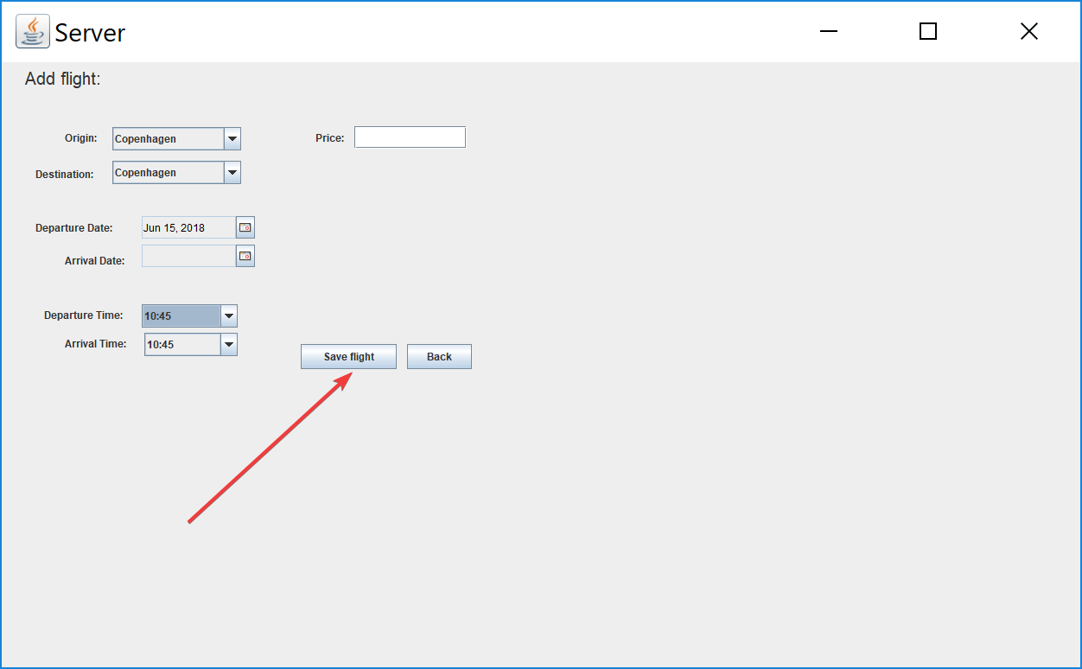

1. Press “Ok”

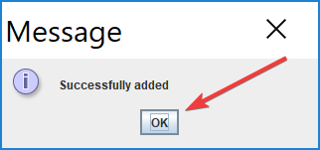

In order to remove a flight you have to:

1. Select a flight from the list

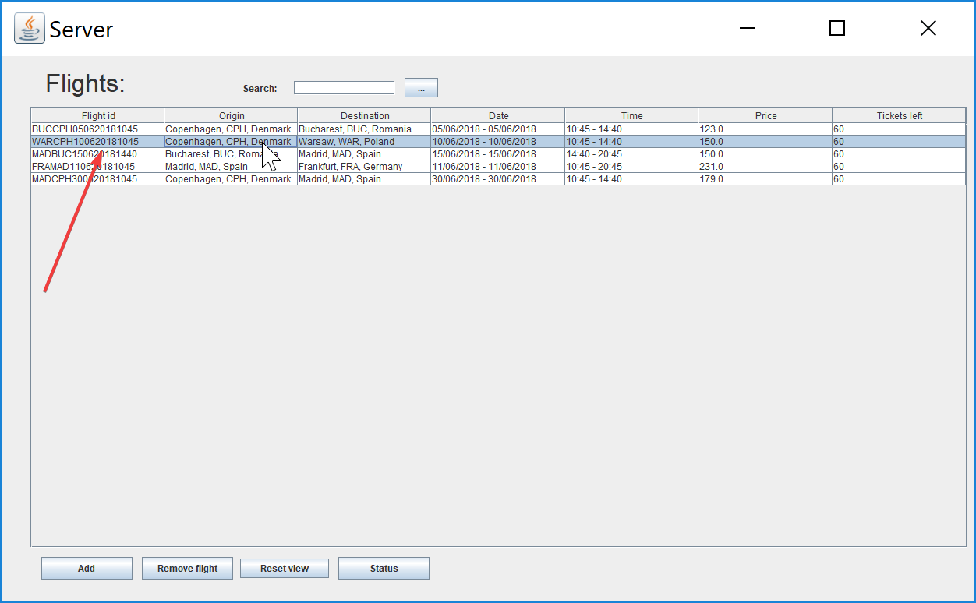

1. Press “Remove flight”

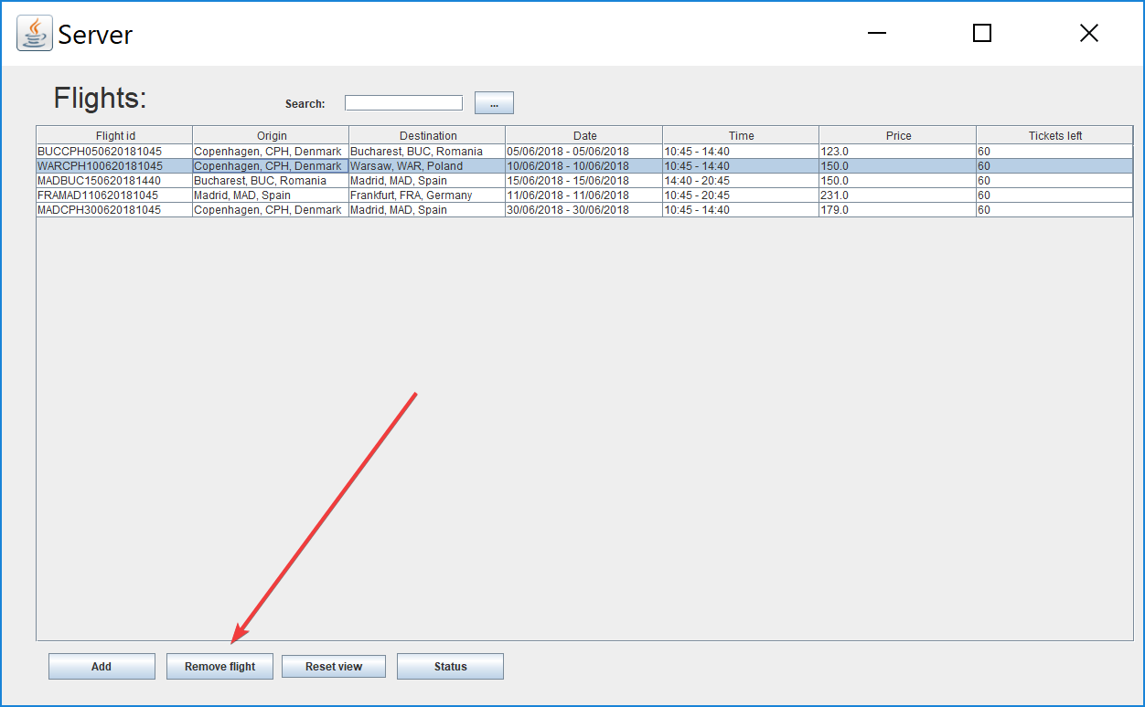

1. Press “Ok”

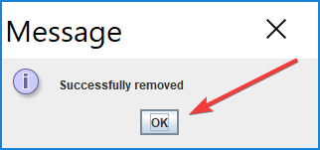

In order to view the updated status of the flights press “Reset view”

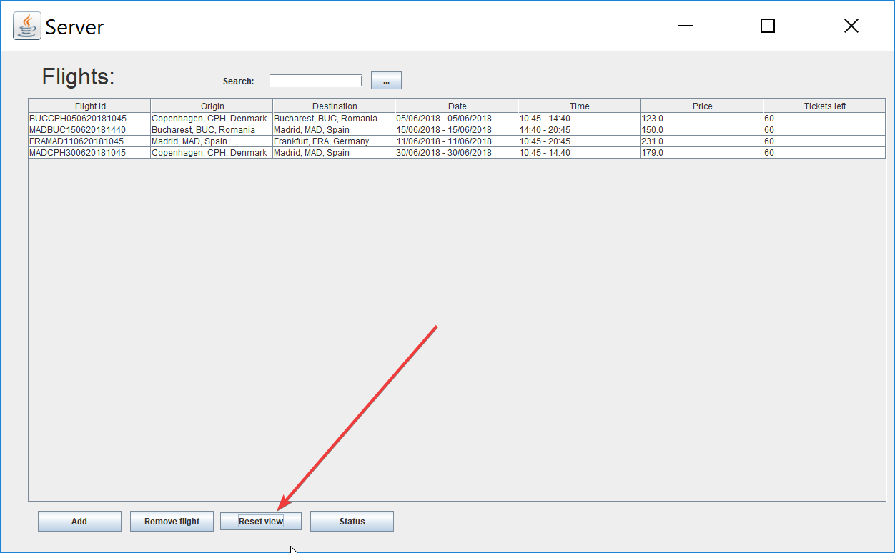

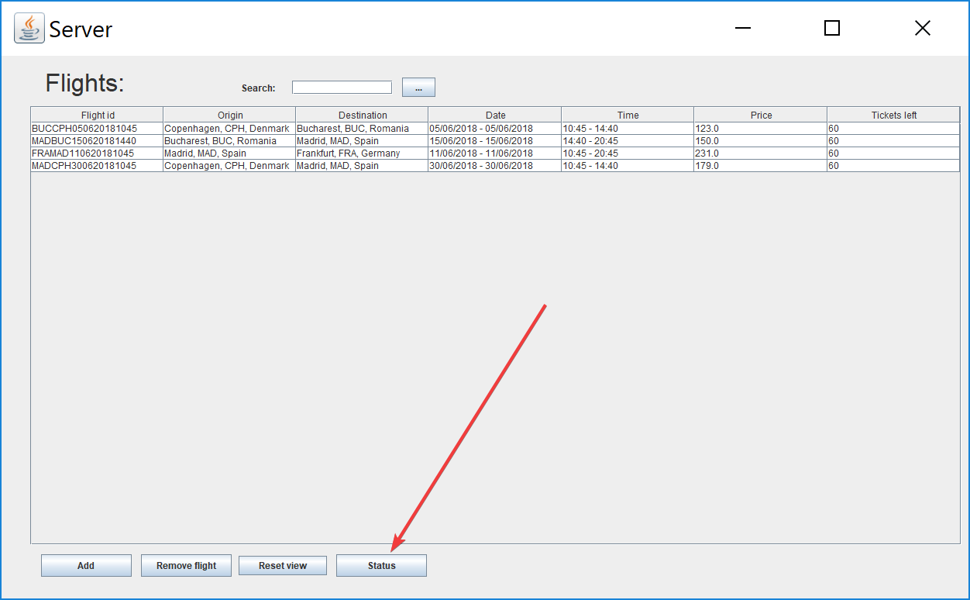In order to view changes done in the database press “Status”

In order to go back to the main window press “Back”

