Appendices

10.1 Activity Diagram 2

10.2 Use Case Description 7

10.3 Class diagram 12

10.4 User Guide 13

10.5 Sequence diagram 25

10.6 Analysis Diagram 26

10.7 Java Documentation 27

10.8 Project Description 28

# 10.1 Activity Diagram

**List Lecturer/Sponsor by Category:**

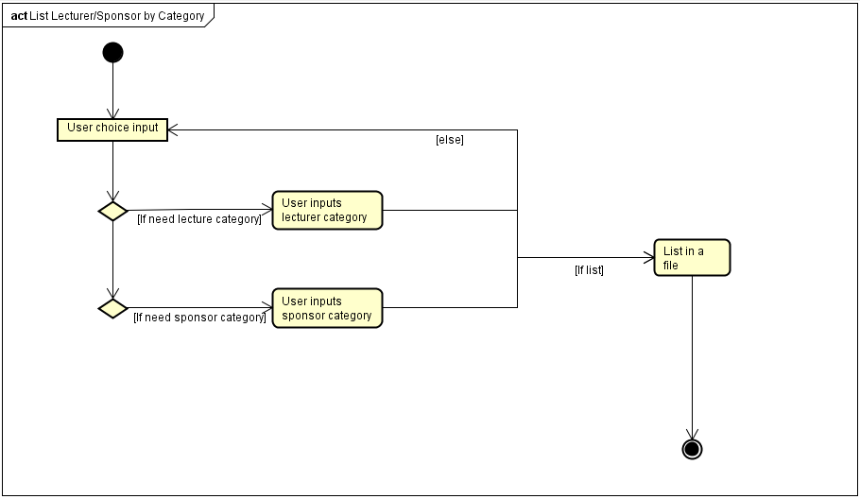

**List Members:**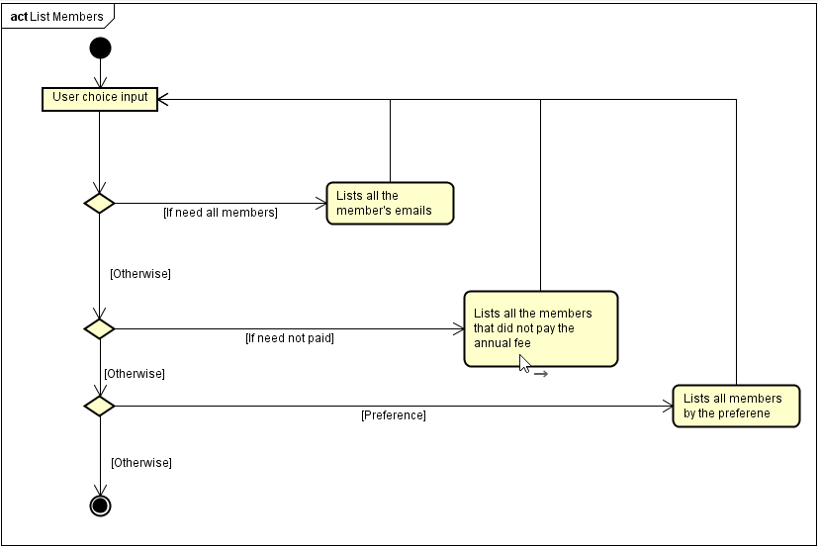

**Manage events:**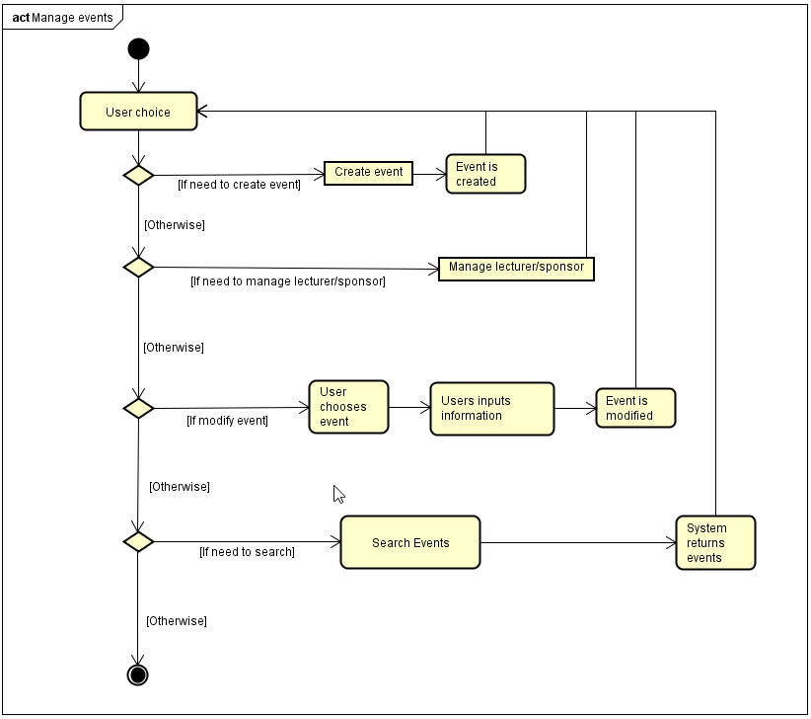

**Mange members:**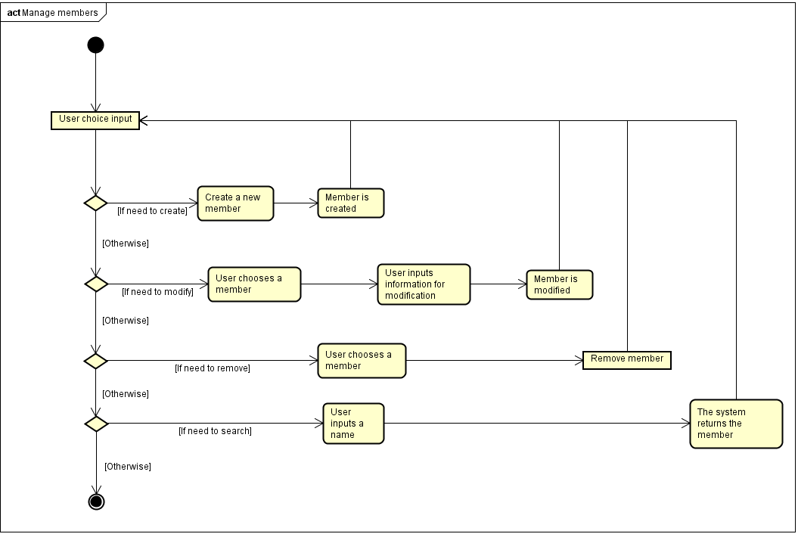

**Search Events:**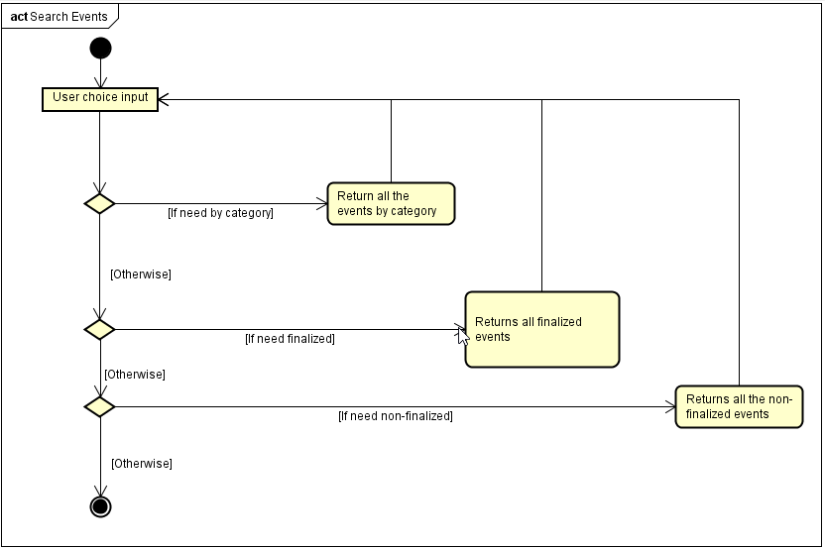

# 10.2 Use Case Description

**List Lecturer/Sponsor by Category**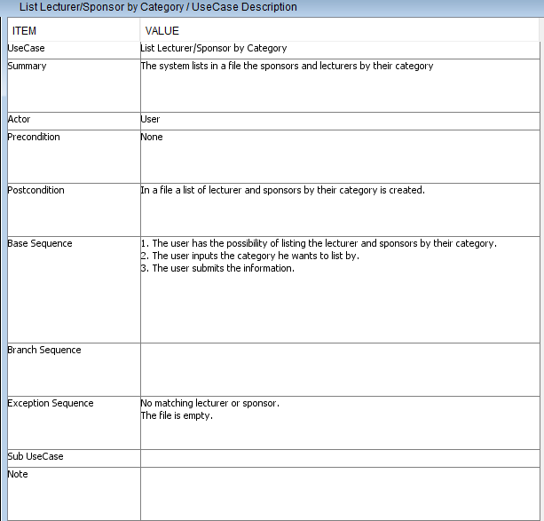

**List Members**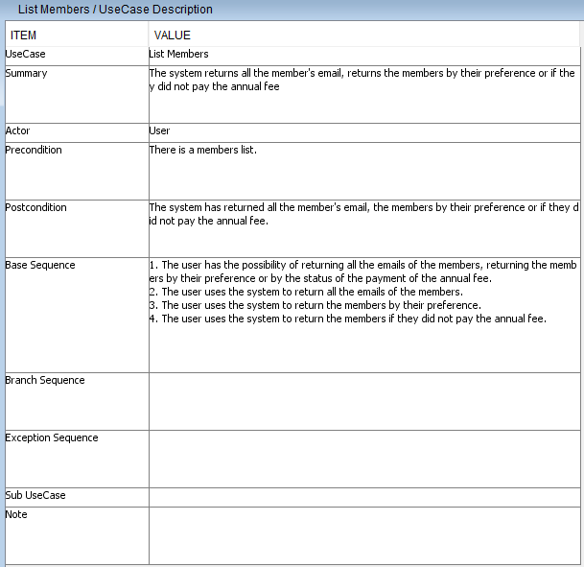

**Manage events**

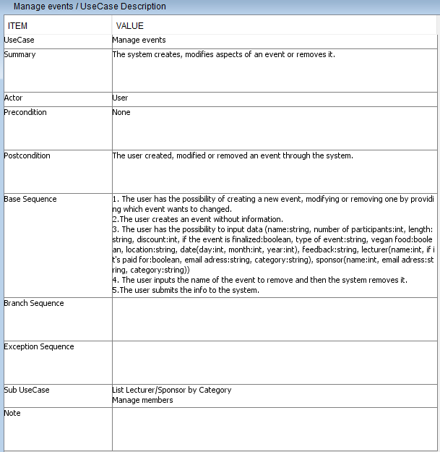

**Manage members**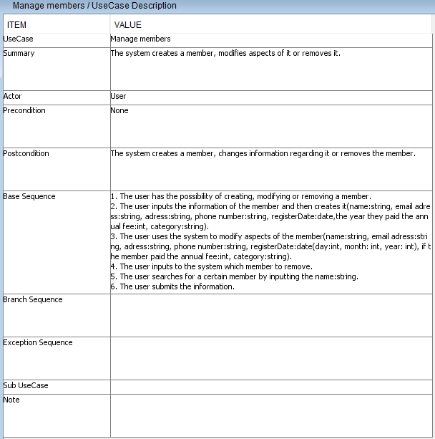

**Search for events**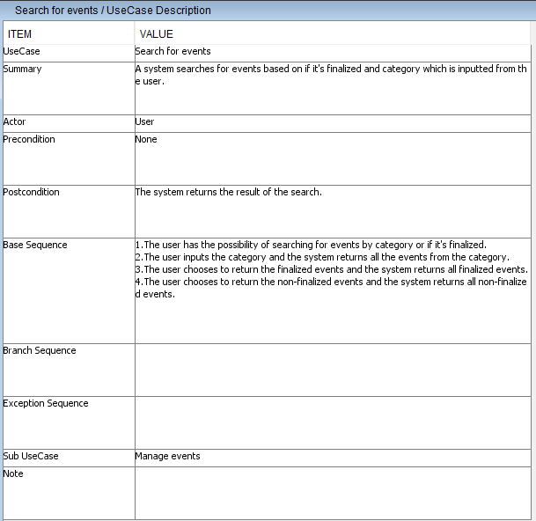

# 10.3 Class diagram

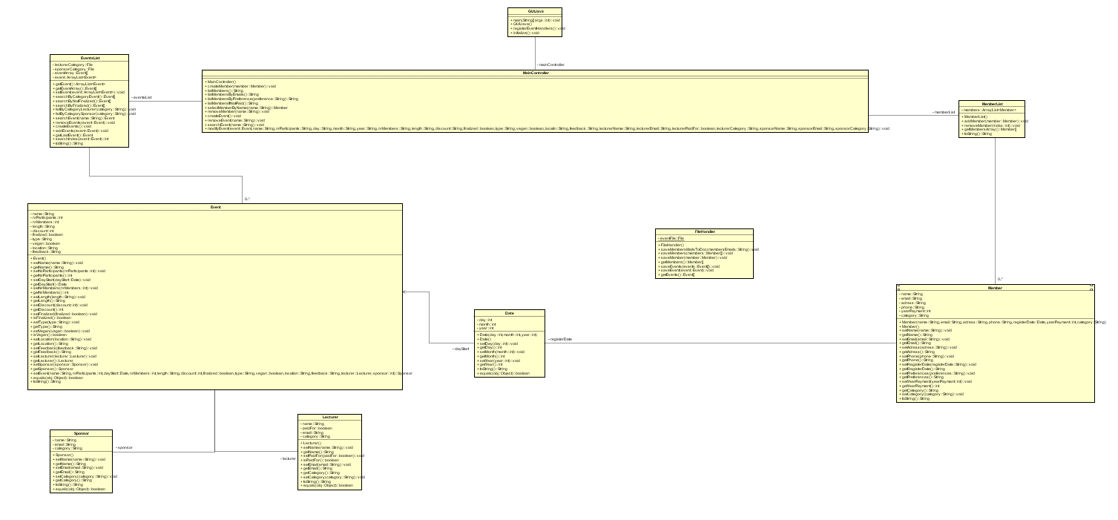

# 10.4 User Guide

Depending on what is what you want to achieve with the system there are certain steps to take.

1. Create an Event
   1. Have selected inside the Events tab, the Manage Event tab. 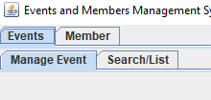
   2. Look for the Create Event button and click it. The event is now created with no information to it. 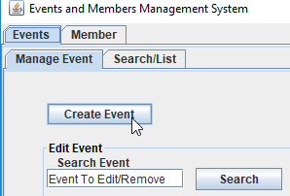
2. Search for an Event
   1. Have selected inside the Events tab, the Manage Event tab. 
   2. Look for the text field to the left of the Search button to input the name of the event you want to search for. 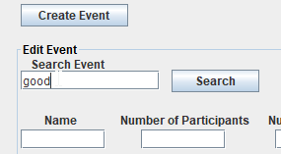
   3. Click the Search button when you inputted the proper name of the event. 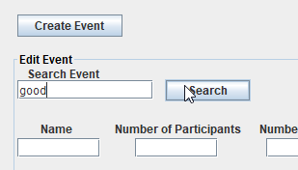
3. Remove an Event
   1. Have selected inside the Events tab, the Manage Event tab. 
   2. Look for the text field to the left of the Search button to input the name of the event you want to remove. 
   3. Search for the Remove button and press it when you are ready to remove the event. 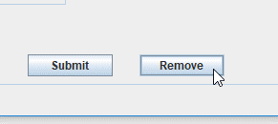

1. Modify an Event
   1. Have selected inside the Events tab, the Manage Event tab. 
   2. Look for the text field to the left of the Search button to input the name of the event you want to modify. 
   3. Have the text fields you want to modify filled with the proper information. You can Search for the Event first (Information pg. 2) to have the fields filled with the previous data. 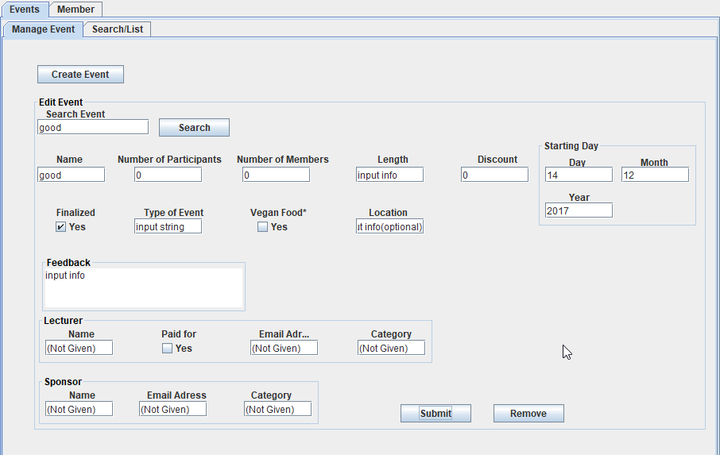
   4. Press submit when you are ready to modify the information regarding the event. 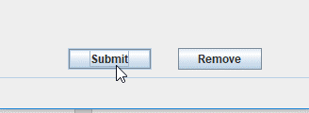

1. Show all Events
   1. Have selected inside the Events tab, the Search/List tab. 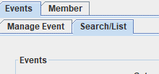
   2. Look for the Show Events button and press it. 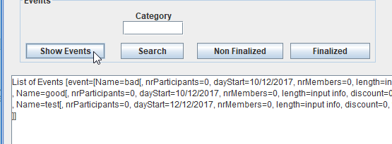

1. Search for Events by the Category of the Lecturer
   1. Have selected inside the Events tab, the Search/List tab. 
   2. Look for the text field above the Search button from this tab and input the category of the lecturer. 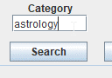
   3. Press the Search button. 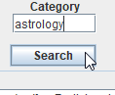
2. Show all Nonfinalized Events
   1. Have selected inside the Events tab, the Search/List tab. 
   2. Look for the Non Finalized button and press it. 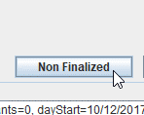

1. Show all Finalized Events
   1. Have selected inside the Events tab, the Search/List tab. 
   2. Look for the Finalized button and press it. 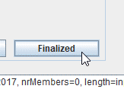
2. List the Lecturers or/and Sponsors by Category
   1. Have selected inside the Events tab, the Search/List tab. 
   2. Search for text fields under Category of Lecturers and Category of Sponsors and add the category you want to list by in a text file. 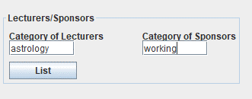
   3. Press the List button. 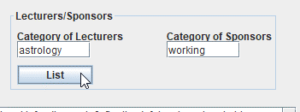
3. Create a Member
   1. Have selected inside the Member tab, the Manage Members tab. 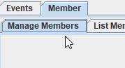
   2. Input the information of the member you want to create inside the text fields and then press the Create Member button. 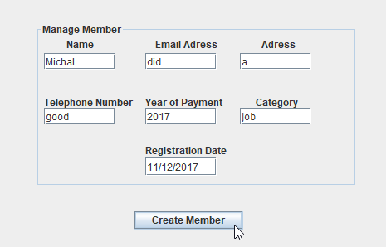

1. Search Member
   1. Have selected inside the Member tab, the Manage Members tab. 
   2. Look for the text field to the left of the Select button and input the name of the member you want to search for and press the Select button. 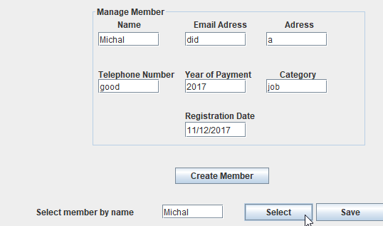

1. Modify a Member
   1. Have selected inside the Member tab, the Manage Members tab. 
   2. Input the information while keeping the name field unmodified and then press save. 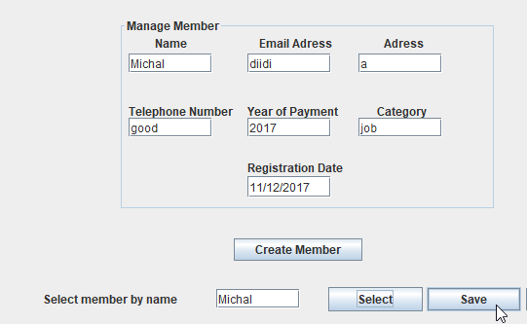

1. Remove a Member
   1. Have selected inside the Member tab, the Manage Members tab. 
   2. Look for the text field to the left of the Select button and input the name of the member you want to remove and press the Remove button. 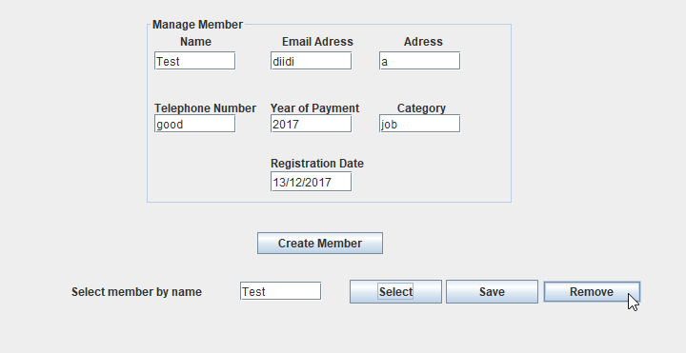

1. List all Member’s Email in a Text File
   1. Have selected inside the Member tab, the List Members tab. 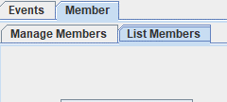
   2. Look for and press List all Emails button.
2. List all Members by Preference in a Text File
   1. Have selected inside the Member tab, the List Members tab. 
   2. Look for the text field above List by Preference button and input the preference. Press the List by Preference button.   
      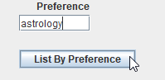
3. List all Members that did not Pay the Annual Fee in a Text File
   1. Have selected inside the Member tab, the List Members tab. 
   2. Look for the List If Not Paid button and press it.  
      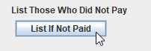

# 10.5 Sequence diagram

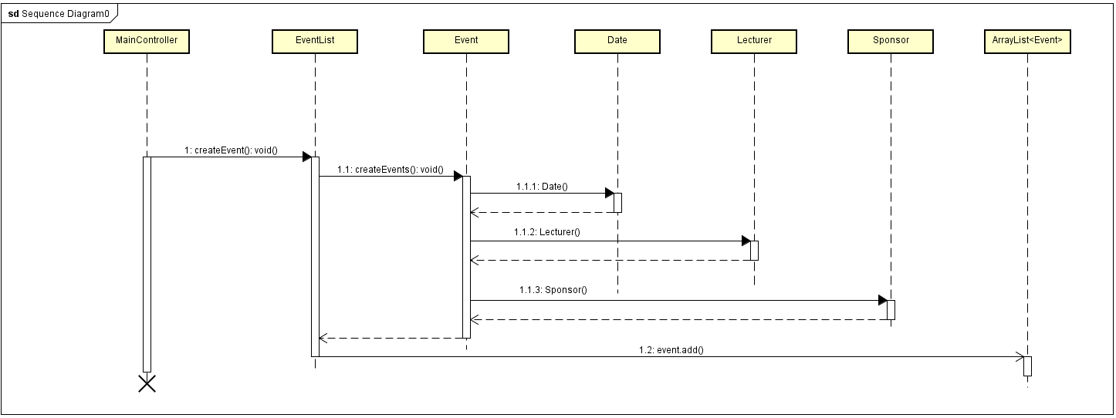

# 10.6 Analysis Diagram

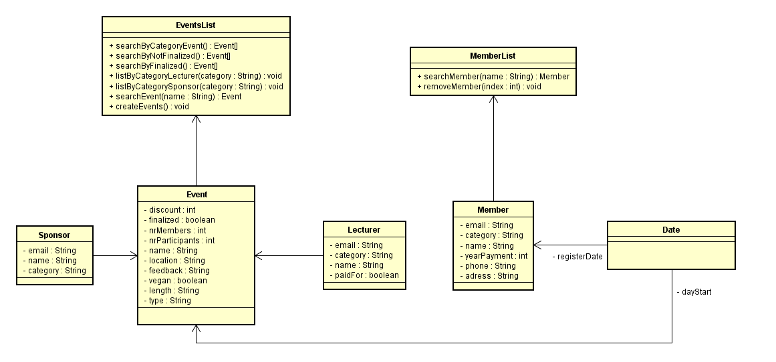

# 10.7 Java Documentation

[](Javadoc-Group2.7z)

# 10.8 Project Description

Table of Contents

1. Background Description

2. Definition of purpose

3. Problem Statement

4. Delimitation

5. Choice of Models and Methods

6. Time Schedule

7. Risk Assessment

8. Resources

# Background description

Vipassanā - Insight Awareness is a non–profit center originally providing spirituals meetings which are based on Buddhism traditions focusing on meditation, but also providing wide variety of events. Its customers can find all sort of events concerning subjects like interpretations, healing, astrology, reincarnation, Karma, alternative health care and much more (Interview for Case SEP,2017).

In the present it is estimated to be over 360 million followers of Buddhism worldwide and over a million American Buddhists today. Buddhist concepts have also been extremely influential and common in modern western culture societies, particularly in the areas of meditation and nonviolence (religionfacts.com, 2017)1. Therefore, there is a big community that needs to have at its disposal the tools to practice their religion in centers like Vipassanā - Insight Awareness, which is one of the organizations that new converts come to, with hope to find their new life principles and to participate in various types of events that will help them gain knowledge about the religion. Buddhism is also the fastest growing religion in Western societies in regard of new converts as well as people who borrow ideas of Buddhism and apply them into their lives (J. Perera, 2008)2. That shows Buddhism’s popularity and the necessity of better and more efficient ways of communication inside the Buddhist communities. This is why the non-profit organizations look forward to expanding and improve their services in order to follow and keep up with the modern world needs.

The Vipassanā center already works on sending out newsletters and balancing their expenses, but they want to further improve their management to have a better serve the people that are interested in their services.

Even though they managed up until now, Vipassanā - Insight Awareness needs a system to advance their communication with their customer base so that they can better deliver what they offer. The management of the organization by being improved will become more attractive to the followers of Buddhism because it will offer a more efficient way of being informed.

# Definition of purpose

To minimize the chances of misunderstandings regarding information involving the events provided by Vipassanā and improve efficiency in the matter of communication with the customer base.

# Problem statement

1. The system implemented in java that handles events, stores and searches for finalized events in a time period for your newsletter, finds non-finalized events to finalize them, searches for sponsors for newsletters, searches for lecturers in a given category in order to create new events, finds events or lecturers specifying a category for potential new events and stores members including their email addresses.

2.The system is maintainable which means it will be designed so that it is easy to modify in the future.

3.The system is persistent which means that it uses secondary files for storage. It will be built so in the future it will be replaced by a database.

# Delimitation

* The system made in JAVA will not be used by Vipassanā’s website
* The website will not be using a database
* The system will not be using the internet to search for the information it needs
* The system will not be in its final state, being open to modifications

# Choice of Models and Methods

The project will be built upon several theoretical models and methods that will help during the product development as well as will ensure of ending up with best solutions.

The first model that will help the team to stay hard-working is acknowledging about the positive and negative motivators. Specifically focusing on certain motivators would allow the team to create a workflow that is both stimulated and creative3. The team have also been taught about the waterfall framework approach. Its principles can very easily be showed on the diagram below [Figure 1.]. It will ensure of not skipping any part of the system development, which will lead the project to the best final results4.

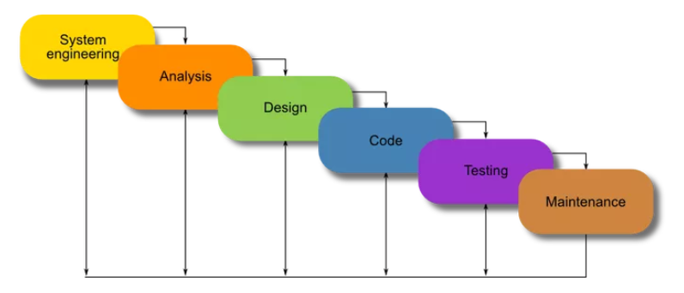

Figure 1. (Andrew Powell-Morse, 2016) the header of the webpage*.5*

# Time Schedule

|  |  |  |
| --- | --- | --- |
| **Tasks (137.5 HOURS)** | **Start Date** | **End date** |
|  |  |  |
| **Analyse (35 HOURS)** |  |  |
| Analysing current tasks and the background | 14.09.17 | 14.09.17 |
| Get in touch with the project requirements | 14.09.17 | 14.09.17 |
|  |  |  |
| **Design (40 HOURS)** |  |  |
| Making a mock-up for the site and a prototype | 15.09.2017 | 15.09.2017 |
| Getting images and art for the site | 16.09.2017 | 16.09.2017 |
|  |  |  |
| **Implementation (50 HOURS)** |  |  |
| Doing a final version of the Website | 17.09.2017 | 17.09.17 |
| Resolving the bugs and the error | 18.09.17 | 18.09.17 |
| Offering a good look to the site | 19.09.17 | 19.09.17 |
| Developing of the Site’s System | 5.11.17 | 5.11.17 |
|  |  |  |
| **Test (10 HOURS)** |  |  |
| Are all pages and features working? | 20.09.17 | 21.09.17 |
| What can be improved? | 20.09.17 | 06.09.17 |
| Testing the Site System | 20.11.17 | 20.11.17 |
|  |  |  |
| **Hand-ins (2.5 HOURS)** |  |  |
| Hand-in project description, research questions, questions for company visit | 18.12.17 | 18.12.17 |
| Hand-in final project description for approval | 19.12.17 | 19.12.17 |
| Hand-in project report | 20.12.17 | 20.12.17 |
|  |  |  |

# Risk Assessment

|  |  |  |  |  |  |  |
| --- | --- | --- | --- | --- | --- | --- |
| **Risks** | **Description** | **Likelihood**  **Scale 1-5** | **Severity**  **Scale 1-5** | **Risk mitigation e.g. preventive & responsive actions** | **Identifiers** | **Responsible** |
| 1 | One or more members are late or they don’t show up  at all | 1 | 2-3 | Make sure everyone knows when and where are the meetings |  |  |
| 2 | Computer error | 2-3 | 4-5 | Backups should be taken on multiple devices and drives, all files must be saved on the cloud and updated as soon as files are modified |  |  |
| 3 | A member of the study group dropping out | 1 | 3-4 | Helping each other with problem in and out of classroom, making sure that no one stays behind with the current status of the project |  |  |
| 4 | Having a ,,writing breakdown” | 3 | 1-2 | Having a to-do list and respect the order of the items, organized working is the key |  |  |
| 5 | Low team motivation | 1-2 | 2-3 | Make sure that no group member is being forced to do a task if is not fitted in his parameters of time and energy |  |  |
| 6 | Scope is not so well defined | 1 | 4-5 | Analysis of the requirements must be done very carefully |  |  |

# 8. Sources of Information

*Interview for Case SEP1* (2017).

1Perera, J., 2008. *Buddhism the fastest growing religion in West.* [Online]   
Available at: http://www.asiantribune.com/?q=node/10418  
[Accessed 11 2017].

2religionfacts.com, 2017. *religionfacts.com.* [Online]   
Available at: http://www.religionfacts.com/buddhism  
[Accessed 11 2017].

3Anthony Bagshawe, 2011. *How to Improve Motivation*. [e-book] bookboon.com. Available through: <https://studienet.via.dk/Class/IT-CSE1V-A17/Session%20Material/How-to-improve-motivation.pdf> [Accessed 23 November 2017]

4Andrew Powell-Morse. 2016. *Waterfall Model: What is It and When Should You Use It?.* [Online] Available at: <https://airbrake.io/blog/sdlc/waterfall-model>. [Accessed 23 November 2017].