## Project Report First Semester

VIPASSANĀ - INSIGHT AWARENESS

Claudiu Rediu (266129)

Boris Sidlo (251341)

Eduard Nicolae Costea (266078)

Michal Ciebien (266908)



Supervisors:

Michael Viuff

Mona Wendel Andersen

Henrik Kronborg Pedersen

# Contents

1 Introduction 2

2 Requirements 2

2.1 Functional Requirements 2

2.2 Non-Functional Requirements 2

3 Analysis 2

4 Design 2

5 Implementation 2

6 Test 2

6.1 Test Specifications 2

7 Results and Discussion 2

8 Conclusion 2

9 Project future 2

10 References 2

11 List of Appendixes 2

Appendix A Project Description 2

**Abstract**

*An abstract is a shortened version of the report and should contain all information necessary for the reader to determine:*

1. *What are the aim and objectives of the project*
2. *What are the main technical choices*
3. *What are the results*

*Frequently, readers of a report will only read the abstract, choosing to read at length those reports that are most interesting to them. For this reason, and because abstracts are frequently made available to engineers by various computer abstracting services, this section should be written carefully and succinctly to have the greatest impact in as few words as possible.*

*Although it appears as the first section in a paper, most report writers write the abstract section last.*

Cf. (Dawson 2009, p.195).

# Introduction

Vipassanā - Insight Awareness is a non–profit center providing spirituals events which are based on Buddhism traditions. Focusing on meditation, specially finding the - Insight Awareness, but also providing lots of events. Customers can find all sort of activities to take part in like interpretations, healing, astrology, reincarnation, Karma, alternative health care and much more (Interview for Case SEP,2017).

In the present there are over 360 million followers of Buddhism worldwide and over a million American Buddhists today. Buddhist concepts have also been influential on western culture in general, particularly in the areas of meditation and nonviolence (religionfacts.com, 2017). There is a big community that needs to have at its disposal the tools to practice their religion in centers like Vipassanā - Insight Awareness. Buddhism is also the fastest growing religion in Western societies both in terms of new converts (J. Perera, 2008). This is why the non-profit organization looks forward to expand their services to as many people as they can.

The center already works on sending out newsletters and articles to its members and balancing their expenses, also wanting to further improve their management to better serve the people that are interested in their services.

Even though they managed up until now, Vipassanā - Insight Awareness needs a system to advance their communication with their customer base so that they can better deliver what they offer. The management of the organization by being improved will become more attractive to the followers of Buddhism because it will offer a more efficient way of being informed.

The delimitations are a result of the request of the clients, together with the current limitations that will be experienced building it. In the project it will be expected that the website will not have a direct connection to the system made in JAVA because it is not requested and it the system would need further improvements to do this. The system made in JAVA will not be using a database or the internet to receive information as the main way of interacting with it are direct input from the user and secondary file storage. The system will not in it is final state as it will be further improved in the future being open to adjustments.

In the Requirements section it will be presented what the system will be capable of and what is expected of it to do.

**Remember:** You must ensure a clear connection between sections in the project report, from Project Description, Requirements, Analysis, Design, Implementation to Test. This means that everything that is implemented can be found in design, everything that is designed is based on the analysis, and anything that is found in analysis has a clear link to requirements, etc.

# Requirements

The user is the only actor interacting with the system and is responsible of directing in what action should the system perform and introducing new information that is not present already in files that are part of the secondary file storage of the system.

## Functional Requirements

1. The system must be able to store members’ names, telephone numbers, email, addresses, preference, year of registrations, year of last fee payment.
2. The system must be able to list out list of all members emails.
3. The system should be able to list out in a file the member’s email address considering their preference or year of last fee payment.
4. The system should be able to list out in a file the lecturers by their category.
5. The system should store lecturer’s name, category, email address and if is paid for the lecture.
6. The system must be able to store an events’ name, category, day of start, length, lecturer(s), number of participants, number of members participating, if its finalized or not, if it has the vegan food if it’s a workshop, location, discount percentage, sponsors feedback for finalized events.
7. The system should search for finalized or not-finalized events or by the category and listing them on the screen.
8. The system must be able to store the sponsor name ,category, email address.

## Non-Functional Requirements

1. The system must be implemented in JAVA.
2. The system must be compatible with Microsoft Windows 7,8,10.
3. The system must answer in 2 seconds 95% of the time.
4. The system must process the info in maximum 3 seconds 85% of time.
5. The system must restore in 10 seconds 90% of the time.
6. The system must use files for secondary storage only.
7. The system must be usability tested by end users.
8. The system must support Microsoft Internet Explorer 9, 10 and 11, Google Chrome 28-47, Mozilla Firefox 32 and Microsoft Edge 20.
9. The system must retain the data of the current process for at least 5 minutes.

# Analysis

The purpose of the analysis section is to outline an understanding of the problem domain and specifically WHAT the stakeholders want. Here, you elaborate on your background description.

You identify objects in the problem domain that will be involved in the solution and how these objects cooperate. The result of this analysis is a Domain Model (Larman 2004, chap.9) and other relevant diagrams.

Use the UML standard for all diagrams where relevant.

**Note: Remember that all implementation dependent objects are not part of the domain model only conceptual classes related to the requirements and the domain.**

**3.1 Use Case Modelling**

In this part of analysis we focus on use case modelling for this we use Astah.

**Use Case Diagram**

From use case diagram,you can see how system can be used by the user. For the successful running of VIPASSANA employees have to be able to **Manage events, Manage lecture/sponsors,Manage members** and **Search for events.**

**Manage events**

User is able to use the system to create, modify aspects of an event or remove it.

**Manage lecturers/sponsors**

User is able to use the system to create, remove or modify information regarding a lecturer or sponsor.

**Manage members**

User is able to use the system to create a member, modify aspects of it or remove it.

**Search for events**

User is able to use the system to search for events based on category and state of finalization.

**List members**

User is able to use the system to return all the member's emails, returns the members by their preference or if they did not pay the annual fee.

**3.2 Use Case Description**

“Manage Events” and “List Members” are the most important use cases because they fulfill the most of the requirements regarding the system. “Manage Events” is used to create events, modify or remove them which is one of the main appliances of the system. “List Members” is used to return lists of members respecting the requirement of having a list of members that did not pay the annual fee. 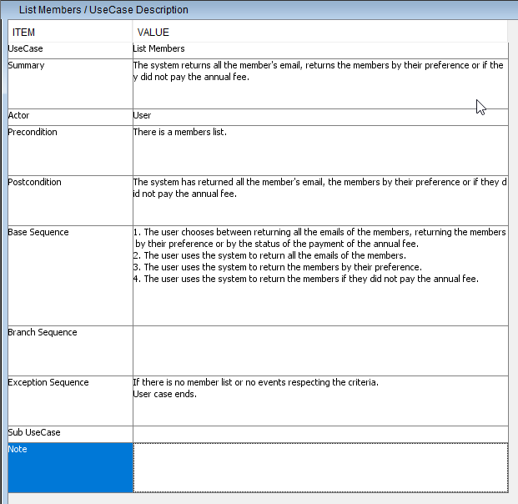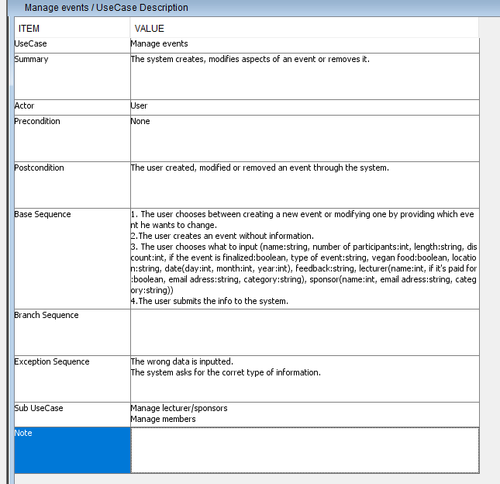

# Design

The purpose of the design section is to outline HOW the system is structured; i.e. to transform the artefacts of the analysis into a model that can be implemented. The design section is relevant for the programmer, whereas the analysis is relevant for the stakeholder.

Elements that may be relevant in this section:

* Architecture: Find architecture patterns here (Leszek Maciaszek 2004, chap.9).
* Technologies: Describe technologies used, also alternative technologies. Argue for choice of technology according to the project aim.
* Design Patterns: Describe which design patterns (GoF (Gamma et al. 2002) etc.) you are using and why.
* Class Diagrams
* Interaction Diagrams
* UI design choices
* Data models, persistence, etc.

You must explain all diagrams in the report. These diagrams including descriptions are the blueprints for the implementation.

Hint: One way to figure out which objects/classes are needed in the design is to apply the General Responsibility Assignment Software Patterns/principles (GRASP) (Larman 2004, chap.17).

Hint: Consider how to design your system to make it testable.

# Implementation

The purpose of the implementation section is to explain interesting code snippets. An idea is to explain the complete path through your system from UI to database etc.

Remember that your implementation must be consistent with your design (Larman 2004, chap.20).

Which standard libraries are used? How are design patterns implemented, etc.

Hint: Implement your code in a testable manner.

# Test

The purpose of the test section is to document the result of your testing; to verify if the content of the requirements section has been fulfilled. How is the system tested, which strategy has been used; e.g. White Box (Unit Test), Black Box, etc.

## Test Specifications

For functional requirements, test specifications must be listed. These test specifications can be described as soon as the functional requirements have been completed (Use Cases including descriptions).

IEEE can be used as a template for test specification (IEEE Computer Society 2008). VIA Library can give you access to this standard.

# Results and Discussion

The purpose of the results and discussion section is to present the outcome and achieved results of the project.

# Conclusion

The purpose of the conclusion section is to compile the results from each section in the report. What is the conclusion? Did the project fulfil the requirements? Etc.

You can only comment on report contents, no new topics or content can be introduced in this section.

# Project future

Reflect on your project from a technical viewpoint and describe what you would change if you could.

Suggest how the project could be improved or made ready for production. Discuss scalability, suggest possible spin offs, what is needed, missing, etc.?

# References

**Note: Use the standard reference method: Harvard Anglia. A very good reference tool is Mendeley** (Mendeley.com 2016), **ask VIA Library if you need help.**

Banger, D., 2014. A Basic Non-Functional Requirements Checklist « Thoughts from the Systems front line.... Available at: https://dalbanger.wordpress.com/2014/01/08/a-basic-non-functional-requirements-checklist/ [Accessed January 31, 2017].

Business Analyst Learnings, 2013. MoSCoW : Requirements Prioritization Technique — Business Analyst Learnings. , pp.1–5. Available at: https://businessanalystlearnings.com/ba-techniques/2013/3/5/moscow-technique-requirements-prioritization [Accessed January 31, 2017].

Dawson, C.W., 2009. *Projects in Computing and Information Systems*, Available at: http://www.sentimentaltoday.net/National_Academy_Press/0321263553.Addison.Wesley.Publishing.Company.Projects.in.Computing.and.Information.Systems.A.Students.Guide.Jun.2005.pdf.

Gamma, E. et al., 2002. *Design Patterns – Elements of Reusable Object-Oriented Software*, Available at: http://books.google.com/books?id=JPOaP7cyk6wC&pg=PA78&dq=intitle:Design+Patterns+Elements+of+Reusable+Object+Oriented+Software&hl=&cd=3&source=gbs_api%5Cnpapers2://publication/uuid/944613AA-7124-44A4-B86F-C7B2123344F3.

IEEE Computer Society, 2008. *IEEE Std 829-2008, IEEE Standard for Software and System Test Documentation*,

Larman, C., 2004. *Applying UML and Patterns: An Introduction to Object-Oriented Analysis and Design and Iterative Development*,

Mendeley.com, 2016. Homepage | Mendeley. Available at: https://www.mendeley.com/ [Accessed February 2, 2017].

YourCoach, S.M.A.R.T. goal setting | SMART | Coaching tools | YourCoach Gent. Available at: http://www.yourcoach.be/en/coaching-tools/smart-goal-setting.php [Accessed August 19, 2017].

# List of Appendixes

The purpose of your appendices is to provide extra information to the expert reader. List the appendices in order of mention.

Examples of appendices

* Project Description
* User Guide
* Source code – source documentation
* Diagrams
* Data sheets
* Etc.

1. Project Description

Insert the original Project Description in here.