ě1.0.0

|  |
| --- |
| **Project Title Subtitle**  **Subtitle** |

**Version history**

|  |  |  |  |  |  |
| --- | --- | --- | --- | --- | --- |
| **Description** | **Version** | **Init** | **Revised** | **Approved** | **Date** |
| Start of document | 0.1.0 | IHA | <INIT> | <INIT> | 2017-01-31 |
| Small corrections | 0.2.0 | IHA | MWA |  | 2017-02-01 |
| Revisions made in workshop meeting | 1.0.0 | MWA/IHA | All | ICT | 2017-08-19 |

**Group: XXXX**

|  |  |
| --- | --- |
| **Student Name** | **Student No** |
|  |  |
|  |  |
|  |  |
|  |  |
|  |  |

# Contents

1 Introduction 2

2 Requirements 2

2.1 Functional Requirements 2

2.2 Non-Functional Requirements 2

3 Analysis 2

4 Design 2

5 Implementation 2

6 Test 2

6.1 Test Specifications 2

7 Results and Discussion 2

8 Conclusion 2

9 Project future 2

10 References 2

11 List of Appendixes 2

Appendix A:Project Description 2

**Abstract**

*Vipassanā is a non-profit center in Horsens, Denmark.It provides events which are based on Buddhism tradition. The system can be used to manage events(i.e.create events,remove events,find lecturers and find sponsors) or search events which are finalized.*

*Vipassanā needs a system, which is based on Java, to store information regarding members, lecturers, sponsors and events. In this system,users can input basic information such as name,email,category,payment condition,and additional information from members(i.e.feedback),it contains menus,buttons,and text field for feedback.User can choose one of two menus(members and events) to store information.*

*In the members menu,there are two main menus inside.One is the menu for managing members,which can be used to add members by storing his or her name,email,address,telephone number,year of payment,category,and the register date.The other is the menu for listing members,which can list members both by category or payment condition of the annual fee.*

*In the events menu,there are two main menus inside.One is the menu for managing events,which can be used to create or modify events by storing its basic information,name of lecturers and sponsors,starting day,and feedback from members.Another is the menu of searching events and listing lecturers and sponsors by their category ,which can be also used to search for events by category or finalization state.*

Introduction

Vipassanā - Insight Awareness is a non–profit centre providing spirituals events which are based on Buddhism traditions. Focusing on meditation, specially finding the - Insight Awareness, but also providing lots of events. Customers can find all sort of activities to take part in like interpretations, healing, astrology, reincarnation, Karma, alternative health care and much more (Interview for Case SEP,2017).

In the present there are over 360 million followers of Buddhism worldwide and over a million American Buddhists today. Buddhist concepts have also been influential on western culture in general, particularly in the areas of meditation and nonviolence (religionfacts.com, 2017). There is a big community that needs to have at its disposal the tools to practice their religion in centres like Vipassanā - Insight Awareness. Buddhism is also the fastest growing religion in Western societies both in terms of new converts (J. Perera, 2008). This is why the non-profit organization looks forward to expand their services to as many people as they can.

The centre already works on sending out newsletters and articles to its members and balancing their expenses, also wanting to further improve their management to better serve the people that are interested in their services.

Even though they managed up until now, Vipassanā - Insight Awareness needs a system to advance their communication with their customer base so that they can better deliver what they offer. The management of the organization by being improved will become more attractive to the followers of Buddhism because it will offer a more efficient way of being informed.

The delimitations are a result of the request of the clients, together with the current limitations that will be experienced building it. In the project it will be expected that the website will not have a direct connection to the system made in JAVA because it is not requested and it the system would need further improvements to do this. The system made in JAVA will not be using a database or the internet to receive information as the main way of interacting with it are direct input from the user and secondary file storage. The system will not in it is final state as it will be further improved in the future being open to adjustments.

In the Requirements section it will be presented what the system will be capable of and what is expected of it to do.

# Requirements

The user is the only actor interacting with the system and is responsible of directing in what action should the system perform and introducing new information that is not present already in files that are part of the secondary file storage of the system.

## Functional Requirements

1. The user should be able to create an event.
2. The user should be able to modify information regarding an event.
3. The system should be able to store an event’s name, number of participants, number of members, length, discount, finalization state, type of event, if it will have a vegan food, location, starting date, feedback, lecturer and a sponsor.
4. The user should be able to remove a specific event from the system.
5. The system should be able to list all the events and specific events by their category or finalization state.
6. The system should be able to store lecturer’s name, sponsorship state, email address and a category.
7. The system should be able to store sponsor’s name, email address and a category.
8. The system should be able to provide a list of sponsors and lecturers sorted by their category.
9. The user should be able to create a member.
10. The user should be able to edit information regarding a member.
11. The system should be able to store member’s name, e-mail address, address, phone number, year of last fee payment, category and registration date.
12. The system should be able to list out the name and email of all the members.
13. The system should be able to list out the name and email of members by their given preference.
14. The system should be able to list out the name, e-mail and the year of the last payment of members that did not pay their annual fee.
15. The user should be able to remove a specific member from the system.

## Non-Functional Requirements

1. The system must be implemented in JAVA.
2. The system must be compatible with Microsoft Windows 7,8,10.
3. The system must answer in 2 seconds 95% of the time.
4. The system must process the info in maximum 3 seconds 85% of time.
5. The system must use files for secondary storage only.
6. The system must be usability tested by end users.
7. The system must retain the data of the current process for at least 5 minutes.

# Analysis

**3.1 Use Case Modelling**

In this part of analysis, we focus on use case modelling for which we used Astah.

**Use Case Diagram**

From the use case diagram, you can see how the system can be used by the user. For the successful running of VIPASSANA, employees must be able to **Manage events, List lecturer/sponsor by category, List members, Manage members** and **Search for events.**

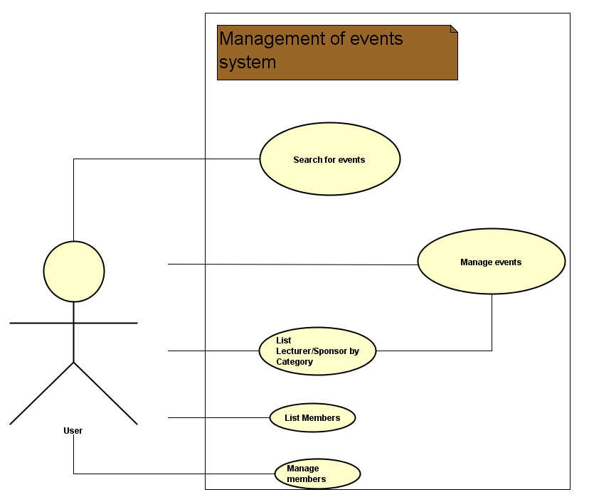

Figure.1 Use Case Diagram

**Manage events**

User can use the system to create, modify aspects of an event or remove it.

**List lecturer/sponsor by category**

User can use the system to list the lecturer and sponsors by their category.

**Manage members**

User can use the system to create a member, modify aspects of it or remove it.

**Search for events**

User can use the system to search for events based on category and state of finalization.

**List members**

User can use the system to return all the member's emails, returns the members by their preference or if they did not pay the annual fee.

**3.2 Use Case Description**

“Manage Events” and “List Members” are the most important use cases because they fulfill the most of the requirements regarding the system. “Manage Events” is used to create events, modify or remove them which is one of the main appliances of the system. “List Members” is used to return lists of members respecting the requirement of having a list of members that did not pay the annual fee.

Appendix.1 Use Case Description

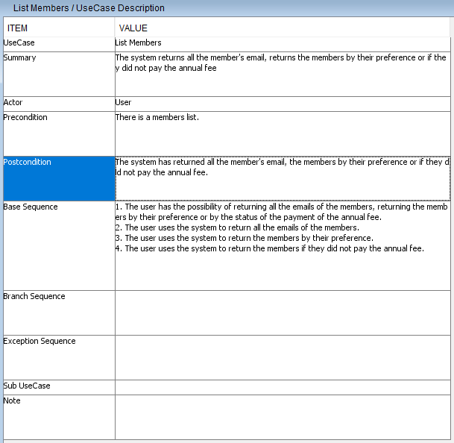

Table.1 List Members

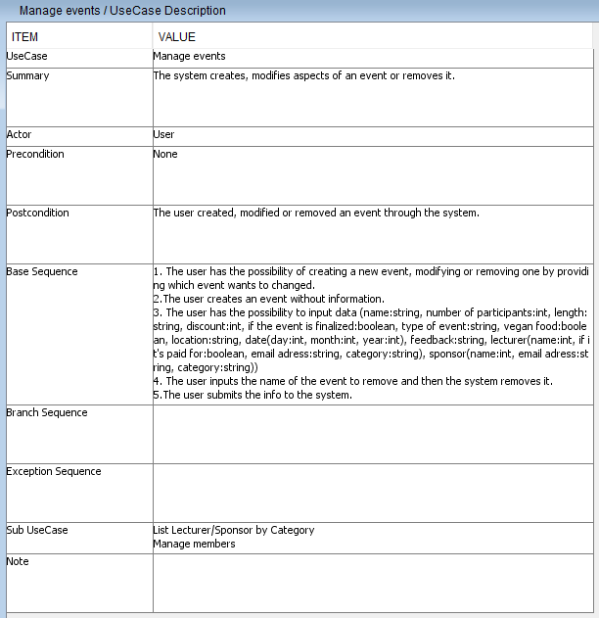

Table.2 Manage Events

**3.3 Actor descriptions**

The users are the only actors who are employed by Vipassana.They interact with the system, and are responsible of directing what action should the system perform and introducing new information that is not present already in the files that are part of the secondary file storage of the system.

# 4 Design

Design Class Diagram

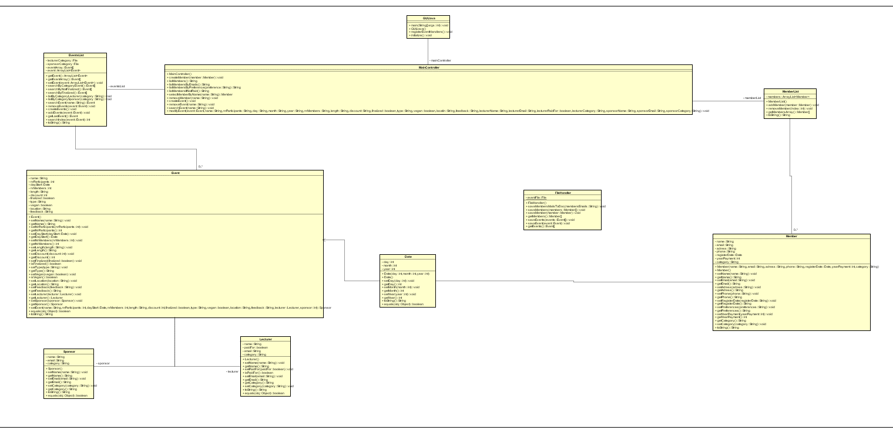

Figure.1 Design Diagram

The most basic class in the system is “Date”,in this class,users can store information of date(day,month,year).

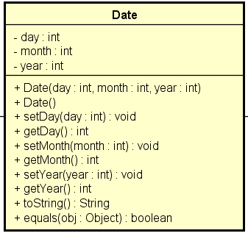

Figure.2 Date

In “Lecturer” and “Sponsor” classes,users can store names,emails and categories for them,but for lecturers,there is a function “paidFor” to check their payment condition.

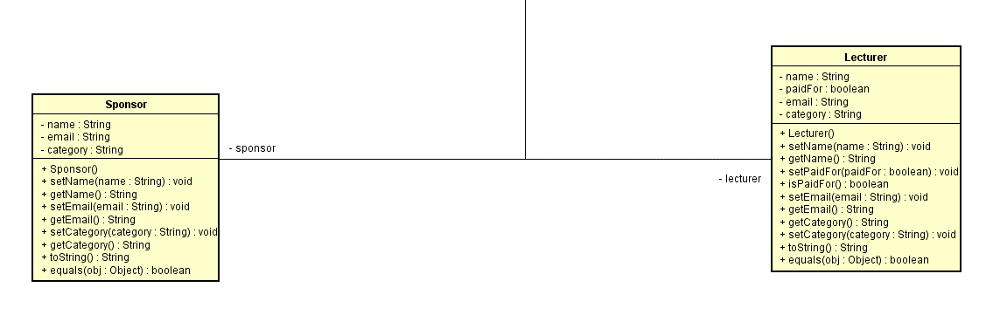

Figure.3 Sponsor and Lecturer

In “Event” class,methods in “Lecturer”,”Sponsor” and “Date” will be used.Users can store names,starting day,amount of members and participants,length,events’ type,discount,location,feedback from members.Users can also check finalization and whether the member is vegan or not.

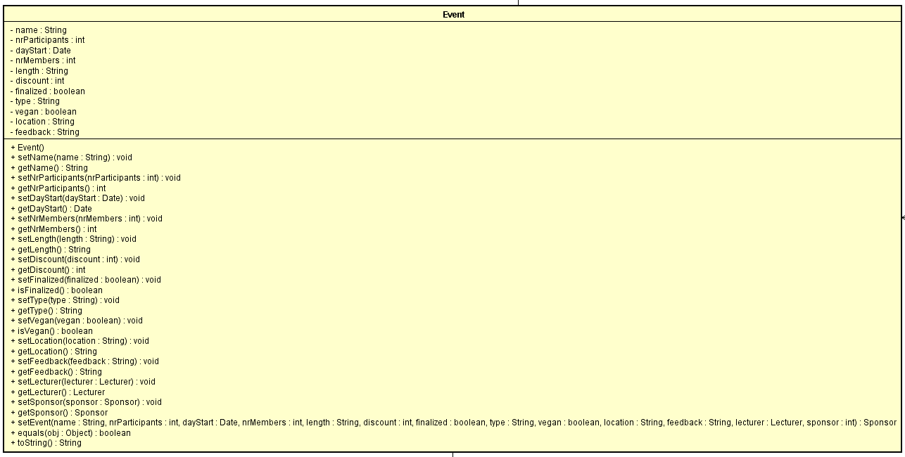

Figure.4 Event

In “Member” class,users can store names,emails,phone numbers,address,register date,year of payment,and the category.

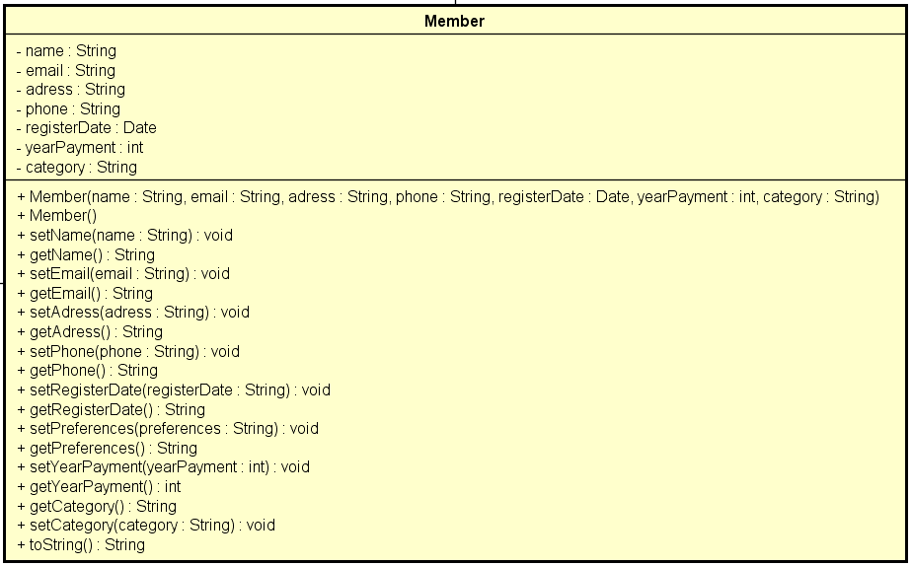

Figure.5 Member

In “FileHandler” class,users can create two files,which are file of events and file of members respectively.Users can write and read information in this two files.

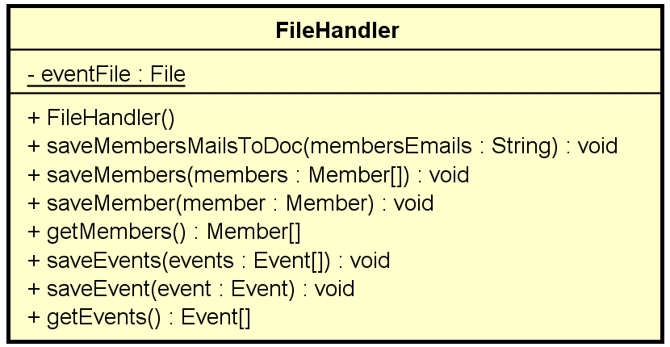

Figure.6 File Handler

In “EventList” class,users can add events,remove events,search events with requirements(names,category and finalization),and read information from the file of events by using the method in “FileHandler”class.

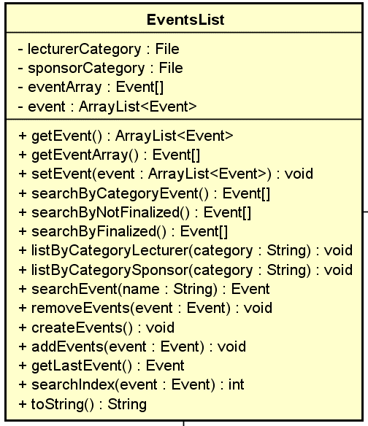

Figure.7 Events List

In “MemberList” class,users can add members,remove members,search events with specification(name,emails,payment condition and preference),and read information from the file of members by using the method in “FileHandler” class.

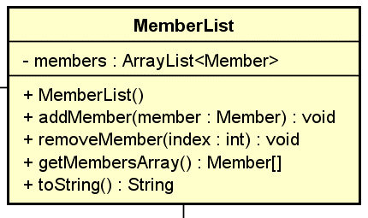

Figure.8 Member List

The sequence diagram describes the how the system creates an event and each object interacts with each other to bring the desired result. The method createEvent() in MainController calls createEvents to add an event to the arraylist of events. In Event the event object is created by giving to each field a value. Also there the date, lecturer and sponsor object are created and sent back to the contructor of Event.

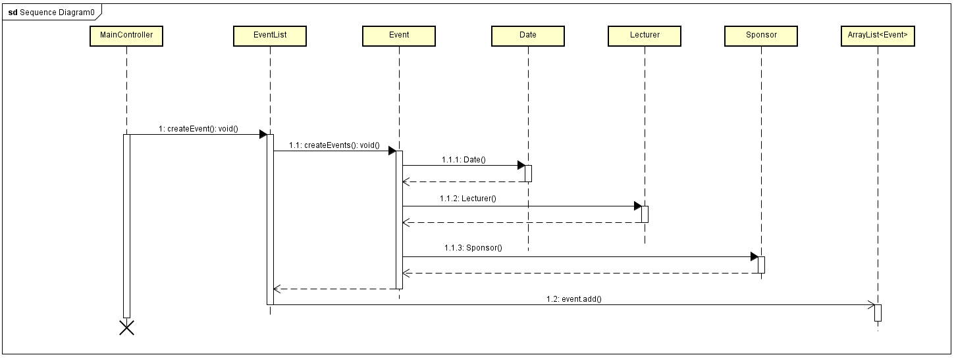

Figure.9 Sequence Diagram

The GUI has four tabs inside which all the elements are put. It is built it in this way so that access to everything that the system does is easier.

The Manage Event tab is built with four buttons with action listeners, text fields and check boxes for the fields of an event. When the Create Event button is pressed all the fields are filled with the values that are given in the system, the reason being that the user would know where he needs to input data.When submitting the changes made to the event, the original name needs to be inputted in the textfield next to the Search button so the system would know what event to change.

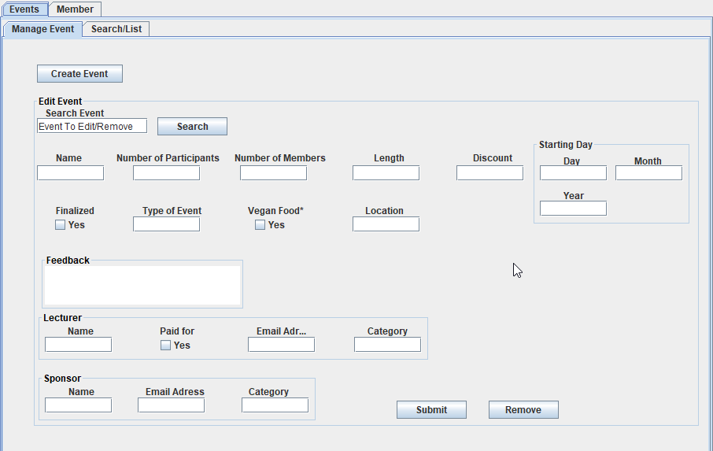

Figure.10 GUI Manage Event tab

The GUI has an textArea object so all the information outputted when events are searched will be there the reason for this being that the user would search for certains events for which it would not have the name. When the List button is pressed a file is created with the information of the lecturers and sponsors by their category. The List button does not show anything in the textArea because it was considered not relevant in fulfilling the requirement of having a list of lecture and sponsors.

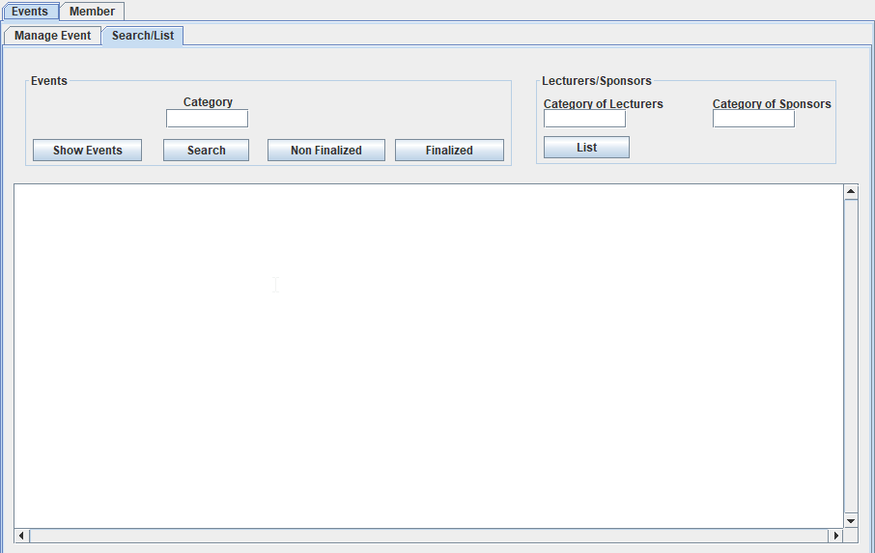

Figure.11 GUI Search/List tab

In the Manage Members tab, in order to create a member all the fields except Registration Date need to be filled. This is because most of the times a member would be created on the day the information is given.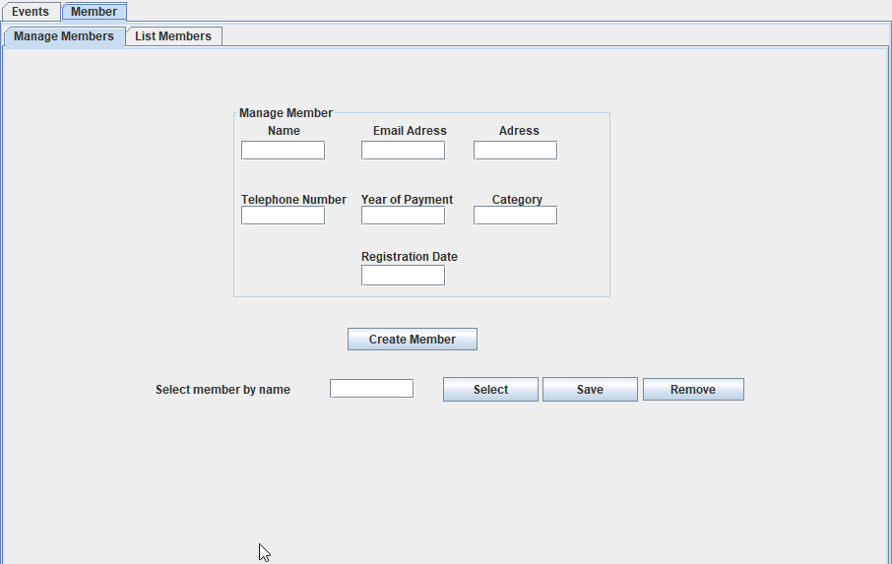

Figure.12 GUI Manange Members tab

The List Members tab has a textArea object in which every time a button is used it shows the the result of the search. The List all Emailsl button also creates a file when pressed. It was built this way as in the interview it was mentioned the need for a list of the emails for the newsletter.

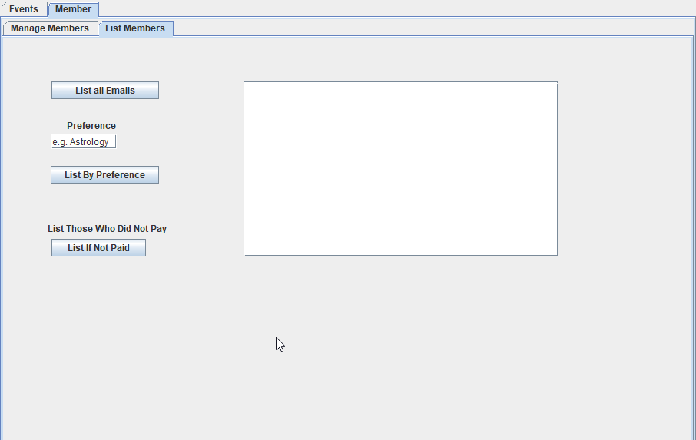

Figure.13 GUI List Members tab

# Implementation

Class MainController is responsible for all the main methods used in the GUI. It is built so it can make the changes and save everything in files that are handled in a static class. One of the most important methods is the modifyEvent as it is used for modifying the fields that describe an event. It is called through an anonymous function in the GUI at the press of the button. To modify a certain event, it searches for the index of the event in the arraylist of events and then calls the set method. In the end of the method it saves the events to a file. The important methods that modifyEvent uses: searchIndex(), saveEvents().

public void modifyEvent(Event event, String name, String nrParticipants,

String day, String month, String year, String nrMembers, String length,

String discount, boolean finalized, String type, boolean vegan,

String location, String feedback, String lecturerName,

String lecturerEmail, boolean lecturerPaidFor, String lecturerCategory,

String sponsorName, String sponsorEmail, String sponsorCategory)

{

int numberParticipants = Integer.parseInt(nrParticipants);

Date dayStart = new Date(Integer.parseInt(day), Integer.parseInt(month),

Integer.parseInt(year));

int numberMembers = Integer.parseInt(nrMembers);

int nrdiscount = Integer.parseInt(discount);

Lecturer lecturer = new Lecturer(lecturerName, lecturerEmail,

lecturerPaidFor, lecturerCategory);

Sponsor sponsor = new Sponsor(sponsorName, sponsorEmail, sponsorCategory);

try

{

eventList.getEvent().get((eventList.searchIndex(event))).setEvent(name,

numberParticipants, dayStart, numberMembers, length, nrdiscount,

finalized, type, vegan, location, feedback, lecturer, sponsor);

}

catch (IndexOutOfBoundsException e)

{

System.out.println("no event found");

}

FileHandler.saveEvents(eventList.getArrayEvent());

}

}

The searchIndex() method returns the position of a certain event that is introduced. It is used to know the position of the event we need to modify in the arrayList. It returns “-1” if no event is found.

public int searchIndex(Event event)

{

for (int i = 0; i < this.event.size(); i++)

{

if (this.event.get(i).equals(event))

return i;

}

return -1;

}

The saveEvents() method uses an array of events to save the objects in a binary file. The choice of using binary files was justified by the flexibility of writing and reading objects from them.

public static void saveEvents(Event[] events) {

ObjectOutputStream out = null;

try {

FileOutputStream fos = new FileOutputStream("events.bin");

out = new ObjectOutputStream(fos);

for (int i = 0; i < events.length; i++) {

out.writeObject(events[i]);

}

} catch (IOException e) {

e.printStackTrace();

}

finally {

try {

out.close();

} catch (IOException e) {

e.printStackTrace();

}

}

}

# Test

The GUI was tested based on the Use Cases assuring proper functionality to it and making sure it respects the requirements. During the implementation period the system was constantly checked for errors. The last version of the system was tested according to the use case and user guide.

1. Manage Events

|  |  |
| --- | --- |
| 1. Has all the options in the Use Case available in the GUI | YES |
| 1. The user can create an event with default fill in the fields | YES |
| 1. The user has the possibility to input data in the GUI fields | YES |
| 1. The user can input what event to remove and remove it | YES |
| 1. The system works according to design choice when the user submits the information in the GUI regarding this use case. | YES |

2. Search for Events

|  |  |
| --- | --- |
| 1. Has all the options in the Use Case available in the GUI | YES |
| 2.The result of the search by category is shown in the GUI | YES |
| 3.The result of the search of finalized events is shown in the GUI | YES |
| 4. The result of the search of nonfinalized events is shown in the GUI | YES |

3. List Lecturer/Sponsor by Category

|  |  |
| --- | --- |
| 1. Has all the options in the Use Case available in the GUI | YES |
| 1. The user can input the category in the GUI | YES |
| 1. The system creates files with the information after the user submits it in the GUI | YES |

4. List Members

|  |  |
| --- | --- |
| 1. Has all the options in the Use Case available in the GUI | YES |
| 2. The system shows all the member’s emails in the GUI and creates a file with the information | YES |
| 1. The system shows all the members in the GUI by their preference | YES |
| 1. The system shows all the members in the GUI that did not pay the annual fee | YES |

1. Manage Members

|  |  |
| --- | --- |
| 1. Has all the options in the Use Case available in the GUI | YES |
| 1. The user can input all the data and create the member | YES |
| 1. The user can input the information to modify a member | YES |
| 1. The user can remove a member by their name | YES |
| 1. The user can search for a member by their name | YES |
| 1. The system works according to design choice when the user submits the information in the GUI regarding this use case. | YES |

# Results and Discussion

The purpose of the results and discussion section is to present the outcome and achieved results of the project.

# Conclusion

The purpose of the conclusion section is to compile the results from each section in the report. What is the conclusion? Did the project fulfil the requirements? Etc.

You can only comment on report contents, no new topics or content can be introduced in this section.

# Project future

Reflect on your project from a technical viewpoint and describe what you would change if you could.

Suggest how the project could be improved or made ready for production. Discuss scalability, suggest possible spin offs, what is needed, missing, etc.?

!!!!!!!!

# References

**Note: Use the standard reference method: Harvard Anglia. A very good reference tool is Mendeley** (Mendeley.com 2016), **ask VIA Library if you need help.**

Banger, D., 2014. A Basic Non-Functional Requirements Checklist « Thoughts from the Systems front line.... Available at: https://dalbanger.wordpress.com/2014/01/08/a-basic-non-functional-requirements-checklist/ [Accessed January 31, 2017].

Business Analyst Learnings, 2013. MoSCoW : Requirements Prioritization Technique — Business Analyst Learnings. , pp.1–5. Available at: https://businessanalystlearnings.com/ba-techniques/2013/3/5/moscow-technique-requirements-prioritization [Accessed January 31, 2017].

Dawson, C.W., 2009. *Projects in Computing and Information Systems*, Available at: http://www.sentimentaltoday.net/National_Academy_Press/0321263553.Addison.Wesley.Publishing.Company.Projects.in.Computing.and.Information.Systems.A.Students.Guide.Jun.2005.pdf.

Gamma, E. et al., 2002. *Design Patterns – Elements of Reusable Object-Oriented Software*, Available at: http://books.google.com/books?id=JPOaP7cyk6wC&pg=PA78&dq=intitle:Design+Patterns+Elements+of+Reusable+Object+Oriented+Software&hl=&cd=3&source=gbs_api%5Cnpapers2://publication/uuid/944613AA-7124-44A4-B86F-C7B2123344F3.

IEEE Computer Society, 2008. *IEEE Std 829-2008, IEEE Standard for Software and System Test Documentation*,

Larman, C., 2004. *Applying UML and Patterns: An Introduction to Object-Oriented Analysis and Design and Iterative Development*,

Mendeley.com, 2016. Homepage | Mendeley. Available at: https://www.mendeley.com/ [Accessed February 2, 2017].

YourCoach, S.M.A.R.T. goal setting | SMART | Coaching tools | YourCoach Gent. Available at: http://www.yourcoach.be/en/coaching-tools/smart-goal-setting.php [Accessed August 19, 2017].

# List of Appendixes

The purpose of your appendices is to provide extra information to the expert reader. List the appendices in order of mention.

Examples of appendices

* Project Description
* User Guide
* Source code – source documentation
* Diagrams
* Data sheets
* Etc.

1. Project Description

Insert the original Project Description in here.