ICT Engineering









User Guide

Claudiu Rediu 266129

Boris Sidlo 251341

Michal Ciebien 266908

Eduard Costea 266078

Peipei Su 266128

Date: 19. 12. 2017

Depending on what is what you want to achieve with the system there are certain steps to take.

1. Create an Event
   1. Have selected inside the Events tab, the Manage Event tab. 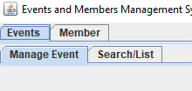
   2. Look for the Create Event button and click it. The event is now created with no information to it. 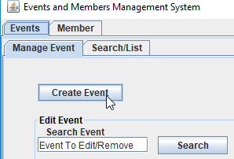
2. Search for an Event
   1. Have selected inside the Events tab, the Manage Event tab. 
   2. Look for the text field to the left of the Search button to input the name of the event you want to search for. 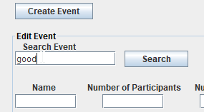
   3. Click the Search button when you inputted the proper name of the event. 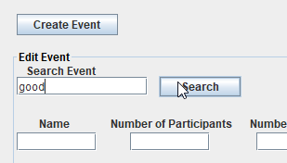
3. Remove an Event
   1. Have selected inside the Events tab, the Manage Event tab. 
   2. Look for the text field to the left of the Search button to input the name of the event you want to remove. 
   3. Search for the Remove button and press it when you are ready to remove the event. 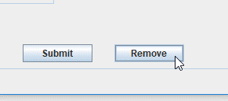

1. Modify an Event
   1. Have selected inside the Events tab, the Manage Event tab. 
   2. Look for the text field to the left of the Search button to input the name of the event you want to modify. 
   3. Have the text fields you want to modify filled with the proper information. You can Search for the Event first (Information pg. 2) to have the fields filled with the previous data. 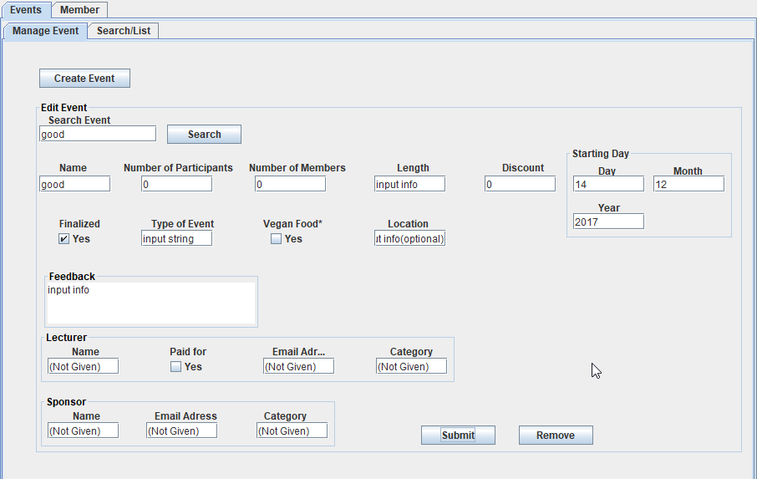
   4. Press submit when you are ready to modify the information regarding the event. 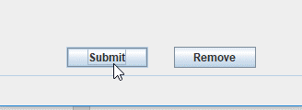
2. Show all Events
   1. Have selected inside the Events tab, the Search/List tab. 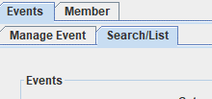
   2. Look for the Show Events button and press it. 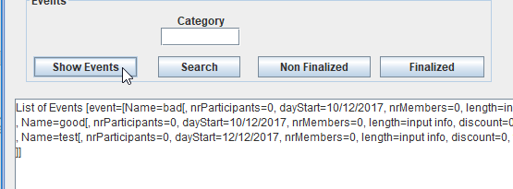
3. Search for Events by the Category of the Lecturer
   1. Have selected inside the Events tab, the Search/List tab. 
   2. Look for the text field above the Search button from this tab and input the category of the lecturer. 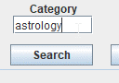
   3. Press the Search button. 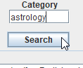
4. Show all Nonfinalized Events
   1. Have selected inside the Events tab, the Search/List tab. 
   2. Look for the Non Finalized button and press it. 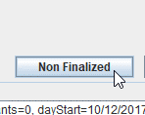
5. Show all Finalized Events
   1. Have selected inside the Events tab, the Search/List tab. 
   2. Look for the Finalized button and press it. 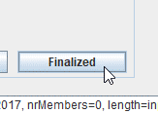
6. List the Lecturers or/and Sponsors by Category
   1. Have selected inside the Events tab, the Search/List tab. 
   2. Search for text fields under Category of Lecturers and Category of Sponsors and add the category you want to list by in a text file. 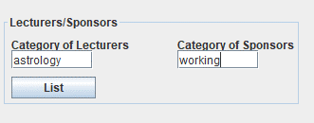
   3. Press the List button. 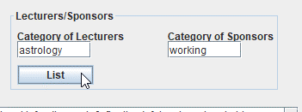
7. Create a Member
   1. Have selected inside the Member tab, the Manage Members tab. 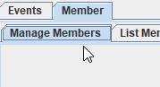
   2. Input the information of the member you want to create inside the text fields and then press the Create Member button. 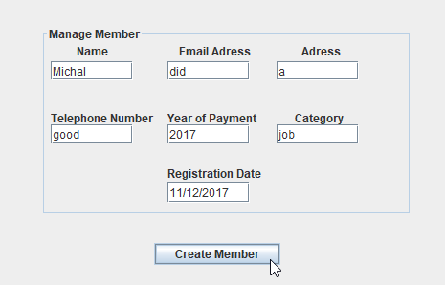
8. Search Member
   1. Have selected inside the Member tab, the Manage Members tab. 
   2. Look for the text field to the left of the Select button and input the name of the member you want to search for and press the Select button. 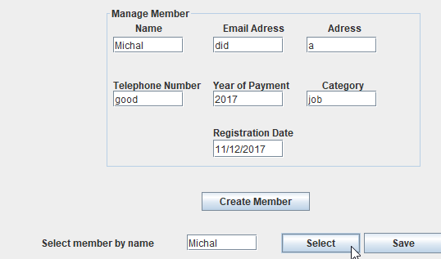
9. Modify a Member
   1. Have selected inside the Member tab, the Manage Members tab. 
   2. Input the information while keeping the name field unmodified and then press save. 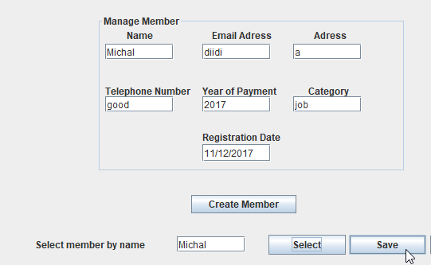
10. Remove a Member
    1. Have selected inside the Member tab, the Manage Members tab. 
    2. Look for the text field to the left of the Select button and input the name of the member you want to remove and press the Remove button. 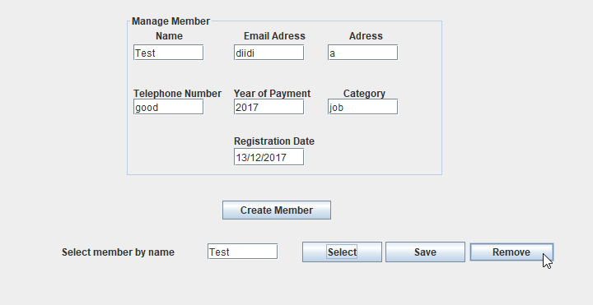
11. List all Member’s Email in a Text File
    1. Have selected inside the Member tab, the List Members tab. 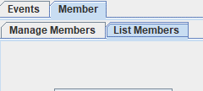
    2. Look for and press List all Emails button.
12. List all Members by Preference in a Text File
    1. Have selected inside the Member tab, the List Members tab. 
    2. Look for the text field above List by Preference button and input the preference. Press the List by Preference button.   
       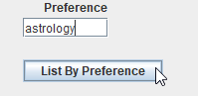
13. List all Members that did not Pay the Annual Fee in a Text File
    1. Have selected inside the Member tab, the List Members tab. 
    2. Look for the List If Not Paid button and press it.  
       