ICT Engineering



Semester Process Report

Group 2

Claudiu Rediu-266129

Boris Sidlo-251341

Eduard Costea-266078

Michal Ciebien-266908

Peipei Su 266128
Supervisors
Michael Viuff
MonaWendel

Date: 19. 12. 2017


Table of contents

1. Group policy 2
2. SWOT analysis 5
Team SWOT 8
3. Group roles 9
Claudiu Rediu 9
Boris Sidlo 9
Eduard Costea 9
Michal Ciebien 9
Peipei Su 10
4. Considerations 11
Claudiu Rediu 11
Boris Sidlo 12
Eduard Costea 13
Michal Ciebien 14
Peipei Su 15
5. Target audience 17
6. List of tasks 18
Claudiu Rediu 18
Eduard Costea 18
Boris Sidlo 18
Michal Ciebien 18
Peipei Su 19
7. Supervisor meetings 20

- Group policy

Group Contract

Group Contract

Date: 18/09/2017

These are the terms of group conduct and cooperation that we agree on as a team.

Participation: We agree to....

Respect the tasks you must do, and the team agreed on to do.

Communication: We agree to...

Communicate any issue you encounter regarding the work and ask for help, so the work will go smoothly. Announce when you want to input your work with a message at least.

Meetings: We agree to....

If you are late the third time you must bring beer, chips or anything you want to bring but it must be enough for all of us. Being late means coming 5-10 minutes late.

Conduct: We agree to....

Communication will be mostly done in meetings and workload will be in most cases done during working sessions in the university in which we will agree on.

Conflict: We agree to....

Any conflict should be brought on a team level, so we can discuss a solution. Conflicts shouldn’t be kept secret from team member.


Deadlines: We agree to....

Try our best to respect the deadlines. If we have an issue we can have an urgent meeting to solve it together fast.

Other Issues:

The beer needs to be cold.

Group Member’s Name | Student number | Signature
Eduard Costea | 266078
Boris Sildo | 251341
Michal Ciebien | 266908
Claudiu Rediu | 266129
Peipei Su | 266128
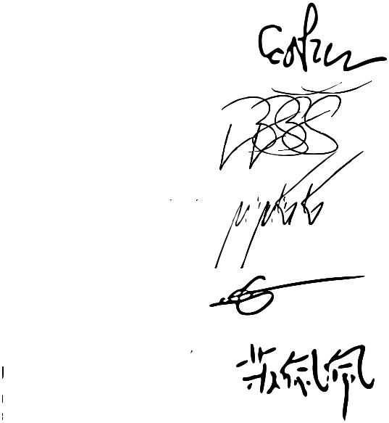

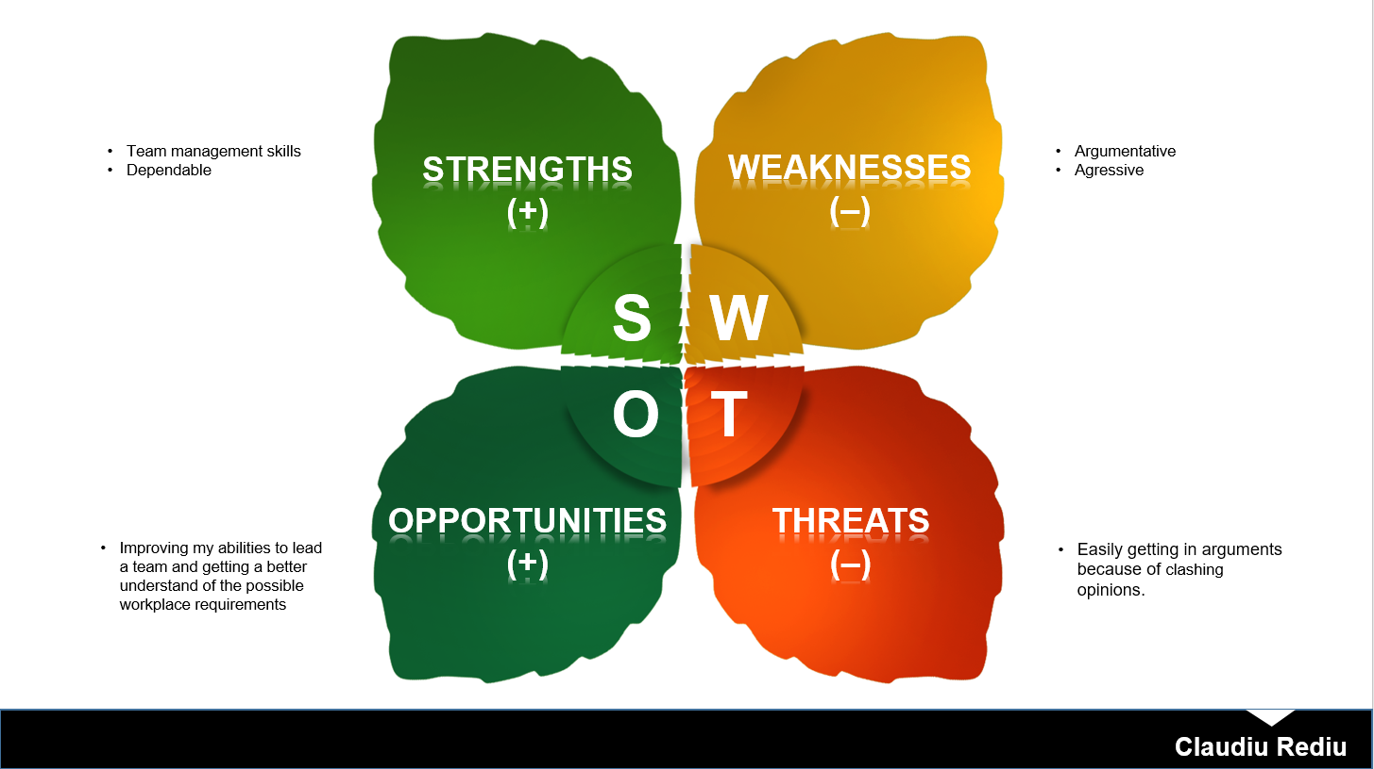
- SWOT analysis

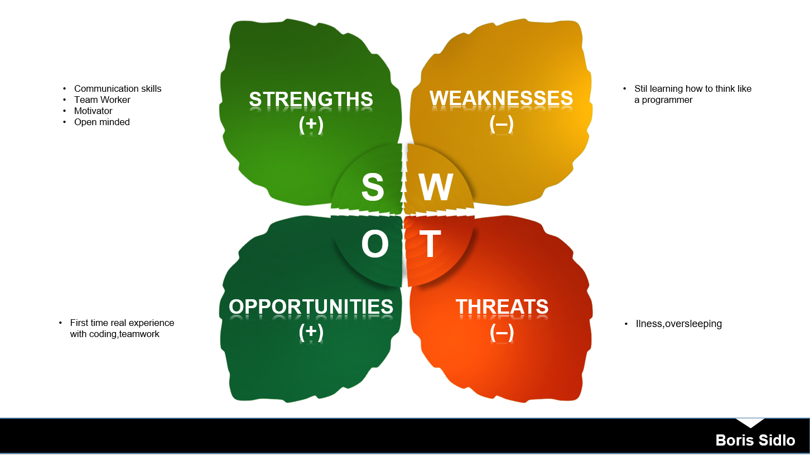

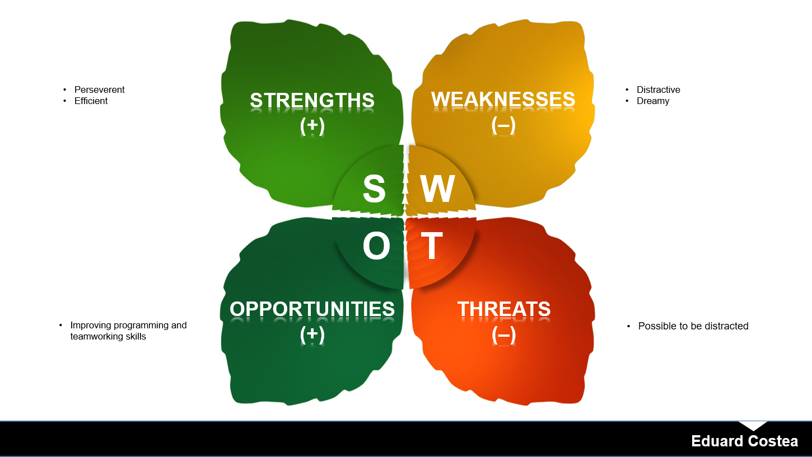

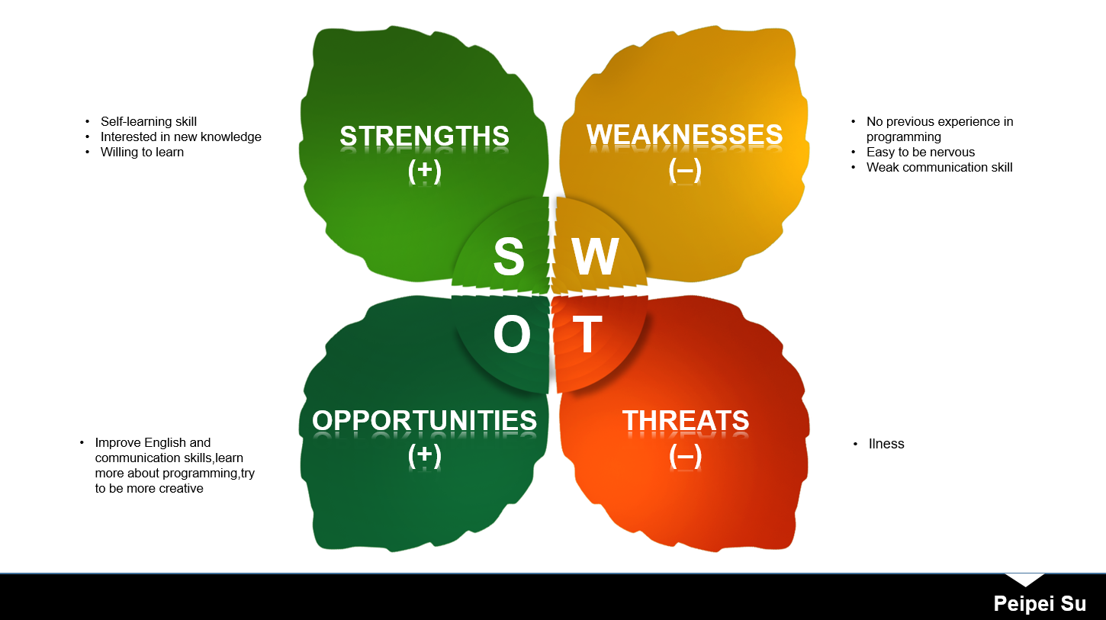

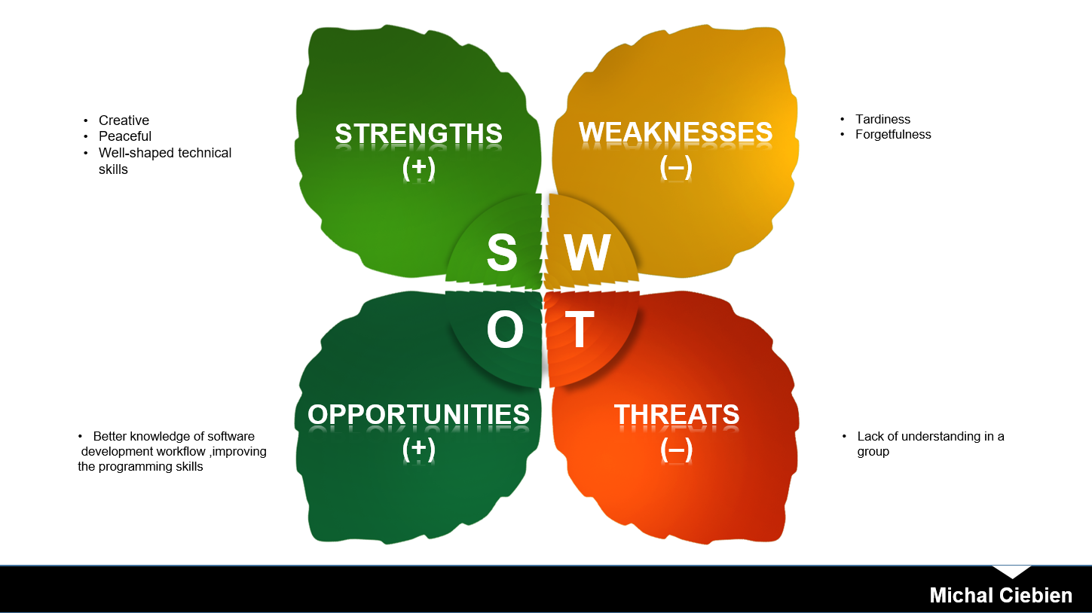

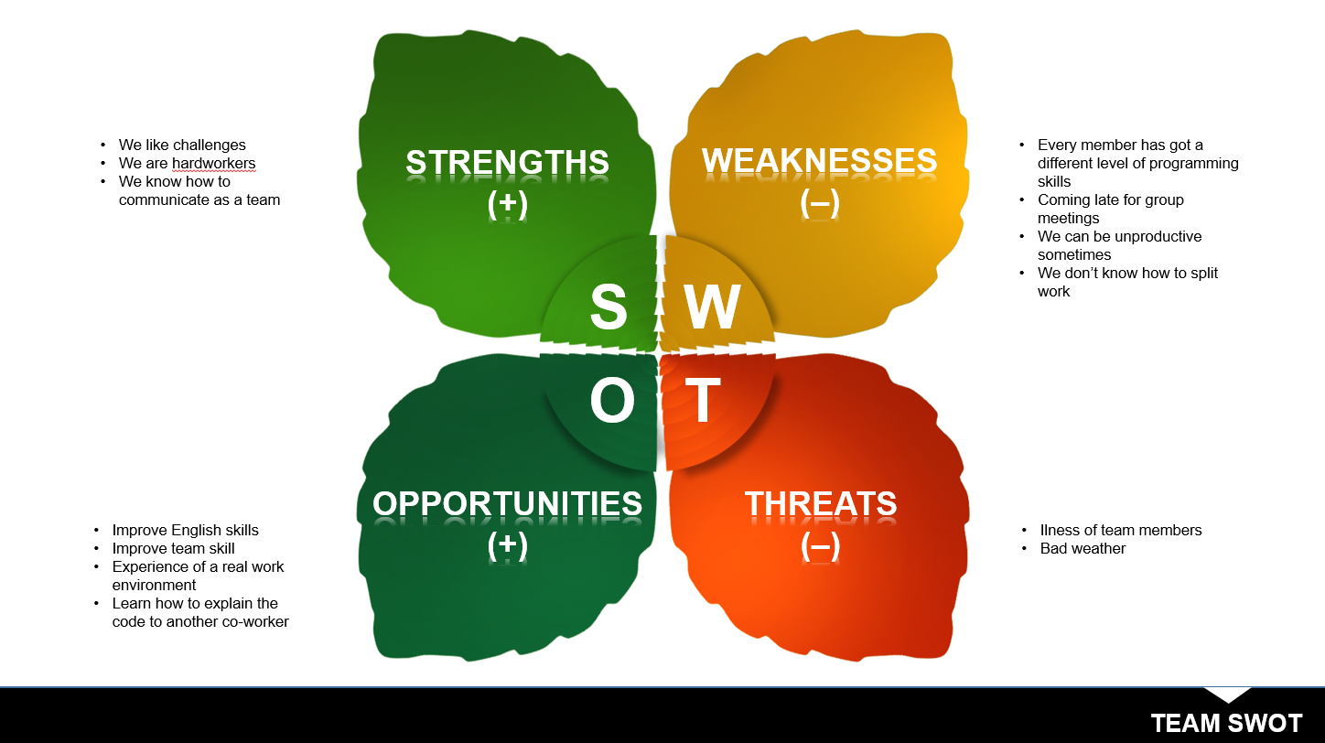
Team SWOT

3. Group roles

Claudiu Rediu(CO-ORDINATOR,SHAPER)

As a coordinator my focus was helping the others in reaching our common goal and bringing each member’s contribution together, so it would create a mostly cohesive result. I tried to solve each issue calmly and as efficient as possible.

As a shaper my role was to generate action and always have our assignments done on time and as good as possible. I managed my team in most aspects that included the project and was present always when needed by others.

Boris Sidlo(RESOURCE INVESTIGATOR,IMPLEMENTOR)

As a resource investigator, My role was make exploring new ideas finding resources and make sure that communication in the group so every member can say his opinion.

As an implementer my role I was helping organized work and put ideas and plans from my team members into action. I was making sure that everybody knows what they are doing an what is important and making deadlines.

Eduard Costea (RESOURCE INVESTIGATOR,SPECIALIST)

As an resource investigator my role was to find and bring new ideas to the team. I did bring new ideas to the implementation and design. It’ve contributed to writing part with ideas too and as an overview the project has become better with any idea.

As a specialist,I was a little bit self-worker but during the project it seemed a good idea that sometime to work alone and after that to check other’s opinions about it. I’ve tried to get my knowledge in everything and to make it better. I was paying attention to the details and trying to polish them.

Michal Ciebien(MONITOR EVALUATER, PLANT)
As a monitor evaluator my role was mainly to give accurate and impartial feedback during the analysis and the design part. Also to ensure others about that they could always rely on me about sharing my opinion on various subjects, which allowed them to confront their own ideas with sober judgments and therefore end up with better results.

As a plant my role was mainly to provide the team with best solutions and ideas that would make our project much better structured in an analysis part, as well as in the design part. This saved a lot of time on actual bug fixing and also made our system more transparent and easy to understand for each team member.

Peipei Su(SPECIALIST,IMPLEMENTER)

As a specialist,I feel enthusiastic about learning new things.My group task is mainly the creation of basic classes coding and project report,but I was interested in learning the knowledge in our GUI and other Java classes when they was done(which is hard but challenging).

As an implementer,my job was to finish my individual task as effective as possible,then showed them to other group members,in order to find whether there were any problems or anywhere that should be fixed or not.

4. Considerations

Claudiu Rediu

Having thought of the work that was done during the whole semester regarding the project, I have an idea of what I have done bad, what I have done well and how to improve in the future.

Firstly, what I have done bad was not trust my team's ability to motivate itself and work towards a satisfying result. My impatience and approach are also to blame. There was a need for a lot more meetings and as I assumed the responsibility of being the leader of the team, should have scheduled at least a weekly sitting when work needed to be done. In the next project, I will listen more to my team members as they said that the best way to do work is during meetings.

Secondly, what I have done well, look forward to improving and continuing. I focused a lot during the project period on bringing together everybody’s work, so it would be cohesive and, from my perspective, brought a good result and a feeling of belonging in the team. Another aspect that I consider I have done well was split the work based on what my team members would like most and be the most specific to what they are good at. I will continue what I have done well while also avoiding being obstructive or a discomfort to my future team members.

One of the main considerations going into a future project is that a project should start being built on the minimum requirements first and further work on that. The issue of having a overly complex design considering the time at disposal was encountered and a very substantial change had to be made to everything that was already built. Another problem was the motivation to work at the assignments on time, but this would have been easily solved with more meetings as previously described. There were moments when just one person has done the work for a certain assignment. This was solved in the project period as everything was split in tasks or done with the whole group present at the meetings.

There are a few ideas that I look to further apply in the next project. Splitting the work based on everyone’s preference and abilities, improves the work experience and brings better results. Having meetings often is crucial to keep the motivation of each member to a high level. Giving the opportunity for each of us to contribute to the project in a meaningful way by thinking of a solution to a problem that they feel confident that they can handle, further improves the work atmosphere which is important for working productively. Having an open talk regarding each member’s shortcomings or what should they do better, improves the trust between each other and brings the team together towards a common goal that everyone considers as most important.

In the middle period of the semester, the project seemed to go towards a bad direction but a meeting in which we discussed what we should have done better, and each member’s shortcomings changed the attitude for the better and everything from there started to further improve in a good working environment. That was one of the most difficult moments to tackle because the tension was building up.

The whole project was a pleasant experience as it helped in developing my leadership skills. Another result of this working period was that I got a much better understanding of what should be the focus in a work environment and how a product is really created. I feel confident that in the future I will be a much better leader, a hard-working team member and honest towards myself and each teammate.

Boris Sidlo

When come to moment to make a group I was really scared just few week of school and you have to make a project group, because find a people who will be your “type of coffee” is really hard and very important because you will spend with them lot of time and you have to create something big but I think we were forming our group just on pure sympathies. And shows up it was working! Me Claudiu, Eduard, and Michael were great we did all group assignment very fine with no problems and with lots of fun. We are all kind geeks, four terrible persons with even more terrible sense of humor and When Michael told us if we can take Peipei to our team, to be honest, I was little bit scared because our workflow is very special but it works for us perfectly but I was wrong, Peipei is awesome person and she made our team even better. Semester project shows me that even totally different types of personalities, countries, continents can work together.
This was the first time I have been working on a project like this. The project which is a basically tiny simulation of small software development team which task is to make a company system for a client. The biggest issue our meetings were that sometimes really unproductive and chaotic everyone wants to do everything but we were getting better and better I think this is a normal process to learn and get the grid in the group.
For me as a person who just now starting with programming and slowly getting in this crazy world of ones and zeros was completely unviable that I am able to understand and be able to do that what I can do now in the begging of the semester. My part of semester project was mostly documentation and hours of brainstorming and coming with new ideas.I also touched the code but I was in this begging and we change our system a lot from the scratch so the final version of system doesn’t include my code but I am person who is humble and If I don’t know something or somebody tell that what I am doing Is wrong I open to learning so I get so much from Cladiu and Michael I was feeling that I am junior programming and I getting so much information also I took apart on making Class Diagrams.

Last two weeks of semester project was really hard but I don’t regret it worth it. I learn not just programming but I think that I definitely learn and get better how to work with people and how to learn from people and I think that we made pretty good job and from our group, we become even more we became friends.

Eduard Costea

I began to work with Claudiu, Boris, and Michal from the first time because I knew them, and I’ve trusted them as being cooperative, communicative and they seemed confident.Later, Peipei joined us and it was a good surprise for the team, she was a good teamwork and a good friend as well because our group was based on friendship, this is why it was easier to do some tasks, being so friendly to each other and feeling comfortable in each other’s presence. The principal task of Semester Project it was given to as in the form of an interview and we were supposed to implement a model for a Spiritual Center. The idea was great because it was so close to reality and practical at the same time.

For me, it was the first time when I’ve worked for so long and so hard on the team, the whole experience, I can say, it was very pleasant and enjoyable. We planned our meetings as much of them as there were needed but in general 2-3 during a week. We worked a lot through the social-media especially on Facebook, we used a project manager named Trello, a version control system Git. We were helped a lot by technology in organizing all the stuff and get it done by the time, every little detail.

Even we were two Romanians, one polish, one Czech and one Chinese in our team we manage to communicate so well between us, there was no problem that could affect performance or quality caused by communication. There were some problems anyway, and we were supposed to remake all the system from the scratch even there were some classes already implemented and some diagrams did.Excepting that all it was according to our to-do list and we made it in time to remake all of the work. All of the system it was better than the previous one.

In conclusion, I learned that I must be more communicative and I developed my social skills a lot. These team workers were the best thing in the whole Semester Project, we had fun together and good moments. We worked together until night, we manage to remake the whole system with one week and a half before the deadline just because we were determined to do something great and we really did it.

Michal Ciebien

After having all of the parts of our project done, I can finally sum up all the work with a view to things that were done well and the ones that were done poorer due to many, now visible circumstances, which I have understood and will be able to take lessons from.

Starting from beginning, which is the group forming part, in which I think we were very lucky to form a team, that could work well and productive throughout the whole semester. We have chosen each other mainly on the personal preferences, so we had no preview of how the each person will behave when it will come to actual work and problems that we would be facing. I can say that it came up extremely well. The overall work was done with a fluent flow and very few "hard-times”, which in the end we got through winning. Also there was the request from Michael, who asked us to invite a new member to our group at the end of November. What I liked very much, was that we all very quickly agreed on that, which showed me that all of us are empathic and have a will of help which meant for me that we will not have any big fights inside the group later on. That’s how we welcomed Peipei as a new member in our team, which later came up to be an extremely valuable member. Thanks to her hard work and devotion we saved a lot of time and could focus on much more project parts at the same time.

The analysis part went very well, but what surprised me during the design part was the amount of work we would need to do in order to end up with wanted results. I think none of our group members were really ready for it, as we very much thought about the project as a pretty easy thing to do. But then we had a lot of problems with understanding how the system should work, which was especially tough for me, as I was responsible for the major part of the system coding, which demanded from me to fully understand the system and the way of how it should be build. Thankfully we had our SDJ supervisor who met with us and helped us get through that part, which I think was the hardest one of all we actually faced.

One of the things I have learned from this project is a much better understanding of what were all the project parts for. I can now see how important each part is and that our early laziness really influenced our overall workflow. I remember I could not really see the purpose of many system analysis’ parts, which seemed dull and irrelevant for me. But the further we got with our project I started to see things differently, as what we were discussing during our meetings were actually things that we should have done earlier in the analysis part. The other thing I have learned from this project is I have learned a lot about programming itself, as it required connecting many Java features into one, well designed and most importantly – working, system.

To sum up, I believe we all have learned a lot on how to choose and work with your group on projects like this. I believe that we earned a lot of experience that will help us in future projects making better products as well as to improve in-group communication and its overall workflow.

Peipei Su

I was a new member who joined this group at the last period of 1st semester project(from 6th December).For this reason,my hardest challenge was to understand all the previous works of this group(i.e. the website,requirement,project description,use case).To understand all the previous works,I downloaded all the relevant files from GitHub,then read through the contents step by step(First,

project description.Second,requirement.Third,all diagrams).

In December,One of our tasks was to make a GUI that could serve a

single user system,then show the system in design diagram and sequence diagram,which was the most difficult part in our project.To work effectively,we met each other in classroom nearly every weekday,and booked 3 supervisor meeting.To make ourselves clearer in the project task,we finished the design diagram for all the class first,mean while,we started to code some of the basic classes(such as “Lecturer”, “Sponsor” and “Event”).We separated the workload,about 3 classes for each person.I finished those classes for me at a very early time,so we have discussed for it on the next day,then got the idea for the relation of each class.After we had an exact concept for what we have to make,the GUI(which was without functionality) and all the basic classes had already been done,then all we needed to do was just add functionality to our system.This was what made me realize the importance of cooperation and labor division.

When worked with the GUI,we met many problems,for example,which classes should we use to create file and read file.To solve this problem,we took a couple of days,but finally found the solution before our second supervisor meeting,and finished the functionality of GUI.And the other example,was I misunderstand the usage of two methods in our “EventList” class,which was,I made an outputting files method as a writing files method,the reversed usage of our original thinking.But this problem was actually very easy to solve,just change the coding in the reverse way,not so difficult as the problem with file handler.After we solved all those problems,I found there were many things still need to learn by myself,and that is the reason why I put “learn more about programming” as part of my opportunity in SWOT analysis.

The other task in December,was to write project report and process report,which was the writing part of our project.I wrote part of project report(abstract,and the design),and found it is not so hard as my original deem.In our project report,we wrote introduction and use case modelling first,but left implementation and test to the final,because before we put the image of our coding to the report page,we need to make sure the system works first.In our process report,we wrote the personal part individually but wrote the team part(team SWOT,target audience) together,since it is the most suitable way to write it.By this chance,I found a more effective way to learn and work myself.

In conclusion,this project made us more confident in social occasion,because we were supposed to work in a team,and practice communication skill.And more importantly,when the project works had been done,we actually improved our programming skill as well,because the task of project was related to our SDJ class,like practices for the course.It is a great experience for me,because in this semester project,I learned both issue solving skill(when my first group did not work,and we decide to split it) and programming skill(which was related to those three

assignments and our final task which was related to Java).

5. Target audience

At the start of writing the documentation, the target audience was chosen as it is an important part in the writing style. For the Project Report, an expert audience is the most adequate as there are a lot of technical information and decisions regarding the building of the project.
The user guide for the system has simple explanations and was built while considering that the reader would be a lay audience. Being a guide to a program, it was written in an easily understandable manner.

6. List of tasks

Claudiu Rediu

- project report

- designed the GUI and added functionality regarding events

- analysis diagram

- design diagram

- use case descriptions

- activity diagram

- appendices

- sequence diagram

Boris Sidlo

-project report
-process report
-coding ”participants”
-checking gudiences

Eduard Costea

-project report
-process report
-coding Event,Date,Member,MemberList
-checking guidance

Michal Ciebien
-Background description + References
-Choice of Models and Methods
-FileHandler, MainController, MemberList, Member, JavaGUI(Members parts) classes
-Functional Requirements
-Design Class Diagrams
-Analysis Diagrams descriptions
-Process Report parts

Peipei Su

-project report

-process report

-coding for "Lecturer" and "Sponsor" class

-coding for parts of "EventList" class

7. Supervisor meetings

In the semester project period there was the opportunity to arrange meetings with the supervisors. The supervisors for this semester are Michael, the SDJ teacher, who covers all the technical documentation and assisted in building the system, and Mona, the SSE teacher, who offered consultation in writing the documentation.

7.12.2017
The first meeting with Michael was about the need for a “Filehandler”. There was not a clear idea of what is the best way to handle files in the system. Michael gave useful tips that improved the system.

8.12.2017
Michael was asked for feedback regarding the GUI and how would be the proper way to write the documentation for the implementation and testing part in the project report. Michael further helped us improve our system and write the proper documentation.

13.12.2017
On this day Mona was asked for feedback for the documentation and what is needed to be closer to completion. There was also a need for confirmation that the documentation was being written in accordance to the requirements for it. Mona assisted with information on what to add to the process report.

14.12.2017
This was the final meeting with Michael in which he was asked regarding the java documentation and how we should include it in our appendices. This meeting was short as most of the things there was a need to discuss about were attended to in other meetings.

