**Q.1) Taking backup of AMI instance on daily basics interval of 12 hours in bash script?**

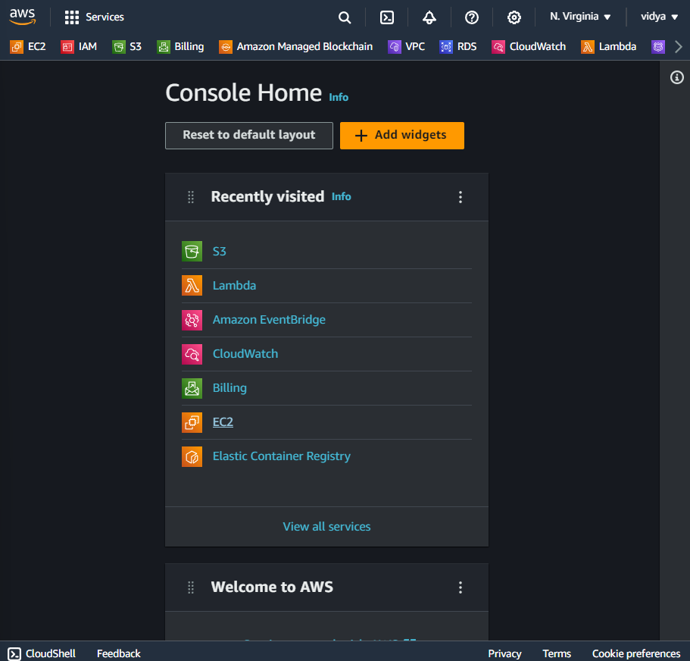

**1.Create instance so login to AWS and got EC2 service and launch instance.**

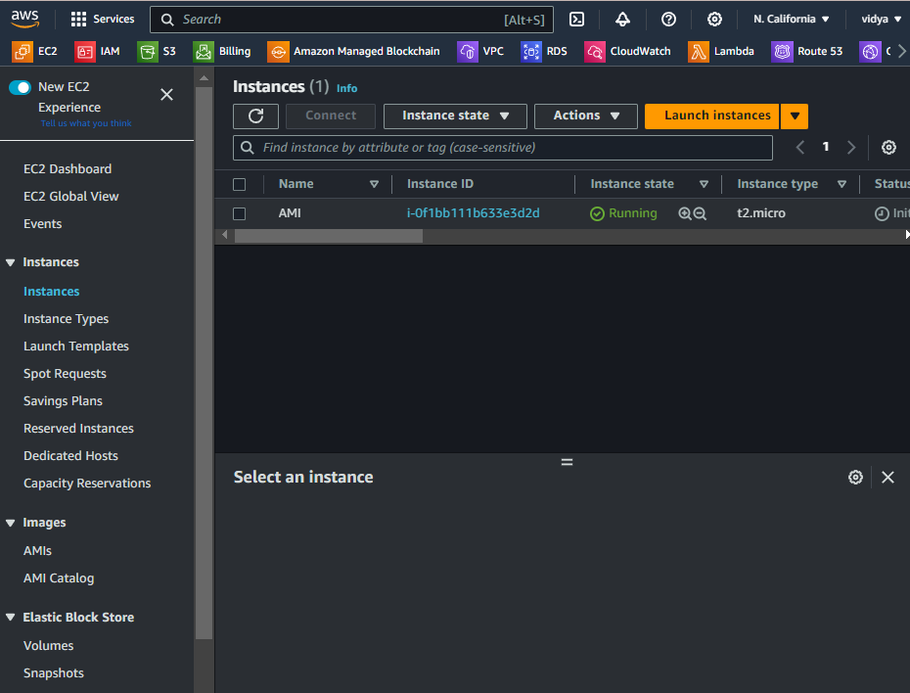

**After that we get access of instance.**

**Create a crontab job to schedule script run on time to take a AMI of instance for security base.**

**And after that create one .ssh file to write a script in it.**

**Created “ami.sh” name file vim editor and write in it a script of taking instance AMI.**

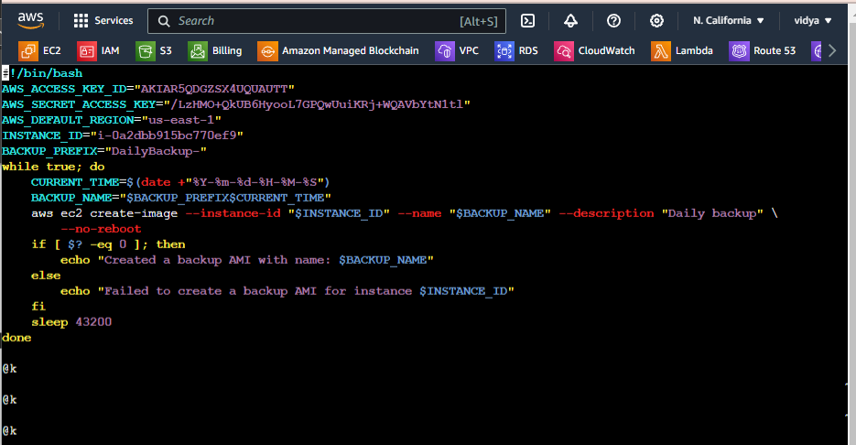

**Give ami.sh file a permission of execute (x) by run command**

**# chmod 555 ami.sh and then before schedule crontab job run this .ssh file**

**to forcefully to test it run or not.**

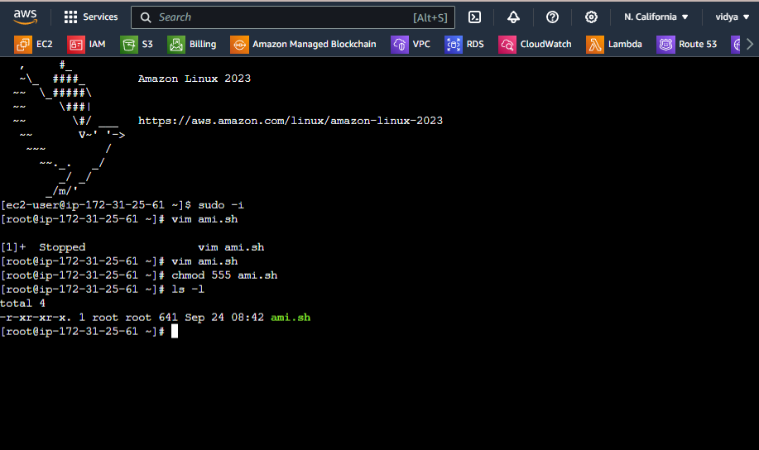

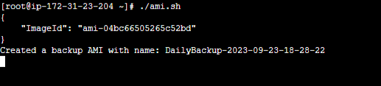

**schedule a crontab job to run this script on on daily basics interval of 12 hours**

**If crontanb command not found then install package by run command**

**# yum install cronie –y**

**And then run configure service**

**# systemctl start crond**

**# systemctl enable crond**

**And then now create crontab job by run command # crontab –e**

**And now gave it file as o */12 * * * /root/ami.sh and your crontab job was scheduled.**

