**Q.2) Script of bash to copy history of Linux machine in file at every hour and then that file copy to specific s3 bucket.**

**Login AWS and launch an instance.**



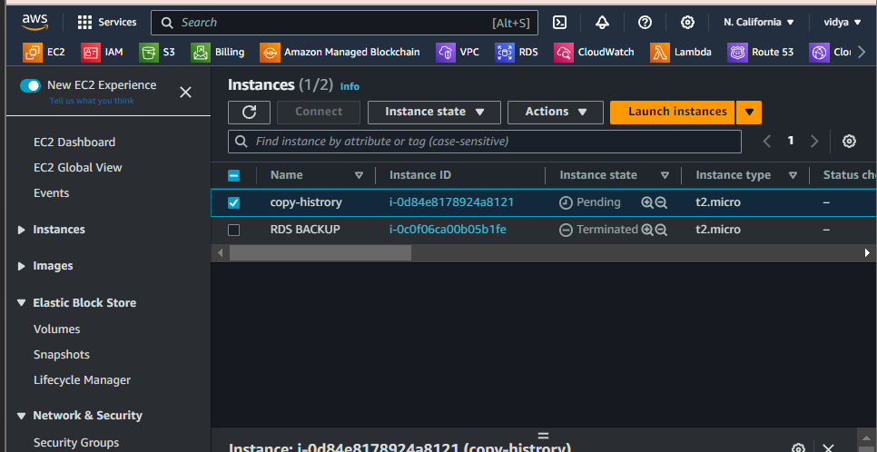

**Create a file .sh file to write a script In it.**

**Created file name cp-history.sh. to created file**

**rdit it by command**

**# vim cp.history.sh and then write script in it**

**And make secure to change with some lines**

**In history_directory= gave the path of history directory and then in s3_bucket= gave bucket name and then save it.**

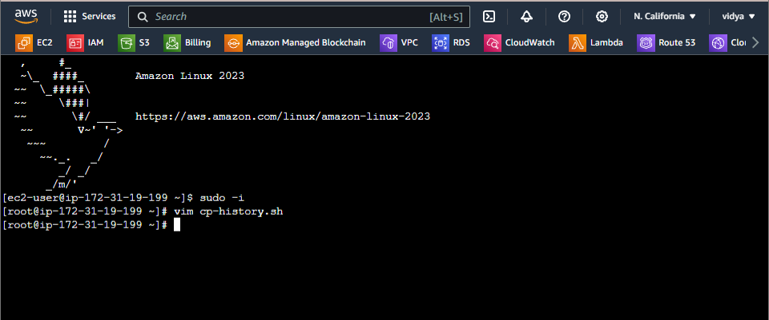

**After that gave it execute permission with command**

**# chmod 555 cp-history.sh**

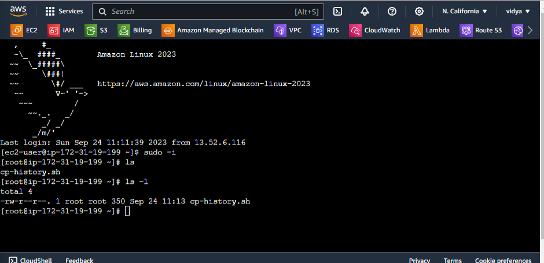

**Now attach a role to that instance or configure AWS. Configure AWS user which has permission of s3.**

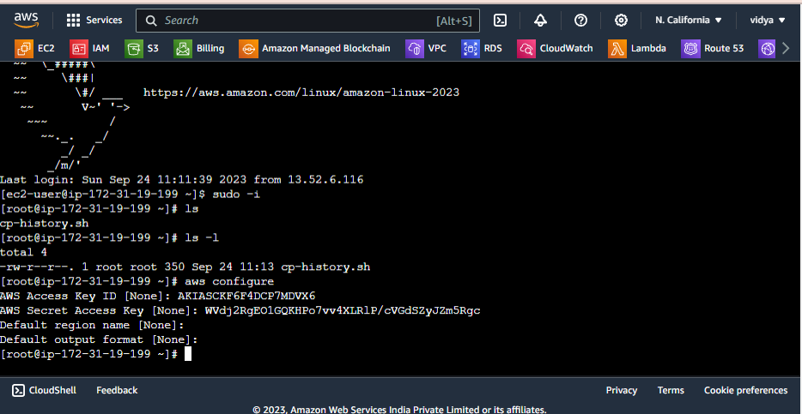

**Now you have to run this script on a particular time so you have to schedule crontab job to run this script every hr. so run command to run create crontab job**

**# crontab –e and then write its filed and path of your .sh file**

**0 * * * * /root/cp-histroy.sh**

**And your job was schedule it means every 1 hour create history directory and that directory send to s3 bucket.**

