**Q.3) Script for bash create a backup of RDS database every 2nd and 4th of each month Friday.**

**Login to AWS and go to ec2 service and launch an instance.**

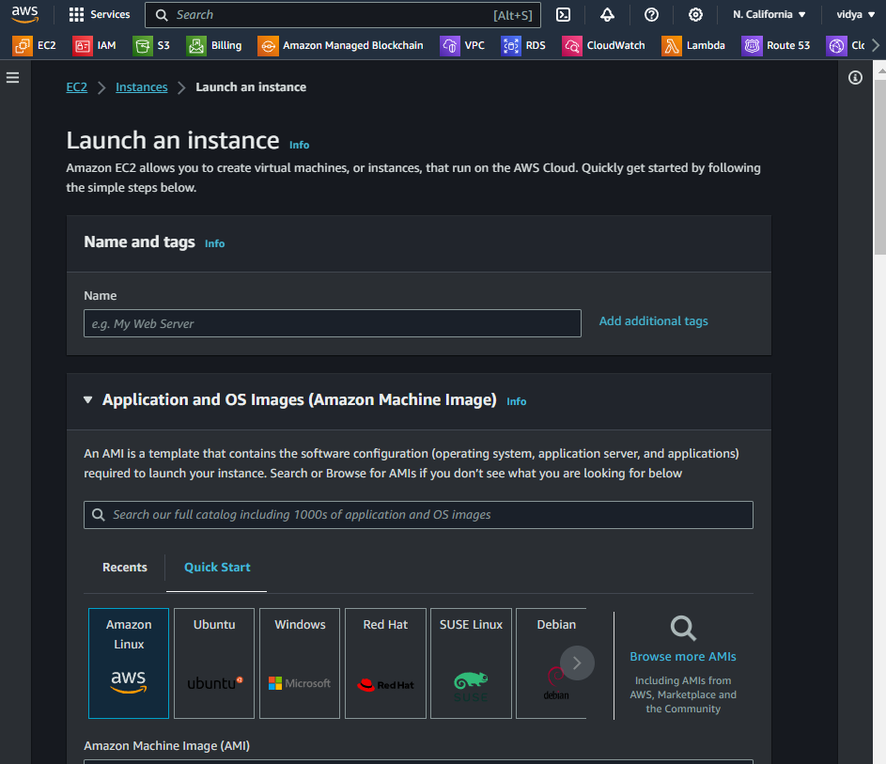

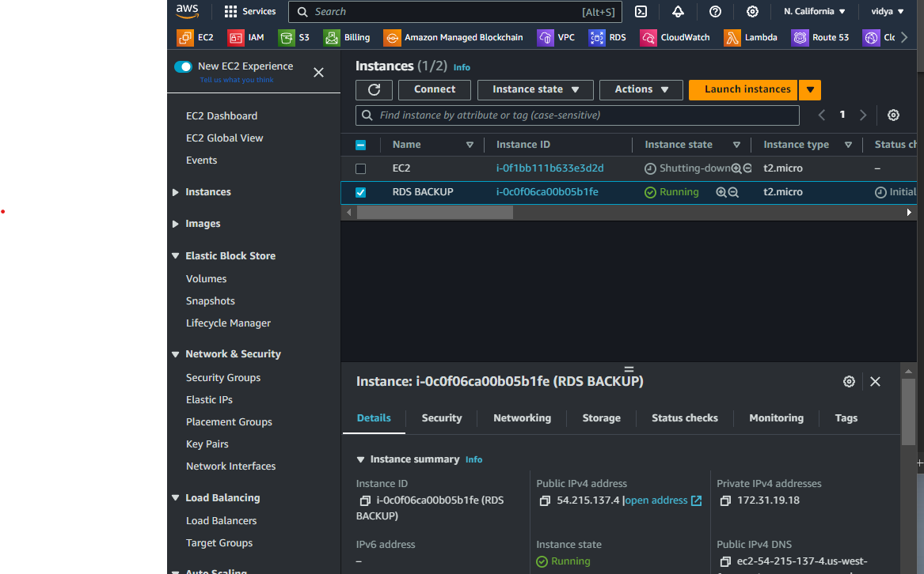

**Now if you have not RDS database then go to RDS service and create a database**

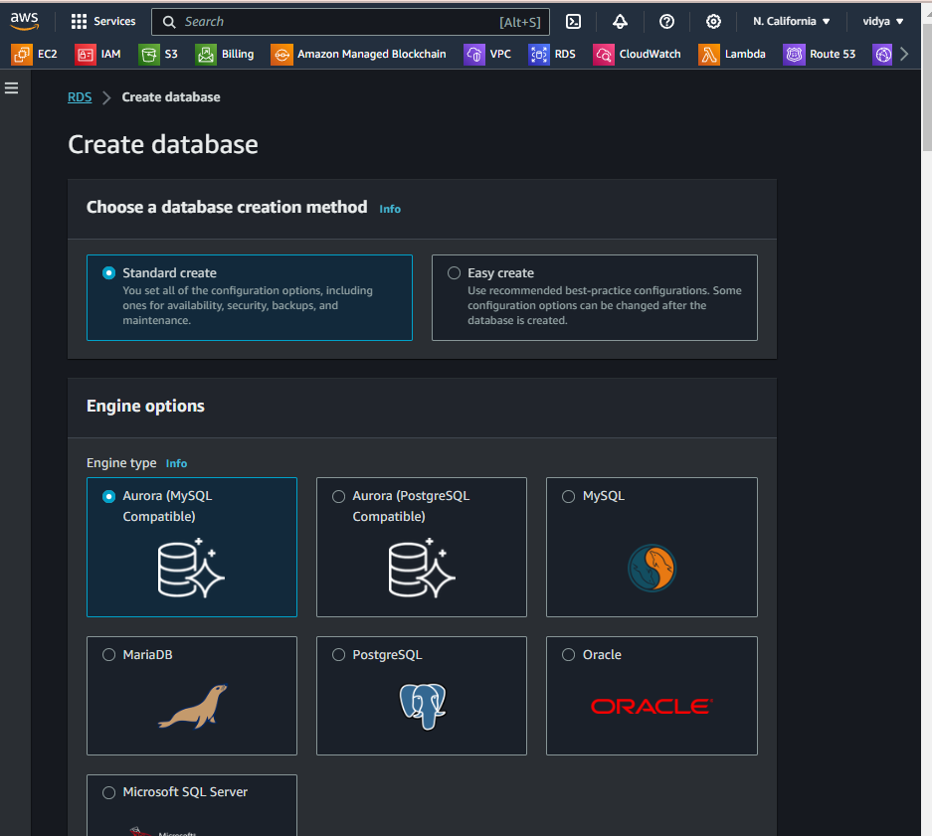

**and if you have a database leave it and go to next step. I have created database already so I have to get snapshot it on every 2nd and 4th Friday of each month.**

**Access of your launche instance.**

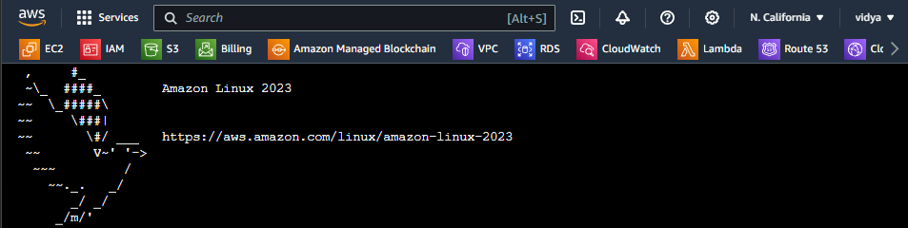

**And in that instance create a .sh file to write a script for create snapshot of that RDS database.**

**Already created backup-db.sh file.**

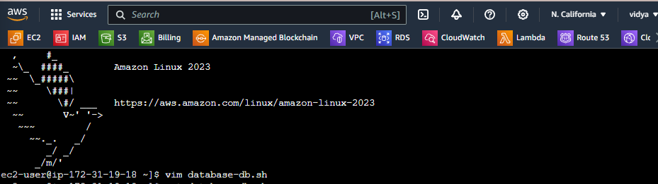

**# Replace with your RDS instance identifier and then AWS region in which your database pf RDS was created.**

**And then save that .sh file**

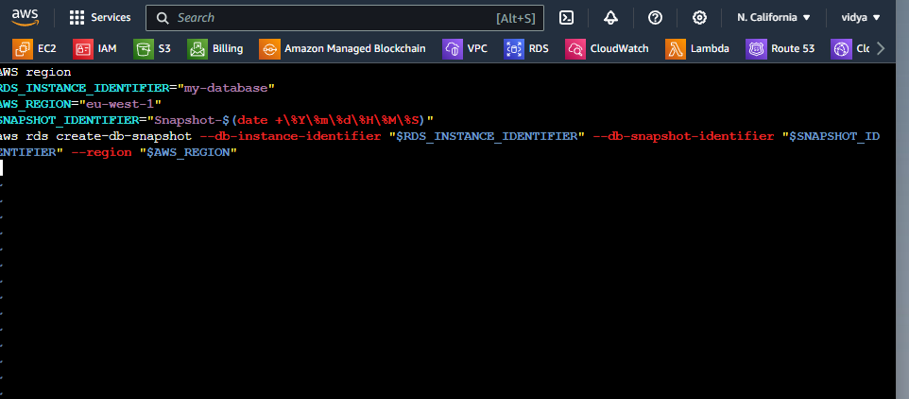

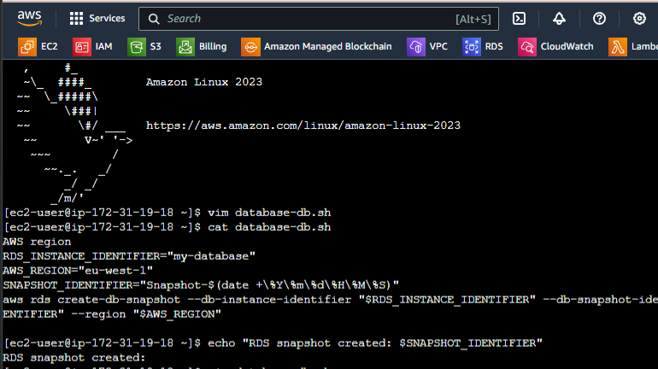**Database-db.sh file a execute permission by run command**

**#chmod 555 database-db.sh and then configure AWS user access and secrete key.**

**Remember one thing that user have access of RDS service access.**

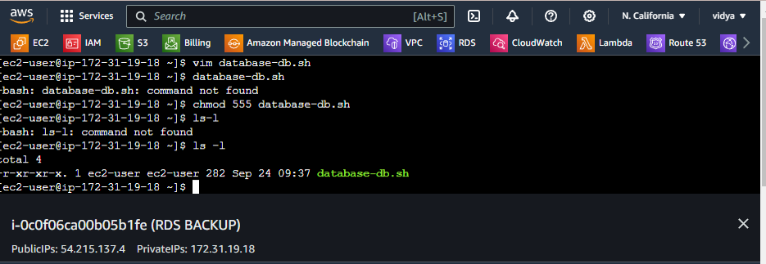

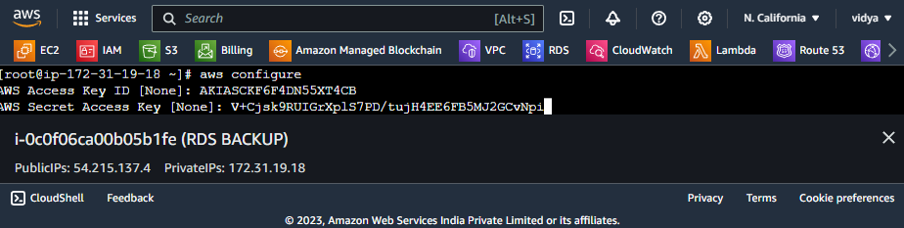

**Schedule crontab job for create a snapshot on time.**

**command**

**# crontab –e**

**And your job was schedule to run on time database-db.sh file. And create snapshot.**

