**C# Selenium Testing**

1. **Continuous Integration model (Jenkins)**
2. **Version control (Git / SVN)**
3. **C# Selenium (Invoke and Picks Test suites)**
4. **Execution of tests**
5. **Report (HTML / PDF)**
6. **Emailing**
7. **Defect tracking (JIRA / Mantis / Bugzilla)**

**Continuous Integration model (Jenkins- C# Selenium):**

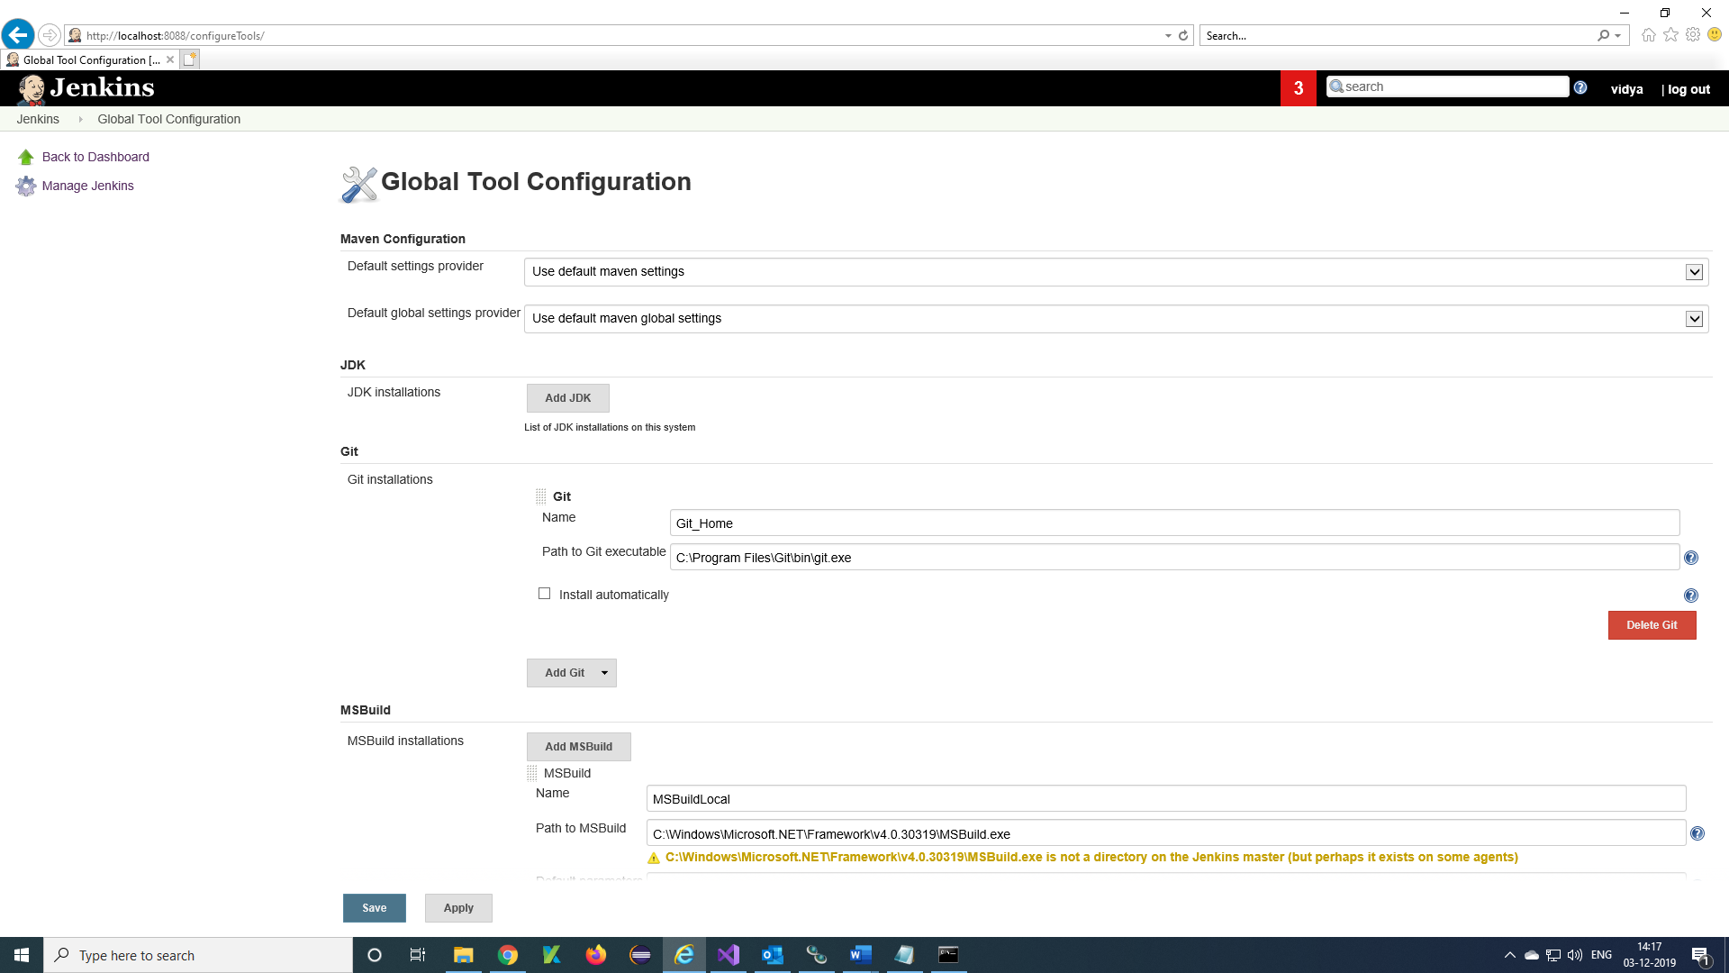

**Git exe path from local machine.**

**Git Repository URL.**

**Calling Local Machine MSBuild in configure.**

**Command to run the tests from C# selenium.**

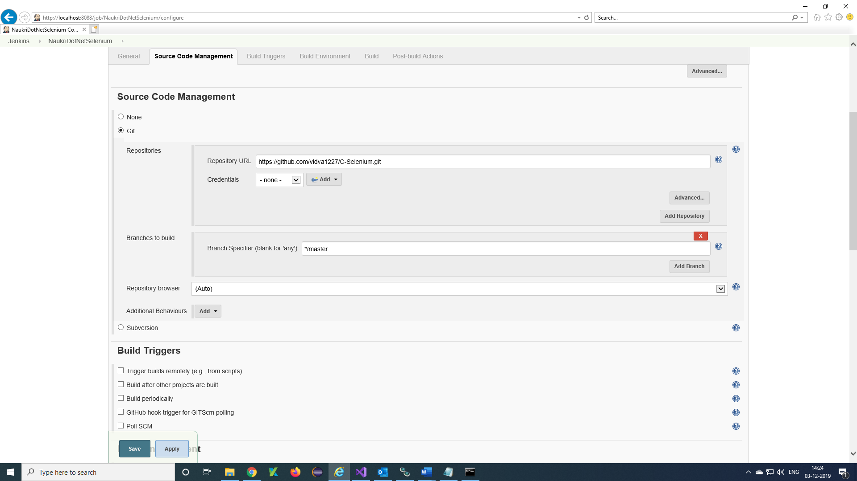

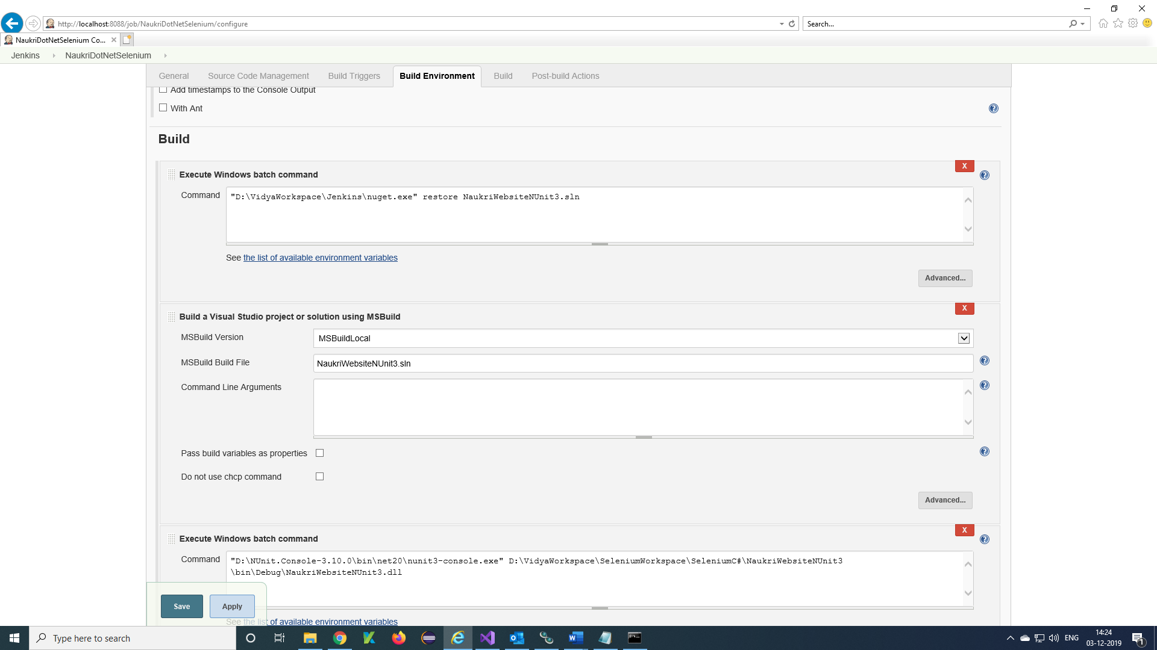

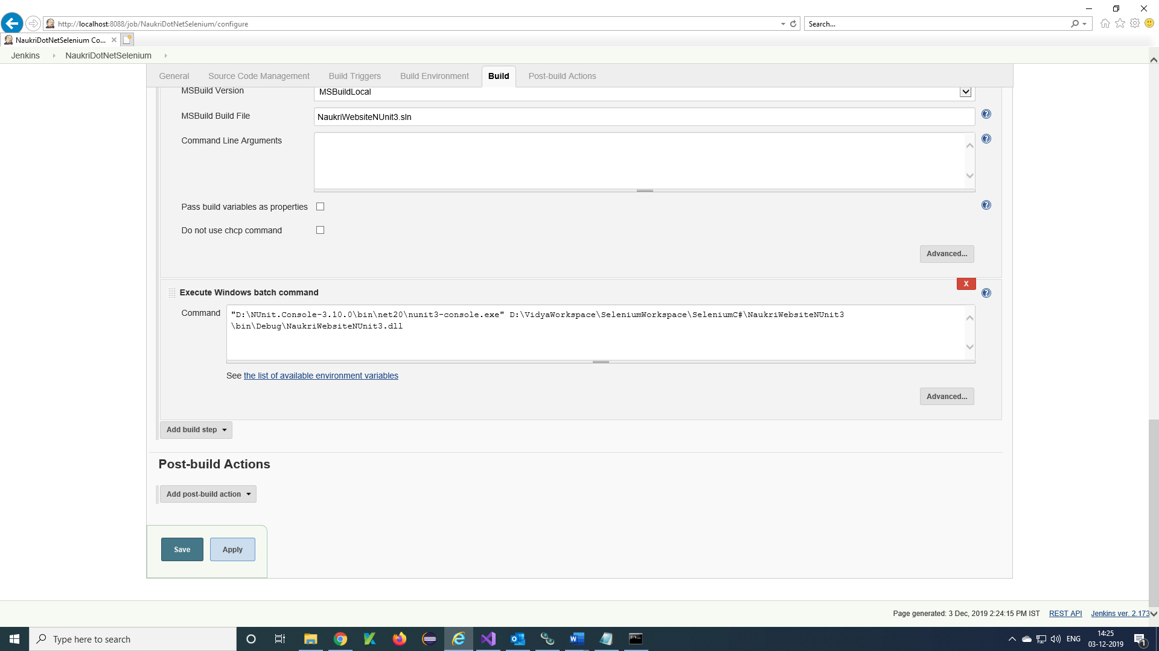

**Version control (GitHub):**

C# selenium project in Git Hub:

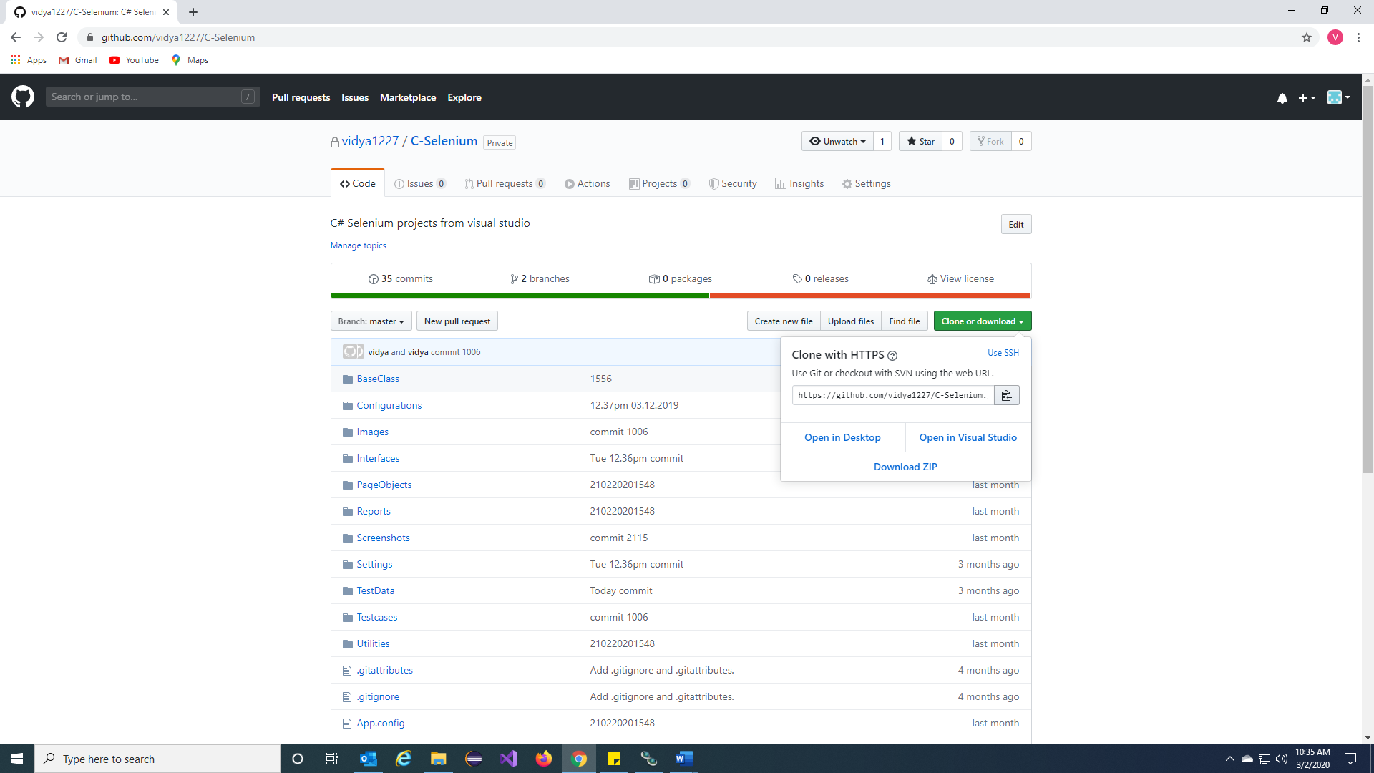

**The project in GitHub and Git URL for Jenkins integration.**

**C# Selenium (Invoke visual studios and Picks Test cases from project):**

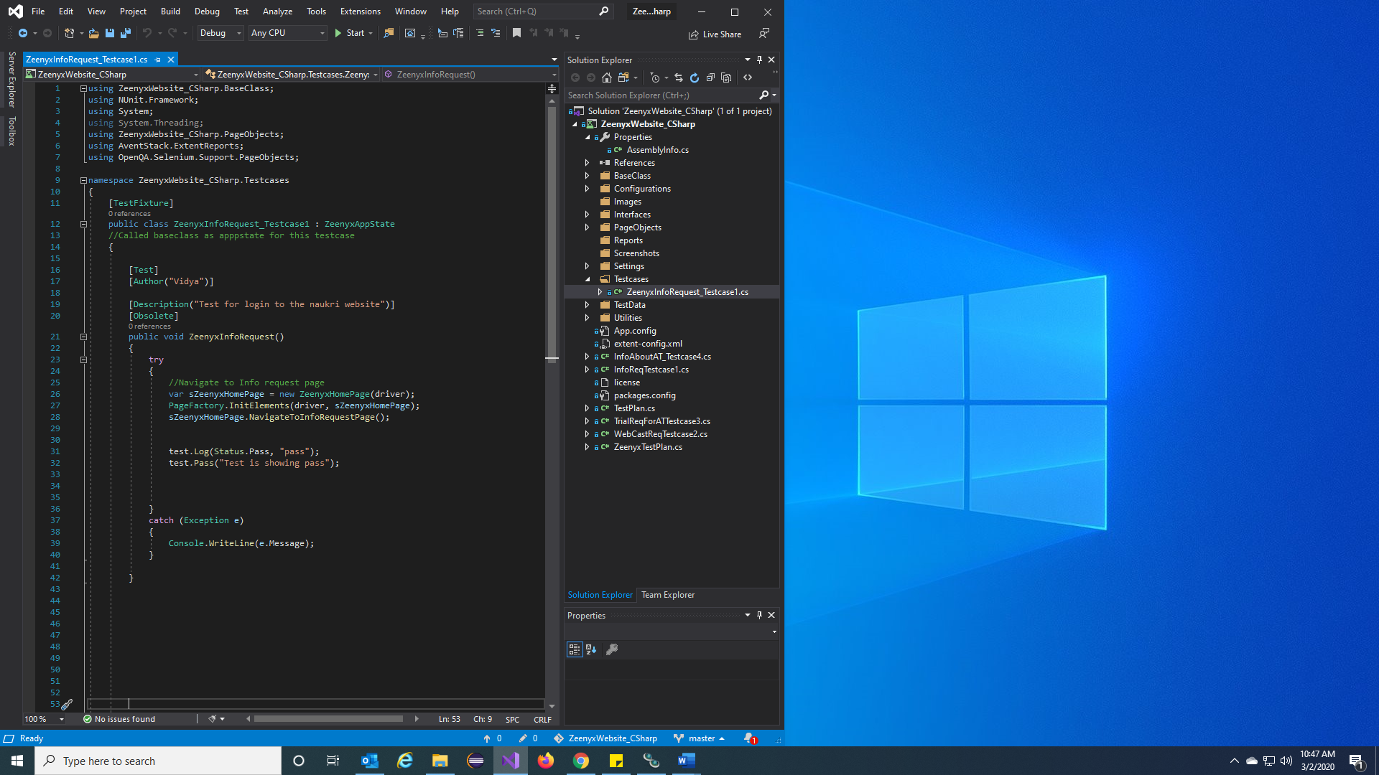

**The C# selenium project in Visual Studio.**

**Execution of tests from command prompt:**

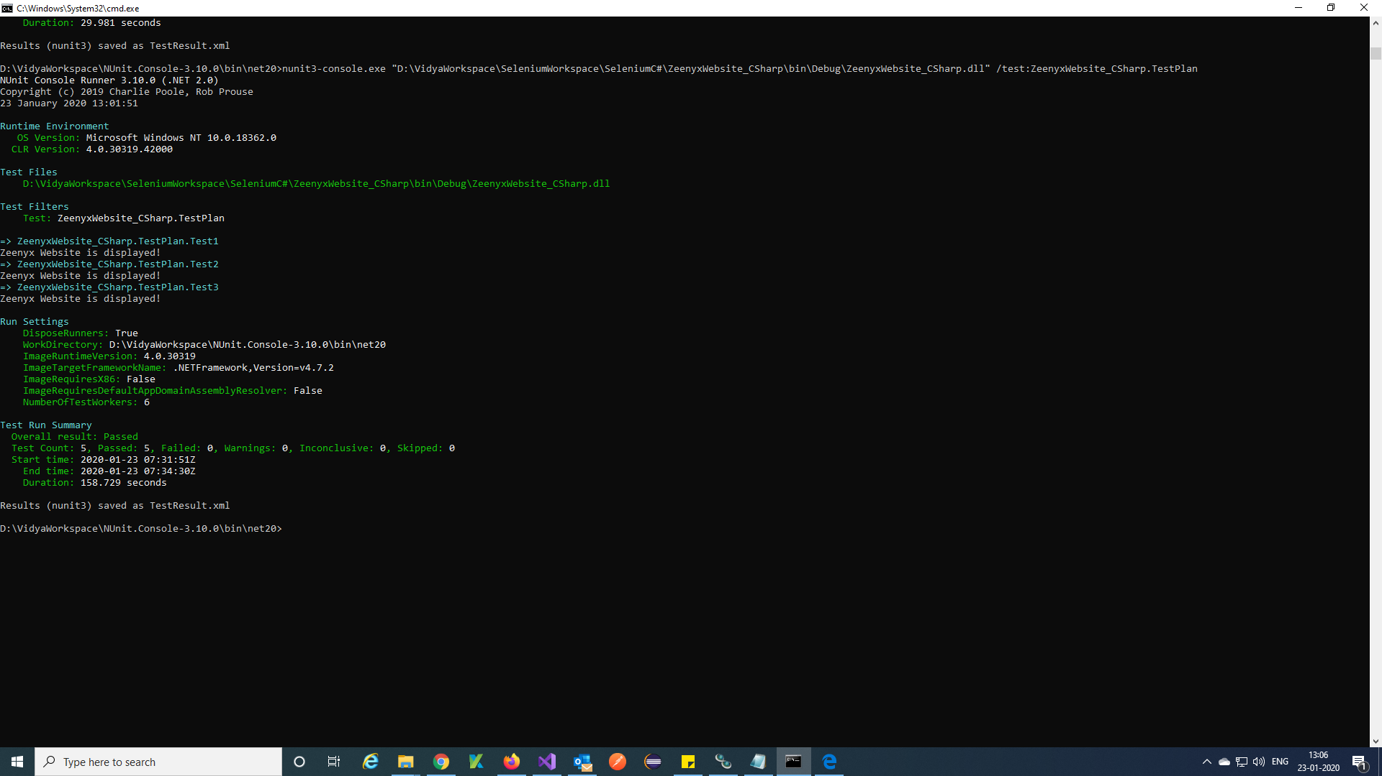

**The Tests are executing from command prompt.**

**Report (HTML):**

Extent report for C# selenium

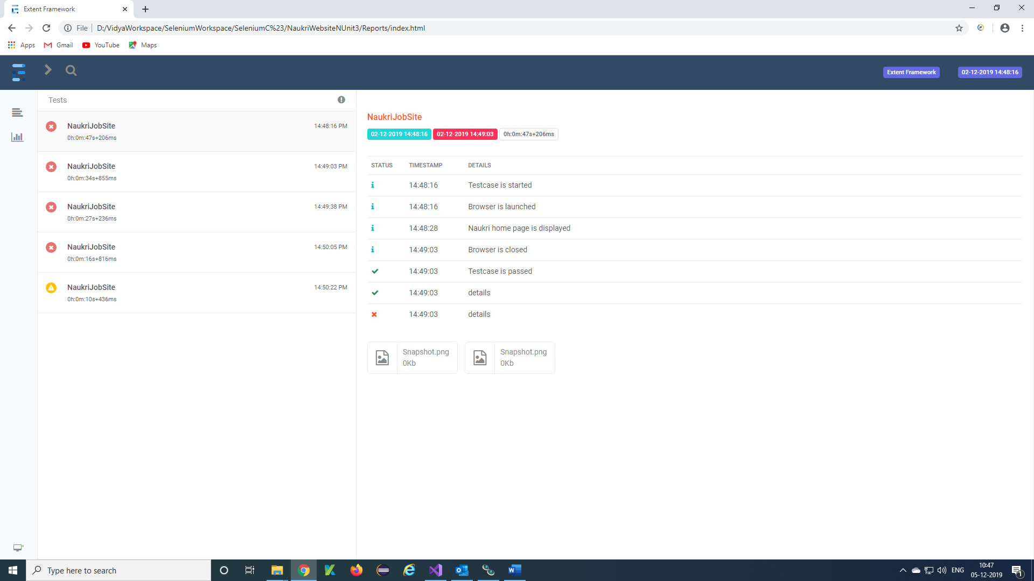

**The Extent report for C# selenium tests.**

Piechart report of the testcases.

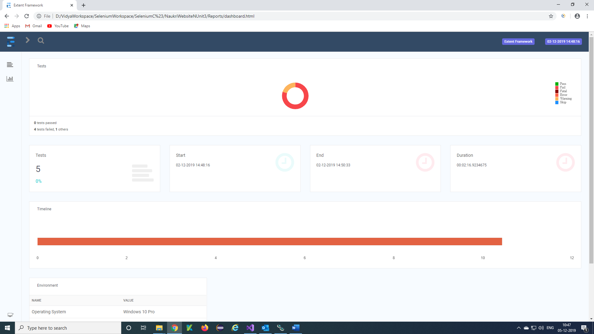

**Emailing:**

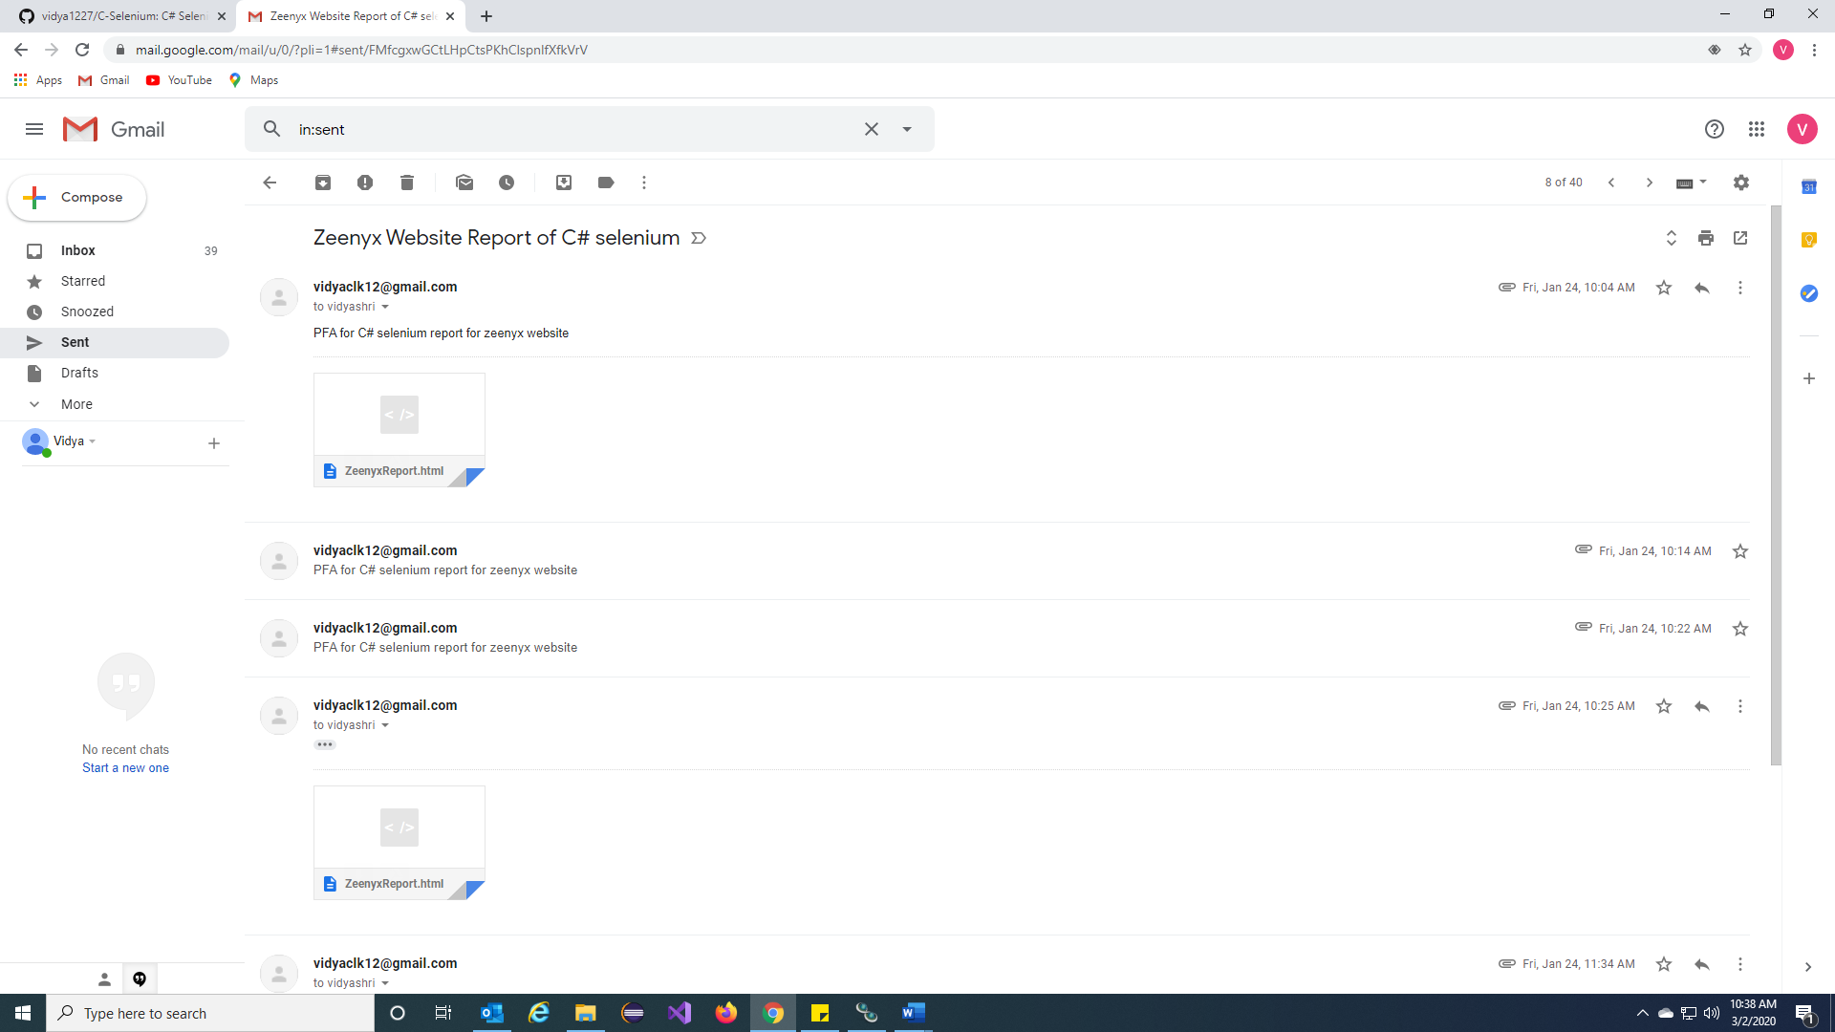

**Sending Reporting mail from C# selenium Scripts.**

**Defect tracking (JIRA):**

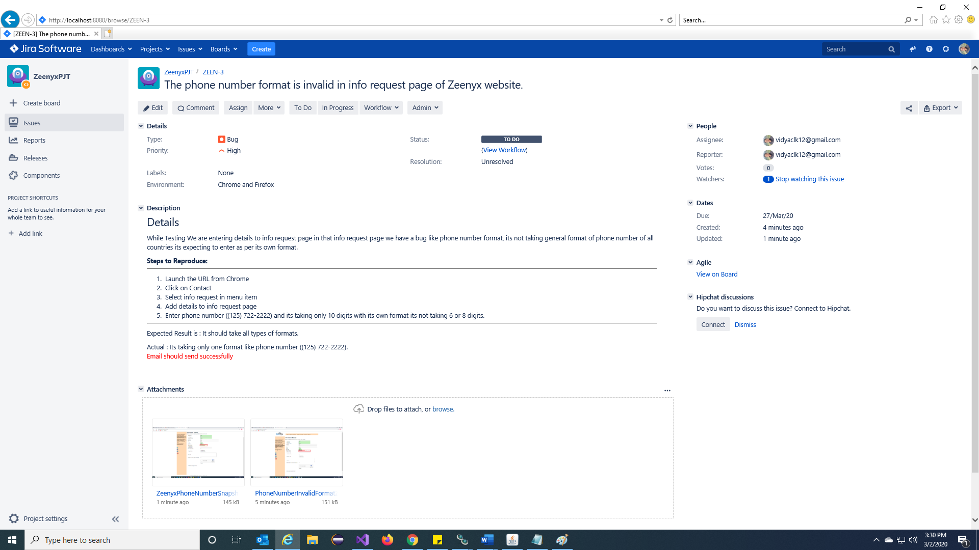

**The BUG created for C# selenium and also added description for the bug and assigned to a tester.**

**Attached Screenshots in BUG reporting of JIRA.**

**Note:** The above bug raised using JIRA defect tracking tool.