***C# Selenium Documents***

***Index:***

1. ***Download and installation of visual studio***
2. ***Create a project in visual studio***

**Set Up Visual Studio:**

Visual Studio is an Integrated Development Environment (IDE) that is used by developers to build applications across multiple platforms such as Windows, Android, iOS and Cloud-based applications.

**Step 1)** Navigate to the URL <https://www.visualstudio.com/downloads/> and Click on the 'Free download' button displayed on Visual Studio Community 2017 tab

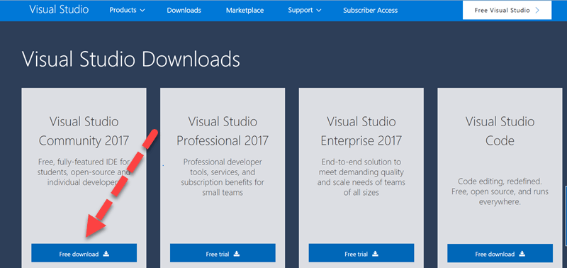

**Step 2)** Open the exe downloaded. Click on 'Yes' if asked for Admin Rights.

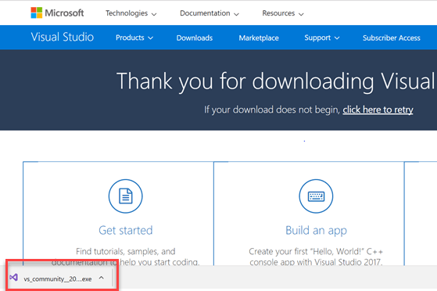

**Step 3)** The below popup will appear. Click on 'Continue' button.

[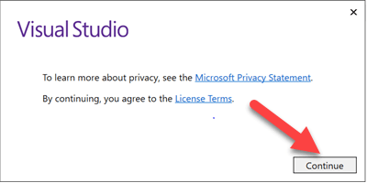](https://www.guru99.com/images/1/103017_0412_SeleniumCWe3.png)

Files will be downloaded as shown in the popup below.

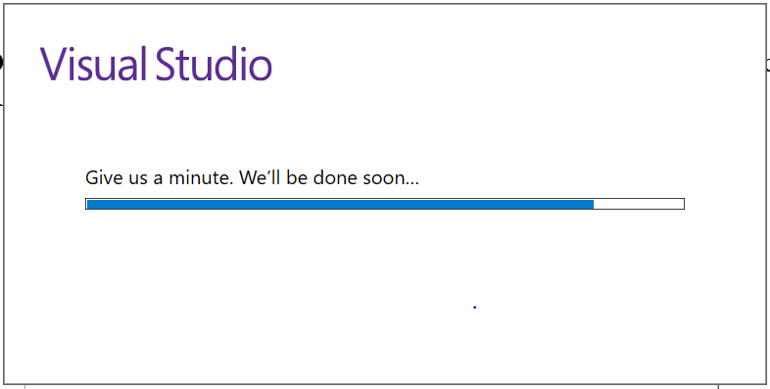

**Step 4)** In the next screen,

Select the checkboxes for

* Universal Windows Platform development
* Net desktop development

Click on 'Install.'

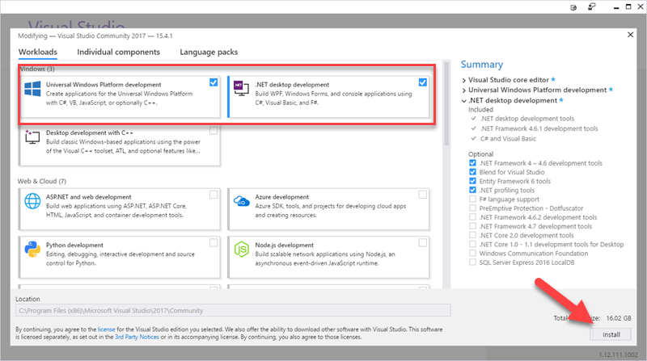

Wait for installation of each component to complete. Files are 16GB in size and will take time.

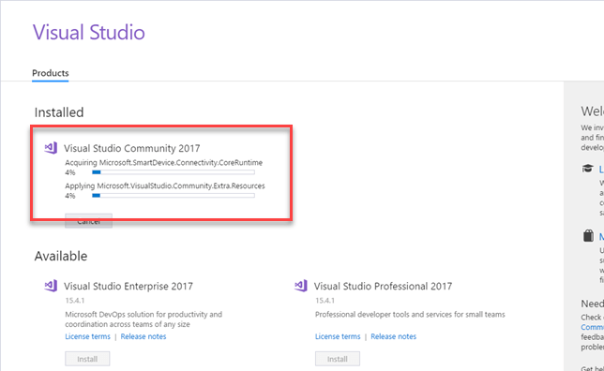

**Step 5)** The below pop up will be displayed. Click on 'Restart' button.

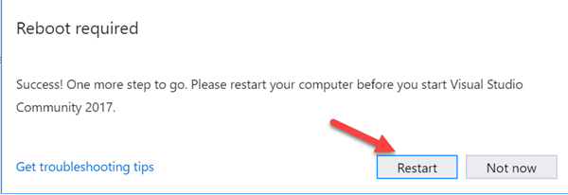

**Step 6)** Once the machine is restarted, search for "Visual Studio 2017" on the start menu and click on the search result. The following popup will appear. Click on "Not now, maybe later" link if you do not have an existing account.

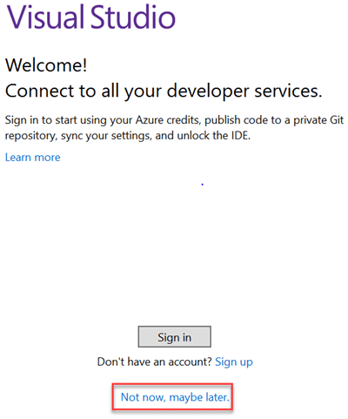

**Step 7)** In the next screen,

* Select colour theme of your liking
* Click the button "Start Visual Studio'"

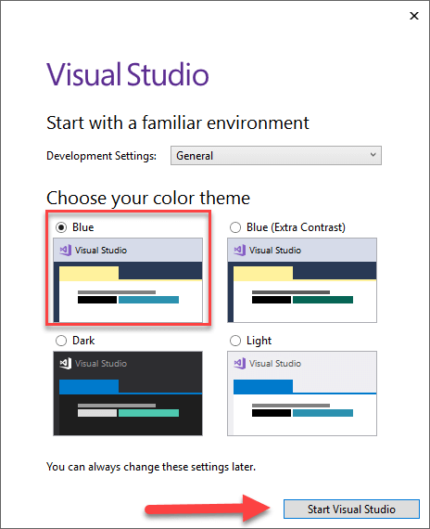

**Step 8)** Visual Studio 'Get Started' screen will appear.

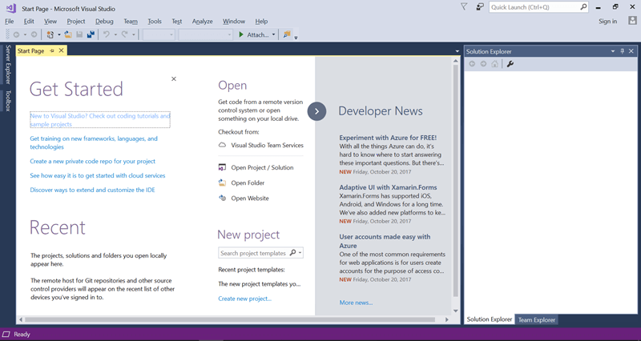

**Step 9)** Help 🡪 About Microsoft Visual Studio and check version and details.

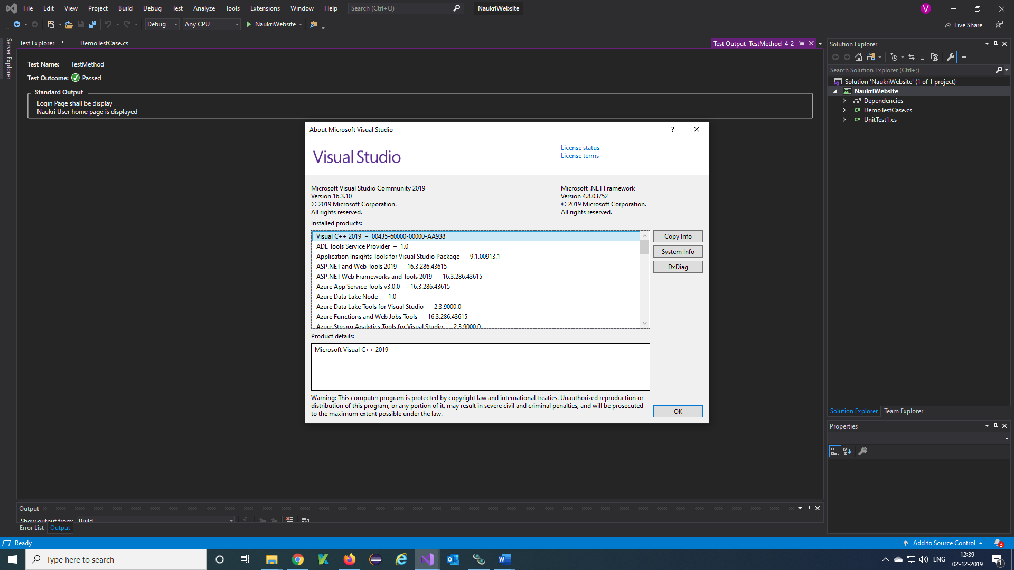

**Create a new project in visual studio:**

**Step 1)** In the File Menu, Click New 🡪 Project

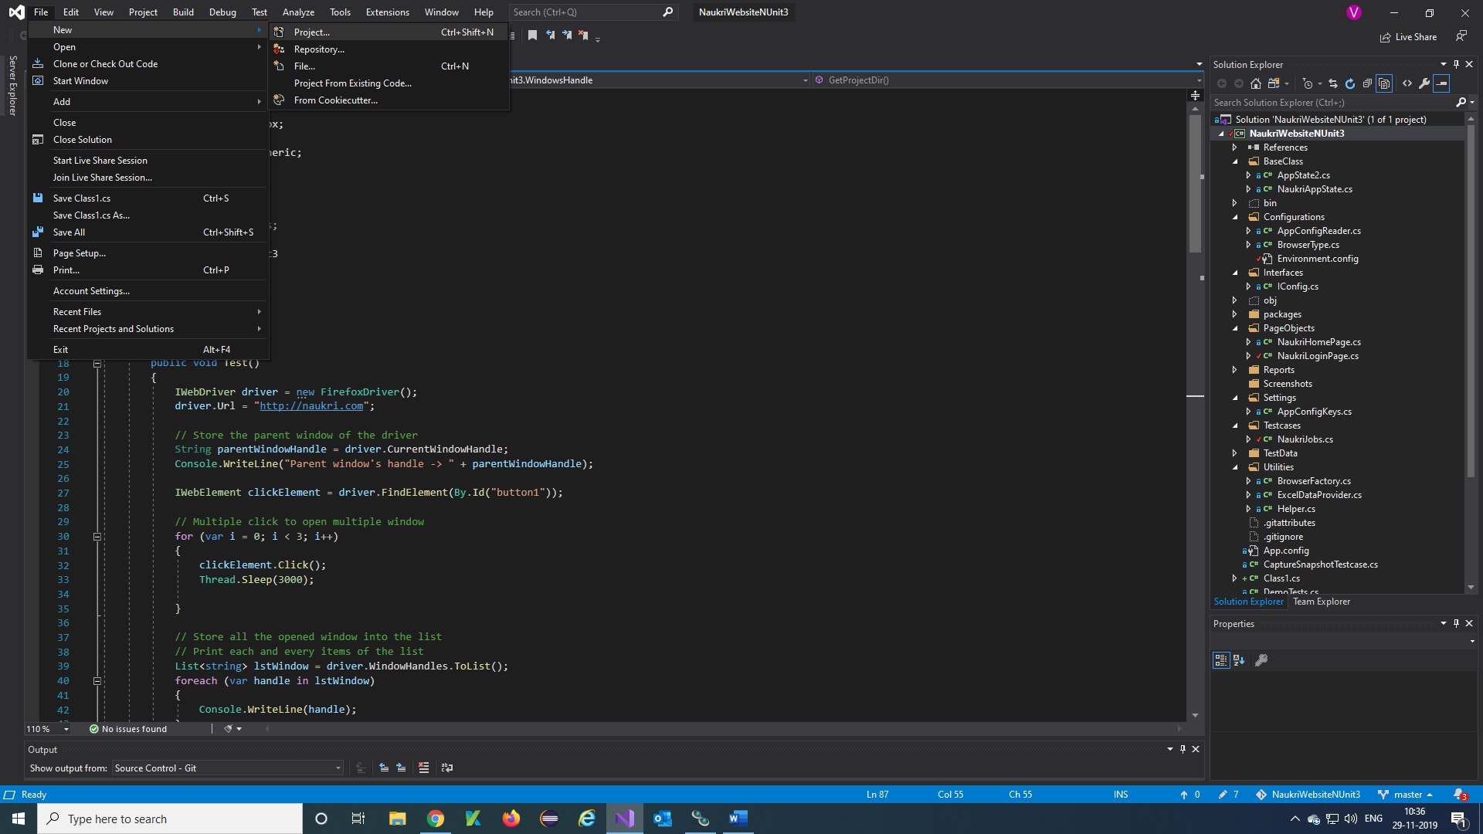

**Step 2)** Create a new project window will open, in that select NUnit Test Project (.NET Core) then Click on Next.

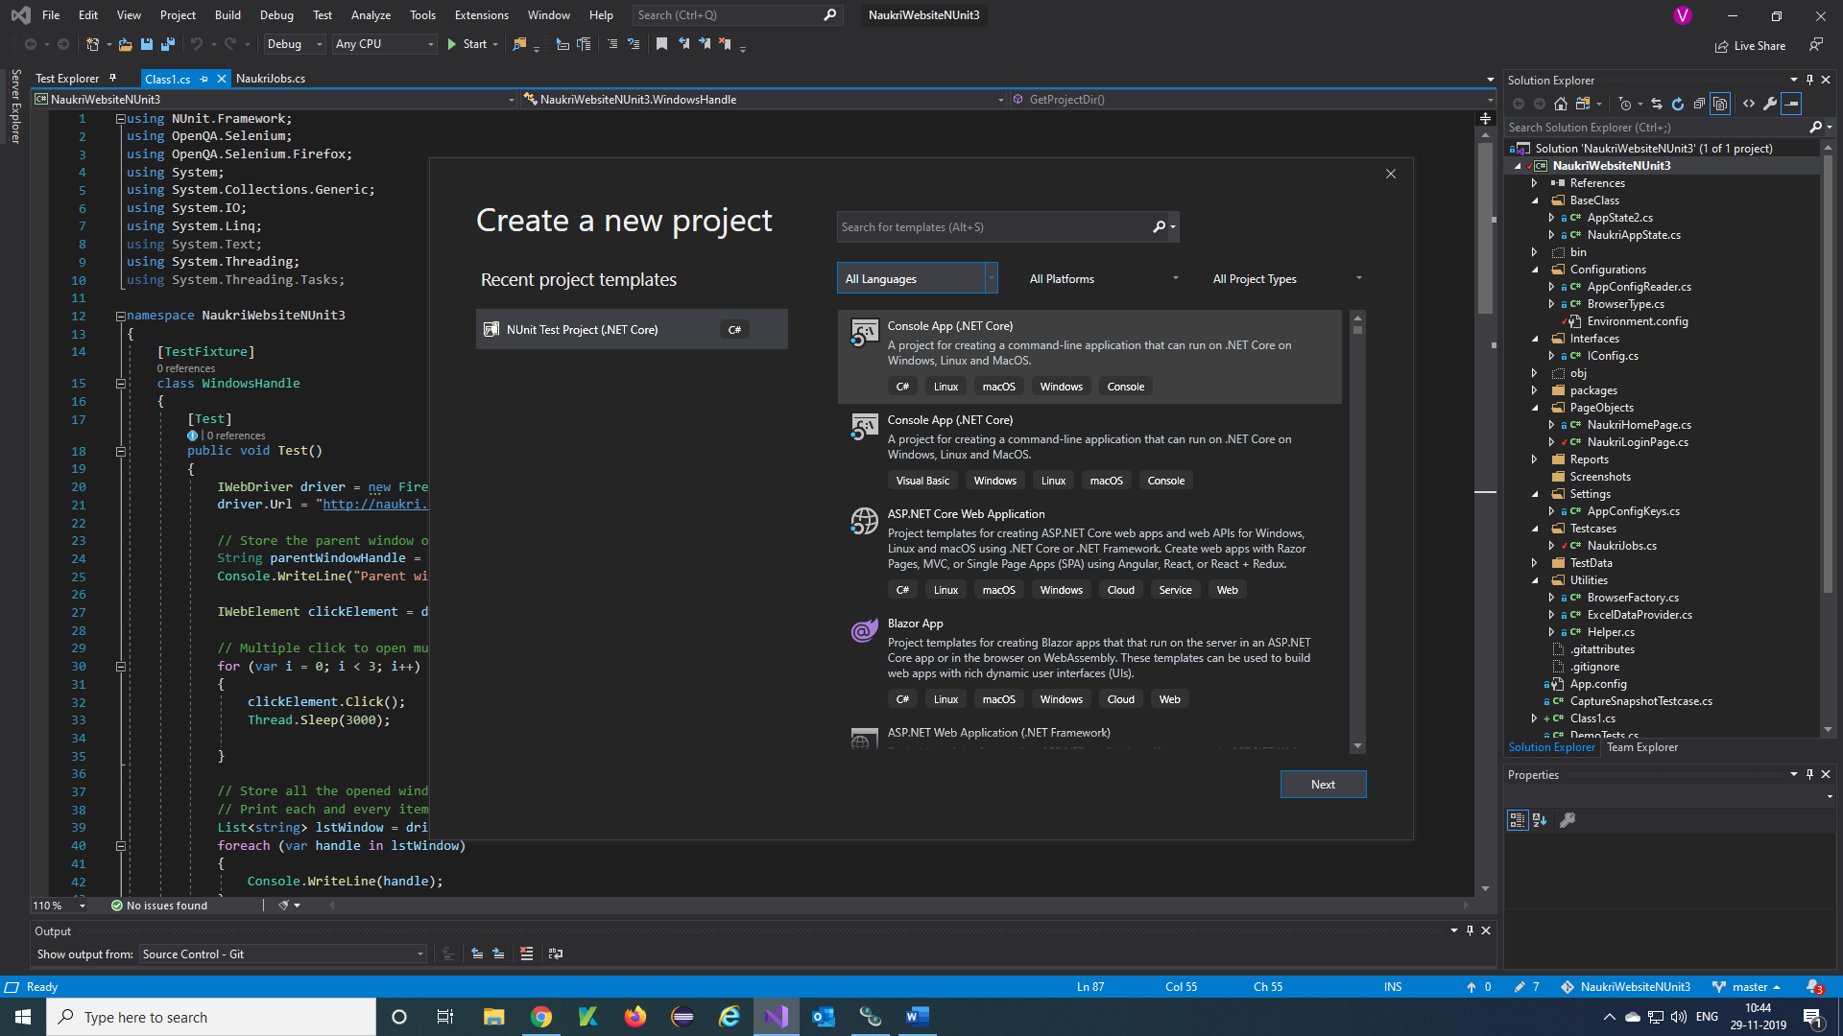

Note: You Can Also create a project using Console App and Unit Test Project and also suitable framework for your project.

**Step 3)** Configure your new project window will open, provide project name, Project Location and click on the check box and click on create button.

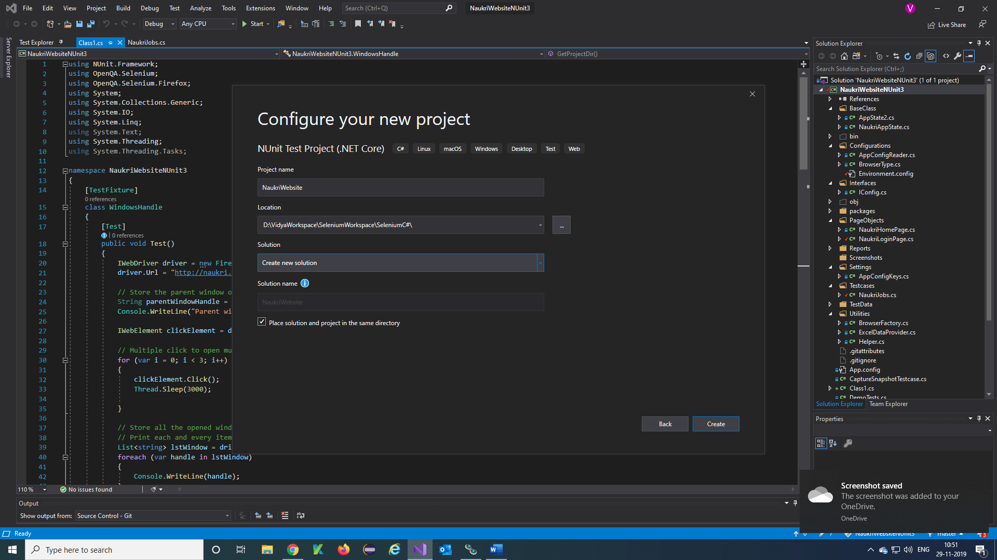

**Step 4)** The below screen will be displayed once the project is successfully created.

