***Object Recognition in Selenium***

***Index:***

1. ***Inspect the Elements***
2. ***Paths in selenium and locating the elements***
3. ***How to write elements in POM (Page Object Model)***

***Step 1)*** Open your browser and enter URL (<https://www.naukri.com/>).

***Step 2)*** Right click on particular object which you want to identify path 🡪 select Inspect option.

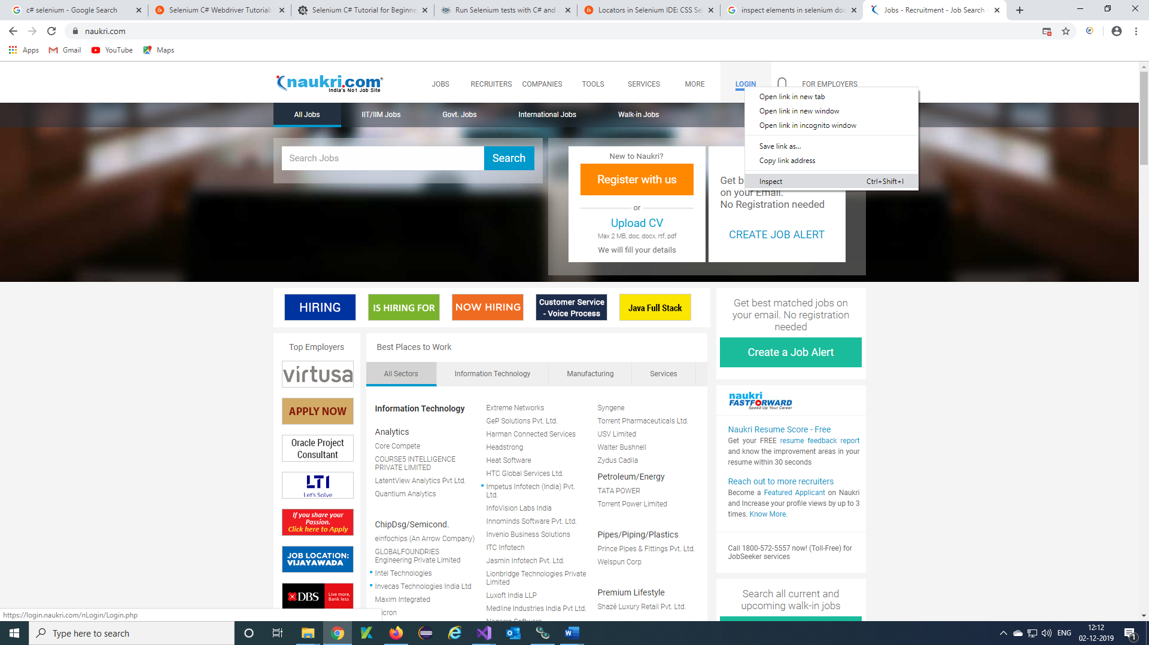

***Step 3)*** This Window will appear.

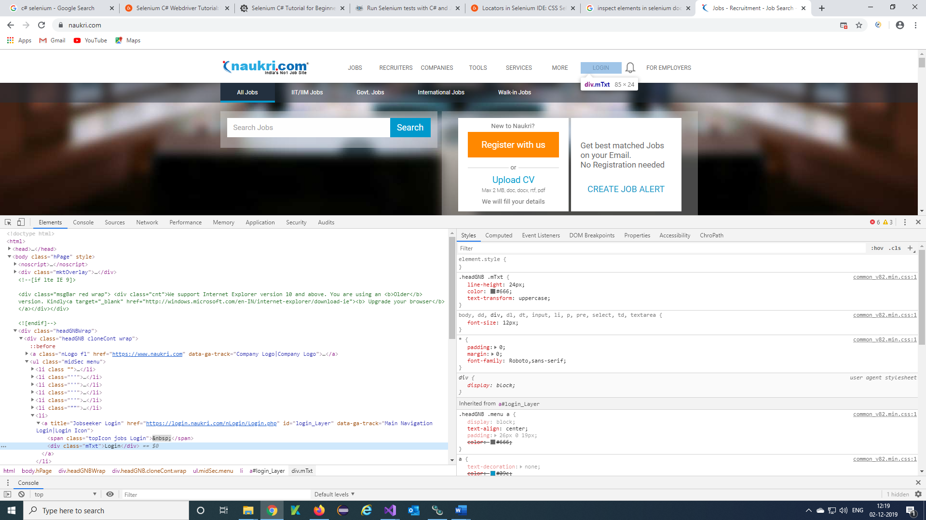

***Step 4)*** Do Ctrl+F from key board and try your path or Right click on object of Html code select copy 🡪 copy xpath, you will get xpath and copy that xpath to your VS code.

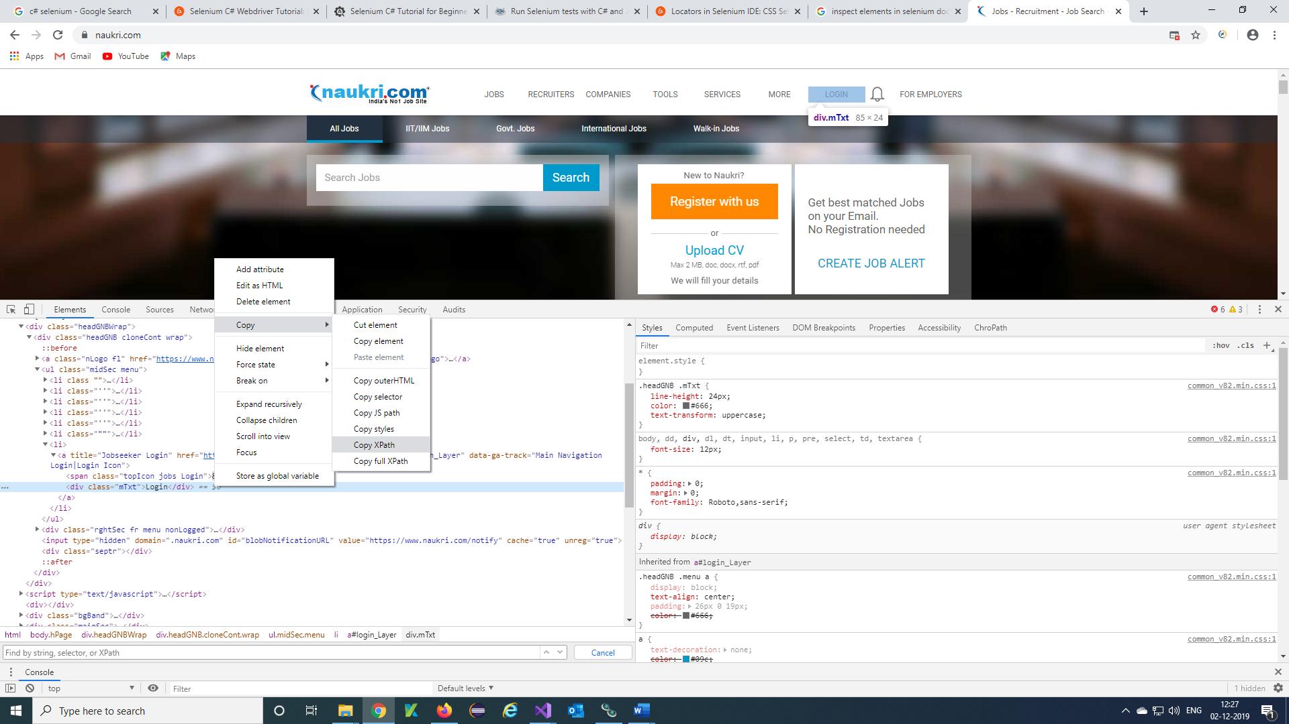

Note: You can try your paths using different Locators like Id, Xpath, Class name, Tag Name, CSS Selector, Link text, Partial link Text.

***Step 5)*** Copy your elements in code using FindElement inbuilt class in selenium WebDriver

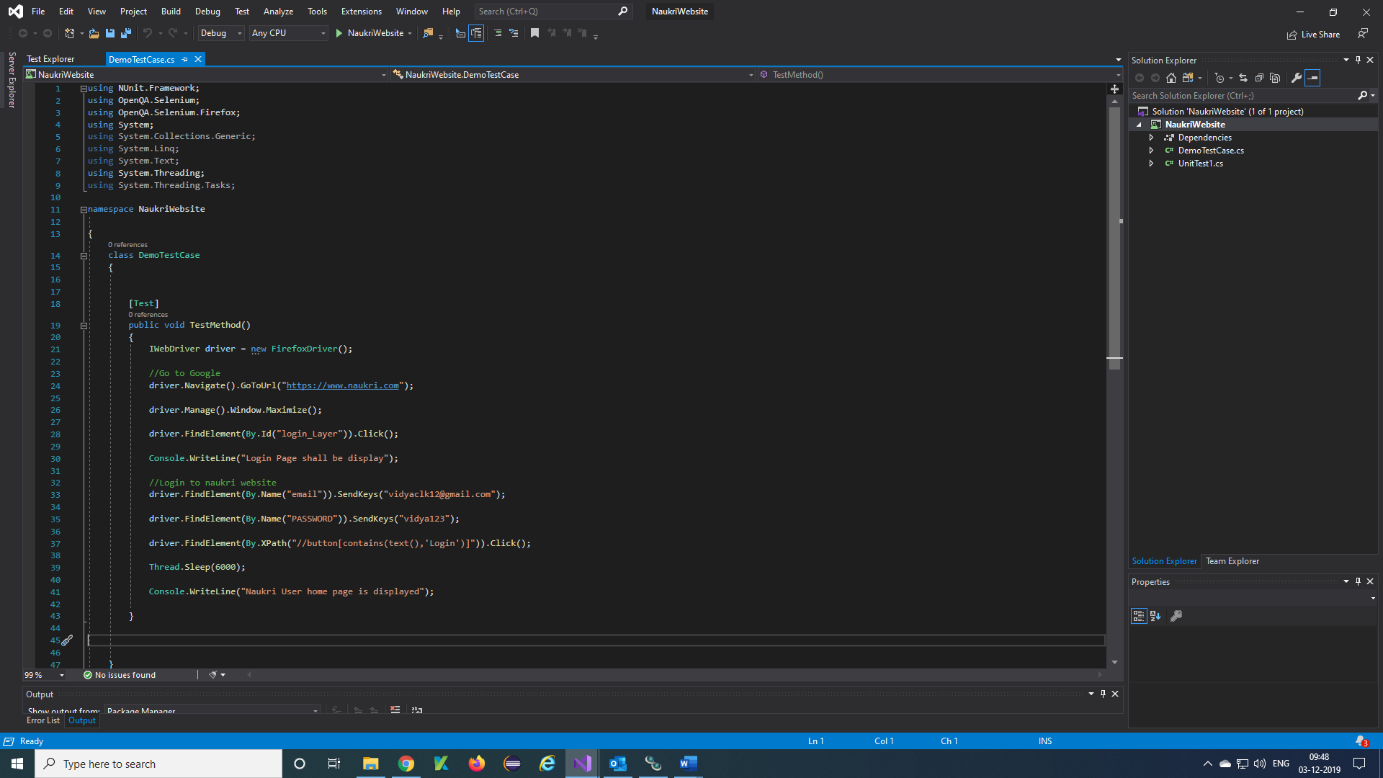



**Note**: We can use POM (Page Object Model) also here using FindsBy annotation using Selenium.Support and NUnit Framework.

