***Run from Command prompt***

***Index:***

1. ***Download and Set up Nunit Console***
2. ***Run project from Command prompt***

***Note:*** NUnit console is needed to run the NUnit tests

***Step 1)*** Open browser and download Nunit Console from URL= <https://nunit.org/download/> and Click on Nunit Console 3.10

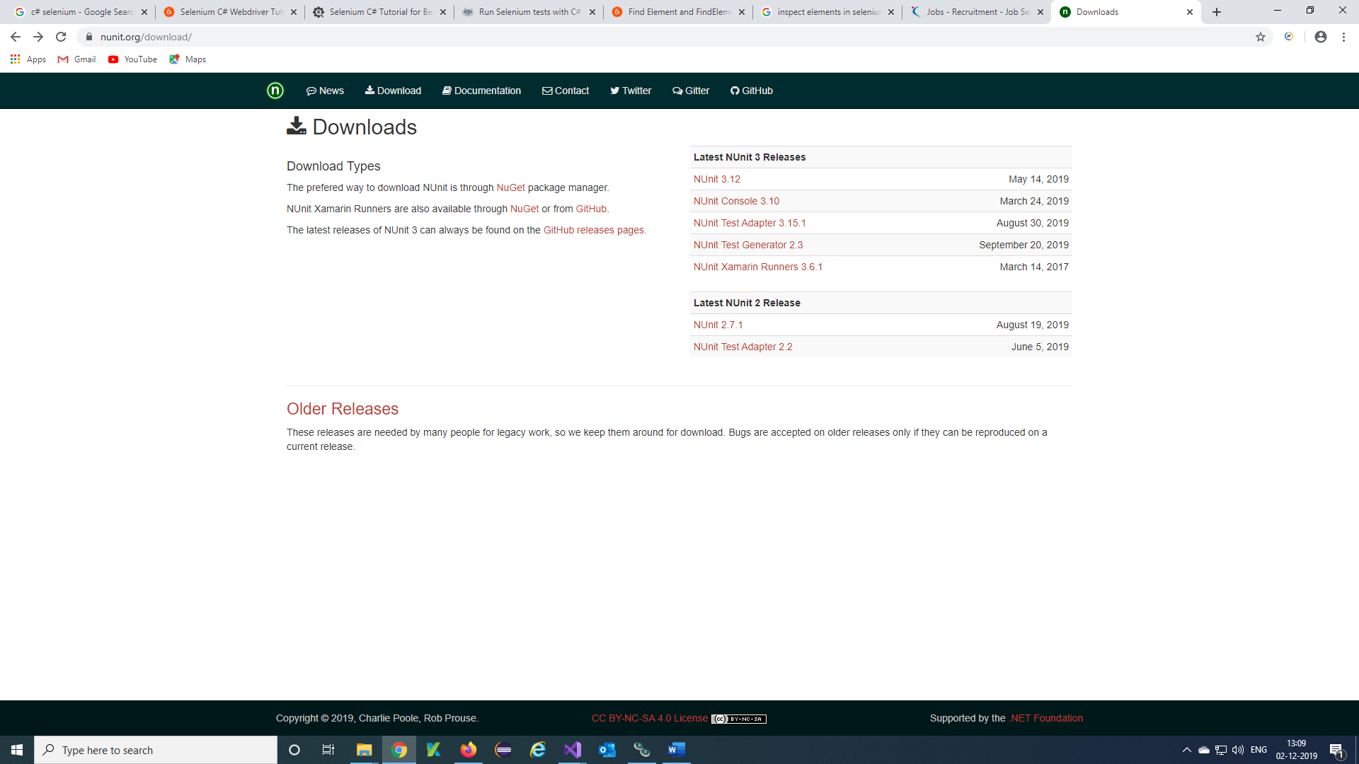

***Step 2)*** Select NUnit.Console.3.10.0.msi

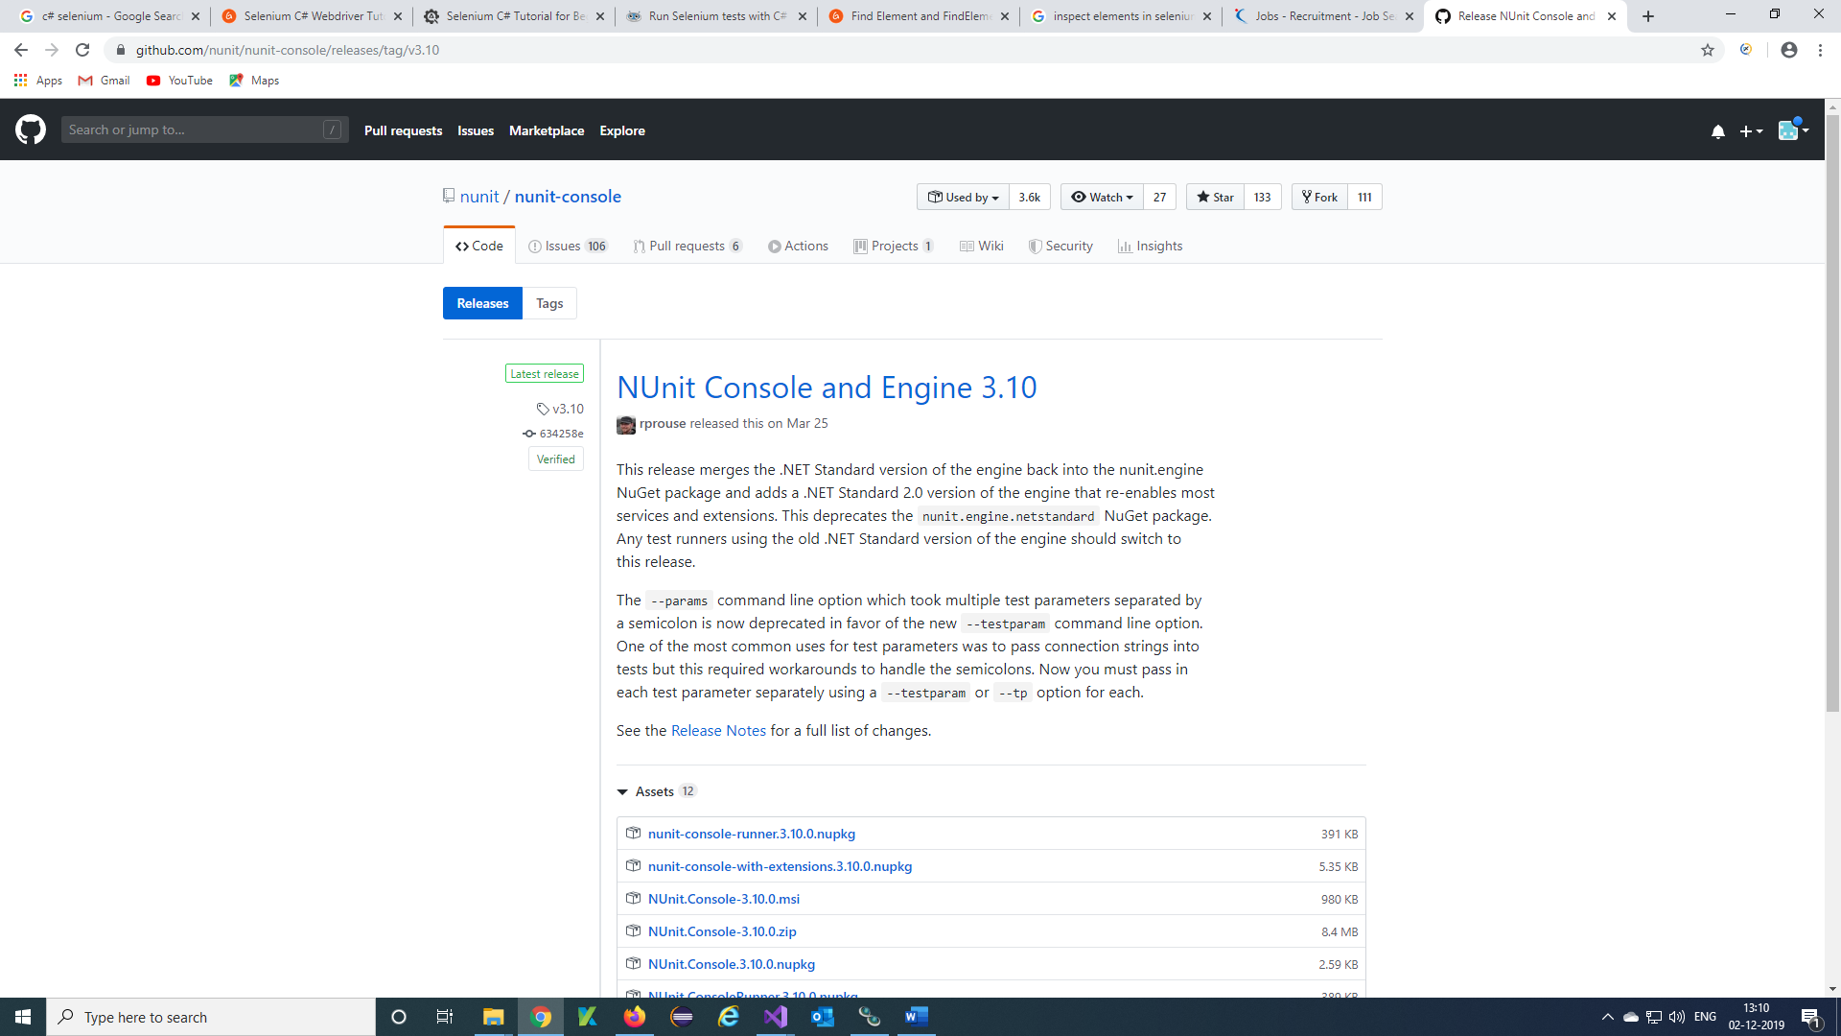

***Step 3)*** Nunit console will downloaded in downloads of your pc.

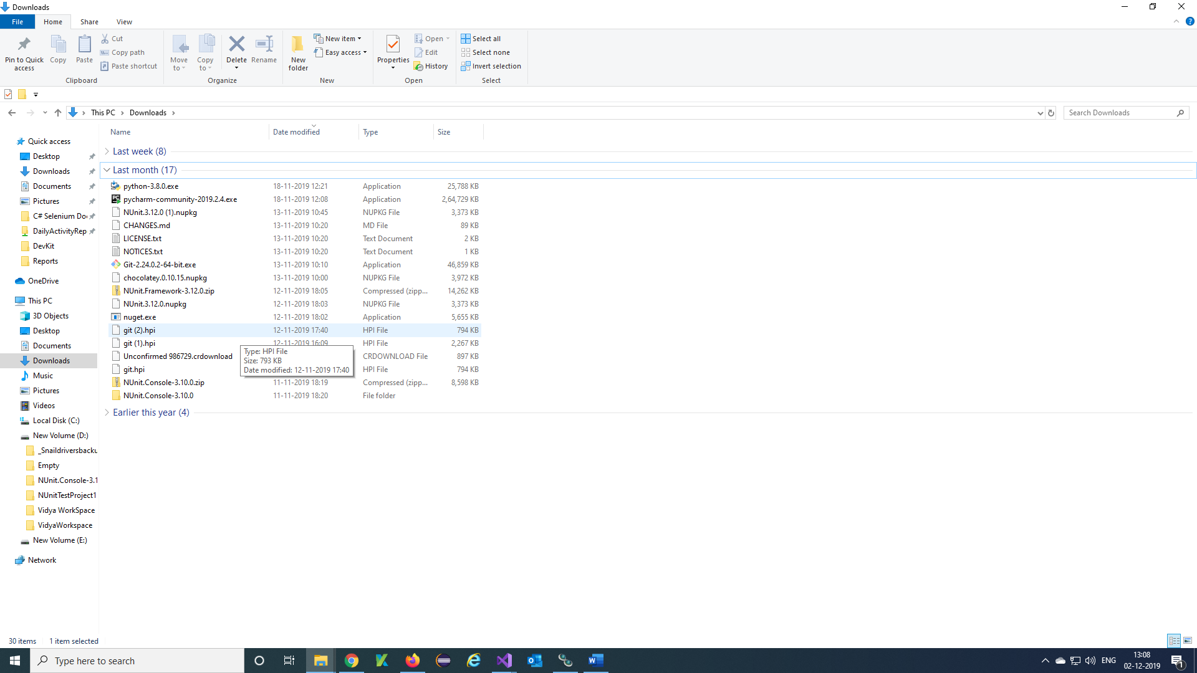

***Step 4)*** Copy and Paste Downloaded Nunit Console to required location and Click on Nunit Console folder

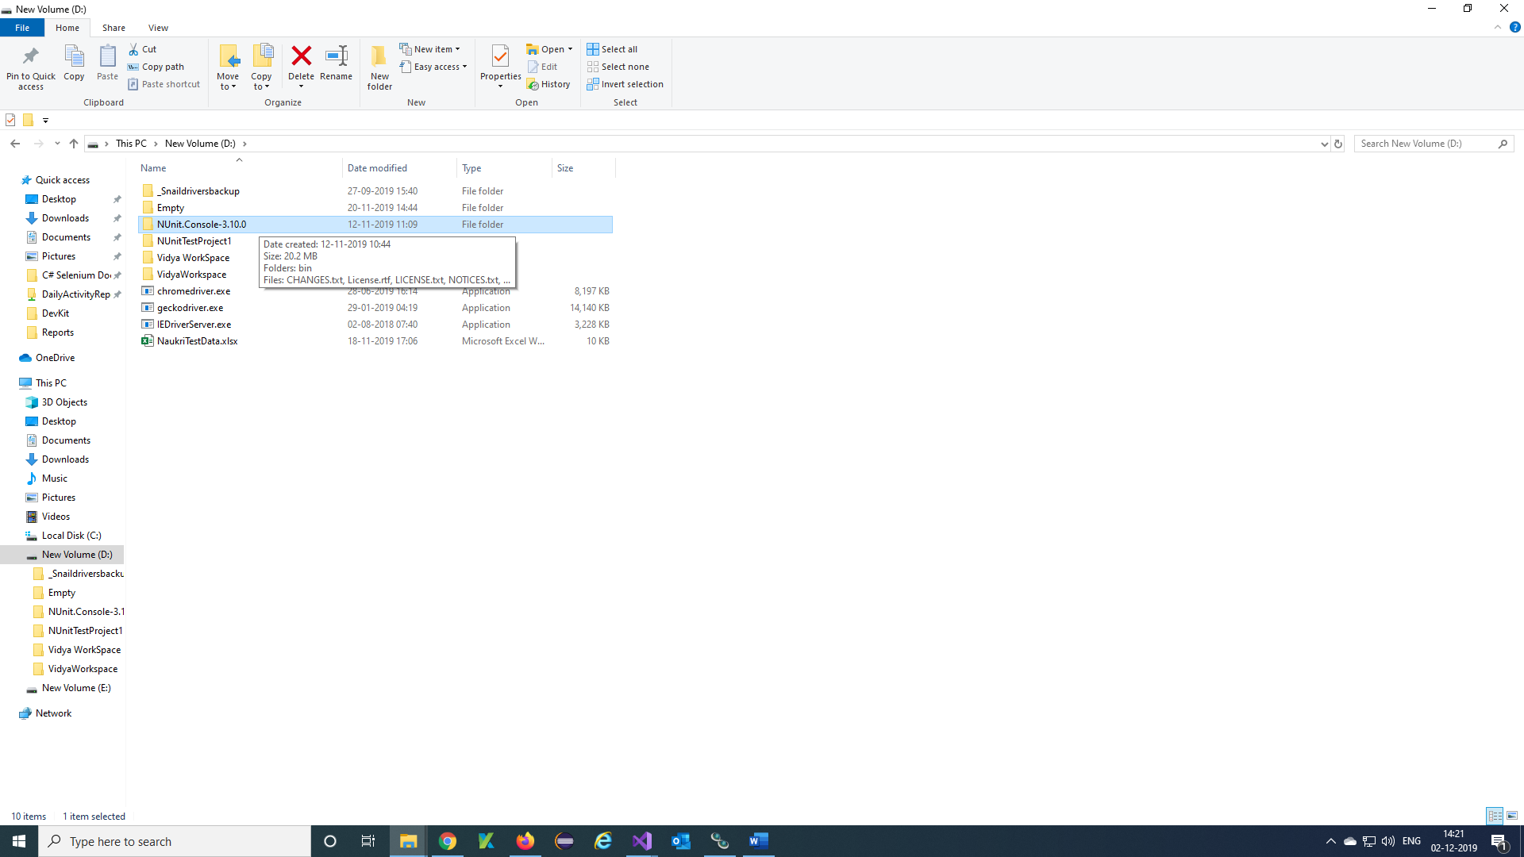

***Step 5)*** Click on bin folder

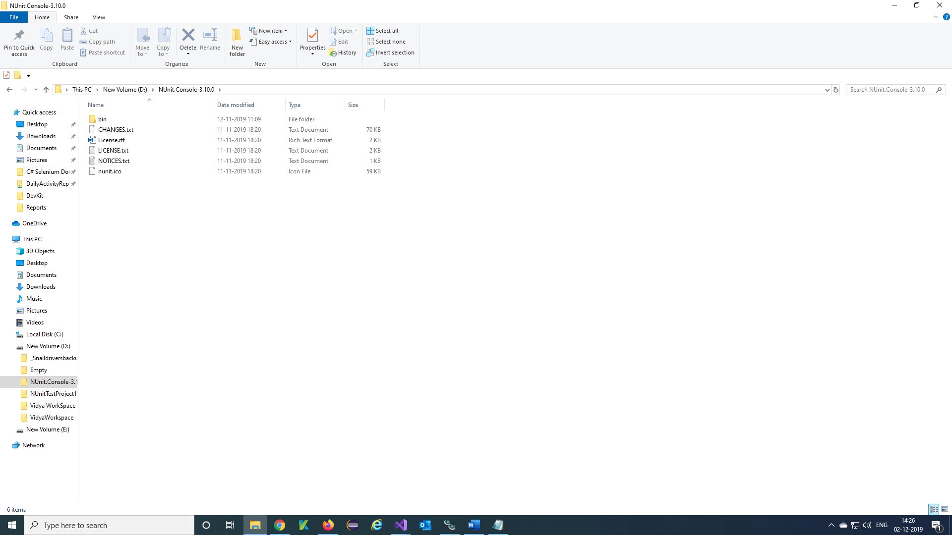

***Step 6)*** Click on net20 folder

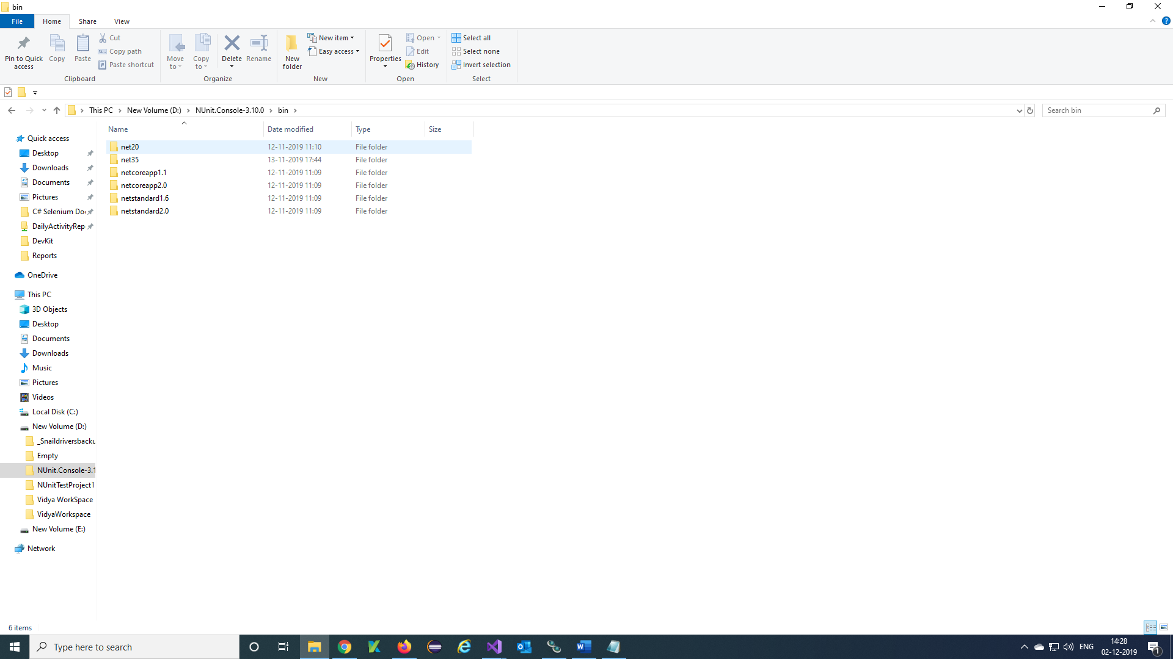

***Step 7)*** nunit3-console.exe will appear

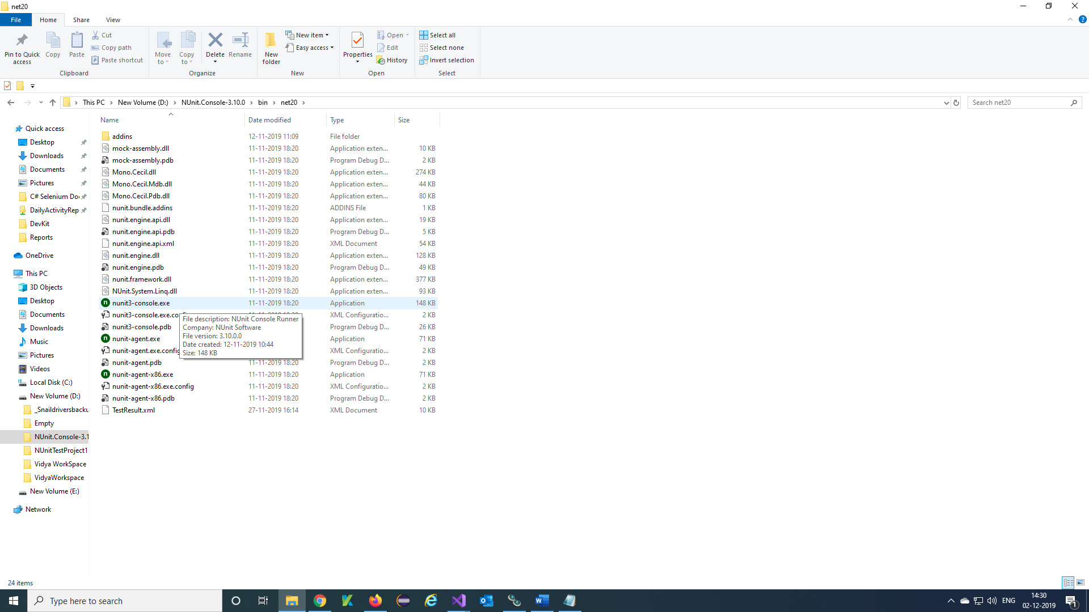

***Step 8)*** Click on location path

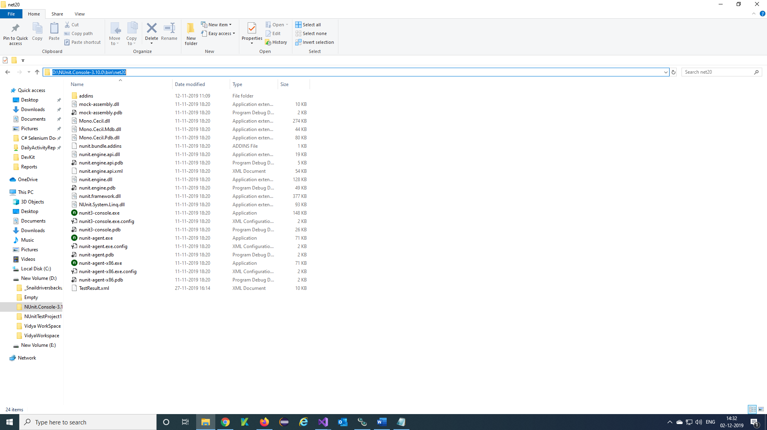

***Step 9)*** Clear the path and type cmd and do Enter from Keyboard.

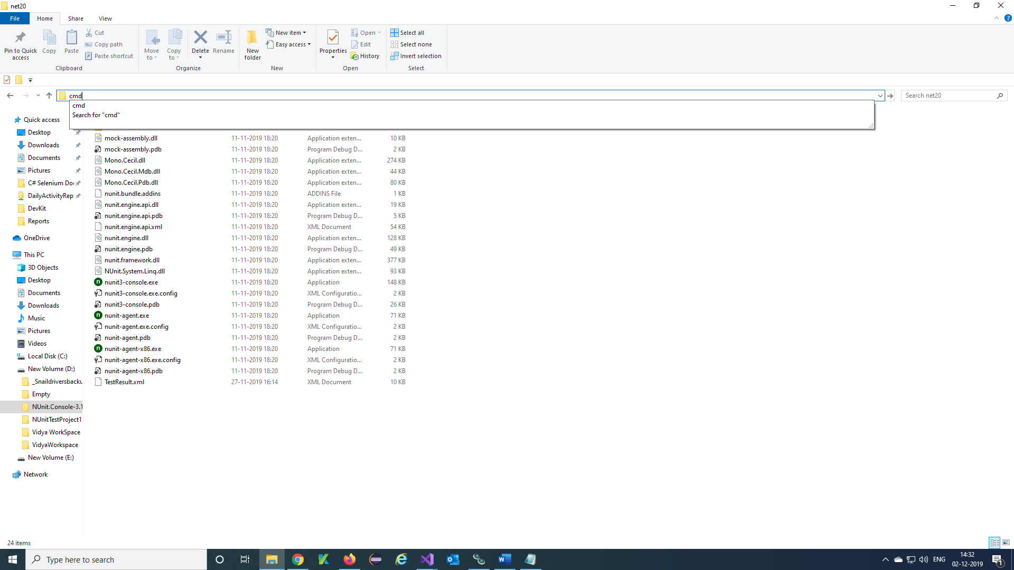

***Step 10)*** This window will appear

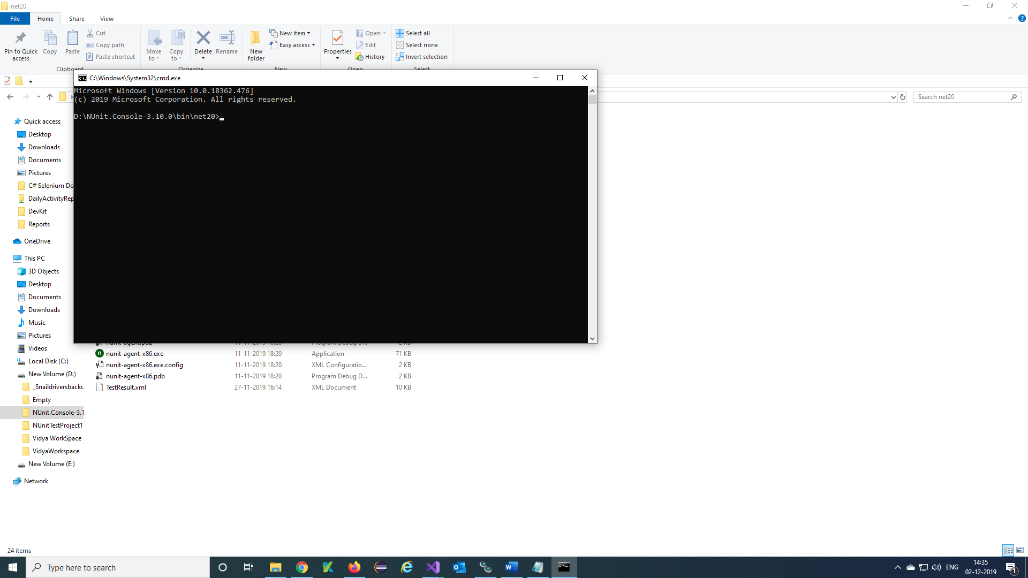

***Step 11)*** Type the Command to run your complete project

Command= nunit3-console.exe D:\VidyaWorkspace\SeleniumWorkspace\SeleniumC#\NaukriWebsiteNUnit3\bin\Debug\NaukriWebsiteNUnit3.dll

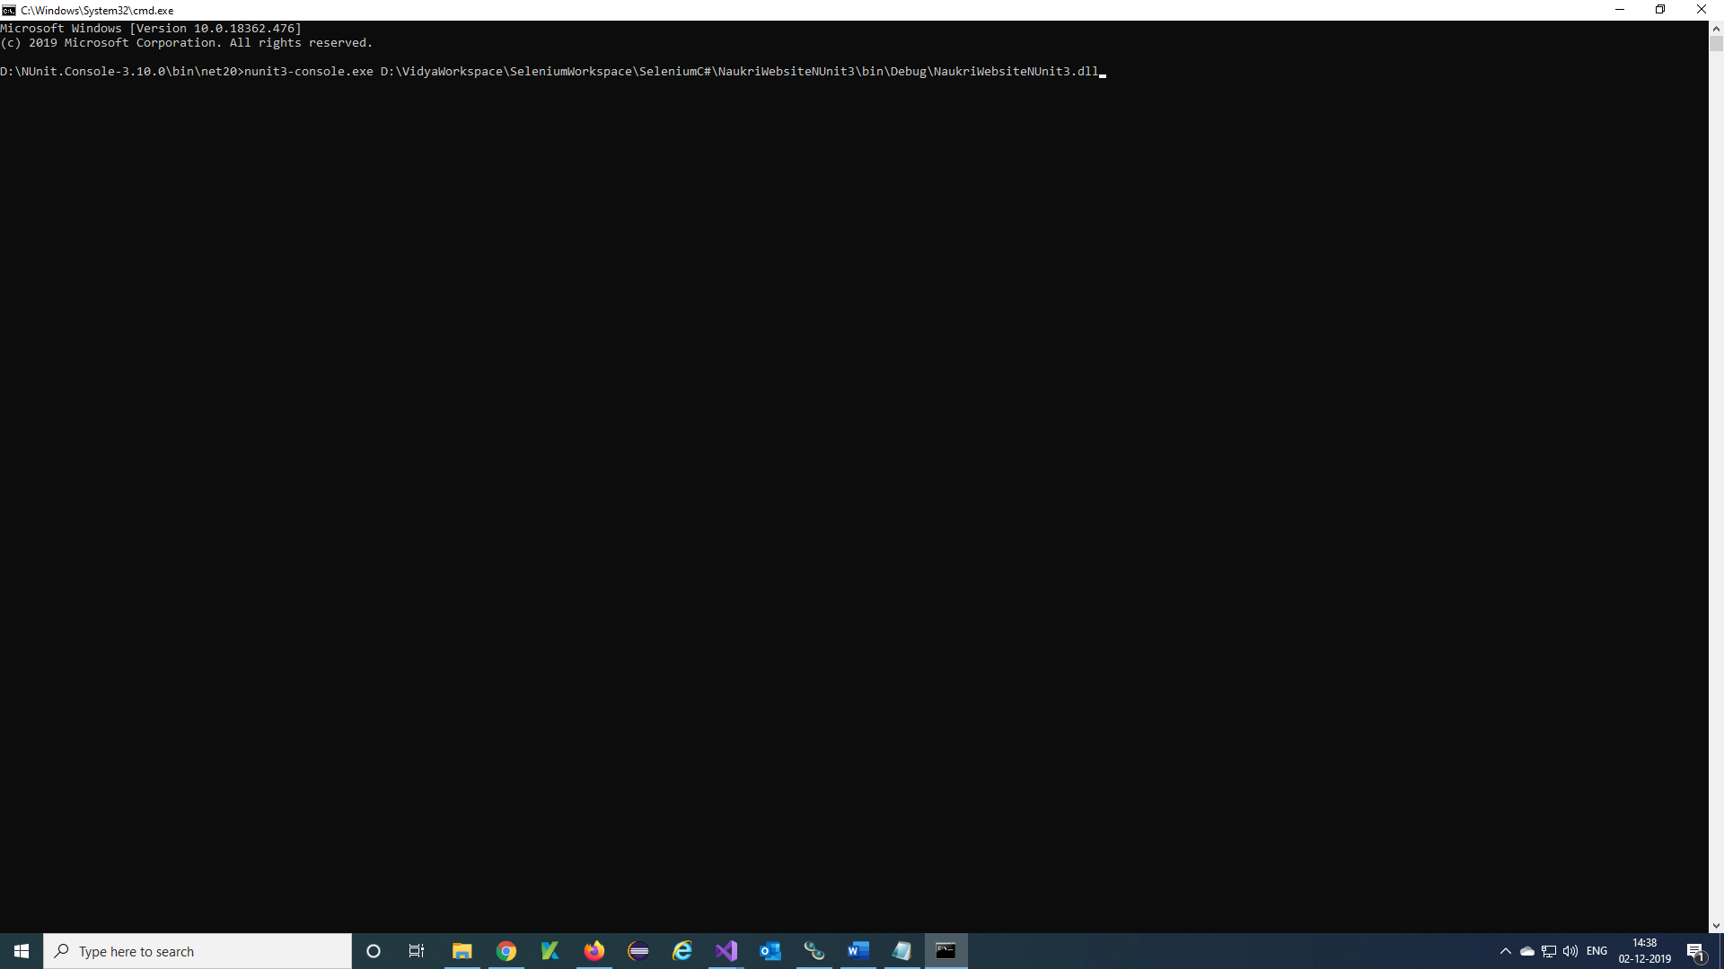

**Note:** Get the project dll path from visual studio Project location

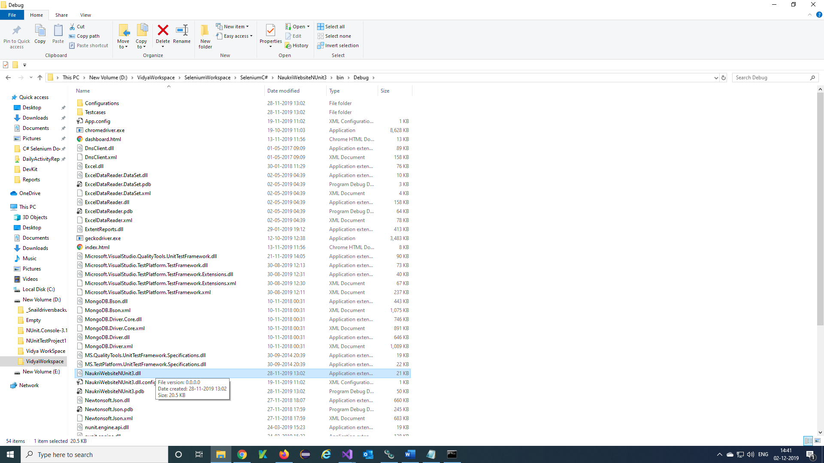

***Step 12)*** Command Prompt will invoke browser and run the testcases

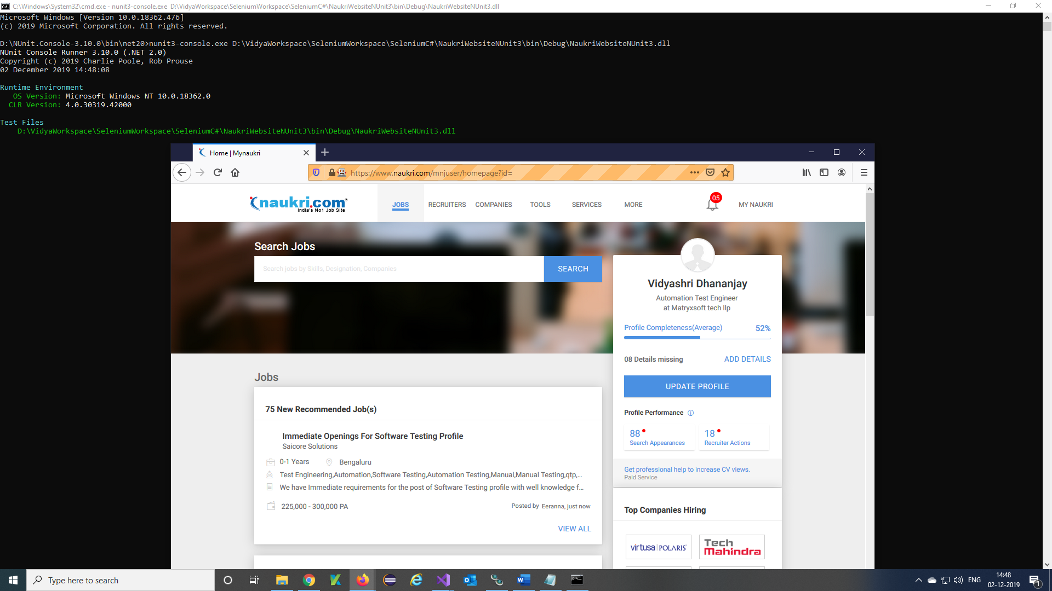

**Note**: 1. Type the command to run single test

nunit3-console.exe "D:\VidyaWorkspace\SeleniumWorkspace\SeleniumC#\ZeenyxWebsite_CSharp\bin\Debug\ZeenyxWebsite_CSharp.dll" /test:ZeenyxWebsite_CSharp.InfoReqTestcase1.Test1

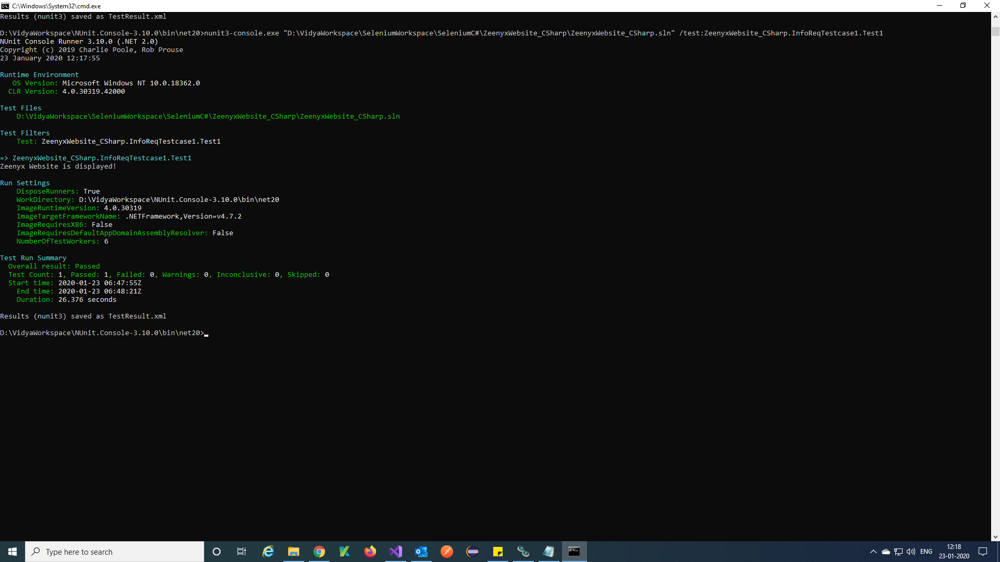

2.Type the command to run Test plan

nunit3-console.exe "D:\VidyaWorkspace\SeleniumWorkspace\SeleniumC#\ZeenyxWebsite_CSharp\bin\Debug\ZeenyxWebsite_CSharp.dll" /test:ZeenyxWebsite_CSharp.TestPlan

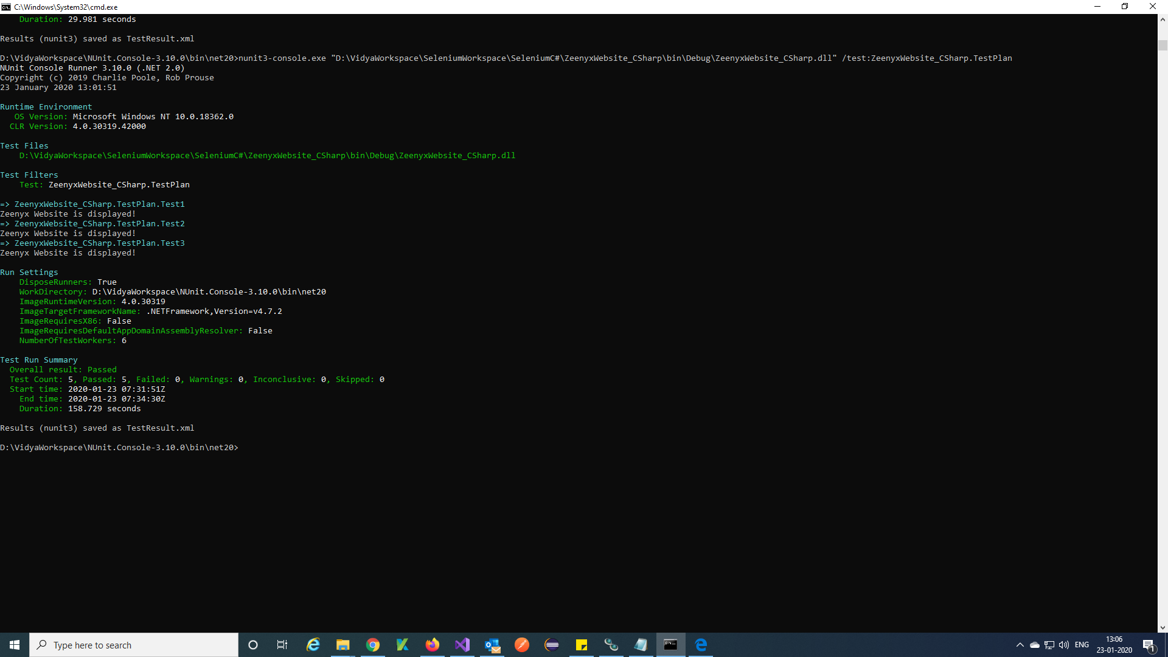

***Step 13)*** Command prompt will give this report once after completed the testcases completely.

