***Project creation in eclipse***

1. ***Create project in eclipse***
2. ***Create a Package and Class***
3. ***Run a simple java program***
4. ***Creation of folders***

**Prerequisites:**

1. Jdk 1.8
2. Eclipse

***Create project in eclipse:***

Step 1) Open eclipse, Click on File🡪New🡪Project.

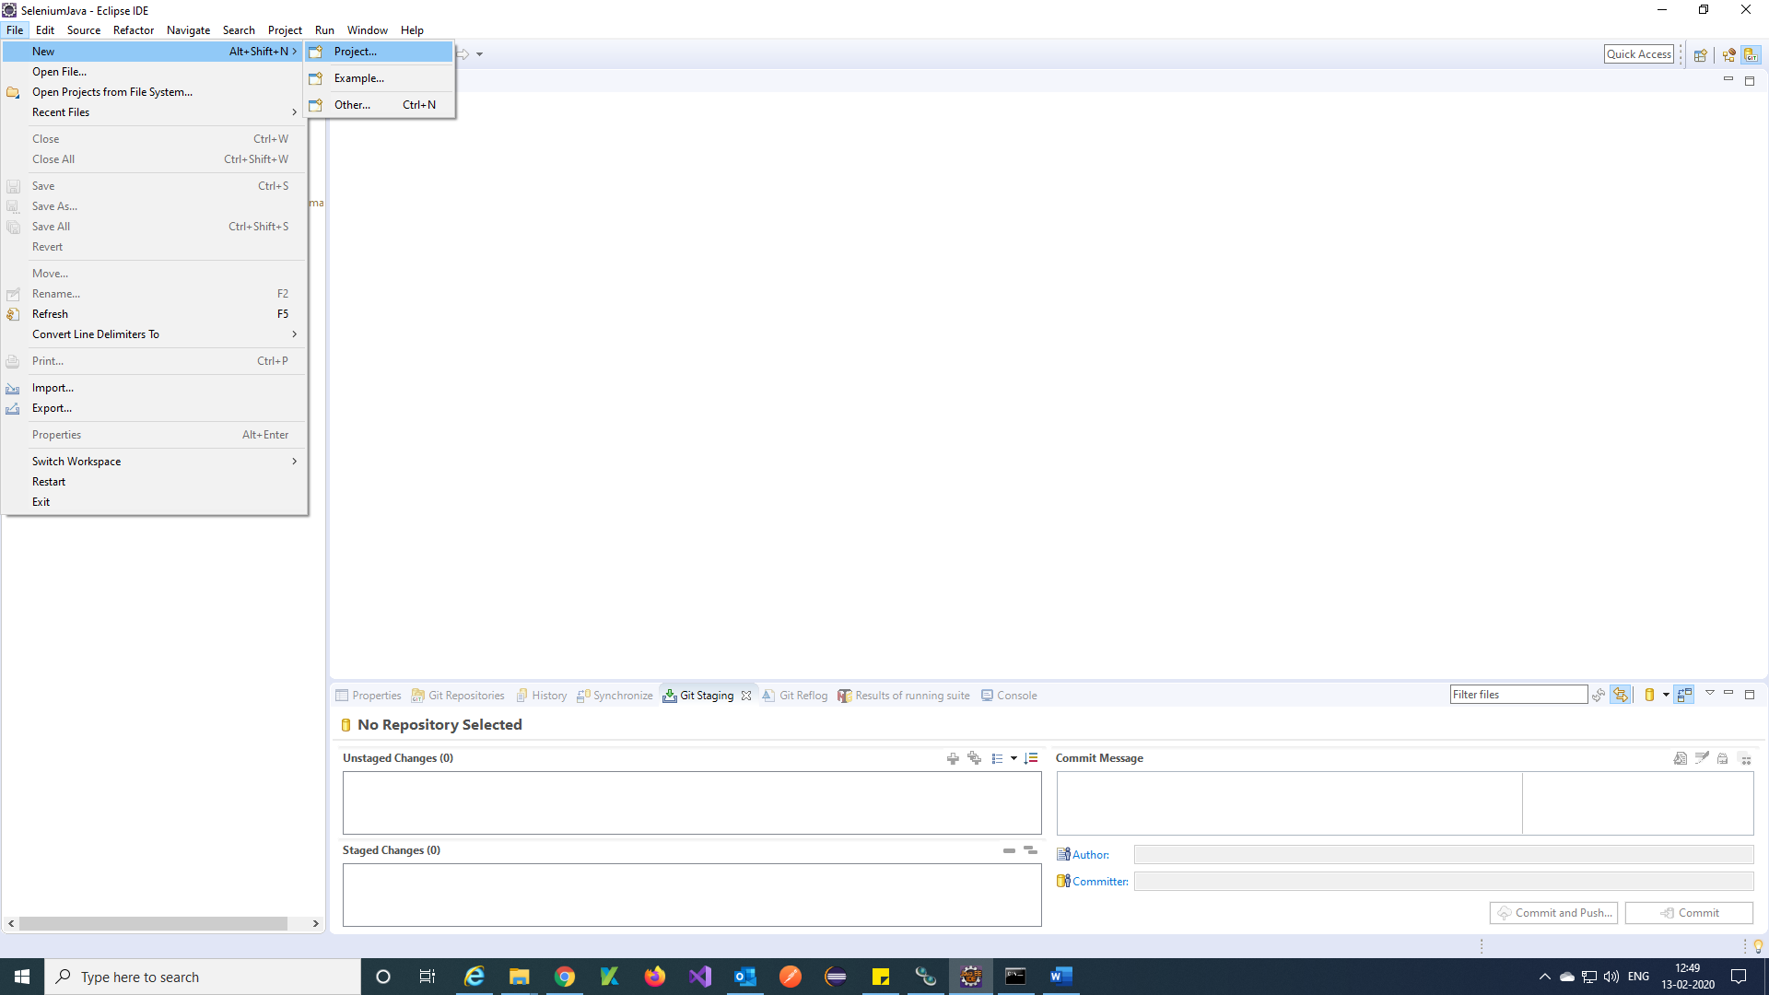

Step 2) Search maven and select Maven Project and click on Next.

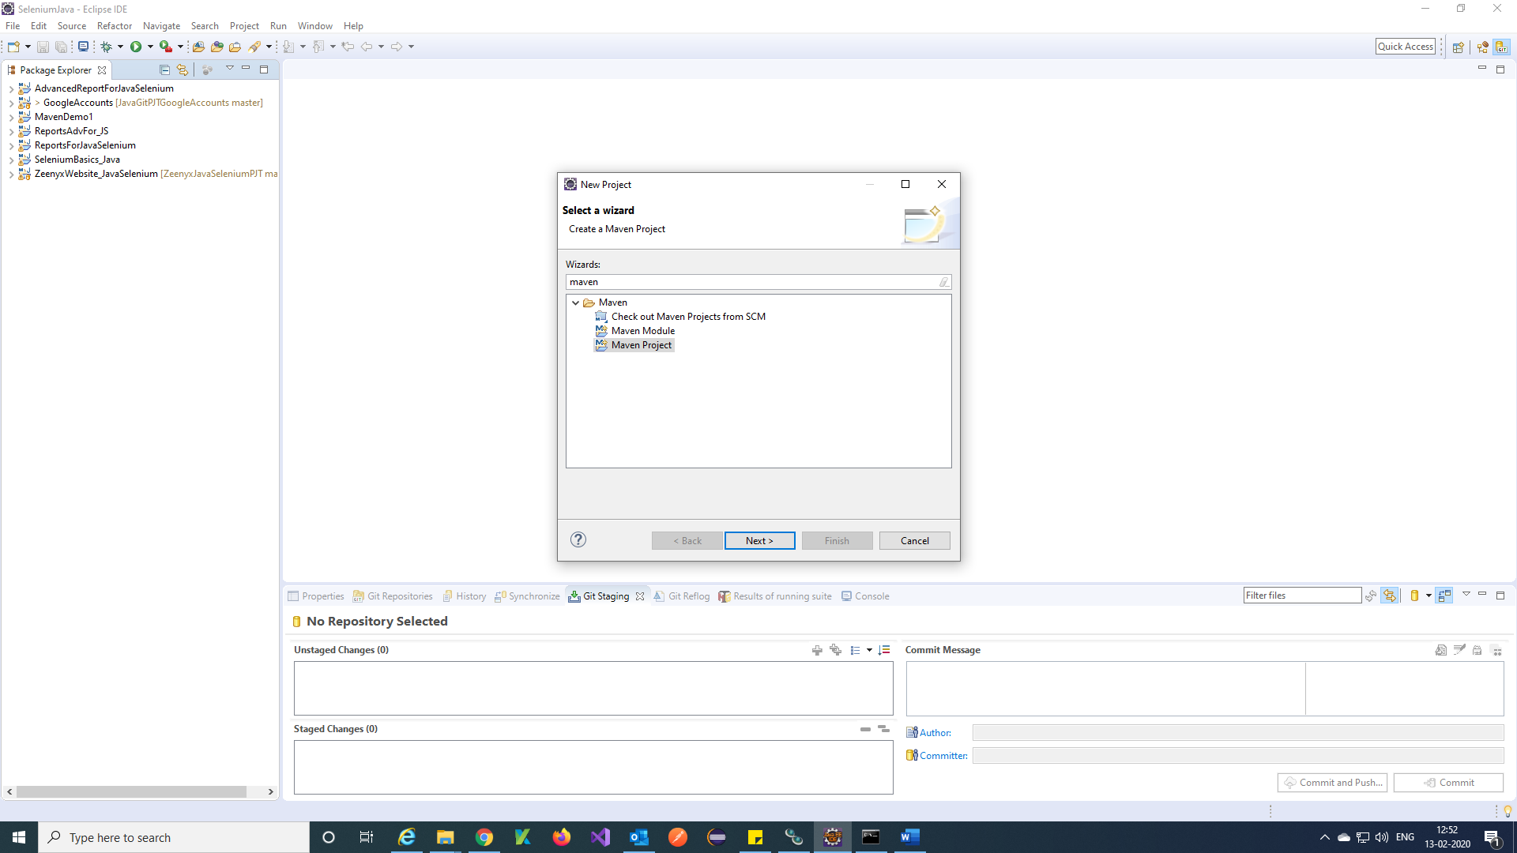

Step 3) Browse project path and click on Next.

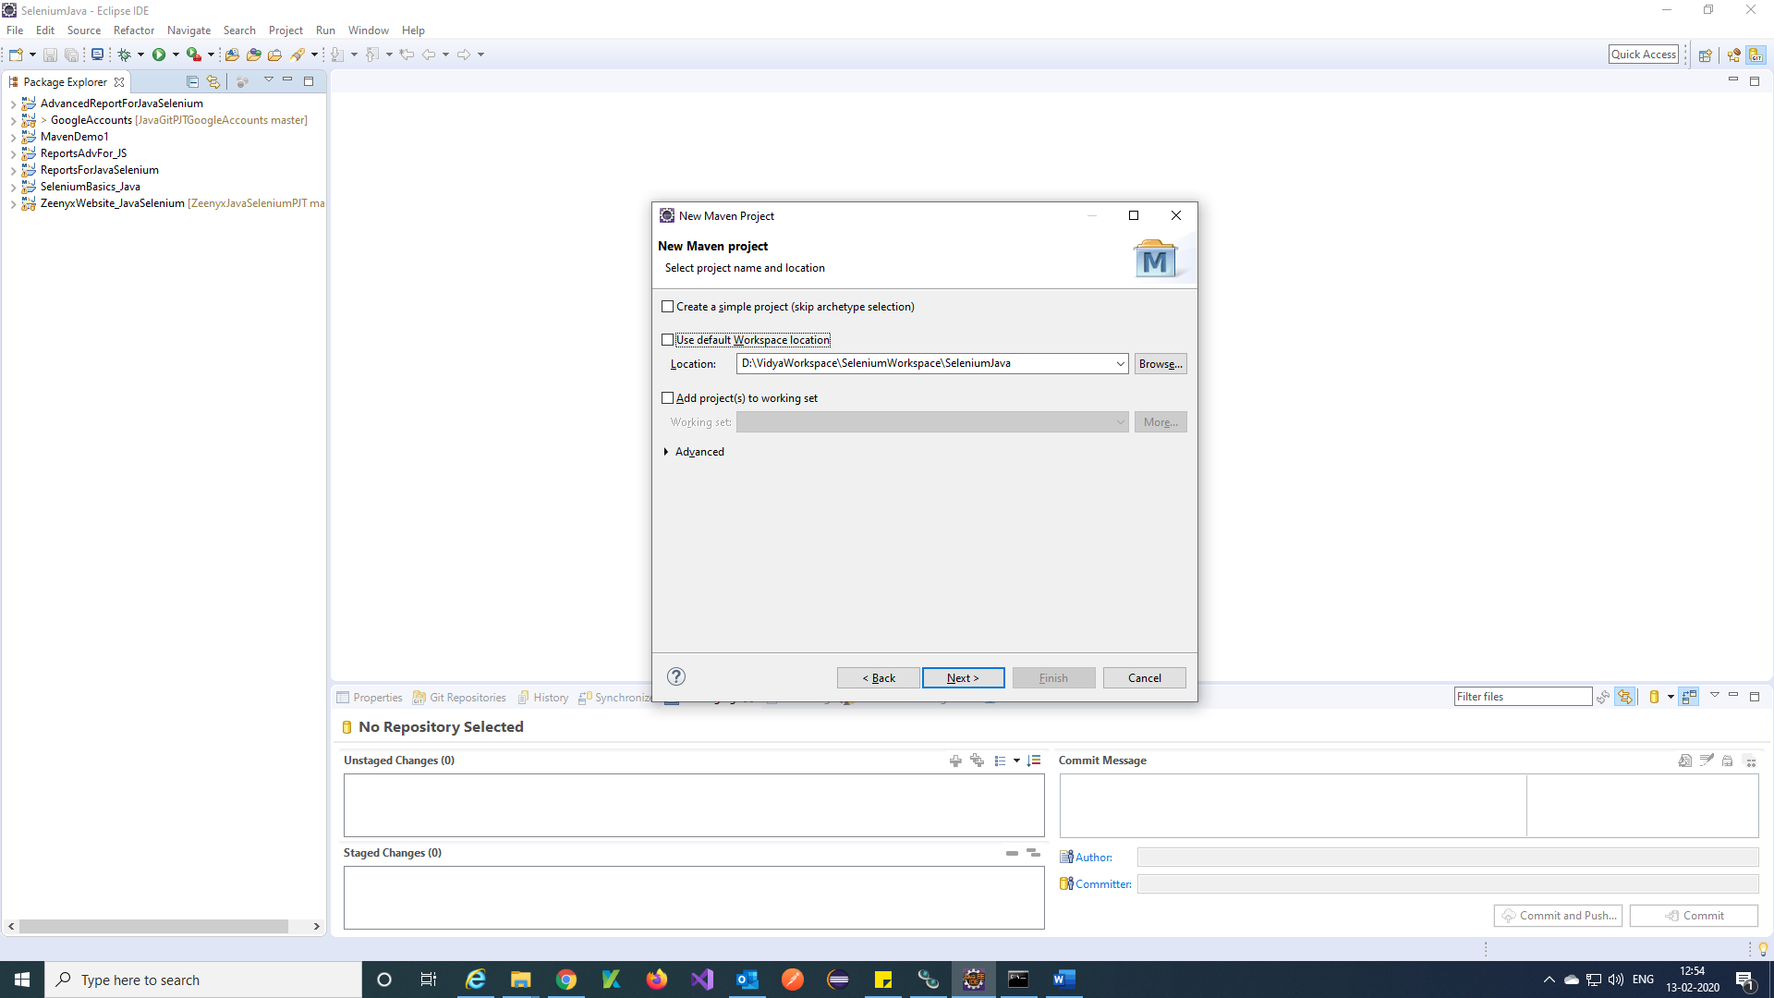

Step 4) Just click on Next.

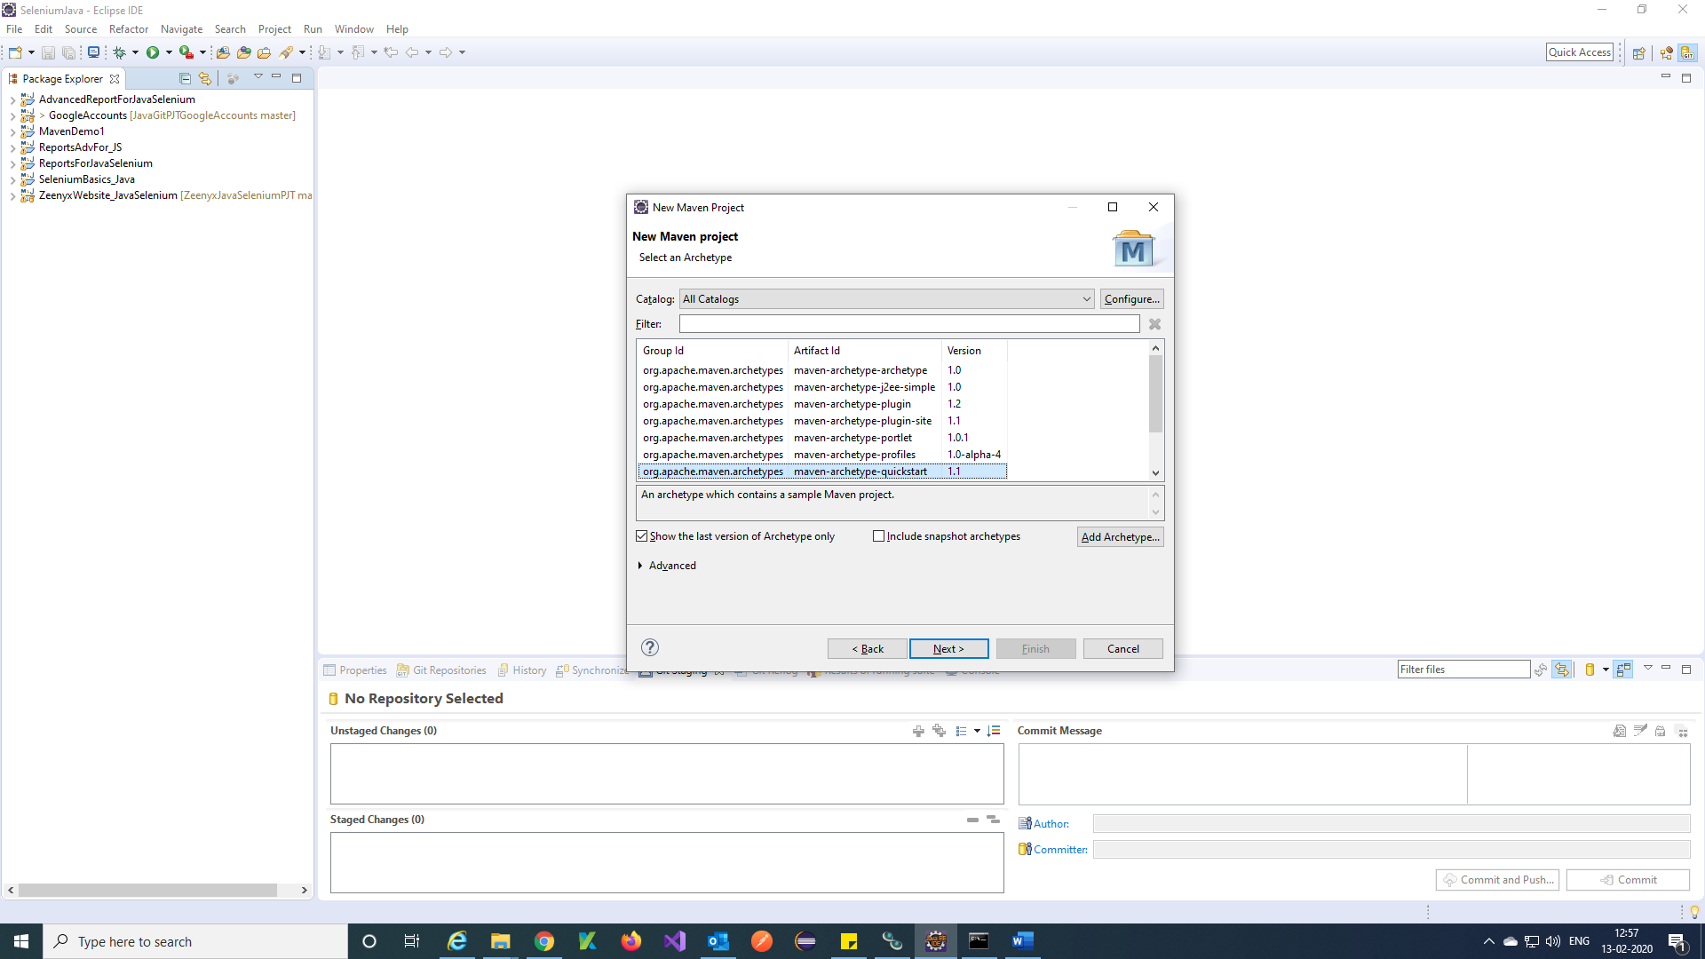

Step 5) Enter Group id and Artifact id and click on Finish.

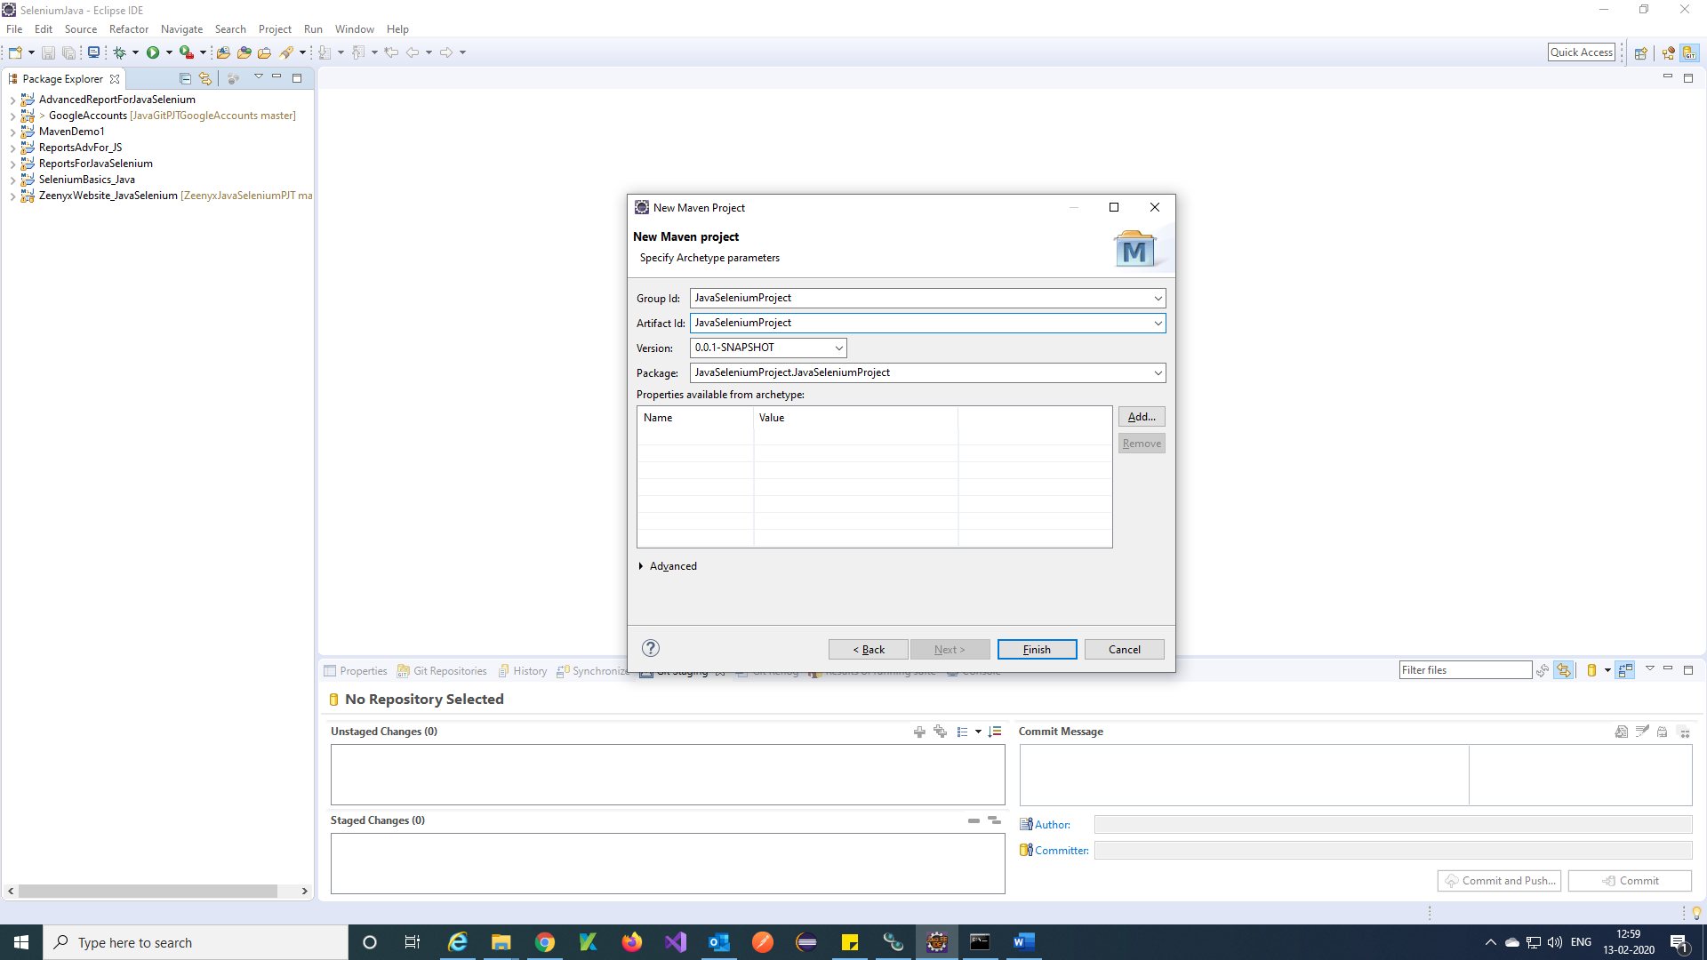

Note: Group id is the project name.

Step 6) your maven project is created. Maven project will give you a pom.xml file and also default packages

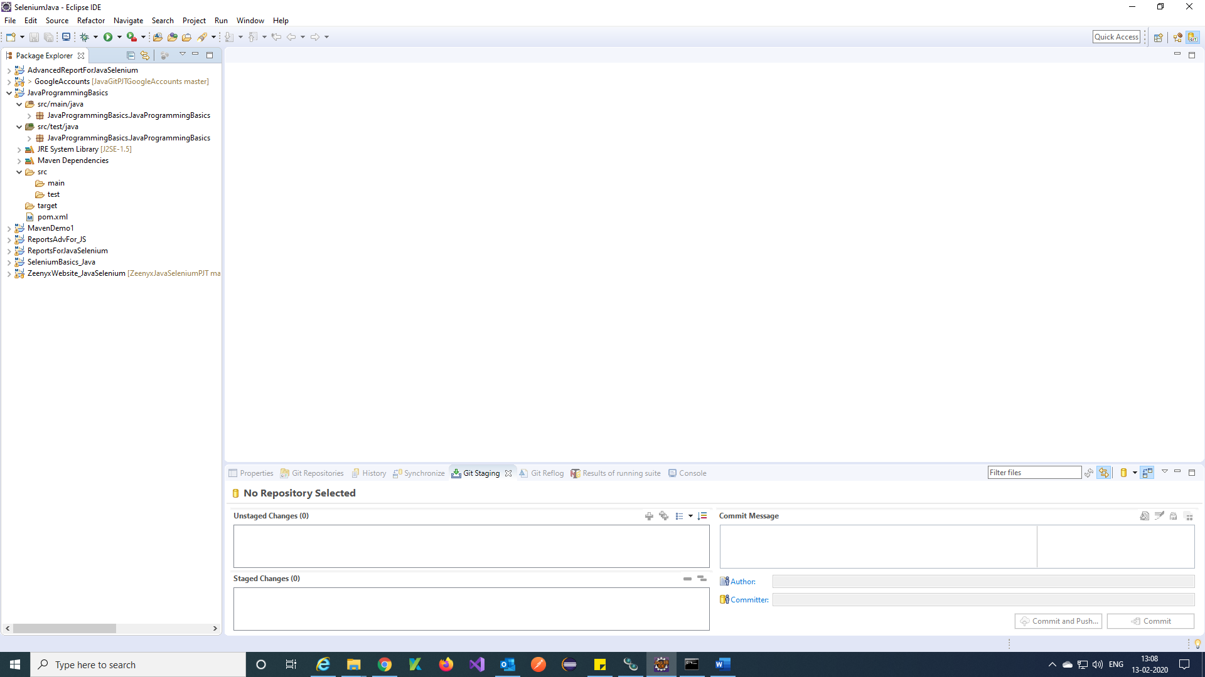

***Create a Package:***

Step 1) Right click on src/test/java 🡪 New 🡪 other

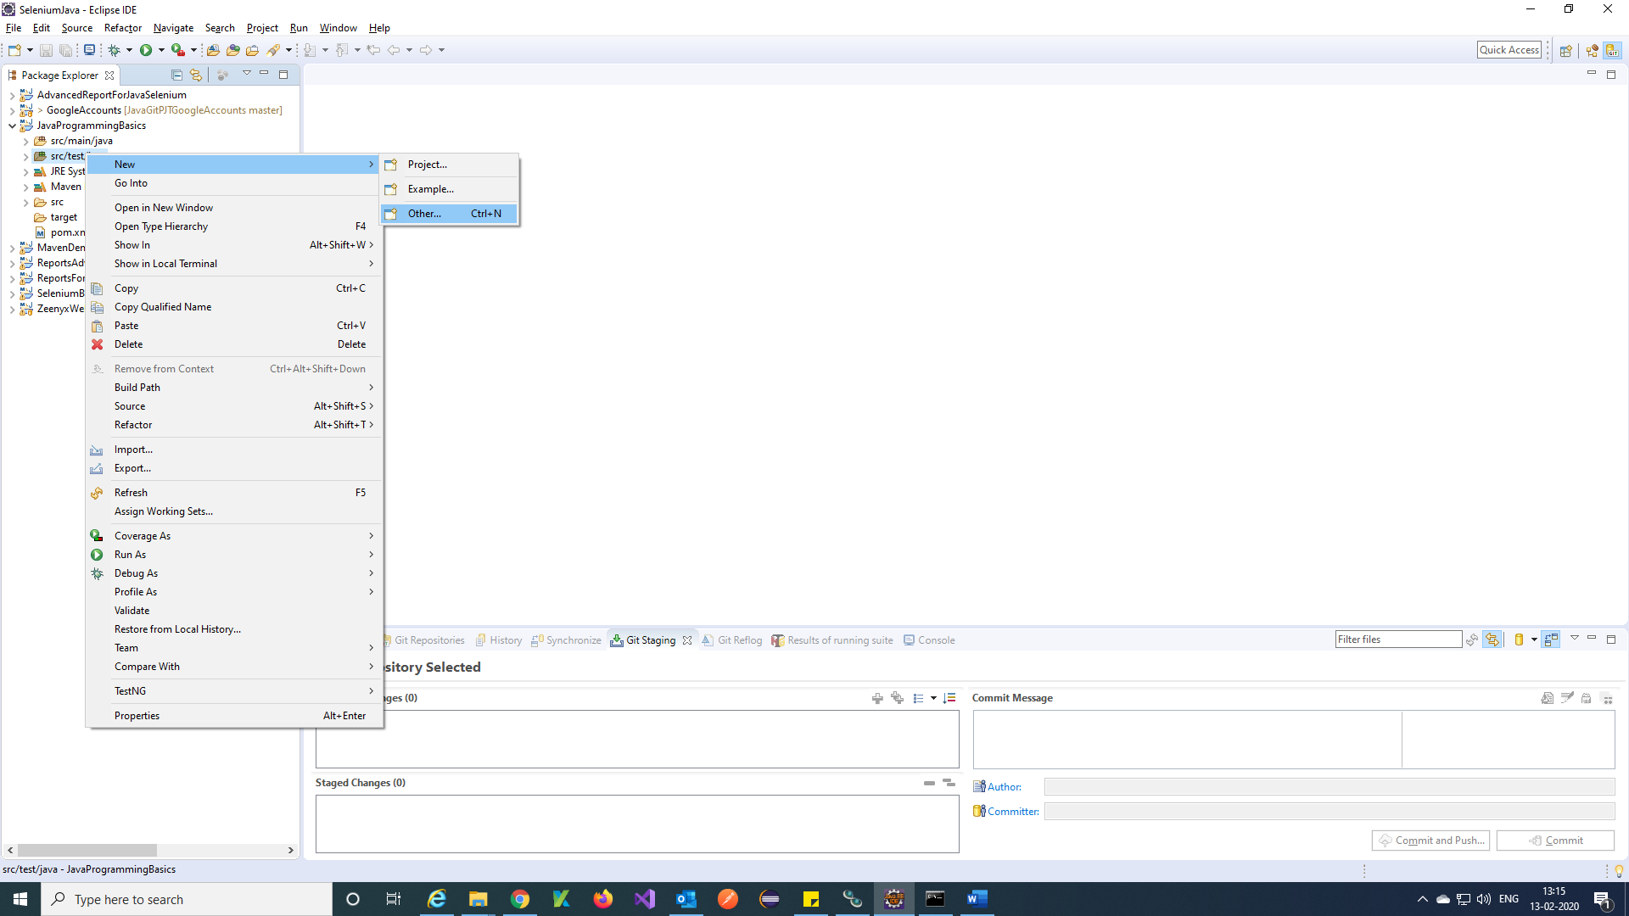

Step 2) Search Package and Select Java Package🡪 Next.

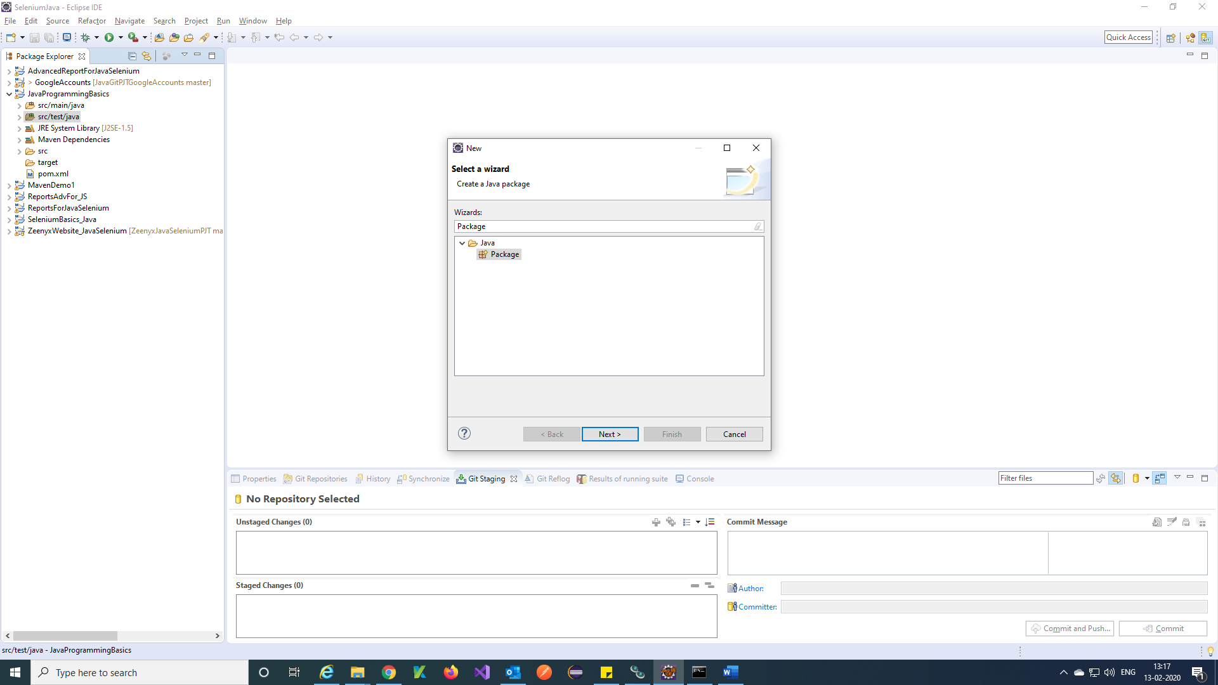

Step 3) Enter package name 🡪 Finish.

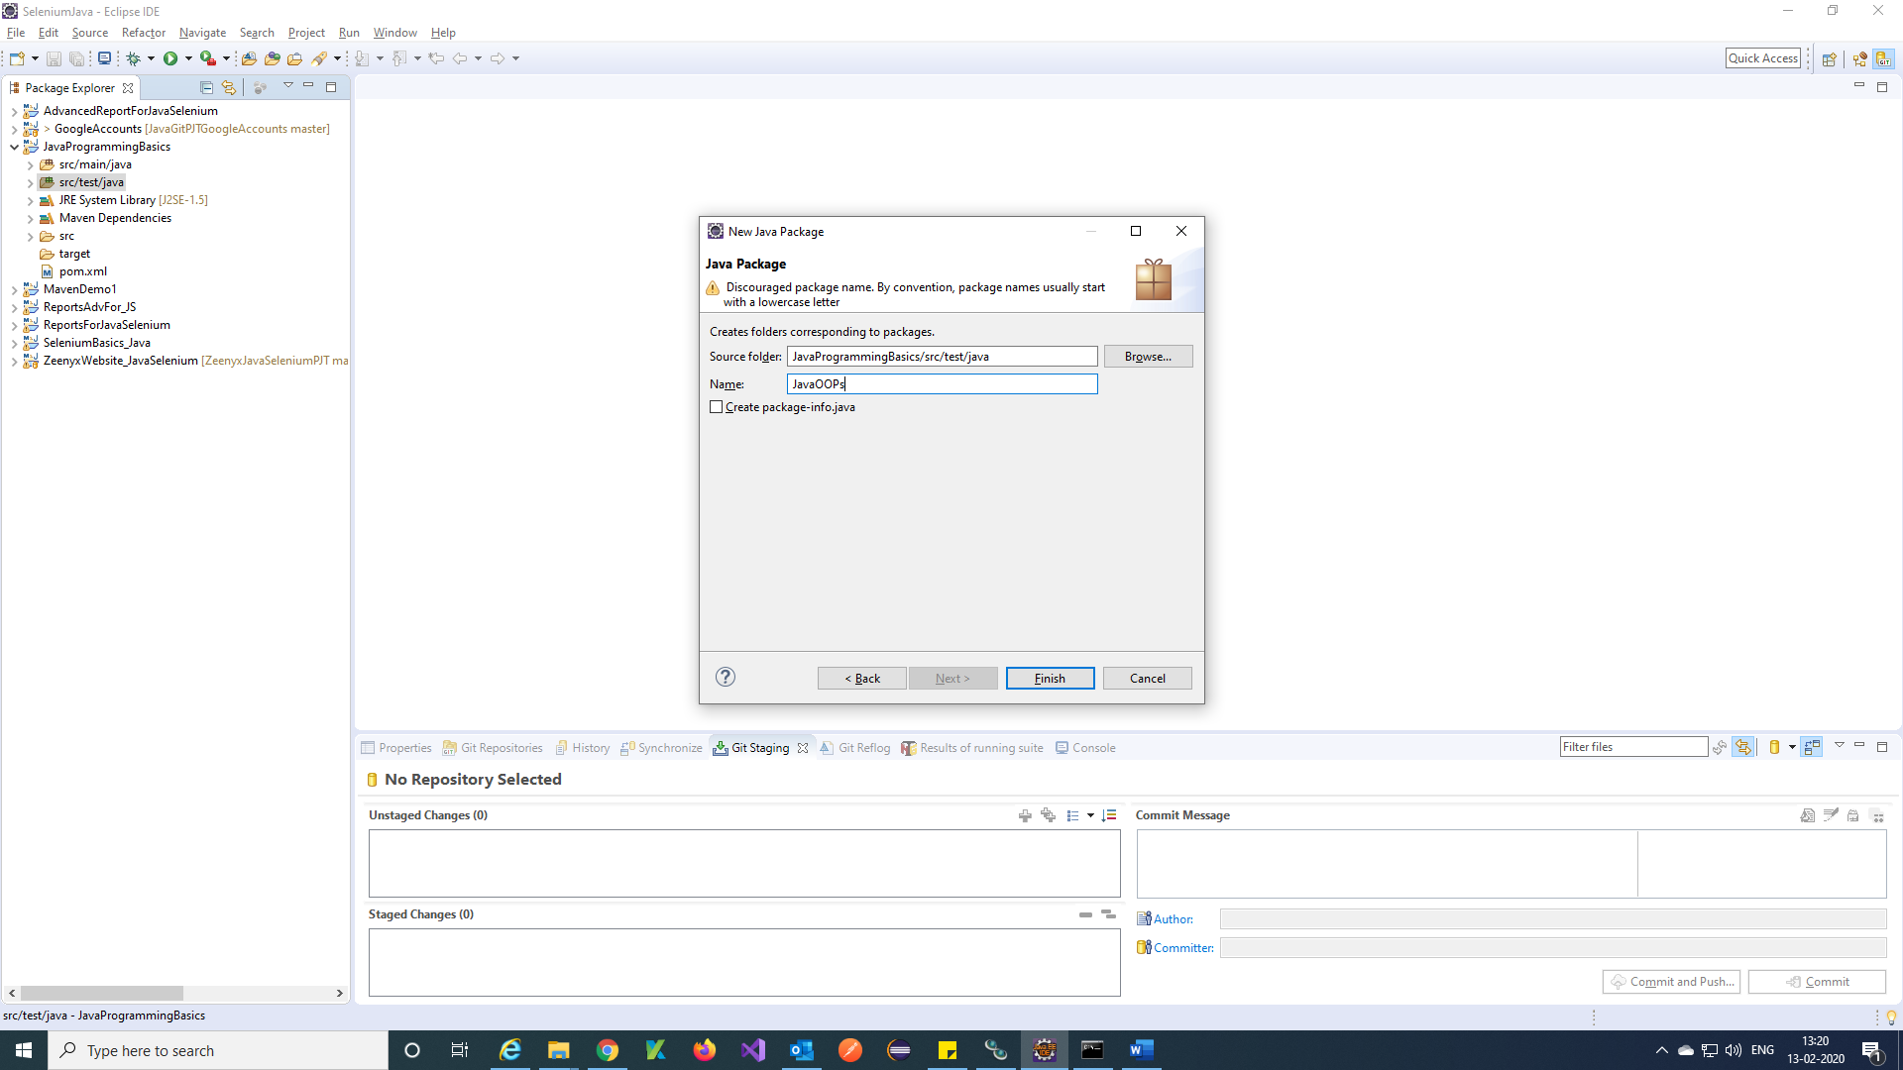

Step 4) Your package is created.

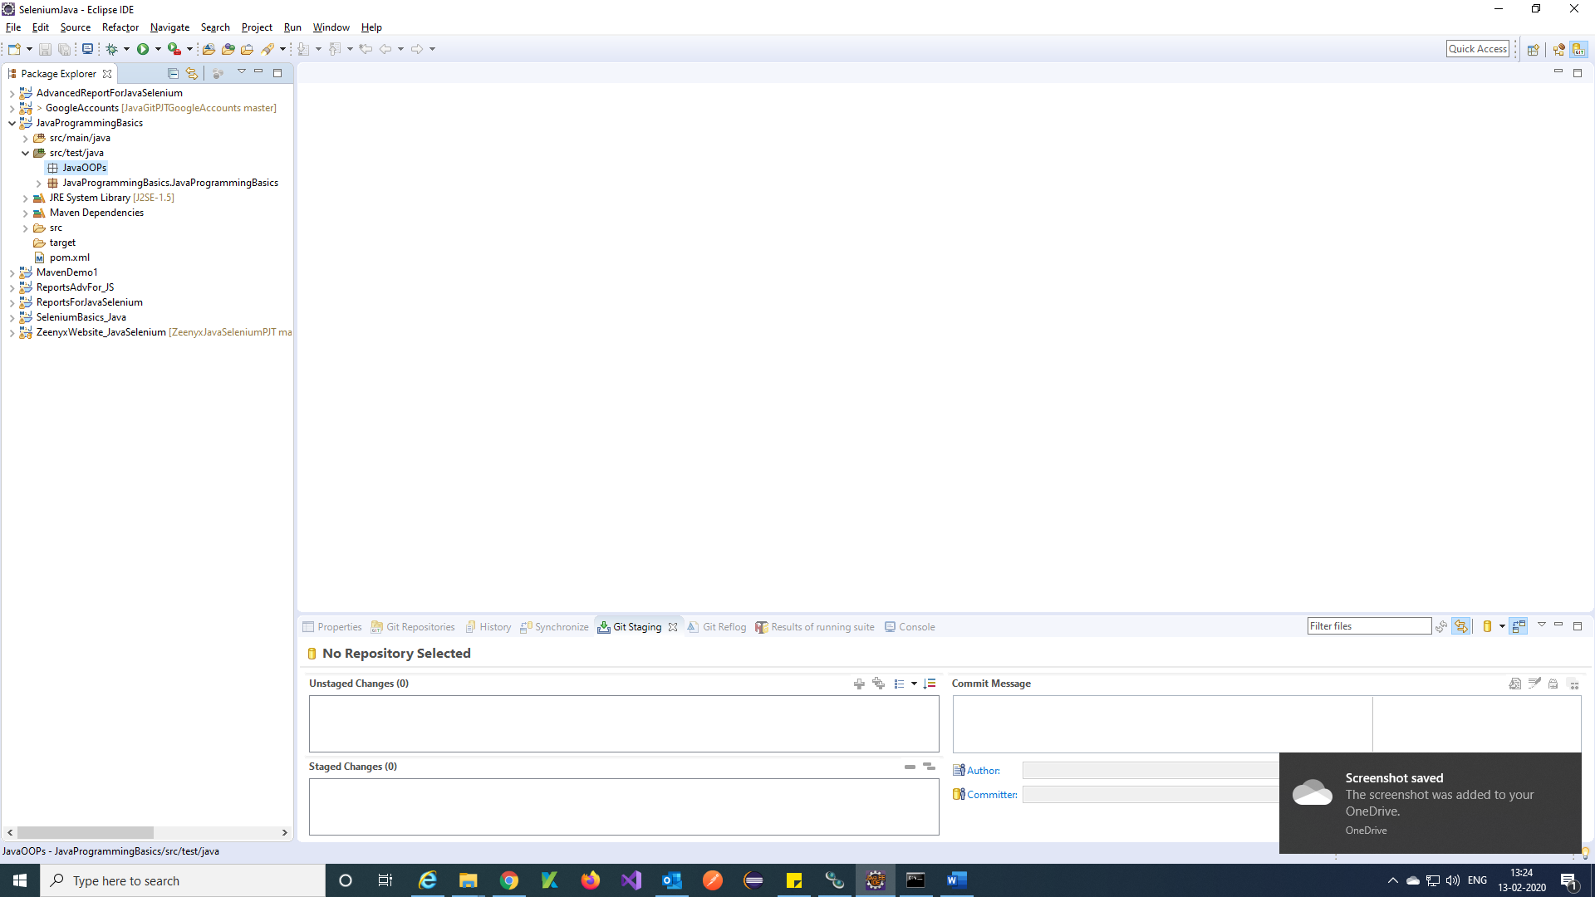

***Create a Class:***

Step 1) Right click on created Package 🡪 New 🡪 other

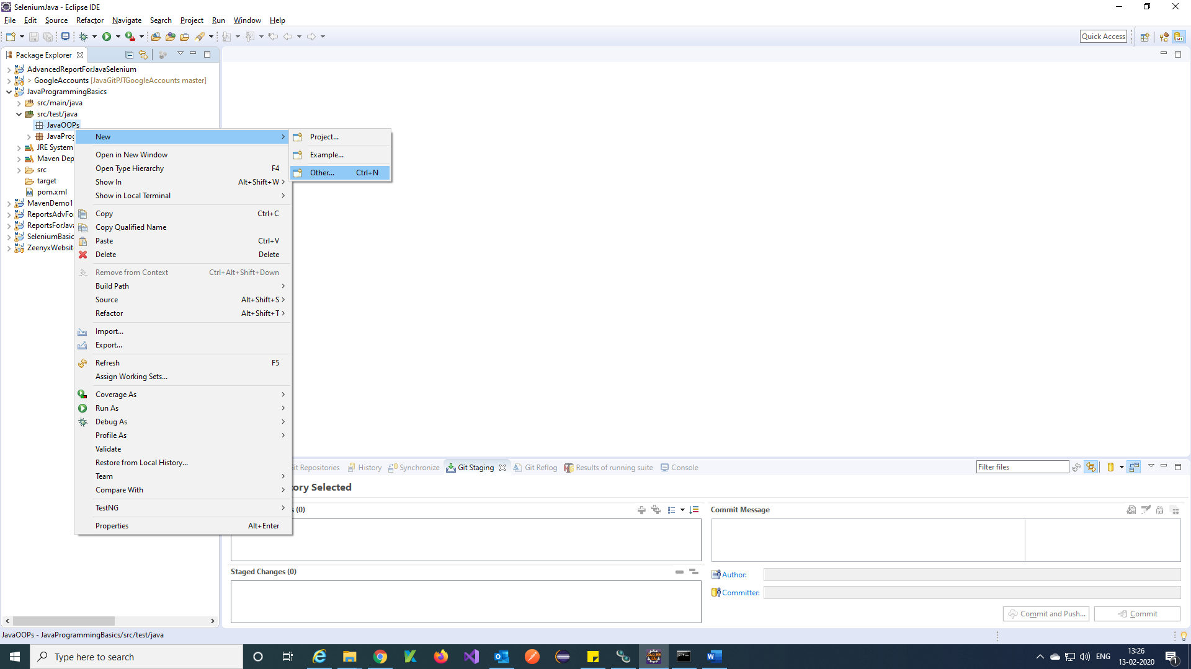

Step 2) Search Class and Select Java Class🡪 Next.

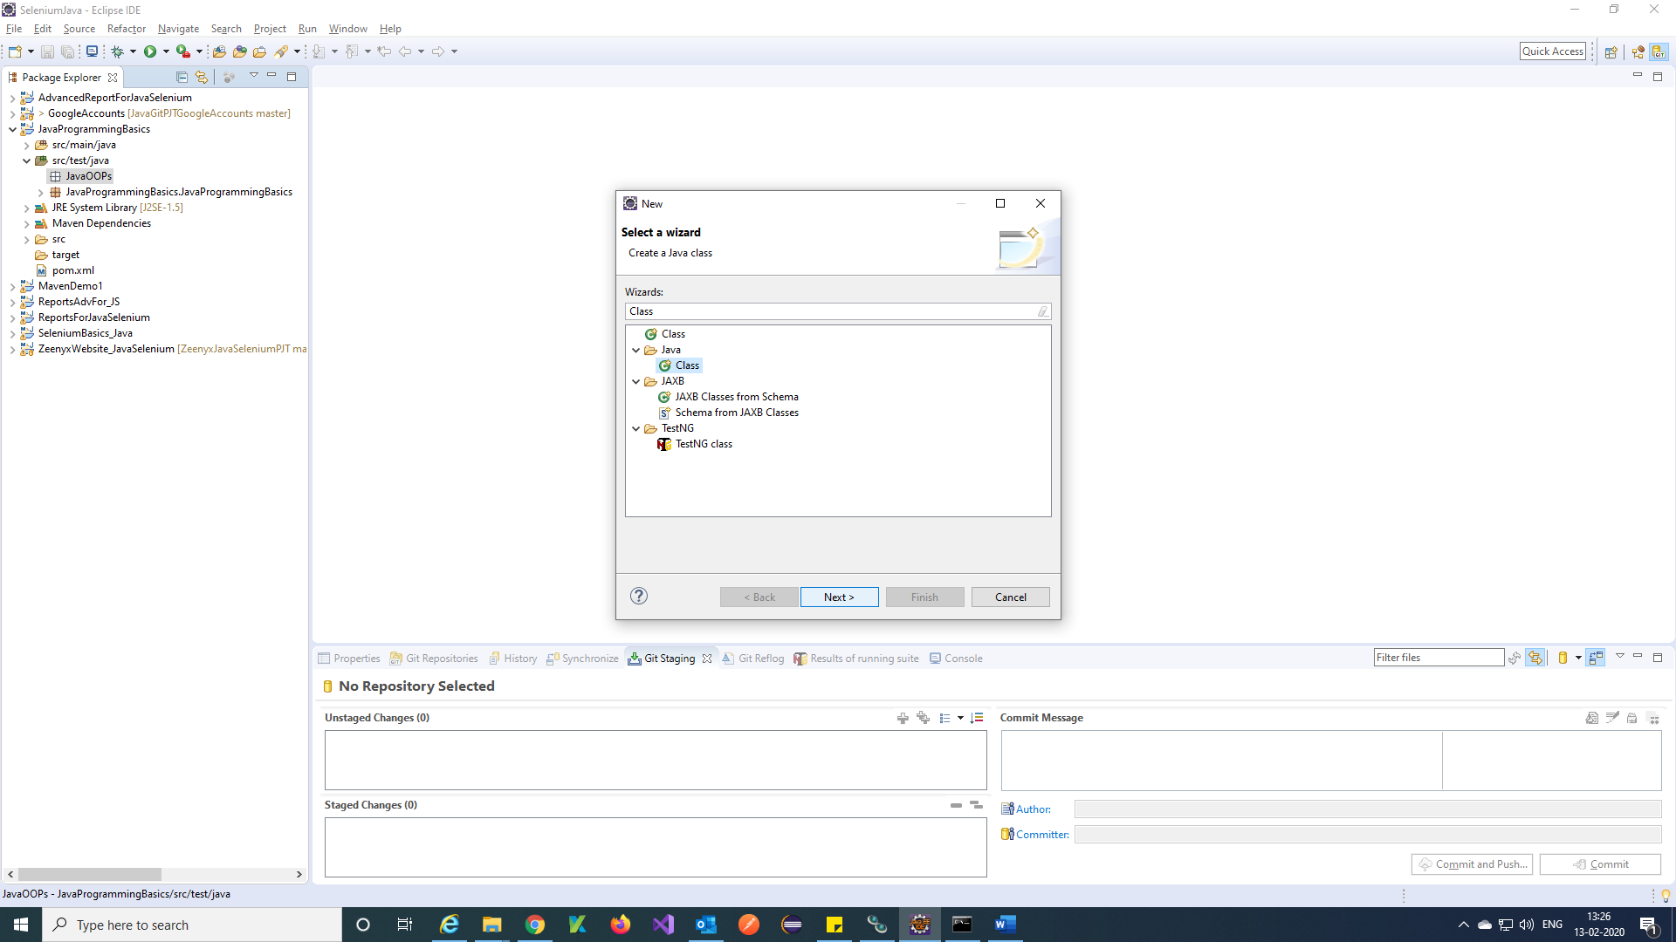

Step 3) Enter class name 🡪 Finish.

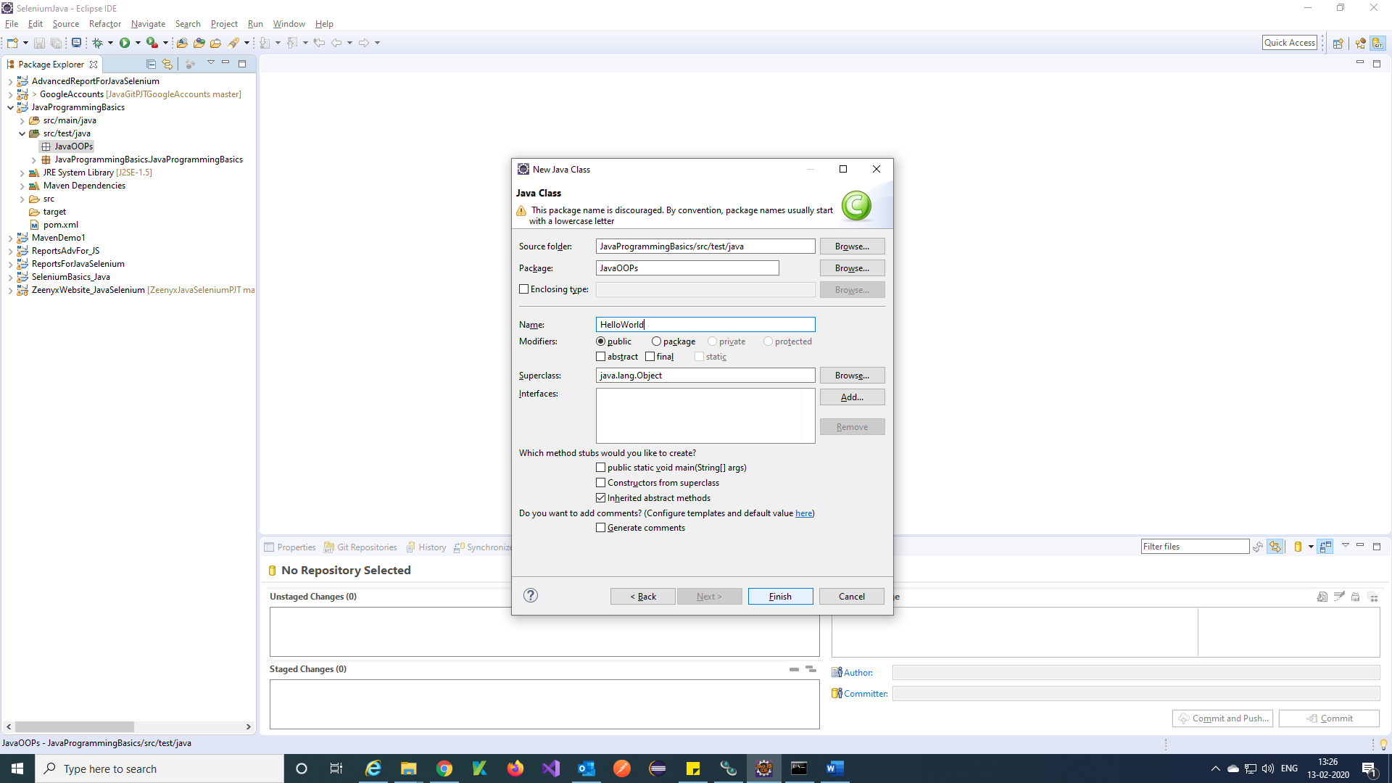

Step 4) Your Class is created.

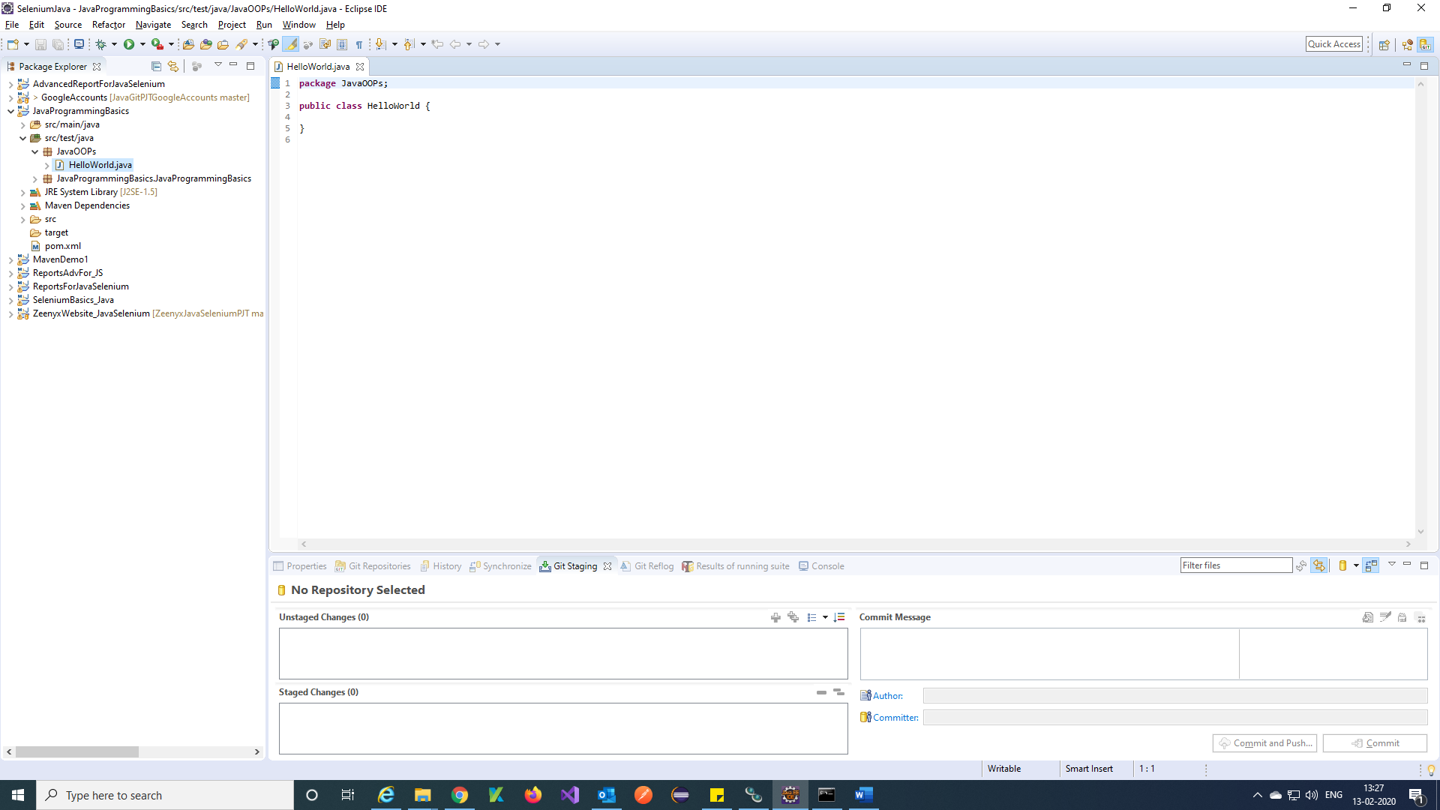

***Run a simple java program:***

Step 1) Create a simple HelloWorld.java program and Save program (Ctrl+S).

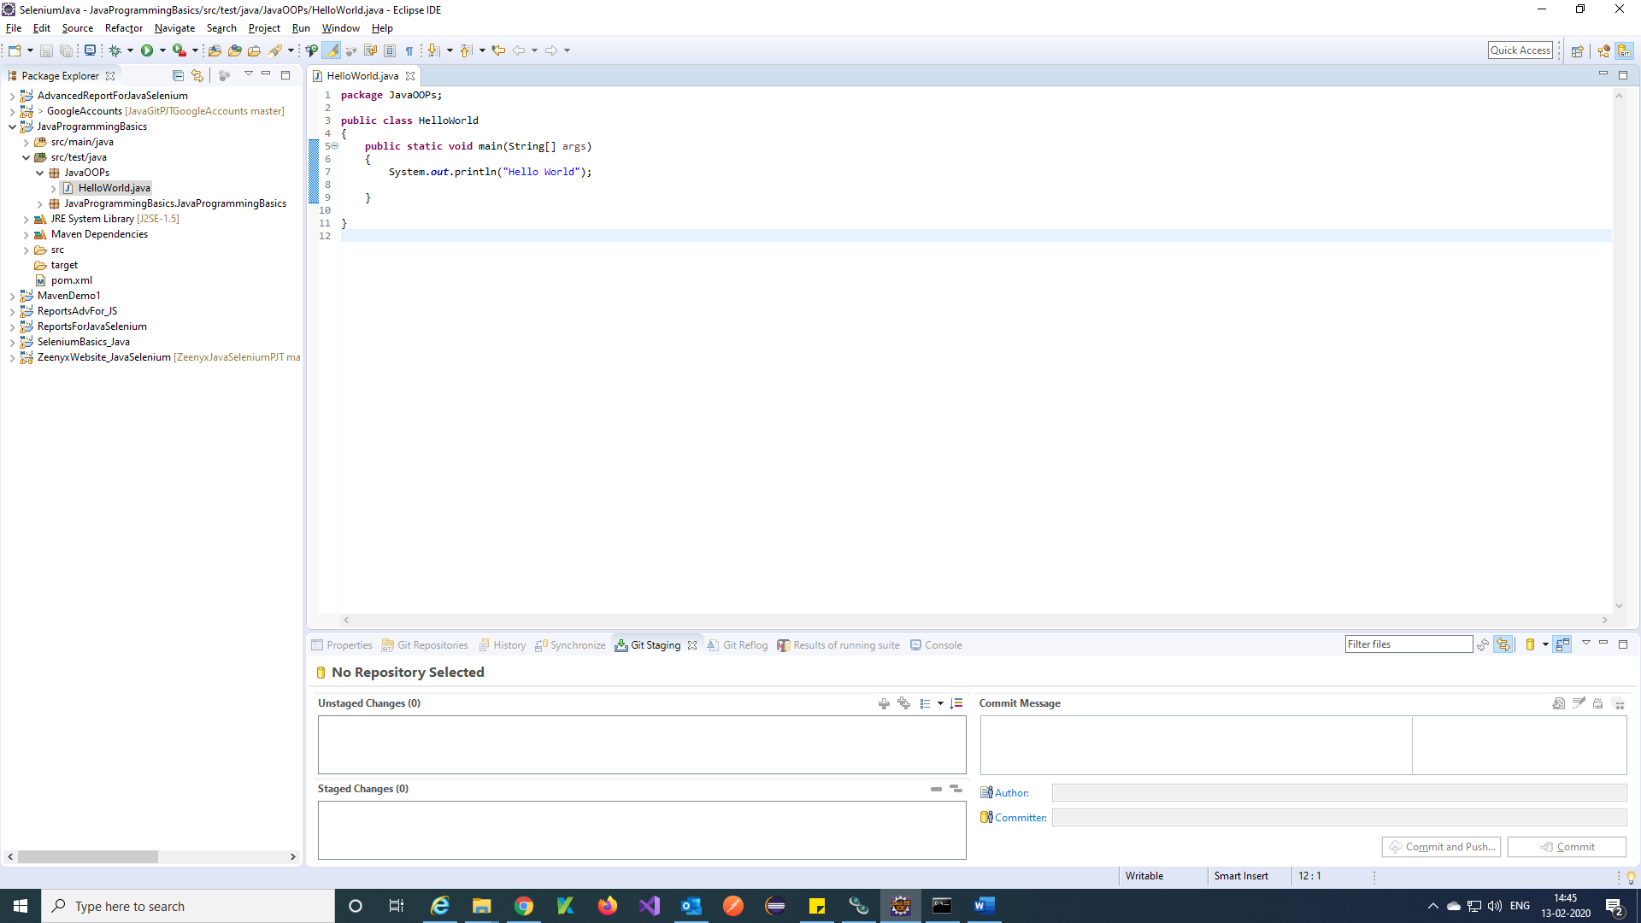

Step 2) Right click on your class and Select Run As 🡪 Java Application.

Or you can run using Run green colour symbol.

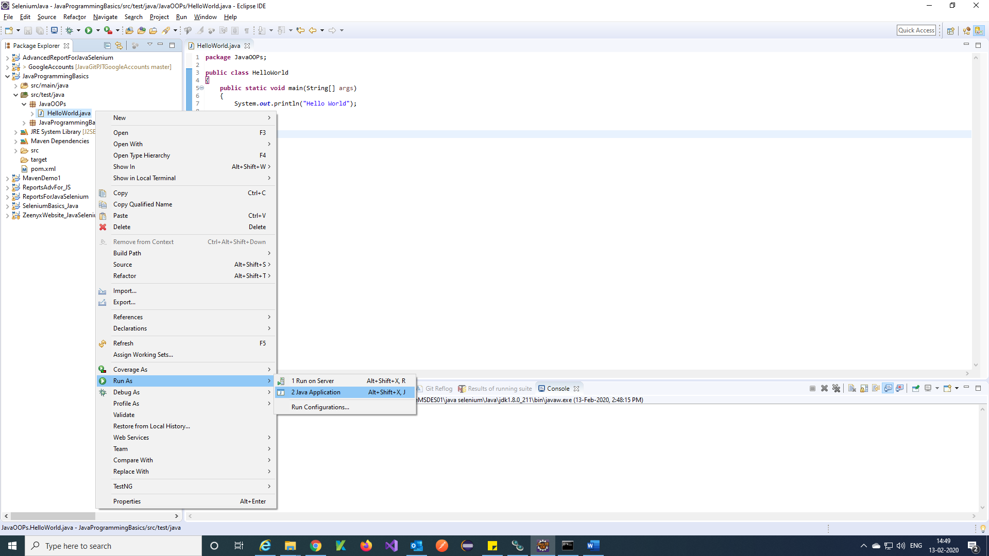

Step 3) After running your class, you will get output in Console.

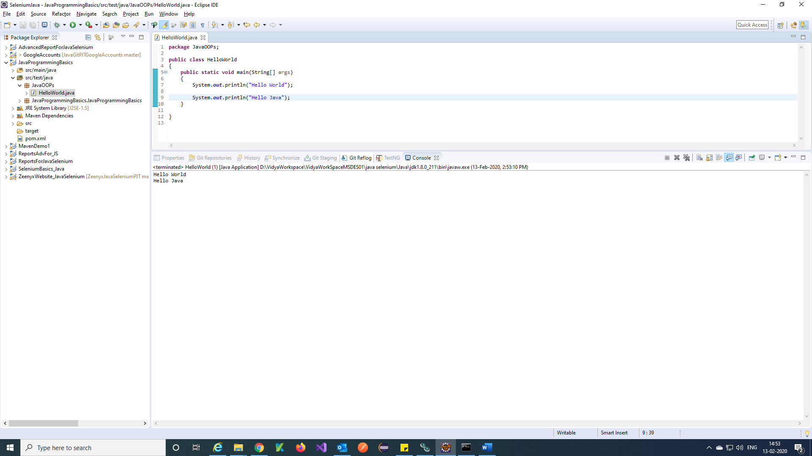

***Creating folder in Eclipse:***

Step 1) Right Click on your project Select New 🡪 Other.

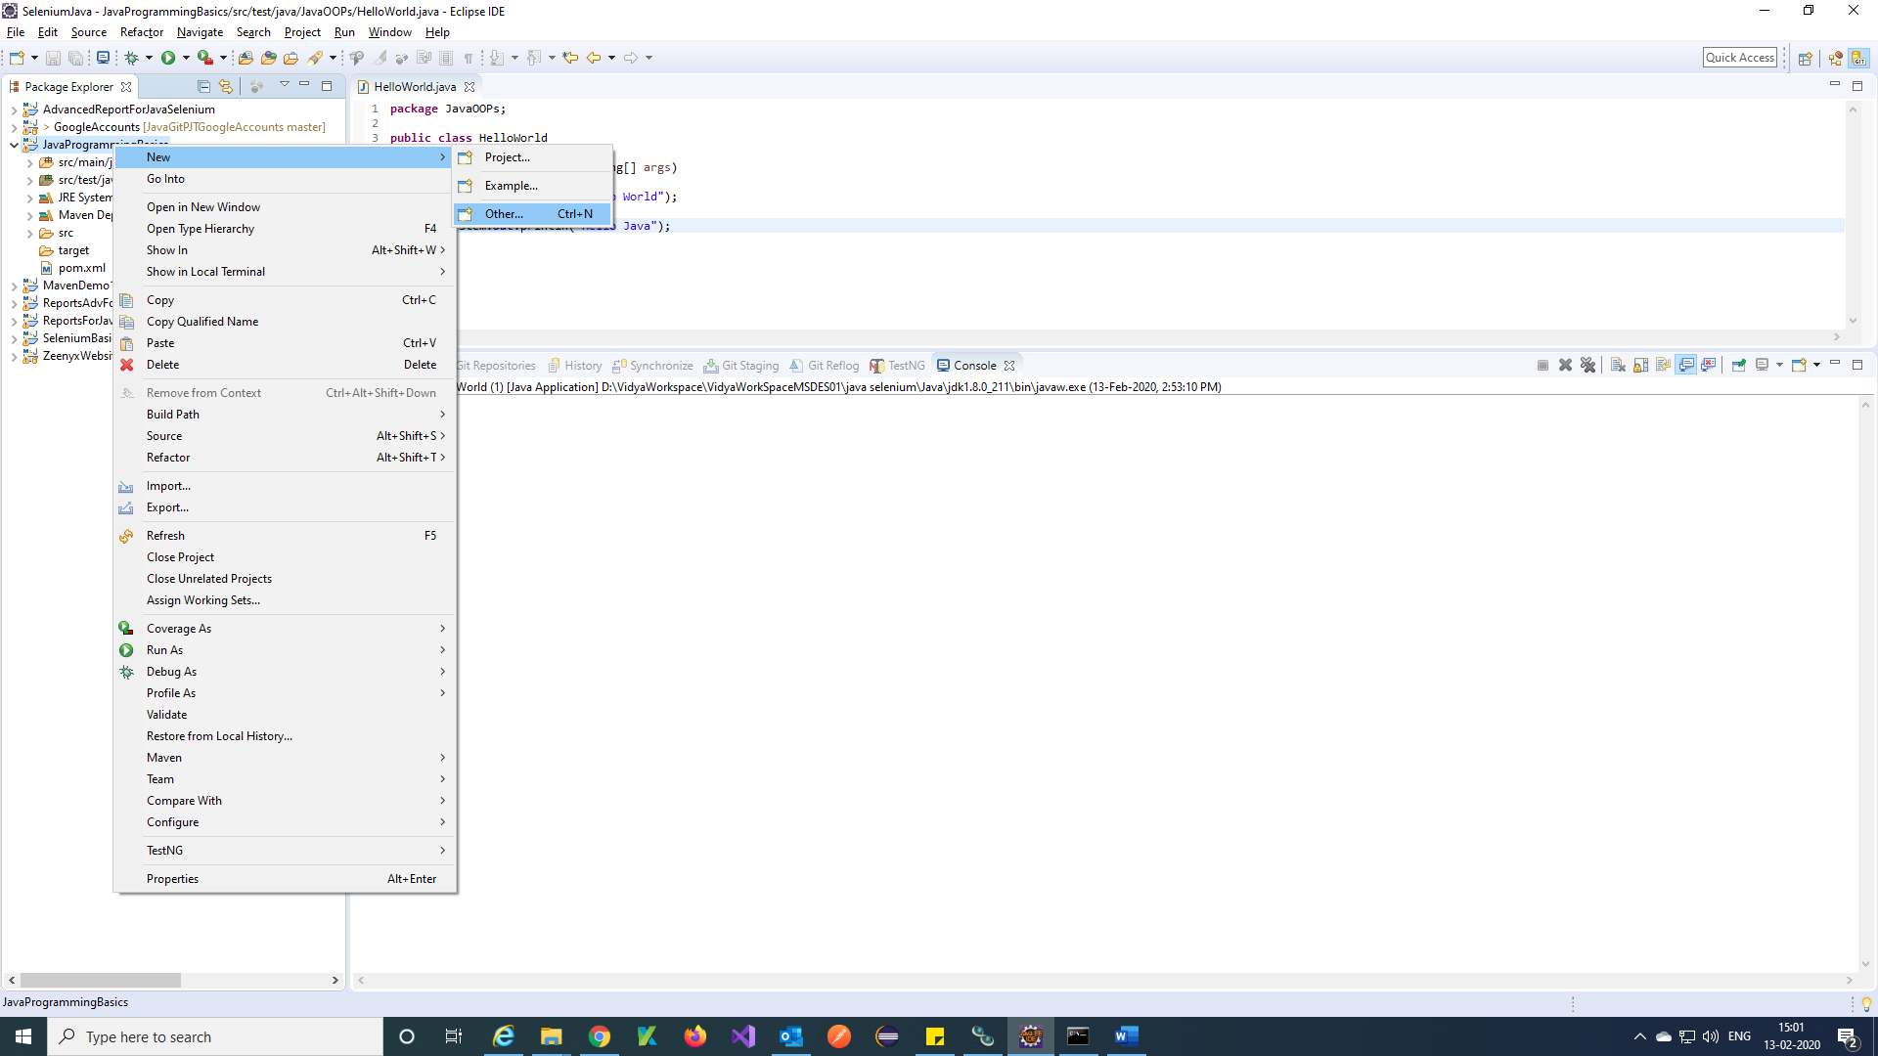

Step 2) Search folder and Select General Folder🡪 Next.

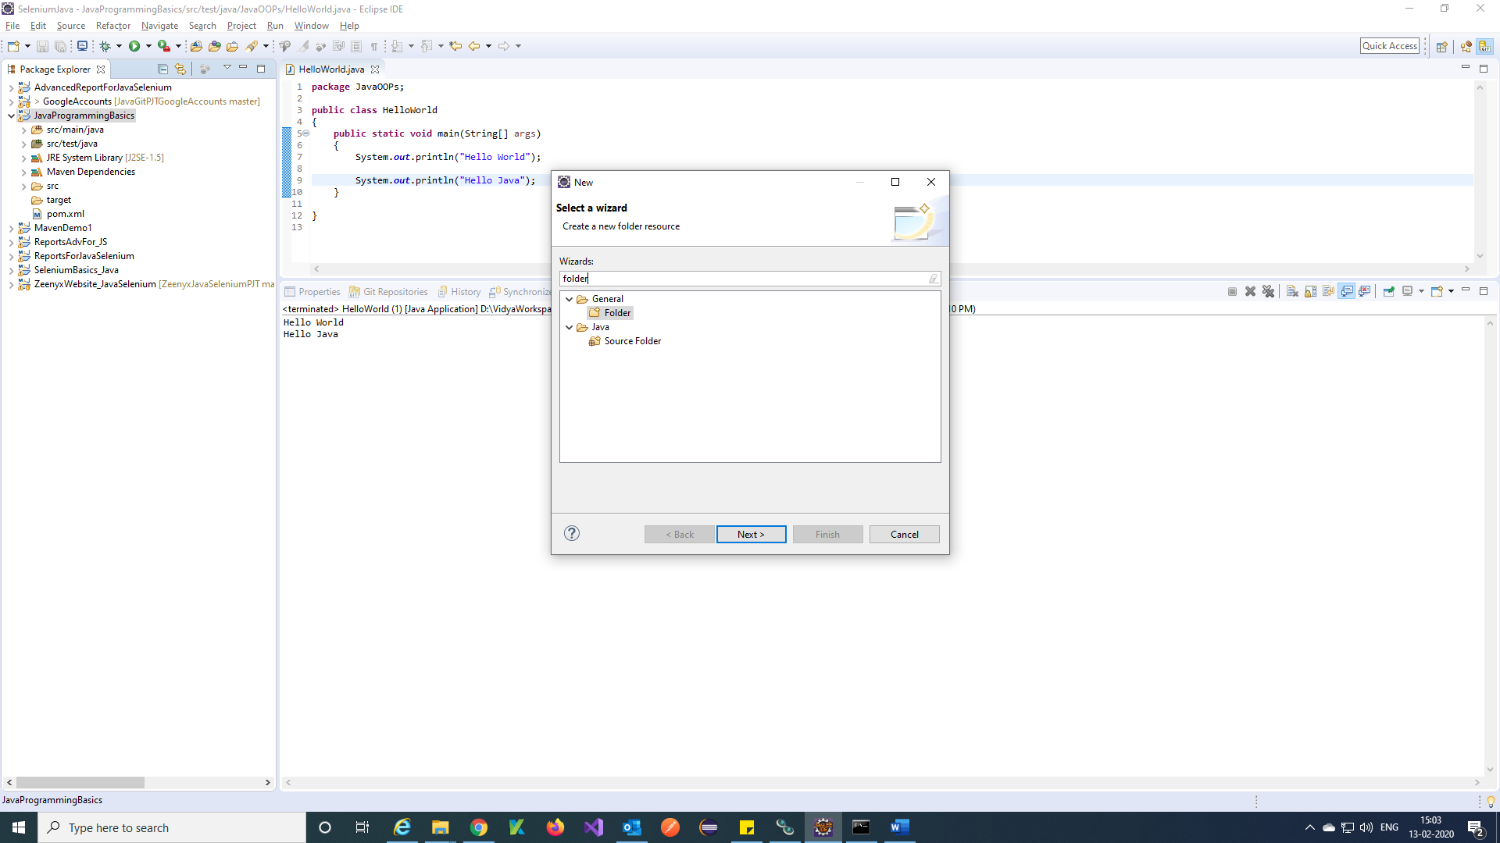

Step 3) Provide folder name 🡪 Finish.

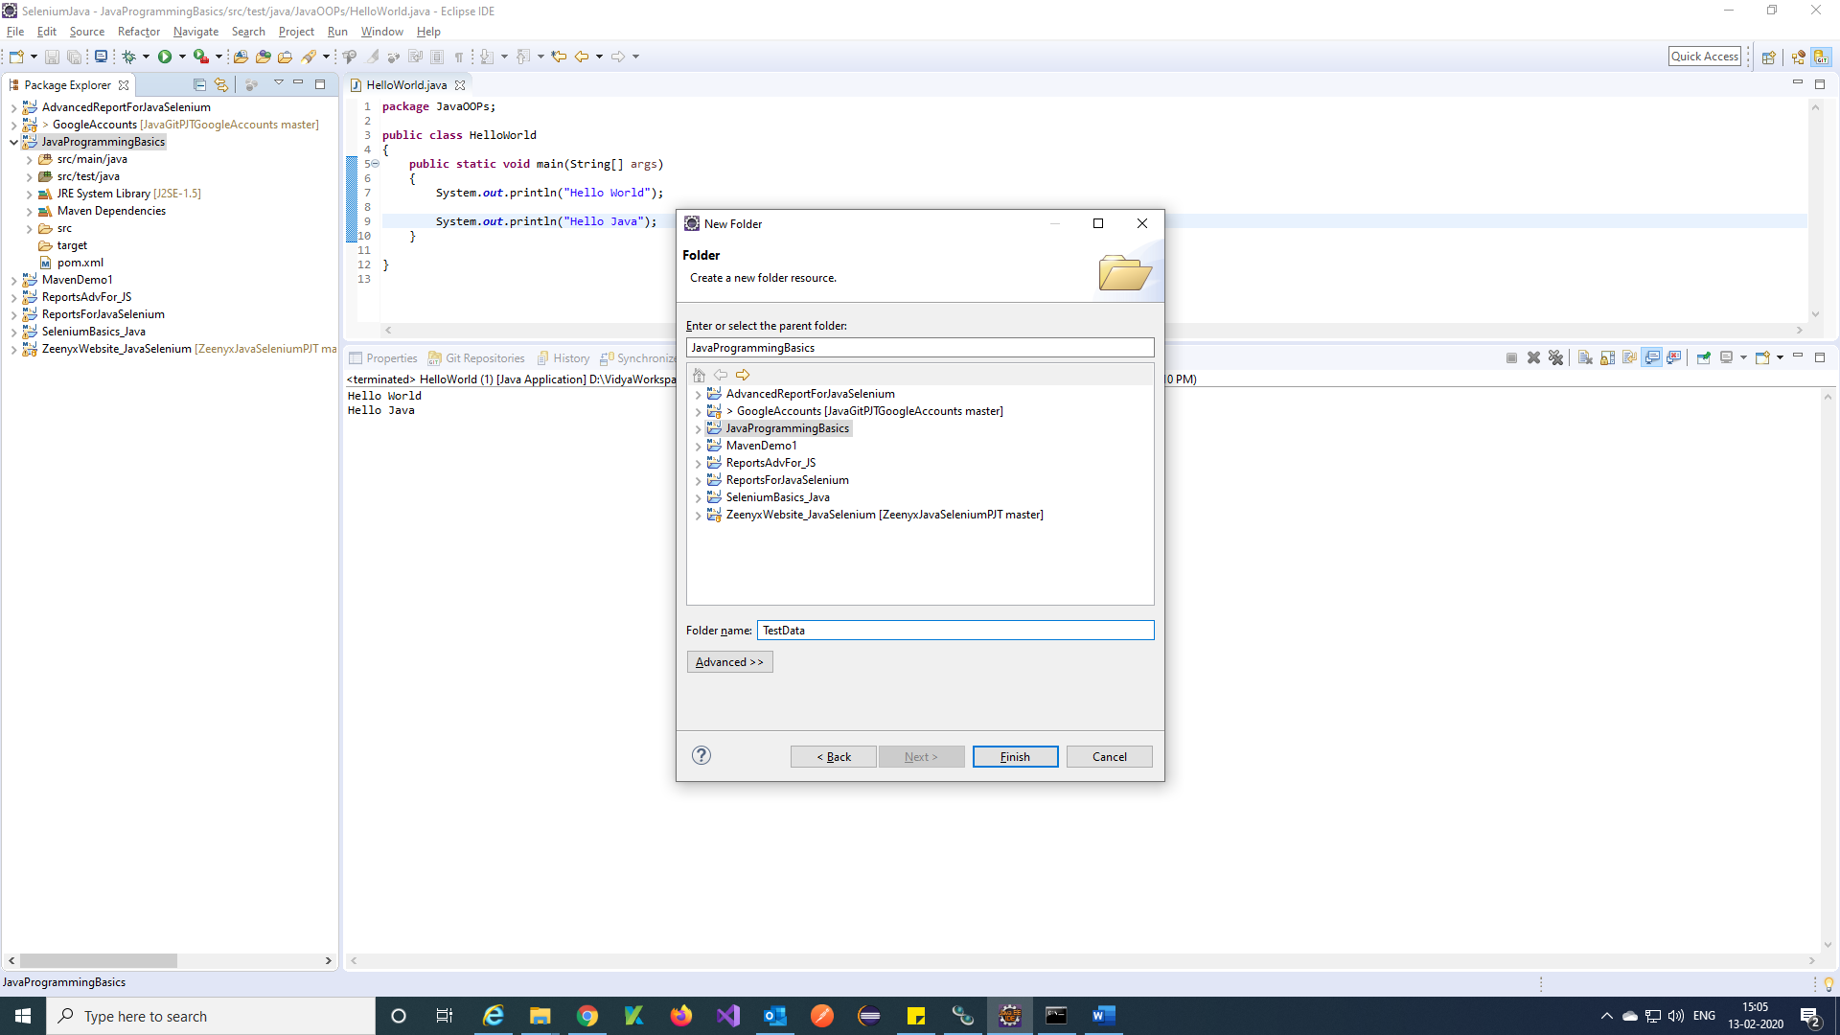

Step 4) Folder is created into your project.

