**Selenium and TestNG Setup**

1. **Selenium setup**
2. **TestNG setup**
3. **Create a Test and Run**

**Prerequisites:**

Maven Project & Pom.xml file

**Selenium SetUp:**

Step 1) Using this URL copy selenium java maven dependency

<https://mvnrepository.com/artifact/org.seleniumhq.selenium/selenium-java/3.141.59>

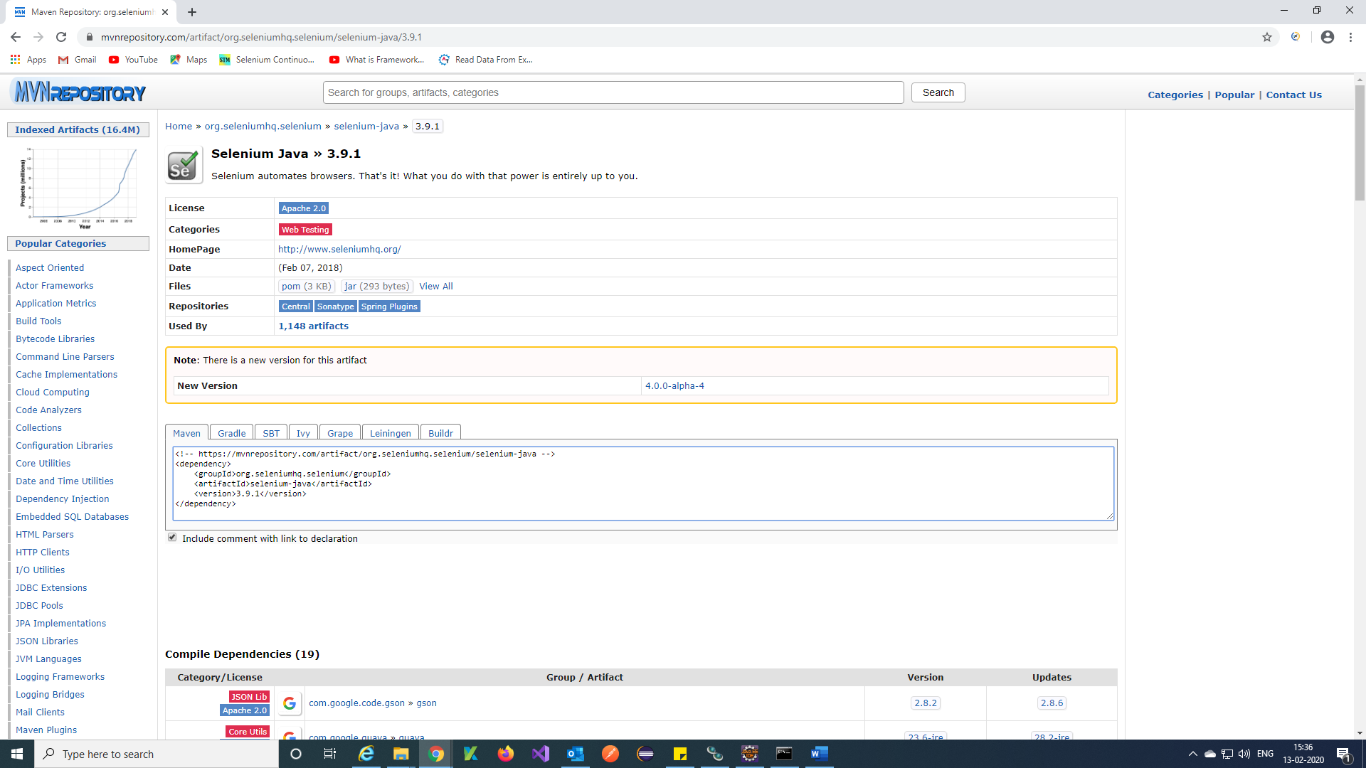

<!-- https://mvnrepository.com/artifact/org.seleniumhq.selenium/selenium-java -->

<dependency>

<groupId>org.seleniumhq.selenium</groupId>

<artifactId>selenium-java</artifactId>

<version>3.9.1</version>

</dependency>

Step 2) Open pom.xml file in maven project and paste the selenium java dependency and Save.

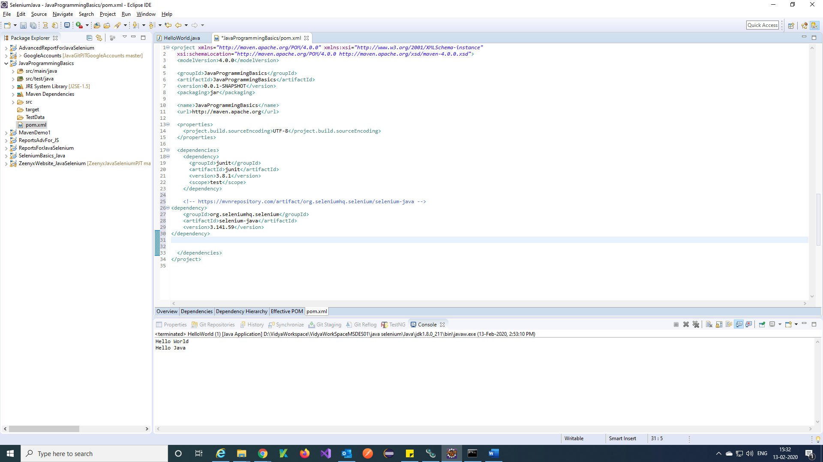

Step 3) Check selenium jar in maven dependency it should added into your project.

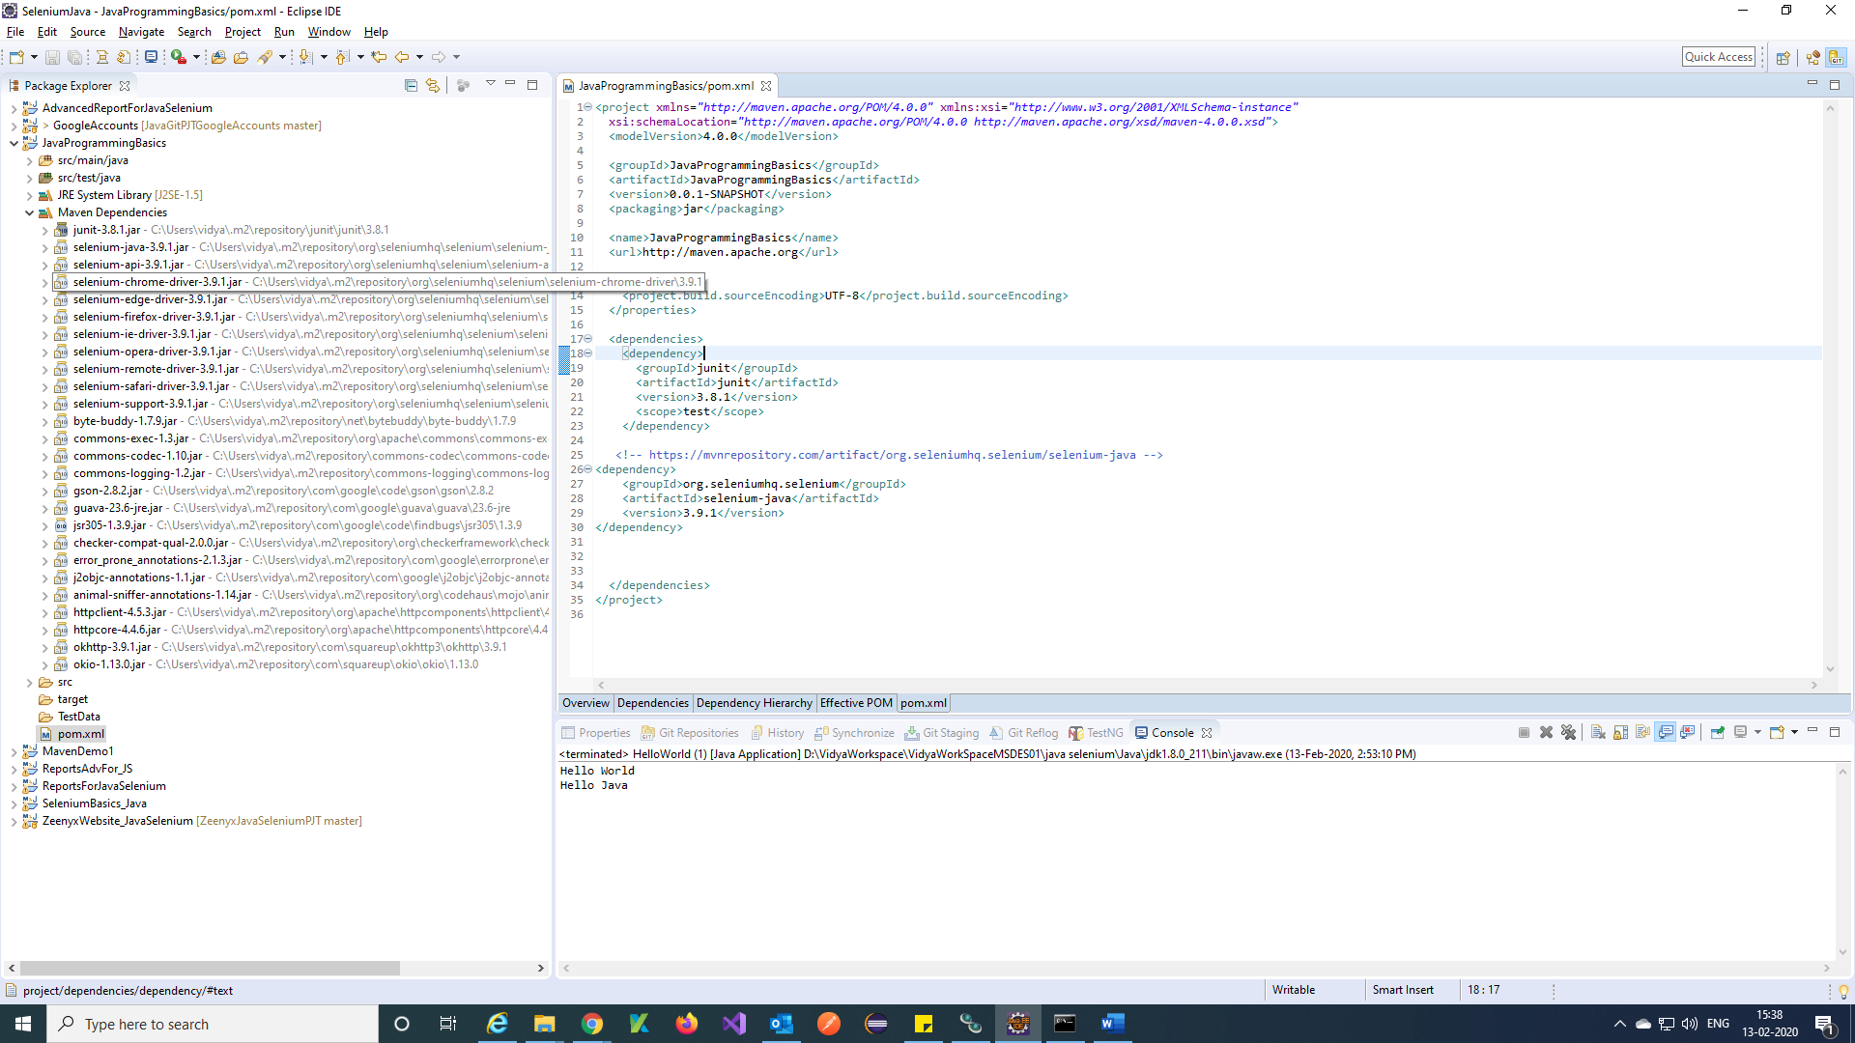

Note: Search required dependencies and add to your project by using this URL <https://mvnrepository.com/>

Add Selenium support dependency and chrome, Firefox, IE Dependencies.

**TestNG SetUp:**

Step 1) Using this URL copy TestNG maven dependency

<https://mvnrepository.com/artifact/org.testng/testng/6.14.3>

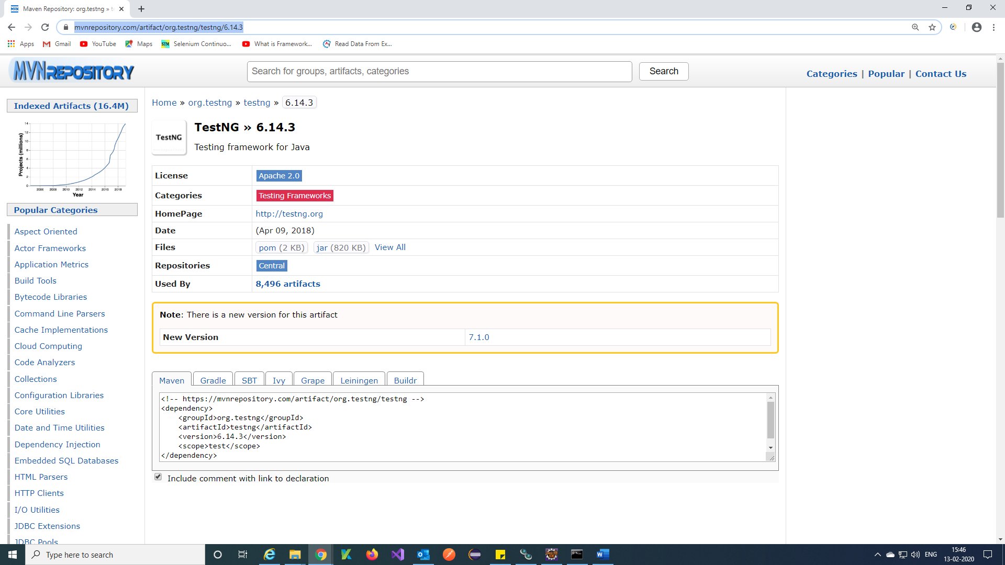

Step 2) Open pom.xml file in maven project and paste the selenium java dependency and Save.

Check selenium jar in maven dependency it should added into your project.

<!-- https://mvnrepository.com/artifact/org.testng/testng -->

<dependency>

<groupId>org.testng</groupId>

<artifactId>testng</artifactId>

<version>6.14.3</version>

<scope>test</scope>

</dependency>

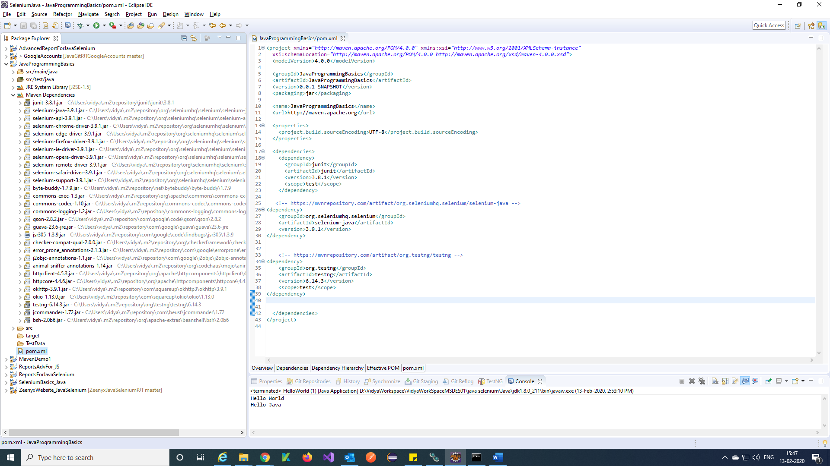

**Create a test and run:**

Step 1) Create a class and Write a simple program

Use @Test annotation of TestNg instead of main method in program and import TestNg annotation.

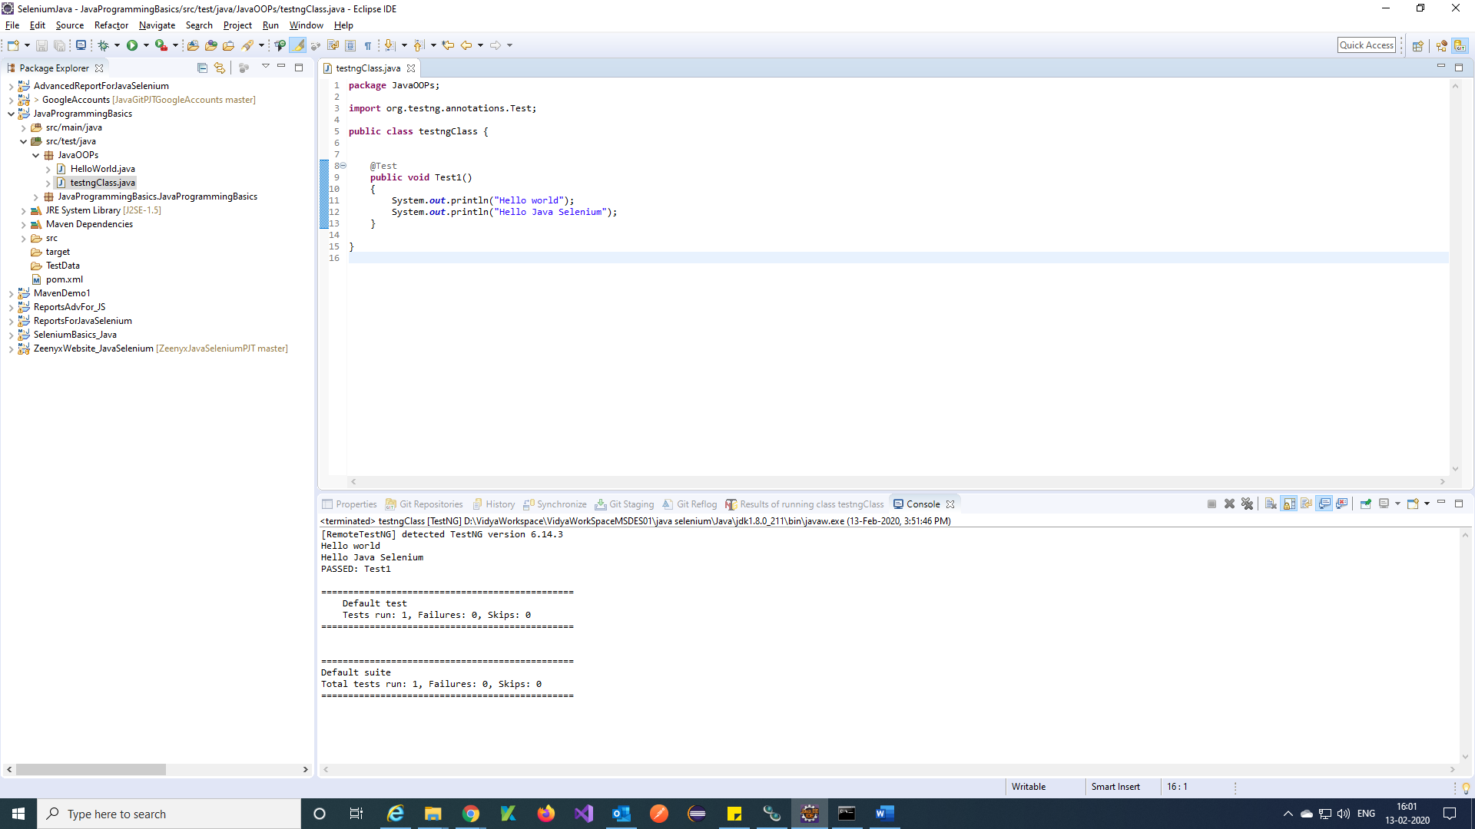

Step 2) Right click on class 🡪 Run As 🡪 TestNG Test.

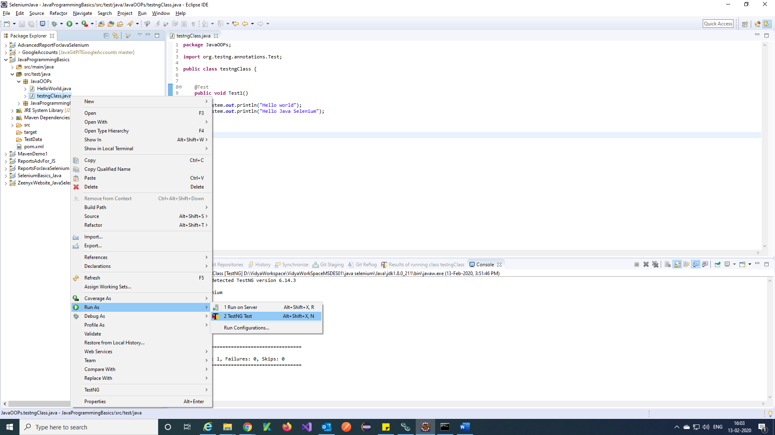

Step 3) We will get output like this in console.

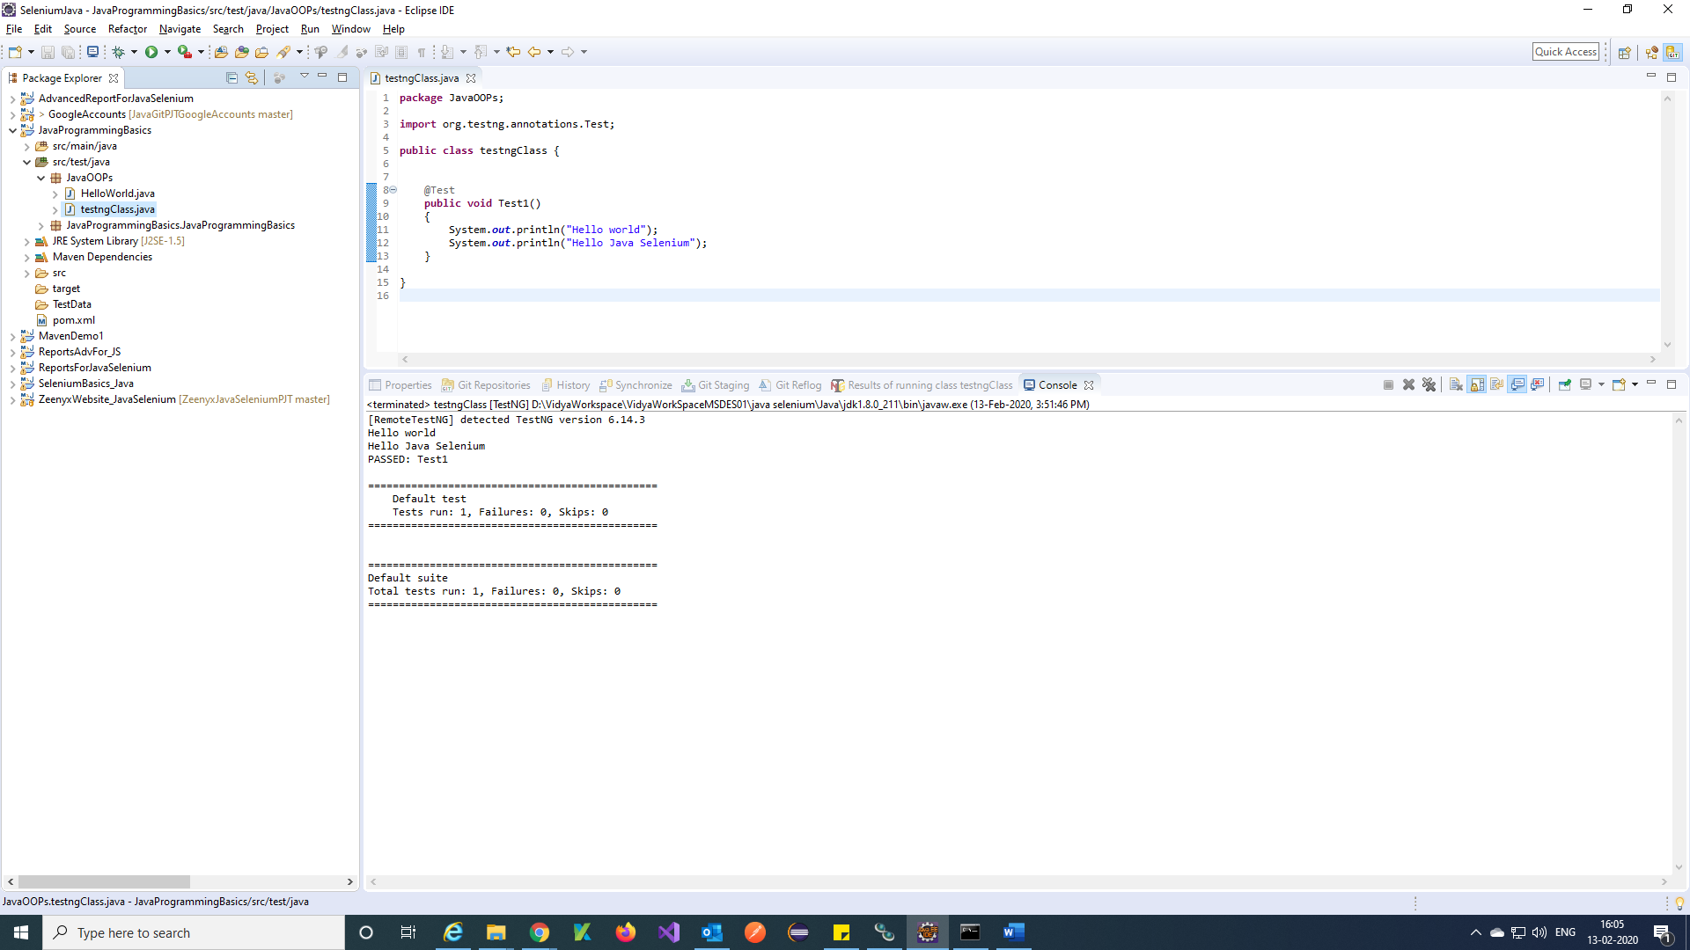

Note: Download Drivers (Chrome, Firefox, IE) and Store in your project always

URL for Chrome driver= <https://chromedriver.chromium.org/downloads>

URL for Firefox driver= <https://github.com/mozilla/geckodriver/releases/tag/v0.26.0>

URL for IE driver = <https://selenium.dev/downloads/>

