**Object Identification in Selenium**

1. **Identification of objects**
2. **Locators in selenium**

**Prerequisites:**

Maven project and Test URLs.

Note: We are working on Zeenyx Website

The URL is <https://www.zeenyx.com/>

**Identification of objects:**

Step 1) Open URL and right click on required object and select Inspect.

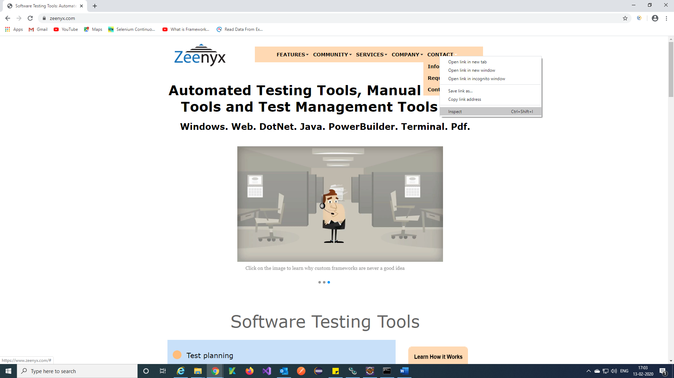

Step 2) You will get below window and Right click on particular object 🡪 Copy 🡪 Copy Xpath.

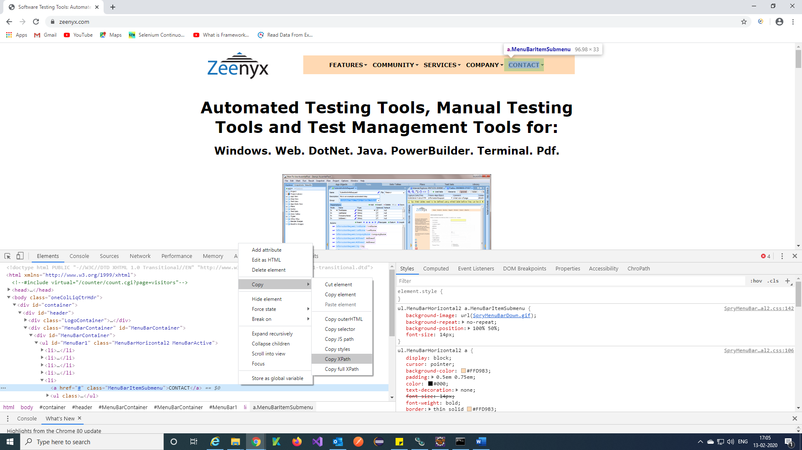

Note: Do Ctrl+F in chrome and paste the copied object path and you can verify whether object is identifying.

**Locators in selenium:**

Locators in Selenium are one of the most powerful commands. Its ideally the building block of the Selenium automation scripts. It helps locate the GUI elements through which multiple user actions can be performed. These are one of the important parameters for scripting, and if they end up to be incorrect or brittle, they may lead to script failure. A good scripting base foundation requires elements to be located appropriately. For this, we have multiple locators in Selenium WebDriver. Below is the list of these locators of Selenium WebDriver:

* [ID](https://www.lambdatest.com/blog/locators-in-selenium-webdriver-with-examples/#testid1)
* [Name](https://www.lambdatest.com/blog/locators-in-selenium-webdriver-with-examples/#testid2)
* [LinkText](https://www.lambdatest.com/blog/locators-in-selenium-webdriver-with-examples/#testid3)
* [Partial LinkText](https://www.lambdatest.com/blog/locators-in-selenium-webdriver-with-examples/#testid4)
* [Tag Name](https://www.lambdatest.com/blog/locators-in-selenium-webdriver-with-examples/#testid5)
* [Class Name](https://www.lambdatest.com/blog/locators-in-selenium-webdriver-with-examples/#testid6)
* [DOM Locator](https://www.lambdatest.com/blog/locators-in-selenium-webdriver-with-examples/#testid7)
* [CSS Selector](https://www.lambdatest.com/blog/locators-in-selenium-webdriver-with-examples/#testid8)
* [Xpath](https://www.lambdatest.com/blog/locators-in-selenium-webdriver-with-examples/#testid9)

Using the above locators in Selenium WebDriver you can locate elements through **“findElement/findElements”** syntax.

// By ID

WebElement Txt_FirstName = driver.findElement(By.*id*("u_0_m"));

// By Name

WebElement Txt_SurName = driver.findElement(By.*name*("lastname"));

// By Xpath

WebElementTxt_EmailOrPhnNmbr=driver.findElement(By.*xpath*("//input[@id='u_0_r']"));

// By ClassName

driver.findElement(By.*className*("inputtext")).sendKeys("ClassNameLocator");

// By tagName

List<WebElement> list = driver.findElements(By.*tagName*("a"));

// By linkText

driver.findElement(By.*linkText*("Create a Page")).click();

// By partialLinkText

driver.findElement(By.*partialLinkText*("Create")).click();

// By cssSelector

driver.findElement(By.*cssSelector*("input.inputtext")).sendKeys("CSSSelectorLocators");

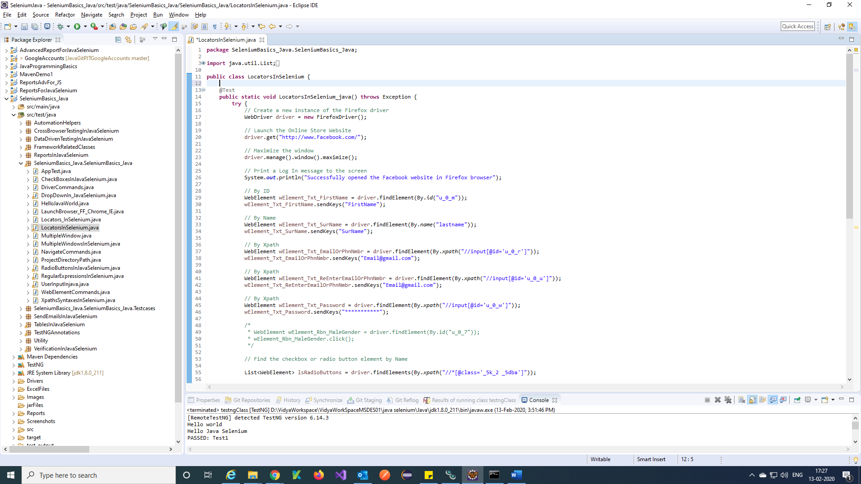

Note: If you want more information on locators refer in Google or YouTube.

Reference 🡪https://youtu.be/F8OddhVyHeE