**Run Tests from Command Prompt**

1. **Run Tests from command prompt**

**Prerequisites:**

1. **Maven project** and **TestNG XML Files**.
2. Apache Maven 3.6.3

Note: Download **Apache Maven 3.6.3** and add bin path to environments variables.

1. Add **maven-surefire-plugin** dependency in pom.xml to your project.

**Prerequisites:**

**Download Apache maven:**

Step 1) Using the below URL download apache maven 3.6.3

<https://maven.apache.org/download.cgi>

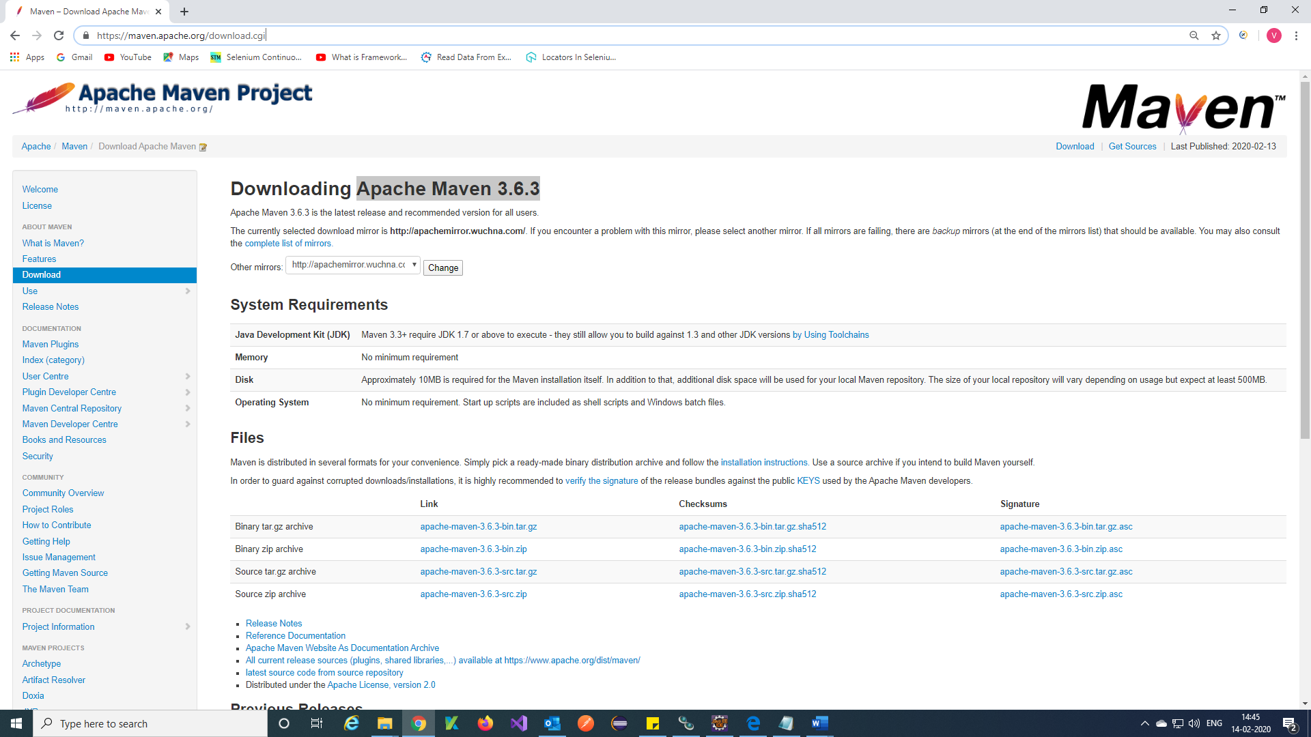

Step 2) Copy bin path and add to environment variables.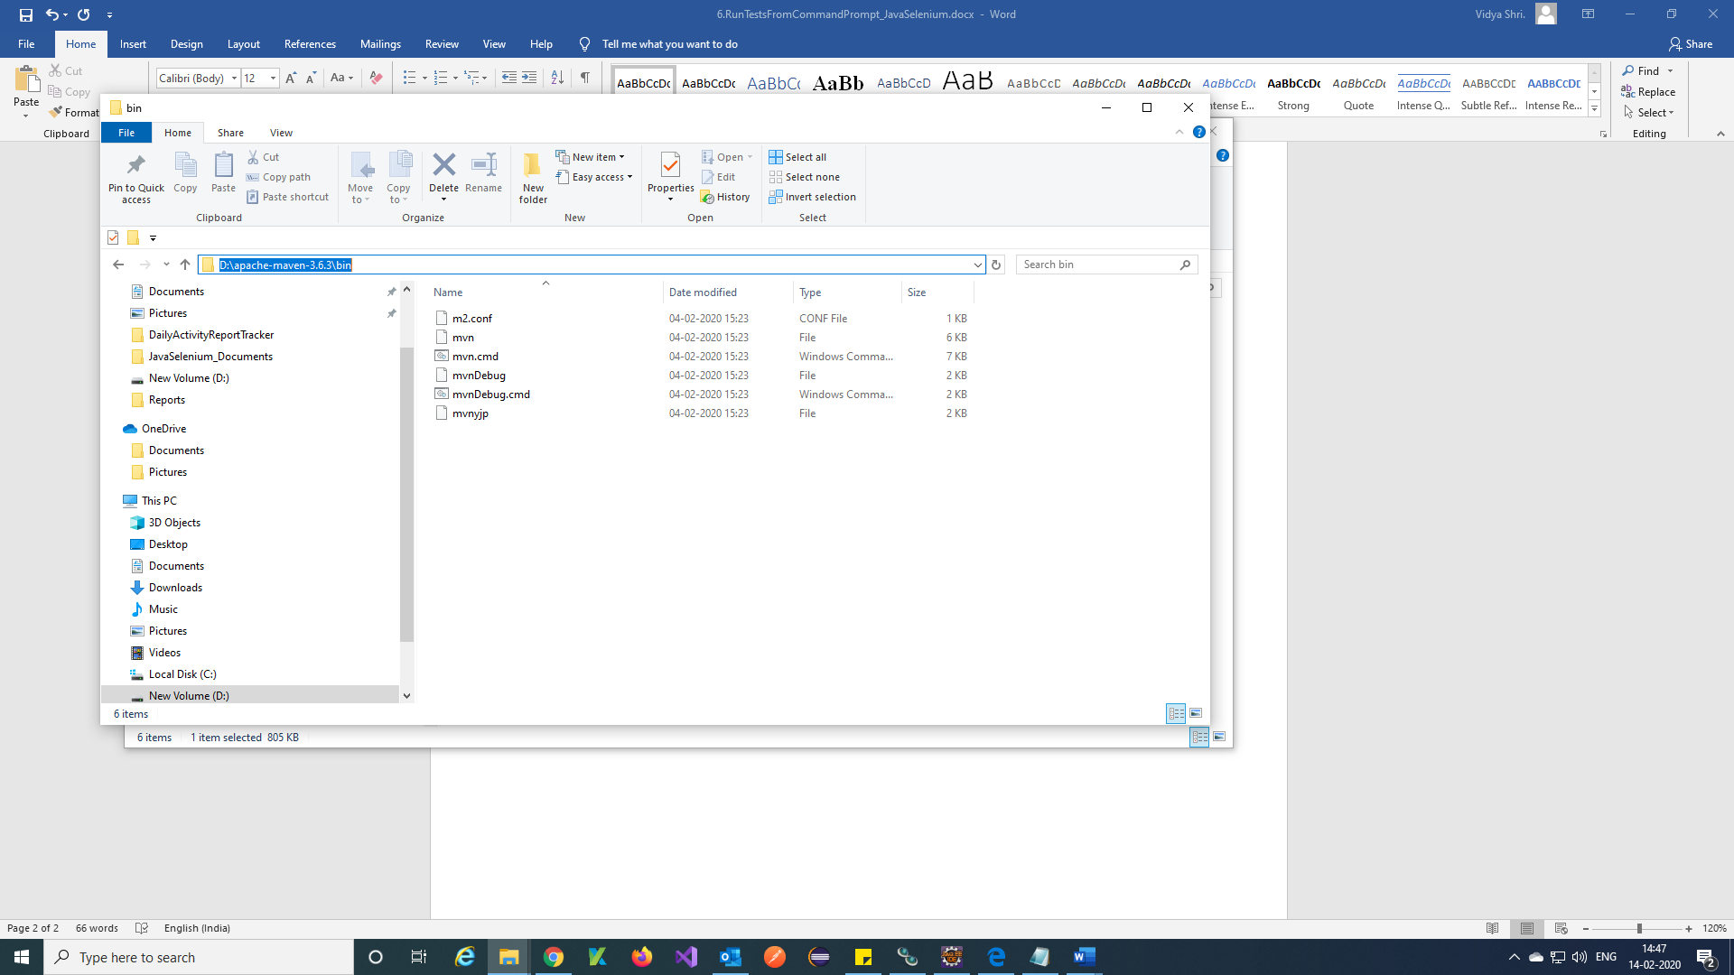

Step 3) Add path 🡪 Ok.

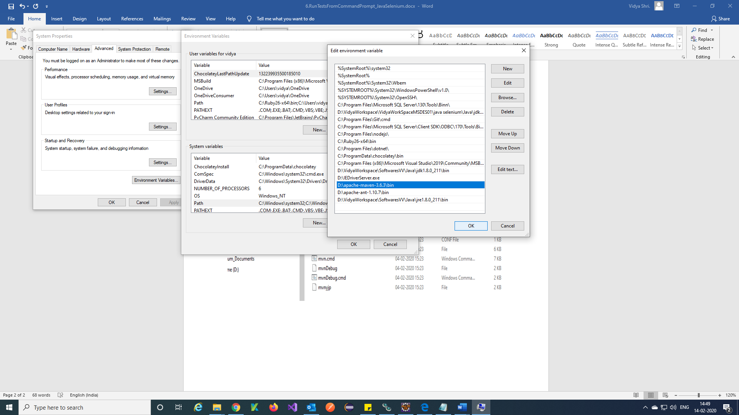

Step 4) Open command prompt and check apache maven is working and check version

Version command = mvn -version

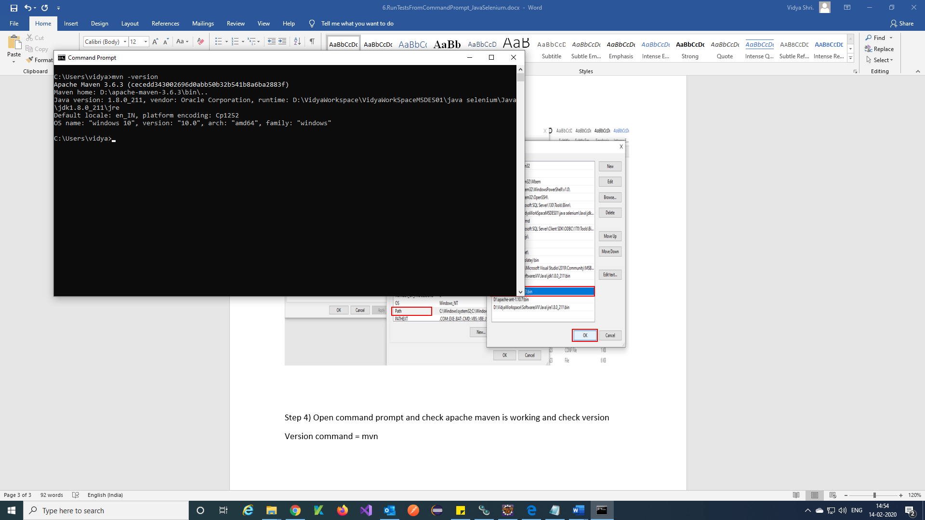

**Add maven surefire plugin to pom.xml:**

Step 1) Using the below URL copy **maven-surefire-plugin** pom and add to pom.xml in your project.

URL = <http://maven.apache.org/surefire/maven-surefire-plugin/examples/testng.html>

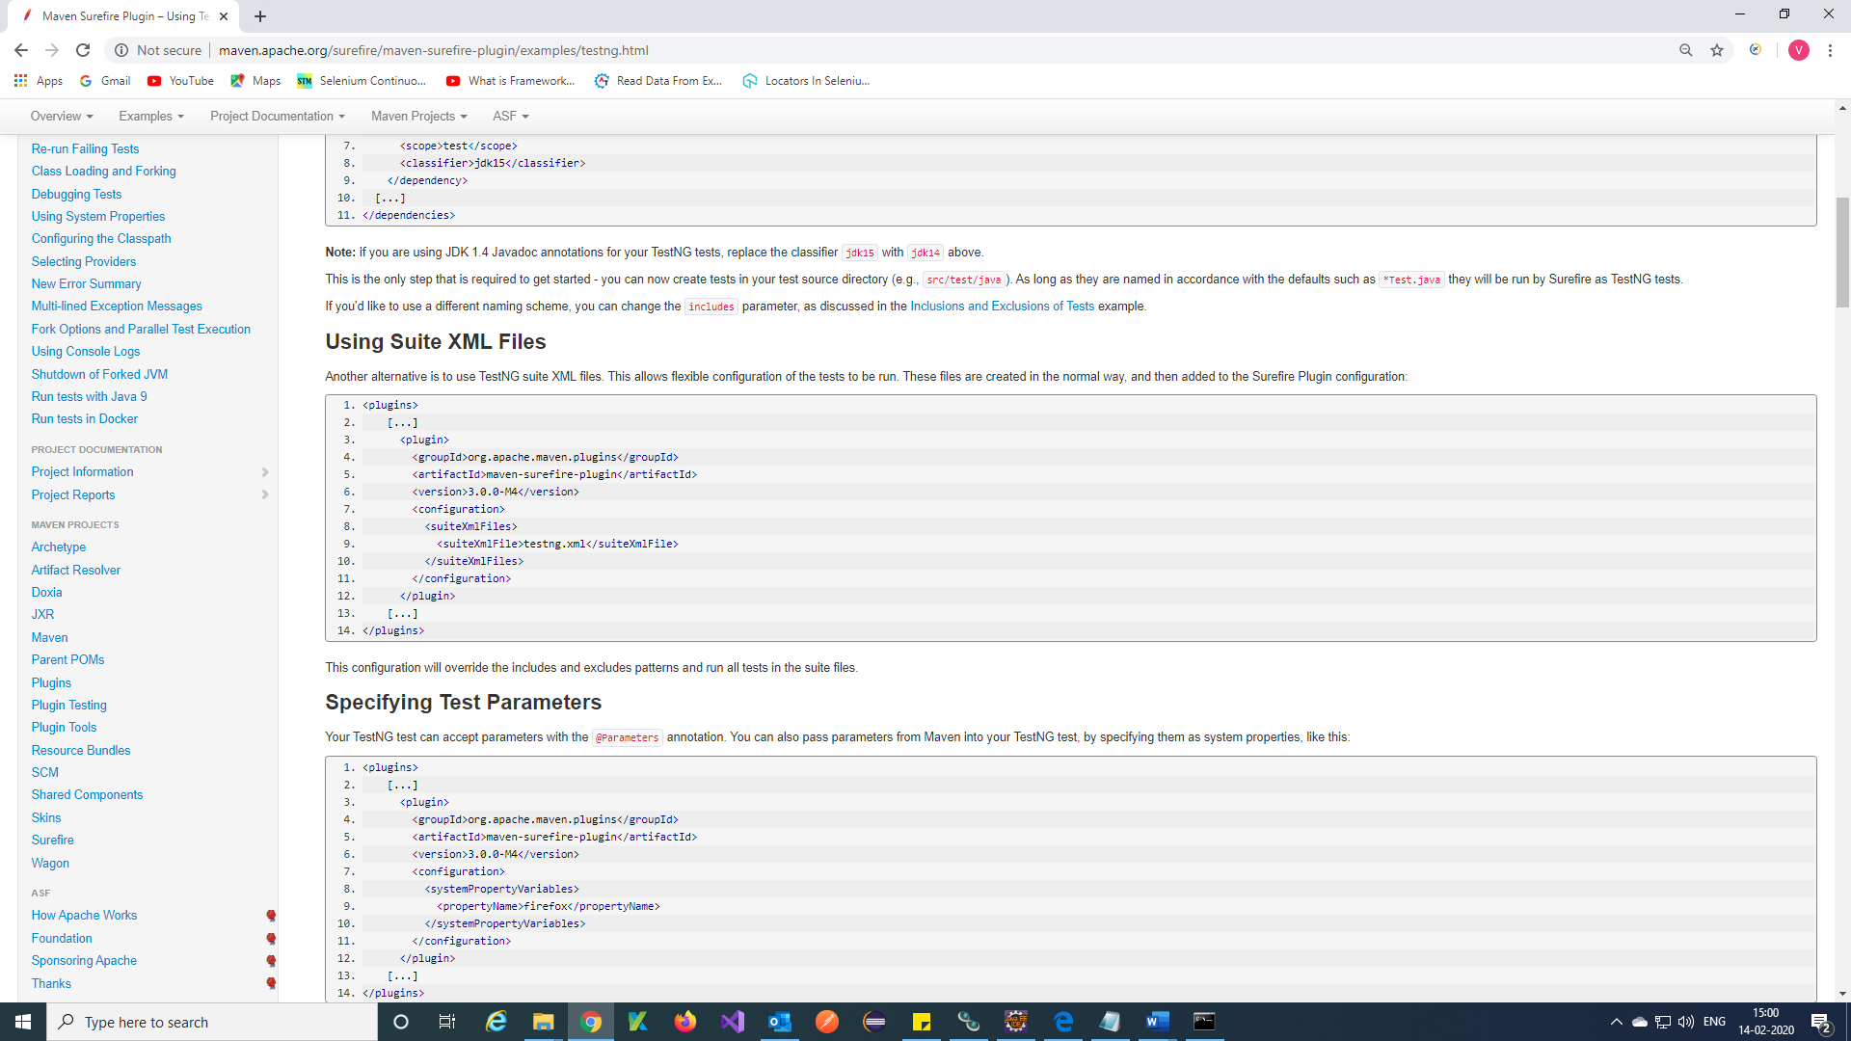

Step 2) Paste in pom.xml

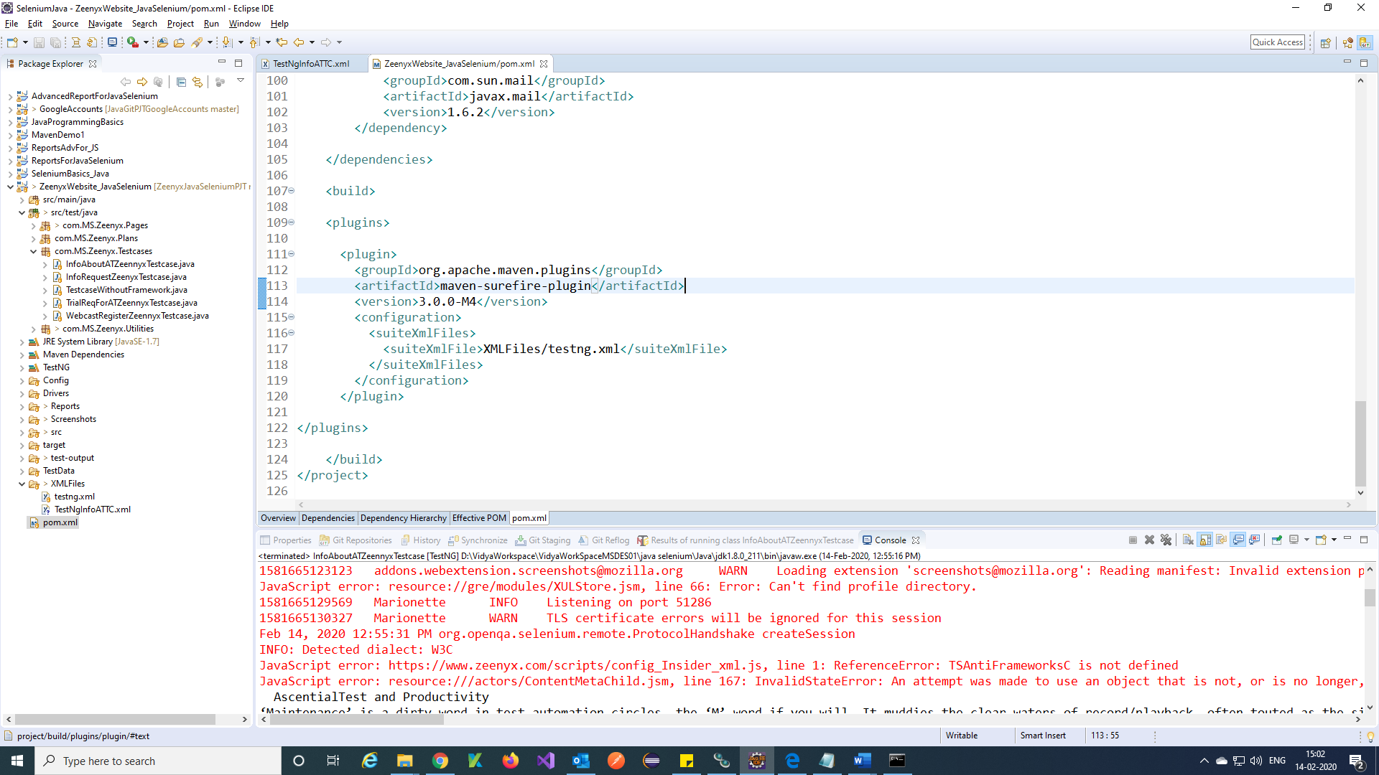

**Run Tests from command prompt:**

Step 1) Open your maven project and add TestNG xml file to your pom.xml and Save.

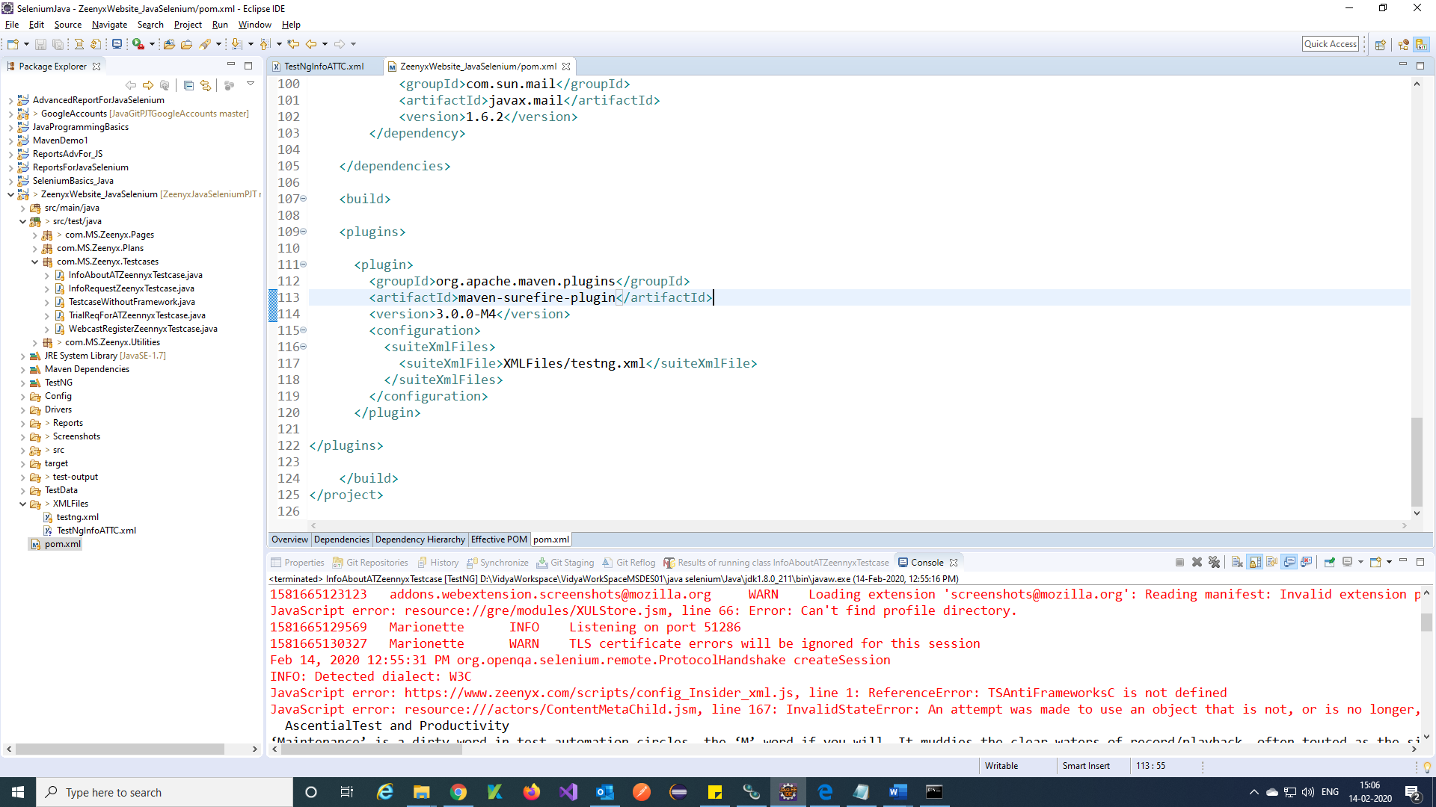

Step 2) Open your project path from command prompt and run command

Command = mvn clean 🡪 it will build your tests

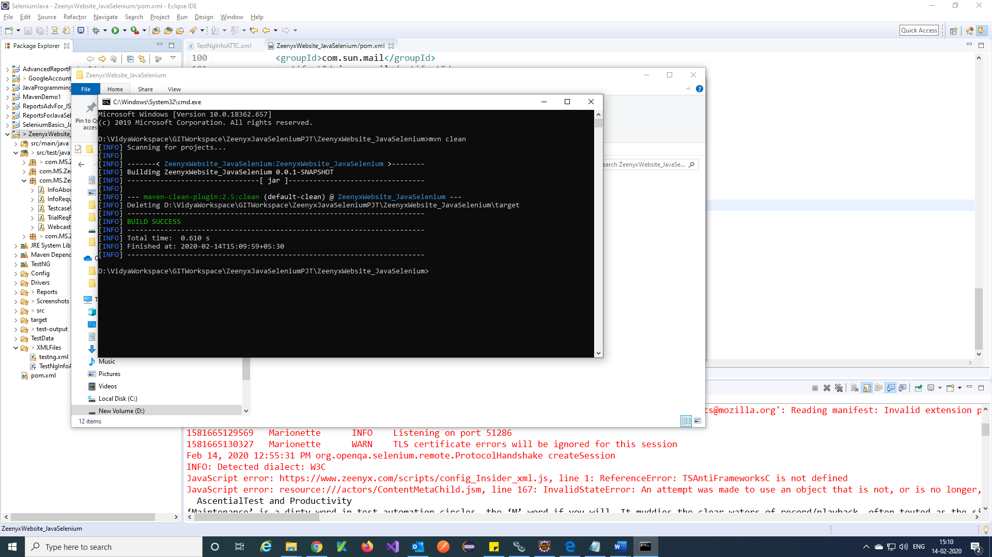

Command to run tests = mvn clean test

