**Create GitHub Account and Repository**

**Create GitHub Account and Repository:**

***Step 1)*** Open Browser and enter URL = <https://github.com/> 🡪 click on SignUP

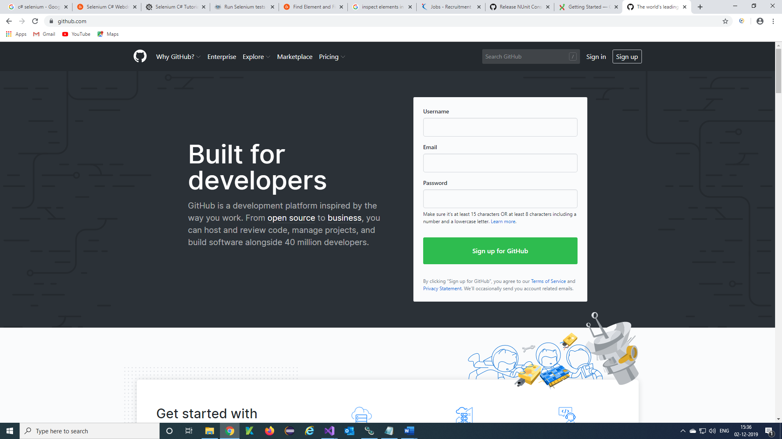

***Step 2)*** Enter Details and Verify 🡪 click on ‘Next a plan’

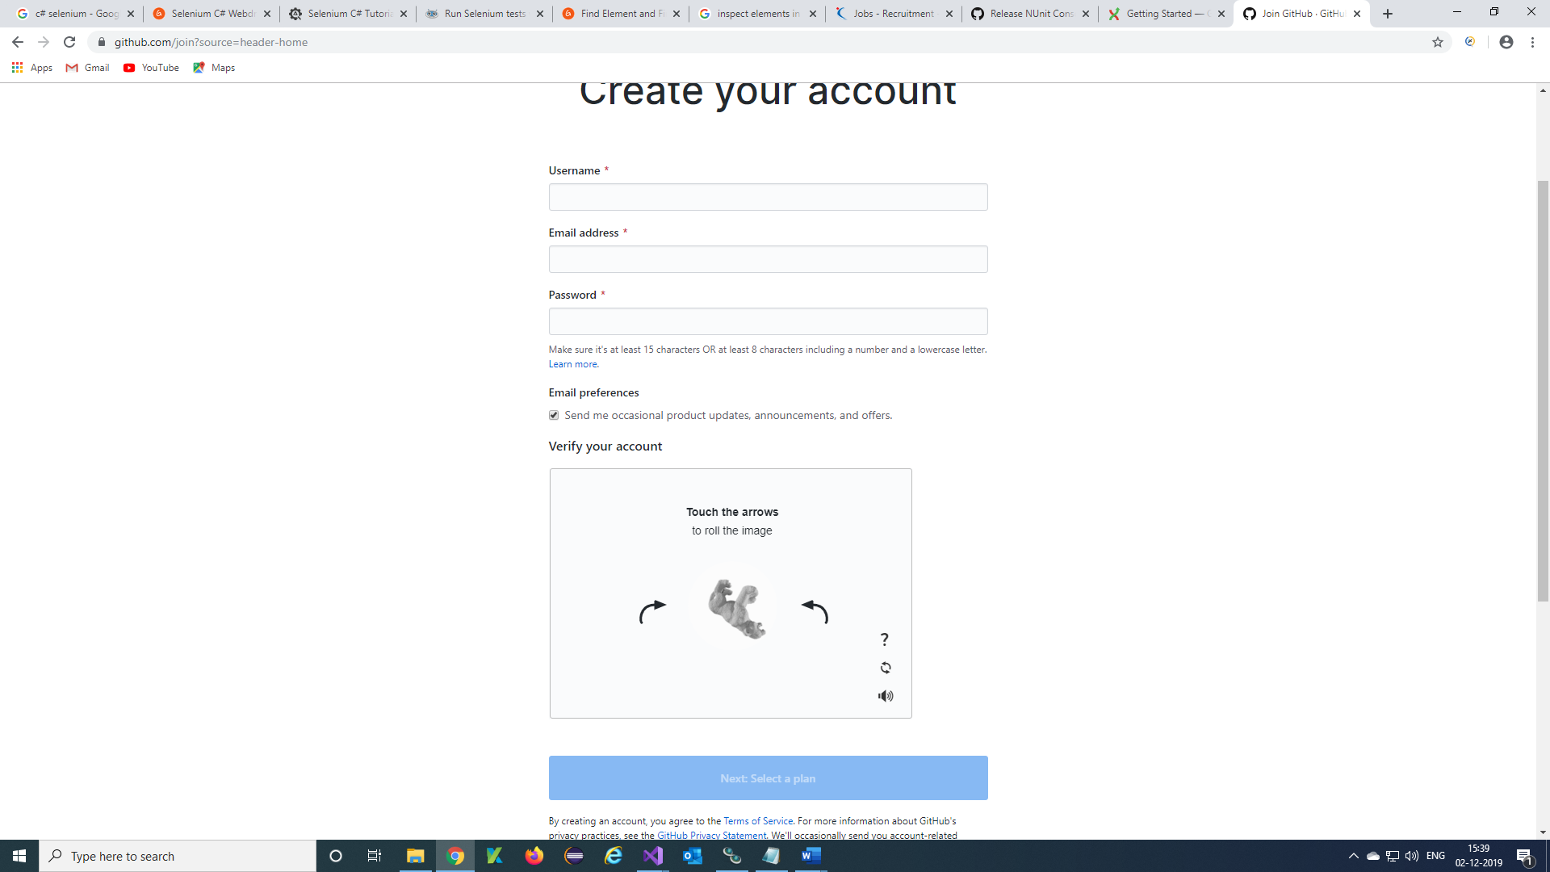

***Step 3)*** SignIn into your created account with your credentials

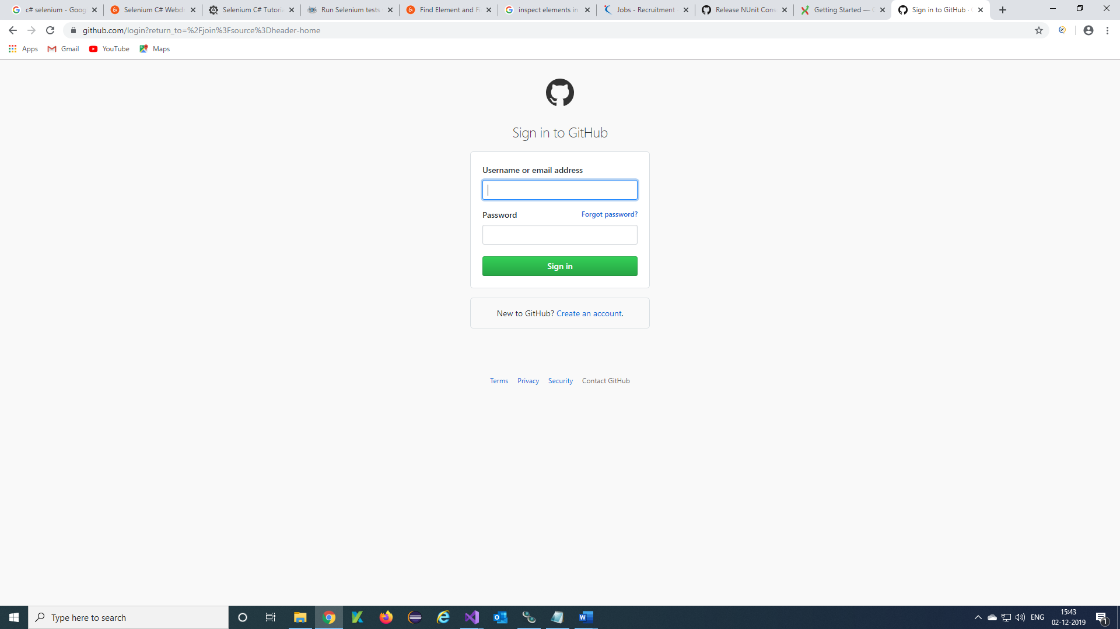

***Step 4)*** Your Account will be displayed 🡪 click on New

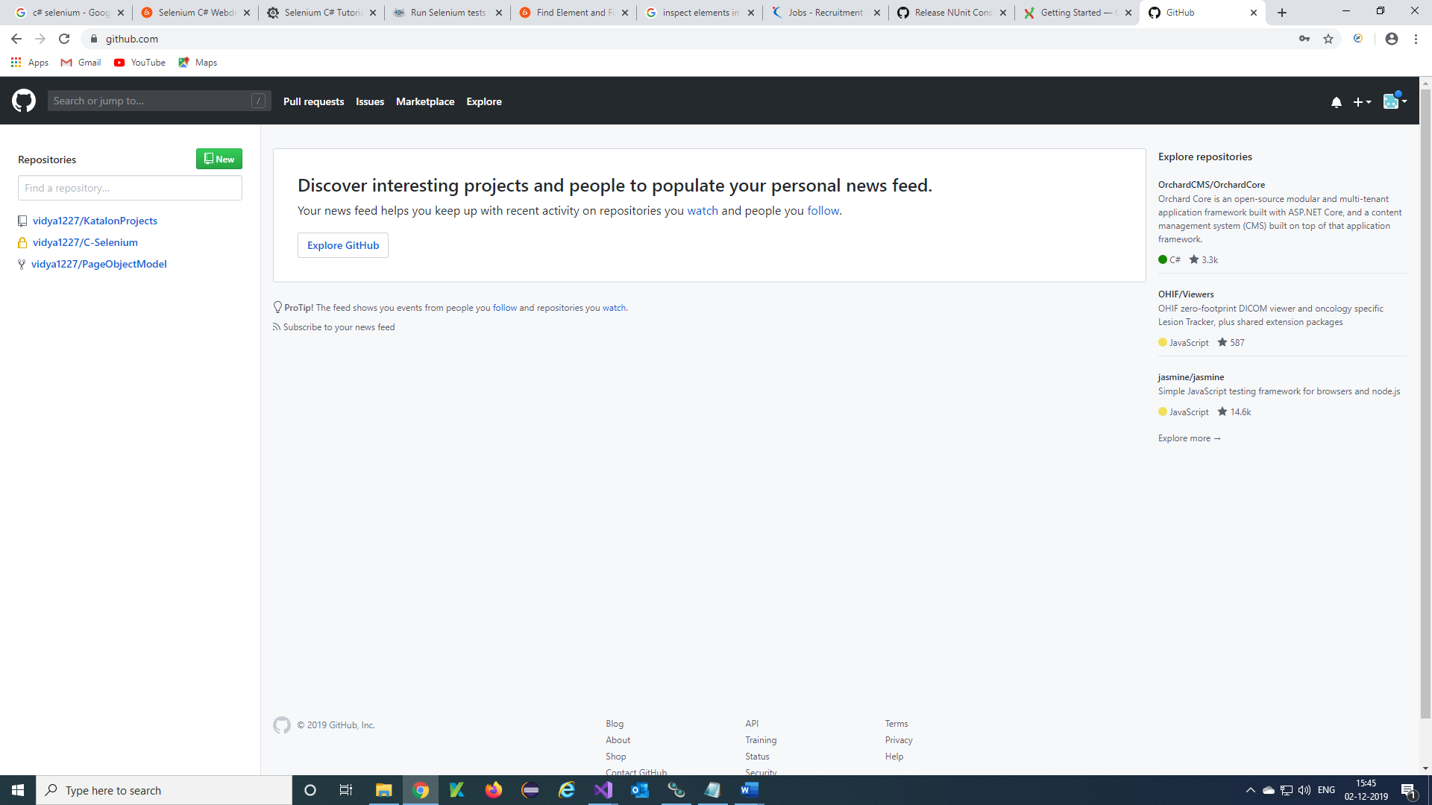

***Step 5)*** Create a new repository will display and Enter Repository name, Description, select the check boxand click on Create repository

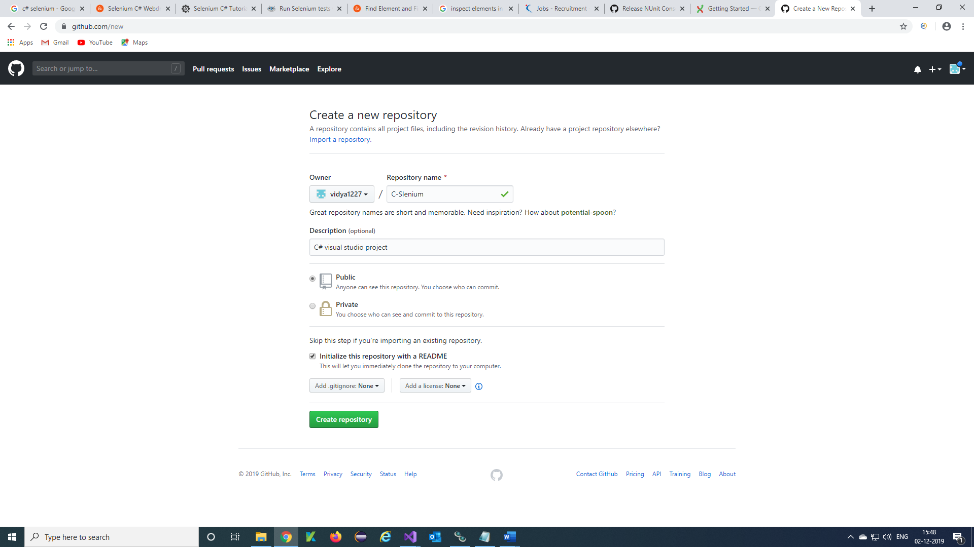

***Step 6)*** Your repository is created and displayed.

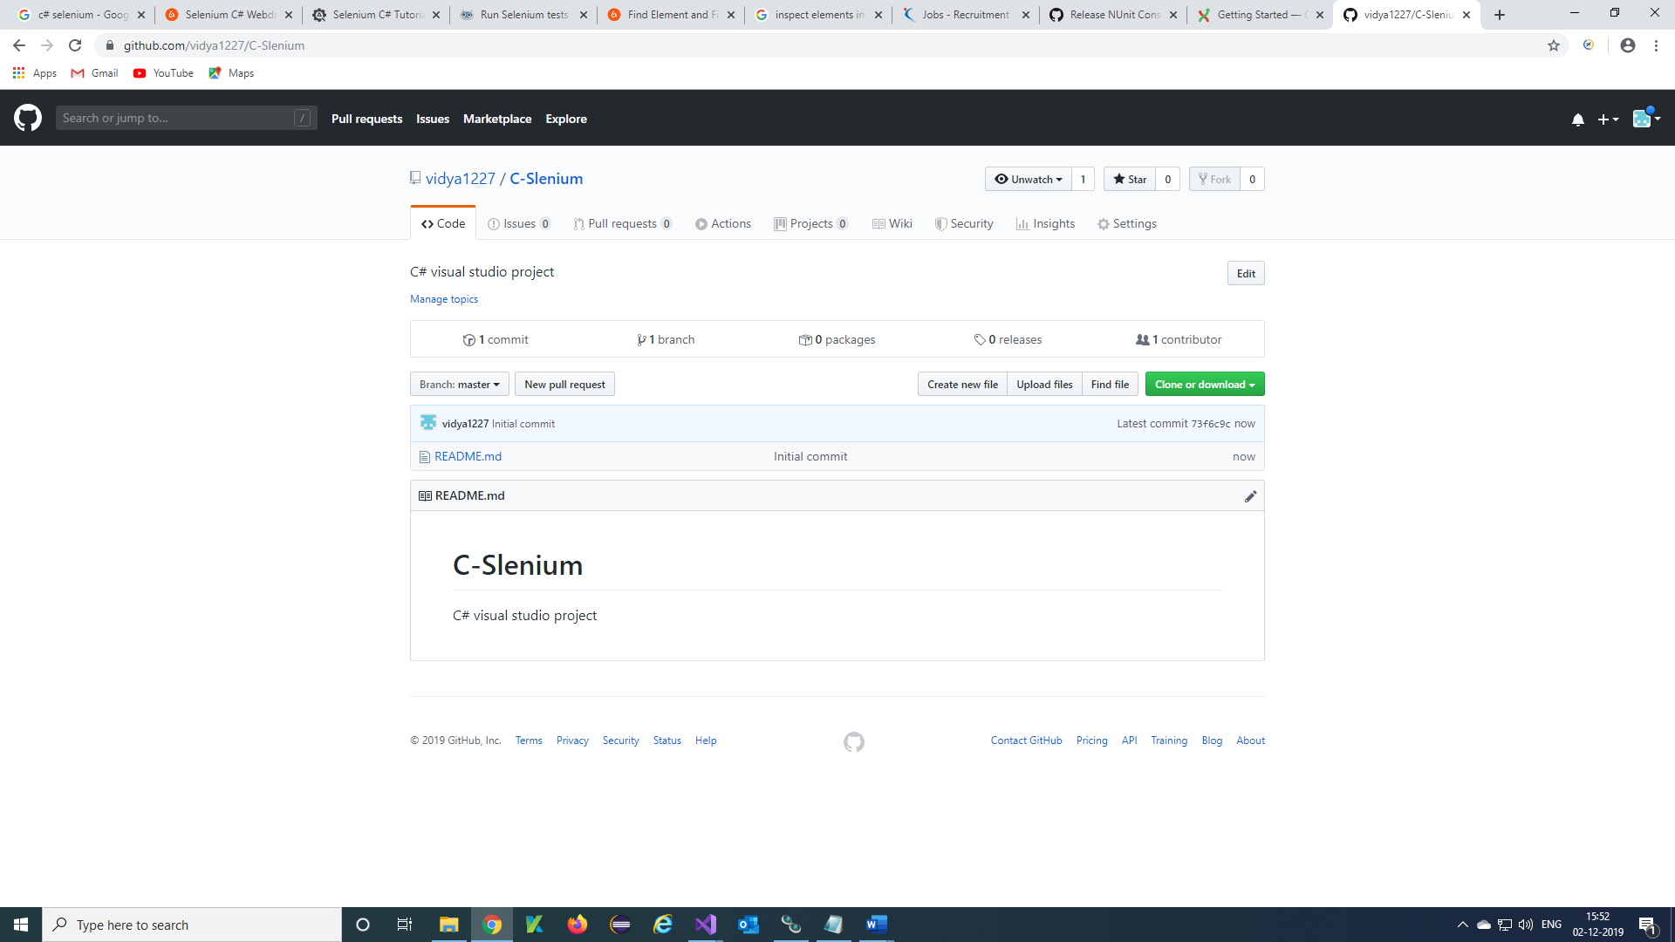

***Step 7)*** Click on Clone or download and copy the URL of repository

