**Java Selenium Testing**

1. **Continuous Integration model (Jenkins)**
2. **Version control (Git / SVN)**
3. **Java Selenium (Invoke and Picks Test suites)**
4. **Execution of tests**
5. **Report (HTML / PDF)**
6. **Emailing**
7. **Defect tracking (JIRA / Mantis / Bugzilla)**

**Continuous Integration model (Jenkins):**

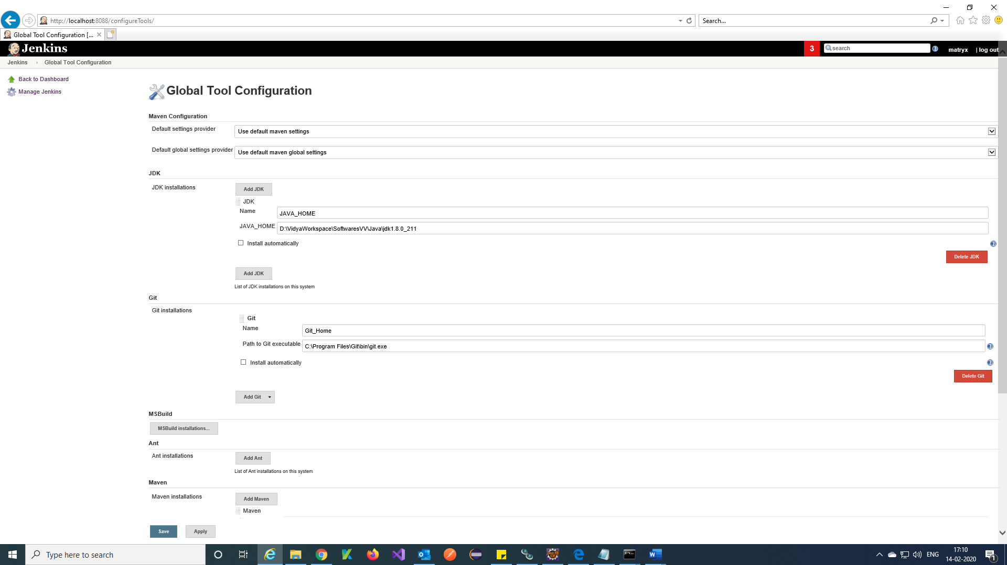

**JDK path.**

**GIT exe path.**

**Apache Maven path.**

**Git repository URL.**

**Command to run the testcase from Eclipse.**

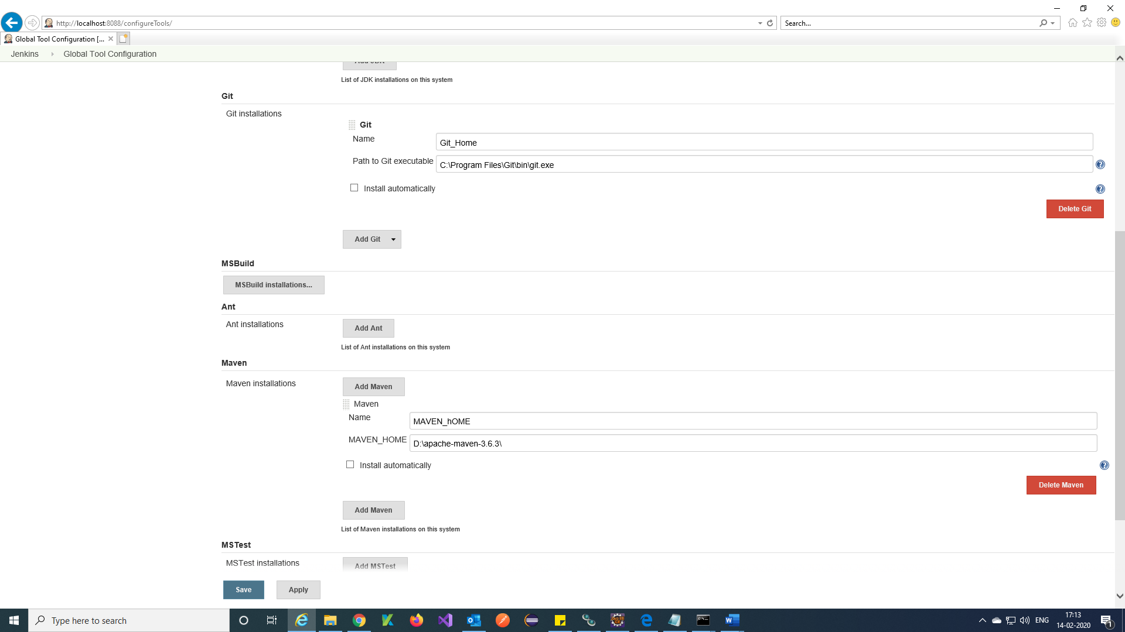

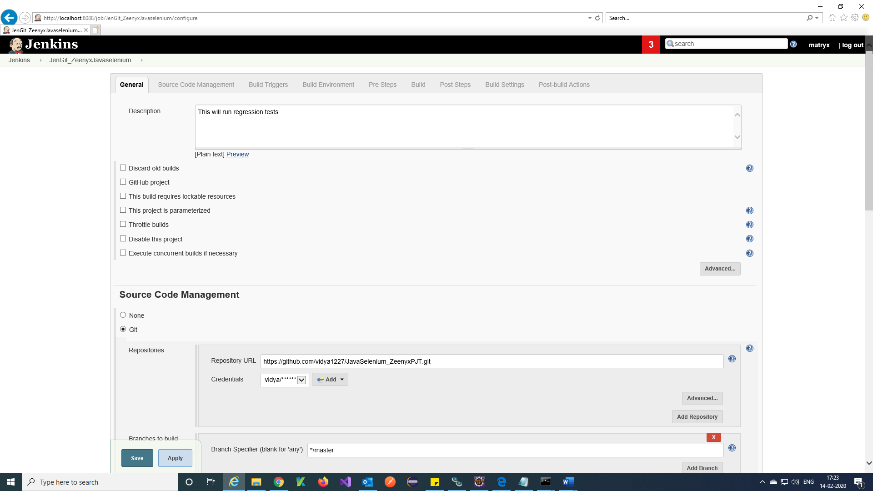

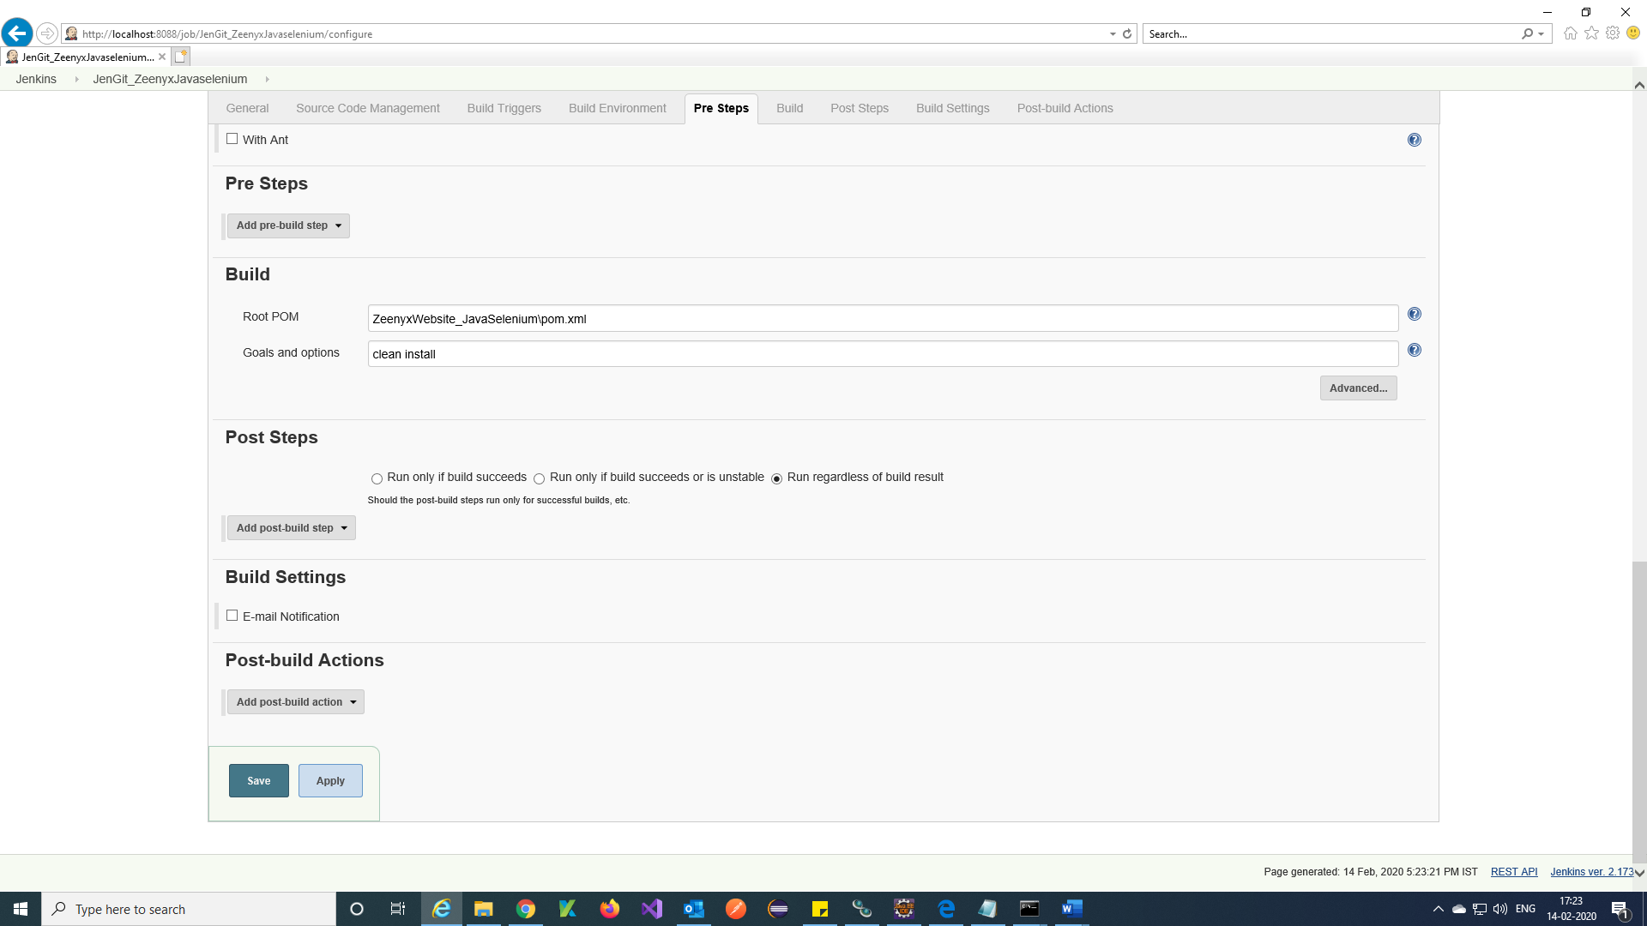

**Version control (GitHub):**

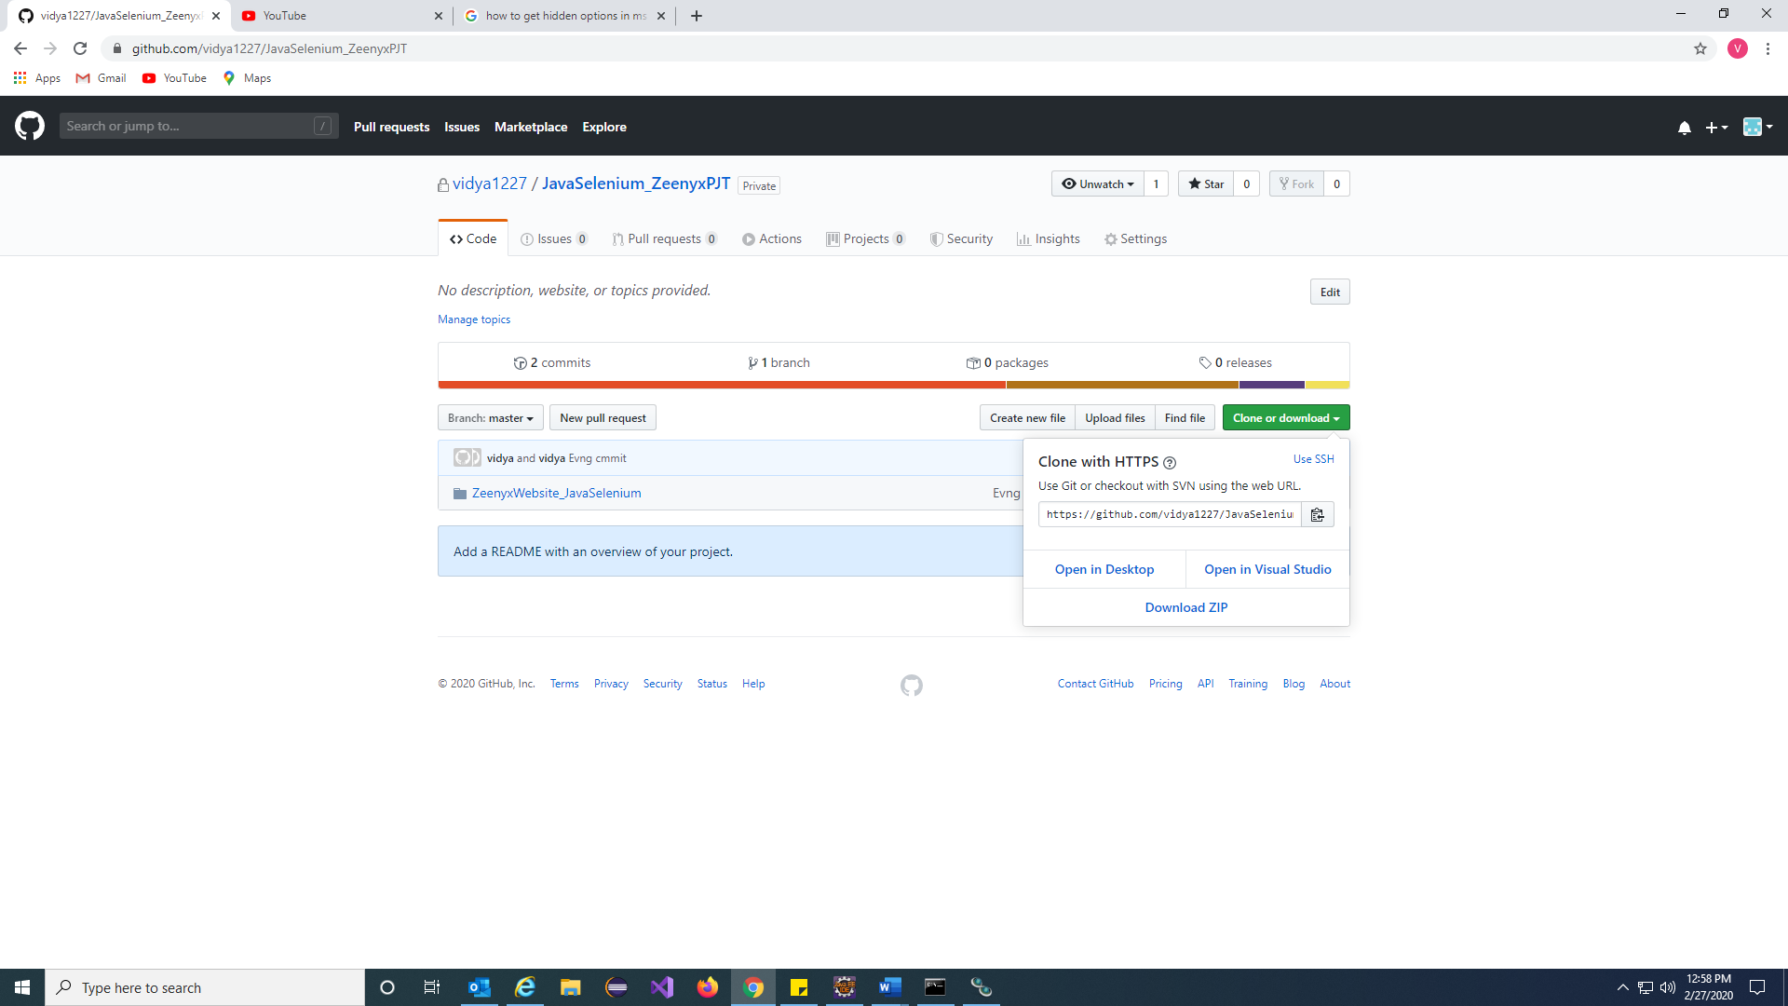

**The project in GitHub and Git URL for Jenkins integration.**

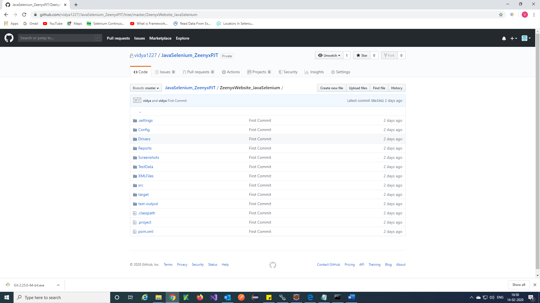

**Java Selenium (Invoke from eclipse and Picks Test suites):**

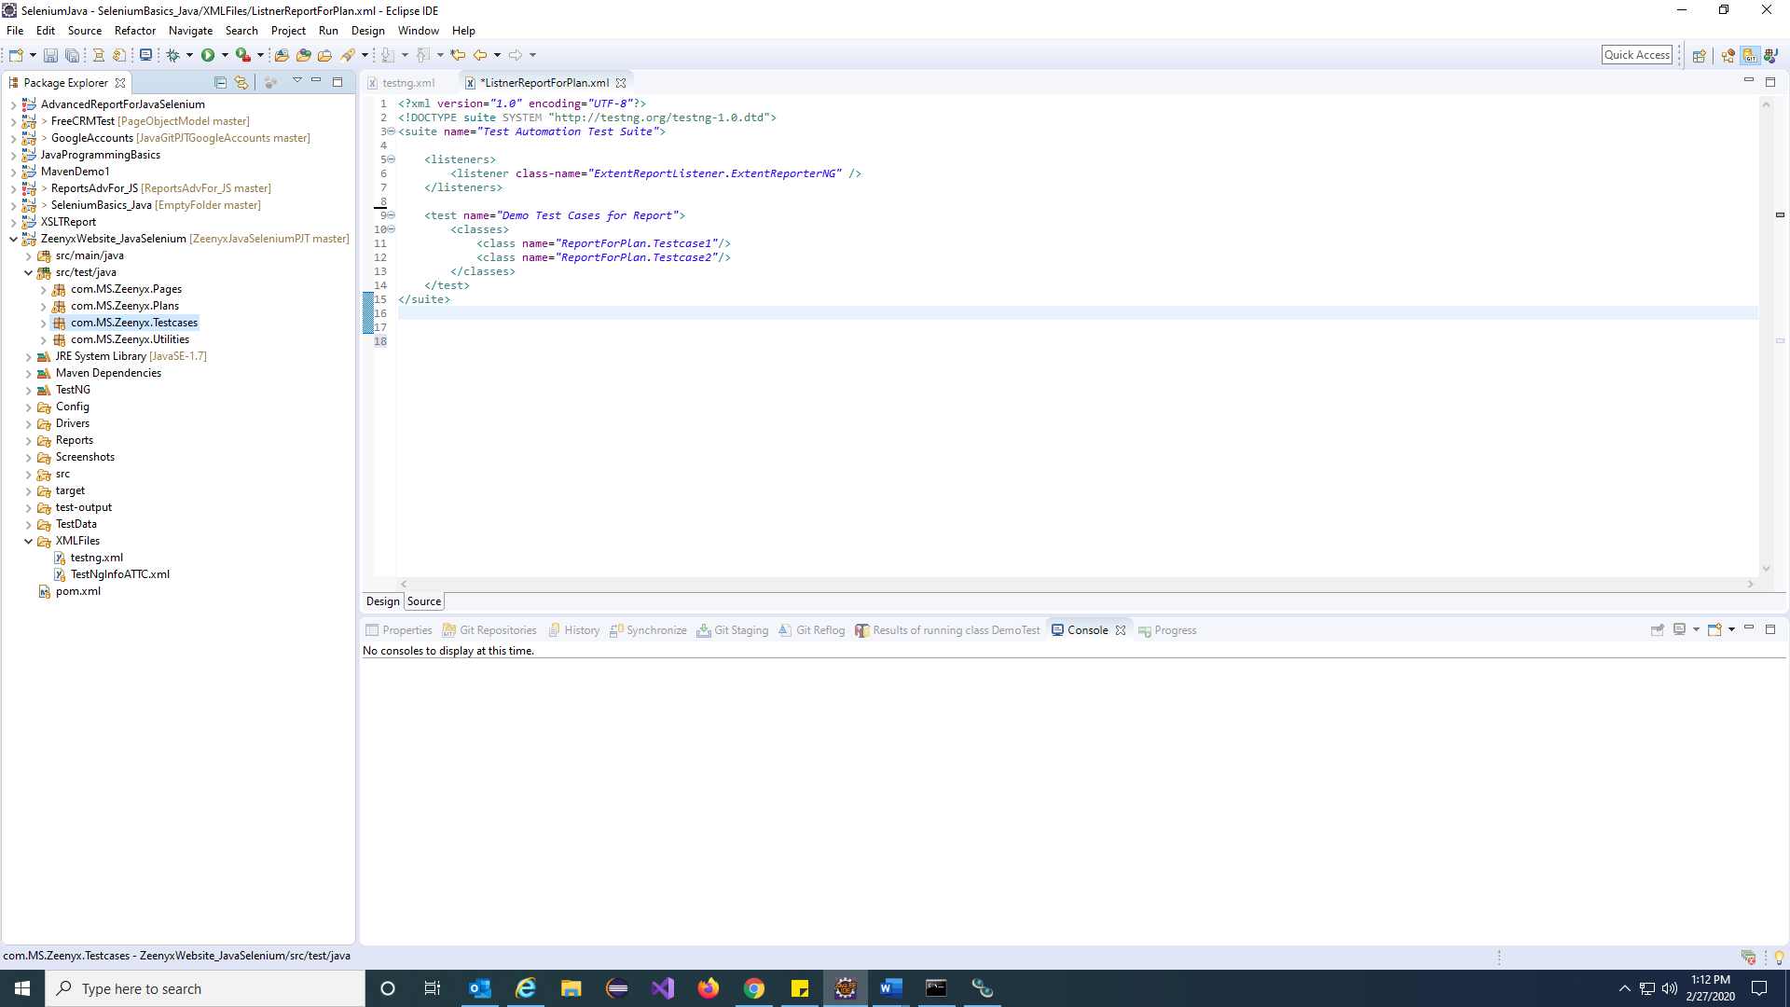

**The Java selenium project in Eclipse**

**Execution of tests from command prompt:**

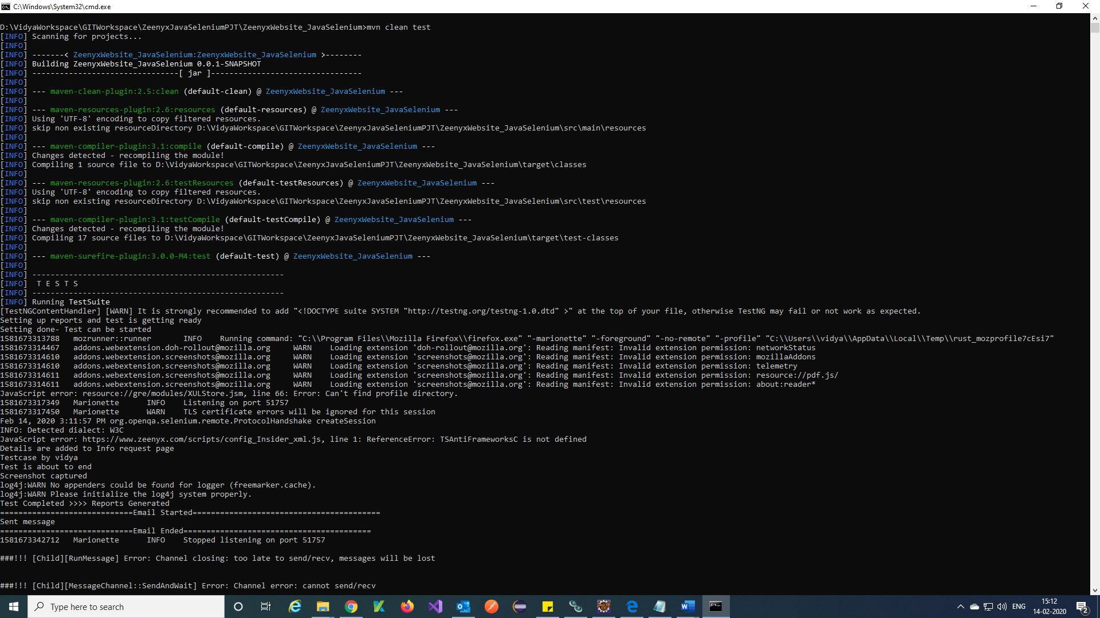

**The Tests are executing from command prompt.**

**Report (HTML):**

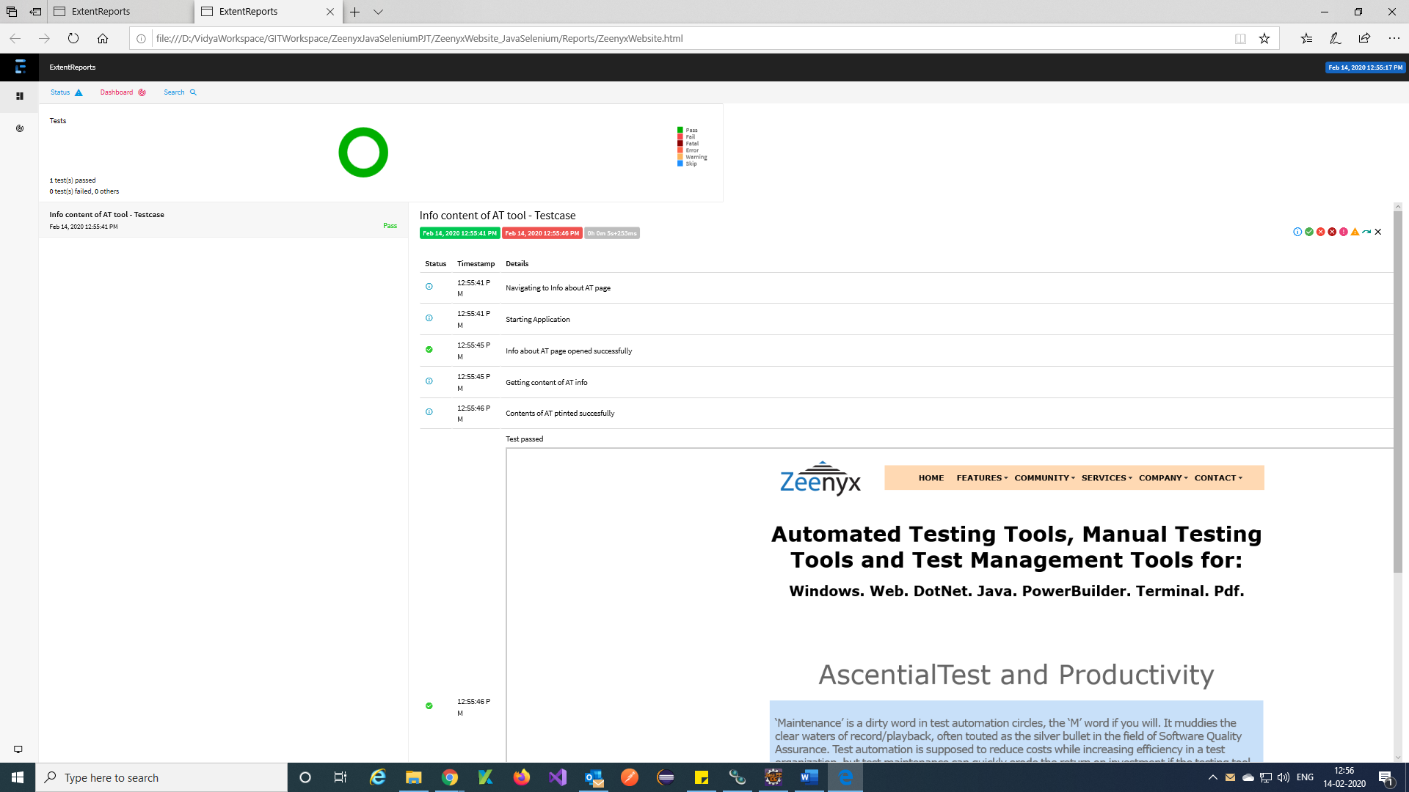

**The Extent report for C# selenium tests.**

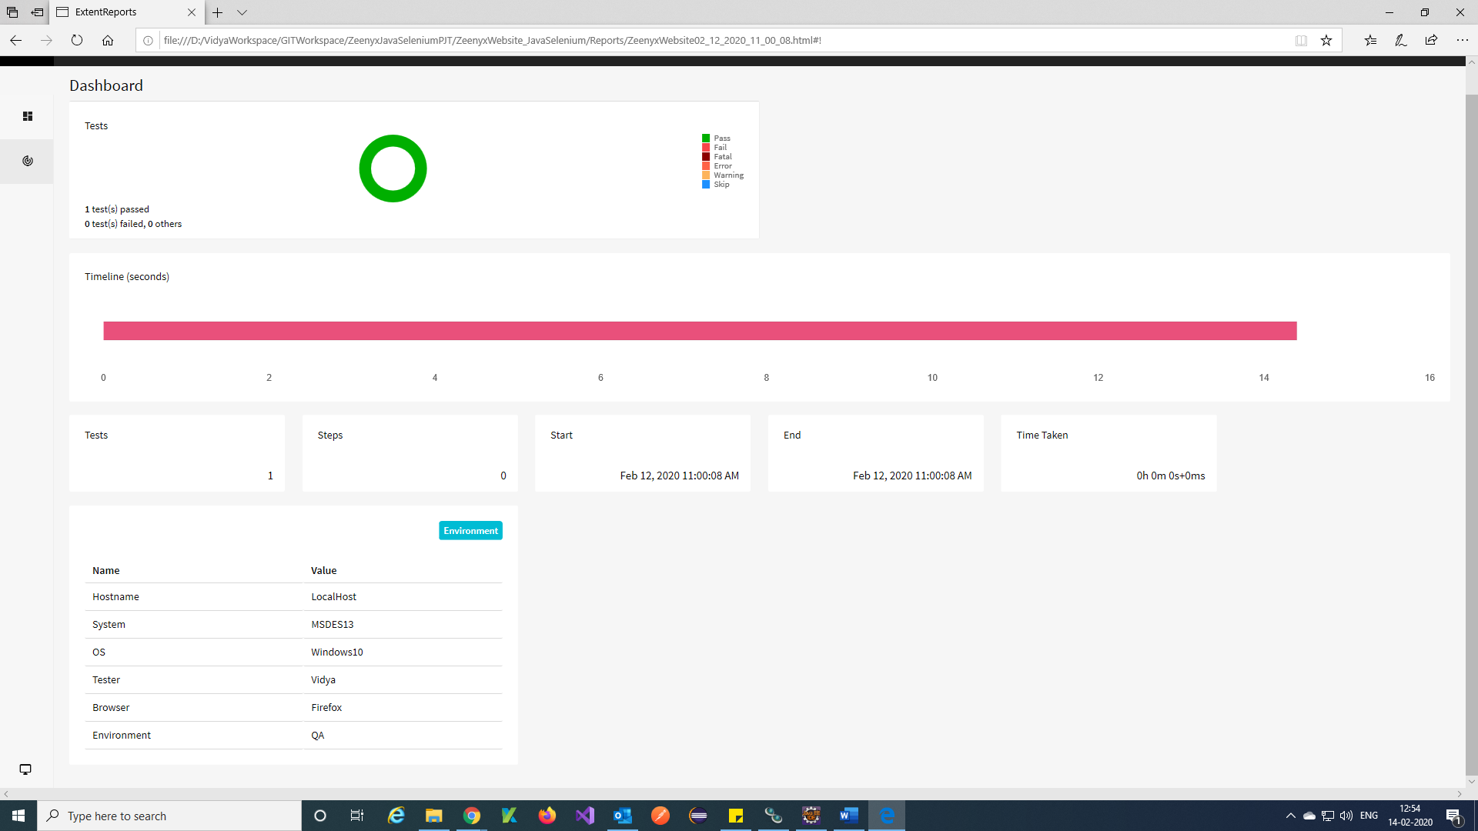

**Emailing:**

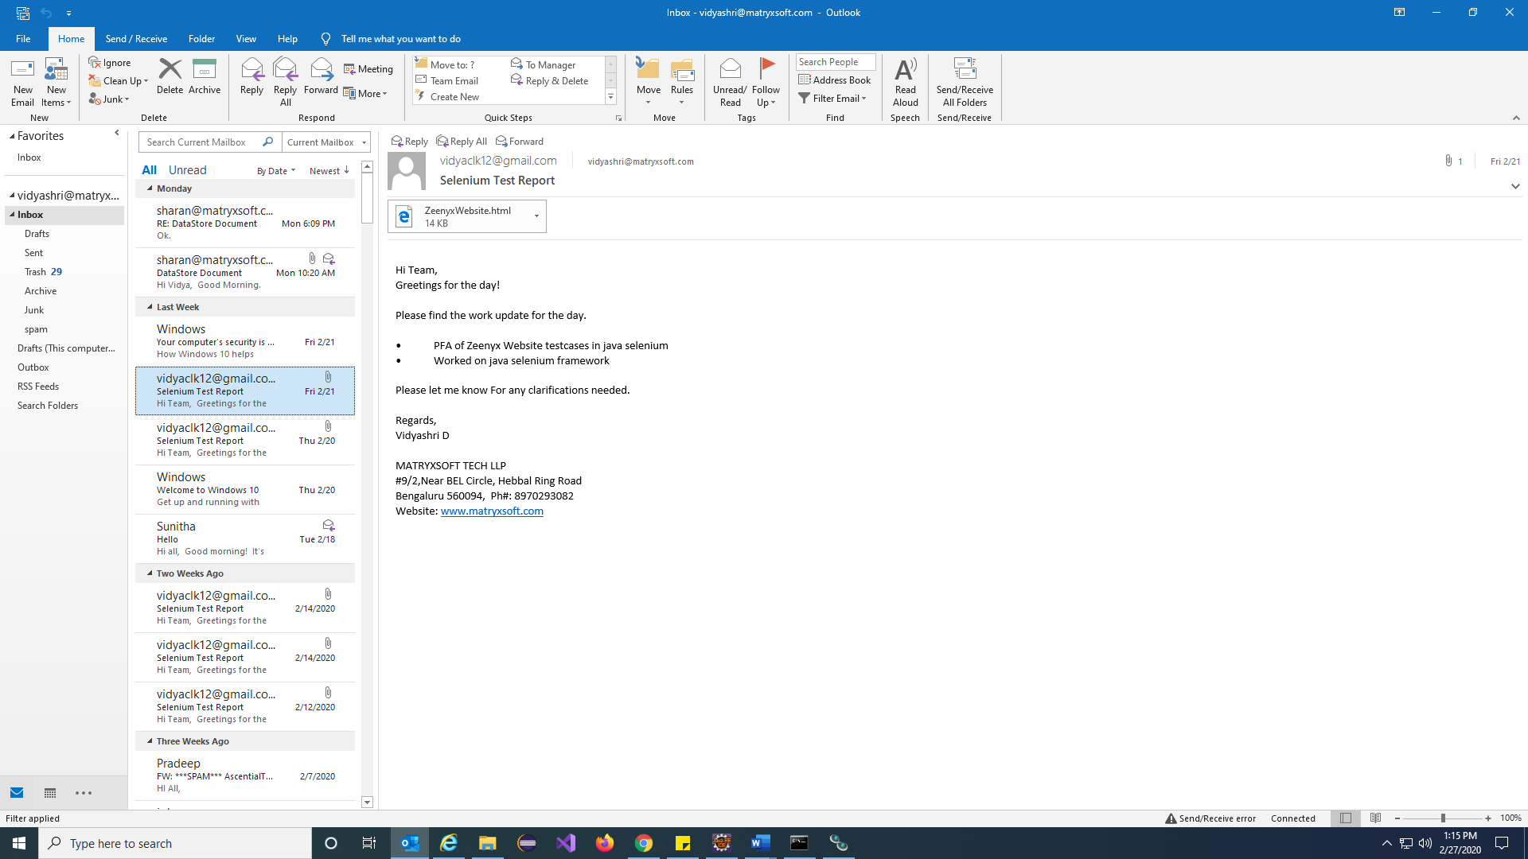

**Sending Reporting mail from Java selenium Scripts.**

**Defect tracking (JIRA):**

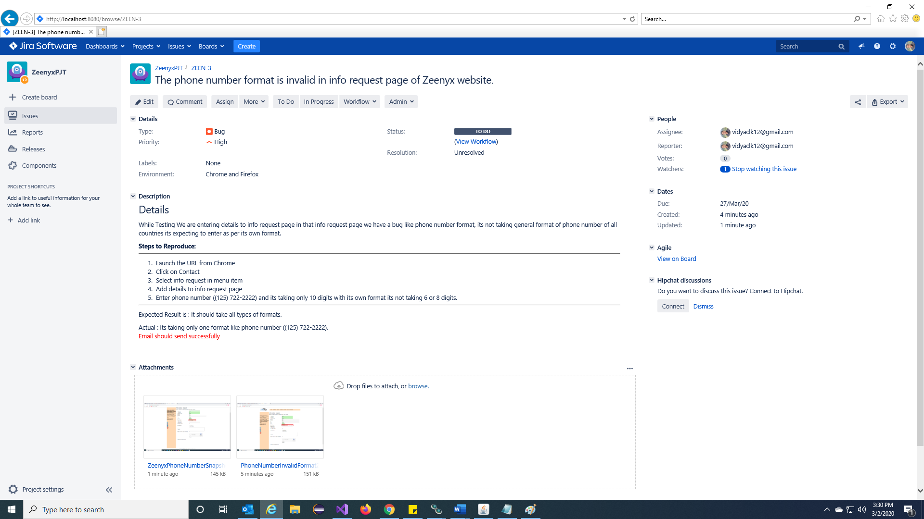

**The BUG created for C# selenium and also added description for the bug and assigned to a tester.**

**Attached Screenshots in BUG reporting of JIRA.**

**Note:** The above bug raised using JIRA defect tracking tool.