**XSLT Report for Selenium tests**

1. **Create XSLT report for selenium tests**

**Prerequisites:**

1. Maven Project with tests

Note: Run the tests which you have created in projects before creating Xslt report because test-output folder is required.

1. Apache Ant 1.10.7
2. XSLT Report jars and xml files

**Apache ant:**

Step 1) Download Apache ant using below URL🡪

<https://ant.apache.org/bindownload.cgi?Preferred=ftp://apache.mirrors.pair.com/>

Step 2) Copy bin path from apache ant.

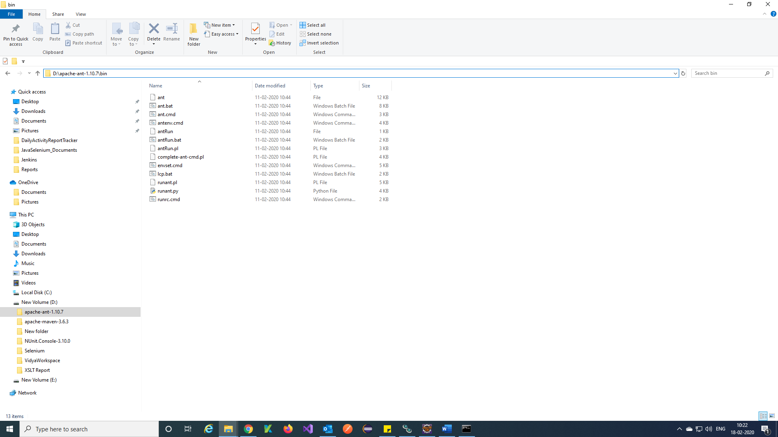

Step 3) Add bin path to environments variables in your system.

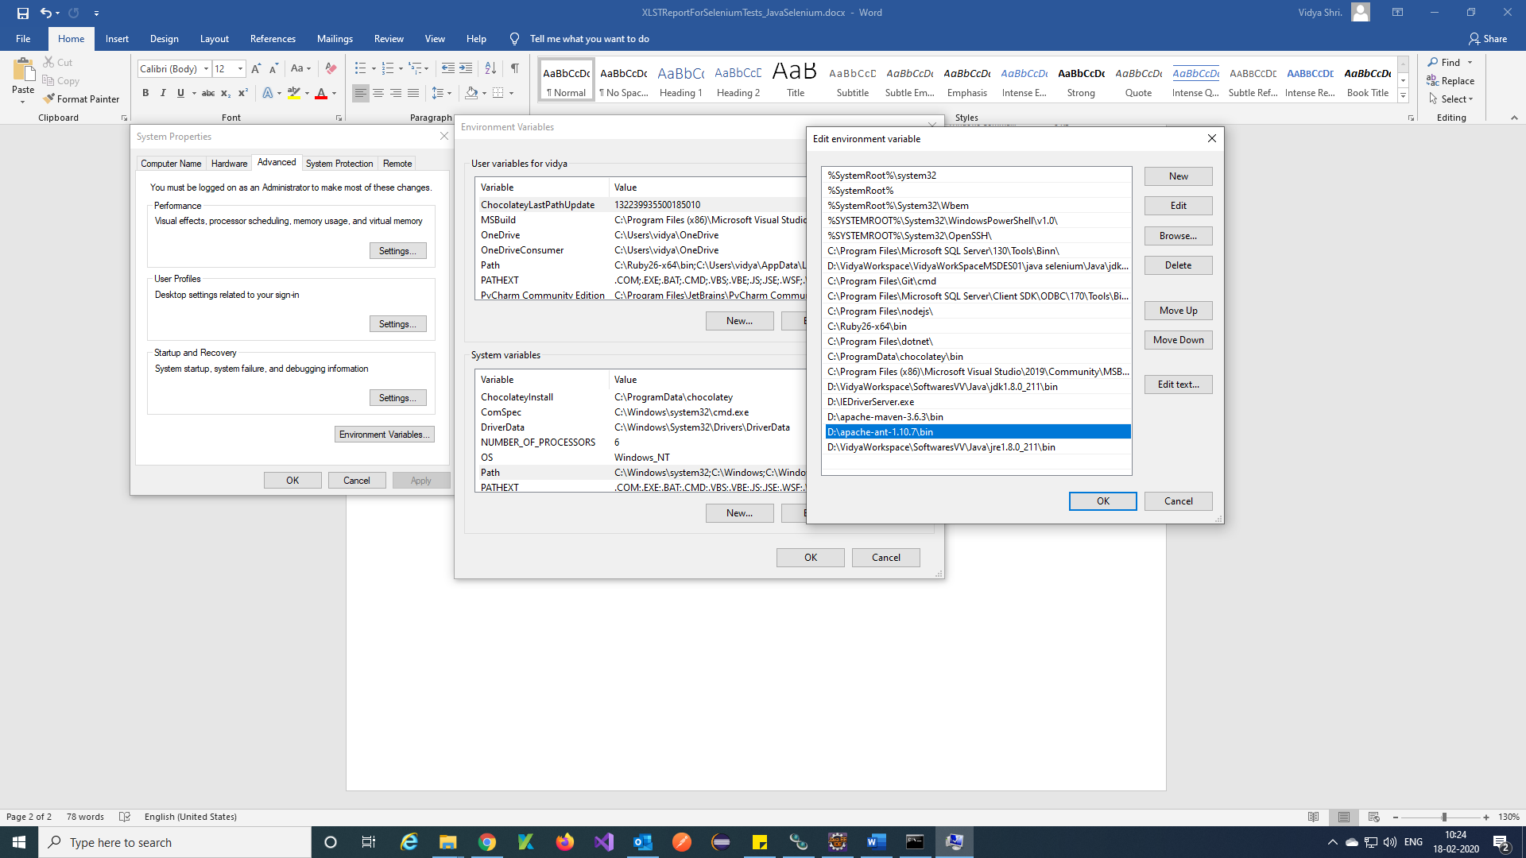

Step 4) Go to command prompt and check ant version.

Command = ant -version

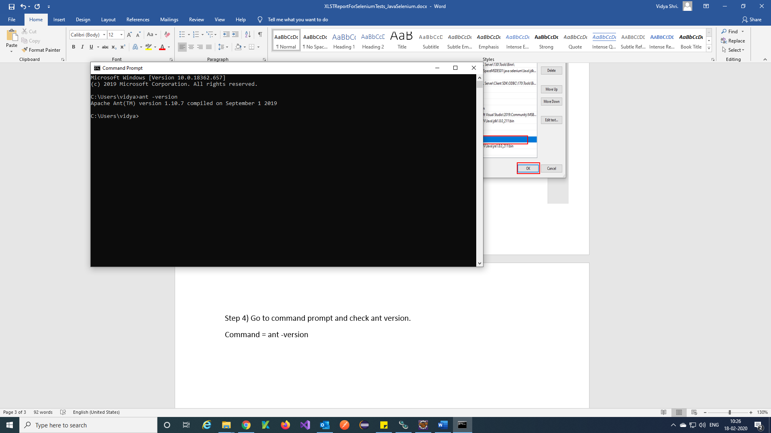

**Download XSLT Report folder:**

Step 1) Download XSLT Reportusing below URL🡪

<https://drive.google.com/drive/u/0/folders/0B5v_nInLNoquV1p5YWtHc3lkUkU>

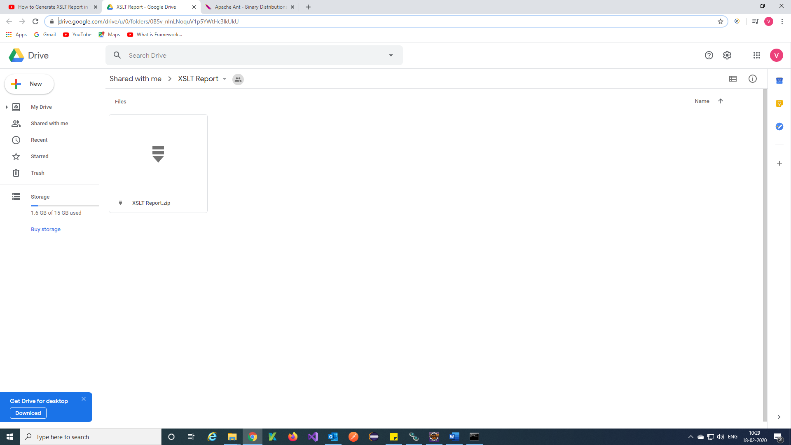

Step 2) Unzip downloaded file and Copy all.

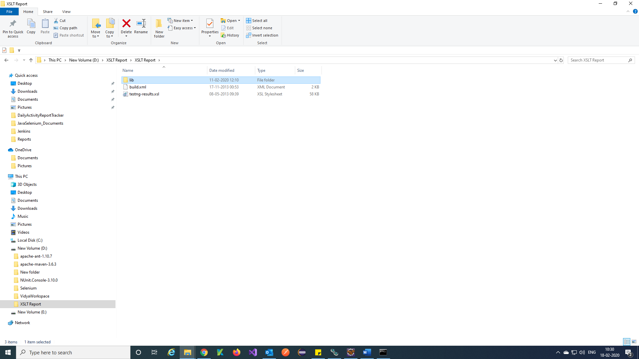

Step 3) Paste all files in Maven project of eclipse.

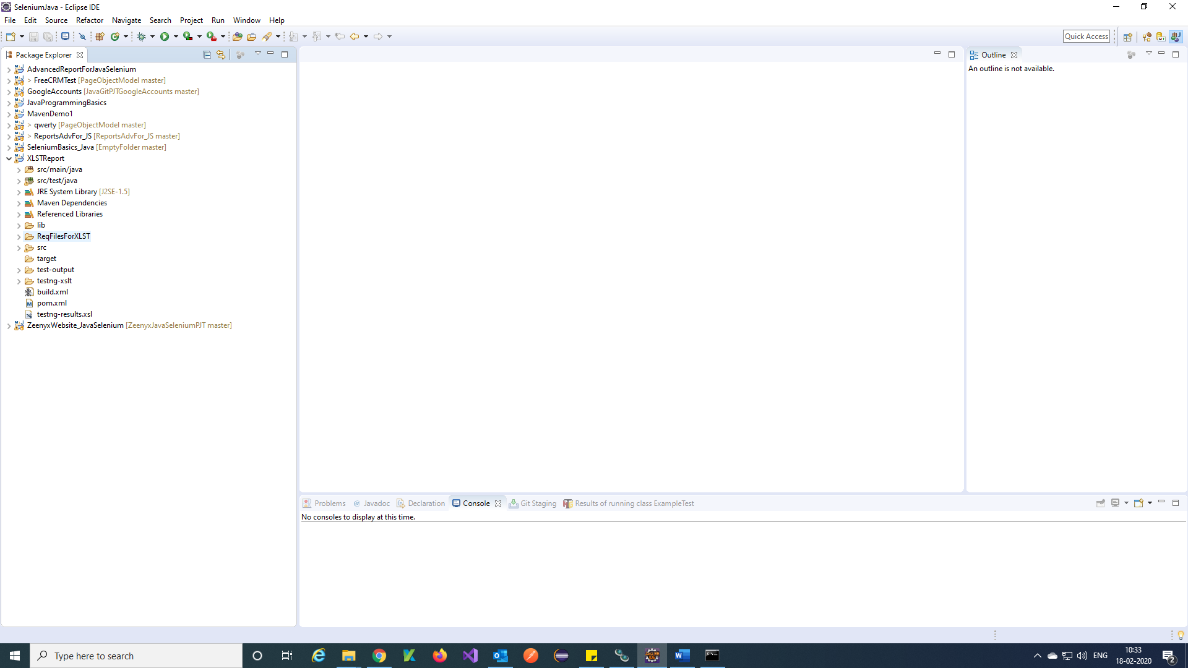

Step 4) Add jar files of saxon-8.7.jar and SaxonLiaison.jar to maven project from XSLT report folder.

**Add jars to project:**

Step 1) Right click on maven project 🡪Build Path 🡪 Configure Build Path.

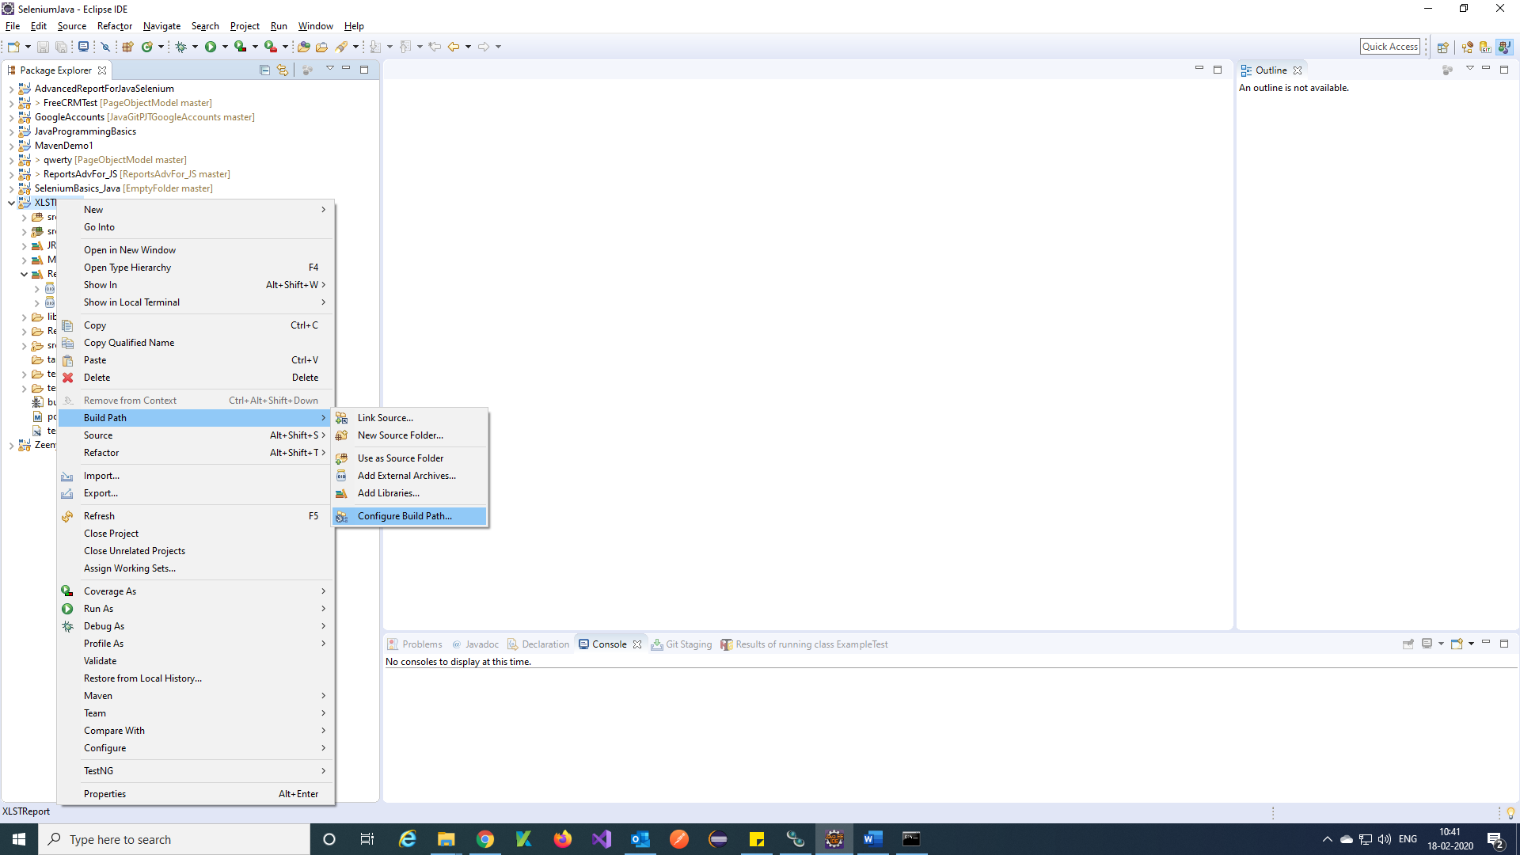

Step 2) Click on Add External JARs.

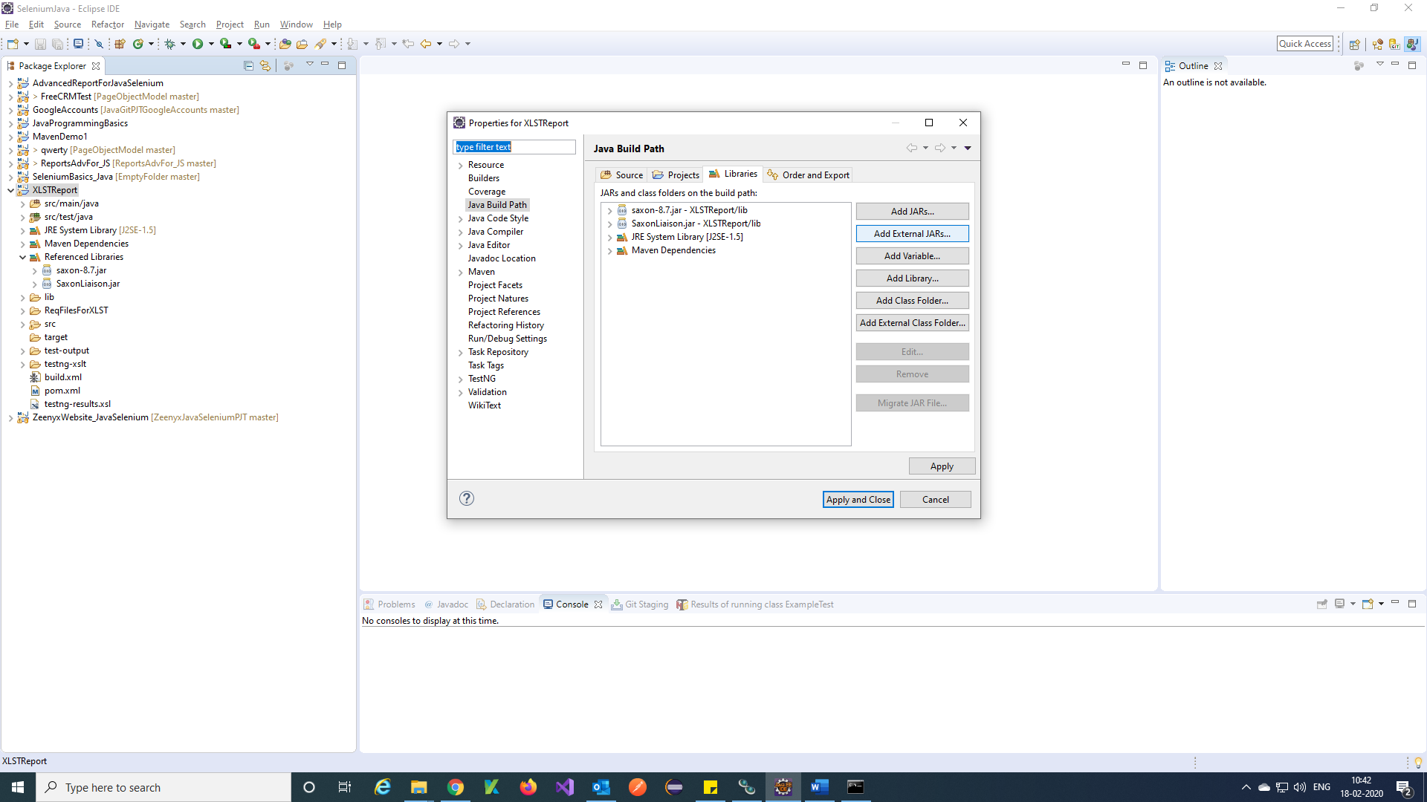

Step 3) Select JARs 🡪 Open.

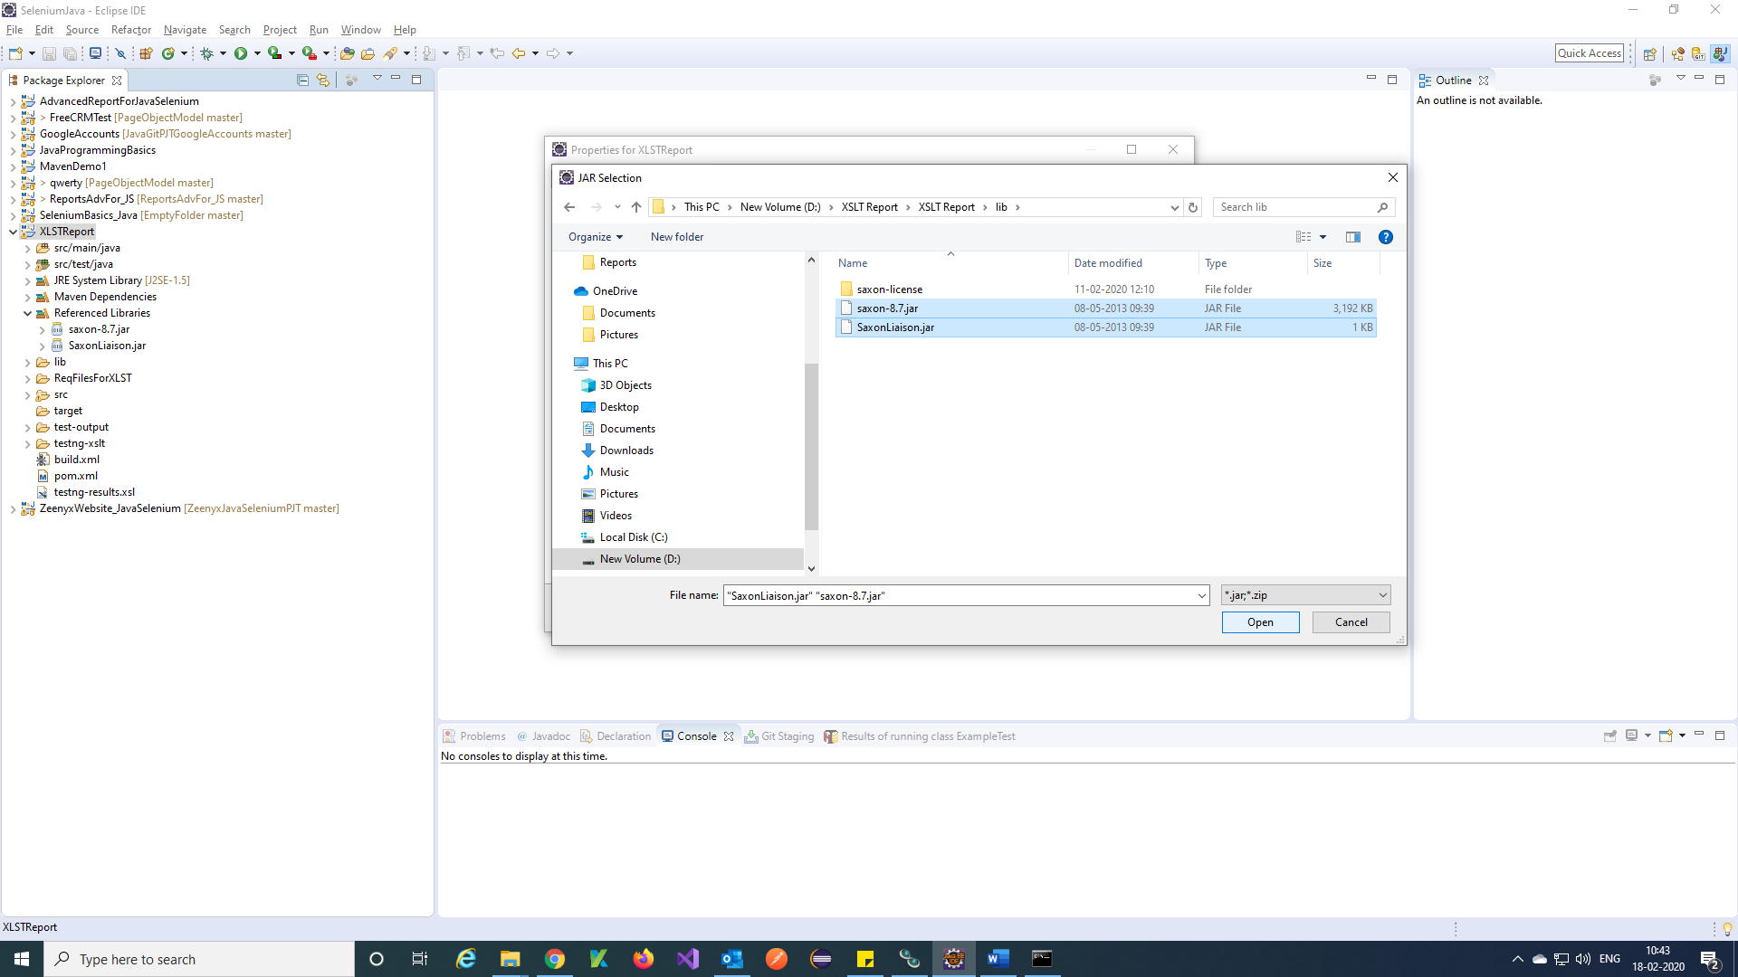

Step 4) Click on Apply and Close.

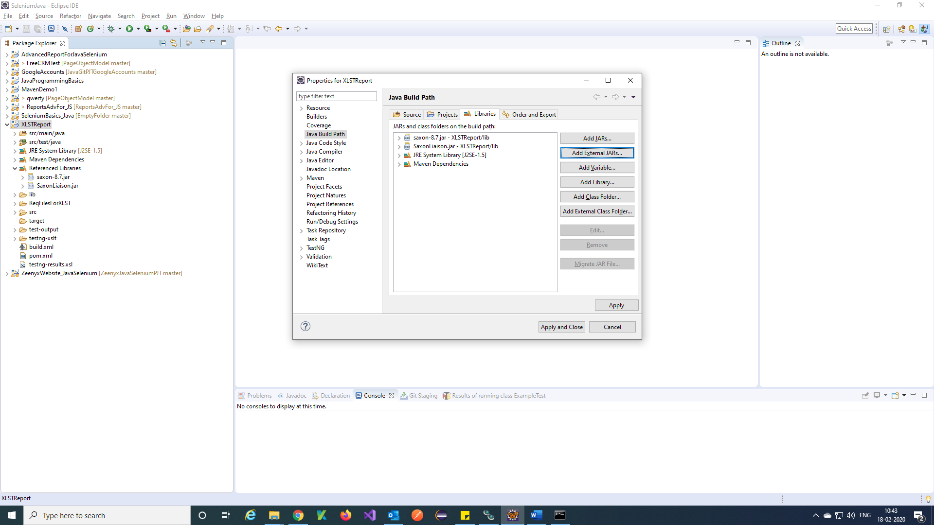

Step 5) Your JARs are added to project.

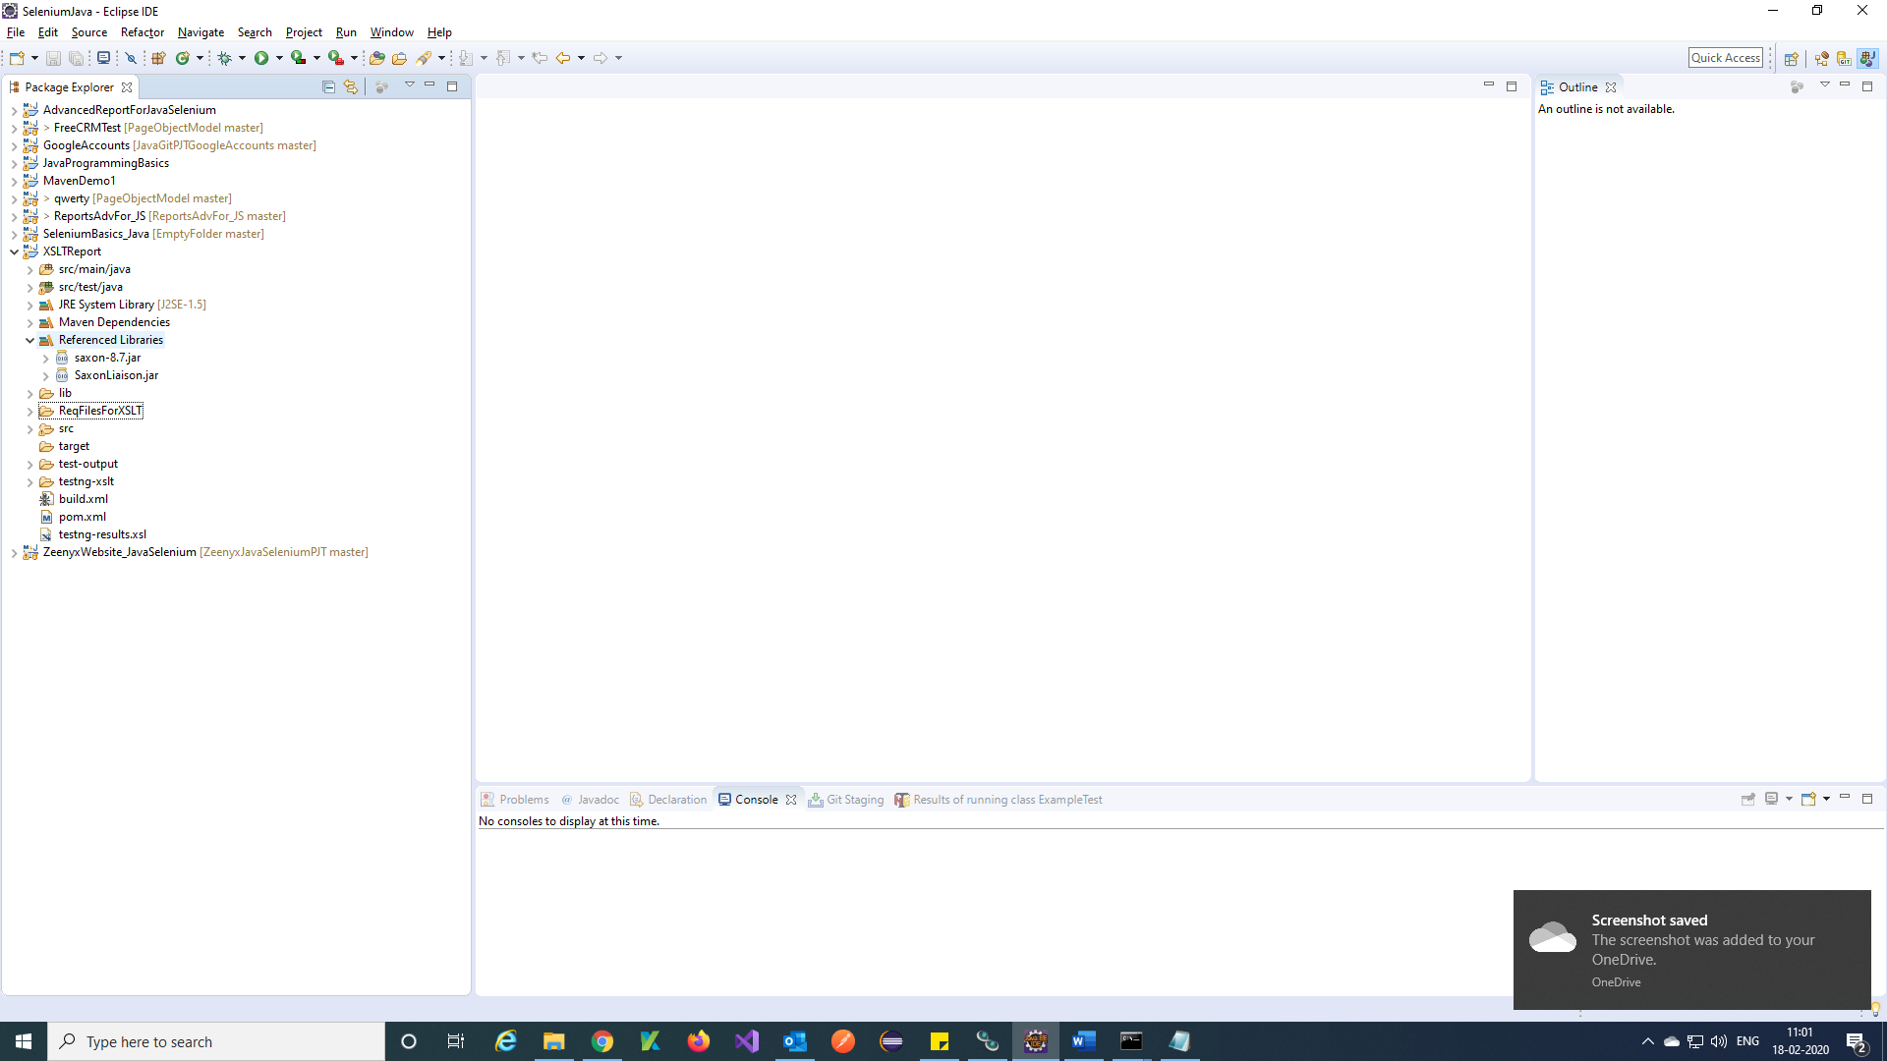

**Steps to get the XSLT Report:**

Step 1) Go to your project location.

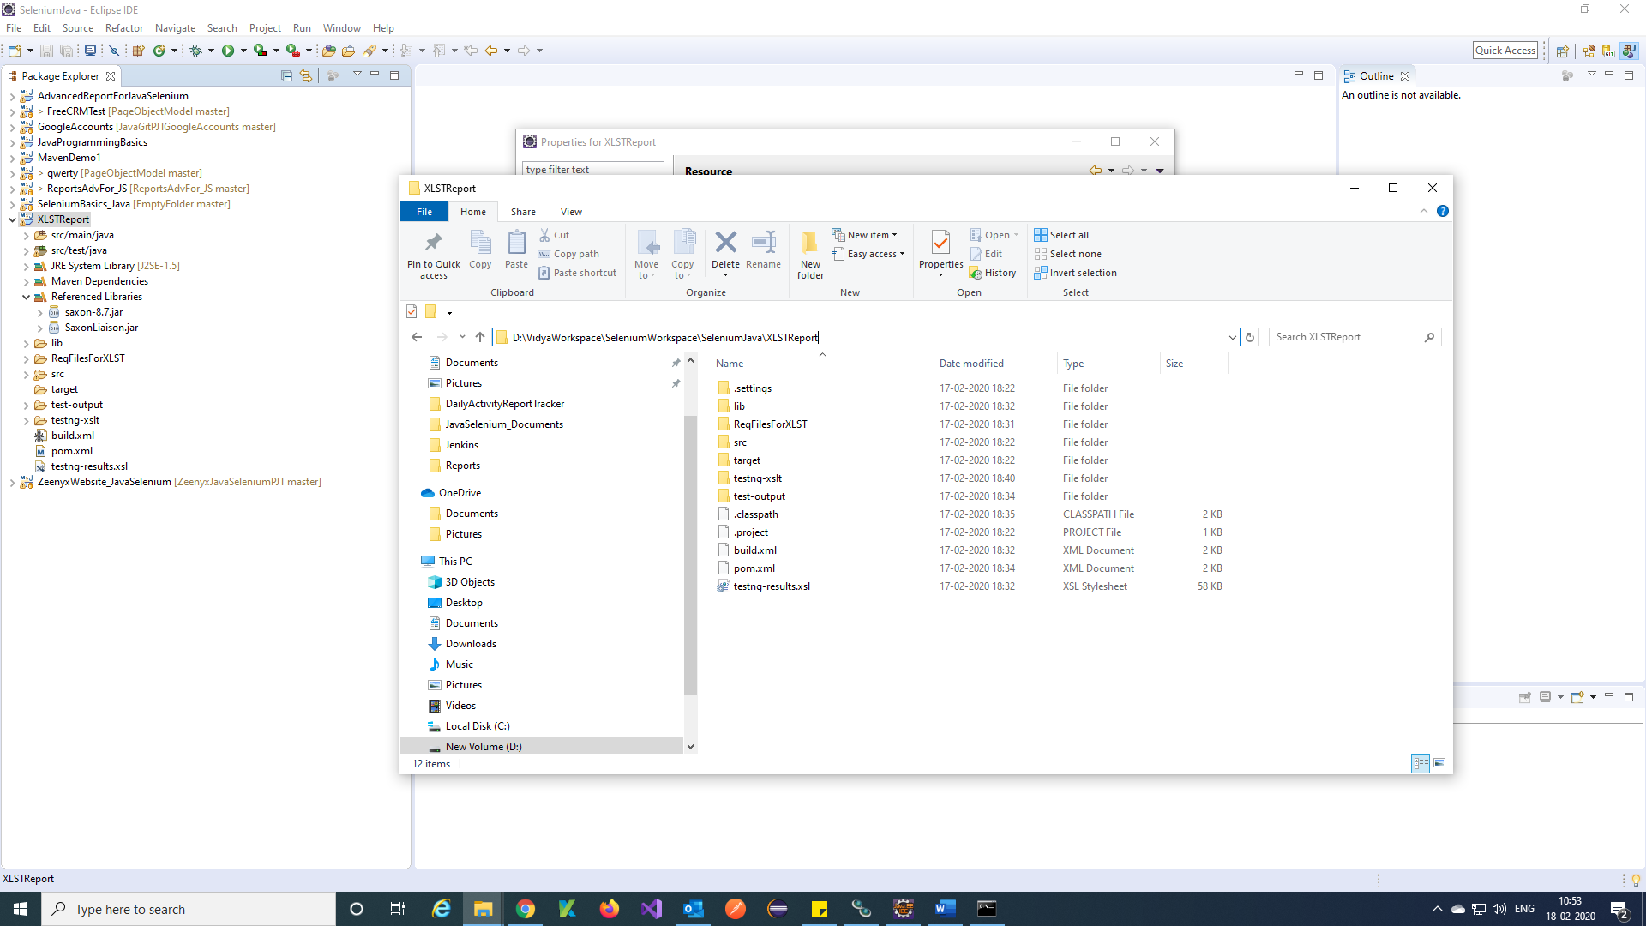

Step 2) Open command prompt from project location and type command.

command to build your project = ant

To generate XSLT report command = ant generateReport

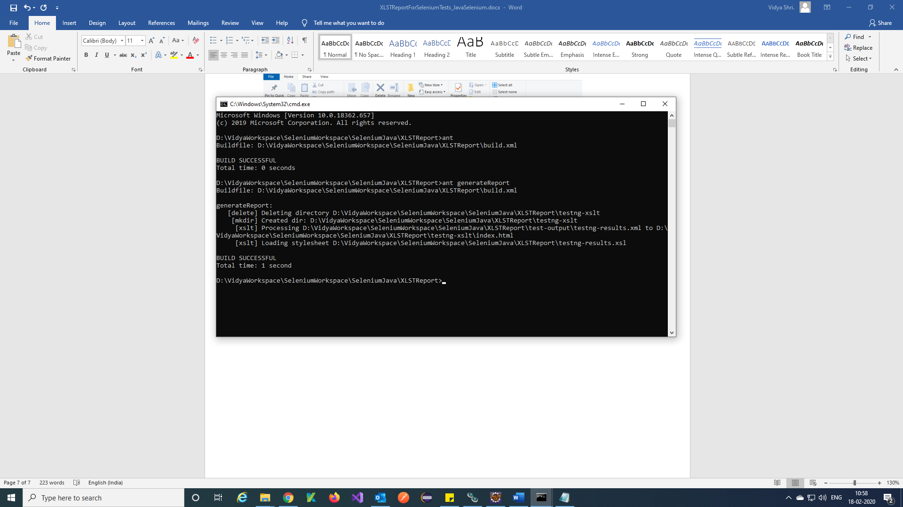

Step 3) Go to project location 🡪 testng-xslt 🡪 index.html

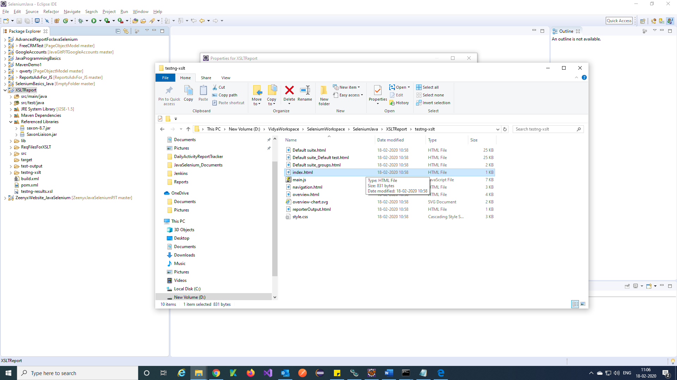

Step 4) You will get XSLT report like this.

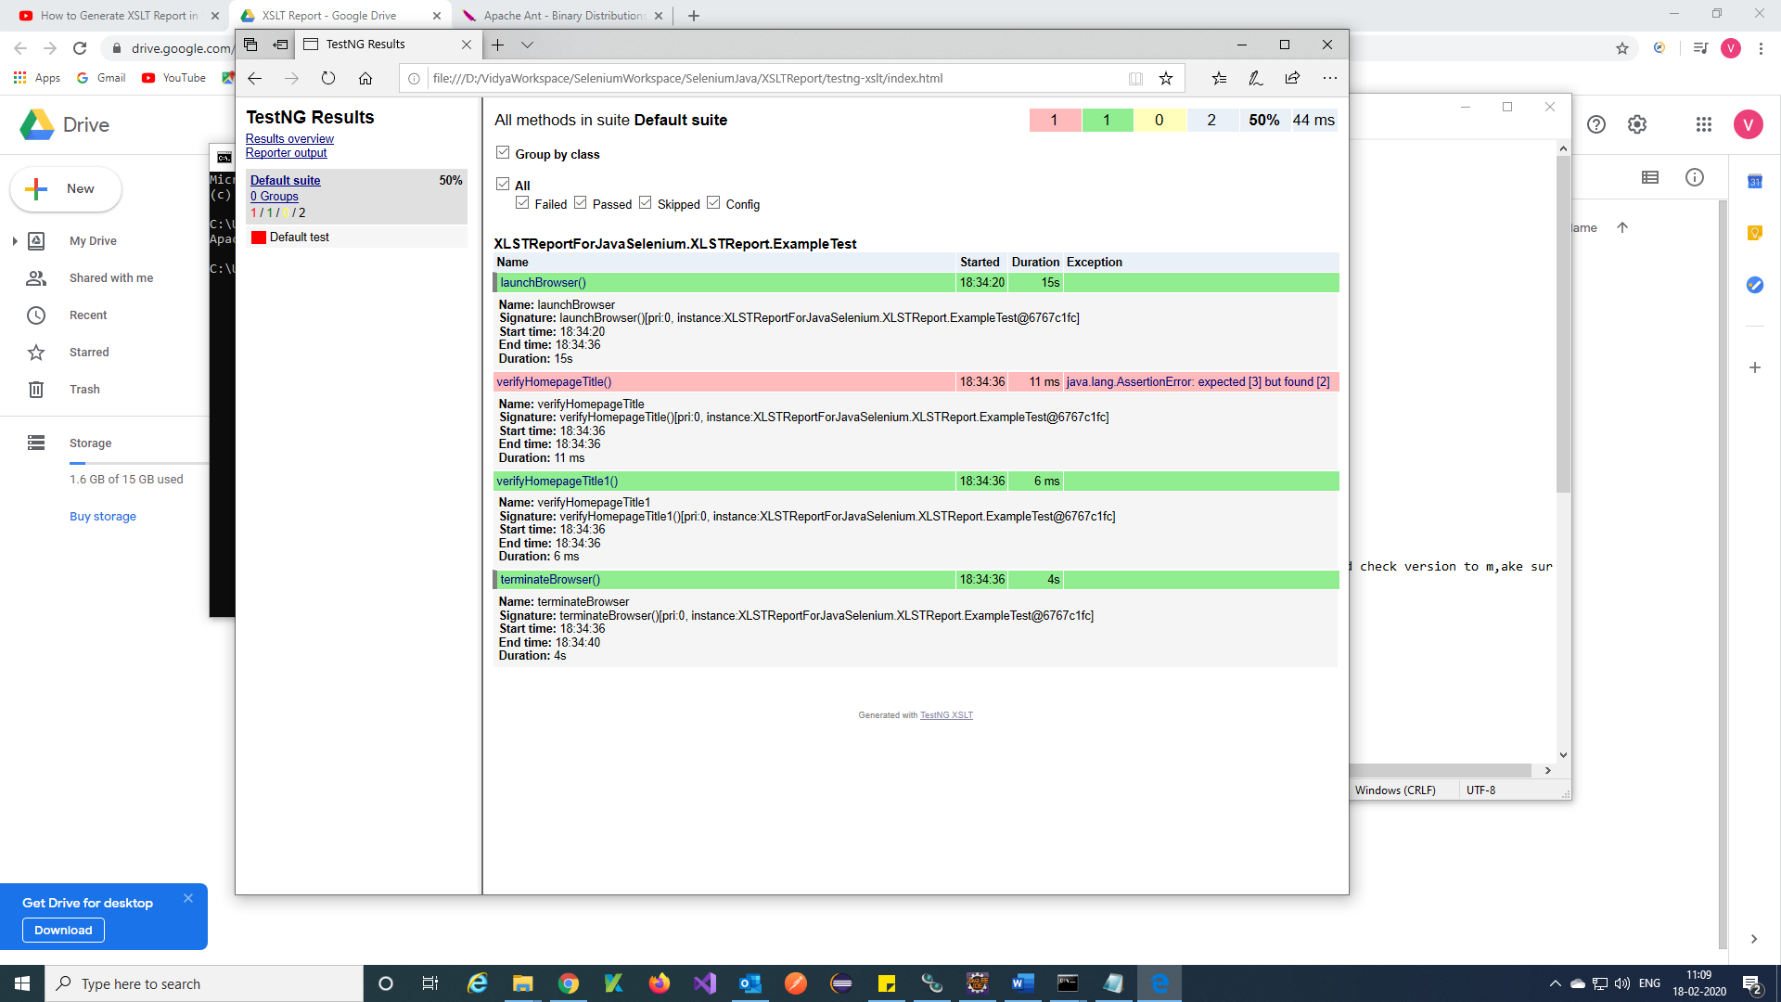

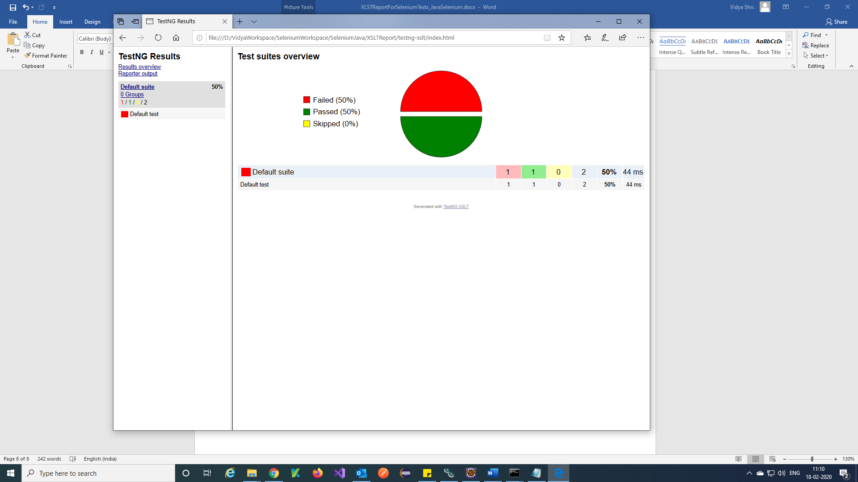

**Reference :**

<https://www.youtube.com/watch?v=ZNkfMDdjGgo&t=766s>