**Handling Dynamic WebTable in Selenium:**

Web Tables are nothing but a HTML table of a Web Application. HTML table holds the data in table format which is often identified in most of the web applications. To check the HTML table is available in the DOM, type and search for table. The elements of the HTML table are:

**<table>** - table name and information

**<tbody>** - table body

**<tr>** **</tr>-** represents the row data of the table

**<th></th>** - header information of the table

**<td></td>** - represents column data of the table

***The Structure of the WebTable will be like:***

**<table>**

**<tbody>**

**<tr>**

**<td></td>**

**<td></td>**

**<td></td>**

**</tr>**

**<tr>**

**<td> </td>**

**</tr>**

**<tr>**

**<td> </td>**

**</tr>**

The relationship between the WebTable Elements inorder to locate the elements in the dom.

<**table**> and <**tr**> is **Grand Parent** to G**rand Child**

<**tr**> and <**td**> is **Parent** to **Child**

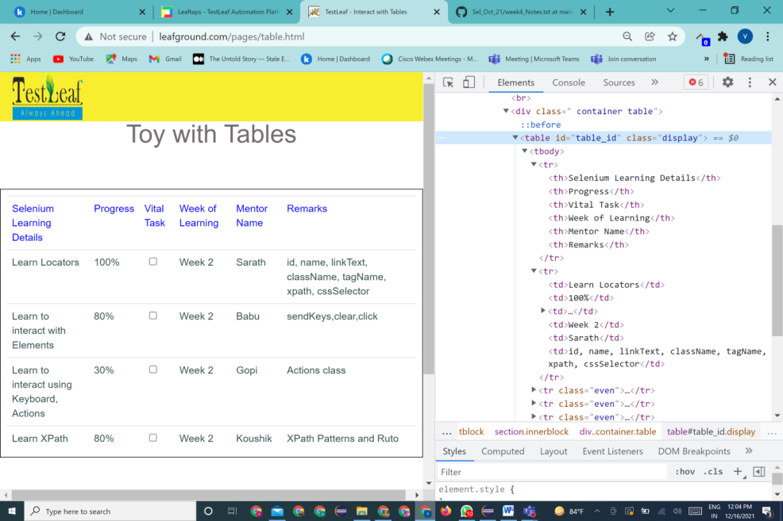**WebTables are of two types:**

**Static Table**:

* Rows and columns of the table will be fixed.
* Fetching data from the table will be easy and can be automated using XPath
* To work this static table data, we need to inspect the required web element and then fetch the data using usual XPath way

In this Leafground WebTable application, the row and column size will not change.

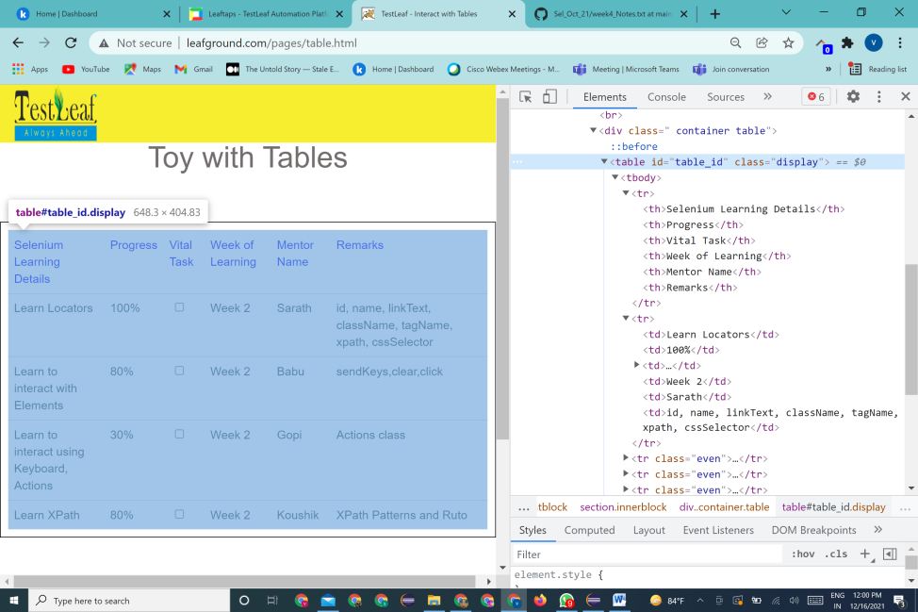

**How to automate the Static WebTable;**

**Step:1** Inspect the table

**Step:2** To hit the table in the dom, use the locator tagname or id to locate element.  
  
driver.findElement(By.id(“table_id”));

**Step:3** To read the data from a particular row,

List<WebElement> rowCount=driver. findElements(By.xpath(“//table[@id=’table_id’//tr”));-> returns list of available row elements under the located table.

**To get the number of rows**-> size() method is a called to get the size of the row element.  
**int size=rowCount.size();**

**Step: 4** To read the data from the column

Column values and size can be accessed through the rows as the columns are static to all rows.

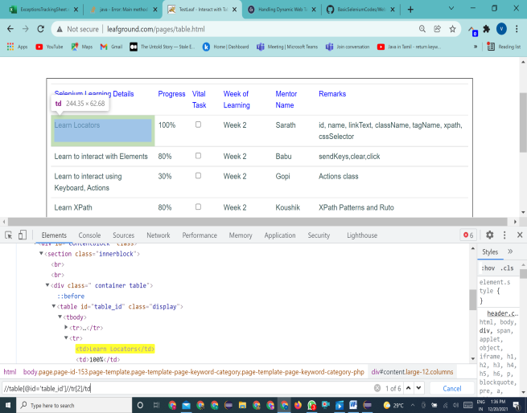 List<WebElement> colCount=driver. findElements(By.xpath(“//table[@id=’table_id’]//tr[2]/td”));

- returns list of column elements under the located row.  
*Here the scenario is hitting the second row from which the columns are identified which using the **Learn Locators** rows, all the corresponding columns are identified and that are as same as other rows.

**int colSize=colCount.size();** ->returns the ***size*** of the columns

To read the data of particular cell

String colValue= driver.findElements(By.xpath(“//table[@id=’table_id’]//tr[2]/td”)).getText();

This will print **LearnLocators** from the table.

If suppose ,we need to read the all the cell data of each and every column , we have to write a dynamic xpath which has to hit the rows and columns of the WebTable.

**public class LearnWebTable {**

**public static void main(String[] args) {**

**WebDriverManager.chromedriver().setup();**

**ChromeDriver driver = new ChromeDriver();**

**driver.manage().window().maximize();**

**driver.get("http://leafground.com/pages/table.html");**

**//to find the number of rows**

**List<WebElement> rows = driver.findElements(By.xpath("//table[@id='table_id']//tr"));**

**int rowSize = rows.size()**

**List<WebElement> tds = diver.findElements(By.xpath("//table[@id='table_id']//tr[r]/td"));**

**int tdSize = tds.size();**

**for (int i = 2; i <= rowSize; i++) {**

**for(int j = 1 ; j <= tdSize; j++) {**

**//i = 2 ; j = 1**

**String text = driver.findElement(By.xpath("//table[@id='table_id']//tr["+i+"]/td["+j+"]")).getText();**

**System.out.println(text);** To get the text of a particular cell with dynamic xpath->which can be used whenever the row and column size changes

**}**

**}}}**

**Dynamic Table:**

* Rows and columns are dynamic
* Cannot be handled easily as the rows and columns are changes according to the application requirement(input to the table).

Most of the Web application uses the dynamic web table to hold dynamic data. We can find these kinds of table in e-commerce websites, ERP application etc. to hold the product details, employee details, customer details etc.

Here, the data will be dynamic. In simple words, the table data will vary for every rows and column. For example, lets take the Erail application. Application holds the data of train names, departure point, destination, train time Schedule, and so on.. each and every data here is dynamic. If any train gets cancelled then the table values changes.

In the above scenario, all the data will be put up inside the HTML Table. Here the values in the row and the column may not be filled always.. Some may have empty values even though the row and column counts are same.

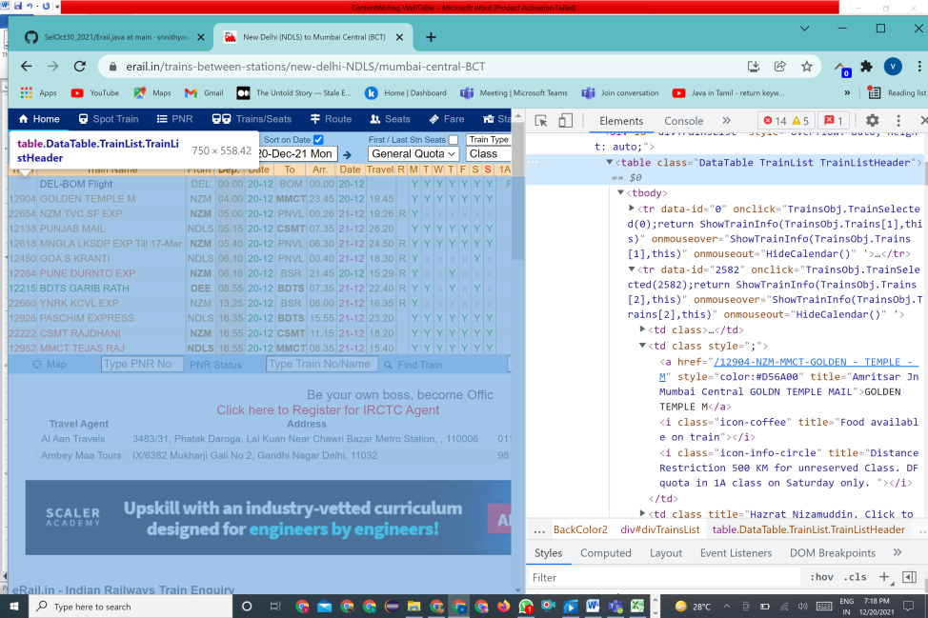

**How to automate the dynamic WebTable:**   
  
Let get in to write the dynamic script to fetch the value (train name) from the table

WebDriverManager.chromedriver().setup();

ChromeDriver **driver** = new ChromeDriver();

**driver**.get("https://erail.in/");

**driver**.manage().window().maximize();

**driver**.manage().timeouts().implicitlyWait(20, TimeUnit.SECONDS);

**driver**.findElement(By.id("chkSelectDateOnly")).click();

WebElement **fromStation** = driver.findElement(By.id("txtStationFrom"));

**fromStation**.clear();

**fromStation**.sendKeys("MAS", Keys.TAB);

WebElement **toStation** = driver.findElement(By.id("txtStationTo"));

**toStation**.clear();

**toStation**.sendKeys("Coimbatore", Keys.TAB);

**// To hit the TABLE**

WebElement **webTable** = driver.findElement(By.xpath("//table[@class='DataTable TrainList TrainListHeader']"));

**//To access all the rows - To find the number of rows in a table**

List<WebElement> **tableRows** = webTable.findElements(By.tagName("tr"));

System.out.println(" Nymber of row in the table: " + tableRows.size());

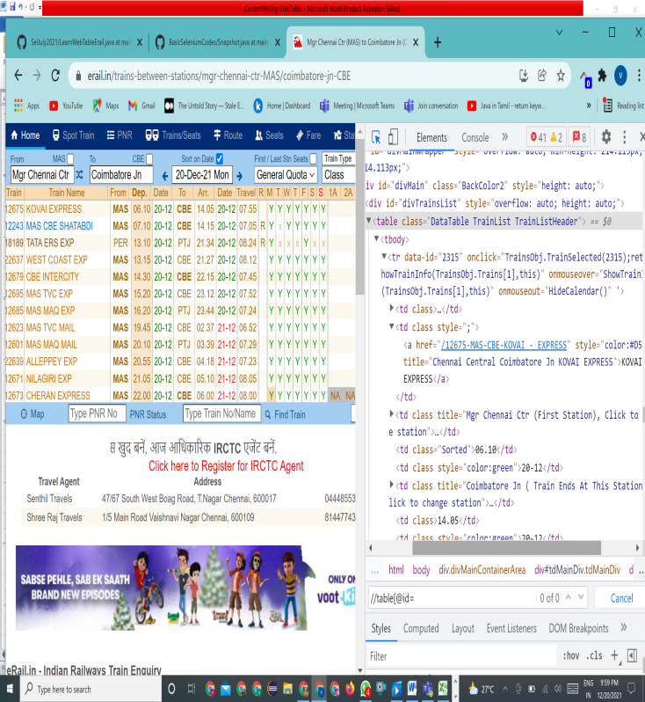**// To find the number of columns in a table by choosing any row**

WebElement **webElement** = tableRows.get(1);

List<**WebElement**> **webCol** = **webElement**.findElements(By.tagName("td"));

System.out.println(" Number of columns in the table: " + **webCol**.size());

**// To get the list of train names from Second column in the table (all the rows -- second col )**

**// 1. strike the first row, take the second col(row. get (0) till get(12))**

for (int i = 0; i < **tableRows**.size(); i++)

{

WebElement allRows = **tableRows**.get(i); // got the specific row

List<WebElement> **allCols** = **allRows**.findElements(By.tagName("td"));

String **allRowsSecColumn** = **allCols**.get(1).getText();

System.out.println(**allRowsSecColumn**);

}