Objective: Practise essential Linux command-line operations — file and directory management, viewing files, searching, archiving, downloading, permissions, and environment variables.

1. Creating and Renaming Files/Directories
- Create a directory named test_dir using mkdir.
- Inside test_dir, create an empty file called example.txt.
- Rename example.txt to renamed_example.txt using mv.
ANSWER-
mkdir test_dir
touch test_dir/example.txt
mv test_dir/example.txt test_dir/renamed_example.txt
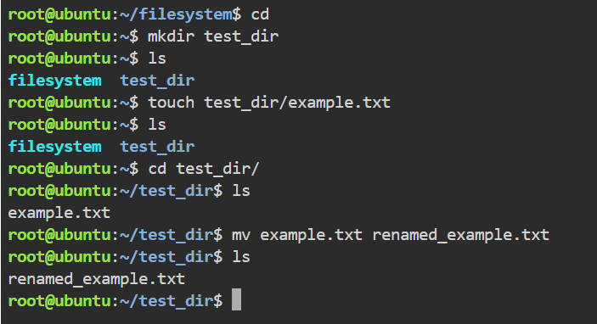

2. Viewing File Contents
- Use cat to display the contents of /etc/passwd.
- Display only the first 5 lines of /etc/passwd using head.

- Display only the last 5 lines of /etc/passwd using tail.
ANSWER-
cat /etc/passwd
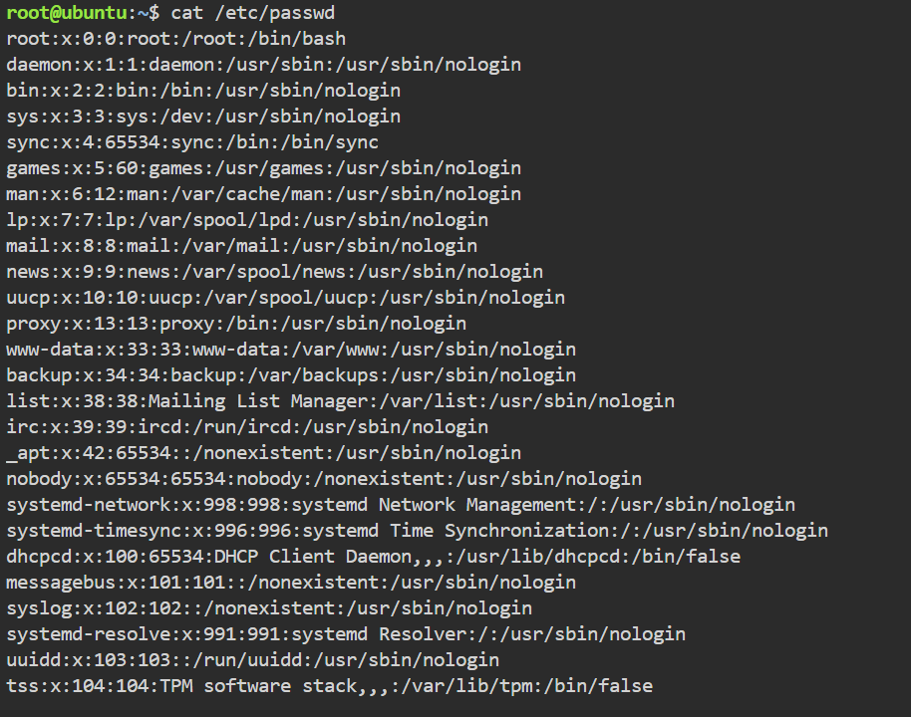
head – 5 /etc/passwd
tail -n 5 /etc/passwd
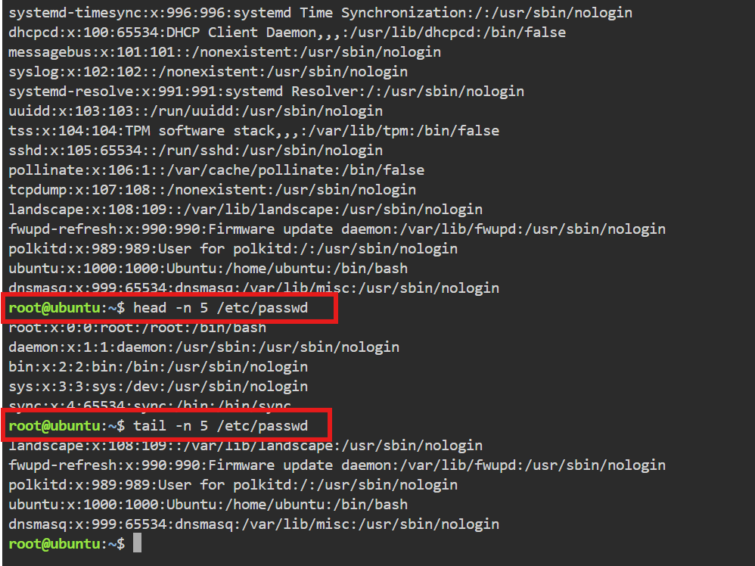

3. Searching for Patterns
- Use grep to find all lines containing the word “root” in /etc/passwd.
ANS-
grep "root" /etc/passwd
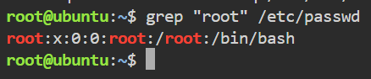

4. Zipping and Unzipping
1. Compress the test_dir directory into a file named test_dir.zip using zip.

- Unzip test_dir.zip into a new directory named unzipped_dir.
ANSWER-
zip -r test_dir.zip test_dir
unzip test_dir.zip -d unzipped_dir
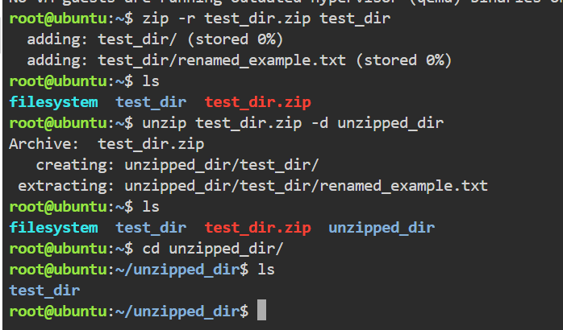

5. Downloading Files
- Use wget to download a file from a URL (e.g., https://example.com/sample.txt).

ANSWER-
wget https://example.com/sample.txt
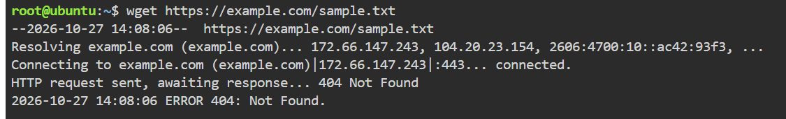
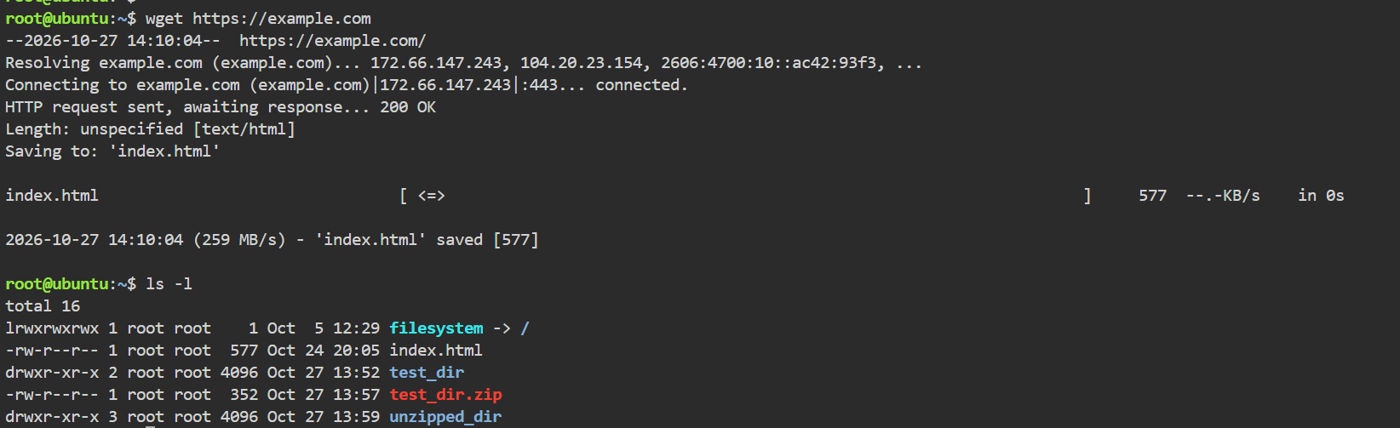
6. Changing Permissions
- Create a file named secure.txt and change its permissions to read-only for everyone using chmod.
ANS-
touch secure.txt
chmod 444 secure.txt
ls -l secure.txt # verify: -r--r--r--
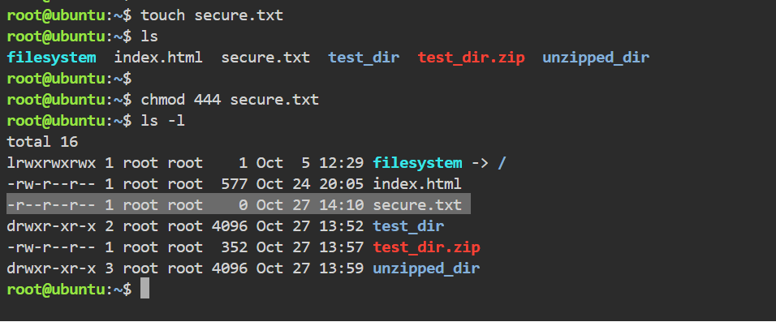

7. Working with Environment Variables
- Use export to set a new environment variable called MY_VAR with the value “Hello, Linux!”.
ANS-
export MY_VAR="Hello, Linux!"
echo $MY_VAR # verify it prints the value
